Міністерство освіти і науки України

Національний університет „Львівська політехніка”

Кафедра ЕОМ



**Звіт**

з лабораторної роботи №3

з дисципліни: “Кросплатформні засоби програмування”

на тему: “Класи та пакети”

Виконав: ст. гр. КІ-34

Зубалій І.А.

Прийняв:

Іванов Ю.С.

Львів – 2022

**Мета:** ознайомитися з процесом розробки класів та пакетів мовоюJava.

**Індивідуальне завдання:** написати та налагодити програму на мові Java, що реалізує у вигляді класу предметну область згідно варіанту:

**5. Машина**

**Хід роботи:**

1. Запустив середовище Eclipse та написав програму згідно індивідуального завдання:

*CarApp.java*

package lab3;

import java.io.FileNotFoundException;

/**

* CarApp class implements main method for Car class possibilities demonstration

*

* @author Zubalii

* @version 1.0

*/

public class CarApp {

/**

* @param args

* @throws FileNotFoundException

*/

public static void main(String[] args) throws FileNotFoundException {

Car car1 = new Car(1.7f, 5, 4);

car1.info();

System.out.println("----------------");

car1.go();

car1.accelerate();

car1.shiftTo(3);

car1.stopTheCar();

System.out.println("\n___NEXT_CAR___\n");

Car car2 = new Car(5.5f, 7, 6);

car2.info();

System.out.println("----------------");

car2.go();

car2.shiftTo(3);

car2.accelerate();

car2.shiftTo(5);

car2.stopTheCar();

}

}

*Car.java*

/**

* lab 3 package

*/

package ki34.hryhlevych.lab3;

import java.io.File;

import java.io.FileNotFoundException;

import java.io.PrintWriter;

/**

* Class Car implements car

*

* **@version** 1.0

*/

public class Car {

private Engine engine;

private Gearbox gearbox;

private Wheels wheels;

private PrintWriter fout;

/**

* Constructor

*

* **@throws** FileNotFoundException

*/

Car() throws FileNotFoundException {

engine = new Engine();

gearbox = new Gearbox();

wheels = new Wheels();

fout = new PrintWriter(new File("Log.txt"));

}

/**

* Constructor

*

* **@param** engine capacity

* **@throws** FileNotFoundException

*/

Car(float engineCapacity) throws FileNotFoundException {

engine = new Engine(engineCapacity);

gearbox = new Gearbox();

wheels = new Wheels();

fout = new PrintWriter(new File("Log.txt"));

}

/**

* Constructor

*

* **@param** engine capacity

* **@param** number of gears

* **@throws** FileNotFoundException

*/

Car(float engineCapacity, int gears) throws FileNotFoundException {

engine = new Engine(engineCapacity);

gearbox = new Gearbox(gears);

wheels = new Wheels();

fout = new PrintWriter(new File("Log.txt"));

}

/**

* Constructor

*

* **@param** engine capacity

* **@param** number of gears

* **@param** number of wheels

* **@throws** FileNotFoundException

*/

Car(float engineCapacity, int gears, int wheelsQuantity) throws FileNotFoundException {

engine = new Engine(engineCapacity);

gearbox = new Gearbox(gears);

wheels = new Wheels(wheelsQuantity);

fout = new PrintWriter(new File("Log.txt"));

}

/**

* Getter for Engine

*/

public Engine getEngine() {

return engine;

}

/**

* Setter for Engine

*/

public void setEngine(Engine engine) {

this.engine = engine;

}

/**

* Getter for Gearbox

*/

public Gearbox getGearbox() {

return gearbox;

}

/**

* Setter for Gearbox

*/

public void setGearbox(Gearbox gearbox) {

this.gearbox = gearbox;

}

/**

* Getter for Wheels

*/

public Wheels getWheels() {

return wheels;

}

/**

* Setter for Wheels

*/

public void setWheels(Wheels wheels) {

this.wheels = wheels;

}

/**

* Method implements car moving

*/

public void go() {

engine.start();

gearbox.shiftGear(1);

engine.gas();

wheels.spin();

System.***out***.println("The car started to go...");

fout.println("The car started to go...");

}

/**

* Method implements car acceleration

*/

public void accelerate() {

while (gearbox.getCurrentGear() != gearbox.getNumberOfGears()) {

gearbox.shiftGear(gearbox.getCurrentGear() + 1);

engine.gas();

}

}

/**

* Method implements car stopping

*/

public void stopTheCar() {

wheels.brake();

gearbox.shiftGear(0);

System.***out***.println("The car is stoped...");

fout.println("The car is stoped...");

}

/**

* Method implements car reverse moving

*/

public void goReverse() {

gearbox.shiftReverse();

engine.gas();

wheels.spin();

}

/**

* Method implements shifting to the required gear

*

* **@param** gear - required gear

*/

public void shiftTo(int gear) {

gearbox.shiftGear(gear);

}

/**

* Method shows car info

*/

public void info() {

System.***out***.println("Engine capacity is: " + engine.getCapacity());

fout.println("Engine capacity is: " + engine.getCapacity());

System.***out***.println("Number of gears is: " + gearbox.getNumberOfGears());

fout.println("Number of gears is: " + gearbox.getNumberOfGears());

System.***out***.println("Number of wheels is: " + wheels.getNumberOfWheels());

fout.println("Number of wheels is: " + wheels.getNumberOfWheels());

}

/**

* Method releases used recourses

*/

public void dispose() {

fout.close();

}

/**

* Class Engine implements car engine

*

* **@author** Maksym Hryhlevych

* **@version** 1.0

*/

class Engine {

private float capacity;

/**

* Constructor

*/

public Engine() {

this.capacity = 1.0f;

}

/**

* Constructor

*

* **@param** engine capacity

*/

public Engine(float capacity) {

this.capacity = capacity;

}

/**

* Getter for capacity

*/

public float getCapacity() {

return capacity;

}

/**

* Setter for capacity

*/

public void setCapacity(float capacity) {

this.capacity = capacity;

}

/**

* Method implements engine start

*/

public void start() {

System.***out***.println("Engine is started...");

fout.println("Engine is started...");

}

/**

* Method implements the operation of the accelerator pedal

*/

public void gas() {

System.***out***.println("Wroom...wroom...");

fout.println("Wroom...wroom...");

}

}

/**

* Class Engine implements car gearbox

*

* **@version** 1.0

*/

class Gearbox {

private int currentGear = 0;

private int numberOfGears;

/**

* Constructor

*/

public Gearbox() {

this.numberOfGears = 4;

}

/**

* Constructor

*

* **@param** number of gears

*/

public Gearbox(int numberOfGears) {

this.numberOfGears = numberOfGears;

}

/**

* Getter for numberOfGears

*/

public int getNumberOfGears() {

return numberOfGears;

}

/**

* Setter for numberOfGears

*/

public void setNumberOfGears(int numberOfGears) {

this.numberOfGears = numberOfGears;

}

/**

* Method implements gear shifting

*

* **@param** required gear

*/

public void shiftGear(int gear) {

if ((gear >= 0) && (gear <= numberOfGears)) {

currentGear = gear;

System.***out***.println("Shifted " + currentGear + " gear");

fout.println("Shifted " + currentGear + " gear");

} else if (gear == 0) {

System.***out***.println("Shifted neutral gear");

fout.println("Shifted neutral gear");

} else {

System.***out***.println("Krhrhrh...This gear doesn't exist");

fout.println("Krhrhrh...This gear doesn't exist");

}

}

/**

* Method implements reverse gear

*/

public void shiftReverse() {

currentGear = -1;

System.***out***.println("Shifted into reverse");

fout.println("Shifted into reverse");

}

/**

* Method returns current gear

*

* **@return** current gear

*/

public int getCurrentGear() {

return currentGear;

}

}

/**

* Class Wheels implements car wheels

*

* **@version** 1.0

*/

class Wheels {

private int numberOfWheels;

/**

* Constructor

*/

public Wheels() {

this.numberOfWheels = 4;

}

/**

* Constructor

*

* **@param** number of wheels

*/

public Wheels(int numberOfWheels) {

this.numberOfWheels = numberOfWheels;

}

/**

* Getter for numberOfWheels

*/

public int getNumberOfWheels() {

return numberOfWheels;

}

/**

* Setter for numberOfWheels

*/

public void setNumberOfWheels(int numberOfWheels) {

this.numberOfWheels = numberOfWheels;

}

/**

* Method implements the rotation of the wheels

*/

public void spin() {

System.***out***.println("Wheels are spinning...");

fout.println("Wheels are spinning...");

}

/**

* Method implements braking

*/

public void brake() {

System.***out***.println("Wheels are braking...");

fout.println("Wheels are braking...");

}

}

}

package lab3;

import java.io.File;

import java.io.FileNotFoundException;

import java.io.PrintWriter;

public class Car {

private Engine engine;

private Gearbox gearbox;

private Wheels wheels;

private PrintWriter fout;

/**

* Constructor

*

* @throws FileNotFoundException

*/

Car() throws FileNotFoundException {

engine = new Engine();

gearbox = new Gearbox();

wheels = new Wheels();

fout = new PrintWriter(new File("Log.txt"));

}

/**

* Constructor

*

* @param engine capacity

* @throws FileNotFoundException

*/

Car(float engineCapacity) throws FileNotFoundException {

engine = new Engine(engineCapacity);

gearbox = new Gearbox();

wheels = new Wheels();

fout = new PrintWriter(new File("Log.txt"));

}

/**

* Constructor

*

* @param engine capacity

* @param number of gears

* @throws FileNotFoundException

*/

Car(float engineCapacity, int gears) throws FileNotFoundException {

engine = new Engine(engineCapacity);

gearbox = new Gearbox(gears);

wheels = new Wheels();

fout = new PrintWriter(new File("Log.txt"));

}

/**

* Constructor

*

* @param engine capacity

* @param number of gears

* @param number of wheels

* @throws FileNotFoundException

*/

Car(float engineCapacity, int gears, int wheelsQuantity) throws FileNotFoundException {

engine = new Engine(engineCapacity);

gearbox = new Gearbox(gears);

wheels = new Wheels(wheelsQuantity);

fout = new PrintWriter(new File("Log.txt"));

}

/**

* Getter for Engine

*/

public Engine getEngine() {

return engine;

}

/**

* Setter for Engine

*/

public void setEngine(Engine engine) {

this.engine = engine;

}

/**

* Getter for Gearbox

*/

public Gearbox getGearbox() {

return gearbox;

}

/**

* Setter for Gearbox

*/

public void setGearbox(Gearbox gearbox) {

this.gearbox = gearbox;

}

/**

* Getter for Wheels

*/

public Wheels getWheels() {

return wheels;

}

/**

* Setter for Wheels

*/

public void setWheels(Wheels wheels) {

this.wheels = wheels;

}

/**

* Method implements car moving

*/

public void go() {

engine.start();

System.out.println("The car started to go...");

fout.println("The car started to go...");

gearbox.shiftGear(1);

engine.gas();

wheels.spin();

}

/**

* Method implements car acceleration

*/

public void accelerate() {

while (gearbox.getCurrentGear() != gearbox.getNumberOfGears()) {

gearbox.shiftGear(gearbox.getCurrentGear() + 1);

engine.gas();

}

}

/**

* Method implements car stopping

*/

public void stopTheCar() {

wheels.brake();

gearbox.shiftGear(0);

System.out.println("The car is stoped...");

fout.println("The car is stoped...");

}

/**

* Method implements car reverse moving

*/

public void goReverse() {

gearbox.shiftReverse();

engine.gas();

wheels.spin();

}

/**

* Method implements shifting to the required gear

*

* @param gear - required gear

*/

public void shiftTo(int gear) {

gearbox.shiftGear(gear);

}

/**

* Method shows car info

*/

public void info() {

System.out.println("Engine capacity is: " + engine.getCapacity());

fout.println("Engine capacity is: " + engine.getCapacity());

System.out.println("Number of gears is: " + gearbox.getNumberOfGears());

fout.println("Number of gears is: " + gearbox.getNumberOfGears());

System.out.println("Number of wheels is: " + wheels.getNumberOfWheels());

fout.println("Number of wheels is: " + wheels.getNumberOfWheels());

}

/**

* Method releases used recourses

*/

public void dispose() {

fout.close();

}

/**

* Class Engine implements car engine

*

* @author Zubalii

* @version 1.0

*/

class Engine {

private float capacity;

/**

* Constructor

*/

public Engine() {

this.capacity = 1.0f;

}

/**

* Constructor

*

* @param engine capacity

*/

public Engine(float capacity) {

this.capacity = capacity;

}

/**

* Getter for capacity

*/

public float getCapacity() {

return capacity;

}

/**

* Setter for capacity

*/

public void setCapacity(float capacity) {

this.capacity = capacity;

}

/**

* Method implements engine start

*/

public void start() {

System.out.println("Engine is started...");

fout.println("Engine is started...");

}

/**

* Method implements the operation of the accelerator pedal

*/

public void gas() {

System.out.println("Wroom...wroom...");

fout.println("Wroom...wroom...");

}

}

/**

* Class Engine implements car gearbox

*

* @author Zubalii

* @version 1.0

*/

class Gearbox {

private int currentGear = 0;

private int numberOfGears;

/**

* Constructor

*/

public Gearbox() {

this.numberOfGears = 4;

}

/**

* Constructor

*

* @param number of gears

*/

public Gearbox(int numberOfGears) {

this.numberOfGears = numberOfGears;

}

/**

* Getter for numberOfGears

*/

public int getNumberOfGears() {

return numberOfGears;

}

/**

* Setter for numberOfGears

*/

public void setNumberOfGears(int numberOfGears) {

this.numberOfGears = numberOfGears;

}

/**

* Method implements gear shifting

*

* @param required gear

*/

public void shiftGear(int gear) {

if ((gear >= 0) && (gear <= numberOfGears)) {

currentGear = gear;

System.out.println("Shifted " + currentGear + " gear");

fout.println("Shifted " + currentGear + " gear");

} else if (gear == 0) {

System.out.println("Shifted neutral gear");

fout.println("Shifted neutral gear");

} else {

System.out.println("Krhrhrh...This gear doesn't exist");

fout.println("Krhrhrh...This gear doesn't exist");

}

}

/**

* Method implements reverse gear

*/

public void shiftReverse() {

currentGear = -1;

System.out.println("Shifted into reverse");

fout.println("Shifted into reverse");

}

/**

* Method returns current gear

*

* @return current gear

*/

public int getCurrentGear() {

return currentGear;

}

}

/**

* Class Wheels implements car wheels

*

* @author Zubalii

* @version 1.0

*/

class Wheels {

private int numberOfWheels;

/**

* Constructor

*/

public Wheels() {

this.numberOfWheels = 4;

}

/**

* Constructor

*

* @param number of wheels

*/

public Wheels(int numberOfWheels) {

this.numberOfWheels = numberOfWheels;

}

/**

* Getter for numberOfWheels

*/

public int getNumberOfWheels() {

return numberOfWheels;

}

/**

* Setter for numberOfWheels

*/

public void setNumberOfWheels(int numberOfWheels) {

this.numberOfWheels = numberOfWheels;

}

/**

* Method implements the rotation of the wheels

*/

public void spin() {

System.out.println("Wheels are spinning...");

fout.println("Wheels are spinning...");

}

/**

* Method implements braking

*/

public void brake() {

System.out.println("Wheels are braking...");

fout.println("Wheels are braking...");

}

}

}

1. Після виконання програми переглянув створений файл Log.txt:

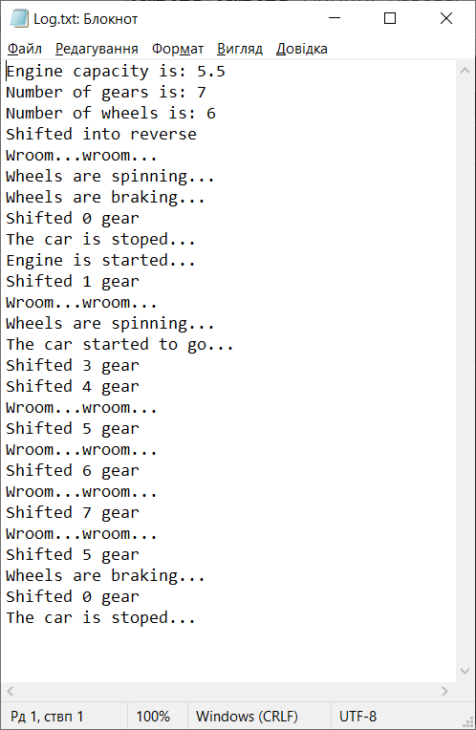

*Рис.1. Результат виконання програми*

1. Згенерував документацію

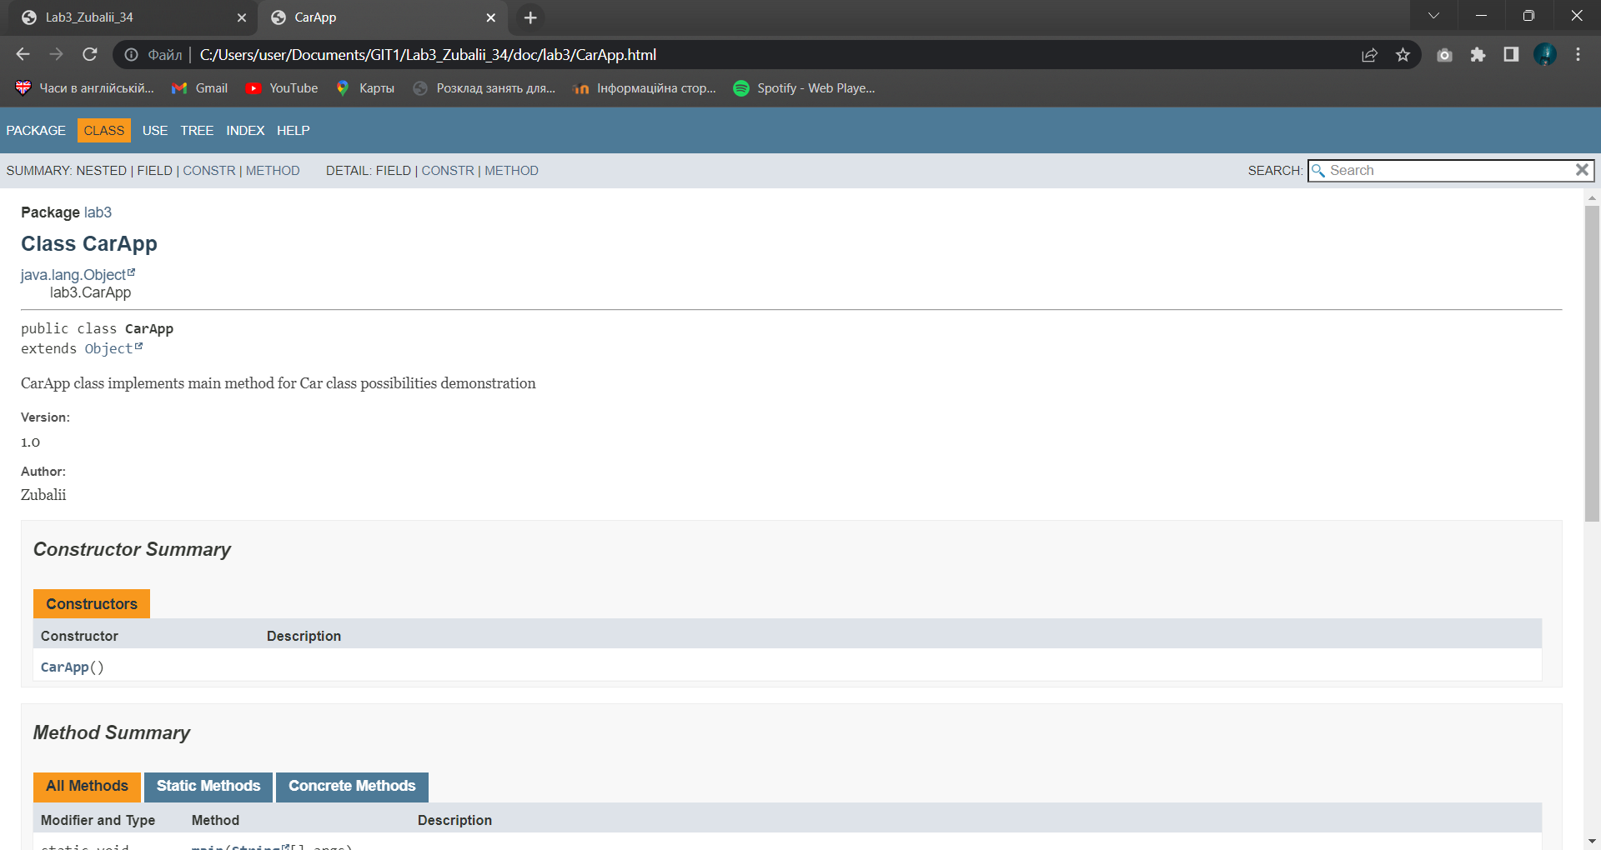

*Рис.3. Згенерований html-файл*

**Висновок:**

На даній лабораторній роботі ознайомився з процесом розробки пакетів та класів мовою Java