Міністерство освіти і науки України

Національний університет „Львівська політехніка”

Кафедра ЕОМ



**Звіт**

з лабораторної роботи №4

з дисципліни: “Кросплатформні засоби програмування”

на тему: “Спадкування та інтерфейси”

Виконав: ст. гр. КІ-34

Зубалій І.А.

Прийняв:

Іванов Ю.С.

Львів – 2022

**Мета:** ознайомитися зі спадкуванням та інтерфейсами у мовіJava.

**Індивідуальне завдання:** написати та налагодити програму на мові Java, що розширює клас, реалізований у лабораторній роботі №3, для реалізації предметної області заданої варіантом:

**5. Машина**

**Хід роботи:**

1. Запустив середовище Eclipse та написав програму згідно індивідуального завдання:

*TruckApp.java*

package lab4;

import java.io.FileNotFoundException;

/**

* TruckApp class implements main method for Truck class possibilities demonstration

*

* @author Zubalii

* @version 1.0

*/

public class TruckApp {

/**

* @param args

* @throws FileNotFoundException

*/

public static void main(String[] args) throws FileNotFoundException {

Truck truck = new Truck(5.5f, 8, 12, 3000);

truck.info();

System.out.println("----------------");

truck.loadCargo(5000);

truck.loadCargo(2000);

truck.go();

truck.shiftTo(3);

truck.accelerate();

truck.shiftTo(5);

truck.stopTheCar();

truck.unloadCargo(5000);

truck.unloadCargo(2000);

}

}

*Truck.java*

package lab4;

import java.io.FileNotFoundException;

/**

* Class Truck implements truck

*

* @author Zubalii

* @version 1.0

*/

public class Truck extends Car implements Trailer {

private int maxCargoWeight;

private int cargoWeight;

/**

* Constructor

*

* @throws FileNotFoundException

*/

Truck() throws FileNotFoundException {

super();

setMaxCargoWeight(0);

}

/**

* Constructor

*

* @param engine capacity

* @throws FileNotFoundException

*/

Truck(float engineCapacity) throws FileNotFoundException {

super(engineCapacity);

setMaxCargoWeight(0);

}

/**

* Constructor

*

* @param engine capacity

* @param number of gears

* @throws FileNotFoundException

*/

Truck(float engineCapacity, int gears) throws FileNotFoundException {

super(engineCapacity, gears);

setMaxCargoWeight(0);

}

/**

* Constructor

*

* @param engine capacity

* @param number of gears

* @param number of wheels

* @throws FileNotFoundException

*/

Truck(float engineCapacity, int gears, int wheelsQuantity) throws FileNotFoundException {

super(engineCapacity, gears, wheelsQuantity);

setMaxCargoWeight(0);

}

/**

* Constructor

*

* @param engine capacity

* @param number of gears

* @param number of wheels

* @param max weight of cargo

* @throws FileNotFoundException

*/

Truck(float engineCapacity, int gears, int wheelsQuantity, int maxCargoWeight) throws FileNotFoundException {

super(engineCapacity, gears, wheelsQuantity);

setMaxCargoWeight(maxCargoWeight);

}

/**

* Setter for maxCargoWeight

*/

@Override

public void setMaxCargoWeight(int weight) {

this.maxCargoWeight = weight;

}

/**

* Getter for maxCargoWeight

*/

@Override

public int getMaxCargoWeight() {

return maxCargoWeight;

}

/**

* Method implements cargo loading

*/

@Override

public void loadCargo(int weight) {

if (weight <= maxCargoWeight - cargoWeight) {

cargoWeight += weight;

System.out.println("The cargo is loaded");

super.fout.println("The cargo is loaded");

} else {

System.out.println("The cargo is not loaded. It's too heavy");

super.fout.println("The cargo is not loaded. It's too heavy");

}

}

/**

* Method implements cargo unloading

*/

@Override

public void unloadCargo(int weight) {

if (weight <= cargoWeight) {

cargoWeight -= weight;

System.out.println("The cargo is unloaded");

super.fout.println("The cargo is unloaded");

} else {

System.out.println("You can't do it");

super.fout.println("You can't do it");

}

}

/**

* Getter for maxCargoWeight

*/

public int getCargoWeight() {

return cargoWeight;

}

/**

* Method implements cargo weight showing

*/

public void viewCargoWeight() {

System.out.println("Current weight of cargo is: " + cargoWeight);

super.fout.println("Current weight of cargo is: " + cargoWeight);

}

/**

* Setter for maxCargoWeight

*/

public void setCargoWeight(int cargoWeight) {

this.cargoWeight = cargoWeight;

}

/**

* Method shows truck info

*/

@Override

public void info() {

super.info();

System.out.println("Max weight of cargo is: " + maxCargoWeight);

super.fout.println("Max weight of cargo is: " + maxCargoWeight);

}

}

*Trailer.java*

package lab4;

/**

* Interface Trailer describes truck trailer

*

* @author Zubalii

* @version 1.0

*/

public abstract interface Trailer {

/**

* Method sets max weight of cargo

*/

void setMaxCargoWeight(int weight);

/**

* Method gets max weight of cargo

*/

int getMaxCargoWeight();

/**

* Method describes max cargo loading

*/

void loadCargo(int weight);

/**

* Method describes max cargo unloading

*/

void unloadCargo(int weight);

}

*Car.java*

package lab4;

import java.io.File;

import java.io.FileNotFoundException;

import java.io.PrintWriter;

/**

* Class Car implements car

*

* @author Zubalii

* @version 1.0

*/

public abstract class Car {

private Engine engine;

private Gearbox gearbox;

private Wheels wheels;

protected PrintWriter fout;

/**

* Constructor

*

* @throws FileNotFoundException

*/

Car() throws FileNotFoundException {

engine = new Engine();

gearbox = new Gearbox();

wheels = new Wheels();

fout = new PrintWriter(new File("Log.txt"));

}

/**

* Constructor

*

* @param engine capacity

* @throws FileNotFoundException

*/

Car(float engineCapacity) throws FileNotFoundException {

engine = new Engine(engineCapacity);

gearbox = new Gearbox();

wheels = new Wheels();

fout = new PrintWriter(new File("Log.txt"));

}

/**

* Constructor

*

* @param engine capacity

* @param number of gears

* @throws FileNotFoundException

*/

Car(float engineCapacity, int gears) throws FileNotFoundException {

engine = new Engine(engineCapacity);

gearbox = new Gearbox(gears);

wheels = new Wheels();

fout = new PrintWriter(new File("Log.txt"));

}

/**

* Constructor

*

* @param engine capacity

* @param number of gears

* @param number of wheels

* @throws FileNotFoundException

*/

Car(float engineCapacity, int gears, int wheelsQuantity) throws FileNotFoundException {

engine = new Engine(engineCapacity);

gearbox = new Gearbox(gears);

wheels = new Wheels(wheelsQuantity);

fout = new PrintWriter(new File("Log.txt"));

}

/**

* Getter for Engine

*/

public Engine getEngine() {

return engine;

}

/**

* Setter for Engine

*/

public void setEngine(Engine engine) {

this.engine = engine;

}

/**

* Getter for Gearbox

*/

public Gearbox getGearbox() {

return gearbox;

}

/**

* Setter for Gearbox

*/

public void setGearbox(Gearbox gearbox) {

this.gearbox = gearbox;

}

/**

* Getter for Wheels

*/

public Wheels getWheels() {

return wheels;

}

/**

* Setter for Wheels

*/

public void setWheels(Wheels wheels) {

this.wheels = wheels;

}

/**

* Method implements car moving

*/

public void go() {

engine.start();

gearbox.shiftGear(1);

engine.gas();

wheels.spin();

System.out.println("The car started to go...");

fout.println("The car started to go...");

}

/**

* Method implements car acceleration

*/

public void accelerate() {

while (gearbox.getCurrentGear() != gearbox.getNumberOfGears()) {

gearbox.shiftGear(gearbox.getCurrentGear() + 1);

engine.gas();

}

}

/**

* Method implements car stopping

*/

public void stopTheCar() {

wheels.brake();

gearbox.shiftGear(0);

System.out.println("The car is stoped...");

fout.println("The car is stoped...");

}

/**

* Method implements car reverse moving

*/

public void goReverse() {

gearbox.shiftReverse();

engine.gas();

wheels.spin();

}

/**

* Method implements shifting to the required gear

*

* @param gear - required gear

*/

public void shiftTo(int gear) {

gearbox.shiftGear(gear);

}

/**

* Method shows car info

*/

public void info() {

System.out.println("Engine capacity is: " + engine.getCapacity());

fout.println("Engine capacity is: " + engine.getCapacity());

System.out.println("Number of gears is: " + gearbox.getNumberOfGears());

fout.println("Number of gears is: " + gearbox.getNumberOfGears());

System.out.println("Number of wheels is: " + wheels.getNumberOfWheels());

fout.println("Number of wheels is: " + wheels.getNumberOfWheels());

}

/**

* Method releases used recourses

*/

public void dispose() {

fout.close();

}

/**

* Class Engine implements car engine

*

* @author Zubalii

* @version 1.0

*/

class Engine {

private float capacity;

/**

* Constructor

*/

public Engine() {

this.capacity = 1.0f;

}

/**

* Constructor

*

* @param engine capacity

*/

public Engine(float capacity) {

this.capacity = capacity;

}

/**

* Getter for capacity

*/

public float getCapacity() {

return capacity;

}

/**

* Setter for capacity

*/

public void setCapacity(float capacity) {

this.capacity = capacity;

}

/**

* Method implements engine start

*/

public void start() {

System.out.println("Engine is started...");

fout.println("Engine is started...");

}

/**

* Method implements the operation of the accelerator pedal

*/

public void gas() {

System.out.println("Wroom...wroom...");

fout.println("Wroom...wroom...");

}

}

/**

* Class Engine implements car gearbox

*

* @author Zubalii

* @version 1.0

*/

class Gearbox {

private int currentGear = 0;

private int numberOfGears;

/**

* Constructor

*/

public Gearbox() {

this.numberOfGears = 4;

}

/**

* Constructor

*

* @param number of gears

*/

public Gearbox(int numberOfGears) {

this.numberOfGears = numberOfGears;

}

/**

* Getter for numberOfGears

*/

public int getNumberOfGears() {

return numberOfGears;

}

/**

* Setter for numberOfGears

*/

public void setNumberOfGears(int numberOfGears) {

this.numberOfGears = numberOfGears;

}

/**

* Method implements gear shifting

*

* @param required gear

*/

public void shiftGear(int gear) {

if ((gear >= 0) && (gear <= numberOfGears)) {

currentGear = gear;

System.out.println("Shifted " + currentGear + " gear");

fout.println("Shifted " + currentGear + " gear");

} else if (gear == 0) {

System.out.println("Shifted neutral gear");

fout.println("Shifted neutral gear");

} else {

System.out.println("Krhrhrh...This gear doesn't exist");

fout.println("Krhrhrh...This gear doesn't exist");

}

}

/**

* Method implements reverse gear

*/

public void shiftReverse() {

currentGear = -1;

System.out.println("Shifted into reverse");

fout.println("Shifted into reverse");

}

/**

* Method returns current gear

*

* @return current gear

*/

public int getCurrentGear() {

return currentGear;

}

}

/**

* Class Wheels implements car wheels

*

* @author Zubalii

* @version 1.0

*/

class Wheels {

private int numberOfWheels;

/**

* Constructor

*/

public Wheels() {

this.numberOfWheels = 4;

}

/**

* Constructor

*

* @param number of wheels

*/

public Wheels(int numberOfWheels) {

this.numberOfWheels = numberOfWheels;

}

/**

* Getter for numberOfWheels

*/

public int getNumberOfWheels() {

return numberOfWheels;

}

/**

* Setter for numberOfWheels

*/

public void setNumberOfWheels(int numberOfWheels) {

this.numberOfWheels = numberOfWheels;

}

/**

* Method implements the rotation of the wheels

*/

public void spin() {

System.out.println("Wheels are spinning...");

fout.println("Wheels are spinning...");

}

/**

* Method implements braking

*/

public void brake() {

System.out.println("Wheels are braking...");

fout.println("Wheels are braking...");

}

}

}

1. Після виконання програми переглянув створений файл Log.txt:

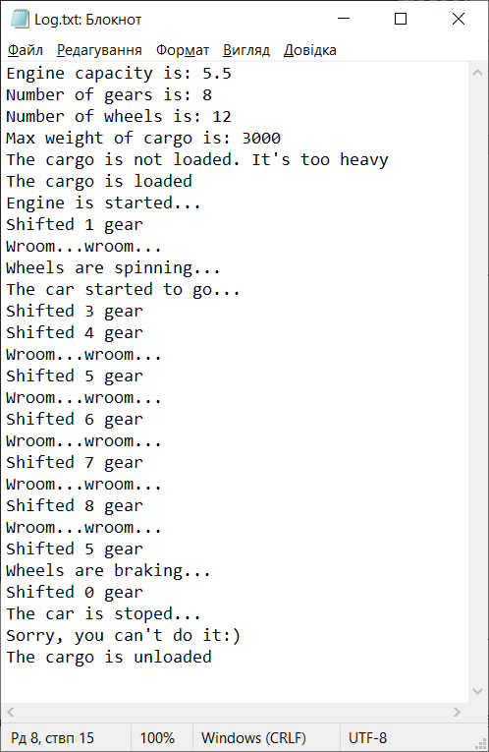

*Рис.1. Результат виконання програми*

1. Згенерував документацію

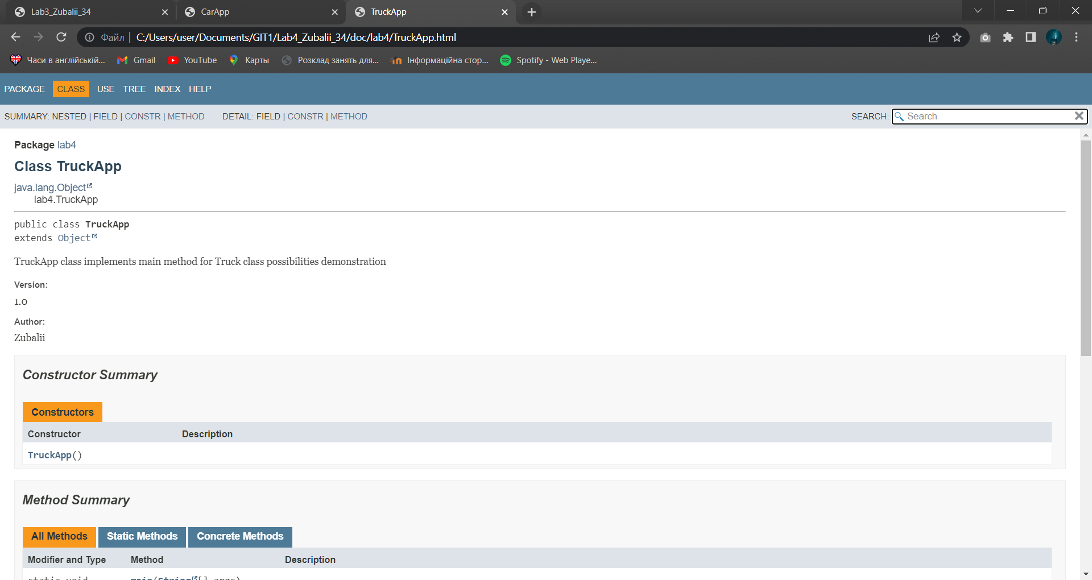

*Рис.3. Згенерований html-файл*

**Висновок:**

На даній лабораторній роботі ознайомився зі спадкуванням та інтерфейсами у мові Java.