KAAIMANS WEB SERVICES PROPOSAL

TIMO HOYLAND

Introduction

Hi, you found me reading in your gardens by the lake a few weeks ago. I didn’t know the lands were private, I’m used to going on beautiful hikes through woods in the summer. Anyhow, I did some digital sleuthing after I was made aware – I’m sorry for the imposition- and I happened across your website and business.

Straightaway I could tell that there are some underlying issues which if fixed would improve your throughput by increasing conversions, improving the experience, traffic and reduce costs per visit.

Websites these days are the digital equivalent of brick-and-mortar stores. Stores with slow or unnatentive employees tend to not fare as well as places where they go above and beyond as a standard. With premium cars, you attract the highest levels of society and they enjoy being spoiled. They want to buy cars from stately homes but they also want to find out more from a beautiful website first.

I’m not saying that the website is the most important part of your business, but it is the workhorse. People can see what you offer from the comfort of their living rooms or while on their lunch. People want modernity, class, and elegance. The web is a graph of interconnected websites where your competitor is only three clicks away. What will make you the winning bid?

Issues Found

There are two clear aspects which we use to rate websites subconsciously: performance and design. This is evident in the car world too where fast cars are revered, even if they might look a little off. This is also why companies such as ferrari and design houses such as Pininfarina have fared so well – they pair the beautiful with the performant.

Performance means something different to everyone. To some it might mean speed, to some fuel efficiency, to some how long their tyres will last at full speed. In this case, performance is a carefully curated hybrid between the experience of a customer and your running costs.

A side benefit of improving performance is also a greater reach not unlike in the car world. If somebody decides to create an unusal car through performance or design, it is likely to fetch more eyes: more people know what an E-type is over an S-Type. This is an indirect cause catapulted through word of mouth of others and in this case, the ranking algorithms of search engines as well as others’ word of mouth.


Mobile Home Page Rankings for KAAIMANS.COM


Desktop Home Page Rankings for KAAIMANS.COM

Performance and Loading Times

Poor overall loading performance due to unnecessary code, slow third-party dependencies and inefficient asset loading strategies.
Slow initial image loading times and suboptimal implementation
95 server requests made from the home page alone, leading to increased costs and bandwidth usage.
Average page size is 211kb, larger than 70% of all other websites but you are in the 32nd percentile for speed.

Accessibility and Usability

Interactive elements (buttons, links) lack proper focus states, names, and accessibility attributes.
Insufficient colour contrast between green and white failing all accessibility standards
Critical components such as the stock filter and not entirely accessible via keyboard navigation.
Bare domains not accounted for, and result in an error message for users.
On the sell car form, the car offerings are specific but direct to cars only of that brand, not to the specifc models listed in the description.
The Inquire button clashes with the contact us button on the sell car page.
Contact us page does not have a direct (visible, not inc footer) (I found it, it says email us but the user does not know how it will work underneath. They do not associate forms with emails) link to the contact us form. The form contradicts the live chat feature also.
I feel that the sale of cars is a part of your services, but that is personal preference.

Search Engine Optimisation (SEO) and Crawlability

Accessibility issues can negatively impact search rankings, as search engines prefer accessible websites.
Certain links and elements on the website are not crawlable, hinmdering discoverability.
75% of your traffic comes from your brand name and not alternative keywords.
Low amount of keywords overall.
This is optional as it is extra work for yourselves but a blogging/ news feature would greatly increase web presence. Better keywords, traffic, and reach but this creates a need for high quality content and greater running costs, I will offset this as much as I can

Design and User Interface (UI)

Inconsistent padding around buttons and layout shifts during page load.
Outdated design.
The AI Icon is inconsistent with the overall design system.
The Livechat icon clashes in usability and visual heirarchy with the AI button.
The email newsletter does not come from a kaaimans domain, rather a netdirector domain which I almost looked over.
Repeated information and text that makes for an unorganised design.
The sell post has a marketing preference option for post, but no data collection for address information occurs.

Dependency and Asset Management

Libraries and dependencies are loaded without apparent necessity.
A large icon pack is loaded at once, increasing asset loading times.

Overall, the system needs to be given an overhaul to comepete with competitors on a national and internation level. Competitors like Amarisupercars have 40 times as much traffic per day. Their website while old, performs well due to their keywords, and a little effort.

Requirements

Performance Optimization
- Minimize unnecessary code and remove unused dependencies
- Optimize asset loading strategies (images, scripts, etc.)
- Reduce the number of server requests and page size
- Improve initial image loading times

Accessibility and Usability
- Ensure interactive elements (buttons, links) have proper focus states, names, and accessibility attributes
- Improve color contrast to meet accessibility standards
- Enable keyboard navigation for all critical components (stock filter, forms, etc.)
- Handle bare domains and provide proper error handling
- Align links and buttons with their intended functionality (e.g., "Inquire" button, "Contact Us" page)
- Provide clear and visible paths to contact forms and other important features

Search Engine Optimization (SEO) and Crawlability
- Address accessibility issues that may negatively impact search rankings
- Ensure all links and elements are crawlable for better discoverability
- Increase the number of relevant keywords and optimize for alternative keywords
- Implement a blog or news section to improve web presence, traffic, and reach (optional)

Design and User Interface (UI)
- Maintain consistent padding and layout across the website
- Modernize the overall design and user interface
- Ensure consistent branding and design system across all elements (icons, buttons, etc.)
- Organize and streamline repetitive information and text
- Clearly separate marketing preferences from essential user information (e.g., address collection)

Dependency and Asset Management
- Load libraries and dependencies only when necessary
- Optimize asset loading strategies for icon packs and other large assets

General Improvements
- Enhance the website's overall performance, accessibility, and user experience
- Align the website with industry best practices and modern standards
- Improve the website's ability to compete with national and international competitors

Proposition

Websites are accesbile everywhere, from any device with a broswer. It’s great for customers on the go.

For a consistent deisgn and feel, a design system must be put in place. This ensures consistentcy and guidelines for future ammendments and scaling.

Design System and Guidelines

Typography

Typography is among the most important elements of any website. It conveys the personality of the website. Josefin Sans is a modern typeface that is legible across scenarios, great for users with poor eyesight. Its minimalist style brings an aire of elegance and remains unique enough to stand out from the crowd.

Main headings are to be used solely in places where the branding must be conveyed (I love the Tollerton Hall logo and I feel that it needs to be toned down for use in 2024 – more on this later (my premise is not logo design unortunately, I wouldn’t do it justice)). This should be once on every page – the Kaaimans name – twice if the rules are broken knowingly.

When headings are needed, use the normal headings. The type system in the code will reflect all of this accordingly for ease of future development.

Text is required to be bold sometimes without being a heading and disrupting the heirarch for screenreaders. This is why bold standard text differs from the standard text through a weight of 100 – Regular 400, and Light 300.

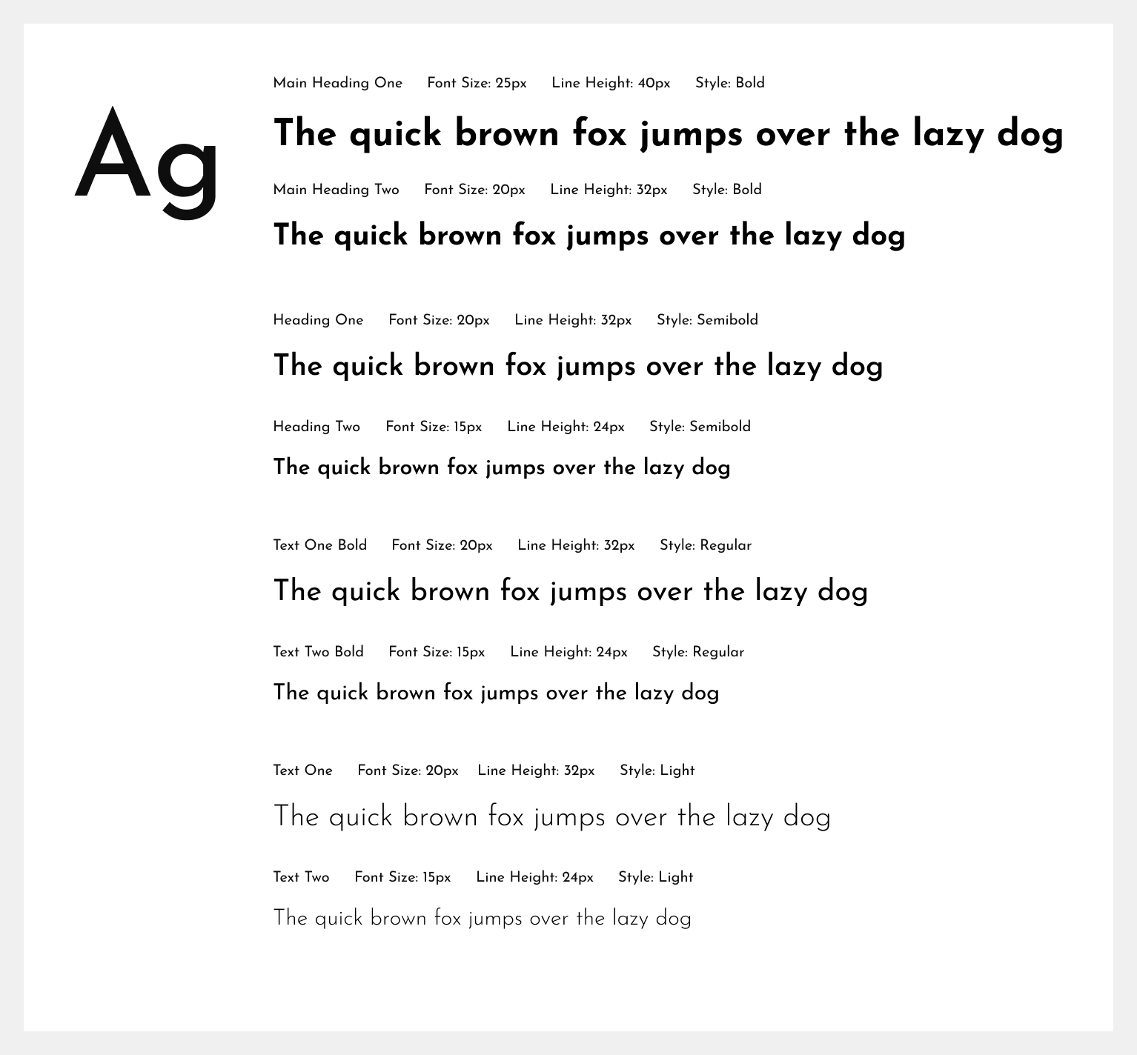

Typography System

Step and Layout

For uniform, professional placing a step and layout must be the same across all scenarios. This is extremely important as incorrect use of this will be subconsciously interpreted as sloppy.

Step is used for consistent padding, margins, and sizing across all elements and their layouts. A consistent step of factor 8px doubles fares well in maintinaing consistency with the type system and lineheight which also folows the same step. 4px is acceptable in unique cases, but that is not normally required.

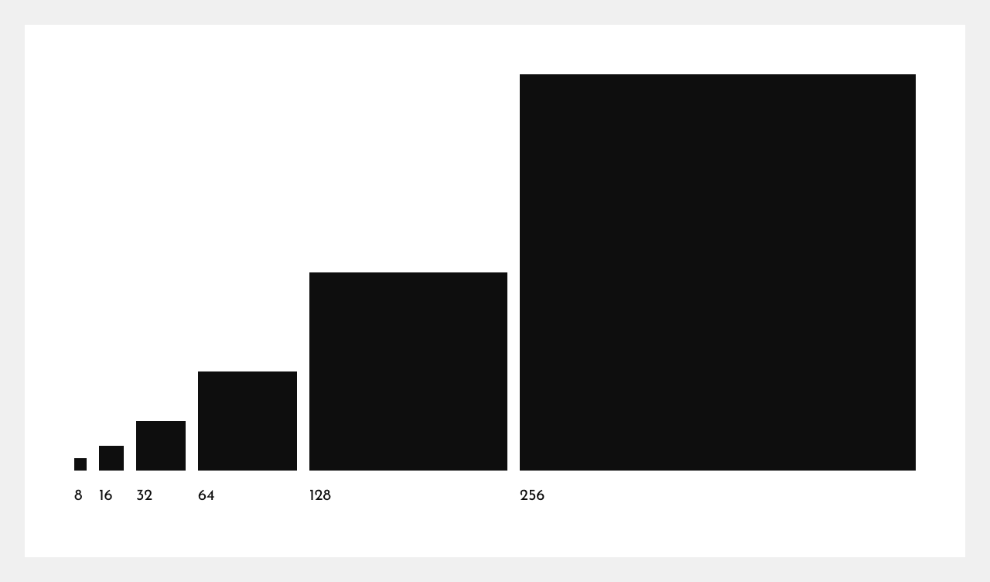

Step System

To accommodate a wide range of devices, I have designed breakpoints – layouts – for devices likely to visit the website: an iPhone 15, the latest offering from Apple other phones have similar sizing; an iPad for users who prefer tablets; and a standard 1920x1080p monitor where scaling will come from viewport height and width. These devices are assumed, forefront runners of this current time period, and other devices will be recognised accordingly also.

The Desktop Grid consists of 12 columns with a 32px gap. The outermost columns are margins. This is the maxium breakpoint I have in mind. Users with ultrawide displays will have enlarged margins. This is suitable for your demographic as this tends to be the technology of a richer demographic.

The Tablet Grid is scaled down for it’s narrowness to 6 columns with the same 32px gap and outermost columns for margins.

The handheld Phone Grid consists of 24px margins. A step away from the rules for I feel 24px is great for breathing room and whitespace. Rows are not implemented for the varying content and layout shifts across devices. The step is there to follow.

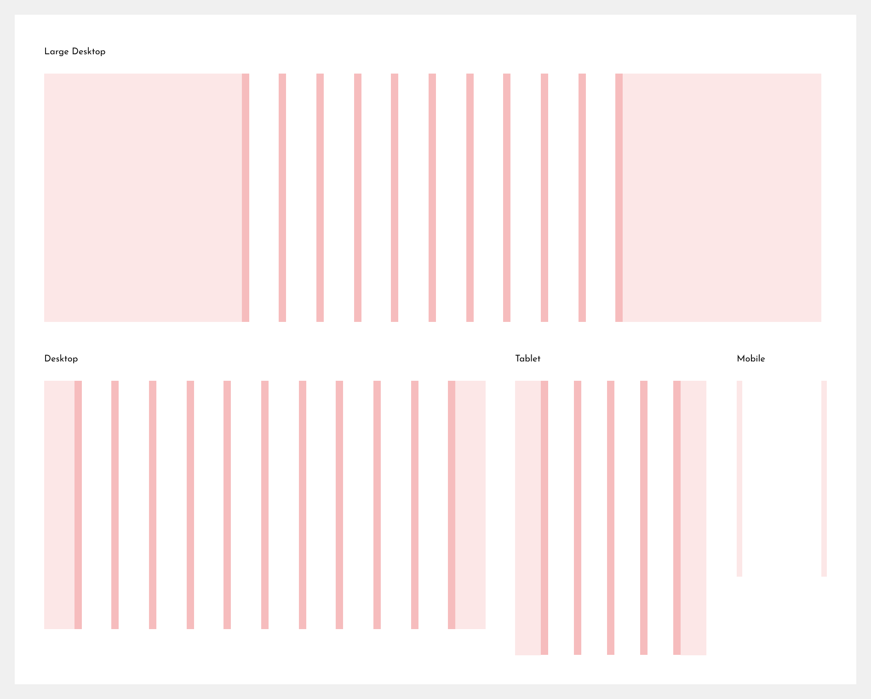

Layout Grid Systems

Border Radii

Kaaimans International is a serious, professional business dealing in high-end luxury vehicles. The connotations of this requires the need for stricter, sharper corners on elements across the page. This gives the sense of importance, vis a vis boucier, laxer corners which convery the feeling of friendliness, and comfort, usually reserved for more inofrmal end-uses.

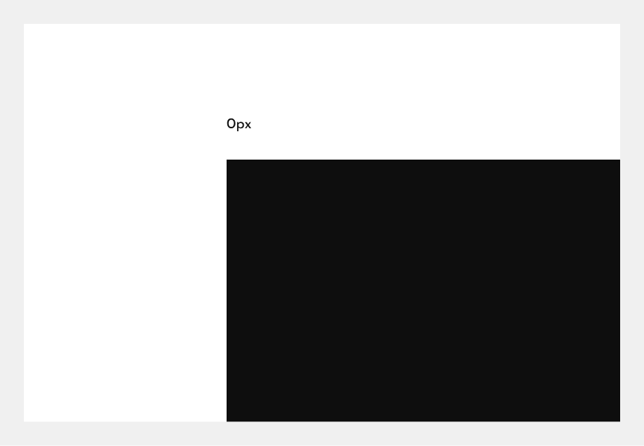

Border Radius Guidelines

Colour Scheme

Colours are very important. They convery emotions and affect a person’s perception. The current green does not meet accessibiltiy guidelines, therefore I chose a darker green to represent your brand. A deep green like such, associates with the deep forest, hunting (hunter green), and is similar to racing green, all a shout to the core of Kaaimans International.

The yellow is in next green on the colour wheel, making for an analagous colour scheme. It serves as the secondary colour, to not over use the primary green and help a user differentiate between elements and their importance.

The red is to be used extremely sparingly for it can bring about connotations of blame for an error, but it is required in certain situations.

There are also variations of the accent colours for end-use states to provide interactivity.

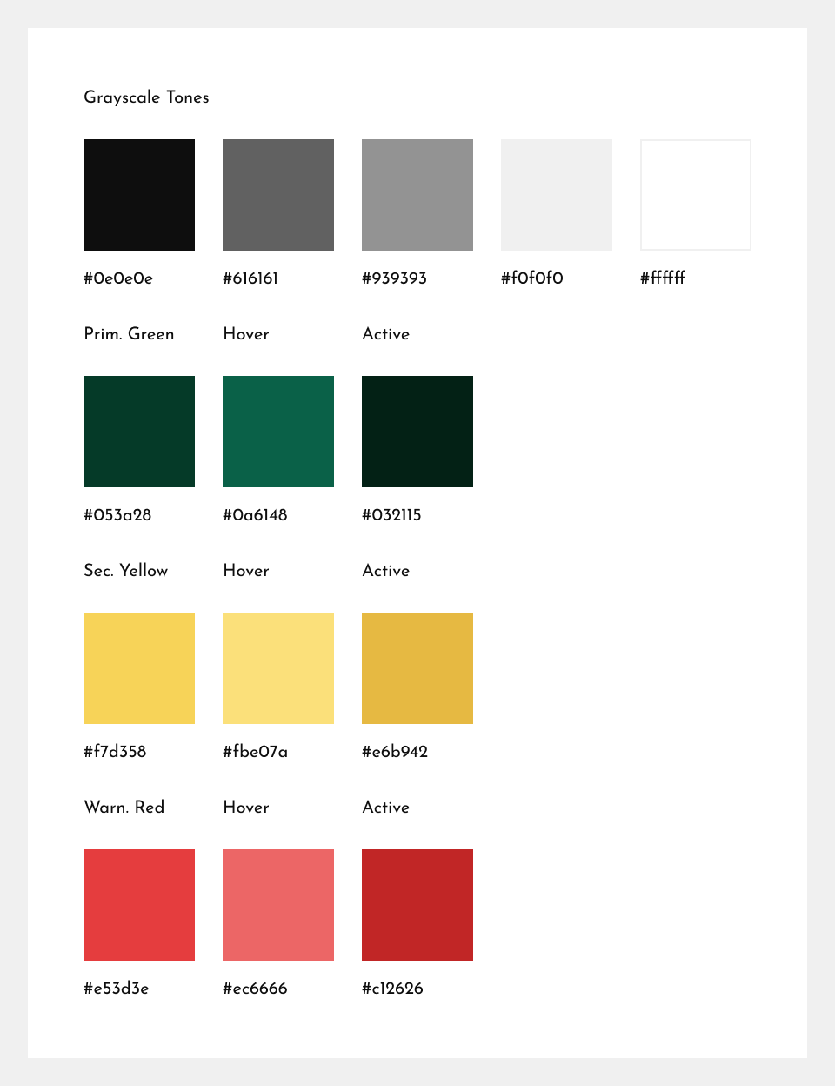
Colour Scheme

Iconography

Icons convey important information, faster than words. I can see you have an existing pack and I will be looking to implement them but, I do not like how they have been implemented which resultes in a slowing down of the page, on the first load. I will check if this is cached for later use. It is important to use widely recognised icons for good useability and accessibility.

Buttons

Buttons add interactivity to a site. Users should be able to easiliy distinguish clickable elements and understand their intended function intuitively. The buttons should fit the overall theme and there should be different types of buttons for different functions such as primary and secondary buttons. They should be accessible and useable. Secondary buttons should appear more frequently to highlight the importance of a primary button when it appears.

The font is Text Two Bold for accessibility and visibility. Vertical padding is 8px, horizontal padding is 32px. The buttons could potentially be stretched across the length of the body for smaller, mobile devices.

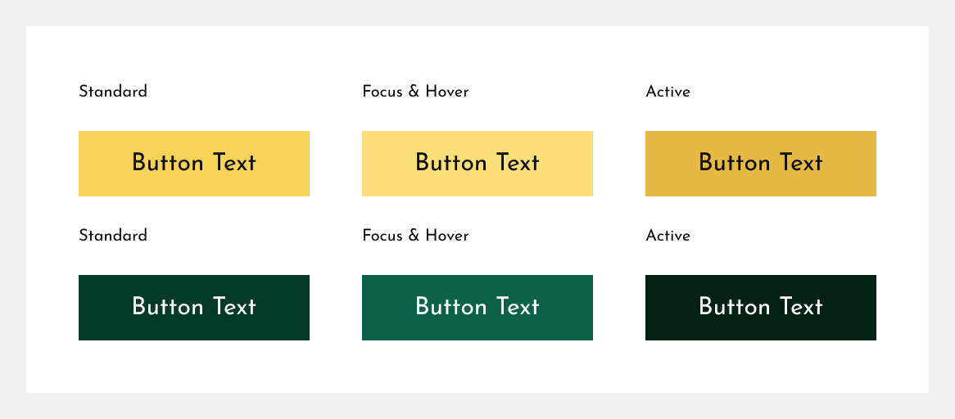

Button Guidelines

Input Fields

Data input is an extremely important aspect to your business: it covers aspects such as search functionality and queris about cars to you team. Input fields must be useable across all devices and be pleasing to the eye and use. This is achieved through smooth animations and transitions.

Clear labelling is an important aspect of useability: labels let the user know what is required from them, and clear error messages show what’s going on.

I have classified the inputs required as single-line inputs, checkboxes, and multi-line textbox inputs where a user may be required to enter a larger amount of text.

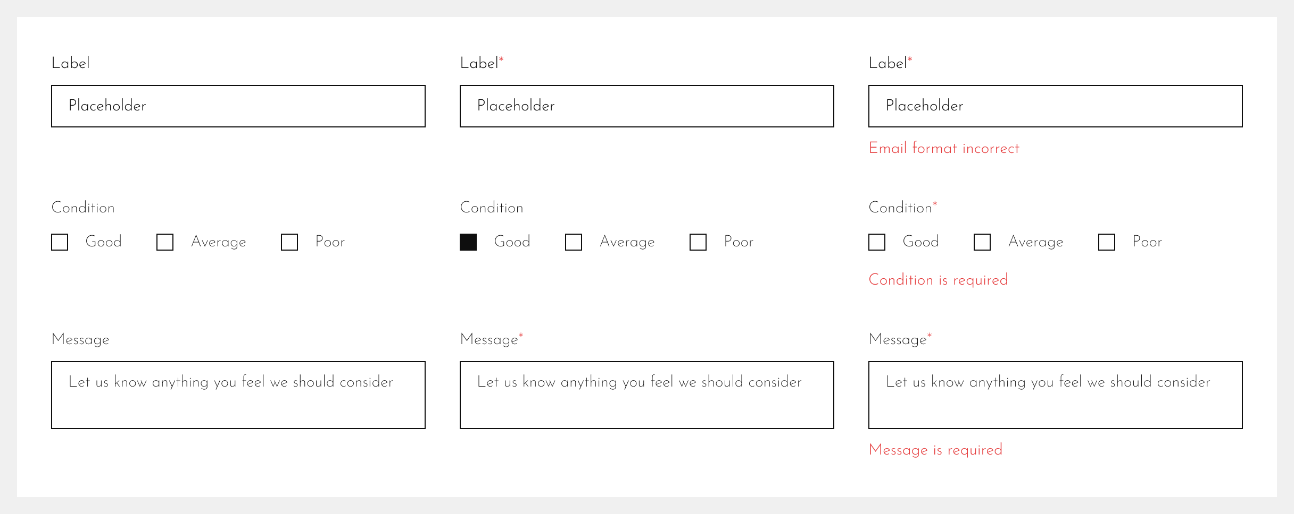
Input Types and Guidelines

Cards

Cards are the cornerstone of modern day user interfaces. The contain secluded, independent information in a uniform manner. The current implementation of cards can be lightened by removing unnecessary elements (I can add things back at your behest. The specific car page contains these details and I felt that they were not required when browsing and might actually impact click throughs negatively). The padding around the sides adds weight to the overall layout and can be removed. I love the banners and I feel that they can be added on the hover of a cardfor a hover usually warrants an intent to request further information and could entice a user for a further clickthrough.

Card images are to be a fixed 256px 1/1 aspect ratio for mobile, but for larger screen sizes may be dynamically sized according to the grid layout.

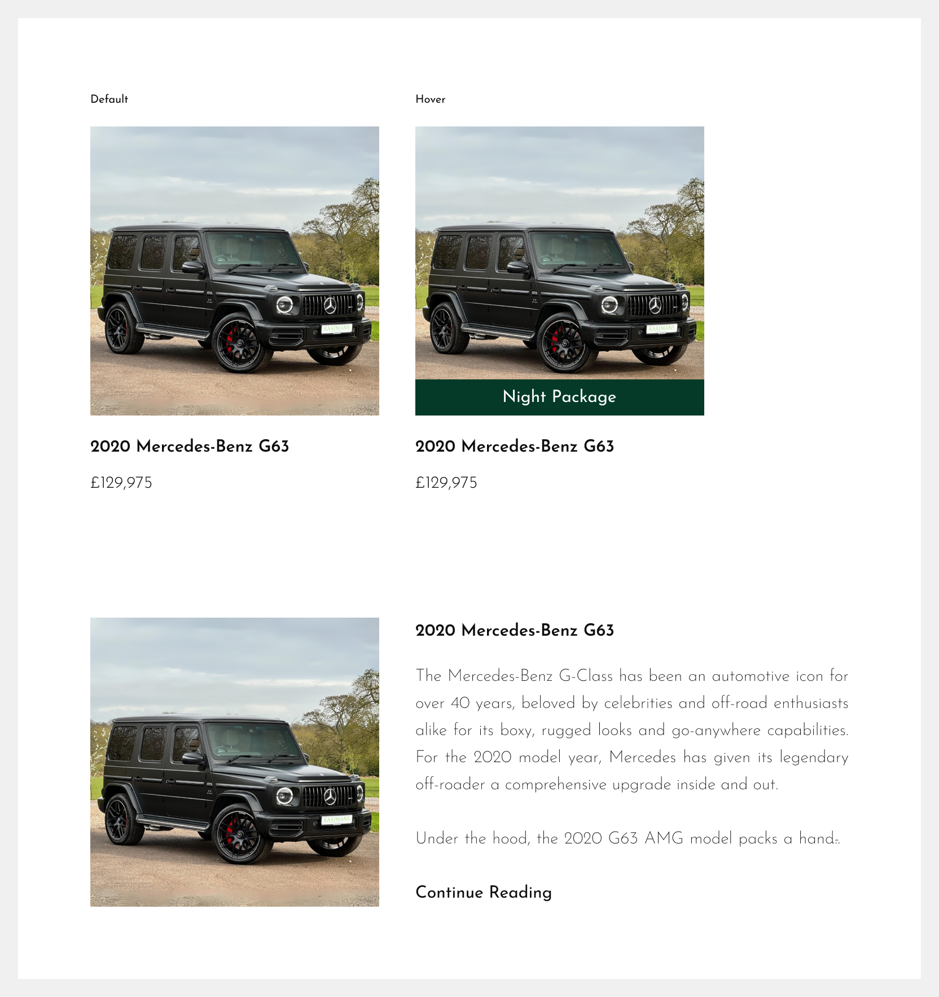

Card Guidelines

