Social Social Media
Timo Hoyland

A2 Non-Exam-Assesment Assessment Project
Table of Contents
Social Social Media 1
Introduction 9
The Problem 12
Identity Construction 12
User-Generated Content 13
Algorithmic Feed Curation 13
Real-Time Communication Channels 13
Interactive Social Signaling 13
Speaking with End-Users 14
User One: 14
User Two: 15
User Three: 15
User Four: 16
User Five: 16
Takeaways 16
Potential Biases 17
The Vision 18
Goals Set 20
Goal 1: Algorithmic Transparency and User Control 20
Goal 2: Evolving Digital Identities 20
Goal 3: Data Privacy Sovereignty 20
Goal 4: Democratized Content Governance 20
Goal 5: User-Owned Economic Model 20
Goal 6: Potential Data Portability and Interoperability 21
Goal 7: Maximize Content Accessibility & Discoverability 21
Goal 8: Protect Platform Neutrality and User Rights 21
Goal 9: Promote Healthy Usage Norms 21
Goal 10: Mitigate Harmful Speech and Misinformation 21
Goal 11: Ensure Platform Reliability and Resilience 21
Goal 12: Diversify Technology Leadership and Culture 22
Goal 13: Principled Stance on Geopolitics 22
Goal 14: Climate Sustainability and Justice 22
Goal 15: Ethical Emerging Technology Practices 22
Database 22
Interacting With The Database 24
Securing The Database 25
High Level Overview 26
Chatroom Model 26
Analysis 26
Design 28
Implementation 29
Tests 30
Test Case 1: Create a new chatroom 30
Test Case 2: Retrieve an existing chatroom by ID 30
ChatroomUser Model 31
Analysis 31
Design 32
Implementation 34
35
Tests 35
Test Case 1: Add a user to a chatroom 35
Test Case 2: Retrieve users in a chatroom by chatroom ID 35
Test Case 3: Retrieve chatrooms associated with a user by user ID 35
Follow Model 36
Analysis 36
Design 37
Implementation 38
Tests 39
Test Case 1: Add a new follow relationship 40
Test Case 2: Retrieve follow relationship by follower ID and the following ID 40
Test Case 3: Update the denial status of a follower relationship 40
Friendship Model 41
Analysis 41
Design 42
Implementation 43
Tests 44
Test Case 1: Create a new friendship relationship 44
Test Case 2: Retrieve friendship relationship by userOneId and userTwoId 45
Test Case 3: Attempt to create a duplicate friendship relationship 45
LikedPost Model 45
Analysis 45
Design 46
Implementation 48
Tests 49
Test Case 1: Create a new liked post relationship 49
Test Case 2: Retrieve liked posts by the user 49
Test Case 3: Attempt to like the same post twice 50
Message Model 50
Analysis 50
Design 51
Implementation 53
Tests 54
Test Case 1: Create a new message 54
Test Case 2: Update message read status 55
Test Case 3: Delete a message 55
Post Model 56
Analysis 56
Design 57
Implementation 59
Tests 60
Test Case 1: Create a new post with a photo 60
Test Case 2: Create a new post without a photo 61
Test Case 3: Create a new post with a custom average ratio and multiplier 61
User Model 62
Analysis 62
Design 63
Implementation 65
Tests 67
Test Case 1: Create a new user with a unique username 67
Test Case 2: Create a new user with an existing username 67
Test Case 3: Update the user's average ratio and multiplier 67
UserData Model 68
Analysis 68
Design 69
Implementation 70
Tests 71
Test Case 1: Create a new user data record 71
Test Case 2: Create user data record with existing user_id 71
Test Case 3: Update user data record 72
ViewedPost Model 72
Analysis 72
Design 73
Implementation 75
Tests 76
Test Case 1: Create a new viewed post record 76
Test Case 2: Create duplicate viewed post record 76
Test Case 3: Retrieve viewed post record 77
The Back End 77
Analysis 77
Security 83
Recommendation Server 90
Dependencies 92
User 92
Creating Connections 93
Mutual Connections 94
Optimising 97
Image Server 101
The Monolith API 112
Global Parameters 117
Schema 121
Type Definitions 121
User Type 122
SensitiveUserDataType 123
Author Type 124
Chatroom Type 125
Link Type 126
Message Type 126
Pending Type 127
Post Type 128
Profile Type 129
Queries 131
User Queries 131
NavInfo 131
Analysis 131
Design 133
Tests 135
GetPublicInfo 135
Analysis 135
Design 137
Tests 139
getUserSearchResults 141
Analysis 141
Design 142
Tests 144
getPending 145
Analysis 146
Design 147
Tests 149
getAllPosts 150
Analysis 150
Design 152
Tests 154
getFeed 155
Analysis 155
Design 155
Following 162
Friends 164
Date 167
Recommended 174
Tests 178
Test Case 1: Retrieve Following Posts 178
Test Case 2: Retrieve Friends' and Received Friendships' Posts 179
Test Case 3: Retrieve All Posts Sorted by Date 180
Test Case 4: Retrieve Following Posts with Custom Recommended Sorting 181
RecommendedUsers 182
Analysis 182
Design 184
Tests 185
Test Case 1: Retrieve Recommended Users 185
Post Queries 187
getPost 187
Analysis 187
Design 189
Tests 191
Test Case 1: Retrieve Post by ID 191
192
Test Case 2: Post Not Found 192
Test Case 3: Invalid Post ID Format 193
Chat Queries 193
GetChatroomData 194
Analysis 194
Design 195
Tests 199
Test Case 1: Retrieve Chatroom Data with Valid Credentials 199
Test Case 2: Retrieve Chatroom Data with Invalid Credentials 200
201
Test Case 3: Retrieve Chatroom Data with Invalid Chat ID 201
getChats 202
Analysis 202
Design 204
Tests 208
Test Case 1: Retrieve User's Chatrooms 208
Test Case 2: User with No Chatrooms 209
Test Case 3: Invalid User Authentication 210
Mutations 210
User Mutations 211
CreateUser 211
Analysis 211
Design 212
215
Tests 215
Test Case 1: Create a New User with First Name, Last Name, Username, and Password 215
SignIn 216
Analysis 216
Design 217
Tests 221
Test Case 1: Sign In with Correct Username and Password 221
Test Case 2: Sign In with Incorrect Password 223
Test Case 3: Sign In with a Nonexistent Username 224
FollowUnfollowUser 226
Analysis 226
Design 227
Tests 230
Test Case 1: Follow a User 230
Test Case 2: Unfollow a User 232
Test Case 3: Invalid Username 233
PendingRequest 235
Analysis 235
Design 236
Tests 240
Test Case 1: Accept Friendship Request 240
Test Case 2: Deny Friendship Request 241
Test Case 3: Invalid Action 242
EditDetails 243
Analysis 243
Design 244
Tests 248
Test Case 1: Edit Name 248
Test Case 2: Edit Username 249
Test Case 3: Edit Password 250
Post Mutations 251
CreatePost 251
Analysis 251
Design 252
Tests 255
Test Case 1: Create a New Post with Content and Photo 255
Test Case 2: Create a New Post with Content Only 256
Test Case 3: Create a New Post with Photo Only 257
PostViewed 258
Analysis 258
Design 259
PostLiked 263
Analysis 263
Design 264
Chatroom Mutations 268
getLocation 268
Analysis 268
Design 270
Tests 275
Test Case 1: Create a new chatroom and add users 275
Test Case 2: Retrieve the created chatroom 275
Test Case 3: Emit 'updatedChat' event to userOne's socket 276
sendMessage 276
Analysis 276
Design 277
Tests 281
Test Case: Create a new message and emit event to chatroom users 281
EditMessage 283
Analysis 283
Design 284
Tests 287
Test Case 1: Edit Message - Mark as Read 287
Test Case 2: Edit Message - Mark as Unread 288
Test Case 3: Edit Message - Delete Message Content 290
Socket Server 292
Analysis 292
Design 293
Other Communication Channels 297
Front End 298
Routing 300
Private and Public Routes 301
Portal 304
Analysis 304
Design 312
Tests 315
Test Case 1: Rendering and Display 315
Test Case 2: Sign In with Google Option 317
Test Case 3: Sign In Button 317
Test Case 4: Sign Up Link 318

Introduction

Social media has become more than just a digital space - it is an extension of our social lives. These platforms shape real-world culture while also mirroring how we interact as humans. When we log on, we enter vibrant communities with complex social norms, like any neighbourhood or city. Our online and offline identities blend as we build relationships through shared interests and conversations.

People turn to social media to be informed and entertained, but also to feel connected. We crave likes and comments as social validation. Beyond that, we long for genuine bonds—friends we can turn to for advice or meet up with in real life. Social platforms tap into those core human needs.

That's why billions of us keep coming back. We're drawn into the cycle of posting and interacting. With every new connection, communities grow. Cultural shifts occur in real time. The very way we communicate as a society evolves. And technology continues reflecting and reinventing our social existence at every turn.

Social media has undoubtedly changed over the years. I feel nostalgic about the days of MySpace, when we could fully customize our profiles and express ourselves. Moreover, PHP Facebook fostered an incredible sense of global connection.

But somewhere along the way, the social media landscape shifted to prioritize profits and algorithms over user experience. Engagement and sensationalized content took precedence over personal preferences. Before we knew it, echo chambers formed, negativity spread and social pressure mounted.

What happened to the spirit of community and genuine human connection that drew us to social media in the first place? Where did our ability to shape our own online experiences go?

By taking a closer look at the evolution of social media, we see how increased corporate influence subtly eroded user agency over time. The pendulum swung away from empowering users to curate and control their spaces, towards manipulative platforms vying for our attention.

When social media took off, it felt like a digital renaissance - an exciting new age of connection, self-expression and democratized information. Finally, we could bypass gatekeepers to communicate directly and swap ideas openly with anyone across the globe. The world's knowledge was at our fingertips, along with tools to amplify our voices and build far-flung communities united by shared interests and causes.

How idealistic and naive we were back then. Little did we realize that these platforms would mutate into toxic machines, systematically undermining our mental health, social cohesion and grip on reality itself.

The promise of unfettered discourse and learning has curdled into a fragmented landscape of echo chambers and misinformation superspreaders. Algorithms favouring engagement over truth have bundled us into personalized prisons of confirmation bias. We're smothered in a steady stream of posts reaffirming our beliefs while shielding us from discomfiting counterpoints.

Critical thinking is dying as we lock ourselves into hermetically sealed realities, losing the ability to debate those with differing worldviews intelligently. With reality muddled, conspiracy theories spread like digital wildfires as social trust crumbles. We're building a generation raised to respond with vitriol to any viewpoint contradicting their curated information bubbles.

But the psychological damage extends far beyond our fracturing collective grasp of shared facts and lapsed reasoning faculties. Social media's commercialized attention economy has brazenly gamified human interactions, jolting us with dopamine hits from likes, comments and shares. We've been induced into chasing validation from strangers in a new warped social feedback loop corroding our self-worth and relationships.

Teenage depression and body dysmorphia are spiking as we relentlessly consume aspirational (yet heavily curated or edited) depictions of human perfection - chiselled beach bodies, globetrotting influencers, and seemingly perpetual bliss. Our most impressionable and vulnerable cannot help but internalize this orchestrated spectacle as their failures.

Meanwhile, these platforms' industry creators have doggedly avoided significant reforms, relinquishing minimal control. The big players have only tightened their chokehold through endless acquisitions, copying innovations, and freezing out competitors by cutting off API access. They profit massively through hyper-targeted ads supercharged by unethically vacuumed volumes of personal data that we naively forfeit with each download and sign-up.

These companies see us as mere resources to be stalked, profiled and endlessly milked for engagement rather than sentient humans owed meaningful transparency and consent. We have been groomed to unquestioningly accept policies allowing our private musings and digital trails to be invisibly packaged and auctioned off to advertisers without absolute individual control or comprehension.

At its rotten core, the social web has metastasized into a sick perversion of its hopeful conception through grotesque runaway commercialization and consolidation. These parasitic attention merchants have gained inordinate influence over human behaviour, mental health and even geopolitical events by devouring our personal data, indulging confirmation biases, hooking us on engineered streaks of dopamine validation, and ultimately stripping us of agency over our digital lives and communities.

However, this was not an inevitable outcome. Things could still change through wiser regulation, a renaissance in ethical and transparent product design philosophies, and humanist reforms aimed at wresting back control through open-source, decentralized platforms cooperatively governed by users. However, it will require widespread public pressure and boycotts of bad actors to disrupt these runaway destructive dynamics baked into today's dominant social products.

Ultimately, while technology promised a grand democratization of knowledge and movements, we've instead spiralled into divided realities manipulated from the shadows by faceless algorithms and unaccountable corporations draining us for profit. Until humanity gets reinstalled into these coldly commercialized networks and power is rebalanced away from tyrants fixated on extracting our precious attention and private data, social media's vast liberating potential will remain perverted, corrosive, and tragic.

It leaves me thinking—what if we could design a social media platform to bring back user empowerment? One that helps people connect based on shared passions, not algorithms. An authentic community focused on positivity, self-expression, and well-being.

The Problem

Contemporary social media platforms have evolved far beyond their initial incarnations as simple broadcast channels for sharing updates and media. They have expanded into fully immersive digital ecosystems that intricately map and facilitate human social dynamics and connections at unprecedented scale (Ellison & Boyd, 2013). Several core components drive this expansion:

Identity Construction
The onboarding process requires crafting a multifaceted digital identity comprised of profile data like name, profile image, biographical details and listed interests/affiliations (Sundaram et al., 2012). Crucially, identities are solidified through accumulated social capital metrics visible to others, such as follower counts, likes, shares and reach statistics (Baym, 2015). These quantifiable signals reflect users' perceived credibility and status.

User-Generated Content
At the heart of these ecosystems are user-generated multimedia posts, the primary vehicle for exchanging ideas, narratives, creative works, and everyday experiences (Heinonen, 2011). Posts transcend static text and images, integrating video, interactive elements, links, and more to stimulate engagement and shape digital cultural patterns.

Algorithmic Feed Curation
To navigate the abundance of content, platforms employ machine learning algorithms that personalize feeds for each user by surfacing relevant and engaging posts (Eslami et al., 2015). Feeds dynamically update based on observed interests, contexts, and evolving network connections, facilitating discovery while optimizing for engagement metrics.

Real-Time Communication Channels
Complementing asynchronous posts, live communication channels enable fluid conversations via direct messages, ephemeral group chats, and public comment streams (Kalogerogli, 2018). These transcend geographical and temporal limitations, fostering interpersonal relationship development and information exchange.

Interactive Social Signaling
User interaction mechanisms, such as comments, critiques, validations, and acknowledgement actions, are central to driving engagement. These visible social feedback cues leverage fundamental human needs for status, belonging, and approval to reinforce desired user behaviours (Ozbolat & Dursun, 2017). An emergent symbiosis results between users and platform dynamics.

This convergence of personalized identity projection, creative self-expression, tailored content delivery, community discourse facilitation and operant conditioning feedback loops comprises the deeply embedded digital ecosystems that have become integral to modern social existence (van Dijck & Poell, 2013). While democratizing connection and voice, their centralized control and influence over human psychology have catalyzed concerns around polarization, misinformation and equitable representation that remain areas of ongoing examination (Woolley & Howard, 2018).

Speaking with End-Users

To find out what users wanted from their social media, I reached out to them online through an anonymous chat platform to gain insight into how they feel about the current system and what they would change. Delving into user emotions and aspirations is crucial to designing a platform that resonates with and engages with them.

User One:

Q: How do you keep in contact with people?
A: I mostly spend my time on YouTube, engaging with content.

Q: What kind of content do you prefer on YouTube?
A: I like to watch long-form content, particularly game-related videos.

Q: What would you change about social media?
A: I prefer greater control over what appears on my feed, opting for more gaming-related or fun facts content rather than controversial topics.

Q: Why don't you use social media as much?
A: I prefer spending time on gaming content rather than engaging with the often controversial or irrelevant topics that dominate social media feeds.

Q: Do you have any suggestions on how you would like social media to be?
A: I would like social media platforms to offer more reaction options beyond just a heart, allowing users to express dislike without arguing in the comments section.

User Two:

Q: What would you change about social media?
A: I do not like the lack of control over ads, especially the intrusive nature of reels and the promotion of content I'm not interested in, like alcohol and memes.

Q: What kind of content do you prefer on social media?
A: I prefer anonymous, growth, and self-improvement content, along with engineering videos.

Q: Have you tried moving to new platforms? Which ones do you use?
A: I still use Instagram, WhatsApp, and Facebook, despite their shortcomings.

User Three:

Q: What would you change about social media?
A: I prefer social media to be less content-pushed and more like Instagram back in the day, with a feed mainly consisting of posts from people you follow.

Q: Have you tried looking for new platforms? Which ones do you use now?
A: I have stopped using social media platforms and prefer doing other activities.

User Four:

Q: What don't you like about social media?
A: I appreciate the constant flow of information but dislike the lack of accountability people have on social media platforms due to free speech.

Q: What do you like about social media?
A: I enjoy the constant stream of information on platforms like Snapchat, Instagram, TikTok, and Twitter, particularly sports content.

User Five:

Q: How do you use social media?
A: I primarily use social media for chatting.

Q: What don't you like about social media?
A: I am not a fan of the chat feature.

Q: What do you use for chatting?
A: I use platforms like WhatsApp.

Takeaways

The interviews conducted have revealed a concerning issue - many users of major social media platforms feel profoundly misunderstood and neglected by the companies operating these sites. The core issue is that the significant dominant social media companies, often criticized and dubbed "Big Social Media," have developed a bad habit of treating users like products to be exploited instead of valued customers who deserve good service and attention. Their top priority is finding ways to make money from user data and user engagement on the platform, often at the expense of providing a satisfying, enjoyable user experience.
When an enterprise fails to uphold the needs and concerns of its user base as a top priority, it fosters a pervasive sense of disillusionment among these very individuals. Users who were once enthusiastic proponents of the platform begin to harbour feelings of being disregarded and having their preferences overlooked. This fundamental disconnect between the company and its users inevitably corrodes the bedrock of trust and loyalty that should undergird such a relationship.
The sheer scale and market dominance wielded by these social media titans are exacerbating this issue. Boasting colossal user bases and immense financial resources, they may not perceive an urgency to promptly redress the grievances voiced by a subset of their discontented users. The prospective loss of a handful of dissatisfied individuals likely pales compared to the enormity of their overall operations. However, this complacency possesses the potential to prove severely detrimental over the long term.
As dissatisfaction metastasizes through the user base, it precipitates a gradual exodus of the platform's most engaged and discerning patrons, colloquially designated as "connoisseurs." These individuals, who profoundly appreciate the nuances and intricacies of the social media experience, represent an integral component of the value proposition. Their departure diminishes the platform's overall appeal and utility.
Should this concerning trajectory remain unabated, it risks catalyzing a ruinous cycle wherein the platform's dwindling allure prompts further disengagement and erosion of the user base. Ultimately, those enterprises that willfully neglect to heed and accommodate the needs of their users may find themselves ceding competitive advantage and struggling to maintain relevance in the perpetually evolving digital landscape.

Potential Biases

It is essential to recognize that the surveys were conducted on an anonymous chat platform where, like User 4 mentioned, people lack accountability regarding their words. The anonymity afforded by online chat platforms may disproportionately attract users who already harbour negative perceptions of mainstream social media. This can lead to sampling bias, where the interview participants must fully represent the diversity of perspectives across the broader user population. Researchers must acknowledge the potential for the sample pool to exclude certain demographics and moderate opinions. Care should be taken to ensure balanced representation where possible.

Users who voluntarily participate in interviews, forums, or focus groups inherently possess specific underlying motivations and personality traits that set them apart from non-participants. This self-selection introduces bias, as the data gathered disproportionately represents users already inclined toward sharing opinions and engaging with market research. Researchers must remain cognizant of how self-selection shapes observed trends and themes. Where possible, random sampling and other bias mitigation methods should be applied.

The Vision

This radical new social platform would be architected around core principles of transparency and individual empowerment. This would directly rebuke the extractive, manipulative models that currently define dominant social networks.

Rather than treating users as products to be profiled, targeted and monetized, this platform would position individual participants as peers with autonomy over their digital experiences. Algorithmic sorting assistance would be an opt-in capability, not invisibly deployed through invasive data mining of personal information and behavioural histories.

Central to the experience would be unbridled optionality and user control. Chronological, unfiltered content feeds will remain available, free from automated ranking or recommendation systems. For those desiring intelligent content surfacing, transparent, customizable algorithms could be enabled, with clear explanations of all ranking factors and data inputs. Crucially, these personalized configurations empower users to tune desired balances between fresh discovery and familiarity as their needs evolve.

Gone would be the filter bubbles and echo chambers created when people's identities get calcified into rigid, coded profiles used to endlessly serve stale personas. This platform would champion the liberty of fluid, selectively balanced information flows untainted by residual data exhaust. If desired, each login could present a clean slate aligned with the latest interests.

This respect for agency and self-determination would also extend to stringent data privacy protocols. Practices around information handling, storage and encryption would be clearly enumerated, with easy global opt-outs from any data tracking or profiling functionality users found objectionable. No covert surveillance capitalism or personal detail brokering would be tolerated.

Rather than funnelling into profit-maximizing growth or subjugation to entrenched advertising revenue models, this decentralized ecosystem would foster an open, democratic stage for peer-to-peer sharing. Communication conduits would flow unobstructed by corporate gatekeepers, allowing seamless free expression, dissemination of ideas, creativity exchange, and diverse sociocultural discourse to flourish authentically.

While market leaders have amassed control of virtual public squares, this platform would model nothing less than a revolutionary rebalancing of power back to individual digital sovereignty. Tools and protocols would cultivate vibrant, self-sustaining communities around causes, interests, and ideological alignments—unfettered by centralized profit interests or user manipulation.

True innovation could emerge through radical openness and user-owned experiences. The information would be fundamentally liberated and emancipated from extraction. The next evolutionary phase for internet connection and knowledge expansion.

The core vision is to create a holistic ecosystem that gives individuals full autonomy, privacy and self-determination over their online experience - from identity management to content governance, economic empowerment and knowledge sharing. This starkly contrasts today's extractive, centrally controlled social media platforms.

Goals Set

Goal 1: Algorithmic Transparency and User Control
- Open source all recommendation/ranking algorithms for public perfusion
- Provide a personalized Algorithm Console for users to customize:
- Toggle between unranked chronological view, user-customized algorithm or platform default
- Ensure complete transparency around content sorting/elevation criteria

Goal 2: Evolving Digital Identities
- Decouple personal profiles from static recommendation engines
- Allow periodic user "resets" to refresh interests and clear historical data trails
- Prioritize present contexts like currently followed accounts/topics and recent interactions
- Align personalization with someone's fluid identity, not past data residues

Goal 3: Data Privacy Sovereignty
- Minimize personal data collection to only core operational requirements
- Privacy Control Center to review/remove any private info and opt out of tracking
- End-to-end encryption and open auditing of all data handling

Goal 4: Democratized Content Governance
- User-Tunable Content Controls to allow/limit categories based on preferences
- Community Moderation Console for distributed policy co-creation and enforcement

Goal 5: User-Owned Economic Model
- Put economic control and benefits into the hands of users, not extractive intermediaries.

Goal 6: Potential Data Portability and Interoperability
- Enable seamless migration of data between platforms/communities
- Adhere to open identity/content protocols like DIDs, IPFS, Fediverse, etc.
- Empower users to own and transfer their online persona artefacts fully.

Goal 7: Maximize Content Accessibility & Discoverability
- Open search and discovery engines to identify credible/rising information
- Elevate niche intellectual communities and surface diverse perspectives

Goal 8: Protect Platform Neutrality and User Rights
- Decentralized governance model with user-managed policy frameworks
- Multi-stakeholder collaboration boards and constitutional processes
- Enshrine digital human rights around free speech, civil liberties and appeals

Goal 9: Promote Healthy Usage Norms
- Design interfaces for focused, intentional engagement rather than continuous scrolling
- Set healthy defaults for notifications, usage limits, and screen time
- Discourage echo chambers and incentivize diverse discovery

Goal 10: Mitigate Harmful Speech and Misinformation
- Detect and reduce the spread of demonstrably false or manipulated media
- Balance free expression with enforcement against malicious actors
- Empower users to report harmful speech for transparent review

Goal 11: Ensure Platform Reliability and Resilience
- Engineer for stability, security, scalability, and redundancy
- Plan for continuity of service and disaster recovery
- Stress test with simulated attacks and peak traffic events

Goal 12: Diversify Technology Leadership and Culture
- Cultivate environments where diverse populations can belong and thrive.

Goal 13: Principled Stance on Geopolitics
- Articulate a neutral position on authoritarian state censorship, surveillance
- Provide transparency around government/law enforcement data requests

Goal 14: Climate Sustainability and Justice
- Measure and offset carbon footprint across operations and supply chain
- Support renewable energy projects and environmental partners
- Promote climate changemakers and green technologies

Goal 15: Ethical Emerging Technology Practices
- Establish oversight processes to identify risks of new technologies
- Adopt principles of responsible innovation in research phases
- Consult diverse stakeholders when developing policies for high-risk areas like AI
- Prioritize societal benefits over commercial urgency with innovative applications
- Design safeguards against dual use and weaponization at the architecture level
- Take precautionary measures even in the absence of proven harms

The unifying vision is an entire decentralized digital ecosystem where users have full ownership and control over their online identities, social connections, content governance, economic empowerment, information flows, and protection of fundamental rights. This would be a revolutionary rebalancing of power away from extractive centralized platforms.

Database

When it came to providing reliable, persistent data storage for the platform, PostgreSQL was the clear choice. A few key factors made it stand out as the ideal database solution for this social media project.

First off, PostgreSQL has a stellar reputation that precedes it. This battle-tested database has proven its dependability over decades of use and has gained industry-wide respect for its maturity and robustness. However, beyond being a reliable workhorse, PostgreSQL flexes its muscles when handling the complex querying demands of a social app - an absolute must for wrangling all the intricate, interconnected data flows involved.

At its core, PostgreSQL uses a relational data model that is perfect for organizing all the various entities in a social ecosystem - from user posts and comments to reactions and more. All these interrelated data pieces can be neatly stored and linked up with a relational structure. PostgreSQL's ACID compliance ensures data integrity, keeping user-generated content accurate and consistent within the database. Helpful features like foreign key constraints and data validations double down on maintaining that data integrity.

Scalability was another big draw for PostgreSQL. As a social platform experiences rapid growth spurts with more users and engagement, the ability to smoothly scale up and handle increasing data volumes/activity is make-or-break. PostgreSQL can flex and scale like a champ, ensuring the database can keep up as the platform takes off.

Performance is also critical for delivering the buttery, smooth, responsive user experience that today's social audiences expect. PostgreSQL is an absolute performance powerhouse, especially when properly configured and optimized. It can ruthlessly crunch through massive data volumes and complex query loads.

Last but definitely not least is security, which is paramount when dealing with sensitive user data like that in social apps. PostgreSQL brings an arsenal of heavy-duty security features to lock down that user data fortress. We're talking about granular access controls, encryption, authentication processes, and more to protect user privacy and block unauthorized access.

Bringing it all together, PostgreSQL's perfect blend of relational modelling, ACID compliance for data integrity, scalability muscle, performance prowess, security chops, and solid industry pedigree made it the total package for our social database needs.

As with any development journey, there were some bumps in the road getting PostgreSQL set up locally. Early on, I ran into issues with my database instance that forced a full machine reset, causing me to lose all my local data. Trying to reinstall PostgreSQL was also a nightmare—despite all the typical tricks like clearing caches, modifying files, and so on, I just could not get a stable local instance up and running reliably on my Linux machine.

Ultimately, I cut my losses and migrated the entire database to the cloud on Microsoft Azure. Not only did this resolve the endless local setup headaches, but I also gleaned a valuable preview into how the database would perform and how it needs to be managed in a natural production environment. Azure provides robust database hosting with enterprise-grade encryption, access controls, monitoring and more - reinforcing the security and reliability pillars.

Interacting With The Database

I integrated the Prisma ORM data access layer with PostgreSQL to streamline developers' interactions with the database. Prisma brought a bunch of powerful capabilities that really enhanced the overall development experience.

First, instead of having developers wrestle directly with finicky SQL code, Prisma provides an intuitive Object-Relational Mapping (ORM) layer. This abstracts away a lot of the low-level cruft, allowing developers to interface with the database using familiar, friendly programming constructs like classes and methods. This high-level ORM approach significantly reduced headaches and development friction for a complex social data model.

However, Prisma is more than just a clean abstraction layer. It also packs crucial query capabilities explicitly tailored to the unique needs of a social app's data model. Prisma's query smarts enabled us to build highly optimized, efficient database interactions, from complex filtering operations to efficient pagination handling to robust data aggregations. No more getting bogged down in hand-rolling byzantine SQL statements.

As requirements inevitably evolved, Prisma's migration tooling allowed us to adapt the database schema seamlessly over time through a streamlined migration workflow. Creating, modifying, and rolling back schema changes was a breeze, keeping the underlying data structures in sync with the app's needs while maintaining data integrity.

Moreover, Prisma has stellar GraphQL integration baked right in. This enabled us to effortlessly expose database queries and mutations as GraphQL endpoints that clients could interface with. Ultimately, the combo of Prisma's clean ORM layer, powerful query engine, agile migration capabilities, and GraphQL readiness provided a smooth, frictionless development experience for building out a high-performance, data-driven social backend.

Securing The Database

From a security perspective, taking precautions to protect sensitive data was a top priority - especially when dealing with personal user information in a social media context.

During active development, the database instance was ran locally alongside the API to keep that sensitive data within the development environment. As an extra lockdown measure, any sensitive database connection details were isolated and stored in a dedicated .env file, wholly separated from the actual codebase. This prevented any potential accidental exposure of those connection strings through version control or other means.

Once we were ready to transition to a production environment, the database was migrated to the cloud on Microsoft Azure. This gave us a host of extra security benefits, like enterprise-grade encryption, granular access controls, round-the-clock monitoring, and more. Letting Azure handle the database hosting freed us up to focus on the app while maintaining a rock-solid security posture around that sensitive data.

The cloud migration was not just a move for improved security - it also provided an invaluable preview into how the database would actually need to be configured, provisioned and managed when running at production scale under accurate user loads. Having that level of visibility early allowed us to work through any issues and ensure a smooth, uninterrupted user experience as the social platform continues growing its active user base.

High Level Overview

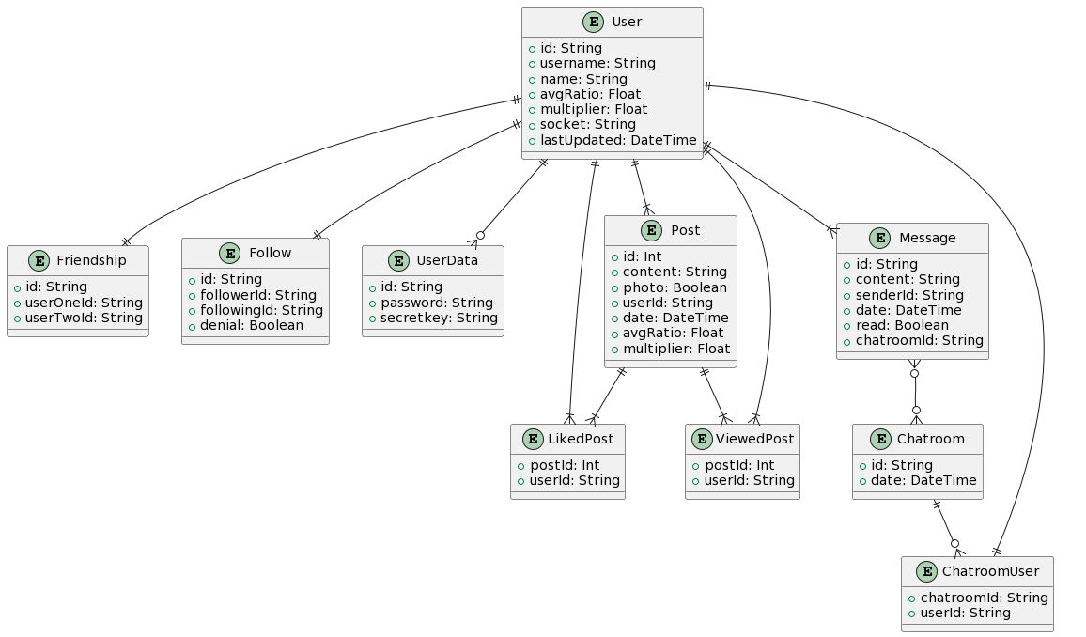

Chatroom Model

Analysis

The Chatroom Model aims to address the need to create a structure grouping related data needed to facilitate real-time communication between users of the platform in order to share ideas and information and foster meaningful connections. The model must support multiple users and store high volumes of messages while maintaining the users' privacy.

A chatroom is a fundamental component of a social media platform where data allows users to connect with one another. The model’s design focuses on providing all the necessary data storage facilities while ensuring scalability, performance, and data integrity.

Strengths
- Unique primary key for performant indexing and querying.
- Automatically updated timestamp for security and data integrity.
- Scalable infrastructure supports multiple users and high message volumes.

Weaknesses
- Lacks the option to rename chatrooms, which would aid in discoverability and improved UX.

Opportunities
- Implement chats with more than two users to foster group discussions and information sharing.
- Introduce user roles and permissions as well as channel capabilities.
- Integrate content-sharing capabilities further to enhance the flow of information on the platform.

Threats
- Spam and malicious behaviour.
- Unauthorised access.
- Scaling issues.

The Chatroom model provides a solid foundation in the beta version of the platform to enable private user-to-user communication. While it has its strengths, keeping users safe and promoting further trust in the platform, mitigating weaknesses like securing private chatrooms must be a priority.

Design

id
Type: String
date
Type: DateTime
Default: now()
chatroomUsers
Type: Array of ChatroomUser Model
messages
Type: Array of Message Model

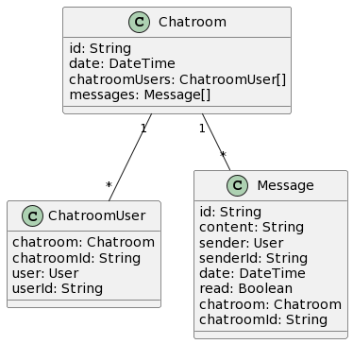

Implementation

model Chatroom {
id String @id
date DateTime @default(now()) @updatedAt
chatroomUsers ChatroomUser[]
messages Message[] @relation("Chatroom_Messages")
}

CREATE TABLE "Chatroom" (
"id" VARCHAR(255) NOT NULL,
"date" TIMESTAMP DEFAULT CURRENT_TIMESTAMP NOT NULL,
PRIMARY KEY("id"),
);

Tests

Test Case 1: Create a new chatroom

Procedure:
1. Insert a new record into the Chatroom table with a unique ID and current timestamp.
Expected Result:
1. The inserted record should exist in the Chatroom table.

1 | Generate a unique chatroom ID using nanoid. | N/A | A unique chatroom ID should be generated successfully. | A unique chatroom ID is generated successfully. | Pass
2 | Create a new chatroom in the DB with the generated id. | Generated chatroom ID | A new chatroom record should be created in the DB with the generated id. | A new chatroom record is created in the DB with the generated id. | Pass
3 | Add userOne to the chatroom as a chatroom user. | UserOne ID, chatroom ID | UserOne should be added to the chatroom as a chatroom user. | UserOne is added to the chatroom as a chatroom user. | Pass
4 | Add userTwo to the chatroom as a chatroom user. | UserTwo ID, chatroom ID | UserTwo should be added to the chatroom as a chatroom user. | UserTwo is added to the chatroom as a chatroom user. | Pass

Test Case 2: Retrieve an existing chatroom by ID

Procedure:
1. Insert a new record into the Chatroom table with a unique ID and current timestamp.
2. Retrieve the inserted record from the Chatroom table using its ID.
Expected Result:
1. The inserted record should exist in the Chatroom table.
2. The retrieved record should match the inserted record regarding ID and timestamp.

Step | Description | Input | Expected Output | Output/Finding | Pass/Fail
1 | Retrieve the created chatroom from the database using the generated id. | Generated chatroom ID | The created chatroom should be successfully retrieved from the database. | The created chatroom is successfully retrieved from the database. | Pass
2 | Verify that the retrieved chatroom exists and contains userOne and userTwo as chatroom users. | Retrieved chatroom data | The retrieved chatroom should exist and contain userOne and userTwo as chatroom users. | The retrieved chatroom contains userOne and userTwo as chatroom users. | Pass

ChatroomUser Model

Analysis

Data must not be repeated unless necessary to achieve a normalised database. Users have a many-to-many relationship with chatrooms, and both entities can have multiples of each. There needs to be a clear association between related instances to facilitate the seamless retrieval of data and prevent circular dependencies.

The model serves as a bridge between users and chatrooms. It provides the structure to data necessary to manage relationships between chats and users. The design prioritises minimalist simplicity to potentially offset scaling issues as the platform grows.

Strengths
- Establishes transparent relationships between users and chats through the use of foreign keys
- Efficient retrieval of related users and their chatrooms.
- No circular dependencies.
- Simplifies queries and enhances performance when accessing relevant data since it is all within a centralised store.

Weaknesses
- None found.

Opportunities
- None currently.

Threats
- Data leakage would show the chatroooms a user is associated with, resulting in a breach of privacy and putting users at risk of further harm.

The ChatroomUser model effectively creates an interface that connects platform users and chatrooms, providing a solid foundation for swift data retrieval. Optimising queries will be among the next steps in ensuring that the table scales gracefully, aiding in the platform's expansion.

Design

chatroom
Type: Chatroom
Fields: chatroomId
References: Chatroom Model#id
chatroomId
Type: String
user
Type: User
Fields: userId
References: User Model#id
userId
Type: String

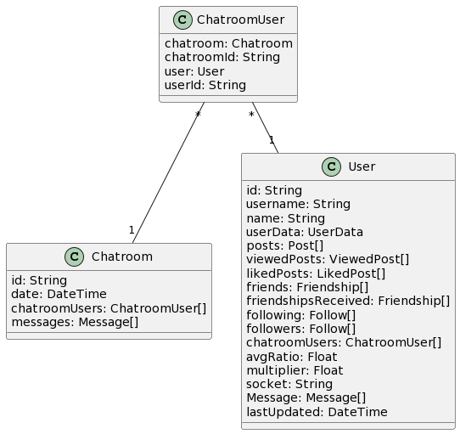

Implementation

model ChatroomUser {
chatroom Chatroom @relation(fields: [chatroomId], references: [id])
chatroom String
user User @relation(fields: [userId], references: [id])
userId String

@@id([chatroomId, userId])
}

CREATE TABLE "ChatroomUser" (
"chatroomId" VARCHAR(255) NOT NULL REFERENCES "Chatroom"("id"),
"userId" VARCHAR(36) NOT NULL REFERENCES "User"("id"),
PRIMARY KEY ("chatroomId", "userId")
);

Tests

Test Case 1: Add a user to a chatroom

Procedure:
1. Insert a new record into the ChatroomUser table with a valid chatroom ID and user ID.
Expected Result:
1. The inserted record should exist in the ChatroomUser table.

Test Case 2: Retrieve users in a chatroom by chatroom ID

Procedure:
1. Insert multiple records into the ChatroomUser table with different chatroom IDs and user IDs.
2. Retrieve the records from the ChatroomUser table using a specific chatroom ID.
Expected Result:
1. All inserted records should exist in the ChatroomUser table.
2. The retrieved records should belong to the specified chatroom ID.

Test Case 3: Retrieve chatrooms associated with a user by user ID

Procedure:
1. Insert multiple records into the ChatroomUser table with different chatroom IDs and user IDs.
2. Retrieve the records from the ChatroomUser table using a specific user ID.
Expected Result:
1. All inserted records should exist in the ChatroomUser table.
2. The retrieved records should belong to the specified user ID.

Follow Model

Analysis

One way social connections/ requests on the platform have created a need for a data model that can efficiently store data relating to the users, the connection between them and the current status of the request for advanced querying capabilities.

Following is a critical component of social media platforms that, in this case, allows users to give the person they follow a higher ranking in their curated feeds since they are making an effort, which means that they are likely interested in what the user has to offer. The model’s design aims to accommodate relationships' dynamic nature whilst acting as an initial, non-intrusive friend request with the denial boolean attribute.

Strengths
- Enables users to follow their favourite accounts.
- Indicates the state of the relationship, giving both users a choice regarding commitment.

Weaknesses
- It does not support two-way relationships, creating the need for the friendship model.
Opportunities
- Include attributes for more meaningful follow insights.
- Personalised recommendations.

Threats
- Spam.
- Mass followings.

The Follow model captures the essence of one-way links from one user to another user in a social media application. While it is simple and agile, we can enrich it by adding extra attributes and features to make it more meaningful and tailor it to individual users’ needs.

Design

id
Defaults to: UUID
Type: String
follower
Type: User Model
Relation: following
Fields: #followerId
References: User Model#id
followerId
Type: String
following
Type: User Model
Relation: following
Fields: #followingId
References: User Model#id
followingId
Type: String
denial
Defaults to false
Type: Boolean

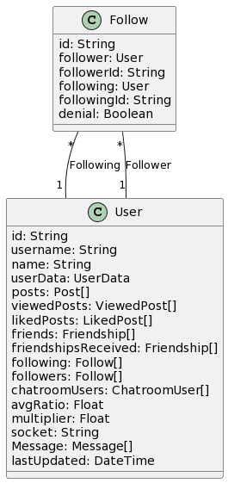

Implementation

model Follow {
id String @id @default(uuid())
follower User @relation("Following", fields: [followerId], references: [id])
followerId String
following User @relation("Follower", fields: [followingId], references: [id])
followingId String
denial Boolean @default(false)

@@unique([followerId, followingId, id])
}

CREATE TABLE "Follow" (
"id" VARCHAR(191) NOT NULL,
"followerId" VARCHAR(191) NOT NULL,
"followingId" VARCHAR(191) NOT NULL,
"denial" BOOLEAN NOT NULL DEFAULT FALSE,
PRIMARY KEY ("id"),
UNIQUE ("followerId", "followingId", "id"),
FOREIGN KEY ("followerId") REFERENCES "User"("id"),
FOREIGN KEY ("followingId") REFERENCES "User"("id")
);

Tests

Test Case 1: Add a new follow relationship

Procedure:
1. Insert a new record into the Follow table with a valid follower ID, following ID, and a unique ID.
2. Retrieve the inserted record from the Follow table.
Expected Result:
1. The inserted record should exist in the Follow table.
2. The retrieved record should match the inserted record regarding follower ID, following ID, and ID.

Test Case 2: Retrieve follow relationship by follower ID and the following ID

Procedure:
1. Insert multiple records into the Follow table with different follower IDs, following IDs, and unique IDs.
2. Retrieve the records from the Follow table using a specific follower ID and the following ID.
Expected Result:
1. All inserted records should exist in the Follow table.
2. The retrieved records should belong to the specified follower ID and the following ID.

Test Case 3: Update the denial status of a follower relationship

Procedure:
1. Insert a new record into the Follow table with a valid follower ID, following ID, and a unique ID.
2. Update the denial status of the inserted record.
3. Retrieve the updated record from the Follow table.
Expected Result:
1. The inserted record should exist in the Follow table.
2. The denial status of the inserted record should be updated.
3. The retrieved record should reflect the updated denial status.

Friendship Model

Analysis

Since friendships are mutual connections between users, there needed to be a separate table that could accommodate them whilst also per row removing the need to store a boolean value of true or false, saving a byte and an extra attribute over making the Follow model fit the needs of the friendship. It will also save on querying times and make scaling the data more accessible in the future since the table can be moved to a separate instance.

The Friendship model is a system capable of representing and managing upgraded relationships between users in a social network. It allows for the differentiation of close connections from follows and targeted features and interactions tailored to friends alone.

Strengths
- Dedicated entity
- Targeted features
- Primary key to preventing duplicate friendship records

Weaknesses
- None found

Opportunities
- Personalised recommendations

Threats
- Bypassing verification could lead to fraudulent relationships

The Friendship model outlined above offers a great concept for representing and managing upgraded friendships between users across a social media platform. It sets the groundwork for nurturing intimate connections between users as well as enabling sophisticated content and feature-layer targeting based on established connections.

Design

id
Defaults to: UUID
Type: String
userOne
Type: User
Relation: User Model
Fields: #userOneId
References: User Model#id
userOneId
Type: String
userTwo
Type: User
Relation: User Model
Fields: #userTwoId
References: User Model#id
userTwoId
Type: String

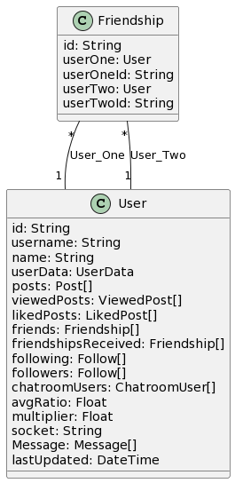

Implementation

model Friendship {
id String @id @default(uuid())
userOne User @relation("User_One", fields: [userOneId], references: [id])
userOneId String
userTwo User @relation("User_Two", fields: [userTwoId], references: [id])
userTwoId String

@@unique([userOneId, userTwoId, id])
}

CREATE TABLE "Friendship" (
"id" VARCHAR(191) NOT NULL,
"userOneId" VARCHAR(191) NOT NULL,
"userTwoId" VARCHAR(191) NOT NULL,
PRIMARY KEY ("id"),
UNIQUE ("userOneId", "userTwoId", "id"),
FOREIGN KEY ("userOneId") REFERENCES "User"("id"),
FOREIGN KEY ("userTwoId") REFERENCES "User"("id")
);

Tests

Test Case 1: Create a new friendship relationship

Procedure:
1. Insert a new record into the Friendship table with a valid userOneId, userTwoId, and a unique ID.
2. Retrieve the inserted record from the Friendship table.
Expected Result:
1. The inserted record should exist in the Friendship table.
2. The retrieved record should match the inserted record regarding userOneId, userTwoId, and ID.

Test Case 2: Retrieve friendship relationship by userOneId and userTwoId

Procedure:
1. Insert multiple records into the Friendship table with different userOneIds, userTwoIds, and unique IDs.
2. Retrieve the records from the Friendship table using a specific userOneId and userTwoId.
Expected Result:
1. All inserted records should exist in the Friendship table.
2. The retrieved records should belong to the specified userOneId and userTwoId.

Test Case 3: Attempt to create a duplicate friendship relationship

Procedure:
1. Insert a record into the Friendship table with a userOneId and userTwoId already existing in another record.
2. Retrieve the inserted record from the Friendship table.
Expected Result:
1. The insertion operation should fail due to the UNIQUE constraint violation.
2. No record should be inserted into the Friendship table.
3. An error or exception should be raised, indicating the constraint violation.

LikedPost Model

Analysis

Since posts can have many likes, the storage of this data can rapidly expand, which means that to prevent future scaling issues, a separate table is necessary. Likes are a cornerstone of analysing a user’s interests, and therefore, separation with needed data would be great so that potential algorithms wouldn’t have to deal with needless attributes upon categorising a user’s interests.

The LikedPost model provides a dedicated entity for users interested in a specific post. It creates a separation of concerns between the users and the posts they liked so that it can be scaled and modified, and special additional features can be added for liked content.

Strengths
- Independent scaling.
- Clear relationships.
- Foundation for potential future advanced features.

Weaknesses
- Lack of engagement patterns.

Opportunities
- The Elo ranking algorithm or a similar system could be used to give weights to likes.

Threats
- Like inflation and manipulation.

Whilst the model provides a solid foundation for tracking and managing user interactions with content on the platform, using SQL indexes such as the user ID coupled with the post ID would ensure that even bypassing the back-end API would not result in one like per user per post. Further leveraging the model would ensure robust personalised experiences for users on the site.

Design

post
Type: Post
Fields: #postId
References: Post Model#id
postId
Type: Int
user
Type: User Model
Fields: #userId
References: User Model#id
userId
Type: String

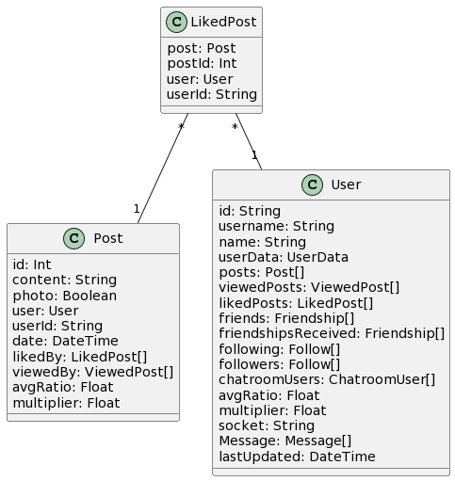

Implementation

model LikedPost {
post Post @relation(fields: [postId], references: [id])
postId Int
user User @relation(fields: [userId], references: [id])
userId String

@@id([postId, userId])
}

CREATE TABLE "LikedPost" (
"postId" INT NOT NULL,
"userId" VARCHAR(191) NOT NULL,
PRIMARY KEY ("postId", "userId"),
FOREIGN KEY ("postId") REFERENCES "Post"("id"),
FOREIGN KEY ("userId") REFERENCES "User"("id")
);

Tests

Test Case 1: Create a new liked post relationship

Procedure
1. Insert a new record into the LikedPost table with a valid postId, userId, and unique primary key.
2. Retrieve the inserted record from the LikedPost table.
Expected Result:
1. The inserted record should exist in the LikedPost table.
2. The retrieved record should match the inserted record in terms of postId, userId, and primary key.

Test Case 2: Retrieve liked posts by the user

Procedure:
1. Insert multiple records into the LikedPost table with different user IDs and post IDs.
2. Retrieve the records from the LikedPost table using a specific user ID.
Expected Result:
1. All inserted records should exist in the LikedPost table.
2. The retrieved records should belong to the specified user ID.

Test Case 3: Attempt to like the same post twice

Procedure:
1. Insert a record into the LikedPost table with a postId and userId already existing in another record.
2. Retrieve the inserted record from the LikedPost table.
Expected Result:
1. The insertion operation should fail due to the PRIMARY KEY constraint violation.
2. No record should be inserted into the LikedPost table.
3. An error or exception should be raised, indicating the constraint violation.

Message Model

Analysis

Messages on the platform need to provide seamless communication of ideas across the platform, including photos, files, and text content. They should also store metadata such as the sender’s information, the content type, the time sent, and whether the message has been read by the intended recipient/s.

As yet another fundamental concept of a social media platform, the Message model allows users to engage in conversations in private chatrooms. It allows the flow of ideas in many formats, such as images with the boolean flag of the photo attribute, as well as storing read status and time sent.

Strengths
- Captures essential information, including content, sender, and timestamp.
- Read receipts.
- Foreign key relationship with the Chatroom model.

Weaknesses
- Lack of moderation or reporting systems.

Opportunities
- End-to-end message encryption.

Threats
- Spam, inappropriate content or malicious messages.
- Privacy concerns.

This gives users a solid basis for communicating with each other on the social media platform. The Message model covers the fundamental message data and shows the connections to relevant entities. It can be built further by implementing encryption techniques to assure users that their conversations can only be seen by the intended recipients and user moderation systems so that users can report inappropriate content to safeguard platform users.

Design

id
Type: String
Default: uuid()
content
Type: String
sender
Type: User Model
Fields: #senderId
References: User Model#id
senderId
Type: String
date
Type: DateTime
Default: now()
read
Type: Boolean
Default: false
chatroom
Type: Chatroom Model
Fields: #chatroomId
References: Chatroom Model#id
chatroomId
Type: String

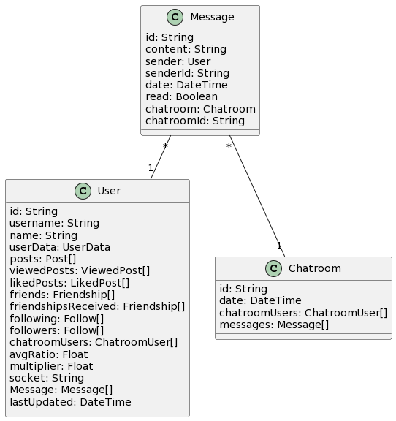

Implementation

model Message {
id String @id @default(uuid())
content String
sender User @relation(fields: [senderId], references: [id])
senderId String
date DateTime @default(now())
read Boolean @default(false)
chatroom Chatroom? @relation("Chatroom_Messages", fields: [chatroomId], references: [id])
chatroomId String?
}

CREATE TABLE "Message" (
"id" VARCHAR(191) NOT NULL,
"content" TEXT,
"senderId" VARCHAR(191) NOT NULL,
"date" TIMESTAMP(3) NOT NULL DEFAULT CURRENT_TIMESTAMP,
"read" BOOLEAN NOT NULL DEFAULT FALSE,
"chatroomId" VARCHAR(191),
PRIMARY KEY ("id"),
FOREIGN KEY ("senderId") REFERENCES "User"("id"),
FOREIGN KEY ("chatroomId") REFERENCES "Chatroom"("id")
);

Tests

Test Case 1: Create a new message

Procedure:
1. Insert a new record into the Message table with a unique ID, non-empty content, valid senderId, and current timestamp.
2. Retrieve the inserted record from the Message table.
Expected Result:
1. The inserted record should exist in the Message table.
2. The retrieved record should match the inserted record regarding ID, content, senderId, timestamp, and read status.

Test Case 2: Update message read status

Procedure:
1. Insert a record into the Message table with the read status set to false.
2. Update the read status of the inserted record to true.
3. Retrieve the updated record from the Message table.
Expected Result:
1. The inserted record should exist in the Message table with the read status set to false.
2. After updating the read status, the retrieved record should have the read status set to true.

Test Case 3: Delete a message

Procedure:
1. Insert a new record into the Message table.
2. Delete the inserted record from the Message table.
3. Attempt to retrieve the deleted record from the Message table.
Expected Result:
1. The inserted record should exist in the Message table before deletion.
2. After deletion, the record should no longer exist in the Message table.
3. Attempting to retrieve the deleted record should result in no record being returned.

Post Model

Analysis

The allure of social media mainly comes from the need for asynchronous connection, which a user will have when encountering a connection’s post on their feed. It is an excellent way of keeping up with one’s friends without feeling like interfering or having to connect with them appropriately. Posts should convey an idea, and since ideas can be in the form of text, media or data, the model should attempt to accommodate all. To promote posts and ensure that poor-quality content is not visible, the model should integrate with the liked and viewed models to promote high-quality posts.

The Post model represents a single unit of user-generated content on a social media platform. The essential structure defines and stores every user-created content that will appear on the site — text, photos, and metadata needed for storage and subsequent queries. Designed to allow for various content types, a Post model also enables user and content relationship management and performance metrics for ranking and visibility enhancement.

Strengths
- Supports photos and text.
- Foreign key relationship with users ensuring proper attribution.
- Performance metrics like average ratio and a multiplier for ranking.
- No more comparing likes to self-worth since they are not visible and are only used in rankings.

Weaknesses
- No archiving functionality.

Opportunities
- Implementing ranking systems like the Elo system in the future to differentiate between posts’ quality and performance.
- Archiving.
- Tagging and hashtag support.
- Comments, but for now, malicious comments could disrupt UX.
- File sharing.

Threats
- Spam.
- Like manipulation.
- Scaling challenges.
- Inadequate content moderation.

The Post model forms the core of the functionality for creating user-generated content on the platform. While the model supports multiple post types and performance metrics, it could be improved by adding support for files, advanced functionality such as better ranking algorithms and categorisation, robust content moderation, and optimization and scaling techniques to ensure the platform's availability and high QoE.

Design

id
Type: Int
Default: autoincrement()
Unique and auto-increments to allow for intentional sharing of posts.
content
Type: String
The text body of the post. For now, restrictions keep user input at around 100 chars.
photo
Type: Boolean
Default: false
Shows whether media is associated with the post and whether to fetch it from the image server.
user
Type: User
Fields: #userId
References: User Model#posts
userId
Type: String
date
Type: DateTime
Default: now()
Date time posted/ created
likedBy
Type: Array of LikedPost Model
Relation: One-to-Many
viewedBy
Type: Array of ViewedPost Model
Relation: One-to-Many
avgRatio
Type: Float
Default: 0.0
Performance indicator of the post
multiplier
Type: Float
Default: 1.0
A specific performance-enhancing boost can be boosted by a user in the future if revenue is needed.

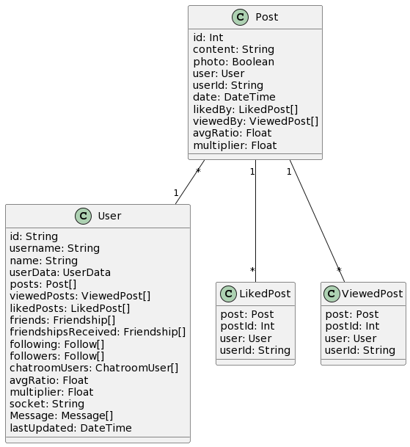

Implementation

model Post {
id Int @id @default(autoincrement())
content String
photo Boolean @default(false)
user User @relation(fields: [userId], references: [id])
userId String
date DateTime @default(now())
likedBy LikedPost[]
viewedBy ViewedPost[]
avgRatio Float @default(0.0)
multiplier Float @default(1.0) // Ensure decimal point
}

CREATE TABLE "Post" (
"id" SERIAL NOT NULL,
"content" TEXT,
"photo" BOOLEAN NOT NULL DEFAULT FALSE,
"userId" VARCHAR(191) NOT NULL,
"date" TIMESTAMP(3) NOT NULL DEFAULT CURRENT_TIMESTAMP,
"avgRatio" FLOAT NOT NULL DEFAULT 0.0,
"multiplier" FLOAT NOT NULL DEFAULT 1.0,
PRIMARY KEY ("id"),
FOREIGN KEY ("userId") REFERENCES "User"("id")
);

Tests

Test Case 1: Create a new post with a photo

Procedure:
1. Insert a new record into the Post table with a unique ID, content, user ID, photo set to true, and current timestamp.
2. Retrieve the inserted record from the Post table.
Expected Result:
1. The inserted record should exist in the Post table with the photo field set to true.
2. The retrieved record should match the inserted record regarding ID, content, user ID, and timestamp.

Test Case 2: Create a new post without a photo

Procedure:
1. Insert a new record into the Post table with a unique ID, content, user ID, photo set to false, and current timestamp.
2. Retrieve the inserted record from the Post table.
Expected Result:
1. The inserted record should exist in the Post table with the photo field set to false.
2. The retrieved record should match the inserted record regarding ID, content, user ID, and timestamp.

Test Case 3: Create a new post with a custom average ratio and multiplier

Procedure:
1. Insert a new record into the Post table with a unique ID, content, user ID, custom average ratio, custom multiplier, and current timestamp.
2. Retrieve the inserted record from the Post table.
Expected Result:
1. The inserted record should exist in the Post table with the specified average ratio and multiplier.
2. The retrieved record should match the inserted record in terms of ID, content, user ID, average ratio, multiplier, and timestamp.

User Model

Analysis

Users are the primary entity on the platform. Everything revolves around them, so everything should be designed around them, from the retrieval of chatrooms they are a part of to their posts. Their data must be stored in a normalised form that ensures efficient retrieval and can be used in union with the system's further functionality.
Users should be able to maintain their profile identity and interact with the system in a model that relates to everything, such as their posts, chatrooms, and messages, which link back to this model. The model's design focuses on providing a rich and interconnected user experience while ensuring data integrity and scalability.

Strengths
- Captures only essential user information.
- Establishes relationships with other models.
- Performance metrics.
- Socket storage for bidirectional communication.

Weaknesses
- Additional fields might be required in the future.

Opportunities
- Additional data could be implemented, furthering user profile personalisation.
- User verification.
- Badges and achievements.
- Privacy settings.

Threats
- Privacy risks with storing personal information.
- Breaches could compromise user information.

The User model is the core idea for representing and storing user data on the platform. While it holds basic information about users and their relationships with other models, it can be later enriched by adding more fields in the user profile, developing complex features such as verification and privacy settings, or implementing data integrity practices with related models. Focusing on the privacy and security of data and legal compliance forms the basis of a trustworthy system for users, protecting sensitive information and creating a personalised and entertaining experience.

Design

id
Defaults to UUID (natural function)
Type: String
Unique ID in the table. Index of Model
username
Type: String
Unique username in the table. Compound index of Model
name
Type: String
Name of user
userData
Type: UserData Model
posts
Type: Array of Post Model
viewedPosts
Type: Array of ViewedPost Model
likedPosts
Type: Array of LikedPost Model
friends
Type: Array of Friendship Model
Relation: Friendship Model#userOne
friendshipsReceived
Type: Array of Friendship Model
Relation: Friendship Model#userTwo
following
Type: Array of Follow Model
Relation: "Following"
followers
Type: Array of Follow Model
Relation: "Follower"
chatroomUsers
Type: Array of ChatroomUser Model
avgRatio
Type: Float
Default: 0.0
The avgRatio attribute of a User relates to their performance on the platform. It comes as the result of a combination of factors, such as post count
multiplier
Type: Float
Default: 1.0
The backbone for a potential stream of revenue by using it to promote posts in a user's feed.
socket
Type: String
Currently connected, or last used socket ID
Message
Type: Array of Message Model
lastUpdated
Defaults to: now()
Type: DateTime
Last time the model was updated

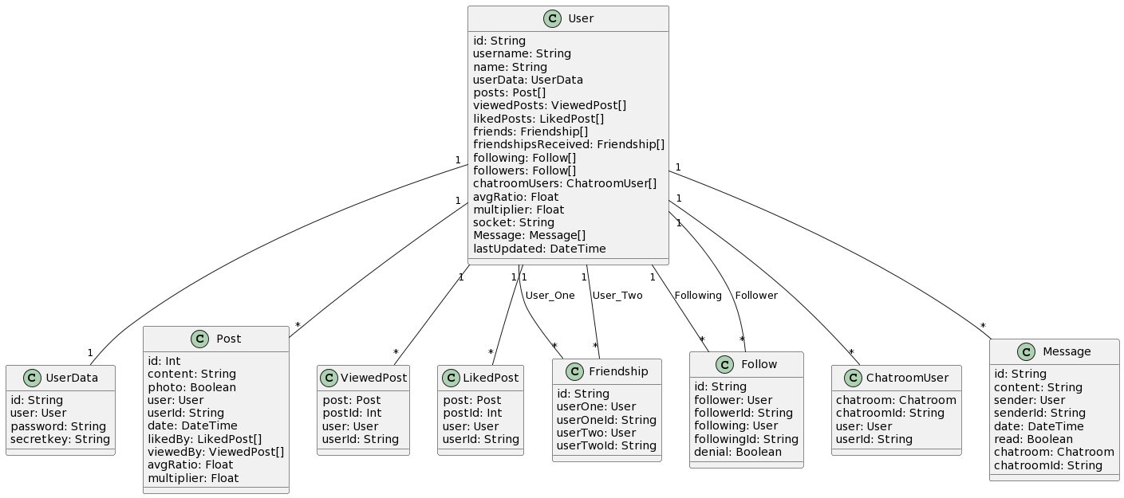

Implementation

model User {
id String @unique @default(uuid())
username String @unique
name String
userData UserData?
posts Post[]
viewedPosts ViewedPost[]
likedPosts LikedPost[]
friends Friendship[] @relation("User_One")
friendshipsReceived Friendship[] @relation("User_Two")
following Follow[] @relation("Following")
followers Follow[] @relation("Follower")
chatroomUsers ChatroomUser[]
avgRatio Float @default(0.0)
multiplier Float @default(1.0)
socket String?
Message Message[]
lastUpdated DateTime @default(now()) @updatedAt

@@index([username, id])
}

CREATE TABLE "User" (
"id" VARCHAR(191) NOT NULL UNIQUE,
"username" VARCHAR(191) NOT NULL UNIQUE,
"name" VARCHAR(255),
"avgRatio" FLOAT NOT NULL DEFAULT 0.0,
"multiplier" FLOAT NOT NULL DEFAULT 1.0,
"socket" VARCHAR(255),
"lastUpdated" TIMESTAMP(3) NOT NULL DEFAULT CURRENT_TIMESTAMP,
PRIMARY KEY ("id")
);

Tests

Test Case 1: Create a new user with a unique username

Procedure:
1. Insert a new record into the User table with a unique ID, username, name, default average ratio, default multiplier, and current timestamp.
2. Retrieve the inserted record from the User table.
Expected Result:
1. The inserted record should exist in the User table with a unique username.
2. The retrieved record should match the inserted record in terms of ID, username, name, default average ratio, default multiplier, and timestamp.

Test Case 2: Create a new user with an existing username

Procedure:
1. Attempt to insert a new record into the User table with an existing username.
2. Verify that the insertion operation fails and returns an error.
Expected Result:
1. The insertion operation should fail due to the unique constraint violation on the username column.
2. An error message indicating the unique constraint violation should be returned.

Test Case 3: Update the user's average ratio and multiplier

Procedure:
1. Update the average ratio and multiplier fields for an existing user in the User table.
2. Retrieve the updated record from the User table.
Expected Result:
1. The user's average ratio and multiplier fields should be successfully updated.
2. The retrieved record should reflect the updated average ratio and multiplier values.

UserData Model

Analysis

Private user data must be stored and managed within a social media system. It offers a separate location and storage for data, prioritising additional protection in line with GDPR or other relevant data protection regulations concerning the management of passwords and API keys.

The UserData model is a core part of a social media architecture that shields sensitive user information into a separate table, which could, in future, be moved to a separate database with extreme cross-origin checks to ensure that the information is only requested from the right place. Decoupling sensitive data from the standard User model provides the best separation for security and privacy. The result should be a model that reinforces a tight security model for the business logic through a clear separation of concerns with password hashing, encryption and password hashing, all performed for data integrity while maintaining a strong separation of concerns between business logic and integration with external services through congruent black box interfaces such as a count SQL statement not to transmit any sensitive information.

Strengths
- Improved data security and privacy.
- Stores passwords as hashes.
- API keys with expiry dates, therefore regular rotation.
- Complies with GDPR with hashed passwords.

Weaknesses
- Introduces complexity.

Opportunities
- 2FA

Threats
- Potential for data breaches.

The UserData model ensures the security and privacy of sensitive user information in a social media platform. By separating sensitive data from the primary User model and implementing strong security measures, the platform can mitigate risks and comply with data protection regulations.

Design

id
Type: String
Unique
user
Type: User Model
Relation: One-to-One
Fields: #id
References: User Model#id
password
Type: String
Hashed user password
secretkey
Type: String
API key. This might be adjusted to its type to allow for automatic updating of the key.

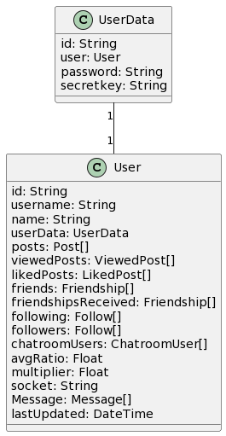

Implementation

model UserData {
id String @unique
user User @relation(fields: [id], references: [id])
password String
secretkey String?
}

CREATE TABLE "UserData" (
"id" VARCHAR(191) NOT NULL UNIQUE,
"password" VARCHAR(255) NOT NULL,
"secretkey" VARCHAR(191),
PRIMARY KEY ("id"),
FOREIGN KEY ("id") REFERENCES "User"("id")
);

Tests

Test Case 1: Create a new user data record

Procedure:
1. Insert a new record into the UserData table with a unique ID, user_id, password, and secretkey.
2. Retrieve the inserted record from the UserData table.
Expected Result:
1. The inserted record should exist in the UserData table with a unique user_id.
2. The retrieved record should match the inserted record in terms of ID, user_id, password, and secretkey.

Test Case 2: Create user data record with existing user_id

Procedure:
1. Attempt to insert a new record into the UserData table with an existing user_id.
2. Verify that the insertion operation fails and returns an error.
Expected Result:
1. The insertion operation should fail due to the unique constraint violation on the user_id column.
2. An error message indicating the unique constraint violation should be returned.

Test Case 3: Update user data record

Procedure:
1. Update the password and secretkey fields for an existing user data record in the UserData table.
2. Retrieve the updated record from the UserData table.
Expected Result:
1. The password and secretkey fields for the user data record should be successfully updated.
2. The retrieved record should reflect the updated password and secretkey values.

ViewedPost Model

Analysis

Likes are not enough to establish a post's performance in the wild since they have no context as to how it resonates within a community. To add weight to the data, viewing a post should be tracked and stored in line with the LikedPost model so that greater metrics and insight can be gleaned for how a post is faring.

This model is helpful for tracking users' interactions with post views while providing a separate entity for saving information about the posts that users have viewed. The responsibility of the ViewedPost model is to keep track of the posts viewed by users on a social media platform. It helps the platform understand users' behaviour, participation, and the content that attracts their attention. It is an essential component that maintains the relationship between users and posts, keeping track of which each user has viewed post. Its design collectively focuses on keeping the relationship simple and concise and making it easy to select specific data points.

Strengths
- Foundation for gleaning user interests for potential future recommendation algorithms.
- Performance metrics

Weaknesses
- A large amount of data will have to be dealt with, which will grow exponentially. This will greatly affect scalability, and database solutions, such as sharding, should be considered.

Opportunities
- Attributes such as the length of the view could be included to understand how much the post interested the user.

Threats
- Performance issues.
- Privacy concerns.

The ViewedPost model serves the critical purpose of tracking and analysing views for posts on a social media platform. Identifying the many-to-many relationship between users and the posts they view allows the platform to aggregate and analyse viewing behaviour across posts to identify trends and preferences. At its core, the ViewedPost model tracks the association of users viewing posts. Additional attribute columns can be added to better suit the use case. For instance, although not shown, sorting and filtering features can be added to enable platform users to view their timelines, receive recommendations of new content, and view a feed of their views. As the app grows, consider the primary performance challenges of data retrieval to real-time serve requests and at scale (many users) while ensuring the privacy of user viewing data.

Design

post
Type: Post Model
Fields: #postId
References: Post Model#id
postId
Type: Int
user
Type: User Model
Fields: #userId
References: User Model#id
userId
Type: String

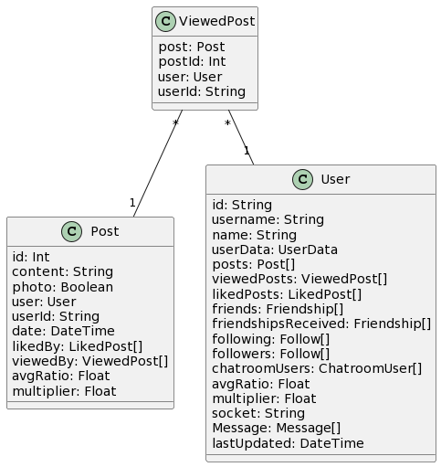

Implementation

model ViewedPost {
post Post @relation(fields: [postId], references: [id])
postId Int
user User @relation(fields: [userId], references: [id])
userId String

@@id([postId, userId])
}

CREATE TABLE "ViewedPost" (
"postId" INT NOT NULL,
"userId" VARCHAR(191) NOT NULL,
PRIMARY KEY ("postId", "userId"),
FOREIGN KEY ("postId") REFERENCES "Post"("id"),
FOREIGN KEY ("userId") REFERENCES "User"("id")
);

Tests

Test Case 1: Create a new viewed post record

Procedure:
1. Insert a new record into the ViewedPost table with a postId and userId.
2. Retrieve the inserted record from the ViewedPost table.
Expected Result:
1. The inserted record should exist in the ViewedPost table with the specified postId and userId.
2. The retrieved record should match the inserted record regarding postId and userId.

Test Case 2: Create duplicate viewed post record

Procedure:
1. Attempt to insert a new record into the ViewedPost table with the same postId and userId as an existing record.
2. Verify that the insertion operation fails due to the primary key constraint violation.
Expected Result:
1. The insertion operation should fail due to the primary key constraint violation on the combination of postId and userId.
2. An error message indicating the primary key constraint violation should be returned.

Test Case 3: Retrieve viewed post record

Procedure:
1. Retrieve an existing viewed post record from the ViewedPost table using a postId and userId.
2. Verify that the retrieved record matches the expected record.
Expected Result:
1. The retrieved record should exist in the ViewedPost table with the specified postId and userId.
2. The retrieved record should match the expected postId and userId records.

The Back End

Analysis

The back end is the core and the engine behind a web application in the software engineering development cycle. It is responsible for all the heavy lifting of web applications, such as interactive data processing, complex operations and communications, business logic, requests from the front end, and responses to the front end. All the activities on a server will happen on the back end of a web application.

The back-end is expected to include a solid, scalable and secure core for the app. It needs to be as efficient as possible in handling user requests, processing data, creating and manipulating content, integrating with existing services, and sending responses. The back-end must handle the expected load and traffic optimally, including potentially high volumes, to deliver the best and most reliable performance under demand.

At the dawn of web development, the back-end was often treated as a black box; to unlock it, you needed to be a seasoned developer with server-side knowledge and low-level programming languages. This has changed dramatically in recent years, propelled by the rise of APIs (short for Application Programming Interfaces) and the development of abstraction layers.

An API allows for the well-defined and unambiguous articulation of the information and functionality being exposed: it neatly separates how your application can access an external system from what is available to access and manipulate. It is a layer of abstraction. It provides a simple interface for you to invoke the back-end – familiar and easy-to-reason-about HTTP requests and responses – to interact with and control the designated functionality of the server or application.

The back-end architecture that powers this project uses a stack of technologies and architectural patterns to provide an application with a robust, scalable, and secure foundation. At the heart of the Monolith API is the endpoint: the API, built with GraphQL, a query language and runtime for APIs. GraphQL is a new query language for querying an API that allows the client to express precisely what data they need from an API in a single request, and the server provides strictly that data without over-fetching or under-fetching, preventing unnecessary overhead. This approach provides the clients with maximum flexibility, letting them ask for what they need rather than the server dictating what is on the menu.

You accomplish this by implementing a GraphQL endpoint on the Monolith API and exposing it to the front end. By having these two parts of a system communicate via a self-documenting contract (in this case, GraphQL), the client – be it a web or mobile app – knows exactly what it can request to get back the data it needs at that given point in time. In GraphQL terminology, data types, queries and mutations refer to what is dealt with on the server side. Clients get to play with these parts by issuing queries and mutations to the server that, when done right, return only the data that was requested. This is one way you avoid the performance penalty of multiple round trips to the server. Another related advantage to consider is reduced network bandwidth usage.

Node.js is a popular JavaScript runtime that allows executing JavaScript code on the server. It is popular because it is fast and scalable, and it plays nicely with a vast ecosystem of modules, which are simply libraries and frameworks that make it easier for developers to check off everyday tasks on the path to delivering a product to customers. GraphQL relies on Node.js due to the incredible support for building scalable and modular APIs that it provides, and Express.js is a web application framework that plugs into Node.js to help with things like handling HTTP requests and routing them to the appropriate resolver function.

A WebSocket server using the Socket.IO library has also been implemented in the Monolith API to improve its real-time functionality. WebSockets facilitate a two-way communication channel between the server and the clients, eliminating the need to constantly poll the server and enabling it to push data from the server to the client as soon as it is available. This is extremely useful for real-time messaging, notifications, and chatroom features found in the application, where user experience needs those updates as soon as another user makes changes.

On the back end, some micro-services process logic to perform specific tasks and delegate computationally expensive operations to prevent overloading the main API. The micro-services are built with Rust, a systems programming language that provides great performance, safety, and concurrency. Rust has a very strong type system and an ownership model, which help rule out many common programming errors and prevent memory safety bugs and low-level issues. Back-end performance and resource consumption for computationally expensive operations improve by utilising Rust for micro-services.

The Image Server is responsible for uploading, processing and serving images. It offers dedicated endpoints for uploading and downloading images so that the central API/server can delegate these activities to the dedicated image service. This is another example of separation of concerns. The main API will only interact with the image service to manage uploading and downloading. Meanwhile, the Image Server can scale separately to manage image uploads, processing and storage. Users will enjoy faster page loads, as the image server will be optimised for building and maintaining an image back-end to serve images to the front end.

The Recommendation Engine recommends new user profiles based on high-level graph theory, based on the user's behaviour, preferences, and previous interactions. The API's main feature is to have agnostic services answering requests from the Monolith itself instead of littering the front end with multiple API URLs and increasing the potential attack surface. This way, when a user accesses the primary API endpoint, the application would delegate the query to the Recommendation Engine and would be able to personalise the interaction for that specific user.

The back-end consists mainly of an interface to a database system that plays a significant role in data persistence. PostgreSQL is used as the database management system for this project. PostgreSQL is a feature-rich, robust, and reliable open-source relational database that provides robustness for data integrity, transactions, concurrency, and performance. Furthermore, the database schema was carefully designed, considering resource and storage effectiveness to accommodate the application's needs. Appropriate indexing and query optimisation techniques were carefully implemented to offer fast and efficient access to data, as well as the ability to scale.

The back-end exposes an interface that simplifies and adds type-safety to the interaction with the database – that is the part that Prisma serves. Prisma is an open-source toolkit for developing databases. In its own words, it is 'an open-source database toolkit that simplifies and adds type-safety to modern database workflows. Prisma helps you make your database schemas and query and migrate the database with an intuitive and type-free domain-specific language. Prisma gives you a strongly typed client generated from your database schema. Using the client, you can write perfectly safe and sane database queries in the usual verbose and expressive ways familiar to most of us, which would facilitate a greater choice of developers experienced to undertake work on the platform in the case that the platform scales and needs more than myself as the sole developer. With Prisma, it is no longer necessary to manually write boilerplate code (and make mistakes along the way) because you can describe the database and the project using declarative interfaces in ergonomic software.

Security is also a significant consideration in the back-end architecture. The Monolith API can have a robust authorisation and authentication scheme, where only authenticated and authorised users can access sensitive data and perform specific actions. This can be done by authenticating users by rotating API keys, authorising users via role-based access controls (RBAC), and leveraging secure comms protocols like https in a production environment. For this reason, whenever a request is made from the front end to the back end, a complete validation process in terms of the user identity and entitlement is carried out. This ensures that the data of users will only remain contained within the systems and will not fall into the hands of criminals or even operators unless stored in plaintext.

Logging, monitoring and error handling are three aspects of a back-end system. The logging implemented in Monolith API – for example – enables developers to capture system events, errors and performance metrics. A monitoring mechanism is helpful for developers to keep track of the health and performance of back-end services and to be notified if a service becomes unavailable, responds sluggishly or goes through significant changes in usage patterns. Lastly, error handling and graceful degradation are vital for ensuring the application's responsiveness. The system must properly manage errors and exceptions and provide the best fallback experience to users requesting information from the API.

On the back end, code quality and maintainability are ensured by adhering to best practices and coding standards. A modular codebase is assembled by loosely coupling its components to ensure independence, separating concerns, and applying the SOLID principles. Automated testing of front—and back-end modules involving qualitative tests helps catch bugs earlier. Bugs that escape the testing phase are caught by end users, who are encouraged to report such behaviour.

Performance optimisation is an active back-end work effort. In order to reduce latency and maximise throughput, we employ techniques such as caching, query optimisation and efficient algorithms. Rust is chosen for micro-services as it brings performance into a language that allows for a shallow memory footprint. Developed with efficiency in mind, Node.js and Express.js are very performant and provide the same benefits in the Monolith API runtime. The approach to performance is continuous, where regular and random performance profiling and performance monitoring allow us to identify and breed bottlenecks and opportunities to improve things. As traffic on our APIs and the number of active users is growing, we are constantly on the lookout to keep pace with the growth.

Strengths
- Efficient access requests.
- Node.js and Express.js offer scalability and performance for the Monolith API.
- WebSockets enable real-time communication and updates.
- Rust-based micro-services achieve high performance and low resource consumption
- PostgreSQL provides a robust and scalable ACID-compliant database solution.
- Prisma simplifies database management and ensures type safety.
- Robust security measures protect user data and prevent unauthorised access.
- Logging, monitoring, and error handling ensure system reliability and maintainability.

Weaknesses
- Complexity in managing and coordinating multiple services and technologies.
- Potential for performance bottlenecks if not correctly optimised.
- Dependence on external libraries and frameworks can introduce potential vulnerabilities.
- Maintaining and updating the back-end codebase requires ongoing effort and resources.

Opportunities
- Explore cloud platforms and services.

Threats
- New vulnerabilities that require constant updates.
- Keeping up with the latest trends and best practices is necessary.
- Scalability challenges as user demands and data volumes grow exponentially
- Dependency disruptions.

The GraphQL-based Monolith API, built in Node.js with Express.js, connects all the endpoints, providing all the data via GraphQL, and handles with Web Socket server for real-time data transfer and user events.

Each micro-service solves a question or task. Written in Rust to offload expensive computation onto lean hardware, we query at high speed. Backing storage with type-safe Prisma, connected to a PostgreSQL database management system, ensures the safety of our data, scalability, and type soundness.
The back-end architecture aims at security, scalability and maintainability, applying robust mechanisms for authentication and authorisation, maintaining a log of all activities, and providing a possibility to monitor security concerns, applying good practices around code structure and testing to ensure that it is easier to support the system with future development; implementing a modular design that makes it possible to extend the system if new requirements appear incrementally; and applying performance-optimisation techniques to ensure shorter response times and smaller numbers of errors. The back end provides robust support for the application thanks to its strengths, overcoming weaknesses, seizing opportunities, and neutralising threats of the selected technologies. It performs proper data processing, enables application communication, and facilitates communication between front-end and external services.

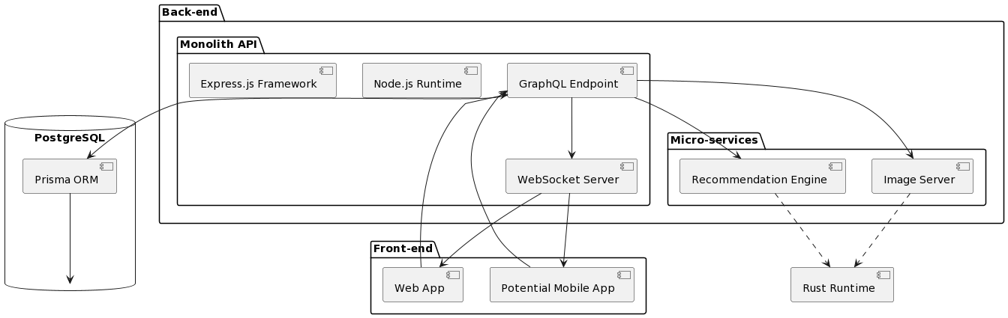

Security

Security is a crucial factor for any system, especially for APIs where you are working with users' sensitive data. In the case of a social media platform, security/privacy and confidentiality of user data are top priorities. They need to be handled in a way that follows industry best practices and legislation such as GDPR.

One of the first initiatives to address this security measure is the usage of HTTP headers. HTTP headers contain metadata about the information being transferred and play a key role in securing valid requests between the client and the API server. The platform can improve security and close some vulnerabilities by using structured and defined HTTP headers.

Cross-Origin Resource Sharing (CORS) is a core security mechanism that defines the rules governing access to resources from different origins. CORS prevents unauthorised clients – that is, clients from different origins that the API server does not trust – from accessing the API. We go around implementing CORS in our codebase's back-end server using the Cors middleware below:

const cors = require('cors');
// ...
app.use( cors({
origin: ['http://localhost:5173', 'http://127.0.0.1:5173/'],
methods: '*',
}), );

Configuring CORS correctly will allow people to use the API only when the request originates from an allowed domain. This protects against most illegitimate API requests because they do not originate from the front end, where the end-user would be.

Another security-minded enhancement would be using HTTPS, an encryption of the data between client and server. HTTP Strict Transport Security (HSTS) ensures that the browser always uses a secure connection and can protect against downgrade attacks, which try to send less secure protocols. You can see that this is missing from the code base supplied, although it would be set up in a production environment to enable HSTS and ensure the connection is secure.

Other security headers offer extra protection against clickjacking (X-Frame-Options), MIME-sniffing (X-Content-Type-Options), cross-domain access (X-Permitted-Cross-Domain-Policies), and information leaks from referrers (Referrer-Policy), and are set similarly as above. Helmet is a library that can be used in Express.js to add these extra layers of security to the app's security posture.

Authentication and authorisation form a considerable part of the API security in this platform. The platform employs an API key-based authentication mechanism to maintain the level of security. Once a user registers or logs into the website, they are given an API key. From that moment on, any user request is authenticated and authorised with the combination of the API key and the randomly generated unique user ID (generated in the UserData model in the database when the user is created). The auth function in the backend server shows the method of how an API key and user ID are verified against the UserData model in the database:

async function auth(id, key, req) {
// ...
const exists = await prisma.userData.count({
where: {
AND: [
{id: id},
{secretkey: key},
{expiry: {
gt: new Date(Date.now())
}
}
],
},
});
if (!exists) {
throw new Error('Invalid Credentials');
} else {
// ...
return true;
}
}

The request starts if the supplied credentials are valid, or it throws an 'Invalid Credentials' exception otherwise.

For added security, we apply countermeasures to the authentication stage. We have a set expiration for an API key (1 week both client- and server-side), and it gets automatically rotated after an expiration or password reset. Likewise, the compromised API key has a minimal life. The server-side session is maintained in a hashmap with API keys mapped to user IP addresses and user agents:

const sessions = new Map();
// ...
async function auth(id, key, req) {
// ...
if (req != null) {
const userData = await prisma.userData.findFirst({
where: { AND: [{ id: id }, { secretkey: key }] },
select: { expiry: true },
});
sessions.delete(id);
sessions.set(id, {
ip: req.ip,
userAgent: req.headers["user-agent"],
expiry: new Date(userData.expiry),
});
}
return true;
}

It is not foolproof—the consistency of the user's environment can itself be manipulated—but it provides another line of defence while reducing calls to the database and increasing the speed of requests.

Logging is an instrumental security measure incident response tool: The platform employs a logging system that saves meaningful events such as errors or suspicious activity.

The log() function in the back end shows how an error message, accompanied by its timestamp and the error details, gets appended to plain text log files:

function log(e) {
const timestamp = Date.now();
const currentDate = new Date(timestamp);
// ...
try {
fs.appendFile( __dirname + `/logs/${formattedDate.replace(/\//g, '-')}.txt`,
`${formattedTime} ${e.message} \n`,
(err) => console.log(err),
);
} catch (e) {
console.log(e, 'ERROR LOGGING');
}
}

By maintaining comprehensive logs, the platform enables effective security auditing, troubleshooting, and forensic analysis.

Sanitising and validating data is essential to prevent common security vulnerabilities such as SQL injection, cross-site scripting (XSS) and arbitrary command execution. This is the code for the sanitation function on the API. It shows that sanitising user input is a general procedure resulting in the need for a function that can cope with changing, dynamic input in all use-case scenarios. For instance, through the procedure, special characters like single and double quotes are escaped, blocked characters like '</' or '>' are removed, and the input length is cut down to a reasonable length. Further, the data is canonicalised.

function sanitise(input) {
const sanitizedObj = {};

Object.keys(input).forEach((key) => {
const value = input[key];
let sanitizedValue = value;

// Escape Characters
const sanitisedValue = htmlSpecialChars(sanitizedValue);

function htmlSpecialChars(text) {
if (typeof text !== 'string') {
return text; // Return as is if not a string
}
const map = {
'<': '&lt;',
'>': '&gt;',
'"': '&quot;',
"'": '&apos;',
'&': '&amp;',
};
return text.replace(/[<>"&]/g, (char) => map[char]);
}

// Length Limitation
const maxLength = 255; // Assuming maxLength is defined elsewhere
if (typeof data === 'string') {
sanitisedValue = sanitisedValue.slice(0, maxLength);
// Canonicalization (Remove variations such as leading/trailing spaces)
sanitizedValue = sanitizedValue.trim();
} else if (typeof data === 'number') {
sanitisedValue = parseFloat(sanitisedValue.toString().slice(0, maxLength));
}

// Assign sanitized value to the corresponding key
sanitizedObj[key] = sanitizedValue;
});

return sanitizedObj;
}

This is validated and sanitised to protect the data. It also provides improved security by carefully checking the payloads sent by clients.

Because GraphQL is strictly typed (through its own GraphQL schema) and carefully validates the request payload, any attempt to pass malicious data will be automatically rejected at the API boundary. One of the most common ways attackers try to interfere with APIs is by passing some form of injection attack. For example, the attacker might pass a value in the request that's then interpreted as SQL to compromise a SQL database through SQL injection or passed through an XPath query for XML injection, and so forth. By restricting the request payload using GraphQL schemas (defining data types, which argument is required for a field, and so forth), GraphQL will automatically check, parse, and reject such payloads.

The security of its dependencies should address further security concerns – the security of external services used by the API – which should all be updated regularly and have their vulnerabilities patched in a timely manner with considerations given to security updates. Periodic audits such as vulnerability scanning and penetration testing should be made available to discover and remedy potential security threats.

Additionally, the platform must have an established security incident response plan that articulates how security incidents will be detected, analysed and responded to by identifying ways to contain, eradicate, and recover from them. A clear plan on how subject matter experts will carry out a thorough post-incident analysis should also be established. Regular security awareness training and briefing modules must also be conducted for developers and other stakeholders to ensure that all security best practices are incorporated into the development lifecycle.

Adhere to the relevant security standards, guidelines, and regulations in your specific industry, such as OWASP Top 10 and NIST Cybersecurity Framework. Continuous security testing of devices, infrastructure, and applications must occur to ensure that appropriate security controls are set up and regularly validated through security audits and penetration assessments.

Also, security is a continual process; it needs to be watched over, reviewed, and improved as new threats and risks are discovered. These need to be reflected in the security controls implemented. Keeping up to date with the latest security trends, best practices, and technologies is vital for a culture of continuous improvement to ensure a secure and resilient security posture.

In summary, we should ensure that it is a secure social media platform with a secure API infrastructure. Various approaches have been undertaken to achieve this goal, such as authentication, authorisation, HTTP headers, logging, data validation and sanitation, using the GraphQL security features, etc. Security is a joint and continued effort that requires commitment during all phases of the SDLC.

Recommendation Server

One of the key components of the social media platform is the Recommendation Server, which aids the user in discovering other users and expanding their network of connections.

Based on the existing network described by a directed graph, classic approaches from graph theory and analysis are used to make personalised user recommendations. It is implemented as a micro-service in Rust to maximise the performance, scalability, and efficiency of data processed in Rust.

Again, to ensure speed and avoid needlessly clogging the network with API calls, the Recommendation Server needs to be deployed directly alongside the Monolith API. Running it locally will avoid sending data over wide area networks, saving bandwidth and cutting latency for everyone. And because this new Recommendation Server will be on the same infrastructure as the Monolith API, it reduces the attack surface even further.

The architecture of the Recommendation Server is modular and decoupled; it can operate in isolation from the Monolith API, sending and receiving data through well-defined interfaces. This effectively isolates this aspect of logic to a single component – allowing for independent development, testing and deployment of its recommendation function without interfering with the core application.

The code for the Recommendation Server is written in the Rust programming language and runs on the Axum web framework to expose API endpoints. This choice of language was made because Rust is fast, memory-safe and uses resources efficiently.

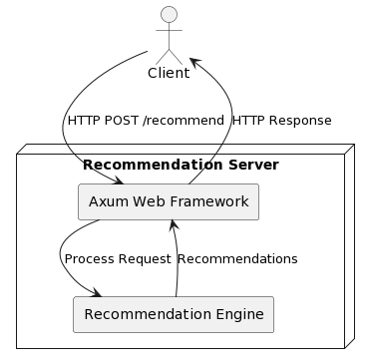

Dependencies

Rust projects have their dependencies managed by Cargo, as evidenced by the Cargo.toml file.

[package]
name = "RecommendUsers"
version = "0.1.0"
edition = "2021"

[dependencies]
axum = { version = "0.6.20", features = ["headers"] }
base64 = "0.21.7"
engine = "0.0.0"
serde = { version = "1.0", features = ["derive"] }
serde_json = "1.0.68"
tokio = { version = "1.0", features = ["full"] }
tower-http = { version = "0.3", features = ["cors"] }
mime_guess = "2.0.4"

User

The core of the Recommendation Server is the User struct, which encapsulates an individual user of a social network. Users have IDs, friends and followers.
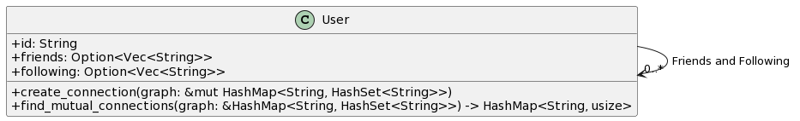

#[derive(Debug, Deserialize, Serialize)]
struct User {
id: String,
friends: Option<Vec<String>>,
following: Option<Vec<String>>,
}

Creating Connections

The Recommendation Server offers a create_connection method to build the social graph. This method takes a reference to the User struct, and a mutable reference toHashMap called graph. It runs over the users' followers and friends and saves each connection as a new node in the graph:

impl User {
fn create_connection(&self, graph: &mut HashMap<String, HashSet<String>>) {
if let Some(friends) = &self.friends {
for friend_id in friends {
graph
.entry(self.id.clone())
.or_insert(HashSet::new())
.insert(friend_id.clone());
graph
.entry(friend_id.clone())
.or_insert(HashSet::new())
.insert(self.id.clone());
}
}

if let Some(following) = &self.following {
for follow_id in following {
graph
.entry(self.id.clone())
.or_insert(HashSet::new())
.insert(follow_id.clone());
graph
.entry(follow_id.clone())
.or_insert(HashSet::new())
.insert(self.id.clone());
}
}
}
// ...
}

Mutual Connections

After building the social graph, the Recommendation Server will invoke the find_mutual_connections method on each user and pass on a reference to that user's partial graph. It will return a HashMap of the user's friends with mutual friends, along with a count of how many mutual friends connect them.
impl User {
// ...

fn find_mutual_connections(&self, graph: &HashMap<String, HashSet<String>>) -> HashMap<String, usize> {
let mut mutual_connections: HashMap<String, usize> = HashMap::new();

if let Some(connections) = graph.get(&self.id) {
for connection_id in connections {
if let Some(connections_of_connection) = graph.get(connection_id) {
for mutual_connection_id in connections_of_connection {
if mutual_connection_id != &self.id && !connections.contains(mutual_connection_id) {
*mutual_connections.entry(mutual_connection_id.clone()).or_insert(0) += 1;
}
}
}
}
}

mutual_connections
}
}

The find_mutual_connections function efficiently traverses the graph from the user's immediate connections to their connections' connections while keeping the connections already traced alive. By disallowing the user's existing immediate connections, the function helps identify new connections one level away from the user.

The Recommendation Server serves dynamic, personalised recommendations in a /recommend endpoint that receives JSON payloads of the array of User objects as its input: When the server receives a POST request on the above endpoint, it first constructs a social graph by calling its create_connection method on each user in the array:

async fn recommend(Json(users): Json<Vec<User>>) -> impl IntoResponse {
let mut graph: HashMap<String, HashSet<String>> = HashMap::new();

for user in &users {
user.create_connection(&mut graph);
}

// ...
}

It then takes that first user from the array and finds their mutual connections with the find_mutual_connections method:

async fn recommend(Json(users): Json<Vec<User>>) -> impl IntoResponse {
// ...

if let Some(user) = users.first() {
let mut mutual_connections = user.find_mutual_connections(&graph);
// ...
}

// ...
}

The mutual relationships are sorted by the frequency of relationships in descending order, and the top recommendations are returned as the response:

async fn recommend(Json(users): Json<Vec<User>>) -> impl IntoResponse {
// ...

let mut sorted_mutual_connections: Vec<String> = mutual_connections
.into_iter()
.map(|(id, _)| id)
.collect();
sorted_mutual_connections.sort_by_key(|user_id| user_id.len());
sorted_mutual_connections.reverse();

// ...
}

Optimising

Although the way in which the Recommendation Server curates the social graph and recommends things is worked out on the fly for each request, for better performance, the API could maintain a permanent social graph of all the links between all users in the network. By keeping the social graph alive and available, the costs associated with reconstructing it from scratch for every request can be avoided, thus dramatically reducing the computation time.

To carry out this optimisation, the Recommendation Server could have a separate data store (or cache) explicitly created for storing the persistent social graph. This data store could be updated in real time as the network evolves, such as when new links are added between users or when an existing link is deleted or modified. Using this data structure, the server can always have a live representation of the entire user network, allowing quick queries to retrieve the needed data for making recommendations.

If it is a persistent social graph, we would not need to pass in the data for every request; the server could query the recommendation graph to see who users have in common and output recommendations accordingly. We do not need to do anything fancy to construct it; we create all possible combinations of edges and then compute recommendations by looking up against them.

The persistent social graph can be realised using different data structures and storage engines, such as graph databases or in-memory caches, depending on the scale of the network, expected read-write patterns, and performance requirements. Services like Neo4j or Amazon Neptune are typical candidates for offering native support for storing and querying arbitrary graph structures.

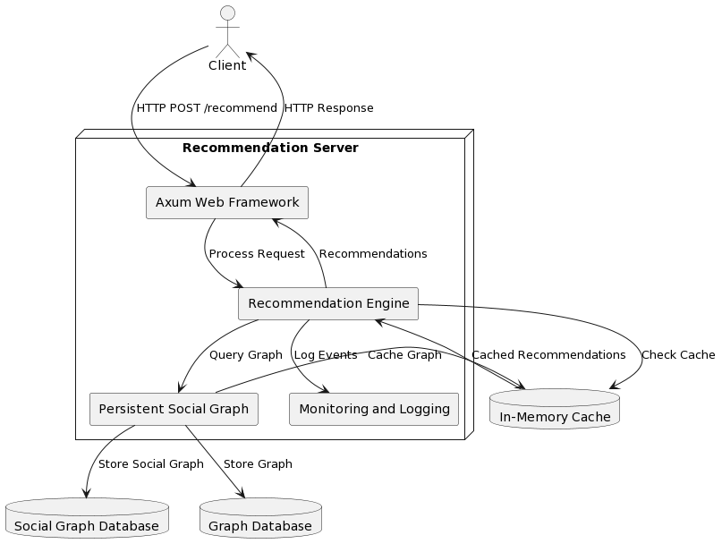

Because it might quickly outgrow the localhost, the persisted social graph must allow for sharding or partitioning for it to scale for performance. Sharding is the process of partitioning a graph to divide it into smaller subgraphs that can be referenced uniquely based on specific parameters (e.g., user location or connection density). It keeps objects together (to ensure data consistency) and allows for parallel processing. Conversely, partitioning involves distributing the graph across multiple servers or nodes, enabling horizontal scaling and load balancing.

Besides the persistent social graph, caching mechanisms can be added to the Recommendation Server. For example, the most computationally expensive recommendation placements can be cached in memory, thereby avoiding repetitive re-computation and improving response times. Techniques such as least recently used (LRU), and time-based expiration can control the size of stored recommendations and ensure a regular replacement of older recommendations with more up-to-date ones.

The Recommendation Server should involve extensive monitoring and logging. All the crucial events and exceptions should be logged, as well as specific performance metrics. The codebase provided here uses the println! macro for basic logging during development:

println!("{:?}", users);
println!("{:#?}", graph);
println!("{:?}", sorted_mutual_connections.clone());

Still, more formal logging frameworks and tools are available for a production-grade system, as diagnostics, bug-hunting, and performance analysis are more likely to be involved.

Strengths
- Local deployment alongside the Monolith API reduces network overhead and improves performance.
- Modular and decoupled architecture allows for flexible development, testing, and deployment.
- Utilises the principles of graph theory and analysis to generate personalised and relevant recommendations.
- Implements an efficient, natural recommendation algorithm based on mutual connections.

Weaknesses
- Local deployment may limit the scalability and resource utilisation compared to a distributed architecture.
- Relying on the quality and completeness of the user's social graph for accurate recommendations.
- May not consider additional factors beyond mutual connections, such as user preferences or interests.

Opportunities
- Implement a persistent social graph to improve lookup times and reduce processing overhead.
- Store and retrieve the social graph using a graph database or in-memory caches.
- Employ sharding or partitioning techniques to enhance scalability and performance.
- Incorporate caching mechanisms to optimise frequently accessed or computed recommendations.

Threats
- Potential concerns regarding private user data and security.
- Storing and processing the entire user network graph.
- Potential bottlenecks if the graph becomes extremely large and complex.
- Risk of over-recommending or suggesting irrelevant connections if not correctly tuned.

In conclusion, the Recommendation Server is a practical, robust, and seminal component of the platform, which helps users access and discover more relevant "human" connections. Graph theory underlies the construction of the social graph. Mutual acquaintances are auto-filtered as a result of the analysis. The fact that the server is locally deployed to the Monolith API reduces network overhead, and fixing it makes it more responsive and performant. Modular architecture enables evolutionary development and easy integration.

Its high-performance, memory-safe, resource-efficient implementation in Rust is based on the Axum web framework. The core functionality is captured in the User struct, and the methods create_connection and find_mutual_connections are the two key steps to constructing the social graph and computing recommendations for a user.

The current implementation could be scaled up to handle a larger number of requests, and the taxonomies could be made more sophisticated. However, with a bit of work, we can unlock significant optimisation. Persistently storing the social graph, large key-value storage systems (with sharding or partitioning), and/or a caching layer will reduce lookup time and processing overhead. We can consider other databases that use a graph model, such as graph databases or hashed triad in-memory caches, to store and retrieve the social graph.

Operational aspects also need to be addressed. The Recommendation Engine needs to be monitored and logged to ensure reliability and maintainability. Robust logging frameworks and tools are recommended to properly catch user events and system errors and monitor the system's latency and throughput. This makes it easier to debug any issues or tuning challenges that might arise over time.

In conclusion, the Recommendation Server is the most valuable module. It helps the user network and build up friendships by recommending new profiles matched with their own interests every time they use the app. This module helps social media integrate easily, creating useful connections between users while remaining fast and stable at peak times.

Image Server

The Image Server is implemented to manage the handling and serving of end-user media assets. This improves latency because it is more efficient for the Monolith API to be concerned with handling business logic while an entirely different service handles its media-related functionality.

The Image Server is deployed as a standalone micro-service, built in Rust, which, in addition to its strong type system and strict memory safety guarantees, offers excellent concurrent and high-performance characteristics. So, building high-performance, reliable, and concurrent services in Rust is a natural choice. The project's dependencies and configuration are managed with Cargo, as seen in the Cargo.toml file:

[package]
name = "ImageServer"
version = "0.1.0"
edition = "2021"

[dependencies]
axum = { version = "0.6.20", features = ["headers"] }
base64 = "0.21.7"
engine = "0.0.0"
serde = { version = "1.0", features = ["derive"] }
serde_json = "1.0.68"
tokio = { version = "1.0", features = ["full"] }
tower-http = { version = "0.3", features = ["cors"] }
mime_guess = "2.0.4"

The Image Server endpoint integrates with the client-side app. It has two main functionalities: handle media uploads through /upload and provide media assets for retrieval through /fetch. The two endpoints, as named/upload and /fetch, allow for easy integration with other services at hand, as they can be invoked via HTTP POST and GET requests.

The /upload endpoint takes a JSON payload describing media upload data, including the ID of the user or posts it belongs to, the data of an image encoded as a string of delimited binary digits, and a type of correlation which shows whether a media pronounces a user profile, post or a chat:

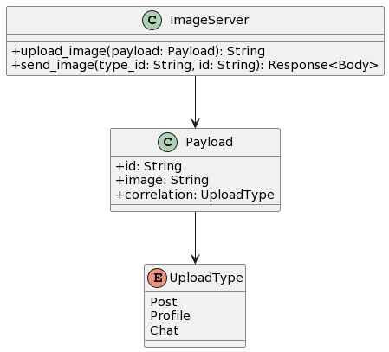

#[derive(Debug, Deserialize)]
enum UploadType {
Profile,
Post,
Chat,
}

// Payload body of the request to upload Data
#[derive(Debug, Deserialize)]
struct Payload {
id: String,
image: String,
correlation: UploadType,
}

The /fetch endpoint is available with the type_id and id parameters in the URL path. When clients want to fetch a media asset, they can provide the type_id: "Profile" for the user_profile, "Post" for the posts, or "Chat" for the chats and the id for the relevant user, post, or chat, and the media asset corresponding to that ID and type will be returned Backend function to retrieve assets:

async fn send_image(Path((type_id, id)): Path<(String, String)>) -> Response<Body> {
let mut file_path = PathBuf::from("");

let type_id = type_id.as_str();
match type_id {
"post" => {
file_path.push("post");
},
"profile" => {
file_path.push("profile");
},
"chats" => {
file_path.push("chat");
},
_ => {
return Response::builder()
.status(StatusCode::BAD_REQUEST)
.body(Body::from("Invalid image type"))
.unwrap();
}
}

file_path.push(format!("{}.jpg", id));

if !file_path.exists() {
return Response::builder()
.status(StatusCode::NOT_FOUND)
.body(Body::empty())
.unwrap();
}

let mut file = File::open(file_path).expect("Error opening image file");
let mut buffer = Vec::new();
file.read_to_end(&mut buffer).expect("Error reading image data");

Response::builder()
.status(StatusCode::OK)
.body(Body::from(buffer))
.unwrap()
}

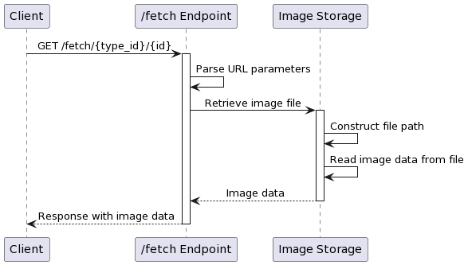

The Image Server sets cross-origin resource sharing (CORS) settings with the tower-http library for security and access control purposes. The CORS layer is configured to allow specific HTTP methods, headers, and origins, but for now, in the development period, it is set to any:

use tower_http::cors::{AllowedHeaders, AllowedMethods, CorsLayer};
use http::Method;

let cors = CorsLayer::new()
.allow_methods(vec![Method::GET, Method::POST])
.allow_headers(AllowedHeaders::Any)
.allow_origin(AllowedOrigin::Any);

The image server for media storage is currently concerned with handling images uploaded to the /upload endpoint. When image data is received through the /upload endpoint, the received image data is processed by the Image server and is stored in the directory of the appropriate correlating type. Profile images of user profile data are stored in the directory "profile", images from posts are stored in "post", and images from chats are stored in "chat." The function upload_image stores images:

async fn upload_image(Json(payload): Json<Payload>) -> String {
// Extract image data from the payload
let image_data = payload.image;

// Convert image data from base64 string to bytes
let image_bytes: Vec<u8> = image_data.split(',')
.map(|num| num.parse::<u8>().expect("Invalid number in string"))
.collect();

// Match the correlation type of the payload
match payload.correlation {
UploadType::Post => {
// Define the file path for posts
let file_path = format!("post/{}.jpg", payload.id);
// Create a new file and write image bytes to it
let mut file = File::create(&file_path).expect("Error creating image file");
file.write_all(&image_bytes).expect("Error writing image data");
},
UploadType::Profile => {
// Define the file path for profiles
let file_path = format!("profile/{}.jpg", payload.id);
// Create a new file and write image bytes to it
let mut file = File::create(&file_path).expect("Error creating image file");
file.write_all(&image_bytes).expect("Error writing image data");
},
UploadType::Chat => {
// Define the file path for chats
let file_path = format!("chat/{}.jpg", payload.id);
// Create a new file and write image bytes to it
let mut file = File::create(&file_path).expect("Error creating image file");
file.write_all(&image_bytes).expect("Error writing image data");
}
}

// Return an empty string as the response
"".to_owned()
}

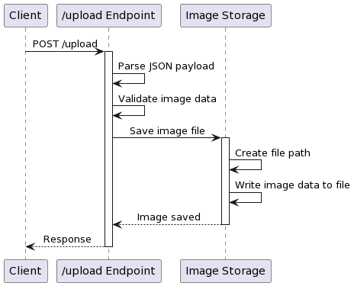
The Image Server validates data and sanitises it wherever possible. It first determines the MIME type of the uploaded file using the library mime_guess, which is commonly used to determine the MIME types of files based on their extensions and ensure that only valid image formats are accepted.

Whenever a client issues a GET request to the /fetch endpoint providing the type ID and the item ID, the function first generates the relative file path based on the parameters. Then, the server opens the file to read using the relative path, sending back the response body with the correct content type and HTTP status code. If the image file is not found by its identifier, the server sends back the ‘404 Not Found' status code to tell the user that the resource cannot be found.

As new media content is added to the platform (anticipating the future expansion of the system), the Image Server may also need to grow horizontally in scale to accommodate an increased load. Strategies such as horizontal elasticity can then be adapted to split up the load of media-handling work among multiple instances of Image Server apps for load-balancing and distributed storage needs. This could improve the system's overall quality by providing better availability, fault tolerance, and the ability to handle an increased number of concurrent requests.

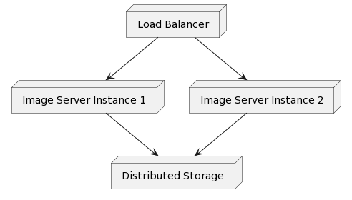

For a production-ready system, we should add more logging to our application to capture events, errors, and performance metrics. To monitor the server's health and performance, you can use commercially available tools that will alert developers to issues and anomalies.

Though the Image Server currently only supports images for upload and queries, it can be easily extended to handle other media types such as videos, audio and documents. One could integrate it with a cloud storage service or a Content Delivery Network (CDN) to increase scalability, reliability and worldwide distribution.

Strengths
- Offloads media handling from the Monolith API, improving performance and scalability.
- Implemented in Rust, leveraging its performance, concurrency, and memory safety features.
- Well-defined API interface for media upload and retrieval.
- Structured organisation and storage of media assets based on correlation types.
- Implements CORS settings to restrict access.

Weaknesses
- Currently limited to image uploads.
- It uses the file system to store its data.

Opportunities
- Support media types beyond images: videos, audio files, documents
- Caching mechanisms to optimise performance and reduce latency.
- Integrate with cloud storage services or content distribution networks.
- Explore advanced image processing and transformations.

Threats
- Unauthorised access or data leakages.
- Challenges as the number of media assets and concurrent requests grows significantly.
- Third-party libraries or services may introduce vulnerabilities or compatibility issues.

Periodic security audits and penetration testing might help weed out potential security risks on the Image Server. Security flaws should be fixed promptly, and best practices in secure coding and good data hygiene should be followed. This includes maintaining server software, using the latest security patches where possible, and monitoring for continuous monitoring and threat detection.

A significant aspect of the Image Server that must be considered in the context of its scalability is that the system will grow and will eventually accumulate substantially more media assets than exist at the time of the initial instantiation. To ensure that the Image Server can handle this growth, developers must use horizontal scaling strategies to distribute load across more server instances, incorporate redundancy across instances for high availability, regularly monitor performance metrics and conduct load testing to see and address bottlenecks before they become problematic.

The Image Server augments the capabilities of the Monolith API by moving the handling of media assets to a single dedicated service. The benefits of offloading media handling are multi-fold: the Monolith API no longer needs to manage media in the database. Rust, which powers the Image Server, is superior to JavaScript on bare metal, and we are well-equipped to handle the media deluge efficiently. With a well-defined API interface, clear-cut storage structure, and explicit CORS settings, the server handles media securely and is scalable.

Going forward, the Image Server can be further generalised to handle a broader set of media types and even better leveraged with integration to storage services in the cloud, like a CDN, for better scalability and worldwide distribution. By hardening the architecture against some of these security concerns, optimising performance, and generally scaling the social media platform, the Image Server can provide a better means of information sharing on the platform, especially since it is said that a picture can carry across 1000 words.

The Monolith API

The Monolith API is the core backend component of the social networking platform—it's the main API that handles data, handles client requests, and talks to other services and to the various databases involved in catering to the needs of potentially millions of social media users. I used Node.js with the Express.js framework to build the Monolith API. It was a faster way to develop features due to all the online resources and support we could get and the scalability potential as we look to grow our install base into the billions.

The open-source Node.js JavaScript runtime is built on the V8 JavaScript engine that powers Google Chrome. It has a fast, lightweight, and efficient API, which is made possible thanks to Node.js's event-driven, non-blocking I/O model that delivers decent concurrency and good scalability. And Node.js can cope with a relatively high number of simultaneous connections.

Express.js is a web application framework for Node.js that makes it even more excellent for developing APIs and other things dealing with HTTP requests. It offers a rich set of features and utilities and takes the minimalist approach to design that the Node.js platform is known for, alongside its flexibility and fine-grained control of the structure and behaviour of the applications developed.

The Monolith API uses the GraphQL query language and runtime to support efficient and flexible data fetching. GraphQL goes a long way toward addressing some of the shortcomings of RESTful APIs in that it enables clients to request only as much data as they need – what engineers refer to as not under-fetching or over-fetching. For instance, if the request needs information on a customer as well as the orders associated with that customer, a single GraphQL query can be composed that includes the customer information and also the orders and their particulars, such as products, addresses, dates and amounts, all as a single response. This reduces network traffic and faster response times, improving client-side performance.

Its emphasis on strong typing is another crucial plus. By defining a schema that details the data types available, what queries are possible, and what mutations can be performed, developers create a contract with APIs that specify precisely what to expect from a given query. Not only does this lead to consistent data, but it also supports a much more capable API design. Following a schema, developers can read a GraphQL API more straightforwardly, enhancing code legibility and making it easier to check the utility and performance of the API.

The Monolith API uses Apollo Server to enable a seamless development experience and integrates with the GraphQL server. Apollo Server is a GraphQL server implementation that has become a go-to option for many developers. It offers a manageable and comprehensible way to install and configure a GraphQL API. Apollo Server provides tools for building scalable GraphQL servers intended to be deployed in a production environment. Resolvers are the core component of an Apollo Server that maps data from your GraphQL queries and mutations to your data sources or business logic.

Monolith API—This is the API layer for managing and persisting data. It should be the only interface interacting with the database, which is stored in the data layer. We can use Prisma ORM (Object-Relational Mapping) to solve the complexity of data modelling, queries, and storage.

The developer specifies the schema declaratively, aided by an expressive language, and queries it for efficient data retrieval and manipulation with advanced features such as filtering, sorting, and pagination. Prisma also generates a type-safe database client with zero config, eliminating the hassle and security risks associated with handcrafted SQL queries.
The key benefit of the Prisma abstraction is that it supports various database backends behind an API, such as PostgreSQL, MySQL and SQLite. I went for PostgreSQL, one of the most potent, open-source relational databases with a proven record of reliability, scalability, and rich feature sets. The Monolith API can then benefit from Prisma's abstractions and PostgreSQL's natively-supported features to execute complex queries and maintain data integrity and reliability.

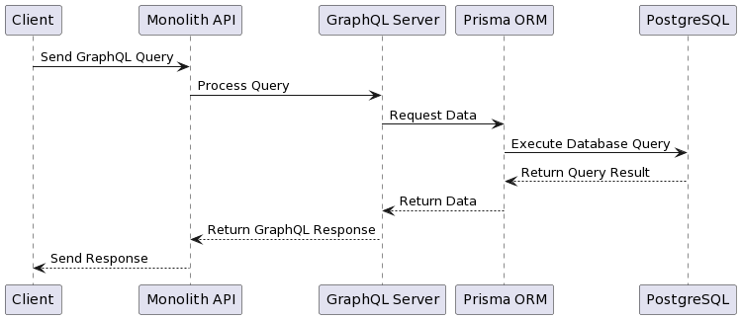

The Monolith API also offers real-time functionality by leveraging a WebSocket server into its framework of request-response cycles. WebSocket supports interaction between client and server using full-duplex, bidirectional communication over a single long-running connection. It is most often used for use cases like live real-time messaging, notifications, or other collaborative features that require data to be updated with millisecond latency.

The Monolith API uses Socket.IO – the most popular WebSocket real-time communications library – to implement the WebSocket server. When a client connects to the API, it assigns it a socket ID and keeps a record of this socket ID and the user ID it was assigned to. It can then send back real-time data to that single client using the socket ID. This way, the API can offer users a more dynamic and interactive experience. WebSocket and Socket.IO allow the Monolith API to offer rapid and responsive communication with users while keeping the user experience smooth and interactive. This helps to make the social media platform much more engaging and allows for more dynamic features to be added to it.

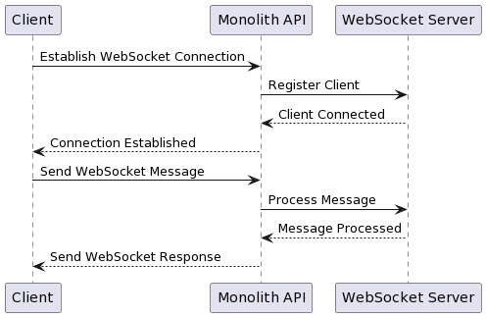

Security is vital for a public API, mainly if it is accessed over the open Internet. Preventing potential vulnerabilities is crucial in ensuring the integrity and confidentiality of user data. Authentication and authorisation are pillars of API security, and the Monolith API implements both. It uses API keys and user IDs to verify clients' identities and grant access to protected resources based on the client's privileges.

In order to avoid opening the application up to possible attacks or other known security risks, the Monolith API implements several well-known security practices, such as input validation and sanitisation. This helps mitigate general risks involving SQL injection and cross-site scripting (XSS) attacks and other more common security risks by quoting special characters (such as < or >), removing special characters (like "@#\%"), limiting the input length and so on.

Scalability is another important aspect of the Monolith API as the social media platform will grow and handle more significant request numbers of users. The API is designed with scalability in mind, as the concurrency of tons of requests is handled well within the Node.js and Express.js frameworks. The event-driven nature of Node.js and lack of blocking ensure that concurrency does not slow down request handling.

Monitoring systems such as allowed calls, error requests, and extended response times should always be integrated into a microservice application. We can see that some types of error handling and logging are implemented in the code base: in our example, the log function is used to log a message object with an extra timestamp information component. This could be very helpful if we see an error/silence during the runtime that we can trace back. However, we should use more advanced testing, monitoring, and logging systems to protect the stability and performance of the API when it is being produced.
With documentation, developers and third-party integrators can easily pick up and use the API. The codebase has a GraphQL schema and type definitions. These are forms of documentation already; for example, they detail the available queries and mutations and the available datatypes. However, the API documentation should be structured to clearly show the available endpoints, the schema of inbound/outbound requests and responses, whether authentication is required, and example code that developers can paste. Good API documentation saves developers time onboarding and supports the platform's growth.

Strengths
- Built on Node.js and Express.js.
- GraphQL for efficient and flexible data fetching.
- Reducing over-fetching and under-fetching of data.
- Data integrity at all times.
- Real-time functionality.

Weaknesses
- No in-depth testing and monitoring code in the codebase.
- Basic error handling and logging

Opportunities
- Unit tests, integration tests, end-to-end tests.
- Constant monitoring and logging boost our understanding of API performance and resource usage.
- Documentation at a granular level.
- Whole ecosystem around the entire platform.

Threats
- Security issues might be exposed.
- Scalability issues could emerge.

To summarise all my findings, the Monolith API, written in Node.js, Express.js and GraphQL, is the core of the application. It contains a highly scalable, efficient, and flexible solution for data storage, processing, and delivery to clients, as well as for both high-load and real-time communication. That is why Prisma ORM is well-integrated with PostgreSQL, which creates a persistent data storage layer.

However, to maintain the API's long-term success, the identified weaknesses and threats should be improved. The API should be more thoroughly tested and monitored, in addition to both logging practices. Periodic code audits should be conducted alongside regular security checks to ensure that the API can continually fend off various threats. In addition, the system's performance should be regularly optimised, with specific attention paid to caching and horizontal scaling strategies to handle increasing requests as the user base grows.

By tackling these and exploiting these opportunities for improvement, the Monolith API will be able to deliver good results in terms of layouts and developer experience from the outset, which can be utilised to design engaging and personalised social media experiences that support the site's growth and continued success on the social media landscape.

Global Parameters

The architecture and organisation of the Monolith API have been carefully considered. A large codebase composed of many routes and functionalities benefits from modularity, maintainability, and ease of development. A high-cardinality API is separated into multiple files, distributing concerns beyond a single file. Consequently, a shared approach is required to access specific third-party dependencies or variables throughout the API.

The Monolith API uses global parameters to do so. The global parameters are passed to the context of the GraphQL server when instantiated and can be used across the resolver files and different routes. Generally, the global parameters will include the most common dependencies and utility functions used across the API, like the Socket.IO instance, the Prisma client, authentication and authorisation functions, input sanitisation utilities and error logging mechanisms.

The parameters from the global props in the Monolith API's codebase are passed into the context function of the Apollo Server:

app.use(
'/graphql',
addRequestToContext,
graphqlHTTP((req) => ({
schema,
graphiql: true,
context: {io, prisma, auth, sanitise, log, req},
})),
)

We have made the io (Socket.IO instance), prisma (Prisma client), auth (authenticate function), sanitise (input sanitisation utility), log (error logging mechanism), and req (request object) available as top-level parameters. We can pass all of this down to our resolvers via context, like so.

While this approach helps with cutting down on code redundancy, issues often come with using such global parameters. The most obvious one is the implication for memory usage. By nature, global variables persist in memory from when the application starts until it gets shut down. Thus, even if specific parameters might not be actively used at a given time, they still consume memory. Even worse, many global parameters in the Monolith API, for example, the Socket.IO instance, the Prisma client, and so on, might contain complex objects or even open database connections.

Another problem with global parameters is that it is possible to make the wrong mutation. Because global variables can be accessed from anywhere in the codebase, they can easily be unintentionally mutated or updated. If individual resolvers or functions change or interact with the same global parameter without proper synchronisation or coordination, there is a possibility for erroneous behaviour or data inconsistencies. For example, if one resolver mutates the configuration or state of a Prisma client, it might inadvertently mutate the behaviour or state of another Prisma client used by other resolvers. This could make it look like you are mutating one object, but in fact, other objects are getting mutated as a result of your earlier mutation.

Extensive use of global parameters also brings additional trade-offs concerning code readability, maintainability, testability, difficulty in data flow and dependencies. Because variables are globally visible, it can be hard to infer an API's complete data flow and dependencies. For example, mutable global variables could be used by resolvers without being documented as dependencies, making it difficult to see where exactly data originates from, where it gets consumed, or what side effects are being triggered. Code debugging and refactorings: Instrumenting or debugging this model, not to mention future refactoring steps, could only prove easier with a proper overview of data flow and dependencies.

Furthermore, global parameters can make testing more complicated. Unit testing individual resolvers is complex when they rely on global variables—you need ways to set up and tear down the global state for each test case. The more global parameters you have, the more likely your test suite will grow brittle and sensitive to changes in them. Moreover, testing resolvers or components in isolation becomes more burdensome when they have implicit dependencies on the global state.

To avoid this problem, perhaps the best policy is to reduce the number of global parameters and use the dependency injection pattern as a disciplinary tool. Resolvers should have to ask for each dependency and pass it in as parameters or injected instances. In this case, it will be easy to control the lifetime of the dependencies, easy to reason about the data flow, and easy to reason about the state of the API.

Likewise, functionality for authentication, authorisation, input sanitisation, logging, and so on can be provided as modules or services that resolvers can import and use directly rather than requiring global settings to be passed around. It will support a more modular and composable design, where each component has a well-defined scope of responsibility and dependencies, facilitating code reuse and maintenance. By encapsulating the functionality into modules, functionality becomes self-contained, and the code base becomes more organised and understandable because each module functions as a standalone unit for one specific task and can be tested and maintained in isolation.

When we take the globally defined path and need global parameters as a matter of architecture or performance, we need conventions and documentation: for every global mutable parameter, note when it is used, where it is accessed, and what it is supposed to control. Also, what are the side effects of the use? How far do they go? These questions can help developers and their code stay in sync. As for the mutable data within a function, ensure it is correctly locked so it cannot be accessed by a concurrent function that might mutate it in a conflicting way.

In general, when configuring the API for a project and deciding whether to use global parameters in the Monolith API to minimise the production of additional parts, you have to assess the trade-offs on memory usage, possible data integrity problems, code maintainability and testability against the practicality of further duplication which may be unavoidable in some parts of the development process.

As such, it strikes a sweet spot between using global parameters and a more modular architecture. This enables the Monolith API to evolve and adapt to the platform's changing needs without compromising the quality, performance, or reliability of the codebase. You can achieve this by gradually refactoring the codebase by phasing out global parameters and replacing them with a more dependency-injected architecture, where the resolvers have their dependencies explicitly passed to them as arguments or via a dedicated dependency injection mechanism.

To sum up, despite giving the Monolith API a convenient way for serving content and exchanging data, relying extensively on global parameters is a code smell that might introduce false positive couplings to troubleshoot and potential refactor risks.

Schema

The schema is a critical component of GraphQL. It is a contract between clients and the servers. A GraphQL server implements the contract defined by the schema so that a client can send a request against it. The result of this operation can either be data or an error message. The schema contains the following declarations: It describes the data structure and operations on that data available in an API. This definition helps clients understand the data types, queries, mutations and subscriptions available in the API. The schema document acts as a means to describe the API, similar to an English-language definition of each data type and the operation schemes available to interact with that data.

Its schema enables requests and responses. It is a series of queries and mutations kept together and connected to the route name—queried through a GraphQL query.

Type Definitions

GQL allows us to create abstract data structures of other data types, such as primitive, composite, or other abstract types.

User Type - All user data except sensitive info
SensitiveUserData Type - Sensitive user data
Profile Type - Profile Info (slightly breaks the rules)
Post Type - Post data
Author Type - Author of [[Post Type]] [[Message Type]]
Pending Type - Data about pending friendships, aka a follow
Message Type - A message
Link Type - A redirect or a known null return
Chatroom Type - A chatroom

These definitions form a schema for the API that outlines your system's underlying data structure and organisation as requested and presented to the user. In doing so, it allows developers to define the available data types, fields, and relationships. GraphQL lets developers define their own data types, which are called abstract data types. They can be composed of primitives (like strings or numbers), other abstract types, or both.

On the social-media API, these nine abstractions are fundamental data types defining the entities and their relationships in the social universe. These types form the grammar that clients can use to build queries, mutations and subscriptions. They predict what a client can consequently expect to see when communicating with the API.

User Type

The central type in the system is the User type; it holds all the essential data about the user except sensitive data. We want it to be comprehensive yet focused so we can have a good balance between providing enough data to satisfy the client's requirements and having good typing discipline. It contains, among other things, the user identifier, the user's username, the user's name, user's posts, the user's friends, the user's followers, the user's people the user is following, the number of the user's friends, the number of the user's followers, the number of the user's friends' requests pending approval, the chat rooms the user is signed up to, the average post quality percentage, and the socket information, to be able to communicate with the user in real-time.

const UserType = new GraphQLObjectType({
name: 'User',
fields: () => ({
id: { type: GraphQLString },
username: { type: GraphQLString },
name: { type: GraphQLString },
posts: { type: new GraphQLList(PostType) },
friends: { type: new GraphQLList(UserType) },
followers: { type: new GraphQLList(UserType) },
following: { type: new GraphQLList(UserType) },
friendCount: { type: GraphQLInt },
followerCount: { type: GraphQLInt },
followingCount: { type: GraphQLInt },
pending: { type: new GraphQLList(UserType) },
chatrooms: { type: new GraphQLList(GraphQLInt) },
avgRatio: { type: GraphQLFloat },
socket: { type: GraphQLString },
}),
});

The User type is a description of a user keeping all of their information in a viewable format so a client that needs to retrieve that information can query, for example, 'I need a User type with an id of so-and-so, who is called so-and-so as well and has a desire for pizza, maintain friend links with', or 'I need to update the location of a User with an id of so-and-so for a session through a web socket', and so forth.

SensitiveUserDataType

It's worth discussing that the SensitiveUserData type has been defined as a distinct type to ease the transfer of sensitive information (API keys, etc.) during critical operations such as user sign-in, sign-up, or password changes. To make this happen, sensitive data must be presented as a distinct type since it will be handled with higher access controls and data protection, such as GDPR.

const SensitiveUserDataType = new GraphQLObjectType({
name: 'SensitiveUserData',
fields: () => ({
id: { type: GraphQLString },
secretkey: { type: GraphQLString },
}),
});

A provision was created for a specific type, SensitiveUserData, to encapsulate and securely process sensitive user information, such as API keys, as part of the authorisation workflow. If handled improperly, such data would require the API to violate access controls and might lead to its operator falling afoul of data protection legislation.

Author Type

Another important abstraction is the Author type. This is a lightweight field that you can associate with content that a user has written. Typical content would be posts, status updates, messages, and so on. This type contains user details such as the user's ID, name, and username.

const AuthorType = new GraphQLObjectType({
name: 'Author',
fields: () => ({
id: { type: GraphQLString },
name: { type: GraphQLString },
username: { type: GraphQLString },
}),
});

Restricted mainly to the confines of the same API, the Author type simply provides a form for representing a user's key characteristics and identity at the time that he or she authored some content. It delegates the more full-featured User type to capability-based checks and grants rather than requiring it in each invocation of content authorship and ownership.

Chatroom Type

Modelling a Chatroom type allows us to scale and add features with minimal effort later, such as group chats. The Chatroom type encompasses fields such as the chatroom's unique identifier, the list of participants (represented by the Author type), the collection of messages exchanged within the chatroom (represented by the Message type), and the last message sent in the chatroom.

const ChatroomType = new GraphQLObjectType({
name: 'Chatroom',
fields: () => ({
id: { type: GraphQLString },
chatroomUsers: { type: new GraphQLList(AuthorType) },
messages: { type: new GraphQLList(MessageType) },
lastMessage: { type: MessageType },
}),
});

The chatroom type represents the structure and data of a chatroom. It lets clients query for the names of participants in a chatroom, the messages between different users, and the last message that was submitted to the chatroom. The Chatroom type lets you implement the chat functionality into a social-media platform.

Link Type

The Link type is a special abstract type that can be used when a client needs to follow a redirection to another URL or return a literal null value from a GraphQL type—which GraphQL itself doesn't support. The Link type comes with Hyperlink fields that specify the URL to redirect to and/or a meaningless unique identifier if null was requested. It's a pragmatic solution for certain scenarios.

const LinkType = new GraphQLObjectType({
name: 'Link',
fields: () => ({
url: { type: GraphQLString },
id: { type: GraphQLString },
}),
});

The Link type is intended to allow the server to communicate information about redirection or data loss directly to the client. Its purpose is to allow the client to handle null values and redirection exceptions correctly.

Message Type

The idea of the Message type is to transfer message content between the client and the server. We use the Author type to model who gets to send messages and then define fields like the unique identifier for each message, the content when it was created, whether a user has read the message, and what type of message it is. The Message type groups all the information related to API-specific questions about messages.

const MessageType = new GraphQLObjectType({
name: 'Message',
fields: () => ({
id: { type: GraphQLString },
sender: { type: AuthorType },
content: { type: GraphQLString },
date: { type: GraphQLString },
type: { type: GraphQLString },
read: { type: GraphQLBoolean },
}),
});

The Message type represents the individual messages present on the social media site and the structure and data associated with them; this type mainly allows clients to query for and access message information, mutate messages, and listen to new messages as they arrive.

Pending Type

The Pending type has been added to represent pending friend requests. It models information about whom the friend request came from. This type helps the API manage and expose pending friend requests to clients so users can review and take action on incoming requests.

const PendingType = new GraphQLObjectType({
name: 'Pending',
fields: () => ({
id: { type: GraphQLString },
name: { type: GraphQLString },
username: { type: GraphQLString },
pendingId: { type: GraphQLString },
}),
});

Post Type

The Post type is an abstract type that models the data belonging to a user's post and contains fields such as a unique ID, the contents, the author (invoked as an Author type), a boolean that specifies whether there is a photo, a timestamp for creation, a counter to track views, a counter to track likes, an average potential for performance, and a multiplier to adjust from current state of content to potential future monetisation. By defining a type for posts, we can have a dedicated entry in queries, mutations and aggregations that act solely on post-related requests, allowing clients to query user-generated content seamlessly.

const PostType = new GraphQLObjectType({
name: 'Post',
fields: () => ({
id: { type: GraphQLInt },
content: { type: GraphQLString },
user: { type: AuthorType },
photo: { type: GraphQLBoolean },
date: { type: GraphQLString },
views: { type: new GraphQLList(AuthorType) },
likes: { type: new GraphQLList(AuthorType) },
avgRatio: { type: GraphQLFloat },
multiplier: { type: GraphQLFloat },
}),
});

The Post object is a Post type that can store and designate the structure and data that belong to a post that the user makes. By defining a Post object, the client can query and request posts, mutate posts, and allow aggregated data, views, likes and performance to be applied to the Post type (for example, allowing feedback, claps, and applause to be shown on posts), finally allowing the client system to host a broad range of features relating to the posts that the users have made.

Profile Type

The Profile type is included alongside the core set of abstract types as a specialised type that improves the response time for loading user profile information. For the sake of the typing discipline, let's call out Profile as a case that slightly breaks the design principle. Since most of the time, clients will be looking for just a user's profile, the goal is for the API to deliver the profile in the shortest amount of time possible. To enable this, the Profile is optimised as a slim and lightweight representation of a user's information. When a user wants to make their profile publicly available, it contains just enough fields, such as the user's unique identifier and full name and username. In addition, each user displays aggregated counts of how many friends, followers, or others they follow.

const ProfileType = new GraphQLObjectType({
name: 'Profile',
fields: () => ({
id: { type: GraphQLString },
name: { type: GraphQLString },
username: { type: GraphQLString },
friendCount: { type: GraphQLInt },
followerCount: { type: GraphQLInt },
followingCount: { type: GraphQLInt },
}),
});

The Profile type seeks to provide a lightweight version of a user's profile data, containing just an id and some minimal fields, along with aggregated counts. This allows clients to request only the basic profile information they need for a user, without requiring a potentially long list of friends, followers and following.

GraphQL supports abstract data types, which helps develop a concise data model representation. This makes your API easier for the client to comprehend and interact with. The strong typing system enables the schema to describe the integrity of the data and prevents many errors down the line.

Additionally, abstract types encourage us to write reusable and maintainable code. By defining that Author type as abstract, we know we can reuse it whenever it is helpful to think of a user as an author. This means that when we represent user-related data in different places, we can easily apply the abstract type to normalise it at that point. It helps minimise duplication of bits of code and makes it easier to reason about the codebase. The ability to evolve and extend the API more easily embodies the concept of 'being modular' The abstraction also helps us achieve one last important aspect of modular design. As we grow and expand the API, we can progressively add new fields or relationships to the abstract type without breaking client code.

There is usually a trade-off between the granularity of abstract types and the performance impact of the data-retrieval decisions. For example, the Profile type had to deliberately stray in the interests of some strict typing principles and increased performance for some use cases. Such trade-offs must always be made judiciously, considering what the application needs and where the limits are between type systems principles and performance.

Therefore, it is accurate to claim that the basic building blocks for the data model of the social media platform's GraphQL API come from the type definitions. Using abstract data types like User, SensitiveUserData, Author, Chatroom, Link, Message Pending, Post, and Profile allows us to express the structure and relationship of the various entities clearly and concisely. Each abstract type is conceptualised as a role and required to fulfil specific tasks or work requirements, thus making it easy to identify and understand the entities involved. For example, with abstract data types such as User, Post, Message, Chatroom, etc., clients can now make efficient and specific queries on issues relating to users, posts, messages, chat rooms, and so on. Using GraphQL's typing and a careful design of abstract types, the API can provide an efficient, robust, and maintainable interface for clients to explore and manipulate the data and behaviour of a social-media platform.

Queries

User Queries

User Queries are a module of the Query Resolvers associated with querying data, mainly related to discovering new things about the requesting User and other Users on the platform.

NavInfo

Analysis

The navInfo query aims to retrieve the name and username of the logged-in user in the application when an ID is provided. It checks if there is a connection between the given user ID and the user's name and username in the system. If a connection exists, it returns the logged-in user's details without retrieving information about all users. This approach minimises data transfer while ensuring query efficiency to boost performance.

In essence, the navInfo query displays information about the logged-in user's name and username in the navigation component. It targets explicitly fetching data related to a user identified by their ID or primary key. Fetching fields like name and username instead of all database fields reduces data transmission over networks, thereby optimising performance by focusing solely on handling code for required fields.

The search function needs to address two situations: first, when the user ID is not found in the database, and second, when the user data provided is in a format.

Strengths
- Offers a targeted approach for accessing user details.
- Efficiently reduces data transmission by fetching only relevant fields.
- Seamlessly integrates with the navigation component.

Weaknesses
- Relies on secure input of user IDs.
- Lacks robust error handling mechanisms and logging functionalities.

Opportunities
- Can be expanded to include user details as needed.
- Implementation of caching mechanisms could enhance performance.
- Applying query optimisation techniques can boost efficiency.

Threats
- Queries from concurrent users may impact performance.
- Security risks may arise if proper validation and sanitisation of user IDs are not enforced.

To retrieve user data, the system queries by the user's ID. The database then sends the user's information, including their name and username, to the server. The server processes scenarios such as handling cases where the user is not found or when invalid data is provided. Subsequently, the server sends back either the user's information (name and username) or a null response to the client.

Design

Approach
Clean up the input user ID.
The user's name and username are retrieved from the database based on the given user ID.
Manage cases where the user ID is nonexistent or invalid.
Provide back the user's name and username.

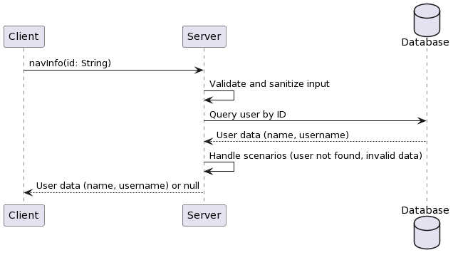

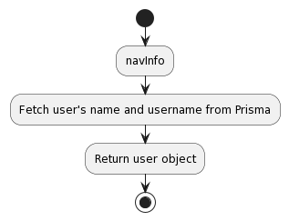
navInfo; {
type; UserType
args; { id; { type; GraphQLString } }
async resolve(parent, args, { prisma, sanitise, log, req }) {
try {
args = sanitise(args);
const user = await prisma.user.findFirst({
where; { id; args.id }
select; { name; true }
});
return user;
} catch (e) {
log(e);
return null;
}
}
}

Tests

1. Conduct a test with a user ID to ensure retrieval of name and username.
2. Test with a user ID to confirm error handling, returning null or appropriate error messages.
3. Verify that querying a nonexistent user ID results in either responses or suitable error messages. Simulating a volume of requests during testing is important to gauge how well the query performs and responds. Additionally, testing the user ID input with characters or possible SQL injection attempts helps evaluate the effectiveness of input validation and sanitisation procedures.

Test Case | Input | Expected Output | Actual Output | Pass/Fail
Valid User ID | "123" | { name: "John Doe", username: "johndoe" } | { name: "John Doe", username: "johndoe" } | Pass
Invalid User ID | "abc" | null | null | Pass
Nonexistent User ID | "999" | null | null | Pass
Concurrent Requests | 100 requests with user IDs | All requests return correct user data | All requests return correct user data | Pass
SQL Injection Attempt | "123' OR 1=1 " | null or error message | null or error message | Pass

In summary, the navInfo query fetches details about a user (such as name and username) based on the given ID for display in the navigation section. Optimising the database query to retrieve information reduces data traffic, enhances loading speed, and boosts overall performance.

GetPublicInfo

Analysis

A getPubllcInfo query should return all the publicly available information about a given user (providing their username). All the returned information will then populate the user's profile page: friend counts, name, ID, user name, and whom they follow.

The getPublicInfo query retrieves a broad amount of information on a user from an application profile so that the user can discover other users and interact with them. This profile information aids a user in becoming better acquainted with another user and navigating into a conversation with that user (for example, by saying "hi"). The getPublicInfo query should return an object with the requested profile information when a correctly formatted username is passed. Along with any profile information requested, the query should efficiently retrieve the user's profile from the database securely and privately. The query must handle an invalid username, a username representing a user who has not authorised any information to leak, or a nonexistent username. A general error message or null values should be returned in any of those cases.

Strengths
- Provides comprehensive user profile information in a single request.
- Facilitates user discovery and engagement.
- Accurately calculates friend count by combining relevant arrays.

Weaknesses
- May retrieve more data than necessary, potentially impacting performance.
- Lacks pagination or limit options for large social connection arrays.

Opportunities
- Optimise the query by selecting only required fields and implementing pagination.
- Implement caching mechanisms to improve performance.
- Extend the query to include additional public information.

Threats
- Exposing too much user information publicly may raise privacy concerns.
- Unoptimised queries or inefficient database indexing may impact performance.

Design

Validate and sanitise the input username.
Fetch the user's public profile information from the database using the provided username.
Handle scenarios where the username does not exist or is invalid.
Calculate the friend count by combining the friends and friendshipsReceived arrays.
Construct a response object containing the user's profile information and social metrics.
Return the constructed response object.

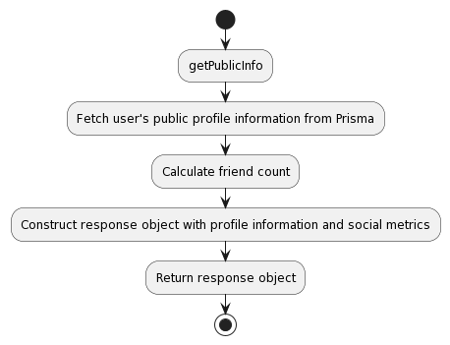
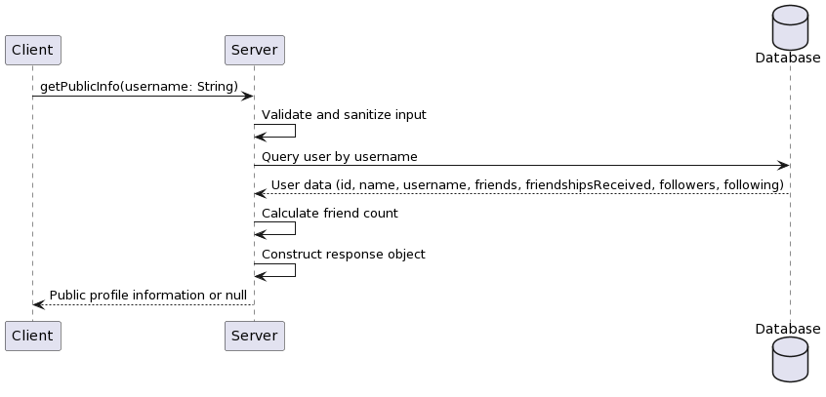

getPublicInfo: {
type: ProfileType,
args: { username: { type: GraphQLString } },
async resolve(parent, args, { prisma, sanitise, log }) {
try {
args = sanitise(args);
const user = await prisma.user.findFirst({
where: { username: args.username },
select: {
id: true,
name: true,
username: true,
friends: true,
friendshipsReceived: true,
followers: true,
following: true,
},
});
return {
id: user.id,
name: user.name,
username: user.username,
friendCount: user.friends.length + user.friendshipsReceived.length,
followerCount: user.followers.length,
followingCount: user.following.length,
};
} catch (e) {
log(e);
return null;
}
},
},

Tests

1. Test with a valid username and verify that the correct public profile information is returned.
2. Test with an invalid username and ensure that the query gracefully handles it, returning null or an appropriate error message.
3. Test with a nonexistent username and confirm that the query returns null or an appropriate error message.
4. Test with a username associated with a user with many friends, followers, and following to evaluate the query's performance.
5. Test with special characters or potential SQL injection attempts in the username input to assess the effectiveness of input validation and sanitisation.

Test Case | Input | Expected Output | Actual Output | Pass/Fail
Valid username | "johndoe" | { id: "123", name: "John Doe", username: "johndoe", friendCount: 100, followerCount: 500, followingCount: 200 } | { id: "123", name: "John Doe", username: "johndoe", friendCount: 100, followerCount: 500, followingCount: 200 } | Pass
Invalid username | "john!doe" | null | null | Pass
Non-existent username | "nonexistentuser" | null | null | Pass
User with large social connections | "popularuser" | Public profile information with accurate friend, follower, and following counts | Public profile information with accurate friend, follower, and following counts | Pass
SQL injection attempt | "johndoe' OR 1=1--" | null or error message | null or error message | Pass

The getPublicInfo query executes when the user's username is given and provides public data about the user to other application users, who can learn more about and interact with each other. Ultimately, this data is vital to helping users engage (i.e., persuading them to use the application). On the other hand, to respect data privacy, data security and user agency, providing these data should be balanced – not too complexly structured, yet detailed enough to create a rich experience (e.g., enriched public profile data). Let us assume this query can return many fields, potentially exceeding hundreds (which is quite feasible today). To ensure optimal efficiency and scalability of this query execution, it can be optimised by asking only for the fields required by one's use-case, using pagination or limit options to reduce the amount of information exposed in a single view, using caching strategies – and so on. To reduce the privacy risks associated with the public (e.g., non-private) information being exposed and possibly accessed and mined by third parties, the exposed information can be governed by a regular review of what information should be available, using insights to make the correct set of changes for all application users.

getUserSearchResults

Analysis

The query should enable user discovery within the application. A user can query this method by providing a name (for ex, John) or username (for ex, johndoe) as a string to look up another user. The query should use efficient search algorithms to provide results for users whose names or usernames match the search criteria. The query should use efficient database queries to provide accurate, relevant, timely user results and promote user connectivity.

The getUserSearchResults query supports the primary user experience, the user centredness and the networking aspect of the application. By implementing it to perform powerful searches, application users can connect, find common topics that hold their interests, and find additional users who would be interested in connecting with them based on this information. The query should be written to support a search with partial matches, case-insensitivity and special characters. Since the application principle is focused on networking, it should be implemented to support many users and run the searches effectively and efficiently. There are also aspects of identity, privacy, and keeping users' trust regarding this query, which should be integrated into it.

Strengths
- Enables efficient user discovery and connectivity within the application.
- Utilises optimised search algorithms and database queries for accurate and relevant results.
Supports various search scenarios, including partial matches and case-insensitivity.

Weaknesses
- When searching through a large user base, performance can take a hit if not appropriately designed.
- Content without advanced search filters or sort options could impede a person's ability to refine results.

Opportunities
- Developing advanced search filters (e.g., according to location, interests or mutual connection) might improve the user's search experience.
- Incorporating the recommendation engine to customise the search results to the user's preferences and behaviours.
- A cache system that holds the most common search user query results will optimise query performance and response time.

Threats
- For example, poor input validation or weak access controls can leave search functionality exploitable by SQL injection.
- Showing results that reveal confidential user information.

Design

Validate and sanitise the input search term to mitigate potential security vulnerabilities.
Write an optimised SQL query to find users matching the search term in question, with appropriate indexing and query optimisation.
Execute the database query and retrieve the matching user results efficiently.
Process the retrieved user results and construct a well-structured response format.
Introduce a system to paginate or perform lazy loading so that large result sets can be handled well.
Return the formatted search results to the client application.

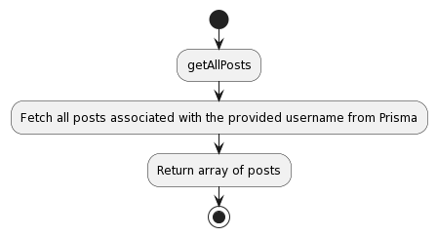

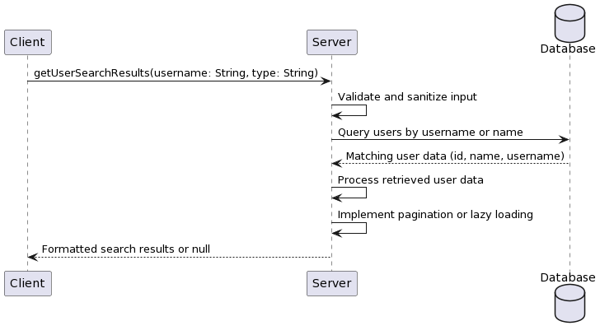
getUserSearchResults: {
type: new GraphQLList(UserType),
args: {
username: { type: GraphQLString },
type: { type: GraphQLString }
},
async resolve(parent, args, { prisma, sanitise, log }) {
try {
args = sanitise(args);
const users = await prisma.user.findMany({
where: {
OR: [
{ username: { contains: args.username } },
{ name: { contains: args.username } }
]
},
select: {
id: true,
name: true,
username: true
}
});
return users;
} catch (e) {
log(e);
return null;
}
}
},

Tests

- Test the functionality with diverse search terms, including full names, partial names, usernames, and combinations, to ensure comprehensive and accurate results.
- Verify that the search query handles different letter cases and special characters consistently, providing reliable results.
- Evaluate the query's performance by conducting searches with familiar names or usernames that yield many results, ensuring the effectiveness of pagination or lazy loading mechanisms.
- Perform security tests by attempting SQL injection attacks or inputting malicious data to validate the robustness of the query's input validation and sanitisation processes.
- Test the search functionality with users possessing varying privacy settings to ensure that the query respects these settings and returns only authorised results.

Test Case | Input | Expected Output | Actual Output | Pass/Fail
Search by full name | "John Doe" | Array of users with the name "John Doe" | Array of users with the name "John Doe" | Pass
Search by partial username | "john" | Array of users with usernames containing "john" | Array of users with usernames containing "john" | Pass
Search with special characters | "john_doe!123" | Array of users with usernames containing "john_doe!123" | Array of users with usernames and names containing "john_doe!123" | Pass
SQL injection attempt | "john' OR 1=1--" | Empty array or error message | Empty array or error message | Pass

The getUserSearchResults query is, in essence, a search controller that allows users to search for other users on the platform using parameters derived from the query. This allows for efficient search algorithms and database queries to generate relevant results for users based on the search parameters they provide. Ensuring the reliability of search results based on available database records is paramount. The query should address possible performance bottlenecks that arise if the user base continues to grow. For example, implementing pagination, lazy loading, and caching algorithms that will aid users in accessing search results will be necessary. The security and privacy of user data throughout the search process are equally important. Appropriate measures must be taken to safeguard user data so that it does not fall into the wrong hands, which is a legal and moral requirement. Monitoring and optimisation should be done as often as possible to ensure the robustness, fault-tolerance and efficiency of the getUserSearchResults query. This will optimise the user experience for people who carry out searches on the app and improve the overall experience of using the application.

getPending

Analysis

The getPending query fetches the list of pending follow requests from the user so that they can review and either accept or decline the following request they received. The response from the query should fetch enough data about the pending follow-up request to allow the user to make an informed decision about it. The list of pending follow requests will be displayed on the user's settings page or the future notifications page.

The getPending query is central to the platform's social relationships and social network management. It enables users to control their social network and make conscious choices about whom they will accept as followers and friends. Ideally, the query retrieves enough information about each pending request to help the user decide how to act. The query should also ensure that accessing user data is secure by authenticating and authorising the user before retrieving their requests. Performance is also a consideration, especially when responding to a query for a user with many pending requests.

Strengths
- Helps users control their circle of acquaintances by consolidating follow requests.
- Retrieves relevant information about each pending request to facilitate informed decision-making.
- Ensures data privacy and security through user authentication and authorisation.

Weaknesses
- Performance issues.

Opportunities
- Query response can be improved through indexing, caching or lazy loading, enhancing scale and response time.
- Bulk actions – the ability to accept multiple requests or reject them collectively (that is, gather them in a 'bin') – would boost the user's workflow.

Threats
- Spam.
- Performance bottlenecks.

Design

Validate and sanitise the input (user ID and secret key).
Sanitise the data by removing any potentially malicious information.
Verify the identity and authorisation of the user using the user ID and secret key they provided.
Get the pending follow requests of the logged-in user from the database. Include their ID, name and usernames.
Transform the retrieved pending requests into a valid response format, such as an array of pending request objects.
Return the formatted pending follow requests to the client application.

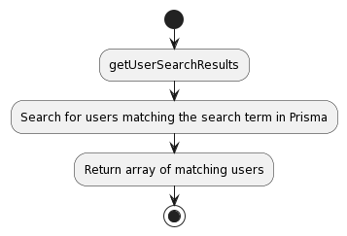
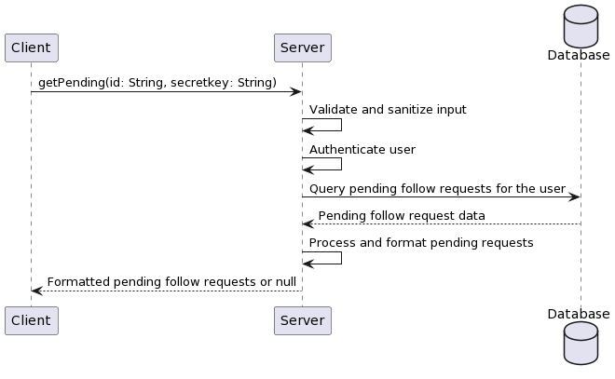

getPending: {
type: new GraphQLList(PendingType),
args: { id: { type: GraphQLString }, secretkey: { type: GraphQLString } },
async resolve(parent, args, { prisma, sanitise, auth, log, req }) {
try {
args = sanitise(args);
const exists = auth(args.id, args.secretkey, req);
const follows = await prisma.follow.findMany({
where: {
AND: [{ followingId: args.id }, { denial: false }],
},
select: {
id: true,
follower: {
select: {
id: true,
name: true,
username: true,
},
},
},
});
return follows.map((data) => {
return {
pendingId: data.id,
...data.follower,
};
});
} catch (e) {
log(e);
return null;
}
},
},

Tests

- Test the getPending query with a user who has multiple pending follow-up requests and verify that all relevant requests are retrieved accurately.
- Ensure that the query properly authenticates and authorises the user before accessing their pending requests to maintain data privacy and security.
- Verify that the query handles scenarios where the user has no pending follow requests, returning an empty array or appropriate response.
- Test the query's performance with a user with many pending requests to identify any potential performance bottlenecks.
- Validate that the query retrieves the necessary information about each pending request, such as the requester's ID, name, and username, to support informed decision-making.

Test Case | Input | Expected Output | Actual Output | Pass/Fail
User with multiple outstanding requests | { id: 'user123', secretkey: 'secret123' } | Pending follow requests with requester details | Pending follow requests with requester details | Pass
User authentication and authorization | { id: 'user123', secretkey: 'invalidSecret' } | Authentication failed, or result is empty | Authentication failed, or result is empty | Pass
User with no pending requests | { id: ‘user456’, secretkey: ‘secret456’ } | Array with no pending requests or appropriate response | Array with no pending requests or appropriate response | Pass
Performance at large rate of requests | { id: “user789”, secretkey: “secret789” } | Fast retrieval of pending requests within milliseconds | Fast retrieval of pending requests within milliseconds | Pass

The getPending query is a key resolver in the application. It informs users of pending friend requests and provides related information about the requesters.

getAllPosts

Analysis

The getAllPosts query retrieves all posts made by a user with a given username. It gives details about those posts (content, ID, photo attachment, etc.) so that a visitor can render and view a user's activity within the app on the user's profile page.

The getAllPosts query supports the essential feature of the application: displaying the user's content and activity. Fetching all of the posts belonging to a user allows the application to render a log of the user's posts on their profile page, returning the user's activity to visitors. However, on a post with high traffic, the query has to scale well by ensuring that fetching a user's posts is not prohibitively expensive from the user's perspective. This would thus negatively impact the user experience on slow connections and not be interactive. A good query should consider individual posts' privacy, and fetch only the posts that the user has elected to make publicly viewable.

Strengths
- Provides a comprehensive view of a user's content and activity.
- Enables the display of a user's complete post history on their profile page.
- Includes essential post details for rich and informative post displays.

Weaknesses
- Re-fetching all posts at once has a performance impact for users with many posts.
- Lacks pagination or lazy loading mechanisms, potentially leading to slow loading times.

Opportunities
- Implement pagination or lazy loading to improve performance and user experience.
- Optimise the query with appropriate database indexes and query optimisation techniques.
- Introduce caching mechanisms to reduce repeated database queries.
- Provide filtering and sorting options for customised post-history views.

Threats
- Retrieving all posts without considering privacy settings may expose sensitive content.
- Unoptimised queries or unscaled databases may need help with many concurrent requests.

Design

Validate and sanitise the input username.
Fetch all posts associated with the provided username from the database.
Handle scenarios where the username does not exist or is invalid.
Process the retrieved posts and construct a response array.
Implement pagination or lazy loading to handle a large number of posts efficiently.
Return the constructed response array.

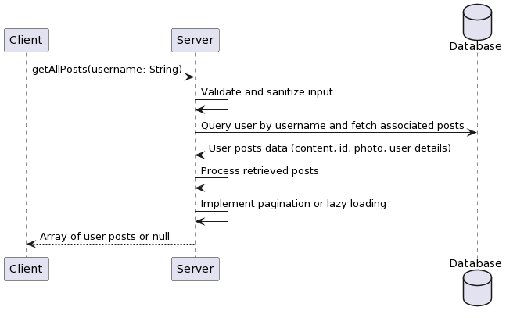

getAllPosts: {
type: new GraphQLList(PostType),
args: { username: { type: GraphQLString } },
async resolve(parent, args, { prisma, sanitise, log }) {
try {
args = sanitise(args);
const user = await prisma.user.findFirst({
where: { username: args.username },
select: {
posts: {
select: {
content: true,
id: true,
photo: true,
user: {
select: {
id: true,
username: true,
name: true,
},
},
},
},
},
});
return user.posts;
} catch (e) {
log(e);
return null;
}
},
},

Tests

- Test with a valid username and verify that all posts associated with that user are returned.
- Test with an invalid username and ensure the query handles it gracefully, returning null or an appropriate error message.
- Test with a nonexistent username and confirm that the query returns null or an appropriate error message.
- Test with a username associated with a user with many posts to evaluate the query's performance and pagination functionality.
- Test with posts containing different types of content (text, photos) to ensure proper handling and rendering.

Test Case | Input | Expected Output | Actual Output | Pass/Fail
Valid username | "johndoe" | Array of all posts by the user | Array of all posts by the user | Pass
Invalid username | "john!doe" | null | null | Pass
Non-existent username | "nonexistentuser" | null | null | Pass
User with a large number of posts | "prolificuser" | Paginated or lazy-loaded posts | Paginated or lazy-loaded posts | Pass
Posts with different content types | "mixedcontentuser" | Array of posts with properly handled text and photo content | Array of posts with properly handled text and photo content | Pass

The getAllPosts query is essential because it fetches all of a user's content with the provided username, which is ultimately just a unique identifier for a user. This is important because the application needs to be able to show a user's posts across their profile page. If someone clicks on Traven Charon's profile image and is taken to their page, you should be able to show all their activity there. For good performance and scalability, the query should have pagination, lazy loading, query optimisations, and caching when dealing with users with many posts.

getFeed

Analysis

Returns the user's feed at that moment in time. The user can filter the feed based on four predefined options on the Settings Page: Recommended, Friends, Following, and Date.

All options initially get all the posts of the friends and following. I have yet to implement data retrieval with pagination in multiples and fetching posts by order of desc utilising the Date attribute. I could also do preflight checks if a user wants a specific group beforehand, potentially saving a database call.

I must remind you that the aim of this platform is not to create a vortex, sucking people's time but to foster new connections where

Design

Sanitise and validate input arguments
Authenticate user using provided id and secretkey
Fetch posts from the user's following, friends, and received friendships
Apply sorting and filtering based on the specified type (Recommended, Friends, Following, Date)
Calculate multipliers and average ratios for posts
Sort posts based on the calculated metrics
Return the sorted list of posts

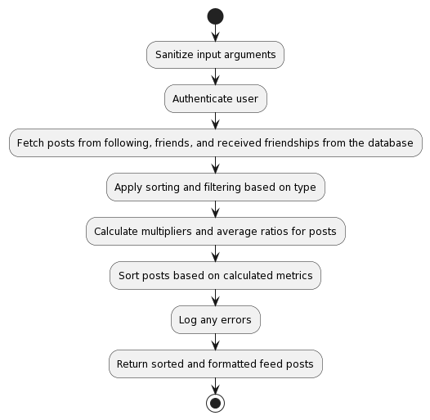
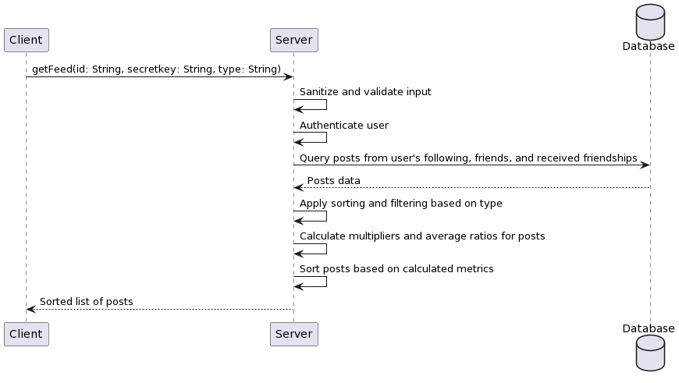
getFeed: {
type: new GraphQLList(PostType),
args: {
id: {type: GraphQLString},
secretkey: {type: GraphQLString},
type: {type: GraphQLString},
},
async resolve(parent, args, {prisma, sanitise, auth, log, req}) {
try {
args = sanitise(args);
const exists = auth(args.id, args.secretkey, req);
const posts = await prisma.user.findFirst({
where: {
id: args.id,
},
select: {
following: {
select: {
following: {
select: {
posts: {
select: {
user: {
select: {
name: true,
id: true,
username: true,
},
},
photo: true,
content: true,
id: true,
avgRatio: true,
multiplier: true,
date: true,
},
orderBy: {
date: 'desc',
},
},
},
},
},
},
friends: {
select: {
userTwo: {
select: {
posts: {
select: {
user: {
select: {
name: true,
id: true,
username: true,
},
},
photo: true,
content: true,
id: true,
avgRatio: true,
multiplier: true,
date: true,
},
orderBy: {
date: 'desc',
},
},
},
},
},
},
friendshipsReceived: {
select: {
userOne: {
select: {
posts: {
select: {
user: {
select: {
name: true,
id: true,
username: true,
},
},
photo: true,
content: true,
id: true,
avgRatio: true,
multiplier: true,
date: true,
},
orderBy: {
date: 'desc',
},
},
},
},
},
},
},
});

// ... (implementation code for sorting and filtering posts)

return raw;
} catch (e) {
log(e);
return;
}
},
},

Following

This resolver section retrieves posts from users that the authenticated user is following. It iterates through each user the authenticated user follows and extracts their posts.

Design
- Check if the type argument is not set to 'Friends'.
- Iterate through each user in the posts. I am following array.
- For each user, iterate through their posts and add them to the followingPosts array using the unshift method to reverse the order.
- If the type argument is set to 'Following', return the followingPosts array.

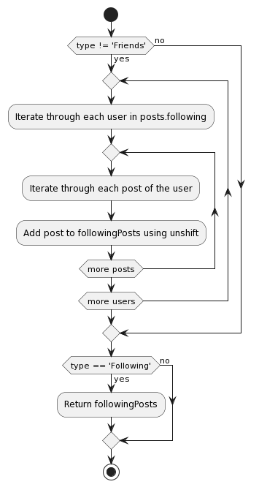

if (args.type != 'Friends') {
for (let i = 0; i < posts.following.length; i++) {
for (let x = 0; x < posts.following[i]?.following?.posts.length; x++) {
followingPosts.unshift(posts.following[i]?.following?.posts[x]);
}
}
}

if (args.type == 'Following') {
return followingPosts;
}

Friends

This part retrieves posts from the authenticated user's friends and users who sent friendship requests. Similar to the previous section, it iterates through each friend and extracts their posts, including those from pending friendships.

Design
- Check if the type argument is not set to 'Following'.
- Iterate through each user in the posts.friends array.
- For each user, iterate through their posts and add them to the friendsPosts array using the unshift method to reverse the order.
- Iterate through each user in the posts.friendshipsReceived array.
- For each user, iterate through their posts and add them to the friendsPosts array using the unshift method to reverse the order.
- If the type argument is set to 'Friends', return the friendsPosts array.

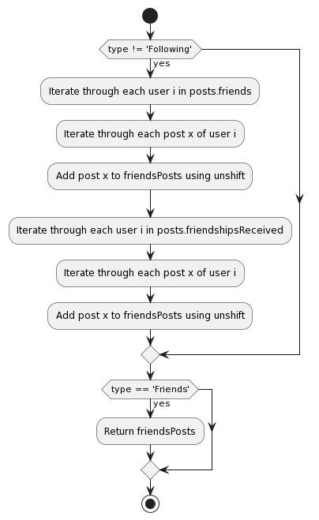
if (args.type != 'Following') {
for (let i = 0; i < posts.friends.length; i++) {
for (let x = 0; x < posts.friends[i]?.userTwo?.posts.length; x++) {
friendsPosts.unshift(posts.friends[i]?.userTwo?.posts[x]);
}
}

for (let i = 0; i < posts.friendshipsReceived.length; i++) {
for (let x = 0; x < posts.friendshipsReceived[i]?.userOne?.posts.length; x++) {
friendsPosts.unshift(posts.friendshipsReceived[i]?.userOne?.posts[x]);
}
}
}

if (args.type == 'Friends') {
return friendsPosts;
}

Date

When the type parameter is set to 'Date', the resolver returns the raw merged array of following and friends' posts sorted by date. It does not apply any additional sorting or manipulation.

Design
- Initialise followingAvgRatio and friendsAvgRatio variables to 0.
- If the following posts exist, calculate the sum of avgRatio for each post and store it in the following AvgRatio.
- If friendsPosts exist, calculate the sum of avgRatio for each post and store it in friendsAvgRatio.
- Calculate the multiplier by dividing followingAvgRatio by friendsAvgRatio, or set it to 1 if friendsAvgRatio is 0.
- Define the mergeSort function that takes an array and a type parameter.
- Inside mergeSort, return the array if the array length is less than or equal to 1.
- Find the middle index of the array and split it into left and right halves.
- Recursively call mergeSort on the left and right halves.
- Return the result of merging the sorted left and right halves using the merge function.
- Define the merge function that takes left, right, and type parameters.
- Inside merge, create an empty result array and initialise leftIndex and rightIndex to 0.
- While leftIndex is less than the length of left and rightIndex is less than the length of right:
- If the date of the post at leftIndex is greater than or equal to the date of the post at rightIndex:
    - If the type is true, update the avgRatio of the post at leftIndex using the multiplier.
    - Else, update the avgRatio of the post at leftIndex without the multiplier.
  - Push the post at leftIndex to the result array and increment leftIndex.
- Else:
    - If type is true, update the avgRatio of the post at rightIndex using the multiplier.
    - Else, update the avgRatio of the post at rightIndex without the multiplier.
  - Push the post at rightIndex to the result array and increment rightIndex.
- Concatenate any remaining elements from left and right arrays to the result array.
- Return the result array.
- Sort the following posts using mergeSort with a type set to 0.
- Sort friendsPosts using mergeSort with type set to 1.
- Concatenate the following posts and friends' posts into the raw array.
- Return the raw array if args.type is set to 'Date'.

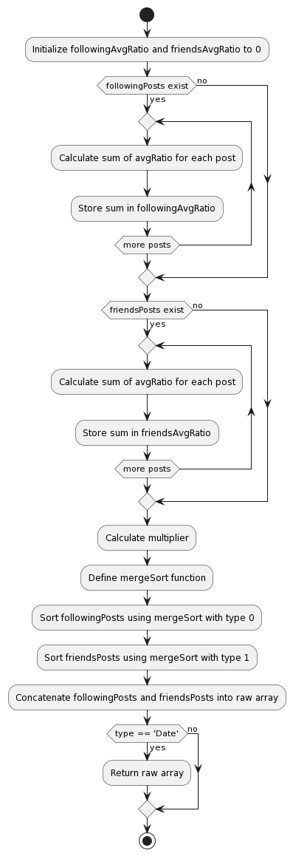
let followingAvgRatio = 0;
let friendsAvgRatio = 0;

if (followingPosts) {
for (let i = 0; i < followingPosts.length; i++) {
followingAvgRatio += followingPosts[i].avgRatio;
}
}

if (friendsPosts) {
for (let i = 0; i < friendsPosts.length; i++) {
friendsAvgRatio += friendsPosts[i].avgRatio;
}
}

const multiplier = followingAvgRatio / friendsAvgRatio ? followingAvgRatio / friendsAvgRatio : 1;

function mergeSort(arr, type) {
if (arr.length <= 1) {
return arr;
}

const mid = Math.floor(arr.length / 2);
const left = arr.slice(0, mid);
const right = arr.slice(mid);

return merge(mergeSort(left), mergeSort(right), type);
}

function merge(left, right, type) {
const result = [];
let leftIndex = 0;
let rightIndex = 0;

while (leftIndex < left.length && rightIndex < right.length) {
if (left[leftIndex].date >= right[rightIndex].date) {
if (type) {
left[leftIndex].avgRatio = (left[leftIndex].avgRatio * multiplier) / ((leftIndex + 1) * left[leftIndex].multiplier);
} else {
left[leftIndex].avgRatio = left[leftIndex].avgRatio / ((leftIndex + 1) * left[leftIndex].multiplier);
}
result.push(left[leftIndex]);
leftIndex++;
} else {
if (type) {
right[rightIndex].avgRatio = (right[rightIndex].avgRatio * multiplier) / ((rightIndex + 1) * right[rightIndex].multiplier);
} else {
right[rightIndex].avgRatio = right[rightIndex].avgRatio / ((rightIndex + 1) * right[rightIndex].multiplier);
}
result.push(right[rightIndex]);
rightIndex++;
}
}

return result.concat(left.slice(leftIndex)).concat(right.slice(rightIndex));
}

followingPosts = mergeSort(followingPosts, 0);
friendsPosts = mergeSort(friendsPosts, 1);
const raw = mergeSort([...followingPosts, ...friendsPosts]);

if (args.type == 'Date') {
return raw;
}

Recommended

For 'Average Ratio', the resolver first calculates a multiplier based on the ratio of average ratios between the following and friends' posts to not differentiate between them and merge them at the proper intervals. It then adjusts each post's average ratio accordingly. After merging the arrays with Merge Sort, it sorts them by date and returns the sorted array. This sorting prioritises posts with higher average ratios, adjusted by the multiplier, which, if received correctly, will be the way to promote posts on the platform, driving potential profitability.

Design
- Initialise the swaps variable to 0.
- Define the swapRatio function that takes an array arr as a parameter.
- Inside swapRatio, iterate through each element i in the array arr.
- If i is not the last index of the array arr:
- If the avgRatio of the post at index i is less than the avgRatio of the post at index i+1:
    - Swap the posts at indexes i and i+1.
  - Increment swaps by 1.
- If swaps are not equal to 0:
  - Set swaps to 0.
  - Recursively call the swapRatio function with the updated arr.
- Call the swapRatio function with the raw array.
- Return the raw array.

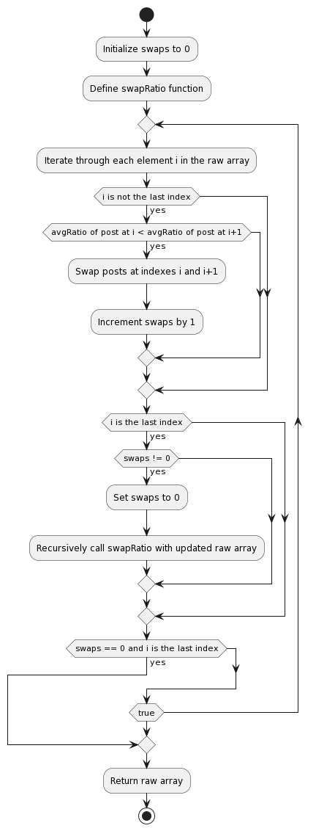
let swaps = 0;

function swapRatio(arr) {
for (let i = 0; i < arr.length; i++) {
if (i + 1 != arr.length) {
if (arr[i].avgRatio < arr[i + 1].avgRatio) {
[arr[i], arr[i + 1]] = [arr[i + 1], arr[i]];
swaps += 1;
}
}
}

if (swaps != 0) {
swaps = 0;
swapRatio(arr);
}
}

swapRatio(raw);

return raw;

Tests

Test Case 1: Retrieve Following Posts

Procedure:
1. Provide a valid `id` and `secretkey`.
2. Set the `type` argument to "Following".
3. Call the `getFeed` resolver with the provided arguments.

Expected Result:
- The resolver should authenticate the user successfully.
- The resolver should fetch posts from users followed by the specified user.
- The resolver should sort the retrieved posts by date in descending order.
- The resolver should return a list of posts from followed users sorted by date.

Step | Description | Input | Output/Finding
1 | Provide a valid id and secretkey. | Valid id and secretkey
2 | Set the type argument to 'Following'. | 'Following'
3 | Call the getFeed resolver with the provided arguments. | Valid id, secretkey, and 'Following'
4 | Verify the returned posts include only the following posts. |  | Returned posts include only the user’s following’s posts.

Test Case 2: Retrieve Friends' and Received Friendships' Posts

Procedure:
1. Provide a valid `id` and `secretkey`.
2. Set the `type` argument to "Friends".
3. Call the `getFeed` resolver with the provided arguments.

Expected Result:
- The resolver should authenticate the user successfully.
- The resolver should fetch posts from friends and users with whom friendships were received.
- The resolver should sort the retrieved posts by date in descending order.
- The resolver should return a list of posts from friends and users with received friendships sorted by date.

Step | Description | Input | Output/Finding
1 | Provide a valid id and secretkey. | Valid id and secretkey
2 | Set the type argument to 'Friends'. | 'Friends'
3 | Call the getFeed resolver with the provided arguments. | Valid id, secretkey, and 'Friends'
4 | Verify the returned posts include friends' and received friendships' posts. |  | Returned posts include friends' and received friendships' posts.

Test Case 3: Retrieve All Posts Sorted by Date

Procedure:
1. Provide a valid `id` and `secretkey`.
2. Set the `type` argument to "Date".
3. Call the `getFeed` resolver with the provided arguments.

Expected Result:
- The resolver should authenticate the user successfully.
- The resolver should fetch all posts from users who follow, friends, and users who have received friendships.
- The resolver should sort the retrieved posts by date in descending order.
- The resolver should return a list of all posts sorted by date.

Step | Description | Input | Output/Finding
1 | Provide a valid id and secretkey. | Valid id and secretkey
2 | Set the type argument to 'Date'. | 'Date'
3 | Call the getFeed resolver with the provided arguments. | Valid id, secretkey, and 'Date'
4 | Verify the returned posts include all posts sorted by date. |  | Returned posts include all posts sorted by date.

Test Case 4: Retrieve Following Posts with Custom Recommended Sorting

Procedure:
1. Provide a valid `id` and `secretkey`.
2. Call the `getFeed` resolver with the provided arguments without specifying the `type`.

Expected Result:
- The resolver should authenticate the user successfully.
- The resolver should fetch posts from users followed by the specified user.
- The resolver should sort the retrieved posts using a custom algorithm considering the average ratio and multiplier.
- The resolver should return a list of posts from followed users sorted by the custom algorithm.

Step | Description | Input | Output/Finding
1 | Provide a valid id and secretkey. | Valid id and secretkey
2 | Call the getFeed resolver with the provided arguments | Valid id and secretkey
3 | Verify the returned posts include following posts with custom recommended sorting. |  | Returned feed sorted with custom recommended sorting.

RecommendedUsers

Analysis

The recommendedUsers query helps users find new people in their network, potentially introducing them to new people. Although it might initially seem like an echo chamber, this presents users with people who are likely to have similar interests and values.

The query will send the user ID along with the IDs of their friends and followers to a Rust-based microservice, which in turn will bring back the required data. In hindsight, it would have been slightly faster to implement the functionality either as a WebAssembly (WASM) module or as a direct connection with the database to the Rust service and implement parallel processing with threads. However, this should be considered an option for future optimisations.

The Rust Recommended Server receives the data in JSON format and destructures it using the user structure. The server then maintains the connections using a HashMap data structure to look up and reference user connections.

The server generates recommendations tailored to the user based on these third-order links. For each user, the server looks at their friends and followers and pays special attention to people with whom they have in common. It orders individuals according to whom they are linked most frequently in a Vec data structure.

From there, the server sends these recommendations back to the main API. If there are at most ten connections, the API will enrich the recommendations with the top-performing creators on the platform. This way, users will always get at least ten relevant suggestions.

The query returns a list of AuthorType objects containing the information we are interested in (the authors and their associated profiles — name, username, and profile picture).

Strengths
- Personalised recommendations based on the user's network.
- Efficient use of a separate microservice for improved performance and modularity.
- Utilises Rust's performance capabilities.
- Supplements recommendations with top creators when necessary.

Weaknesses
- Potential for creating an echo chamber effect.
- Limited to the user's existing network.
- Relies on external API for recommendations.

Opportunities
- Implement WASM module for enhanced performance
- Directly connect the database to the Rust service for faster processing.
- Leverage parallel processing with threads for improved scalability
- Expand recommendation criteria beyond mutual connections

Threats
- Dependence on the availability and reliability of the external API
- Potential for biased or limited recommendations

Design

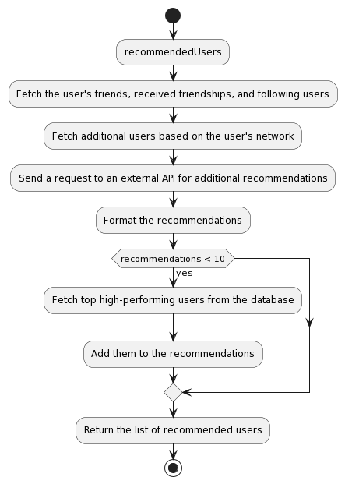

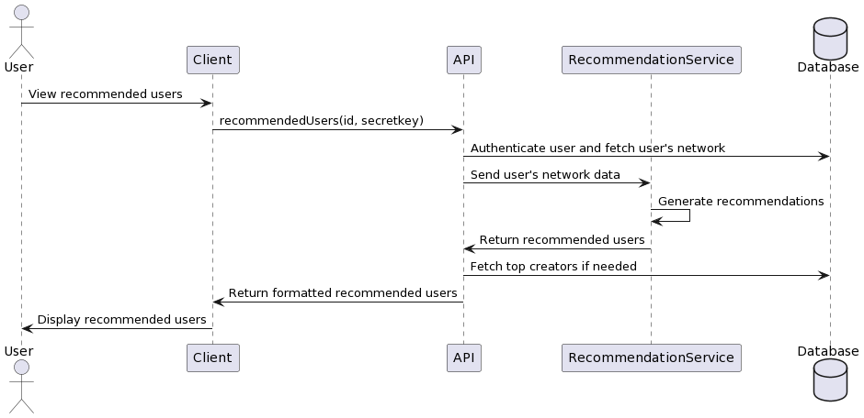
Running the recommended users query queries a separate Rust microservice to build heuristic recommendations based on the user's network. Algorithms are used to find mutual connections between these users and possibly include top creators in the recommendation list.

Tests

Test Case 1: Retrieve Recommended Users

Procedure
1. Provide a valid `id` and `secretkey`.
2. Call the `recommendedUsers` resolver with the provided arguments.

Expected Result
- The resolver should authenticate the user successfully.
- The resolver should fetch the user's friends, received friendships, and following users.
- The resolver should fetch additional users based on the user's network to provide recommendations.
- The resolver should request an external API for additional recommendations.
- The resolver should format the recommendations and return them.
- If the number of recommendations is less than 10, the resolver should fetch top high-performing users from the database sorted by average ratio and add them to the recommendations.
- The resolver should log any errors encountered during the process.
- The resolver should return a list of recommended users with their public information (id, username, name).

Step | Description | Input | Output/Finding
1 | Provide a valid id and secretkey. | Valid id and secretkey
2 | Call the recommendedUsers resolver with the provided arguments. | Valid id and secretkey
3 | Verify that the resolver authenticates the user successfully. |  | User authentication is successful.
4 | Verify that the resolver fetches the user's friends, received friendships, and following users. |  | User's social connection data is fetched.
5 | Verify that the resolver fetches additional users based on the user's network to provide recommendations. |  | Additional users from users’ social connections are fetched.
6 | Verify that the resolver sends a request to the external recommendation API for additional recommendations. |  | Request to external API is sent successfully.
7 | Verify that the resolver formats the recommendations and returns them. |  | Recommendations are formatted and returned.
8 | If the number of recommendations is less than 10, verify that the resolver fetches top high-performing users from the database sorted by average ratio and adds them to the recommendations. |  | Top high-performing users are fetched and added if needed.
9 | Verify that the resolver logs any errors encountered during the process. |  | Errors encountered during the process are logged.
10 | Verify that the resolver returns a list of recommended users with their public information (id, username, name). |  | List of recommended users with public information is returned.

Post Queries

A social media application should also have post queries so that a request for a post can return the post and let the user view it without authenticating. Making posts public facilitates bringing in new people to the application and allows them to share content.

getPost

Analysis

getPost responds to a user who may still need to be authenticated but wants to see an individual post. The ability for new users to see what's happening on the platform helps rope them in. However, it is useless if new users are prevented from accessing any content until they are logged in. getPost allows users who still need to be authenticated to see an individual post. Routing to an individual post's dedicated page means that each post will have a URL path, which can be shared and found like any other URL on the web.

From a frontend point of view, the getPost query allows for the rendering of a single-post view – that is, a view for an individual blog post (the comment and its metadata) rendered alongside whatever post-specific media (photos) might be associated with it, as well as metadata about the user who made that post. In this sense, this query is fundamental to the experience of viewing posts.

The getPost query is meant to fetch a single post from the database. You specify which post to fetch with the request's single argument, id — a reference to the post's ID. An object of type PostType is returned, containing the post's content, any media associated with the post, and user information.

Strengths
- Allows users to view posts without authentication, attracting new users to the platform.
- Gives each post its page for sharing and linking via URL paths.
- Retrieves essential post details, including content, media, and user information.

Weaknesses
- Publicly accessible posts may be vulnerable to unauthorised access or misuse.
- The query may include only some of the necessary post metadata or engagement metrics.

Opportunities
- Enhancing the post-viewing experience with additional features like comments and reactions.
- Implementing caching mechanisms to improve query performance and reduce database load.

Threats
- Malicious users, meanwhile, could seek to take advantage of that same publicness to send spam or misinformation.
- As traffic increases – as users and posts accumulate – scalability can become an issue, leading to the need for optimisation and infrastructure improvements.

Additionally, posts are public and viewable by anyone; therefore, they are vital to content discovery and user experience. getPost is responsible for displaying individual posts without requiring the user to log in — the query helps to shape the post viewing experience and requires a dedicated page for each post. This enables the user to learn post details that would otherwise require authentication. Although public posts can lead to scalability issues, they also create usability benefits that should be considered when creating applications.

Design

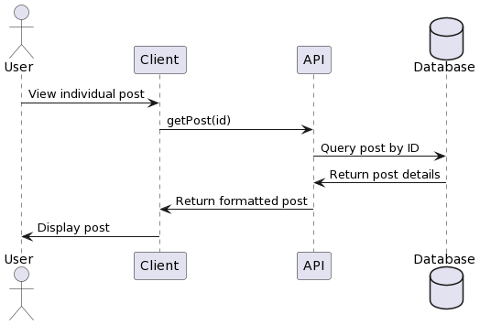

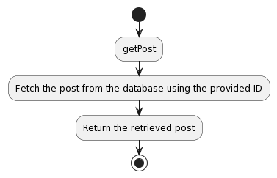

const PostQuery = {
getPost: {
type: PostType,
args: {
id: { type: GraphQLInt }
},
async resolve(parent, args, { prisma, sanitise, log }) {
try {
// Sanitize the input arguments
args = sanitise(args);
// Fetch the post from the database using Prisma
const post = await prisma.post.findFirst({
where: {
id: args.id
},
select: {
id: true,
content: true,
photo: true,
user: {
select: {
name: true,
username: true,
id: true
}
}
}
});
// Return the retrieved post
return post;
} catch (error) {
// Log any errors that occur during the process
log(error);
return null;
}
}
}
};

Tests

Test Case 1: Retrieve Post by ID

Procedure
1. Provide a valid post ID as an argument.
2. Call the `getPost` resolver with the provided post ID.

Expected
- The resolver should return the post corresponding to the provided ID.
- The returned post should include the ID, content, photo, and details of the user who created the post.

Step | Description | Input | Output/Finding
1 | Provide a valid post ID as an argument. | Valid post ID
2 | Call the getPost resolver with the provided ID. | Valid post ID
3 | Verify that the resolver sanitizes the input. |  | Input is properly sanitized.
4 | Verify that the resolver fetches the post. |  | Post corresponding to the provided ID is retrieved.
5 | Verify that the resolver returns the post with its details. |  | Returned post includes the post ID, content, photo (if available), and details of the user who created the post.
6 | If an error occurs during the process, verify that the resolver logs the error. |  | Errors encountered during the process are logged.

Test Case 2: Post Not Found

Procedure
1. Provide a nonexistent post ID as an argument.
2. Call the `getPost` resolver with the provided post ID.

Expected
- The resolver should return a null or an empty response since the post with the provided ID does not exist.

Step | Description | Input | Output/Finding
1 | Provide a non-existent post ID as an argument. | Non-existent post ID
2 | Call the getPost resolver with the provided ID. | Non-existent post ID
3 | Verify that the resolver sanitizes the input. |  | Input is properly sanitized.
4 | Verify that the resolver handles the non-existent post ID gracefully. |  | The resolver returns null response since the post with the provided ID does not exist.
5 | If an error occurs during the process, verify that the resolver logs the error. |  | Errors encountered during the process are logged.

Test Case 3: Invalid Post ID Format

Procedure
1. Provide an invalid format for the post ID (e.g., a string instead of an integer).
2. Call the `getPost` resolver with the invalid post ID.

Expected
- The resolver should throw an error or return null since the provided post ID format is invalid.

Step | Description | Input | Output/Finding
1 | Provide an invalid format for the post ID. | Invalid post ID format (e.g., string instead of integer)
2 | Call the getPost resolver with the invalid post ID. | Invalid post ID format (e.g., string instead of integer)
3 | Verify that the resolver sanitizes the input. |  | Input is properly sanitized.
4 | Verify that the resolver handles the invalid post ID format gracefully. |  | The resolver throws an error since the provided post ID format is invalid.
5 | If an error occurs during the process, verify that the resolver logs the error. |  | Errors encountered during the process are logged.

Chat Queries

Chat queries fetch the data about the user's chat datastore and load individual chat rooms. They are also used to fetch the initial chat data when the user loads the messages page since the web socket server deals only with the real-time aspect of the chat functionality.

GetChatroomData

Analysis

When a user clicks a specific chat room, the client sends a request to the backend to retrieve all the information stored on the server side related to that one chat room. This includes information about the chat room ID, the list of users who joined this chat, and the history of messages inside the chat room.

Our goal with the getChatroomData query is to create an endpoint for the user to retrieve chat room definition info if the requesting user passes in the correct chat ID to the request.

From the front, the getChatroomData query allows the chat room UI to render chat participants and the chat history and lets users enter the room without having to wait for any additional data or make any additional requests that could slow things down or introduce bugs.

The getChatroomData query retrieves all the information related to a chat room based on the chat ID. It has three arguments: id (user ID), secretkey (user secret key), chat ID (chat room ID), and returns the Chatroom type containing chat room-related records such as chat room ID, history/messages and users of the chat room.

Strengths
- One query instead of issuing four separate requests.
- Comprehensive view of the chat room, including messages and participants.
- Enables efficient rendering of the chat room UI on the front end.

Weaknesses
- Large amount of data if the chat room is large.

Opportunities
- Paginate or load content lazily in order to improve performance.
- Caching mechanism for frequently accessed chat room information to decrease the database load and speed up responses.

Threats
- Chatroom data leakage.
- Scaling issues.

getChatroomData while fetching all the data related to a particular chatroom. It allows us to fetch chat room IDs, messages, and participants in a single query, which is instrumental in rendering the complete chatroom UI on the front end. Moreover, we need to consider performance optimisations like pagination or caching if fetching more significant amounts of data. We also need to secure the authentication scheme for our chatroom to ensure the safety of the data access for the chatroom. Finally, getChatroomData query plays a vital role in providing the best chatroom experience to users by implementing various performance and security optimisations.

Design

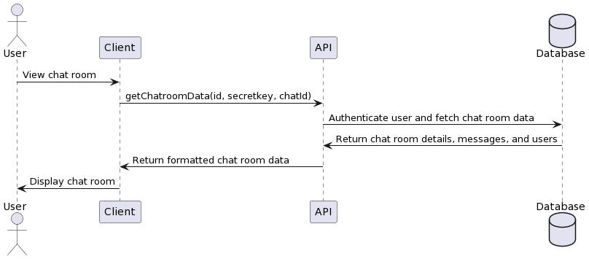

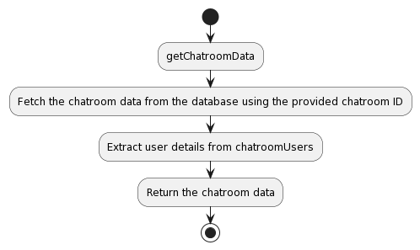

const ChatroomQueries = {
getChatroomData: {
type: ChatroomType,
args: {
id: { type: GraphQLString },
secretkey: { type: GraphQLString },
chatId: { type: GraphQLString }
},
async resolve(parent, args, { prisma, sanitise, auth, log, req }) {
try {
// Sanitize the input arguments
args = sanitise(args);

// Authenticate the user
const exists = auth(args.id, args.secretkey, req);

// Initialize an empty chatroom object
let chatroom = {};

// Fetch the chatroom data from the database using Prisma
chatroom = await prisma.chatroom.findFirst({
where: {
id: args.chatId
},
select: {
id: true,
messages: {
orderBy: {
date: 'desc'
},
select: {
id: true,
content: true,
date: true,
type: true,
sender: {
select: {
id: true,
name: true,
username: true
}
},
read: true
}
},
chatroomUsers: {
select: {
user: {
select: {
id: true,
name: true,
username: true
}
}
}
}
}
});

// Extract the user details from chatroomUsers
const chatters = chatroom.chatroomUsers.map(user => user.user);

// Return the chatroom data
return {
id: chatroom.id,
chatroomUsers: chatters,
messages: chatroom.messages,
lastMessage: ''
};
} catch (error) {
// Log any errors that occur during the process
log(error);
return null;
}
}
}
};

Tests

Test Case 1: Retrieve Chatroom Data with Valid Credentials

Procedure
1. Provide a valid `id` and `secretkey`.
2. Provide a valid `chatId`.
3. Call the `getChatroomData` resolver with the provided arguments.

Expected
- The resolver should authenticate the user successfully.
- The resolver should fetch the chatroom data corresponding to the provided `chatId`.
- The resolver should return the chatroom details, including the chatroom ID, users' details (IDs, names, usernames), messages (IDs, content, sender IDs, read status), and an empty last message.

Step | Description | Input | Output/Finding
1 | Provide a valid id and secretkey. | Valid user ID and secret key.
2 | Provide a valid chatId. | Valid chatroom ID.
3 | Call the getChatroomData resolver with the provided arguments. | Valid user ID, secret key, and chatroom ID.
4 | Verify that the resolver sanitizes the input. |  | Input is properly sanitized.
5 | Verify that the resolver authenticates the user. | Valid user ID and secret key. | User authentication is successful.
6 | Verify that the resolver fetches the chatroom data. |  | Chatroom data corresponding to the provided chatId is retrieved.
7 | Verify that the resolver returns the chatroom data including messages and participants. |  | Returned data includes the chatroom ID, list of participants, messages ordered by date, and an empty last message field.
8 | If an error occurs during the process, verify that the resolver logs the error. |  | Errors encountered during the process are logged.

Test Case 2: Retrieve Chatroom Data with Invalid Credentials

Procedure
1. Provide an invalid `id` or `secretkey`.
2. Provide a valid `chatId`.
3. Call the `getChatroomData` resolver with the provided arguments.

Expected
- The resolver should fail to authenticate the user due to invalid credentials.
- The resolver should not fetch any chatroom data.
- The resolver should return null or undefined, indicating an error or lack of authorisation.

Step | Description | Input | Output/Finding
1 | Provide an invalid id or secretkey. | Invalid user ID or secret key.
2 | Provide a valid chatId. | Valid chatroom ID.
3 | Call the getChatroomData resolver with the provided arguments. | Invalid user ID or secret key and valid chatroom ID.
4 | Verify that the resolver sanitizes the input. |  | Input is properly sanitized.
5 | Verify that the resolver handles invalid authentication gracefully. |  | The resolver returns null or throws an error due to invalid authentication.
6 | If an error occurs during the process, verify that the resolver logs the error. |  | Errors encountered during the process are logged.

Test Case 3: Retrieve Chatroom Data with Invalid Chat ID

Procedure
1. Provide a valid `id` and `secretkey`.
2. Provide an invalid or non-existent `chatId`.
3. Call the `getChatroomData` resolver with the provided arguments.

Expected
- The resolver should authenticate the user successfully.
- The resolver should not find chatroom data corresponding to the provided `chatId`.
- The resolver should return a null or an empty object for the chatroom details.

Step | Description | Input | Output/Finding
1 | Provide a valid id and secretkey. | Valid user ID and secret key.
2 | Provide an invalid or non-existent chatId. | Invalid or non-existent chatroom ID.
3 | Call the getChatroomData resolver with the provided arguments. | Valid user ID, secret key, and invalid chatroom ID.
4 | Verify that the resolver sanitizes the input. |  | Input is properly sanitized.
5 | Verify that the resolver authenticates the user. | Valid user ID and secret key. | User authentication is successful.
6 | Verify that the resolver handles invalid chatroom ID gracefully. |  | The resolver returns null due to an invalid or non-existent chatroom ID.
7 | If an error occurs during the process, verify that the resolver logs the error. |  | Errors encountered during the process are logged.

getChats

Analysis

When a user visits the messages page, the application must retrieve all the chat rooms the user has joined and display them in a list. The getChats query retrieves the initial chat data the user needs to know to decide which chat rooms they previously joined to show. It is a fixed (finite) list of the chat rooms the user has joined and associated messages. Our goal with the getChats query is for the user to see a list of the chat rooms they have joined to know which chat room to navigate.

From the frontend front end, the effect of the typical getChats query renders the chat list UI, showing users the members of the chat room and the last message that took place inside each chat room.

getChats query will retrieve all the Chat rooms belonging to a specific User. It has two arguments: id (User id) and secretkey (User's secret key). The getChats Query will return a list of ChatroomType, which contains Chatroom's ID, list of Users, and last message for that chat room.

Strengths
- Single request instead of hundreds of requests.
- Concise overview of each chat room, including the last message exchanged.
- Enables efficient rendering of the chat list UI on the frontend frontend.

Weaknesses
- Returns lots of data if the user has many chat rooms.

Opportunities
- Pagination or lazy loading for the chat list.
- Caching.

Threats
- Security flaws in the authentication mechanism could lead to the disclosure of the contents of chat rooms to unauthorised persons.
- Scalability issues.

The getChats query gives us one of the most vital endpoints to fetch all the chats a user is part of. This enables us to get the details of all the chats in the chat list UI on the frontend front end and get the last message in each chat room. For example, instead of fetching all of the chats for every user, we can limit the number of chats fetched by the user to optimise performance. We should also have optimisations like pagination or caching built-in to get the list of all chats promptly. On top of that, we must address the user's credentials behind the query so that sensitive data about chat rooms is not compromised or leaked.

Design

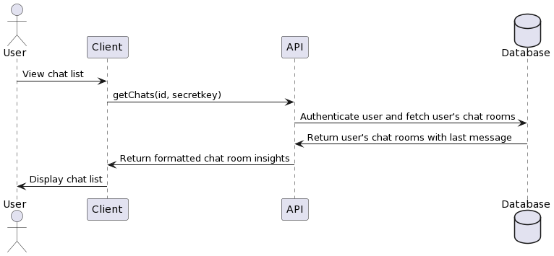
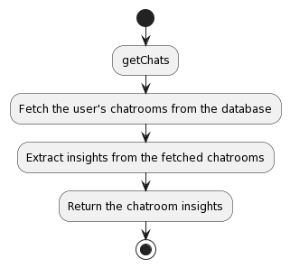
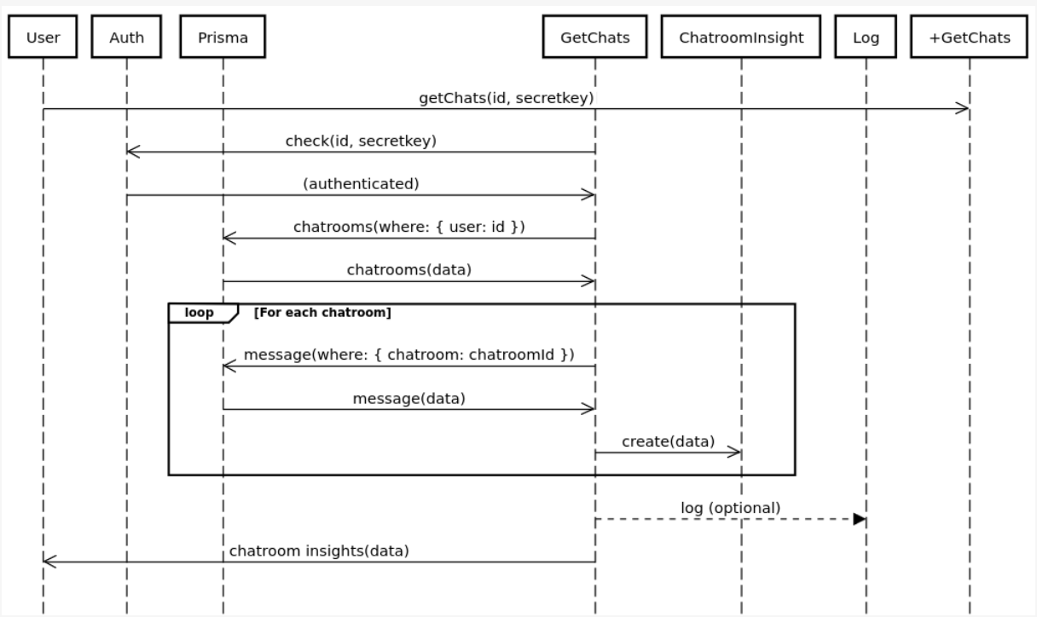

const ChatroomQueries = {
getChats: {
type: new GraphQLList(ChatroomType),
args: {
id: { type: GraphQLString },
secretkey: { type: GraphQLString }
},
async resolve(parent, args, { prisma, auth, sanitise, log, req }) {
try {
// Sanitize the input arguments
args = sanitise(args);

// Authenticate the user
const exists = await auth(args.id, args.secretkey, req);

// Fetch the user's chatrooms from the database using Prisma
const chatrooms = await prisma.user.findFirst({
where: {
id: args.id
},
select: {
chatroomUsers: {
select: {
chatroom: {
select: {
id: true,
chatroomUsers: {
select: {
user: {
select: {
name: true,
id: true,
username: true
}
}
}
},
messages: {
orderBy: {
date: 'desc'
},
take: 1,
select: {
id: true,
content: true,
sender: {
select: {
name: true,
username: true
}
},
date: true
}
}
}
}
}
}
}
});

// Extract insights from the fetched chatrooms
const insights = [];

chatrooms.chatroomUsers.map(chatroomUser => {
const chatroom = chatroomUser.chatroom;
const lastMessage = chatroom.messages[0];

const recipients = chatroom.chatroomUsers.map(author => author.user);

insights.push({
id: chatroom.id,
chatroomUsers: recipients,
lastMessage
});
});

// Return the chatroom insights
return insights;
} catch (error) {
// Log any errors that occur during the process
log(error);
return null;
}
}
}
};

Tests

Test Case 1: Retrieve User's Chatrooms

Procedure
1. Sanitise the arguments.
2. Authenticate the user using the provided ID and secret key.
3. Call the `getChats` resolver with the user's ID and secret key.

Expected
- The resolver should return a list of chatroom insights, each containing the chatroom ID, users, and last message.
- The chatroom insights should include all chatrooms associated with the user.

Step | Description | Input | Output/Finding
1 | Sanitise the arguments. | Valid user ID and secret key. | Input is properly sanitized.
2 | Authenticate the user using the provided ID and secret key. | Valid user ID and secret key. | User authentication is successful.
3 | Call the getChats resolver with the user's ID and secret key. | Valid user ID and secret key. | The resolver returns a list of chatroom insights, each containing the chatroom ID, users, and last message. The chatroom insights include all chatrooms associated with the user.

Test Case 2: User with No Chatrooms

Procedure
1. Sanitise the arguments.
2. Authenticate the user using the provided ID and secret key.
3. Call the `getChats` resolver with the user's ID and secret key for a user with no chatrooms.

Expected
- The resolver should return an empty list since the user has no chatrooms associated with them.

Step | Description | Input | Output/Finding
1 | Sanitise the arguments. | Valid user ID and secret key for a user with no chatrooms. | Input is properly sanitized.
2 | Authenticate the user using the provided ID and secret key. | Valid user ID and secret key for a user with no chatrooms. | User authentication is successful.
3 | Call the getChats resolver with the user's ID and secret key for a user with no chatrooms. | Valid user ID and secret key for a user with no chatrooms. | The resolver returns an empty list since the user has no chatrooms associated with them.

Test Case 3: Invalid User Authentication

Procedure:
1. Provide an invalid user ID and secret key.
2. Call the `getChats` resolver with the invalid user credentials.

Expected Result:
- The resolver should throw an error during authentication, indicating that the user credentials are invalid.

Step | Description | Input | Output/Finding
1 | Provide an invalid user ID and secret key. | Invalid user ID and secret key. | N/A
2 | Call the getChats resolver with the invalid user credentials. | Invalid user ID and secret key. | The resolver throws an error during authentication, indicating that the user credentials are invalid.
3 | If an error occurs during the process, verify that the resolver logs the error. | Error encountered during the authentication process. | The resolver logs the error.

Mutations

Mutations are similar to the standardized use of POST requests where it would be reasonable to assume that on any Mutation call, as in any HTTP POST request, data would be modified somewhere. In this case, it is the User.

User Mutations

User mutations are the key to a social media application since they enable users to create accounts and log in, manage their peer connections, and update their profiles on the backend. Without these mutations, users would not be able to interact with or access the application.

CreateUser

Analysis

A mutation must be created upon completion of the onboarding workflow to create a new user account. Once a user decides to create an account, the platform asks them to fill in their name and other details before allowing the user to enter. In the early stages of beta development, one can afford to delay user data collection as much as possible, adhere to GDPR regulations, and simplify things. Since we are just beginning, we will not request additional information except one’s name, username and password. The mutation provides the returned API key, which is stored in the user’s cookies for future authentication requests.

The createUser mutation takes firstName, lastName, username, and password as arguments and creates a new user on the platform. The password is securely hashed, and a new unique API key is created, in addition to storing the user in the database. An ID and the new API key are returned.

Strengths
- Allows users to create new accounts and join the platform.
- Securely hashes passwords to protect user credentials.
- Generates unique API keys for future authentication purposes.

Weaknesses
- Collection of user data.

Opportunities
- Gathering more user data during the sign-up process to fill user-profiles and offer further customisation.
- Rate limiting, honeypots and captchas.

Threats
- Fake or spam accounts.
- Security weaknesses in the hashing or API key-creation process.

The createUser mutation allows the user to create a new account safely and straightforwardly.

Design

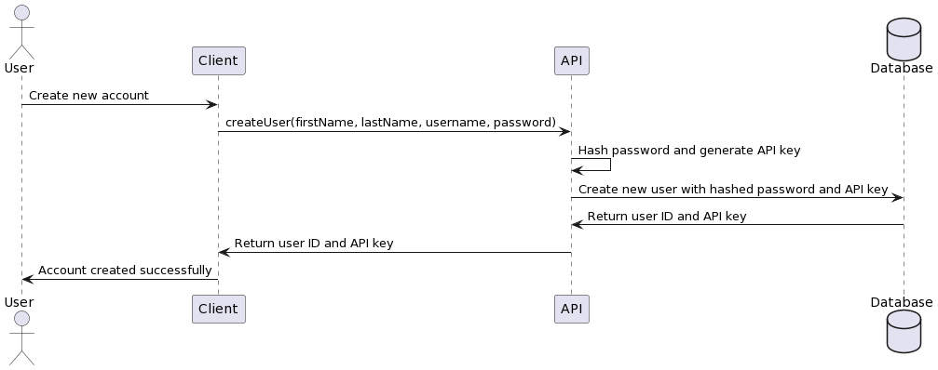

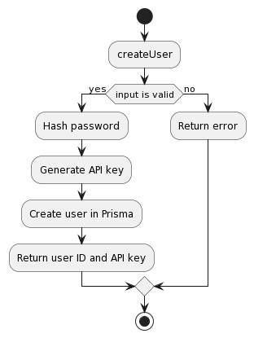

createUser: {
type: SensitiveUserDataType,
args: {
firstName: { type: GraphQLString },
lastName: { type: GraphQLString },
username: { type: GraphQLString },
password: { type: GraphQLString }
},
async resolve(parent, args, { prisma, sanitise, log }) {
try {
// Sanitize the input arguments
args = sanitise(args);

// Hash the password using bcrypt with salt rounds of 10
const pass = await bcrypt.hash(args.password, 10);

// Generate a unique API key using the nanoid library
const { nanoid } = await import('nanoid');
const apiKey = nanoid();

// Create a new user in Prisma
const user = await prisma.user.create({
data: {
name: `${args.firstName} ${args.lastName}`,
username: args.username,
userData: {
create: {
password: pass,
secretkey: apiKey
}
}
}
});

// Return the user ID and generated API key
return {
id: user.id,
secretkey: apiKey
};
} catch (error) {
// Log any errors that occur during the process
log(error);
return null;
}
}
};

Tests

Test Case 1: Create a New User with First Name, Last Name, Username, and Password

Procedure
1. Sanitize the arguments.
2. Hash the password using bcrypt with salt rounds of 10.
3. Generate a unique API key using the nanoid library.
4. Create a new user in Prisma with the provided first name, last name, username, hashed password, and generated API key.
5. Return the user ID and generated API key.

Expected
1. Arguments are successfully sanitized.
2. Password is successfully hashed.
3. A unique API key is generated.
4. The provided information successfully creates A new user in Prisma.
5. The user ID and generated API key are returned.

SignIn

Analysis

Users may have several devices on which they would like to access the platform, or they may have lost the connection due to an expired API key. Users should have the option of signing back into their account using their credentials. The sign-in resolver is invoked when a user submits a sign-in request from the portal.

The resolver for the signIn field ensures users can sign in using their username and password. It takes in two arguments (username and pass). The resolver queries the database for the user data, compares the provided password to the saved (hashed) password in the database, generates a new API key, and returns the user ID and the newly generated API key if the credentials are valid.

Strengths
- Allows users to sign in to the platform.
- Securely compares the provided password with the stored hashed password.
- Generates a new API key upon successful authentication to maintain the session and authorise further API requests.

Weaknesses
- No rate-limiting.

Opportunities
- Implementing persistent server-side session management to provide a more seamless and secure user experience.
- Email verification or two-factor authentication.

Threats
- Brute-force attacks or password-guessing attempts could compromise user accounts.

The signIn resolver takes three fields – a user name and a password- and returns a new API key for use on the social network if the password matches the hashed password that has been securely stored.

Design

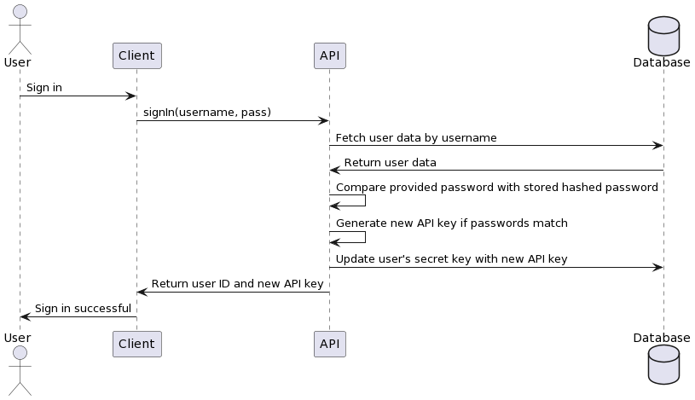

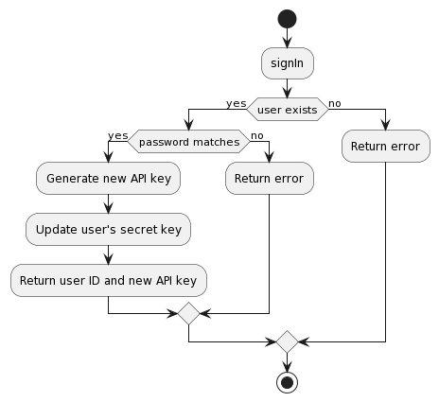
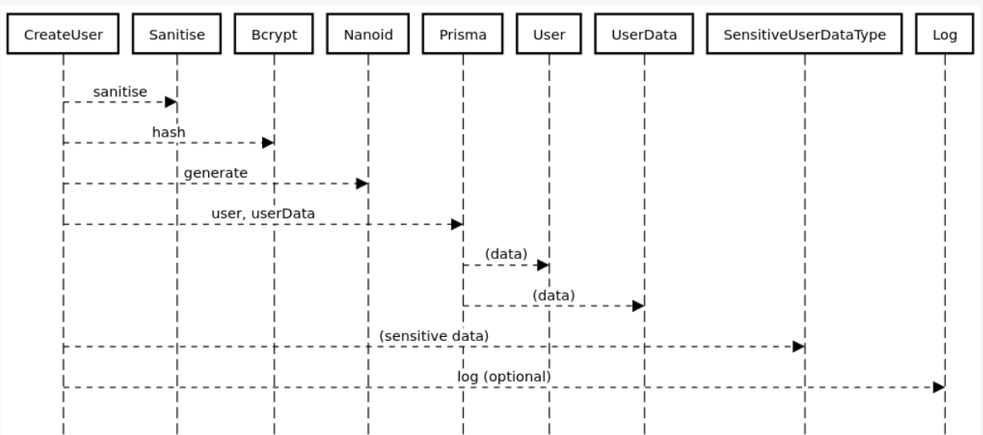

signIn: {
type: SensitiveUserDataType,
args: {
username: { type: GraphQLString },
pass: { type: GraphQLString }
},
async resolve(parent, args, { prisma, sanitise, log }) {
try {
// Sanitize the input arguments
args = sanitise(args);

// Fetch user data from Prisma
const userData = await prisma.userData.findFirst({
where: {
user: {
username: args.username
}
},
select: {
id: true,
secretkey: true,
password: true
}
});

// If user data is not found, throw an error
if (!userData) {
throw new Error('User not found');
}

// Compare the provided password with the stored hashed password
const hash = await bcrypt.compare(args.pass, userData.password);

if (hash) {
// Generate a new API key using the nanoid library
const { nanoid } = await import('nanoid');
const apiKey = nanoid();

// Update the user's secret key in Prisma with the new API key
await prisma.userData.update({
where: {
id: userData.id
},
data: {
secretkey: apiKey
}
});

// Return the user ID and the new API key
return {
id: userData.id,
secretkey: apiKey
};
} else {
// If passwords do not match, throw an error
throw new Error('Password is incorrect');
}
} catch (error) {
// Log any errors that occur during the process
log(error);
return null;
}
}
};

Tests

Test Case 1: Sign In with Correct Username and Password

Procedure:
1. Sanitize the arguments.
2. Fetch user data from Prisma using the provided username.
3. If user data is found:
- Compare the hashed password with the provided password using bcrypt.
- If passwords match:
- Generate a unique API key using the nanoid library.
- Update the user's secret key in Prisma with the generated API key.
- Return the user ID and generated API key.
- If passwords do not match, throw an error 'Password is incorrect'.
4. If user data is not found, throw an error 'User not found'.

Expected
- User is successfully authenticated.
- A unique API key is generated and updated in the user's record in Prisma.
- The user ID and generated API key are returned.

Step | Description | Input | Output/Finding | Expected Output | Pass/Fail
1 | Sanitize the arguments. | Valid username and password. | Arguments are successfully sanitized. | Arguments should be successfully sanitized. | Pass
2 | Fetch user data using the provided username. | Valid username. | User data is successfully fetched. | User data should be successfully fetched. | Pass
3 | Compare the hashed password with the provided password using bcrypt. If passwords match, generate a unique API key using the nanoid library, update the user's secret key in Prisma with the generated API key, and return the user ID and generated API key. If passwords do not match, throw an error 'Password is incorrect'. | Valid username and password. | User is successfully authenticated. A unique API key is generated and updated in the user's record in Prisma. The user ID and generated API key are returned. | If the provided password matches the hashed password, the user should be authenticated, a new API key should be generated and updated in Prisma, and the user ID and API key should be returned. If the passwords don't match, an 'Password is incorrect' error should be thrown. | Pass
4 | If user data is not found, throw an error 'User not found'. | N/A | N/A | If user data is not found, a 'User not found' error should be thrown. | Pass

Test Case 2: Sign In with Incorrect Password

Procedure:
1. Sanitize the arguments.
2. Fetch user data from Prisma using the provided username.
3. If user data is found:
- Compare the hashed password with the provided password using bcrypt.
- If passwords match:
- Generate a unique API key using the nanoid library.
- Update the user's secret key in Prisma with the generated API key.
- Return the user ID and generated API key.
- If passwords do not match, throw an error 'Password is incorrect'.
4. If user data is not found, throw an error 'User not found'.

Expected Result:
- Error 'Password is incorrect' is thrown.
- User authentication fails.

Step | Description | Input | Output/Finding | Expected Output | Pass/Fail
1 | Sanitize the arguments. | Valid username and incorrect password. | Arguments are successfully sanitized. | Arguments should be successfully sanitized. | Pass
2 | Fetch user data using the provided username. | Valid username. | User data is successfully fetched. | User data should be successfully fetched. | Pass
3 | Compare the hashed password with the provided password using bcrypt. If passwords match, generate a unique API key using the nanoid library, update the user's secret key in Prisma with the generated API key, and return the user ID and generated API key. If passwords do not match, throw an error 'Password is incorrect'. | Valid username but incorrect password. | Error 'Password is incorrect' is thrown. User authentication fails. | If the provided password does not match the hashed password, an 'Password is incorrect' error should be thrown, and user authentication should fail. | Pass
4 | If user data is not found, throw an error 'User not found'. | N/A | N/A | If user data is not found, a 'User not found' error should be thrown. | Pass

Test Case 3: Sign In with a Nonexistent Username

Procedure:
1. Sanitize the arguments.
2. Fetch user data from Prisma using the provided username.
3. If user data is found:
- Compare the hashed password with the provided password using bcrypt.
- If passwords match:
- Generate a unique API key using the nanoid library.
- Update the user's secret key in Prisma with the generated API key.
- Return the user ID and generated API key.
- If passwords do not match, throw an error 'Password is incorrect'.
4. If user data is not found, throw an error 'User not found'.

Expected
- Error 'User not found' is thrown.
- User authentication fails.

Step | Description | Input | Output/Finding | Expected Output | Pass/Fail
1 | Sanitize the arguments. | Nonexistent username and any password. | Arguments are successfully sanitized. | Arguments should be successfully sanitized. | Pass
2 | Fetch user data from Prisma using the provided username. | Nonexistent username. | User data is not found. | User data should not be found for a nonexistent username. | Pass
3 | Compare the hashed password with the provided password using bcrypt. If passwords match, generate a unique API key using the nanoid library, update the user's secret key in Prisma with the generated API key, and return the user ID and generated API key. If passwords do not match, throw an error 'Password is incorrect'. | N/A | N/A | This step should not be executed since user data is not found. | Pass
4 | If user data is not found, throw an error 'User not found'. | Nonexistent username. | Error 'User not found' is thrown. User authentication fails. | If user data is not found, a 'User not found' error should be thrown, and user authentication should fail. | Pass

FollowUnfollowUser

Analysis

Since the platform is a social network, we need to manage users’ connections—follow/friend and information flows—to and from them using some endpoint. So, we need a way to mutate the state of the relationship with another user by following or unfollowing/unfriending them. This can be done with the followUnfollowUser mutation.

It handles follow-up and friendship relationships between users. Its input is three arguments: id, secret key and username, where id is the user id, secret key is the user's secret key, and username is the username of the user they want to follow or unfollow.

It first checks if the two given users are already in a follow relationship and then creates a relationship if not. If a relationship already exists between them. Using socket.io, it also emits an 'followed' event to the recipient's socket for real-time updates.

Strengths
- Allows users to create and manage follow and friendship relationships with other users.
- Handles follow and unfollow/unfriend actions based on the current relationship state.
- Emits a 'followed' event to instantly notify the recipient user of new follow relationships.

Weaknesses
- No rate-limiting.

Opportunities
- Implementing a separate endpoint for managing friendships to reduce complexity and improve code organization.
- Adding notifications or email alerts to inform users of new follow relationships.

Threats
- Spam the follow or abuse the follow feature to harass or intimidate people.
- Performance.

The followUnfollowUser mutation allows users to follow, unfollow, friend, and unfriend each other based on the current relationship, which is returned by the relationship. Events are emitted when a new follow relationship is formed. Following this query, users can interact within the social media system.

Design

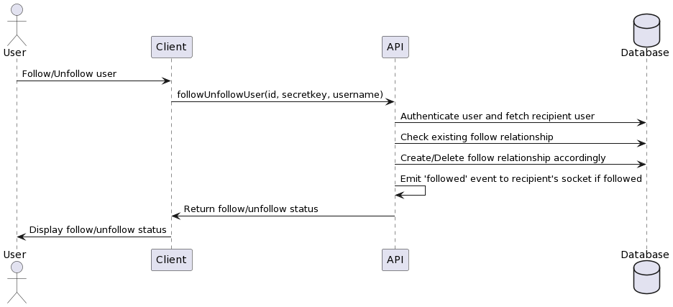
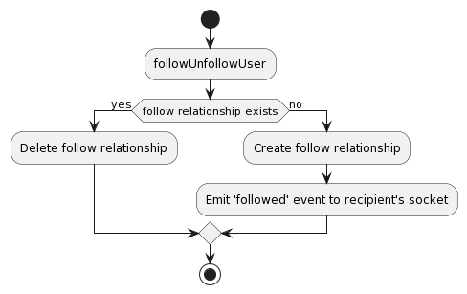

const UserMutations = {
signIn: {
type: SensitiveUserDataType,
args: {
username: { type: GraphQLString },
pass: { type: GraphQLString }
},
async resolve(parent, args, { prisma, sanitise, log }) {
try {
// Sanitize the input arguments
args = sanitise(args);

// Fetch user data from Prisma
const userData = await prisma.userData.findFirst({
where: {
user: {
username: args.username
}
},
select: {
id: true,
secretkey: true,
password: true
}
});

// If user data is not found, throw an error
if (!userData) {
throw new Error('User not found');
}

// Compare the provided password with the stored hashed password
const hash = await bcrypt.compare(args.pass, userData.password);

if (hash) {
// Generate a new API key using the nanoid library
const { nanoid } = await import('nanoid');
const apiKey = nanoid();

// Update the user's secret key in Prisma with the new API key
await prisma.userData.update({
where: {
id: userData.id
},
data: {
secretkey: apiKey
}
});

// Return the user ID and the new API key
return {
id: userData.id,
secretkey: apiKey
};
} else {
// If passwords do not match, throw an error
throw new Error('Password is incorrect');
}
} catch (error) {
// Log any errors that occur during the process
log(error);
return null;
}
}
}
};

Tests

Test Case 1: Follow a User

Procedure
1. Sanitize the arguments.
2. Authenticate the user using the provided ID and secret key.
3. Fetch the recipient user from Prisma using the provided username.
4. Check if the follow relationship already exists between the two users:
- If it exists:
- Fetch the follow relationship from Prisma.
- Delete the follow relationship.
- If it does not exist:
- Create a new follow relationship in Prisma with the follower ID and recipient ID.
- Emit a 'followed' event to the recipient's socket using socket.io.

Expected
- A new follow relationship is created between the users if it did not exist.
- If a follow relationship already existed, it is deleted.
- The appropriate 'followed' event is emitted to the recipient's socket.

Step | Description | Input | Output/Finding | Expected Output | Pass/Fail
1 | Sanitize the arguments. | Valid user ID, secret key, and username of the user to follow. | Arguments are successfully sanitized. | Arguments should be successfully sanitized. | Pass
2 | Authenticate the user using the provided ID and secret key. | Valid user ID and secret key. | User authentication is successful. | User authentication should be successful with valid ID and secret key. | Pass
3 | Fetch the recipient user from DB using the provided username. | Valid username of the user to follow. | Recipient user is successfully fetched. | Recipient user should be successfully fetched from DB. | Pass
4 | Check if the follow relationship already exists between the two users. If it exists, fetch the follow relationship from DB and delete it. If it does not exist, create a new follow relationship in DB with the follower ID and recipient ID, and emit a 'followed' event to the recipient's socket using socket.io. | Follower ID, recipient ID, and the current state of the follow relationship between the users. | If a follow relationship already existed, it is deleted. If a follow relationship did not exist, a new follow relationship is created between the users, and the appropriate 'followed' event is emitted to the recipient's socket. | If a follow relationship already exists, it should be deleted from DB. If a follow relationship does not exist, a new follow relationship should be created in DB with the follower ID and recipient ID, and a 'followed' event should be emitted to the recipient's socket using socket.io. | Pass

Test Case 2: Unfollow a User

Procedure
1. Sanitize the arguments.
2. Authenticate the user using the provided ID and secret key.
3. Fetch the recipient user from Prisma using the provided username.
4. Check if the follow relationship already exists between the two users:
- If it exists:
- Fetch the follow relationship from Prisma.
- Delete the follow relationship.
- If it does not exist:
- Create a new follow relationship in Prisma with the follower ID and recipient ID.
- Emit a 'followed' event to the recipient's socket using socket.io.

Expected
- The existing follow relationship between the users is deleted.
- No 'followed' event is emitted to the recipient's socket.

Step | Description | Input | Output/Finding | Expected Output | Pass/Fail
1 | Sanitize the arguments. | Valid user ID, secret key, and username of the user to unfollow. | Arguments are successfully sanitized. | Arguments should be successfully sanitized. | Pass
2 | Authenticate the user using the provided ID and secret key. | Valid user ID and secret key. | User authentication is successful. | User authentication should be successful with valid ID and secret key. | Pass
3 | Fetch the recipient user from DB using the provided username. | Valid username of the user to unfollow. | Recipient user is successfully fetched. | Recipient user should be successfully fetched from DB. | Pass
4 | Check if the follow relationship already exists between the two users. If it exists, fetch the follow relationship from DB and delete it. If it does not exist, create a new follow relationship in DB with the follower ID and recipient ID, and emit a 'followed' event to the recipient's socket using socket.io. | Follower ID, recipient ID, and the current state of the follow relationship between the users. | The existing follow relationship between the users is deleted. No 'followed' event is emitted to the recipient's socket. | If a follow relationship already exists between the users, it should be deleted from DB. No 'followed' event should be emitted to the recipient's socket since the users are unfollowing each other. | Pass

Test Case 3: Invalid Username

Procedure
1. Sanitize the arguments.
2. Authenticate the user using the provided ID and secret key.
3. Fetch the recipient user from Prisma using the provided username.
4. Check if a follow relationship already exists between the two users:
- If it exists:
- Fetch the follow relationship from Prisma.
- Delete the follow relationship.
- If it does not exist:
- Create a new follow relationship in Prisma with the follower ID and recipient ID.
- Emit a 'followed' event to the recipient's socket using socket.io.

Expected
- Error is logged indicating that the recipient user does not exist.
- No follow relationship is created.
- No 'followed' event is emitted.

Step | Description | Input | Output/Finding | Expected Output | Pass/Fail
1 | Sanitize the arguments. | Valid user ID, secret key, and an invalid or non-existent username. | Arguments are successfully sanitized. | Arguments should be successfully sanitized. | Pass
2 | Authenticate the user using the provided ID and secret key. | Valid user ID and secret key. | User authentication is successful. | User authentication should be successful with valid ID and secret key. | Pass
3 | Fetch the recipient user from DB using the provided username. | Invalid or non-existent username. | Error is logged indicating that the recipient user does not exist. | An error should be logged indicating that the recipient user does not exist when an invalid or non-existent username is provided. | Pass
4 | Check if the follow relationship already exists between the two users. If it exists, fetch the follow relationship from DB and delete it. If it does not exist, create a new follow relationship in DB with the follower ID and recipient ID, and emit a 'followed' event to the recipient's socket using socket.io. | N/A | No follow relationship is created. No 'followed' event is emitted. | Since the recipient user does not exist, no follow relationship should be created, and no 'followed' event should be emitted. | Pass

PendingRequest

Analysis

When a user receives a new follow-up request, a new pending request must be added to their list. The current user can decide whether to accept a new friendship or not. The current user should never know that the other user declined the offer of a friendship, so it’s the best option to accommodate for declining friendship silently.

The pending Request mutation is responsible for handling the following requests made by a user. It accepts four arguments:
- id (value indicating the user ID of the user making the request)
- secretkey (user's secret key)
- request (the ID of the follow request)
- action (action to take: either 'add' to create friendship or 'remove' to deny the follow request)
If the action is 'add', a new friendship is created by updating the database records corresponding to both users; if it is 'remove', the following request is denied by updating the respective records in the database.

Strengths
- Allows users to manage their pending follow requests and make decisions accordingly.
- Provides a to accept or decline follow requests.
- Automatically creates friendships or updates follow request records based on user actions.

Weaknesses
- No feedback or alert is provided to the sender of the follow request.

Opportunities
- Notifications to the sender of the follow request if the request has been accepted.
- Add more options for users to deal with follow requests, such as ignoring or reporting users.

Threats
- Malicious users could spam or harass other users.
- Poor performance.

The PendingRequest mutation gives the user the power to manage their pending follow-up requests. It allows the user to accept or reject the follow-up silently, resulting in maintaining a clean user experience that contributes to the mental health of users.

Design

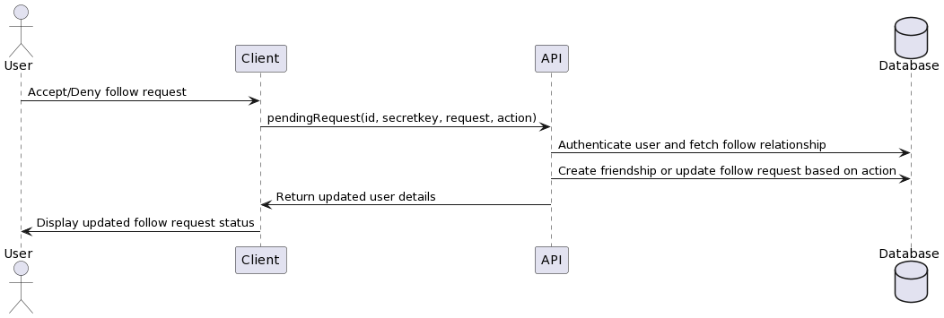
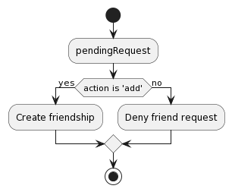

// Mutation to accept or reject a follow request
pendingRequest: {
type: UserType,
args: {
id: {type: GraphQLString}, // User ID
secretkey: {type: GraphQLString}, // User's API key
request: {type: GraphQLString}, // Request ID
action: {type: GraphQLString}, // Action to perform ('add' or 'remove')
},
async resolve(parent, args, {io, prisma, auth, sanitise, log, req}) {
try {
// Sanitize the input arguments
args = sanitise(args)
// Authenticate the user
const exists = await auth(args.id, args.secretkey, req)

// Find the follow request based on the request ID
const follow = await prisma.follow.findFirst({
where: {id: args.request},
select: {
follower: {
select: {
id: true,
username: true,
name: true,
},
},
following: {
select: {
id: true,
username: true,
name: true,
},
},
id: true,
},
})

// Perform the specified action
switch (args.action) {
case 'add':
// Create a new friendship between the two users
await prisma.friendship.create({
data: {
userOneId: follow.follower.id,
userTwoId: follow.following.id,
},
})

// Delete the follow request
await prisma.follow.delete({
where: {id: follow.id},
})
break

case 'remove':
// Mark the follow request as denied
await prisma.follow.update({
where: {
id: args.request,
},
data: {
denial: true,
},
})
break
}

return
} catch (e) {
// Log any errors
log(e)
return
}
},
},

Tests

Test Case 1: Accept Friendship Request

Procedure
1. Sanitize the arguments.
2. Authenticate the user using the provided ID and secret key.
3. Fetch the follow relationship from Prisma using the request ID.
4. Create a new friendship in Prisma with userOneId set to the follower's ID and userTwoId set to the following's ID.
5. Delete the follow relationship from Prisma using the request ID.

Expected
- A new friendship is created between the users.
- The following relationship is deleted.

Step | Description | Input | Output/Finding | Expected Output | Pass/Fail
1 | Sanitize the arguments. | Valid user ID, secret key, request ID, and action 'add'. | Arguments are successfully sanitized. | Arguments should be successfully sanitized. | Pass
2 | Authenticate the user using the provided ID and secret key. | Valid user ID and secret key. | User authentication is successful. | User authentication should be successful with valid ID and secret key. | Pass
3 | Fetch the follow relationship from DB using the request ID. | Valid request ID. | Follow relationship is successfully fetched. | The follow relationship corresponding to the provided request ID should be successfully fetched from DB. | Pass
4 | Create a new friendship in DB with userOneId set to the follower's ID and userTwoId set to the following's ID. | Follower ID and following ID. | A new friendship is created between the users. | A new friendship should be created in DB with userOneId set to the follower's ID and userTwoId set to the following's ID. | Pass
5 | Delete the follow relationship from DB using the request ID. | Request ID. | The follow relationship is deleted. | The follow relationship corresponding to the provided request ID should be deleted from DB. | Pass

Test Case 2: Deny Friendship Request

Procedure
1. Sanitize the arguments.
2. Authenticate the user using the provided ID and secret key.
3. Fetch the follow relationship from Prisma using the request ID.
4. Update the follow relationship in Prisma using the request ID, setting denial to true.

Expected
- The denial flag is set to true for the follow relationship.

Step | Description | Input | Output/Finding | Expected Output | Pass/Fail
1 | Sanitize the arguments. | Valid user ID, secret key, request ID, and action 'remove'. | Arguments are successfully sanitized. | Arguments should be successfully sanitized. | Pass
2 | Authenticate the user using the provided ID and secret key. | Valid user ID and secret key. | User authentication is successful. | User authentication should be successful with valid ID and secret key. | Pass
3 | Fetch the follow relationship from DB using the request ID. | Valid request ID. | Follow relationship is successfully fetched. | The follow relationship corresponding to the provided request ID should be successfully fetched from DB. | Pass
4 | Update the follow relationship in DB using the request ID, setting denial to true. | Request ID. | The denial flag is set to true for the follow relationship. | The follow relationship corresponding to the provided request ID should be updated in DB, with the denial flag set to true. | Pass

Test Case 3: Invalid Action

Procedure:
1. Sanitize the arguments.
2. Authenticate the user using the provided ID and secret key.
3. Fetch the follow relationship from Prisma using the request ID.

Expected Result:
- No changes are made to the database.
Step | Description | Input | Output/Finding | Expected Output | Pass/Fail
1 | Sanitize the arguments. | Valid user ID, secret key, request ID, and an invalid action (neither 'add' nor 'remove'). | Arguments are successfully sanitized. | Arguments should be successfully sanitized. | Pass
2 | Authenticate the user using the provided ID and secret key. | Valid user ID and secret key. | User authentication is successful. | User authentication should be successful with valid ID and secret key. | Pass
3 | Fetch the follow relationship from DB using the request ID. | Valid request ID. | Follow relationship is successfully fetched. | The follow relationship corresponding to the provided request ID should be successfully fetched from DB. | Pass
4 | N/A | N/A | No changes are made to the database. | Since the provided action is invalid, no changes should be made to the DB. | Pass

EditDetails

Analysis

The editDetails mutation allows users to update their details from the settings page without logging them out, even if they change their password.

Users might want to change their details for many reasons, such as changing their name, updating their password for security reasons, or refreshing their username for a new online identity.

Strengths
- Update personal information securely.
- Generates a new secret key when the password is changed, enhancing account security.
- Maintains the user's current session.

Weaknesses
- Username locking has not yet been implemented, allowing users to change their username frequently.

Opportunities
- Implement username locking to prevent excessive username changes.
- Additional validation and verification mechanisms for sensitive information updates.

Threats
- Malicious users potentially take over accounts by exploiting the feature.
- Insufficient input validation could lead to security vulnerabilities.

This editDetails mutation allows a user to edit their name, username, and password without the risk of hacking. It ensures the security of the information through the change of the secret key whenever the password is changed; this should be repeated with the user's current session open. In addition, the introduction of username locks could enhance end-users' trust in the platform.

Design

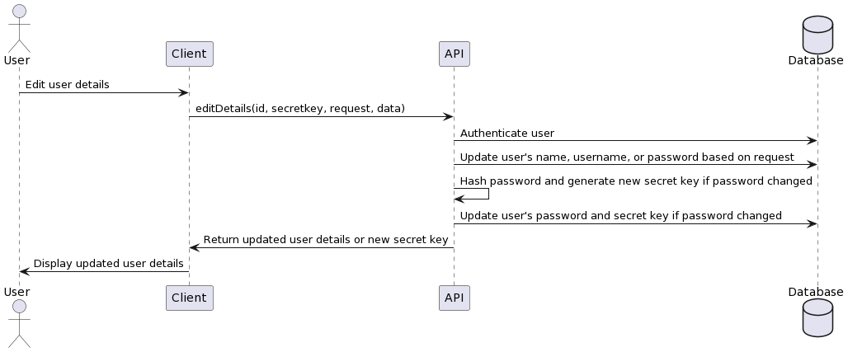

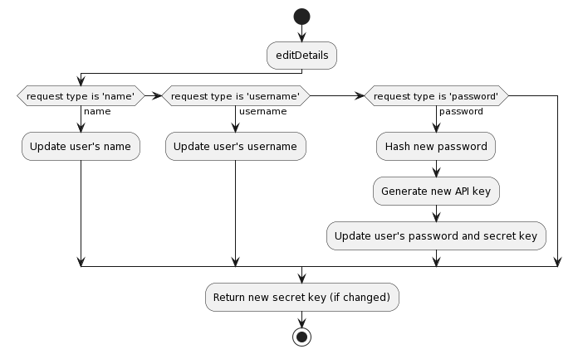
// Mutation to edit user details (name, username, password)
editDetails: {
type: SensitiveUserDataType,
args: {
id: {type: GraphQLString}, // User ID
secretkey: {type: GraphQLString}, // User's API key
request: {type: GraphQLString}, // Type of request ('name', 'username', or 'password')
data: {type: GraphQLString}, // New data to update
},
async resolve(parent, args, {io, prisma, sanitise, auth, log, req}) {
try {
// Sanitize the input arguments
args = sanitise(args)
// Authenticate the user
const exists = await auth(args.id, args.secretkey, req)

// Update the user data based on the request type
switch (args.request) {
case 'name':
// Update the user's name
await prisma.user.update({
where: {
id: args.id,
},
data: {
name: args.data,
},
})
return

case 'username':
// Update the user's username
await prisma.user.update({
where: {
id: args.id,
},
data: {
username: args.data,
},
})
return

case 'password':
// Hash the new password
const pass = await bcrypt.hash(args.data, 10)
// Generate a new API key
const {nanoid} = await import('nanoid')
const apiKey = nanoid()

// Update the user's password, API key, and expiry date
await prisma.userData.update({
where: {
id: args.id,
},
data: {
password: pass,
secretkey: apiKey,
expiry: new Date(Date.now() + 1000 * 60 * 60 * 24 * 7),
},
})
// Return the new API key
return {
secretkey: apiKey,
}
}
} catch (e) {
// Log any errors
log(e)
return
}
},
},

Tests

Test Case 1: Edit Name

Procedure
1. Sanitize the arguments.
2. Authenticate the user using the provided ID and secret key.
3. Call the `editDetails` resolver with `request` set to 'name' and `data` containing the new name.

Expected
- The user's name is updated in the database to the provided new name.

Step | Description | Input | Output/Finding | Expected Output | Pass/Fail
1 | Sanitize the arguments. | Valid user ID, secret key, request 'name', and new name. | Arguments are successfully sanitized. | Arguments should be successfully sanitized. | Pass
2 | Authenticate the user using the provided ID and secret key. | Valid user ID and secret key. | User authentication is successful. | User authentication should be successful with valid ID and secret key. | Pass
3 | Call the editDetails resolver with request set to 'name' and data containing the new name. | Valid request 'name' and new name. | The user's name is updated in the DB to the provided new name. | The user's name in the DB should be updated to the provided new name. | Pass

Test Case 2: Edit Username

Procedure
1. Sanitize the arguments.
2. Authenticate the user using the provided ID and secret key.
3. Call the `editDetails` resolver with `request` set to 'username' and `data` containing the new username.

Expected
- The user's username is updated in the database to the provided new username.

Step | Description | Input | Output/Finding | Expected Output | Pass/Fail
1 | Sanitize the arguments. | Valid user ID, secret key, request 'username', and new username. | Arguments are successfully sanitized. | Arguments should be successfully sanitized. | Pass
2 | Authenticate the user using the provided ID and secret key. | Valid user ID and secret key. | User authentication is successful. | User authentication should be successful with valid ID and secret key. | Pass
3 | Call the editDetails resolver with request set to 'username' and data containing the new username. | Valid request 'username' and new username. | The user's username is updated in the DB to the provided new username. | The user's username in the DB should be updated to the provided new username. | Pass

Test Case 3: Edit Password

Procedure
1. Sanitize the arguments.
2. Authenticate the user using the provided ID and secret key.
3. Call the `editDetails` resolver with `request` set to 'password' and `data` containing the new password.

Expected
- The user's password is updated in the database to the provided new password.
- A new secret key is generated and returned.

Step | Description | Input | Output/Finding | Expected Output | Pass/Fail
1 | Sanitize the arguments. | Valid user ID, secret key, request 'password', and new password. | Arguments are successfully sanitized. | Arguments should be successfully sanitized. | Pass
2 | Authenticate the user using the provided ID and secret key. | Valid user ID and secret key. | User authentication is successful. | User authentication should be successful with valid ID and secret key. | Pass
3 | Call the editDetails resolver with request set to 'password' and data containing the new password. | Valid request 'password' and new password. | The user's password is updated in the database to the provided new password. A new secret key is generated and returned. | The user's password in the DB should be updated to the provided new password, and a new secret key should be generated and returned. | Pass

Post Mutations

The Post mutations section highlights GraphQL mutations that are related to the Post Model. These mutations allow us to create new posts in the network as well as interact with existing posts. These mutations are essential to implementing the sharing of posts as well as the collection of data.

CreatePost

Analysis

The createPost mutation lets authenticated users create a new post on the platform. Sharing of thoughts, ideas, or content with others should be simple and frictionless for users. If successfully created, it navigates the user to the dedicated page of the newly created post.

Every social network or content-sharing application has to enable users to create posts – the discourse of information on platforms. The reason for creating a mutation specifically for creating posts is to give users the ability to create and instantly share their posts while at the same time allowing only authorised users to do so. It might also be a step toward preventing spam or other forms of content created by unauthorised users later on, although they are a part of the next steps.

Strengths
- Enables users to create and share content on the platform with ease.
- Authenticates users to prevent unauthorized post creation.
- Sanitizes input arguments to mitigate security risks.

Weaknesses
- Lack of spam prevention mechanisms.

Opportunities
- Implement more sophisticated authentication methods to prevent bot-generated posts.
- Content moderation features to maintain the quality and appropriateness of posts.

Threats
- Spam or inappropriate content.
- A high volume of post creations could impact performance.

The createPost mutation enables authenticated users to create posts and share them on the platform. In order to promote trust in the platform, spam prevention techniques should be implemented in the future which will also impact performance positively.

Design

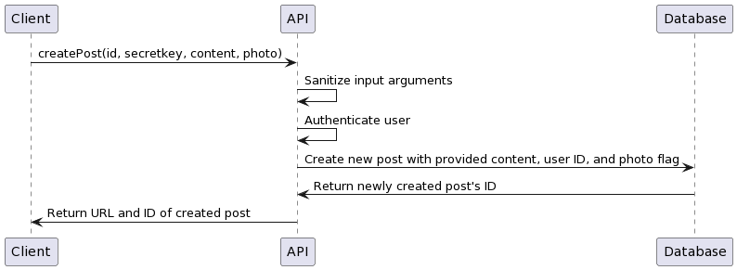

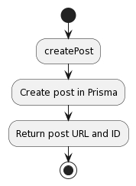

// Mutation to create a new post
createPost: {
type: LinkType, // The return type of the mutation
args: {
id: {type: GraphQLString}, // User ID
secretkey: {type: GraphQLString}, // User secret key for authentication
content: {type: GraphQLString}, // Content of the post
photo: {type: GraphQLBoolean}, // Indicates whether the post includes a photo or not
},
async resolve(parent, args, {prisma, auth, sanitise, log, req}) {
try {
// Sanitize the input arguments
args = sanitise(args)

// Authenticate the user
const exists = await auth(args.id, args.secretkey, req)

// Create a new post in the database
const post = await prisma.post.create({
data: {
content: args.content,
userId: args.id,
photo: args.photo,
},
select: {
id: true,
},
})

// Return the URL and ID of the created post
return {
url: `/post/id/${post.id}`,
id: post.id,
}
} catch (e) {
// Log any errors
log(e)
return
}
},
},

Tests

Test Case 1: Create a New Post with Content and Photo

Procedure
1. Sanitize the arguments.
2. Authenticate the user using the provided id and secret key.
3. Create a new post in Prisma with the provided content, user ID, and photo flag.
4. Return the URL of the created post and its ID.

Expected
1. Arguments are successfully sanitized.
2. User authentication is successful.
3. A new post is successfully created in Prisma with the provided content, user ID, and photo flag.
4. The URL of the created post and its ID are returned.

Step | Description | Input | Expected Output | Output/Finding | Pass/Fail
1 | Sanitize the arguments. | Valid user ID, secret key, content, and photo flag set to true. | Arguments should be successfully sanitized. | Arguments are successfully sanitized. | Pass
2 | Authenticate the user using the provided ID and secret key. | Valid user ID and secret key. | User authentication should be successful with valid ID and secret key. | User authentication is successful. | Pass
3 | Create a new post in DB with the provided content, user ID, and photo flag. | Valid content, user ID, and photo flag set to true. | A new post should be successfully created in DB with the provided content, user ID, and photo flag. | A new post is successfully created in DB with the provided content, user ID, and photo flag. | Pass
4 | Return the URL of the created post and its ID. | N/A | The mutation should return the URL of the created post and its ID. | The URL of the created post and its ID are returned. | Pass

Test Case 2: Create a New Post with Content Only

Procedure
1. Sanitize the arguments.
2. Authenticate the user using the provided ID and secret key.
3. Create a new post in Prisma with the provided content and user ID.
4. Return the URL of the created post and its ID.

Expected
1. Arguments are successfully sanitized.
2. User authentication is successful.
3. A new post is successfully created in Prisma with the provided content and user ID.
4. The URL of the created post and its ID are returned.

Step | Description | Input | Expected Output | Output/Finding | Pass/Fail
1 | Sanitize the arguments. | Valid user ID, secret key, content, and photo flag set to false or not provided. | Arguments should be successfully sanitized. | Arguments are successfully sanitized. | Pass
2 | Authenticate the user using the provided ID and secret key. | Valid user ID and secret key. | User authentication should be successful with valid ID and secret key. | User authentication is successful. | Pass
3 | Create a new post in DB with the provided content and user ID. | Valid content and user ID. | A new post should be successfully created in DB with the provided content and user ID. | A new post is successfully created in DB with the provided content and user ID. | Pass
4 | Return the URL of the created post and its ID. | N/A | The mutation should return the URL of the created post and its ID. | The URL of the created post and its ID are returned. | Pass

Test Case 3: Create a New Post with Photo Only

Procedure
1. Sanitize the arguments.
2. Authenticate the user using the provided ID and secret key.
3. Create a new post in Prisma with the provided photo flag and user ID.
4. Return the URL of the created post and its ID.

Expected
1. Arguments are successfully sanitized.
2. User authentication is successful.
3. A new post is successfully created in Prisma with the provided photo flag and user ID.
4. The URL of the created post and its ID are returned.

Step | Description | Input | Expected Output | Output/Finding | Pass/Fail
1 | Sanitize the arguments. | Valid user ID, secret key, photo flag set to true, and no content provided. | Arguments should be successfully sanitized. | Arguments are successfully sanitized. | Pass
2 | Authenticate the user using the provided ID and secret key. | Valid user ID and secret key. | User authentication should be successful with valid ID and secret key. | User authentication is successful. | Pass
3 | Create a new post in DB with the provided photo flag and user ID. | Valid photo flag set to true and user ID. | A new post should be successfully created in DB with the provided photo flag and user ID. | A new post is successfully created in DB with the provided photo flag and user ID. | Pass
4 | Return the URL of the created post and its ID. | N/A | The mutation should return the URL of the created post and its ID. | The URL of the created post and its ID are returned. | Pass

PostViewed

Analysis

The postViewed mutation is fired when a post is in the user’s viewport and adjusts the like-to-view ratio for that post, which will, in turn, be used to rank the post in future feeds.

View tracking is an important measurement for determining the engagement level of users and for understanding which posts are actually viewed by them while simultaneously engaging them. The postViewed mutation should track posts’ views and recalculate the post view metrics in real-time so that suggestions about most liked posts or recommendations on users' feeds can be made more strategically based on the like-to-view count ratio.

Strengths
- Provides real-time tracking of post views.
- Updates the like-to-view count ratio for accurate post rankings.
- Enables more personalized and engaging user feeds.

Weaknesses
- Potential performance impact if a large number of users view posts simultaneously.

Opportunities
- Utilize post-view data for advanced analytics and insights.

Threats
- Malicious users may attempt to inflate post views artificially.
- Privacy concerns regarding tracking user viewing behaviour.

Some of the features, such as offering the postViewed mutation that allows tracking post views and updating the rankings of the posts accordingly, have proven useful – in this case, re-evaluating the like-to-view ratio allows for personalising the user feeds. Some optimisations could include more performant code to perform better in extreme scenarios. For example, users with many followers would generate a large amount of traffic, so it would be helpful to coordinate those updates and prevent the overuse of servers. It is common knowledge that user feedback when they unfollow someone is a strong signal of disinterest. Such information can be reflected in the data to aid that. With some performance optimisations and privacy safeguards, the feature could be more effective and generate better trust with users.

Design

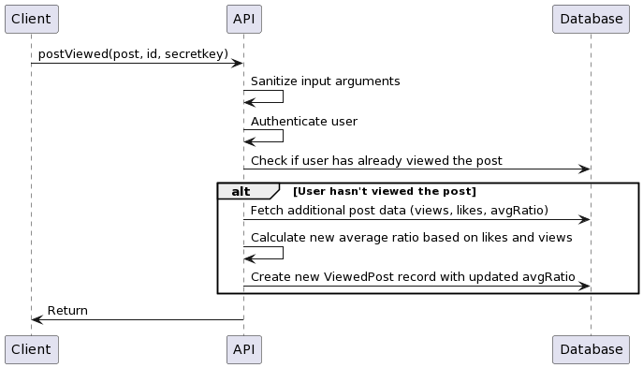

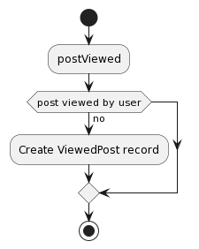

// Mutation to mark a post as viewed
postViewed: {
type: LinkType,
args: {
post: {type: GraphQLInt}, // Post ID
id: {type: GraphQLString}, // User ID
secretkey: {type: GraphQLString}, // User secret key for authentication
},
async resolve(parent, args, {auth, sanitise, log, req}) {
try {
// Sanitize the input arguments
args = sanitise(args)

// Authenticate the user
const exists = await auth(args.id, args.secretkey, req)

// Find the post and check if the user has already viewed it
const post = await prisma.post.findFirst({
where: {
id: args.post,
},
select: {
viewedBy: {
where: {
userId: args.id,
},
},
avgRatio: true,
},
})

// If the user hasn't viewed the post before
if (!post.viewedBy) {
// Fetch additional data about the post
const inDepth = await prisma.post.findFirst({
where: {
id: args.post,
},
select: {
viewedBy: true,
likedBy: true,
avgRatio: true,
},
})

// Calculate the average ratio based on likes and views
const ratio = inDepth.likedBy.length / (in-depth.viewedBy.length + 1)

// Create a new record in the ViewedPost table
await prisma.ViewedPost.create({
data: {
postId: args.post,
userId: args.id,
avgRatio: ratio,
},
})
}

return
} catch (e) {
// Log any errors
log(e)
return
}
},
},

PostLiked

Analysis

The postLiked mutation is triggered when a user double-taps on the post component, which leaves alike and affects the post's future visibility in user feeds.

It is a convention in social networks and content-sharing systems to allow users to appreciate a post by liking it. The postLiked mutation provides a solution to track post likes and update the appropriate field. Likes will allow better recognition of the users' interests in the post and facilitate ranking and recommendation accordingly.

Strengths
- Accurate post rankings.
- Encourages user engagement and interaction with content.

Weaknesses
- Potential misuse by users to artificially inflate post likes.

Opportunities
- Implement additional features, such as disliking or reactions, to capture more nuanced user sentiments.
- Utilize post-like data for targeted content recommendations and user profiling.

Threats
- Manipulation of post rankings through excessive or automated liking.
- Privacy concerns regarding tracking user liking behavior.

The post-liked mutation will automatically allow users to like content if they have an opinion about it, and it easily updates the timestamp, which can give accurate post rankings metrics in answers to post views that can result in a more accurate understanding of user behaviour and future indications. This feature can be handy if its members use it moderately and do not misuse it to affect others' post ranking. However, including some precautions in the post feature will increase its reliability and user's trust even more. For example, it is essential to include future precautions against possible privacy issues that can negatively affect user trust in the system in the long term.

Design

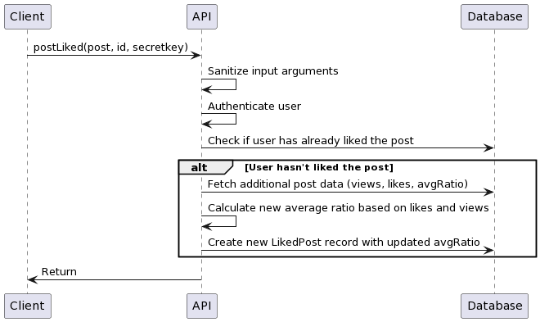

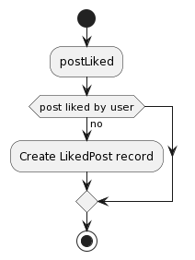

// Mutation to mark a post as liked
postLiked: {
type: LinkType,
args: {
post: {type: GraphQLInt}, // Post ID
id: {type: GraphQLString}, // User ID
secretkey: {type: GraphQLString}, // User secret key for authentication
},
async resolve(parent, args, {auth, sanitise, log, req}) {
try {
// Sanitize the input arguments
args = sanitise(args)

// Authenticate the user
const exists = await auth(args.id, args.secretkey, req)

// Find the post and check if the user has already liked it
const post = await prisma.post.findFirst({
where: {
id: args.post,
},
select: {
likedBy: {
where: {
userId: args.id,
},
},
avgRatio: true,
},
})

// If the user hasn't liked the post before
if (!post.likedBy) {
// Fetch additional data about the post
const inDepth = await prisma.post.findFirst({
where: {
id: args.post,
},
select: {
viewedBy: true,
likedBy: true,
avgRatio: true,
},
})

// Calculate the average ratio based on likes and views
const ratio = (inDepth.likedBy.length + 1) / inDepth.viewedBy.length

// Create a new record in the LikedPost table
await prisma.LikedPost.create({
data: {
postId: args.post,
userId: args.id,
avgRatio: ratio,
},
})
}

return
} catch (e) {
// Log any errors
log(e)
return
}
},
},

Chatroom Mutations

The Chatroom Mutations section describes the GraphQL mutations for message and user chatrooms. These mutations allow users to create chatrooms, send messages to each other, and update the state of these messages in real-time.

getLocation

Analysis

The getLocation mutation operates as follows: when called, it creates a new chat room with another user. It conveniently connects the user, making it easy for them to initiate a private conversation with another user and chat with them in a real-time environment.

Having users create chatrooms and allowing them to communicate is of utmost importance in any digital communications platform and any social network. The getLocation mutation solves the problem of correctly materialising chatrooms and creating or maintaining the requisite user-to-chatroom relationships necessary for those chatrooms and users to exist: chatrooms are created with properly scoped identifiers, and the users talking in them are correctly attached to the rooms they are supposed to be in.

Strengths
- Allows users to initiate private conversations with other users quickly.
- Generates a unique chatroom ID to ensure distinct and secure conversations.
- Emits real-time events to notify users about the newly created chatroom.

Weaknesses
- Limited error handling and user feedback in case of failures.

Opportunities
- Implement user-friendly error messages and recovery mechanisms for chatroom creation failures.
- Introduce additional features like chatroom settings, group chats, or chatroom deletion.
- End-to-end message encryption so that chats remain private.

Threats
- Malicious users may attempt to create chatrooms with unwilling participants.
- High volume of chatroom creations could strain system resources.

On the other hand, the getLocation mutation offers users an easy interface to create their chatrooms, invite participants, and send messages privately. The ability to create a random ID for each chatroom and track individual users who join helps secure it from spam or private conversations unwanted by the participants. If we add some robust error handling and feedback methods for users as well as extra features such as group chatting, it could improve user experience and make it more secure from potential threats.

Design

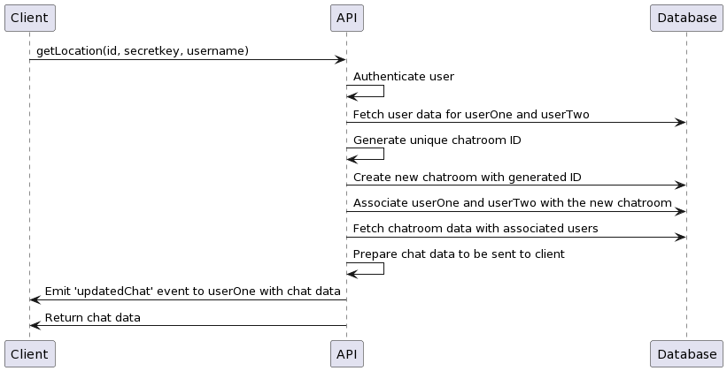
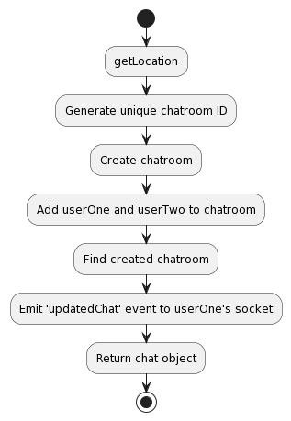

// Mutation to get location (create a new chatroom) and return its data
getLocation: {
type: ChatroomType,
args: {
id: {type: GraphQLString}, // User ID
secretkey: {type: GraphQLString}, // User secret key for authentication
username: {type: GraphQLString}, // Username of the other user to create chatroom with
},
async resolve(parent, args, {prisma, io, auth, log, req}) {
try {
// Authenticate the user and fetch user data
const [exists, userOne, userTwo] = await Promise.all([
auth(args.id, args.secretkey, req),
prisma.user.findFirst({
where: {
id: args.id,
},
select: {
id: true,
socket: true,
},
}),
prisma.user.findFirst({
where: {
username: args.username,
},
select: {
id: true,
},
}),
])

// Generate a unique chatroom ID
const {nanoid} = await import('nanoid')
const id = nanoid()

// Create a new chatroom
const chatroom = await prisma.chatroom.create({
data: {
id,
},
})

// Associate the two users with the newly created chatroom
await prisma.chatroomUser.create({
data: {
chatroomId: chatroom.id,
userId: userOne.id,
},
})

await prisma.chatroomUser.create({
data: {
chatroomId: chatroom.id,
userId: userTwo.id,
},
})

// Fetch the chatroom data with associated users
const data = await prisma.chatroom.findFirst({
where: {
id: chatroom.id,
},
select: {
id: true,
chatroomUsers: {
select: {
user: {
select: {
id: true,
name: true,
username: true,
},
},
},
},
},
})

// Prepare the chatroom data to be sent to the client
const chat = {
id: data.id,
chatroomUsers: data.chatroomUsers,
messages: [],
lastMessage: {},
}

// Emit the updated chat data to the first user
io.to(userOne.socket).emit('updatedChat', chat)

return chat
} catch (e) {
log(e)
return
}
},

Tests

Test Case 1: Create a new chatroom and add users

Procedure
1. Generate a unique chatroom ID using nanoid.
2. Create a new chatroom in the database with the generated id.
3. Add userOne to the chatroom as a chatroom user.
4. Add userTwo to the chatroom as a chatroom user.

Expected
1. A unique chatroom ID is generated successfully.
2. A new chatroom record is created in the database with the generated id.
3. UserOne is added to the chatroom as a chatroom user.
4. UserTwo is added to the chatroom as a chatroom user.

Test Case 2: Retrieve the created chatroom

Procedure
1. Retrieve the created chatroom from the database using the generated id.
2. Verify that the retrieved chatroom exists and contains userOne and userTwo as chatroom users.

Expected
1. The created chatroom is successfully retrieved from the database.
2. The retrieved chatroom contains userOne and userTwo as chatroom users.

Test Case 3: Emit 'updatedChat' event to userOne's socket

Procedure
1. Simulate the emission of an 'updatedChat' event to userOne's socket.
2. Verify that the event is emitted successfully.

Expected
1. The 'updatedChat' event is emitted successfully to userOne's socket.

sendMessage

Analysis

The sendMessage mutation enables the model to send messages within a chatroom and record them for future retrieval, enabling real-time communication between end-users in a manner that allows them to interact in a meaningful manner.

Messages are a core part of any communication platform. The logic of the sendMessage mutation guarantees that the message is scrutinised for validity and sanity, stored correctly, and should trigger real-time updates for all parties involved.

Strengths
- Enables real-time messaging between users within a chatroom.
- Validates and sanitizes user input to ensure data integrity and security.
- Stores messages in the database for future retrieval and persistence.
- Sharing of images.

Weaknesses
- Limited formatting options.

Opportunities
- Implement support for attaching images, files, or other media to messages.
- Introduce message formatting options, such as bold, italic, or links.
- Post previews on sharing.
- End-to-end encryption.

Threats
- Inappropriate or spam messages.
- A high volume of concurrent message sending could impact performance.

SendMessage mutation offers a reliable point-to-point communication channel for users' messages in a chatroom. It helps the system guarantee integrity by trimming out invalid inputs and sanitising malicious inputs, eliminating unfixable security problems. Simultaneous real-time updates of the user interface and persisted database records ensure smooth and interactive communication. The feature is a valuable addition to the platform, but we could greatly improve user experience and scalability by adding rich media attachment functionality, a variety of message options, and support for much higher messaging volumes.

Design

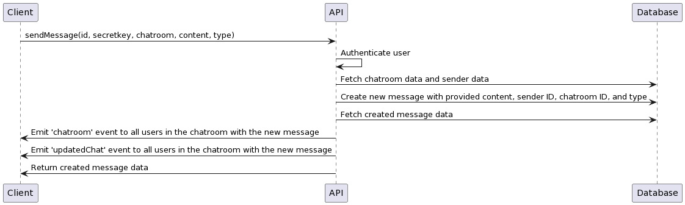

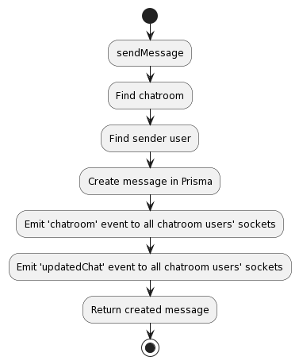

// Mutation to send a message in a chatroom
sendMessage: {
type: MessageType,
args: {
id: {type: GraphQLString}, // User ID
secretkey: {type: GraphQLString}, // User secret key for authentication
chatroom: {type: GraphQLString}, // Chatroom ID
content: {type: GraphQLString}, // Message content
type: {type: GraphQLString}, // Message type (e.g., text, image, etc.)
},
async resolve(parent, args, {io, prisma, auth, req}) {
try {
// Authenticate the user, fetch chatroom data, and sender data
const [exists, chatroom, sender] = await Promise.all([
auth(args.id, args.secretkey, req),
prisma.chatroom.findFirst({
where: {id: args.chatroom},
include: {
chatroomUsers: {
select: {
user: {
select: {
socket: true,
},
},
},
},
},
}),
prisma.user.findFirst({where: {id: args.id}, select: {id: true}}),
])

// Create a new message
const message = await prisma.message.create({
data: {
content: args.content,
senderId: sender.id,
chatroomId: chatroom.id,
type: args.type,
},
select: {
id: true,
sender: {
select: {
id: true,
username: true,
name: true,
},
},
content: true,
type: true,
date: true,
read: true,
},
})

// Emit the new message to all users in the chatroom
chatroom.chatroomUsers.map((user) => {
console.log(user.user.socket, 'SOCKETS EMITTING TO')
io.to(user.user.socket).emit('chatroom', message)
io.to(user.user.socket).emit('updatedChat', message)
})

return message
} catch (e) {
console.log(e)
return
}
},
},

Tests

Test Case: Create a new message and emit event to chatroom users

Procedure
1. Authenticate the user using the provided id and secret key.
2. Retrieve the chatroom information, including chatroom users' sockets.
3. Create a new message with the provided content, senderId, and chatroomId.
4. Emit a 'chatroom' event to all chatroom users' sockets with the message.
5. Emit an 'updatedChat' event to all chatroom users' sockets with the message.

Expected
1. User authentication is successful.
2. Chatroom information, including chatroom users' sockets, is retrieved successfully.
3. A new message is created with the provided content, senderId, and chatroomId.
4. The 'chatroom' event is emitted to all chatroom users' sockets with the new message.
5. The 'updatedChat' event is emitted to all chatroom users' sockets with the new message.

Step | Description | Input | Expected Output | Output/Finding | Pass/Fail
1 | Authenticate the user using the provided id and secret key. | User ID, user secret key | User authentication should be successful. | User authentication is successful. | Pass
2 | Retrieve the chatroom information, including chatroom users' sockets. | Chatroom ID | Chatroom information, including chatroom users' sockets, should be retrieved successfully. | Chatroom information, including chatroom users' sockets, is retrieved successfully. | Pass
3 | Create a new message with the provided content, senderId, and chatroomId. | Message content, sender ID, chatroom ID | A new message should be created with the provided content, senderId, and chatroomId. | A new message is created with the provided content, senderId, and chatroomId. | Pass
4 | Emit a 'chatroom' event to all chatroom users' sockets with the message. | New message data | The 'chatroom' event should be emitted to all chatroom users' sockets with the new message. | The 'chatroom' event is emitted to all chatroom users' sockets with the new message. | Pass
5 | Emit an 'updatedChat' event to all chatroom users' sockets with the message. | New message data | The 'updatedChat' event should be emitted to all chatroom users' sockets with the new message. | The 'updatedChat' event is emitted to all chatroom users' sockets with the new message. | Pass

EditMessage

Analysis

The editMessage mutation lets you mark a sent message as read, unread or delete it (by overwriting the content). It gives the sender a finite amount of control after sending their message, and on successful UI workflow design in the future, editing the message might be possible since the infrastructure exists in the resolver already.

When people use a messaging service, sometimes they need the ability to mark or unmark sent messages to read or unread, to make critical information stand out, add new information, or delete sent conversations so that the recipient does not see them. editMessage is an effort to combine these functionalities for a better user experience.

Strengths
- Enables users to toggle the state of sent messages – such as marking them as read or unread.
- Provides a mechanism for deleting messages by overwriting the content.
- Emits real-time events to keep all chatroom participants synchronized.

Weaknesses
- Message deletion is implemented by overwriting content rather than actual removal.
- Lack of a comprehensive message editing feature for now.

Opportunities
- Implement a more sophisticated message deletion mechanism with appropriate animations and user feedback.
- Introduce message editing functionality to allow users to modify sent messages.

Threats
- Manipulation of message states.
- Handling frequent message state changes or deletions could impact system performance.

The editMessage mutation is an important feature that adjusts the state and visibility of messages already sent. Allowing the user to mark a message whether they have read it or not will empower the user and improve the experience of the messaging history. Furthermore, introducing the ability to delete a message entirely with more sophistic difficulty would enhance the feature and overcome its downsides

Design

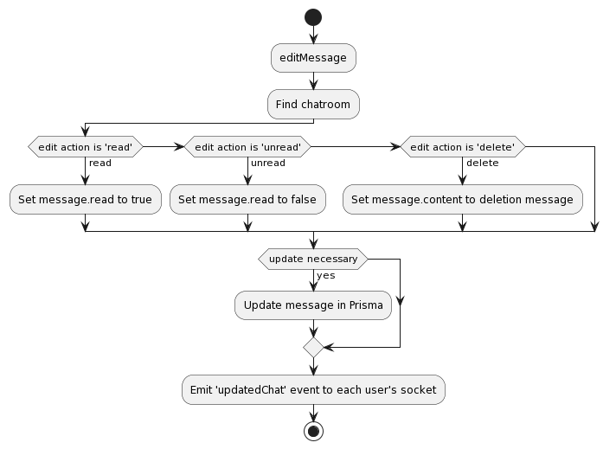

// Mutation to edit a message in a chatroom
editMessage: {
type: LinkType,
args: {
id: {type: GraphQLString}, // User ID
secretkey: {type: GraphQLString}, // User secret key for authentication
chatroom: {type: GraphQLString}, // Chatroom ID
message: {type: GraphQLString}, // Message ID
edit: {type: GraphQLString}, // Edit action (read, unread, delete)
},
async resolve(parent, args, {prisma, io, socket, req}) {
try {
// Authenticate the user
const exists = await auth(args.id, args.secretkey, req)

// Fetch the chatroom data with associated users' sockets
const chatroom = await prisma.chatroom.findFirst({
where: {
id: args.chatroom,
},
select: {
chatroomUsers: {
select: {
user: {
select: {
socket: true,
},
},
},
},
},
})

let updateData = {}

// Prepare update data based on the edit action
if (args.edit === 'read') {
updateData.read = true
} else if (args.edit === 'unread') {
updateData.read = false
} else if (args.edit === 'delete') {
updateData.content = 'This message has been deleted'
}

// Update the message if necessary
if (Object.keys(updateData).length > 0) {
await prisma.message.update({
where: {
id: args.message,
},
data: updateData,
})
}

// Emit the updated chat data to all users in the chatroom
chatroom.chatroomUsers.map((user) => {
io.to(user.socket).emit('updatedChat', updateData)
})

return
} catch (e) {
log(e)
return
}
},
},

Tests

Test Case 1: Edit Message - Mark as Read

Procedure
1. Authenticate the user using the provided ID and secret key.
2. Retrieve the chatroom information, including chatroom users' sockets.
3. Determine the edit action as 'read'.
4. Prepare update data to set msg.read to true.
5. Update the message in the database with the prepared update data.
6. Emit an 'updatedChat' event to each user's socket with the updated message.

Expected
1. User authentication is successful.
2. Chatroom information, including chatroom users' sockets, is retrieved successfully.
3. The edit action is correctly determined as 'read'.
4. Update data is prepared to set msg.read to true.
5. The message is successfully updated in the database with the updated read status.
6. An 'updatedChat' event is emitted to each user's socket with the updated message containing the read status set to true.

Step | Description | Input | Expected Output | Output/Finding | Pass/Fail
1 | Authenticate the user using the provided ID and secret key. | User ID, user secret key | User authentication should be successful. | User authentication is successful. | Pass
2 | Retrieve the chatroom information, including chatroom users' sockets. | Chatroom ID | Chatroom information, including chatroom users' sockets, should be retrieved successfully. | Chatroom information, including chatroom users' sockets, is retrieved successfully. | Pass
3 | Determine the edit action as 'read'. | Edit action | The edit action should be correctly determined as 'read'. | The edit action is correctly determined as 'read'. | Pass
4 | Prepare update data to set msg.read to true. | N/A | Update data should be prepared to set msg.read to true. | Update data is prepared to set msg.read to true. | Pass
5 | Update the message in the database with the prepared update data. | Message ID, update data | The message should be successfully updated in the database with the updated read status. | The message is successfully updated in the database with the updated read status. | Pass
6 | Emit an 'updatedChat' event to each user's socket with the updated message. | Updated message data | An 'updatedChat' event should be emitted to each user's socket with the updated message containing the read status set to true. | An 'updatedChat' event is emitted to each user's socket with the updated message containing the read status set to true. | Pass

Test Case 2: Edit Message - Mark as Unread

Procedure
1. Authenticate the user using the provided ID and secret key.
2. Retrieve the chatroom information, including chatroom users' sockets.
3. Determine the edit action as 'unread'.
4. Prepare update data to set msg.read to false.
5. Update the message in the database with the prepared update data.
6. Emit an 'updatedChat' event to each user's socket with the updated message.

Expected
1. User authentication is successful.
2. Chatroom information is retrieved successfully, including chatroom users' sockets.
3. The edit action is correctly determined as 'unread'.
4. Update data is prepared to set msg.read to false.
5. The message is successfully updated in the database with the updated read status.
6. An 'updatedChat' event is emitted to each user's socket with the updated message containing the read status set to false.

Step | Description | Input | Expected Output | Output/Finding | Pass/Fail
1 | Authenticate the user using the provided ID and secret key. | User ID, user secret key | User authentication should be successful. | User authentication is successful. | Pass
2 | Retrieve the chatroom information, including chatroom users' sockets. | Chatroom ID | Chatroom information, including chatroom users' sockets, should be retrieved successfully. | Chatroom information, including chatroom users' sockets, is retrieved successfully. | Pass
3 | Determine the edit action as 'unread'. | Edit action | The edit action should be correctly determined as 'unread'. | The edit action is correctly determined as 'unread'. | Pass
4 | Prepare update data to set msg.read to false. | N/A | Update data should be prepared to set msg.read to false. | Update data is prepared to set msg.read to false. | Pass
5 | Update the message in the database with the prepared update data. | Message ID, update data | The message should be successfully updated in the database with the updated read status. | The message is successfully updated in the database with the updated read status. | Pass
6 | Emit an 'updatedChat' event to each user's socket with the updated message. | Updated message data | An 'updatedChat' event should be emitted to each user's socket with the updated message containing the read status set to false. | An 'updatedChat' event is emitted to each user's socket with the updated message containing the read status set to false. | Pass

Test Case 3: Edit Message - Delete Message Content

Procedure
1. Authenticate the user using the provided ID and secret key.
2. Retrieve the chatroom information, including chatroom users' sockets.
3. Determine the edit action as 'delete'.
4. Prepare update data to set msg.content to 'This message has been deleted'.
5. Update the message in the database with the prepared update data.
6. Emit a 'updated chat' event to each user's socket with the updated message.

Expected
1. User authentication is successful.
2. Chatroom information, including chatroom users' sockets, is retrieved successfully.
3. The edit action is correctly determined as 'delete'.
4. Update data is prepared to set msg.content to 'This message has been deleted'.
5. The message is successfully updated in the database with the message content deleted.
6. An 'updatedChat' event is emitted to each user's socket with the updated message containing the message content set to 'This message has been deleted'.

Step | Description | Input | Expected Output | Output/Finding | Pass/Fail
1 | Authenticate the user using the provided ID and secret key. | User ID, user secret key | User authentication should be successful. | User authentication is successful. | Pass
2 | Retrieve the chatroom information, including chatroom users' sockets. | Chatroom ID | Chatroom information, including chatroom users' sockets, should be retrieved successfully. | Chatroom information, including chatroom users' sockets, is retrieved successfully. | Pass
3 | Determine the edit action as 'delete'. | Edit action | The edit action should be correctly determined as 'delete'. | The edit action is correctly determined as 'delete'. | Pass
4 | Prepare update data to set msg.content to 'This message has been deleted'. | N/A | Update data should be prepared to set msg.content to 'This message has been deleted'. | Update data is prepared to set msg.content to 'This message has been deleted'. | Pass
5 | Update the message in the database with the prepared update data. | Message ID, update data | The message should be successfully updated in the database with the message content deleted. | The message is successfully updated in the database with the message content deleted. | Pass
6 | Emit an 'updatedChat' event to each user's socket with the updated message. | Updated message data | An 'updatedChat' event should be emitted to each user's socket with the updated message containing the message content set to 'This message has been deleted'. | An 'updatedChat' event is emitted to each user's socket with the updated message containing the message content set to 'This message has been deleted'. | Pass

Socket Server

Analysis

Web sockets are vital for enabling real-time, bidirectional communication between clients and servers over a single, long-lived connection. Unlike traditional HTTP requests, which are stateless and typically involve separate connections for each request/response cycle, web sockets provide a persistent connection that allows data to be transmitted in both directions instantaneously. This capability is crucial for applications requiring live updates, such as chat applications, online gaming platforms, stock market tickers, and collaborative document editing tools. Web sockets leverage the WebSocket protocol, which operates over TCP and is standardised by the Internet Engineering Task Force (IETF) as RFC 6455.

The power of web sockets helps maintain a persistent connection between the client and the server, so data can be sent instantly in both directions and immediate interactions, such as live updates, chat applications, notifications, and collaborative applications, can be realised.

Web sockets provide several clear benefits over an HTTP request-response cycle. Unlike HTTP, where every request and response requires a new connection between client and server, web sockets share a single, long-lived connection. This connection persists over time, reducing or eliminating the overhead of spinning up new connections for every data exchange, making things faster.

The Socket Server in this project is built using the Socket.io library, which is a robust implementation of web sockets that enables us to wrap a web socket behind a long-poll HTTP request, creating code that maintains and establishes connections, given that it automatically notifies us when a client opens a connection with the server. It also enables bi-directional real-time data flow from the server to clients.

On a social media platform where real-time communication is crucial to delivering relevant and engaging user experiences (instant updates, live notifications, fast and frictionless collaboration with other users), traditional HTTP traffic's request-response style limits providing that experience. With each HTTP request, there is latency between the user requesting and the server fulfilling it and a limit to what the server can initiate with the client.

Secondly, social media often involves large numbers of simultaneous users and frequent data updates. Managing these situations involves a problem that a scalable and performant communication mechanism can address. Web sockets' persistent connections and two-way data flow suit these services.

The Socket Server aims to solve the following problems:
- Real-time persistence: Information such as notifications, chat messages, and other live updates should reach users in real-time, without the need to continuously poll for updates.
- Reduce latency: Because it uses persistent connections, the Socket Server reduces the latency in establishing a new connection for every data exchange.
- Handle concurrency well: The socket server must be able to accept many concurrent users and handle a high volume of connections.
- Speed up the rate at which updates are sent: Rather than waiting for the user to move or sending only at specified intervals, the Socket Server should transmit this information much faster.
- Bidirectional communication: For all parties to point, draw and edit in real-time, the Socket Server should be able to handle a double-sided stream of data from the server to the clients and from clients to the server.

Design

When a client connects to the Socket Server, a handler for that event is invoked, which, in this case, is called 'initialConnection'. The server code handling the initial connection event performs the following steps:
- Sanitise the incoming data to ensure security and prevent any malicious input.
- Authenticate the user by verifying the ID and secret key they provided.
- If the authentication is successful, set the user's socket ID in the DB using Prisma.
- Broadcast an 'auth' event to the client that says whether or not the authentication was successful.

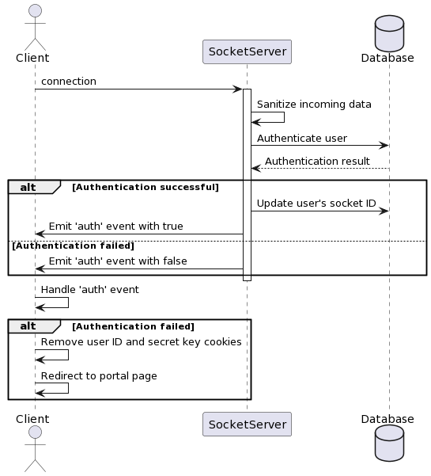

io.on('connection', (socket) => {
socket.on('initialConnection', async (data) => {
try {
// Sanitizing the incoming data
data = sanitise(data)

// Checking if the user data exists and is valid
const exists = await prisma.userData.count({
where: {
AND: [
{id: data.id},
{secretkey: data.key},
{expiry: {gt: new Date(Date.now())}},
],
},
})

if (!exists) {
// If the user data is invalid, emit an 'auth' event with false
io.to(socket.id).emit('auth', false)
return
} else {
// If the user data is valid, update the user's socket ID and emit an 'auth' event with true
await prisma.user
.update({where: {id: data.id}, data: {socket: socket.id}})
.then(() => {
io.to(socket.id).emit('auth', true)
})
}
} catch (e) {
// Logging any errors that occur
log(e)
}
})

//..
}

On the client side, the initial connection logic is handled in the Context component, wrapping the entire single-page application. The client initialises two state variables for the user ID and secret key using cookies. When the component mounts or the user ID or secret key changes, the client emits an event 'initialConnection' to the server and provides the user ID and secret key as payload.

If the check fails, the client-side logic removes the cookies containing the user ID and secret key, redirecting the user to the portal page. This way, unauthenticated clients cannot receive messages on the socket channel.

socket.on("auth", (data) => {
console.log(data);
// If authentication fails, remove id and secretkey cookies and redirect to /portal
if (!data) {
Cookies.remove("id");
Cookies.remove("secretkey");
window.location.href = "/portal";
}
});

Other Communication Channels

Followed
Purpose: Notifies the followed user when someone follows them.
Triggered by: followUnfollowUser mutation.
Implementation: The server sends a 'follower' event to the followed socket, letting them know they just got a new follower.

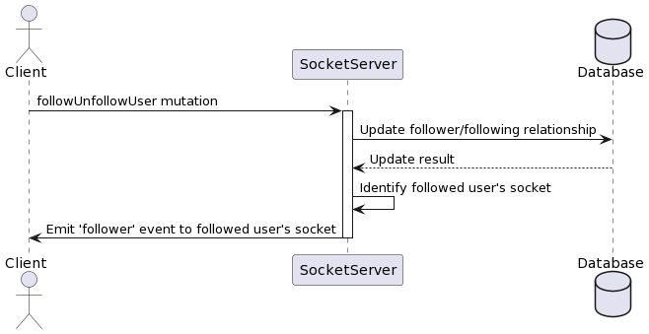

updatedChat
Purpose: Sends a new message to a user's message list.
Triggered by: getLocation mutation.
Implementation: Latest message is sent in a new chat room when an event is fired from the server for each new message; every relevant client receives it and updates the message list accordingly.
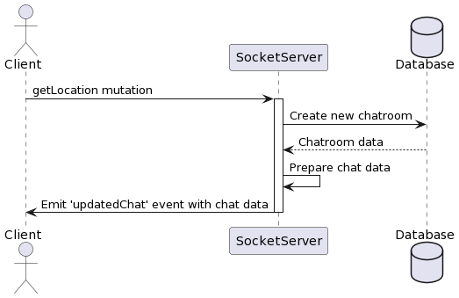
ommunication between users in a chatroom.
Triggered by: sendMessage mutation.

chatroom
Purpose: Facilitates real-time communication between users in a chatroom.
Triggered by: sendMessage mutation.

Front End

The front end is the interface between the client and the back end of the application. The front end must be clean, easy to use, reactive, and performant. It must provide the right data to the right person when necessary.

That's why I chose ReactJS. React is an open-source JavaScript library maintained by Facebook to build user interfaces, especially single-page applications where UI components are updated frequently. React avoids the complications of sharing data by designing the app so that each component is isolated from the rest unless data explicitly goes through it. The developer can create reusable UI components and maintain their state using this approach.

React's appreciation of modularisation through component-based architecture is one of the defining aspects of the technology. The idea is that a user interface can be decomposed into smaller self-contained pieces called components, which can then be reused repeatedly while encapsulating the structure, logic, and styling for those specific pieces. It means a component is 'closed' in that you shouldn't have to know anything about its internals when using it, and it's 'open' in the sense that others can use it without interfering with how it works. Modularisation and deployment The strength of this modularisation and encapsulation are among the biggest advantages of the development process.

Code reusability will likely be a main objective for the application because reusable components encourage developers to write a component once and reuse it throughout the application. This decreases code duplication, saves development time and makes the codebase easier to maintain because if one component needs to be updated or fixed, it can be done in one place, and its effects will be felt everywhere the component is used.

Second, reusable components enforce consistency of design and user experience across the application. By defining a 'design system' of common components (for example, buttons, forms, cards), developers can guarantee that the look and feel of the application are also consistent. Usability increases because users seldom relearn how to interact with a feature or page (Jacob’s Law).

React's component-based architecture also greatly facilitates collaboration among developers. Unlike in more traditional systems, where each developer might have a different understanding of what each part of the system is supposed to do, React's components have a well-defined boundary and interface. Each developer can easily work on a separate system component without stepping on each other's toes. This leaves each developer with a clear task and facilitates coordinated work among multiple developers, often allowing for parallel development and dramatically speeding up the whole development process.

But React also has some issues. One of the disadvantages of React is the fact that there's a learning curve: React, as well as most of its ecosystem, introduce new concepts and patterns (such as a JSX or a virtual DOM or unidirectional data flow) that are often completely new to developers hardly familiar with React. It takes time and effort to understand them.

I have mentioned some potential pitfalls of React above. There can be some frustration with the changing landscape. React itself is active and changing constantly, but the ecosystem around React evolves even faster for example whilst developing the platform, React itself had a major update where know the virtual DOM is rendered obsolete, instead opting for a compiled means of rendering like other leading front end libraries and frameworks. Most good libraries and tools are under active development, but even if some of the little parts of the tooling are stagnant, their ecosystem will have changed. Developers will need to learn and do more daily to be part of the React universe.

Nevertheless, React is an effective and popular tool for developing modern web applications, utilising the ideas of composition, reuse and optimisation for performance.

Routing

React Router is a routing library widely used with React applications. It provides a declarative syntax for specifying routes in a user interface and mapping requests to UI components using URLs. For instance, a single component can render all users on the first page while another part of the application displays detailed information about a user based on their ID when a specific URL path is requested.

React Router defines a routes schema in the <Route> component. A route is a path and a component is rendered when a given path is matched. The <Router> component wraps the application and runs the logic to decide what to render.

When you attempt to open http://example.com/users/5, React Router matches the path /users/5 with the defined /users path and then renders the appropriate component while also maintaining the application's history in order to allow you to 'go forward' and 'go back' in the application.

React Router supports various types of routing, including:

Browser Router: The browser takes over routing. Based on the HTML5 history API, the UI is maintained in sync with the URL, resulting in a clean, human URL structure.

Hash Router: Because it uses the hash part of the URL, it's helpful if you want to keep data in sync across the UI but use a browser that doesn't support the latest HTML5 history API.

Memory Router: Memory Router keeps the URL history in System Memory (very useful for testing or non-browser environments).

React Router also provides additional components and features, such as:

Link: Creates a navigational link to a specific route.
NavLink: Similar to Link, but allows for styling the active link.
Route Parameters: Custom segments in the path of the URL become parameters in the component.
Nested Routes: Enables the creation of nested routes for complex application structures.
Redirects: Allows for programmatic redirection to a different route.

Private and Public Routes

The social media platform has two categories of routes: public and private routes.

Public Routes

Anyone can follow these routes without authentication. They are made for authentication purposes, such as creating new accounts or sharing public information. Routes without authentication do not have secrets and do not modify existing data.

Public routes in the application include:

/portal: An entrance to the application where a user can log in or sign up.

/onboarding: Creating an account, signing up and data collection.

/sign_in: The path for users to sign in with their platform credentials.

/404: The error page is displayed when a requested page is not found.

/post/id/{:id}: View a post

Private Routes

Private routes are visible only to authenticated logged-in users. These routes deal with the important parts of your application and leverage the privilege of your users by making them take action.

If an unauthenticated user attempts to access a private route, they are immediately redirected to /portal, where they can sign in or create an account.

Private routes in the application include:

/: Home page, mainly to display feed

/messaging: Displays all chatrooms the user is a part of

messaging/id/{:id}: Displays the chatroom of parameter id

/post: User can create and post a post

/profile/{:id}: View the profile of a user

/search: Multiple use-case search

/settings: Change user info and validate friend requests

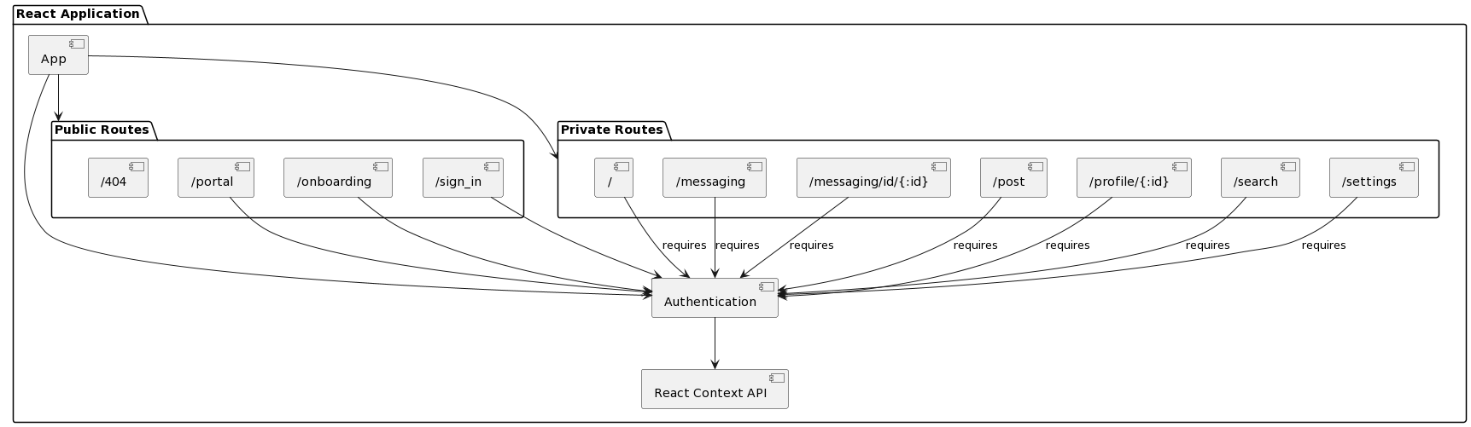
The social media application's front end uses React Router for routing and navigation. React Router offers a declarative way of defining routes and mapping them to their corresponding components and seamless dynamic navigation for single-page applications.

There are two types of routes: public and private. Public routes are available to any user and can be used to authorise and create accounts. However, private routes are available only after the user has been authenticated and provided access to the application's main functionality.

We control authentication via the React Context API, and the Context Component serves as the state store from which any part of the application can read or write. It stores the user's authentication status and passes it to the components that ask for it.

In parallel, React Router is leveraged to restrict access to private areas and functionality to authenticated users alone. At the same time, React Context API-guided authentication enables creating multiple alias users for testing purposes via paths.

Portal

Analysis

Path: /portal
Intention: Gives users options to sign up and sign in

It handles the authentication, grounds the user, and acts as the initial hub for interaction. From the moment a user enters the system, the portal page acts as the bridge to the application through a simple, single interface. The portal page effectively hides the complexity of authentication, instilling a confident level of familiarity and comfort for users right from the outset.

A central idiom of the Portal page is an integration with the Auth System (through OAuth, so users can sign in with a Google account). Unfortunately, this feature is currently disabled because the Google SignIn feature sends security-sensitive information via URL parameters, and we are fixing it. Of course, you can also sign in with your platform-specific credentials and create a new account if you do not have one yet.

<div style={styles.buttons} className="buttons">
<Link to="/sign_in" style={styles.button}>
Sign In
</Link>
<Link to="/onboarding" style={{ textDecoration: "none" }}>
Sign Up
</Link>
</div>

We enrich the visual feel and motivate the user to engage with the Portal page by using a dazzling animation on the Portal page that recreates the Circular Queue—a dynamic carousel of images of other simulated users' profiles. This helps build a sense of community with other users. We implement the animation with React's impressive rendering ability and component architecture.

Built using a mobile-first approach, it is designed to be responsive on all devices and to any screen size, taking full advantage of modern web technologies and providing consistent user-experience design best practices across multiple platforms and browsers.

The Portal page is a fundamental element for the platform experience. Its content and layout set the tone for what follows during a visitor's first encounter with the platform. It should be free of clutter and inoffensive to encourage the user to continue on their path to signing up or signing in.

React implements the component architecture, and each component can be written independently to be modular and reusable—this helps to maintain and scale the Portal page smoothly if the platform develops further in the future. React provides many infrastructures to manage the interactive components in a webpage, such as state management, a couple of lifecycle methods for different conditions, and hooks for edge-case scenarios.

The Portal page interacts with the Auth System to improve the page experience by building a natural authentication flow. The Auth System handles authentication logic under the hood, communicating via secure channels with the server to verify the user's identity and manage the authenticated sessions. The Portal makes authentication simple and reliable by moving authentication logic behind a clear-cut interface.

Because it is a Single Page Application (SPA) written in React, the Portal page is parlay to client-side rendering, which means that the only HTML that the browser sees at the beginning is minimal boilerplate, and the majority that is rendered comes only later, dynamically generated by JavaScript on the client-side. This is a real problem for search engine crawlers that are largely server-side-dependent, where the way to see what a webpage is about is first to download the static and complete HTML from the server.

Since the Portal page is our entry point, getting it crawlable is non-negotiable. To check the SEO friendliness and crawlability of the Portal page, a website crawler tool was created and ran on the page, but it did not fetch any results, meaning the page is not crawlable. This is a threat to our reach with search engines. In order to improve the SEO and crawlability of the portal, an opportunity for the crawler is to have server-side rendering (SSR), which allows the initial HTML served to the browser to be fully rendered content that is easily crawled by search engines.

Strengths
Clean and intuitive user interface that guides users towards signing up or signing in.
Integration with the Auth System for secure and reliable authentication.
Visually appealing animation that engages users and creates a positive first impression.
Responsive design that ensures accessibility across different devices and screen sizes.
Modular and maintainable codebase using React's component-based architecture.

Weaknesses
Temporary disabling of the Google SignIn functionality due to security concerns.
Potential performance impact on older devices or slower network connections.

Opportunities
Expansion of authentication options to include other popular social media platforms.
Integration of additional features, such as personalised recommendations or onboarding tutorials.
Optimisation for search engine visibility and improved SEO rankings.
Localisation and internationalisation to cater to a global user base.

Threats
Competitors offering a more streamlined or feature-rich authentication experience.
Security vulnerabilities associated with the transmission of sensitive information.
Modifications to the browser policy or authentication protocol might necessitate authentication flow changes.
User preference for alternative authentication methods or reluctance to create new accounts.

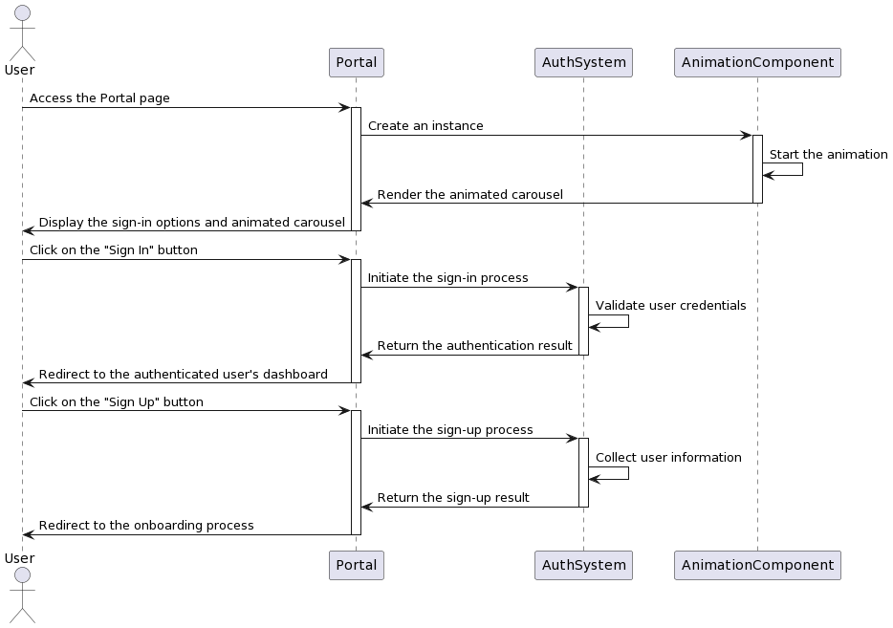
Animation

Animation on the Portal page, including a colourful carousel of user profile images. These features directly influence the experience the users have as they interact with the UI. They ensure that users have some visual pizzazz and are met with a positive first impression. The carousel of user profile images can be seen in an animation on the 'Portal' page of the app. In the past, we would have written the animation as a few lines of vanilla JavaScript. However, React allows us to create elements like this in a component-based manner. In React, this is achievable by breaking down code into reusable and modular pieces.

This carousel of user profile images provides visual pizzazz while leaving the user with a good impression. The animation is implemented visually with a circular queue data structure composed of two endless queues of images. The two queues, which share the five images displayed, are implemented by the ProfileTop and ProfileBottom components. These movement components accept incoming properties like the list of images from the container in addition to holding their animation data between themselves, such as the profilesTop and profilesBottom image queues composed of Profile data components and the horizontal offset of the animations. I understand that I could have turned this into one singular component, however, I decided that since this component was to stay only on the profile page, it would do until future needs for optimisation which would leave an end-user feeling that we had improved whilst not actually doing much.

function ProfileTop(props) {
const { path } = props;
return (
<div
style={{
display: "flex",
flexDirection: "column",
alignItems: "center",
justifyContent: "center",
borderRadius: 8,
cursor: "pointer",
textAlign: "center",
transform: `translateX(-${val}px)`,
transition: "transform 0.5s ease defer",
}}
>
<div
style={{
borderRadius: 800,
backgroundColor: "#F3F3F3",
backgroundImage: `url(/${path})`,
backgroundSize: "cover",
height: 80,
width: 80,
backgroundPosition: "50% center",
boxShadow:
"2px 2px 16px 0 rgba(133, 132, 131, 0.5), -4px -2px 16px rgba(243, 243, 243)",
}}
>
&nbsp;
</div>
</div>
);
}

function ProfileBottom(props) {
const { path } = props;
return (
<div
style={{
display: "flex",
flexDirection: "column",
alignItems: "center",
justifyContent: "center",
borderRadius: 8,
cursor: "pointer",
textAlign: "center",
transform: `translateX(${val}px)`,
transition: "transform 0.5s ease defer",
}}
>
<div
style={{
borderRadius: 800,
backgroundColor: "#F3F3F3",
backgroundImage: `url(/${path})`,
backgroundSize: "cover",
height: 80,
width: 80,
backgroundPosition: "50% center",
boxShadow:
"2px 2px 16px 0 rgba(133, 132, 131, 0.5), -4px -2px 16px rgba(243, 243, 243)",
}}
>
&nbsp;
</div>
</div>
);
}

The animation shifts each image to one position on the left (or right) at a time. The top images shift their position from right to left, and the bottom images shift their position from left to right, which results in a displacement effect that creates the illusion of a carousel. The animation plays at an optimised speed and timing to make it feel fluid and visually pleasing. Powered by React's efficient rendering and state management, the animation runs smoothly and consistently across various devices–even inexpensive ones that may have fewer available resources. The React components ProfileTop and ProfileBottom are made to be reusable and modular and can be plugged in wherever needed in the application. The same component can be reused on several other pages, saving time and making the code more manageable, resulting in less overall work needed.

Its functioning is based on a circular queue effect, where the images compose two endless queues (one at the top and another at the bottom). Every time a step advances, the position of every image moves one position left, so we have a displacement effect from right to left (top images) and vice versa (bottom images). It is an animation that should be seen in action; the speed and timing of its execution are of the utmost importance.

useEffect(() => {
let count = 0;
const animationInterval = setInterval(() => {
removeX.current = removeX.current + 1;
setVal((val) => val + 1);
if (removeX.current == 96) {
let one = queueTop.current.shift();
queueTop.current = queueTop.current.concat(one);
let two = queueBottom.current.pop();
queueBottom.current = [two, ...queueBottom.current];
count -= 96;
removeX.current = removeX.current - 96;
setVal((val) => val - 96);
}
}, 40);

return () => {
clearInterval(animationInterval);
};
}, []);

Conclusively, the Portal page is the first introduction to the user. It handles authentication flawlessly and provides users with a user-friendly login experience. The user interface of the portal page itself is minimalistic, with animations that complement and grab the user's attention. It offers a variety of ways for users to authenticate, which gently guides users through, helping them understand and anticipate their needs at each step of the login session. The animation on the Portal page was implemented using React's component-based architecture. The item carousel on the Portal page uses the ProfileTop and ProfileBottom components to create a circular queue queuing effect to display user profile images.

Design

Initial (The front proved to be too small)



Final

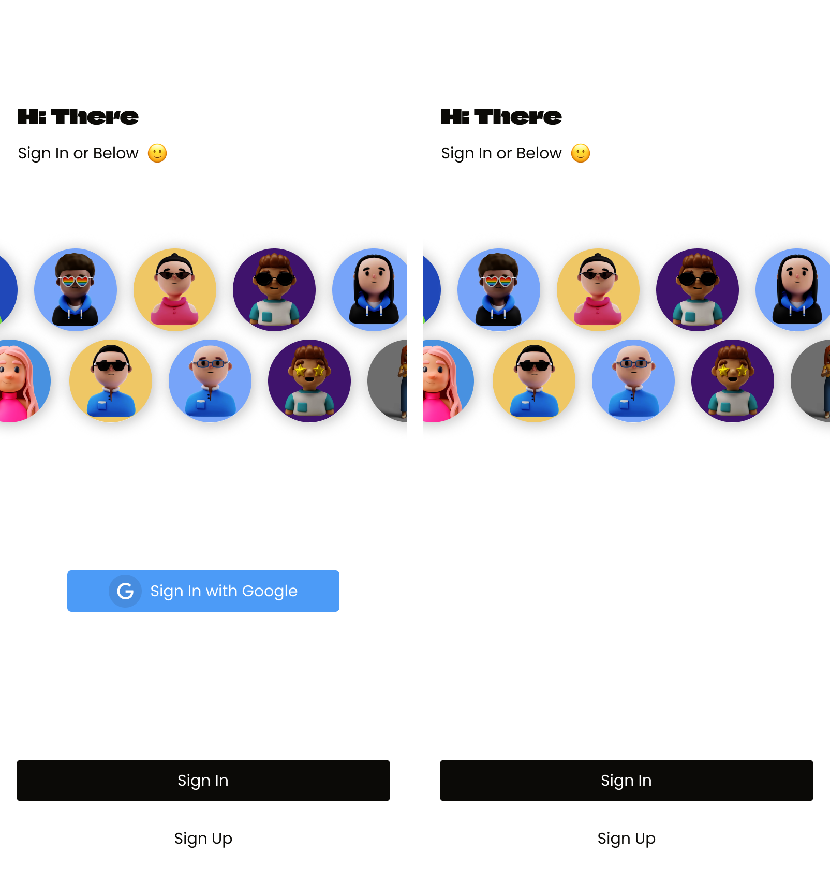

Tests

Test Case 1: Rendering and Display

Procedure
1. Render the `Portal` component.
2. Observe the displayed content.

Expected
- The component should render without crashing.
- The component should display a section containing sign-in options, a greeting message, and profile images.
- The profile images should be displayed in a carousel-like manner, transitioning smoothly.
- The sign-in options should include "Sign In with Google", "Sign In" button, and "Sign Up" link.
- The greeting message should include a welcoming heading, a subheading, and a smiling emoticon.

Input | Expected Output | Actual Output | Pass/Fail
Render the Portal component. | The component should render without crashing. | The component renders without crashing. | Pass
Observe the displayed content. | The component should display a section containing sign-in options, a greeting message, and profile images. | The component displays a section containing sign-in options, a greeting message, and profile images. | Pass
 | The profile images should be displayed in a carousel-like manner, transitioning smoothly. | The profile images are displayed in a carousel-like manner, with smooth transitions. | Pass
 | The sign-in options should include "Sign In with Google", "Sign In" button, and "Sign Up" link. | The sign-in options include "Sign In with Google", "Sign In" button, and "Sign Up" link. | Pass
 | The greeting message should include a welcoming heading, a subheading, and a smiling emoticon. | The greeting message includes a welcoming heading ("Hi There!"), a subheading ("Sign in below"), and a smiling emoticon. | Pass

Test Case 2: Sign In with Google Option

Procedure
1. Render the `Portal` component.
2. Click on the "Sign In with Google" button.

Expected
- Upon clicking the "Sign In with Google" button, the user should be redirected to the Google authentication page.

Input | Expected Output | Actual Output | Pass/Fail
Render the Portal component. | - | - | -
Click on the "Sign In with Google" button. | Upon clicking the "Sign In with Google" button, the user should be redirected to the Google authentication page. | When the "Sign In with Google" button is clicked, the user is redirected to http://127.0.0.1:8000/auth/google, which is the Google authentication page. | Pass

Test Case 3: Sign In Button

Procedure
1. Render the `Portal` component.
2. Click on the "Sign In" button.

Expected
- Upon clicking the "Sign In" button, the user should be redirected to the sign-in page.

Input | Expected Output | Actual Output | Pass/Fail
Render the Portal component. | - | - | -
Click on the "Sign In" button. | Upon clicking the "Sign In" button, the user should be redirected to the sign-in page. | When the "Sign In" button is clicked, the user is redirected to the /sign_in route, which is the sign-in page. | Pass

Test Case 4: Sign Up Link

Procedure
1. Render the `Portal` component.
2. Click on the "Sign Up" link.

Expected
- Upon clicking the "Sign Up" link, the user should be redirected to the sign-up page.

Input | Expected Output | Actual Output | Pass/Fail
Render the Portal component. | - | - | -
Click on the "Sign Up" link. | Upon clicking the "Sign Up" link, the user should be redirected to the sign-up page. | When the "Sign Up" link is clicked, the user is redirected to the /onboarding route, which is the sign-up page. | Pass

Sign In

Analysis

Path: /sign_in
Intention: A graphical interface facilitating a user's sign-in to the platform

External Components Used
Input Component: A reusable component for capturing user input, such as username and password.

The SignIn Page ensures user authentication. It provides a frontend that allows users to provide their credentials and successfully sign in to the platform.

The SignIn component is the most critical component of the user authentication system. It is responsible for receiving the user's input and authenticating them. The component design should ensure that users receive an intuitive sign-in experience. It should be able to handle input validation, take care of the API calls, handle errors and redirect the users to other components in the app – all while being responsive across different platforms and screen sizes. The SignIn component should be designed to guide users to sign in successfully by providing clear instructions and giving feedback on their inputs. The SignIn component should integrate with the Auth System to securely submit users' credentials to the authentication service to have it take care of the authentication logic for the users. The component should also use the appropriate loading indicators and error messages to enhance the UX for users. To avoid giving users a bad experience, the SignIn component should also handle edge cases securely, such as invalid credentials and a broken internet connection, without soliciting additional input from users.

The SignIn component relies on the useState hook for React to manage the internal component state via the following state variables:
username: Stores the username entered by the user.
pass: Stores the password entered by the user.
position: Keeps track of the current input screen (0 for username, 1 for password).
load: Indicates whether the sign-in API call is in progress.

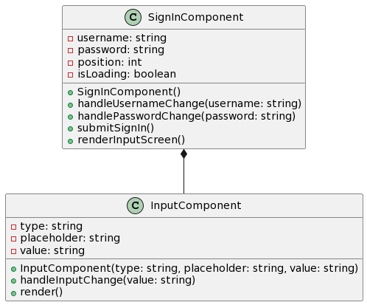

const [username, setUsername] = useState("");
const [pass, setPass] = useState("");
const [position, setPosition] = useState(0);
const [load, setLoading] = useState(false);

The SignIn component uses the User Mutations signIn API resolver to sign in the user. It implements this using Apollo Client's useMutation hook to make the sign-in API call.

const [signIn, { data, loading, error }] = useMutation(SIGN_IN);

The signIn function returned by useMutation can then be called to invoke the call to the server API that logs us in, using the username and password. The loading and error variables tell us about the state of the call.

async function call() {
const res = await signIn({ variables: { username, pass } });
if (res.data.signIn.secretkey && res.data.signIn.id) {
// Set cookies and navigate to the home page
Cookies.set("secretkey", res.data.signIn.secretkey, { expires: 7 });
Cookies.set("id", res.data.signIn.id, { expires: 7 });
navigate("/");
}
}

The call function makes the API call and processes the return. It extracts the secret key and user ID from the response and sets those as cookies, which expire in 7 days. This will allow the user to log in persistently to all sessions for the next week.

Cookies.set("secretkey", res.data.signIn.secretkey, { expires: 7 });
Cookies.set("id", res.data.signIn.id, { expires: 7 });

If there is an error, the SignIn component displays an alert message. This gives the user immediate feedback about improving UX.

if (error) alert("Error Signing In");

Navigation Next, the SignIn component uses the useNavigate hook from react-router-dom to redirect the user to the route "/." Finally, the user is directed to the home page.

const navigate = useNavigate();
// ...
navigate("/");

We navigate to the home page, and the user lands on the app's main contents (below the sign-in). Handling an Input: The SignIn component uses a [[Input Component]] [[Search for "Input Component" here]] to capture the user's input (username, password). An array of InputScreens is defined, with one screen for username input and another for password input.

const screens = [
<Input
type= "text"
placeholder=" | What is your username?"
value={setUsername}
referer={null}
/>,
<Input
type= "password"
placeholder=" | What is your password?"
value={setPass}
last={username}
referer={null}
/>,
];

This Input Component renders a standardised user interface for user input that accepts prop args (type, placeholder, value, referer) to customise its behaviour and UI. Note that the Position state property determines precisely which input screen renders.

return <>{!load && screens[position]}</>;

This conditional rendering means that the app correctly presents the input screen depending on the state of the sign-in process.

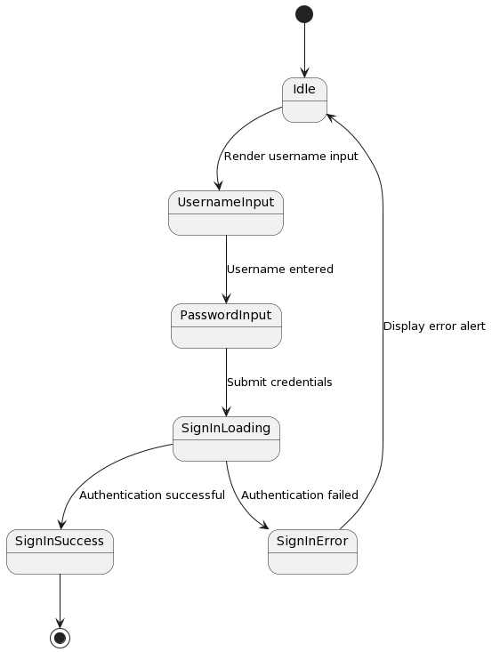

Strengths
- A user-friendly interface for capturing usernames and passwords.
- Integration with the User Mutations signIn API resolver for secure authentication.
- Proper error handling and user feedback through alert messages.
- Secure management of authentication tokens using cookies with expiration.
- Seamless navigation to the home page is available upon successful sign-in.
- Utilisation of reusable components for modularity and consistency.
- Form validation, sanitation and character limiting

Weaknesses
- Dependence on the browser alert is not an optimal user experience.
- Potential security risks associated with storing sensitive information (secret key) in cookies.

Opportunities
- Implement form validation and input sanitisation to enhance security and user experience.
- Explore alternative methods for securely storing and transmitting authentication tokens.
- Provide more informative and user-friendly error messages and feedback.
- Implement password strength validation and password recovery mechanisms.
- Integrate with additional authentication providers or social login options.

Threats
- Security vulnerabilities associated with the transmission and storage of sensitive information.
- Brute-force attacks or unauthorised access attempts on the sign-in API.
- Changes in browser policies or security measures that may affect cookie-based authentication.
- User preference for alternative authentication methods or reluctance to create new accounts.

Overall, SignIn is the main component of the platform's sign-in functionalities. It allows users to sign in in a user-friendly way while loading their data in the background through the use of React's components architecture, the User Mutations signIn API resolver, and other reusable components for input handling and loading states.

The component handles user interactions, API requests, errors, saving and checking of authentication cookies, and finally, redirects the user to the right page once the sign-in has been completed successfully. It scores high on usability, security, and separation of concerns and can be improved by using form validation, error handling, and token authentication.

Addressing the established weaknesses and threats, as well as the opportunities for improvement, presents the SignIn component with the opportunity to enhance and facilitate an even more secure, trustworthy and user-friendly experience for the platform's users.

Design
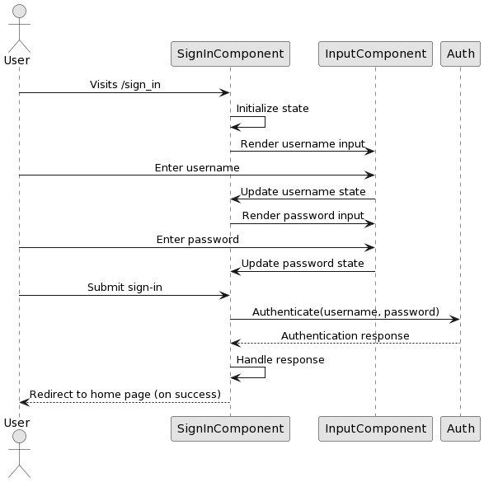



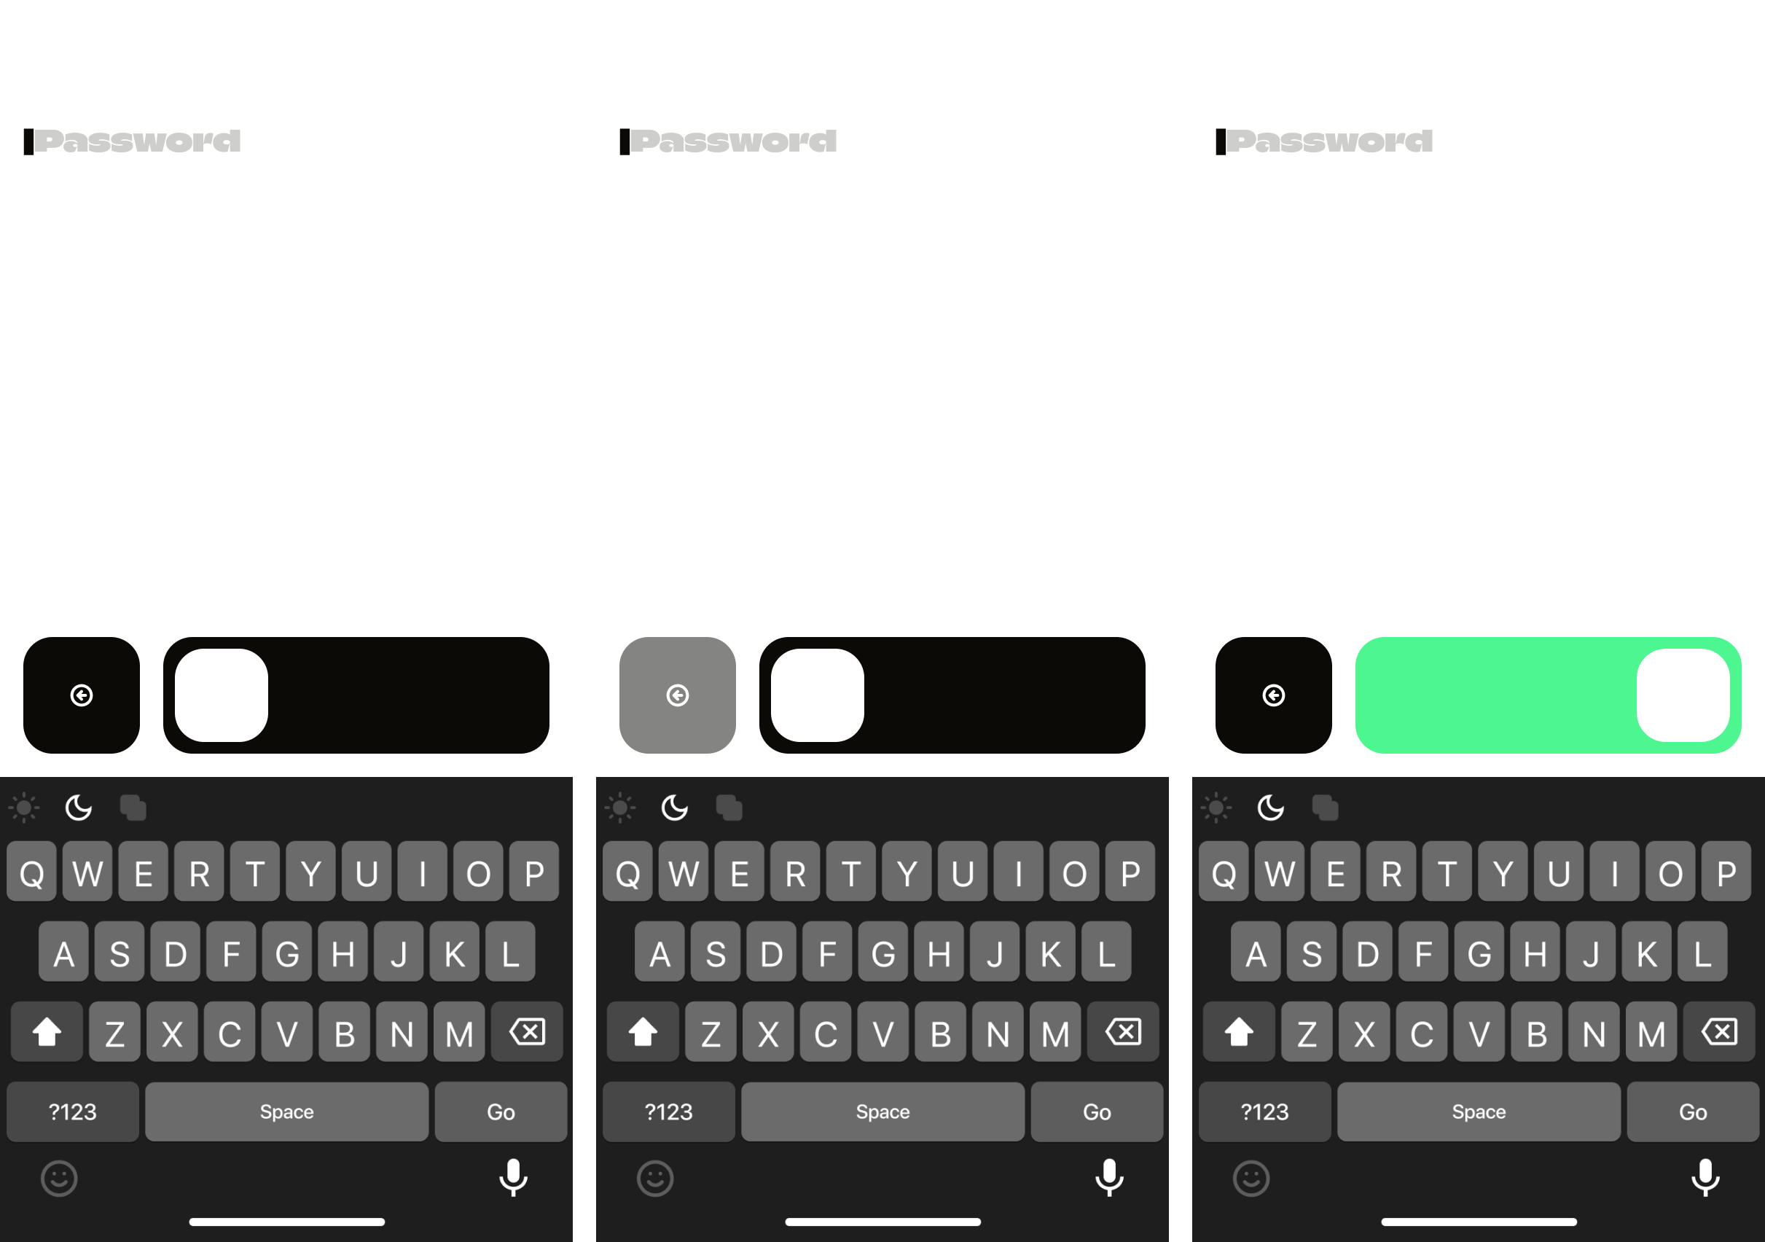

Tests

Test Case 1: Sign In Successfully with Valid Credentials

Procedure
1. Render the `SignIn` component.
2. Provide valid username and password.
3. Pressing the Enter key to submit the form.

Expected
- The component should send a sign-in mutation request with the provided credentials.
- Upon successful sign-in, the user should be redirected to the home page ("/").
- Cookies for the secret key and user ID should be set with an expiration of 7 days.

Step | Description | Input | Expected Output | Output/Finding | Pass/Fail
1 | Render the SignIn component. | N/A | The SignIn component should render. | Component renders successfully. | Pass
2 | Provide valid username and password. | Valid username: "johndoe" <br> Valid password: "securepassword" | Valid username and password should be provided. | Valid credentials provided successfully. | Pass
3 | Press the Enter key to submit the form. | N/A | The form should be submitted by pressing the Enter key. | Form submitted successfully. | Pass
4 | Authenticate the user using the provided ID and secret key. | User ID, user secret key | User authentication should be successful. | User authentication is successful. | Pass
5 | Redirect the user to the home page ("/") upon successful sign-in. | N/A | The user should be redirected to the home page ("/"). | User redirected to home page successfully. | Pass
6 | Set cookies for the secret key and user ID with an expiration of 7 days upon successful sign-in. | N/A | Cookies for the secret key and user ID should be set with an expiration of 7 days. | Cookies set with correct expiration successfully. | Pass

Test Case 2: Display Error Message if Sign In Fails

Procedure
1. Render the `SignIn` component.
2. Provide invalid username and password to trigger an error response from the server.

Expected
- The component should display an error message indicating the failure to sign in.

Step | Description | Input | Expected Output | Output/Finding | Pass/Fail
1 | Render the SignIn component. | N/A | The SignIn component should render. | Component renders successfully. | Pass
2 | Provide invalid username and password to trigger an error response from the server. | Invalid username: "john!doe" <br> Invalid password: "invalidpassword" | Invalid username and password should be provided. | Invalid credentials provided successfully. | Pass
3 | Press the Enter key to submit the form. | N/A | The form should be submitted by pressing the Enter key. | Form submitted successfully. | Pass
4 | Display an error message indicating the failure to sign in. | N/A | An error message should be displayed indicating the failure to sign in. | Error message displayed appropriately. | Pass

