### 获取mongo

wget https://fastdl.mongodb.org/linux/mongodb-linux-x86_64-amazon-3.6.4.tgz

mv  mongodb-linux-x86_64-amazon-3.6.4/ /usr/local/mongodb

### 走一边

systemctl stop firewalld.service #停止firewall

systemctl disable firewalld.service #禁止firewall开机启动

firewall-cmd --state #查看默认防火墙状态（关闭后显示notrunning，开启后显示running）

### 配置环境变量

sudo vi /etc/profile

export MONGODB_HOME=/usr/local/mongodb

export PATH=$PATH:$MONGODB_HOME/bin

source /etc/profile

### 创建mongo的data目录和log目录

sudo mkdir -p /usr/local/mongodb/data/db  
chmod 777 /usr/local/mongodb/data/db

sudo mkdir -p /usr/local/mongodb/logs

chmod 777 /usr/local/mongodb/logs

cd /usr/local/mongodb/logs

touch mongodb.log

### mongo配置文件

vim /usr/local/mongodb/bin/mongodb.conf

dbpath = /usr/local/mongodb/data/db #数据文件存放目录

logpath = /usr/local/mongodb/logs/mongodb.log #日志文件存放目录

port = 27017 #端口

fork = true #以守护程序的方式启用，即在后台运行

bind_ip = 0.0.0.0

### mongo以配置文件启动

cd /usr/local/mongodb/bin

./mongod -f mongodb.conf

#启动服务

systemctl start mongodb.service

#关闭服务

systemctl stop mongodb.service

#开机启动

systemctl enable mongodb.service

### 连接mongo数据库

./mongo

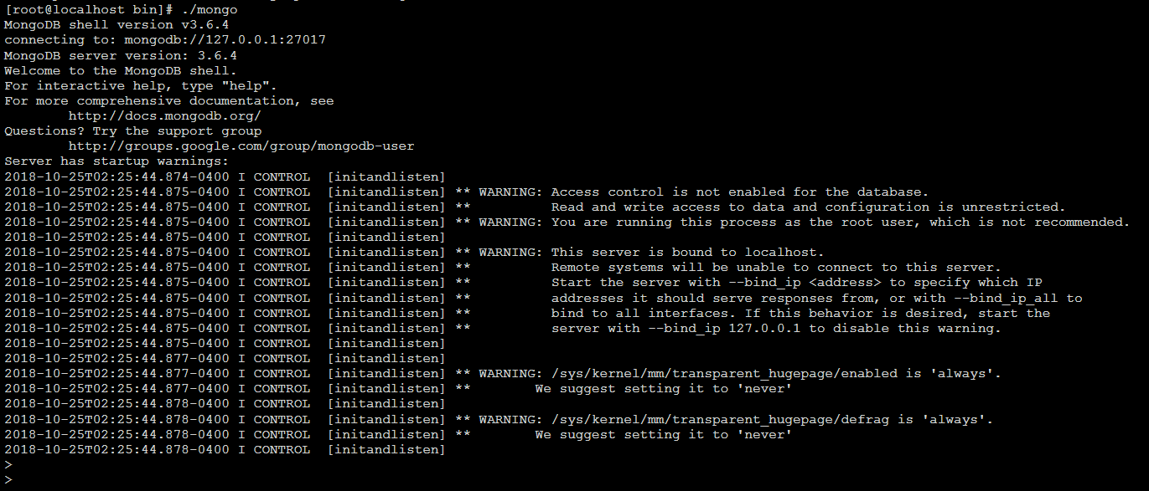

### java操作mongodb

1:

<https://www.cnblogs.com/lwy19998273333/p/5793141.html>

2:

|  |
| --- |
| <dependency>  <groupId>org.mongodb</groupId>  <artifactId>mongo-java-driver</artifactId>  <version>3.5.0</version>  </dependency> |

|  |
| --- |
| **package** com.ssm.controller;  **import** com.mongodb.BasicDBObject;  **import** com.mongodb.DB;  **import** com.mongodb.DBCollection;  **import** com.mongodb.DBCursor;  **import** com.mongodb.MongoClient;  **import** com.mongodb.MongoException;  **import** com.mongodb.client.MongoDatabase;  **import** java.util.Date;  **public** **class** HelloMongoDB {  **public** **static** **void** main(String[] args) {  **try** {  /**** Connect to MongoDB ****/  // Since 2.10.0, uses MongoClient  MongoClient mongo = **new** MongoClient("192.168.106.34", 27017);  /**** Get database ****/  // if database doesn't exists, MongoDB will create it for you  DB db = mongo.~~getDB~~("testdb");  MongoDatabase mongoDatabase = mongo.getDatabase("testdb");  /**** Get collection / table from 'testdb' ****/  // if collection doesn't exists, MongoDB will create it for you  DBCollection table = db.getCollection("user");  /**** Insert ****/  // create a document to store key and value  BasicDBObject document = **new** BasicDBObject();  document.put("name", "mkyong");  document.put("age", 30);  document.put("createdDate", **new** Date());  table.insert(document);  /**** Find and display ****/  BasicDBObject searchQuery = **new** BasicDBObject();  searchQuery.put("name", "mkyong");  DBCursor cursor = table.find(searchQuery);  **while** (cursor.hasNext()) {  System.***out***.println(cursor.next());  }  /**** Update ****/  // search document where name="mkyong" and update it with new values  BasicDBObject query = **new** BasicDBObject();  query.put("name", "mkyong");  BasicDBObject newDocument = **new** BasicDBObject();  newDocument.put("name", "mkyong-updated");  BasicDBObject updateObj = **new** BasicDBObject();  updateObj.put("$set", newDocument);  table.update(query, updateObj);  /**** Find and display ****/  BasicDBObject searchQuery2 = **new** BasicDBObject().append("name", "mkyong-updated");  DBCursor cursor2 = table.find(searchQuery2);  **while** (cursor2.hasNext()) {  System.***out***.println(cursor2.next());  }  /**** Done ****/  System.***out***.println("Done");  } **catch** (MongoException e) {  e.printStackTrace();  }  }  } |

|  |
| --- |
| >  > db.user.find()  { "_id" : ObjectId("5bd165f93ebf4521d08ecb20"), "name" : "mkyong-updated", "age" : 30, "createdDate" : ISODate("2018-10-25T06:43:05.064Z") }  > |