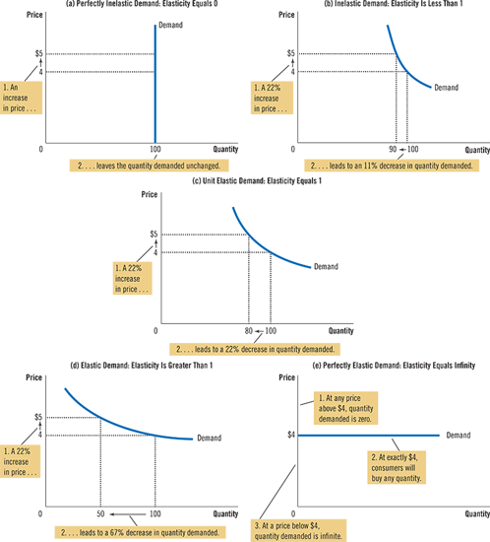

A series of five graphs, (a) through (e), plots different price elasticity scenarios, each graph plotting the quantity on the horizontal axis and price on the vertical axis. In graph (a), titled Perfectly Inelastic Supply: Elasticity Equals 0, the supply curve is a vertical line perpendicular at 100 on the horizontal axis. To the supply curve, two perpendiculars are dropped from points 4 and 5 dollars on the vertical axis. Two callouts, one pointing at the increase in price from 4 to 5 dollars and the other at the supply curve, read, "An increase in price … leaves the quantity supplied unchanged." In graph (b), titled Inelastic Supply: Elasticity Is Less Than 1, the supply curve is an upward sloping line that if extended would touch the horizontal axis to the right of the origin. From two points on the curve, perpendiculars are dropped to the two axes. The perpendiculars from the first point are at 100 on the horizontal axis and at 4 on the vertical axis. Those from the second point a little higher up on the curve are similarly at 110 and 5. Two callouts, one pointing at the increase in price from 4 to 5 dollars and the other at the increase from 100 to 110, read, "A 22% increase in price … leads to a 10% increase in quantity supplied." In graph (c), titled Unit Elastic Supply: Elasticity Equals 1, the supply curve is an upward sloping line beginning at the origin. From two points on the curve, perpendiculars are dropped to the two axes. The perpendiculars from the first point are at 100 on the horizontal axis and at 4 on the vertical axis. Those from the second point a little higher up on the curve are similarly at 125 and 5. Two callouts, one pointing at the increase in price from 4 to 5 dollars and the other at the increase from 100 to 125, read, "A 22% increase in price … leads to a 22% increase in quantity supplied." In graph (d), titled Elastic Supply: Elasticity Is Greater Than 1, the supply curve is an upward sloping line that if extended would touch the vertical axis above the origin. From two points on the curve, perpendiculars are dropped to the two axes. The perpendiculars from the first point are at 100 on the horizontal axis and at 4 on the vertical axis. Those from the second point a little higher up on the curve are similarly at 200 and 5. Two callouts, one pointing at the increase in price from 4 to 5 dollars and the other at the increase from 100 to 200, read, "A 22% increase in price … leads to a 67% increase in quantity supplied." In graph (e), titled Perfectly Elastic Supply: Elasticity Equals Infinity, the supply curve is a horizontal line perpendicular at 4 dollars on the vertical axis. Callouts state, "At any price above 4 dollars, quantity supplied is infinite. At exactly 4 dollars, producers will supply any quantity. At a price below 4 dollars, quantity supplied is zero."

