13/1/2017

SWD500

Kris Jenkins

Contents

Planning 2

Low fidelity Sketches 2

Desktop Screen 2

Tablet Screen 3

Phone Screen 4

Medium Fidelity Sketches 5

Desktop Screen 5

Tablet Screen 6

Phone Screen 7

Final design 8

Desktop Screen 8

Tablet Screen 8

Phone Screen 9

Time management 9

Stylesheet 10

Test Plan 11

GitHub URL 13

Desktop Screen 13

Tablet Screen 13

Phone Screen 13

# Planning

## Low fidelity Sketches

### Desktop Screen

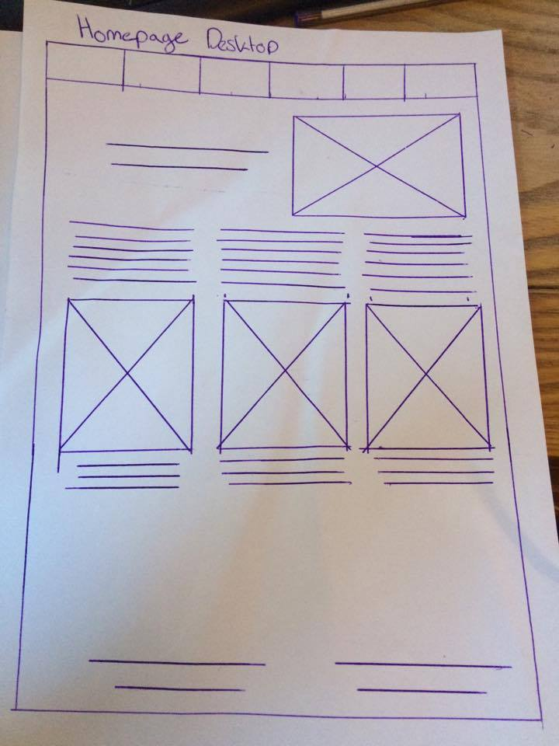

### Tablet Screen

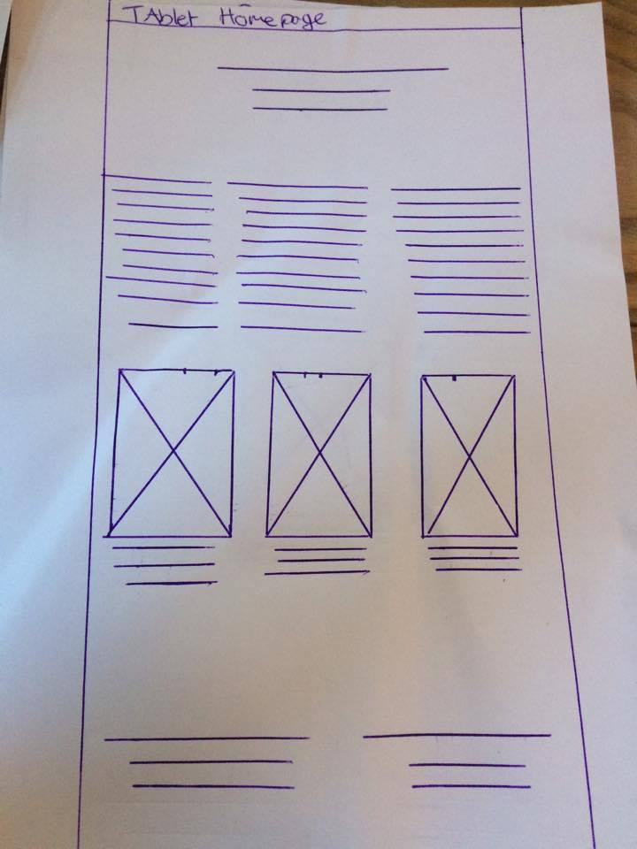

### Phone Screen

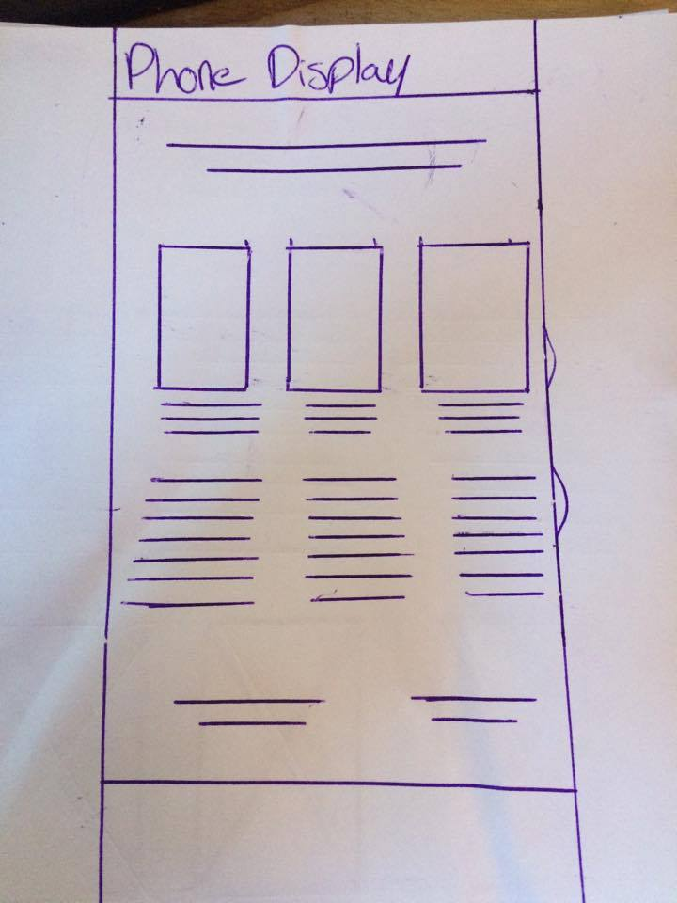

## Medium Fidelity Sketches

### Desktop Screen

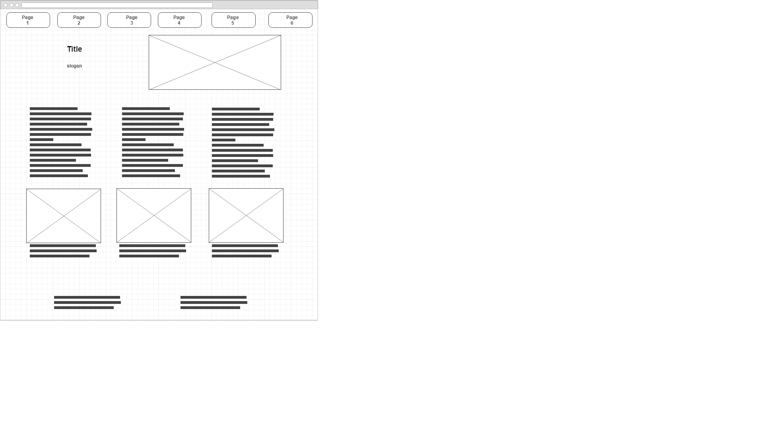

### Tablet Screen

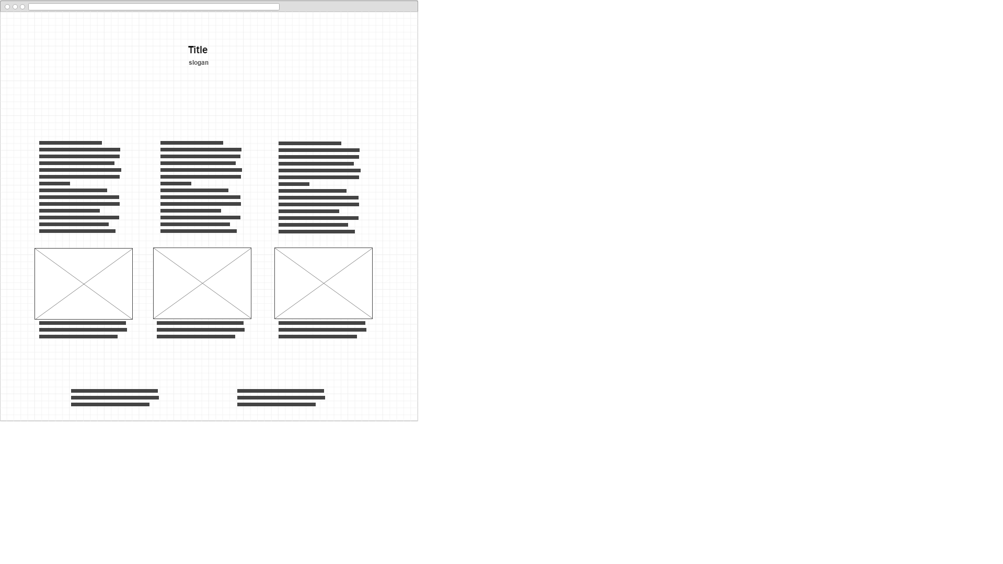

### Phone Screen

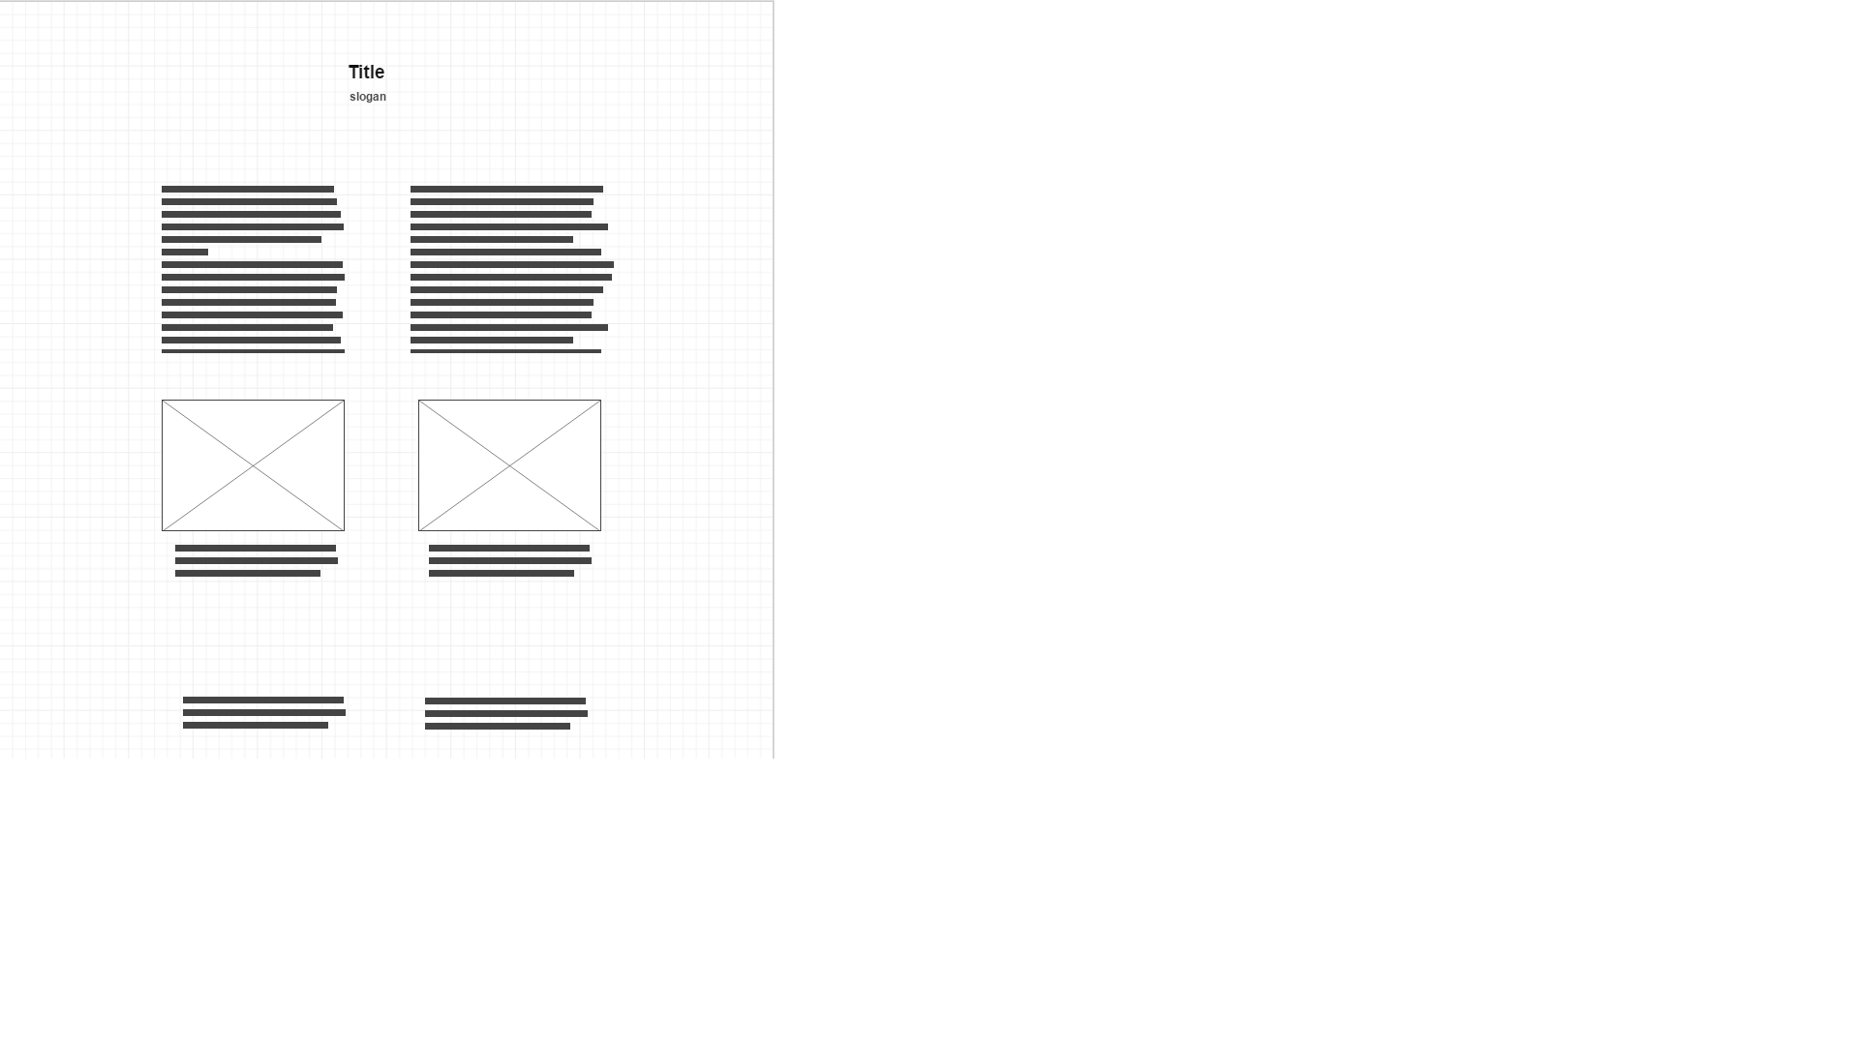

# Final design

### Desktop Screen

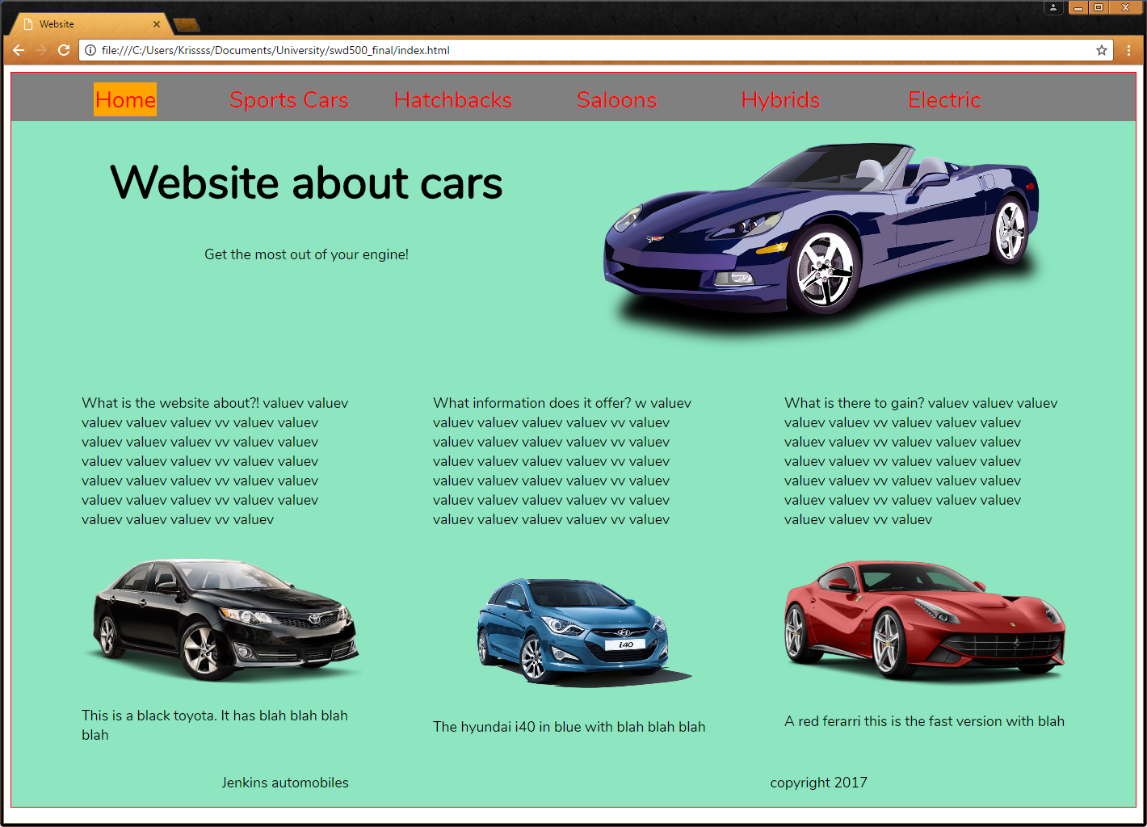

### Tablet Screen

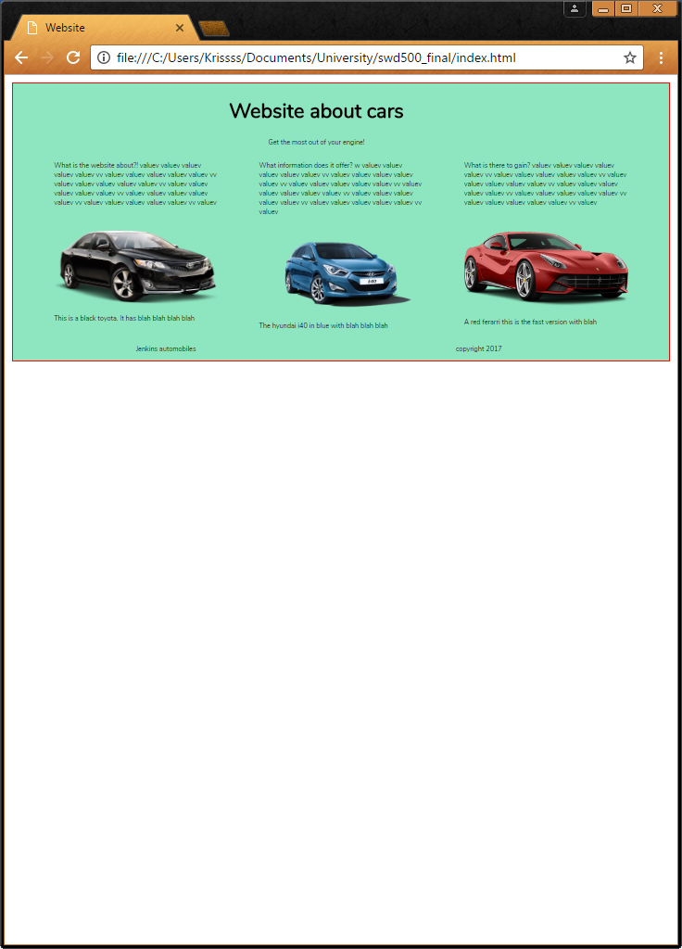

### Phone Screen

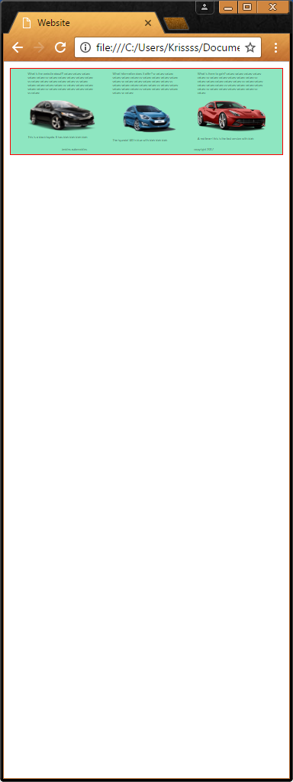

## Time management

## Stylesheet

‌Car Website Stylesheet

**Swatches**



RGB: 255,0,0

HEX: #FF0000

CMYK: 0,1,1,0

RGB: 142,230,193

HEX: #8EE6C1

CMYK: 0.38, 0,0.16,0.1

RGB: 0,0,0

HEX: #000000

CMYK: 0,0,0,1

**Typography**

A​‌B​‌C​‌Ć​‌Č​‌D​‌Đ​‌E​‌F​‌G​‌H​‌I​‌J​‌K​‌L​‌M​‌N​‌O​‌P​‌Q​‌R​‌S​‌Š​‌T​‌U​‌V​‌W​‌X​‌Y​‌Z​‌Ž​‌a​‌b​‌c​‌č​‌ć​‌d​‌đ​‌e​‌f​‌g​‌h​‌i​‌j​‌k​‌l​‌m​‌n​‌o​‌p​‌q​‌r​‌s​‌š​‌t​‌u​‌v​‌w​‌x​‌y​‌z​‌ž​‌Ă​‌Â​‌Ê​‌Ô​‌Ơ​‌Ư​‌ă​‌â​‌ê​‌ô​‌ơ​‌ư​‌1​‌2​‌3​‌4​‌5​‌6​‌7​‌8​‌9​‌0​‌‘​‌?​‌’​‌“​‌!​‌”​‌(​‌%​‌)​‌[​‌#​‌]​‌{​‌@​‌}​‌/​‌&​‌<​‌-​‌+​‌÷​‌×​‌=​‌>​‌®​‌©​‌$​‌€​‌£​‌¥​‌¢​‌:​‌;​‌,​‌.​‌*

# Test Plan

Does it change affectively to the phone viewport when it reaches the correct width?

When it reaches the phone viewport the top section is hidden, so yes.



Does it change affectively to the tablet viewport when it reaches the correct width?

When it reaches the tablet viewport the top bar and an image is hidden, so yes.



Is the Typography Responsive, scale with the page?

The typography is fully responsive; it changes size depending on the scale of the viewport.

Are the images responsive, scale with the page?

The images are fully responsive; it changes size depending on the scale of the viewport.

Does the navigation change appropriately, hide when reaching a certain width?

When it reaches a small enough veiw, the website will hide the nav so give a clearer picture.



Work in alternate browsers?

The image below was taken from Microsoft edge, seems to work the exact same.

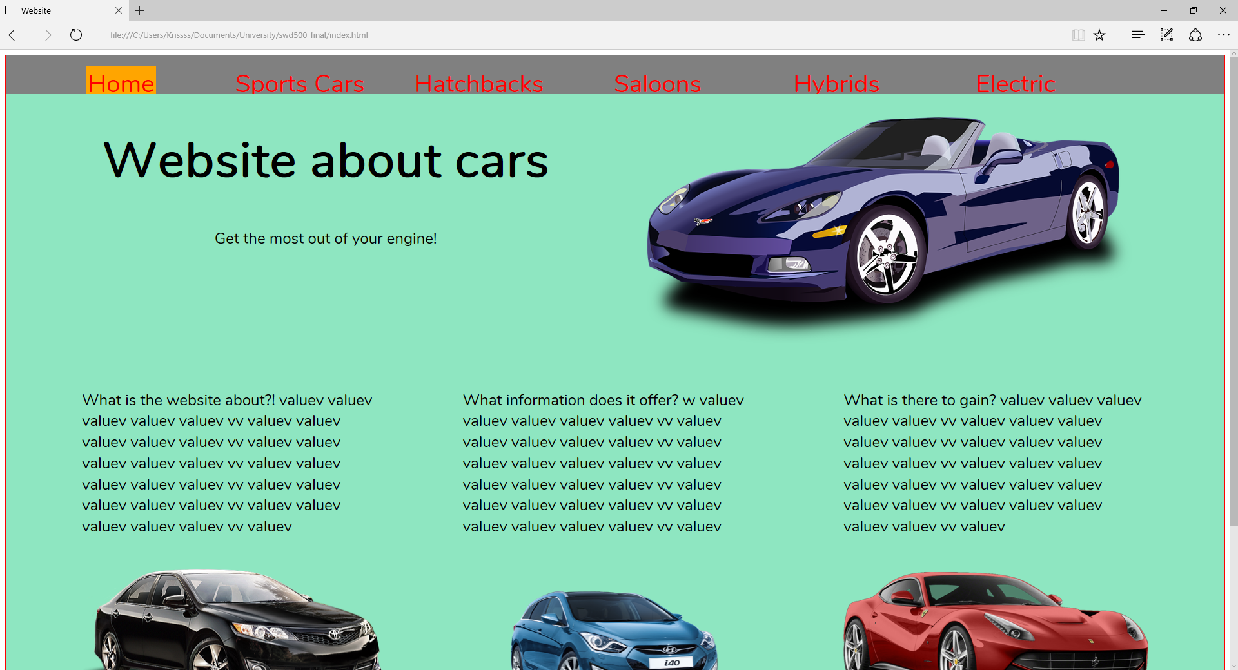

Easy to navigate, clear process?

A long bar across the top of the page, makes it very simple to find where to go. All labeled appropriately to assist the user.



Is it consistent from page to page, theme looks good?

These are two of the pages, as you can tell they have the same theme so keep consistency.

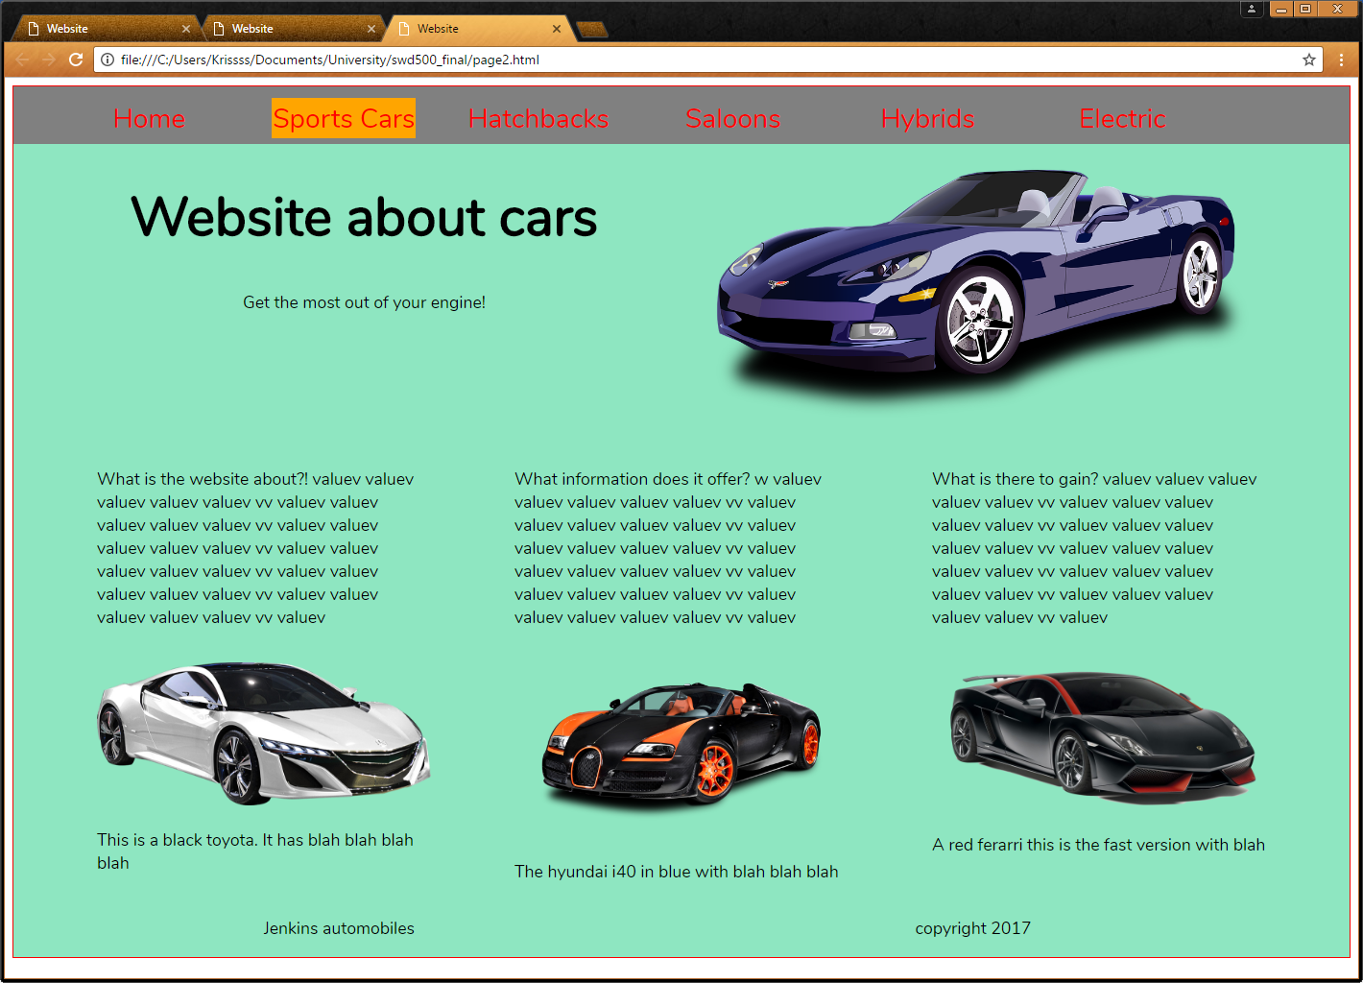 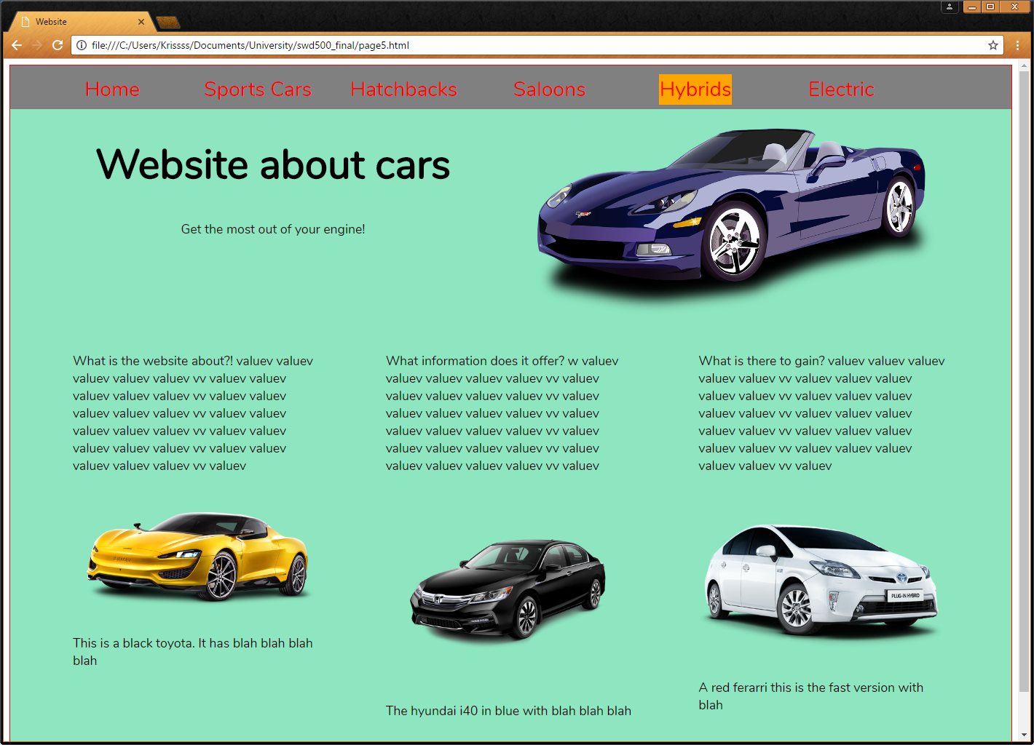

# GitHub URL

### Desktop Screen

### Tablet Screen

### Phone Screen