To Whom it May Concern,

Please accept this letter as documentation of my absence in claiming my credentials. I am currently in Manila for a very important reason and if you have any questions just contact me.

By means of this letter, I delegate Marc Joseph Acar the authority to claim the following:

1. My transcript of records
2. Diploma

Thank you for your approval!

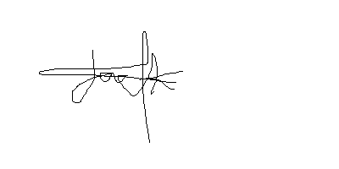Regards,

Jack Owen Bula  
xkulliber.96@gmail.com  
09301110087