1

Faculty of Informatics and Computer Science

Information System/Computer Networks/Software Engineering/ Computer Science

Inventory and Supply Chain Management System

By: Ahmed Mohamed Karam 236548

Supervised By:

Dr. Nermin Othman

November 2025

Abstract
Small and medium-sized enterprises (SMEs) often manage inventory using ad-hoc rules, spreadsheets and disconnected systems. Sales, purchasing and stock data are rarely integrated, and formal forecasting or inventory control models are seldom applied. As a result, firms struggle to answer basic questions about future demand, when to reorder and how much safety stock is required, leading to stockouts, overstock and inefficient use of working capital. Existing enterprise planning tools are powerful but too complex and expensive for many SMEs, while lightweight applications typically offer only simple, opaque reorder rules. This gap motivates the need for a transparent, educational and affordable decision-support system for inventory and supply chain management.

The main objective of this project is to design and develop an Inventory and Supply Chain Management System that embeds sound forecasting and inventory control principles in a form suitable for SMEs. Specifically, the system aims to integrate demand forecasting with classical inventory policies (EOQ, reorder point and safety stock), provide clear decision support for replenishment, and offer a simple web-based interface that non-expert users can operate. By doing so, the project seeks to make academic concepts from inventory and supply chain theory more accessible and practically useful.

The methodology combines literature-based research, requirements analysis, system design, implementation and evaluation. Key textbooks and research papers on inventory control, forecasting and supply chain coordination were reviewed, alongside an analysis of existing applications such as Odoo Inventory, Zoho Inventory and TradeGecko. Functional and non-functional requirements were derived from this survey, and a three-layer architecture was designed. The proposed system was then modelled using UML (use case, sequence and class diagrams) and implemented as a prototype that stores master data, imports demand and inventory history, applies simple moving average and exponential smoothing forecasts, and calculates EOQ, reorder points and safety stock to generate replenishment recommendations.

The resulting prototype demonstrates that it is feasible to operationalise established forecasting and inventory control methods in a lightweight, web-based tool targeted at SMEs. The system improves visibility of demand and stock, structures replenishment decisions and makes underlying calculations explicit to the user. Evaluation using illustrative scenarios and realistic demand data indicates that the system can help reduce reliance on informal spreadsheet-based practices and provides a foundation for future extensions, such as more advanced forecasting models or tighter integration with existing enterprise systems.

Table of Contents
1 1
Inventory and Supply Chain Management System 1
By: Ahmed Mohamed Karam 236548 1
Supervised By: 1
Dr. Nermin Othman 1
November 2025 1
Abstract 2
Attestation &Turnitin Report 4
Acknowledgements 5
List of Figures 7
7
Figure 3.1:Forecasting and inventory decision pipeline: 8
8
List of Tables: 10
Aspect 10
Research Papers (Silver, Chopra & Meindl, Makridakis) 10
Existing Applications (Odoo, Zoho, TradeGecko) 10
Main focus 10
Inventory policies, supply chain coordination, forecasting accuracy 10
Transaction processing, stock visibility, operational control 10
Forecasting methods 10
Formal time series models and error analysis 10
Simple historical totals or basic rules 10
Inventory policy detail 10
Explicit EOQ and related formulas; links between inventory and strategy 10
Reorder points and safety stock often set as fixed parameters 10
Transparency and users 10
High transparency; aimed at planners with analytical skills 10
Medium/low transparency; aimed at SME managers and operational staff 10
Introduction 12
1.1 Overview 12
1.2 Problem Statement 12
1.3 Scope and Objectives 13
1.4 Report Organization 14
1.5 Work Methodology 14
1.6 Work Plan (Gantt Chart) 15
2 Related Work 17
2.1 Introduction 17
2.2 Research Literature on Inventory and Supply Chain Management 18
2.2.1 Silver, Pyke & Peterson: Inventory Management and Production Planning 18
2.2.2 Chopra & Meindl: Supply Chain Strategy, Planning, and Operation 18
2.2.3 Makridakis, Wheelwright & Hyndman: Forecasting Methods 19
2.3 Comparative Analysis of Key Research Papers 19
2.4 Existing Inventory and Supply Chain Management Applications 21
2.4.1 Odoo Inventory 21
2.4.2 Zoho Inventory 22
2.4.3 TradeGecko / QuickBooks Commerce 22
2.5 Comparison Between Research and Applications 23
3 Proposed System 25
3.1 Introduction 25
3.2 System Overview and Objectives 25
3.3 System Requirements 26
3.3.1 Functional Requirements 26
3.3.2 Non-Functional Requirements 28
3.4 System Architecture 28
3.5 Algorithms and Models 29
3.5.1 Table of Algorithms : 30
3.6 Data Flow and Machine Learning / Forecasting Pipeline 31
3.7 UML-Based Design of the System 33
3.7.1 Use Case Model 33
3.7.2 Sequence Diagram 34
3.7.3 Class Diagram 34
3.8 Implementation Considerations 35

Attestation &Turnitin Report
I understand the nature of plagiarism, and I am aware of the University’s policy on this.
I certify that this dissertation reports original work carried out by me during my university project except for the following (to be adjusted according to the actual circumstances of the project):
- The literature review and background sections in Chapter 2 are based on published books and research papers, which are fully cited in the References section.
- Standard forecasting and inventory control formulas (such as Simple Moving Average, Exponential Smoothing, EOQ and Reorder Point calculations) used in Chapter 3 and Chapter 4 follow classical definitions from textbooks (for example, Silver et al., Chopra & Meindl, and Makridakis et al.) and are implemented or adapted by me for this project.
- Any external libraries, frameworks or tools used for implementation (for example, web frameworks or database systems) are employed according to their respective licences and are referenced where appropriate in Chapter 4.
- Any diagrams or templates adapted from teaching materials provided by the Faculty are used with permission and acknowledged in the relevant sections.

Acknowledgements

I would like to express my sincere gratitude to my supervisor, Dr. Nermin Othman, for her continuous guidance, support and constructive feedback throughout the course of this graduation project. Her insights, patience and encouragement were invaluable in shaping the direction of the work and in helping me overcome the various challenges encountered along the way.

List of Figures
Figure 1.1: Gant Chart

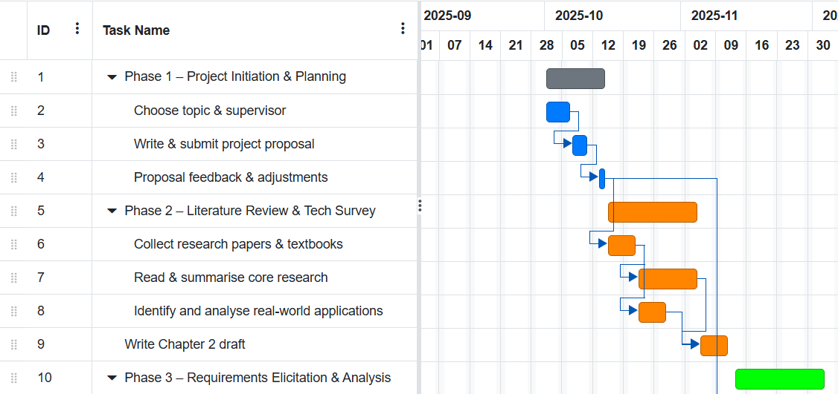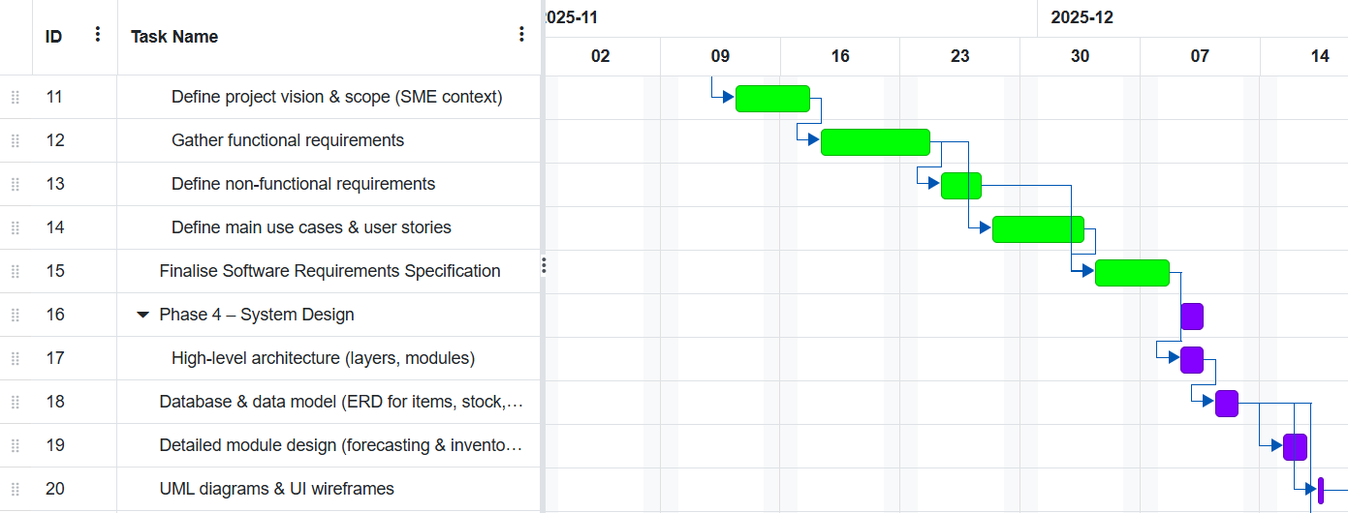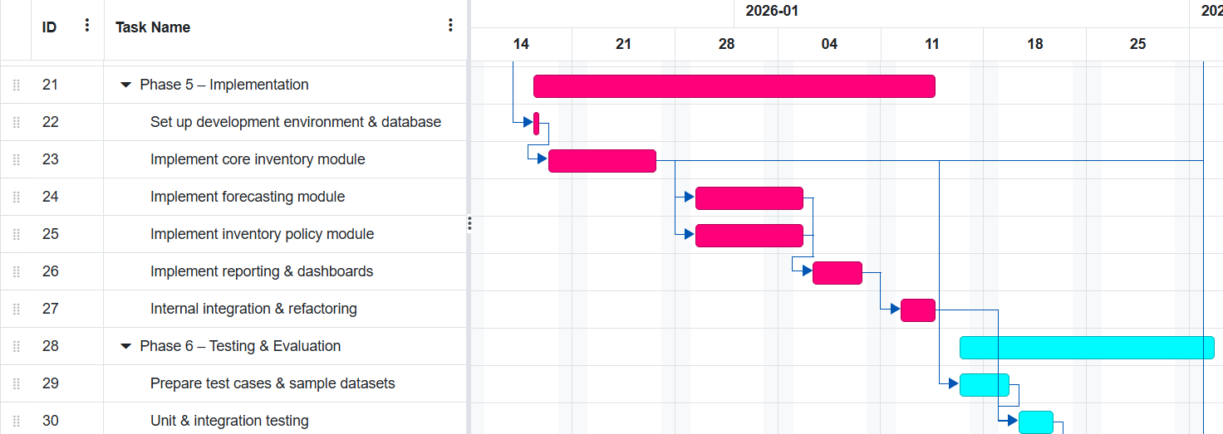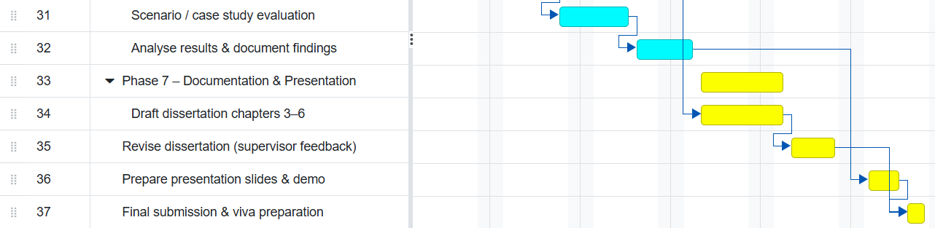

Figure 3.1:Forecasting and inventory decision pipeline: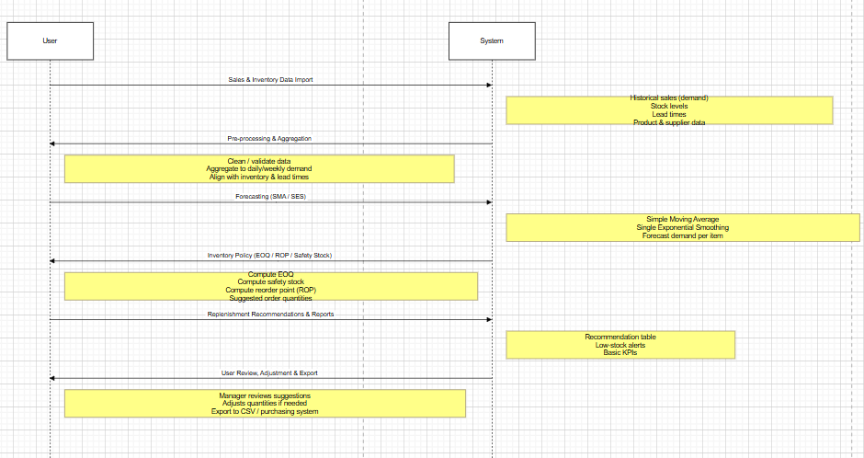

Figure 3.2: Use case diagram of the proposed system:

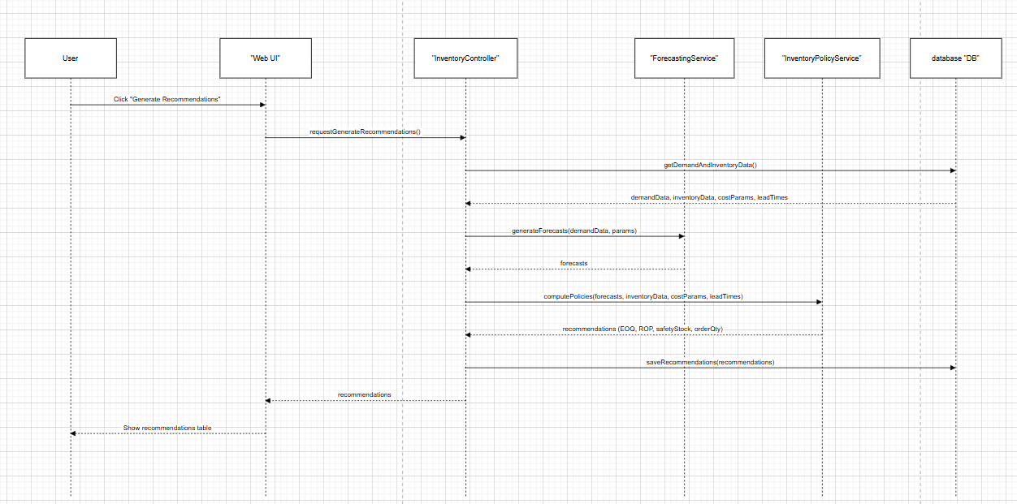

Figure 3.3 : Use case diagram :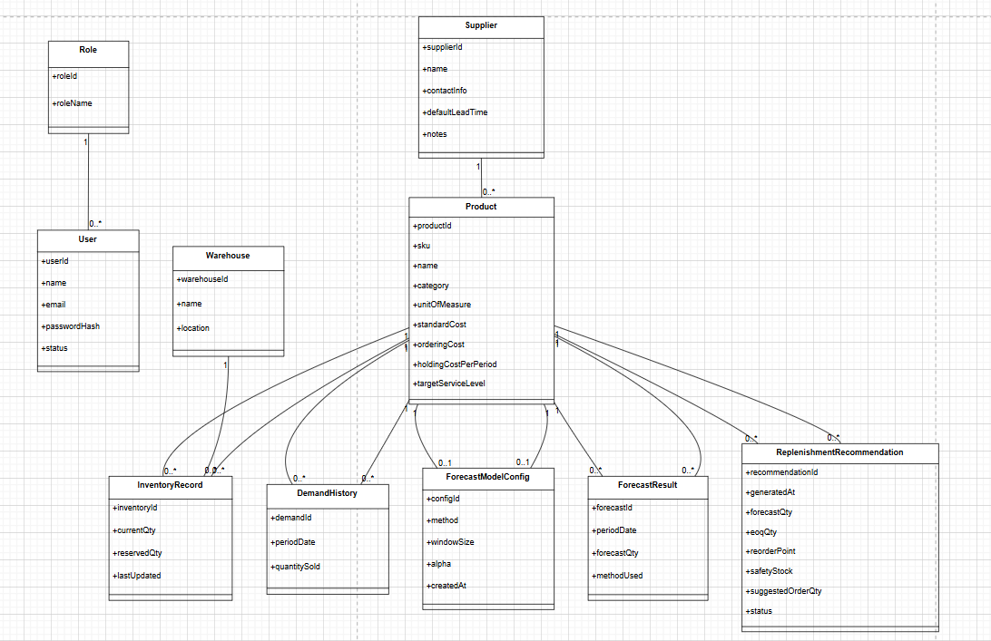

List of Tables:
Table 2.1: Comparison between selected research papers and SME inventory applications
Aspect | Research Papers (Silver, Chopra & Meindl, Makridakis) | Existing Applications (Odoo, Zoho, TradeGecko)
Main focus | Inventory policies, supply chain coordination, forecasting accuracy | Transaction processing, stock visibility, operational control
Forecasting methods | Formal time series models and error analysis | Simple historical totals or basic rules
Inventory policy detail | Explicit EOQ and related formulas; links between inventory and strategy | Reorder points and safety stock often set as fixed parameters
Transparency and users | High transparency; aimed at planners with analytical skills | Medium/low transparency; aimed at SME managers and operational staff

Table 3.1: Algorithms and models used in the proposed system
Algorithm | Category | Input Data | Output | Purpose in the Proposed System
Simple Moving Average (SMA) | Forecasting | Historical demand for an item over the last n periods | Forecast of demand for the next period | Provides a simple baseline forecast for items with relatively stable demand when data is limited or noise is low.
Single Exponential Smoothing | Forecasting | Historical demand per period and a smoothing parameter α (0 < α ≤ 1) | Updated forecast for the next period | Generates more responsive forecasts than SMA by giving more weight to recent observations for items with changing demand.
Economic Order Quantity (EOQ) | Inventory Control | Annual demand for the item, ordering or setup cost per order, holding cost per unit per year | Recommended order quantity | Determines the cost-efficient order quantity for items with relatively stable demand and cost structure, reducing total relevant cost.
Reorder Point (ROP) with Safety Stock | Inventory Control | Average demand per period, supplier lead time, demand variability (e.g. standard deviation), and desired service level | Reorder point (units) at which a new order is triggered | Ensures new orders are placed early enough to avoid stockouts by combining average demand, safety stock and lead time into a clear reorder rule.
Safety Stock | Inventory Control | Standard deviation of demand during lead time desired service level factor, average time | Safety stock quantity | Calculates an extra buffer of stock to protect against demand and lead-time variability.

Introduction

1.1 Overview

Inventory and supply chain management are one of the most critical areas in the competitiveness and survival of modern organisations. Firms must make decisions such as how much to order, when to order, and where to position the inventory in the supply chain-to avoid being out of stock and also to avoid excessive stock. Poorly managed inventory results in lost sales, higher holding costs, and operational disruption. At the same time, most SMEs still rely on disintegrated spreadsheets and manual rules of thumb rather than systematic and data-driven methods for planning and replenishment.

The huge amount of literature dealing with inventory control and supply chain management has produced, in the last decades, a large set of models, policies and best practices to perform stock level planning and to coordinate supply chains. Classical works present well-established techniques to set order quantities, safety stock and re-order points. More recent studies link forecasting quality and information sharing to the overall supply chain performance. However, these methods are often presented in a mathematical or conceptual way and are not always translated into practical and integrated tools that SMEs can easily adopt.

In parallel, commercial inventory and planning systems have emerged as part of ERP and cloud-based platforms. Enterprise solutions offer advanced functions for demand planning and multi-echelon optimisation whereas mid-market tools offer practical stock tracking, reordering rules and basic forecast-based alerts. Despite this, gaps remain between the academic models and functionality in lightweight systems, especially for smaller firms needing a simple yet analytically grounded decision support tool.

This project proposes the design and development of an Inventory and Supply Chain Management System that bridges this gap. The system will integrate basic demand forecasting with practical inventory control policies into one platform, so as to offer SMEs a structured, transparent, and configurable way to manage their stock, suppliers, and replenishment decisions.

1.2 Problem Statement
In many organisations, especially SMEs, inventory is still managed using ad-hoc rules, manually updated spreadsheets and fragmented information systems. Sales, purchasing and stock movements are often recorded in separate files or applications, with little integration or standardisation. As a result, managers struggle to answer basic questions such as:
- What is the expected demand for each item over the next period?
- When should a new order be placed to avoid stockouts?
- How much safety stock is needed to cope with demand and lead time variability?
Without systematic methods, firms either overstock, tying up working capital and increasing storage costs, or understock, suffering lost sales, rush orders and poor customer service. The situation is aggravated by demand uncertainty, variable supplier lead times and the lack of clear visibility across the supply chain, which can contribute to phenomena such as the bullwhip effect.
Existing enterprise-grade planning tools address many of these issues, but they are typically expensive, complex to implement and targeted at large organisations with dedicated planning teams. Lightweight commercial inventory systems are easier to adopt but often provide only simple reorder point rules and limited, opaque forecasting logic. For SMEs, there is a need for a transparent and educational system that embeds key concepts from inventory and supply chain theory while remaining practical, configurable and aligned with their data and resource constraints.
Therefore, the core problem addressed by this project can be stated as follows:
How can we design and implement an integrated inventory and supply chain management system that uses sound forecasting and inventory control principles to support SMEs in making better replenishment decisions, while remaining simple, affordable and transparent to use?

1.3 Scope and Objectives
The scope of this project is limited to the inbound and internal inventory management aspects of a supply chain. The system focuses on stock control for finished goods or components within one organisation (possibly across multiple locations), assuming that transportation and detailed production scheduling are handled externally or by other systems. The project does not aim to build a full enterprise resource planning (ERP) solution, nor to optimise complex network design decisions; instead, it concentrates on data capture, forecasting, inventory policy calculation and decision support at item and location level.
Within this scope, the main objectives of the project are:
1. To analyse the requirements of SMEs with respect to inventory and basic supply chain management, identifying common pain points, data structures and decision processes.
2. To review relevant research and existing applications in inventory control, forecasting and supply chain planning, and to extract a subset of practical methods suitable for implementation in a mid-scale decision support system.
3. To design a system architecture and data model that supports product, supplier and transaction management, as well as the configuration of inventory policies and forecasting methods.
4. To implement a prototype Inventory and Supply Chain Management System that:
- stores and manages master data (items, suppliers, locations),
- records inventory transactions and demand history,
- applies selected forecasting methods to estimate future demand, and
- uses inventory control formulas to compute suggested order quantities and reorder points.
5. To evaluate the system through scenarios or case studies using realistic data, assessing its ability to improve visibility, structure decision-making and reduce the risk of stockouts or excessive inventory.
By achieving these objectives, the project aims to demonstrate that a carefully designed system can make academic methods more accessible to practitioners and can serve as a stepping stone toward more advanced planning capabilities.

1.4 Report Organization
The remainder of this dissertation is organised into seven chapters, following the structure required by the faculty template.
Chapter 1 – Introduction provides the background, problem statement, scope and objectives of the project, as well as the overall methodology and work plan.
Chapter 2 – Related Work (State-of-the-Art) reviews relevant literature on inventory and supply chain management, demand forecasting and supply chain collaboration, and examines existing commercial systems such as Odoo Inventory, Zoho Inventory and TradeGecko. The chapter highlights similarities and differences between research papers and real-world applications, and identifies gaps that motivate the proposed solution.
Chapter 3 – Proposed Solution describes the conceptual design of the Inventory and Supply Chain Management System, including its solution methodology, functional and non-functional requirements, and the overall design or simulation setup.
Chapter 4 – Implementation presents the technologies used and explains how the design was translated into a working software prototype.
Chapter 5 – Testing and Evaluation outlines the testing strategy, test cases and evaluation criteria used to assess the system’s correctness and performance.
Chapter 6 – Results and Discussions reports and interprets the results obtained from the evaluation, relating them to the original objectives and to findings from the literature.
Chapter 7 – Conclusions and Future Work summarises the main contributions of the project, discusses its limitations and suggests directions for further development and research.

1.5 Work Methodology
The work methodology adopted in this project combines elements of literature-based research, requirements analysis, iterative software development and empirical evaluation. It can be broadly divided into the following phases:
1. Literature Review and Technology Survey:
In this phase, key textbooks and research papers on inventory management, forecasting and supply chain planning were studied to understand established theories and practical methods. At the same time, commercial systems such as SAP IBP, Oracle NetSuite, Odoo Inventory, Zoho Inventory and TradeGecko were analysed to identify common features and practical implementation patterns.
2. Requirements Elicitation and Analysis:
Based on the literature and application survey, a set of functional and non-functional requirements was formulated. This included defining the main user roles, the core use cases (for example, adding items, recording transactions, generating forecasts and viewing recommended orders), and constraints related to usability, data quality and performance.
3. System Design:
In this phase, the system architecture, data model and main modules were designed. Particular attention was given to the separation of concerns between the data storage layer, the application logic layer (forecasting and inventory control) and the user interface layer. Design artefacts such as use case diagrams, class diagrams and sequence diagrams were produced to document the system structure and interactions.
4. Implementation:
The design was then implemented as a software prototype using an appropriate technology stack. During implementation, emphasis was placed on modularity, clarity and the ability to adjust or extend forecasting and inventory policy algorithms in the future.
5. Testing and Evaluation:
Finally, the system was tested to verify that functional requirements were met and that the calculations produced by the forecasting and inventory modules were correct for sample data. Evaluation scenarios or case studies were used to explore how the system behaves under different demand patterns and parameter settings, and to assess its potential benefits compared with manual or spreadsheet-based approaches.
This structured methodology ensures that the proposed system is grounded in existing knowledge, systematically designed and empirically evaluated rather than developed in an ad-hoc manner.

1.6 Work Plan (Gantt Chart)
The project was planned and monitored using a work plan, represented as a Gantt chart that spans the full duration of the graduation project. The plan allocates time for each of the phases described in Section 1.5, including literature review, requirements analysis, system design, implementation, testing, documentation and final preparation of the dissertation.

Figure 1.1: Gant Chart


2 Related Work

2.1 Introduction
The present chapter conducts a thorough investigation of the literature related to inventory and supply chain management and thereby contextualizes the master's thesis. the literature review is structured in two main sections. The first section deals with academic research that offers the theoretical basis for inventory management, supply chain collaboration and demand prediction. The second part scrutinizes the software applications used by companies at present to control their inventory and perform basic supply chain operations. The objective here is not just to provide a recap of the past but also to draw a clear line of distinction between research works and business applications while at the same time showing the connection of each group with the proposed IMS and SCM. The chapter wraps up by pointing out the voids and the chances that eventuate the system design portrayed in Chapter 3.

2.2 Research Literature on Inventory and Supply Chain Management
The research literature on inventory and supply chain management is extensive. Based on the prepared research summaries for this project, three key works were selected because they are most closely related to the intended functionality of the proposed system:
- Silver, Pyke & Peterson – Inventory Management and Production Planning and Scheduling.
- Chopra & Meindl – Supply Chain Management: Strategy, Planning, and Operation.
- Makridakis, Wheelwright & Hyndman – Forecasting: Methods and Applications.
Together these three works provide the main theoretical basis for the project’s inventory policies, supply chain perspective and forecasting methods.

2.2.1 Silver, Pyke & Peterson: Inventory Management and Production Planning
Silver, Pyke and Peterson present one of the most influential practical treatments of inventory management and production planning. Their work focuses on how firms can determine when to order and how much to order in order to minimise total relevant costs, including ordering or setup costs, holding costs, and shortage or penalty costs. The book introduces classical policies such as the Economic Order Quantity (EOQ) model, reorder point systems and lot-sizing procedures for production environments.
A key contribution is the clear explanation of different inventory control systems, for example continuous review (Q,R) policies, periodic review policies, and various safety stock strategies to deal with demand and lead time variability. The models assume a structured, quantitative approach where demand, costs and lead times can be estimated, and they show how small changes in these parameters can affect the recommended order quantities and service levels. The limitation highlighted in the summary is that these models often assume relatively stable parameter estimates and simplified stochastic structures, which may not fully capture complex real-world variability.
For this graduation project, Silver et al. provide the core inventory control logic. The proposed system draws on their ideas when calculating recommended order quantities and reorder points, especially for items with relatively stable and observable demand patterns. Their formulations guide the design of the inventory policy module, where basic EOQ and reorder-point calculations are implemented in a form that is usable by small and medium-sized enterprises (SMEs).

2.2.2 Chopra & Meindl: Supply Chain Strategy, Planning, and Operation
Chopra and Meindl offer a broad and managerial treatment of supply chain management, linking strategy, planning and operations. They explain how decisions on network design, sourcing, inventory positioning and transportation should align with the overall competitive strategy of the firm. A central theme is the importance of information sharing and coordination mechanisms to reduce the bullwhip effect and improve overall performance.
The book discusses how aligned incentives and better integration across the supply chain can reduce safety stocks, improve responsiveness and lower costs. It provides frameworks for deciding where to hold inventory, how to coordinate with suppliers and customers, and how to design planning processes for different supply chain strategies (for example, efficient versus responsive chains). However, the guidance is largely high-level; firms still need to adapt the concepts and perform cost–benefit analysis for their specific context.
For this project, Chopra and Meindl provide the supply chain view that complements the more operational inventory formulas. They justify why the proposed system should not only calculate order quantities, but also support decisions about where to hold stock, how to share information and how to coordinate with suppliers, at least at a basic level suitable for SMEs.

2.2.3 Makridakis, Wheelwright & Hyndman: Forecasting Methods
Makridakis, Wheelwright and Hyndman focus on forecasting for managerial decisionmaking. This book covers a wide range of methods, from the naive forecasts and moving averages to exponential smoothing and to more advanced ARIMA-models. The emphasis is on practical applicability: methods should be simple enough to implement, but also capable of yielding reasonable accuracy for business data.
The authors stress the importance of forecast evaluation and model selection. They discuss error measures such as MAE (Mean Absolute Error) and MAPE (Mean Absolute Percentage Error), and it will be seen that more complex models do not necessarily always outperform the simplest, especially for noisy or sparse data. The summary prepared for this project mentioned that this book provided structured guidance to model selection and evaluation, but the practitioner still needed some skill to tune models to the data in hand.
The basis for the demand forecasting module of the graduation project is given by Makridakis et al. The system is designed to implement a small number of easy-to-use methods (for example, moving averages and exponential smoothing) rather than highly complex models that would be difficult for SMEs to understand and maintain. The guiding principles in this book will be followed with regard to which methods are implemented and how the system reports forecast performance.

2.3 Comparative Analysis of Key Research Papers
paper | Model | Accuracy | Main Goal of the Paper | Key Limitations
Silver, Pyke & Peterson – Inventory Management and Production Planning and Scheduling | Classical inventory models such as EOQ, reorder point (Q,R) policies, periodic review policies, and safety stock formulas | Shows, through analytical derivations and worked examples, how these policies can minimise total relevant cost (ordering, holding, stockout) when parameters are reasonably estimated | To provide a practical yet rigorous framework for determining order quantities, reorder points and safety stocks for different inventory situations | Assumes relatively stable demand, lead time and cost parameters; models are simplified and do not fully capture high uncertainty or very complex multi-echelon supply chains
Chopra & Meindl – Supply Chain Management: Strategy, Planning, and Operation | Conceptual and quantitative frameworks for supply chain strategy, network design, inventory positioning, coordination and bullwhip-effect analysis | Demonstrates via examples and case studies how better coordination and information sharing can reduce inventories and improve service levels across the supply chain | To link competitive strategy with supply chain strategy and provide managers with tools to design, plan and coordinate supply chains (including where and how much inventory to hold) | Provides high-level frameworks rather than detailed algorithms; success depends on firm-specific implementation, good data and aligned incentives, which are not guaranteed in practice
Makridakis, Wheelwright & Hyndman – Forecasting: Methods and Applications | Time-series forecasting methods such as naïve forecasts, moving averages, exponential smoothing and ARIMA, plus procedures for evaluating forecast accuracy | Compares methods empirically using error measures (e.g. MAE, MAPE), showing that simple methods often perform competitively against more complex models in many business datasets | To provide practical guidance on choosing, applying and evaluating forecasting methods for business and economic data | Focuses mainly on time-series forecasting and does not directly specify how forecasts should be embedded in inventory or supply chain decision rules; requires some statistical understanding from the user
The three selected works collectively provide a conceptual toolkit for the project:
- Silver, Pyke & Peterson define the structures of classical inventory policies and explain how order quantities, reorder points and safety stocks should be calculated in order to balance different cost components.
- Chopra & Meindl contribute a broader supply chain strategy and coordination perspective, explaining how inventory is connected to information sharing, network design and the bullwhip effect.
- Makridakis, Wheelwright & Hyndman provide practical forecasting methods and evaluation criteria that can be embedded in decision-support tools.

Other works in the literature (for example, Babai et al. on forecasting and inventory performance, Chen et al. on quantifying the bullwhip effect, and Syntetos et al. on demand categorisation) complement these three by examining specific issues such as multi-echelon interactions, the drivers of variability amplification and the choice of forecasting methods for different demand patterns. However, the primary theoretical anchor of this project is the combination of inventory control (Silver), supply chain coordination (Chopra & Meindl) and forecasting practice (Makridakis et al.).
From the point of view of an SME, these works also share some limitations:
- They are mostly presented as mathematical models and conceptual frameworks, not as ready-to-use software tools.
- Applying them requires quantitative expertise and time to translate equations into working systems.
- Issues such as database design, user interface, and how to present recommendations in an understandable way are outside their scope.
Therefore, while the research literature clearly explains what should be done in theory, it does not fully address how a smaller firm can embed these methods in a practical information system. This gap motivates the second part of the chapter, which examines existing software solutions that operationalise parts of these ideas.

2.4 Existing Inventory and Supply Chain Management Applications
To understand how theory is implemented in practice, several commercial applications were analysed. From the broader survey summarised for this project, three systems were selected as the most relevant benchmarks for the proposed Inventory and Supply Chain Management System:
- Odoo Inventory – open-source ERP inventory module.
- Zoho Inventory – cloud-based inventory and order management for SMBs.
- TradeGecko / QuickBooks Commerce – inventory and order management for multi-channel SMEs.
These applications target small and medium-sized enterprises and offer varying degrees of support for stock tracking, purchasing and basic planning.

2.4.1 Odoo Inventory

Odoo Inventory is an open-source module that forms part of the wider Odoo ERP ecosystem. It provides functionality for product management, multiple warehouses, stock moves, and simple replenishment rules. Users can define minimum and maximum stock levels or simple reorder rules which trigger purchase or manufacturing orders when quantities fall below a threshold.

Odoo's strengths, according to the application summary of the project, are its modular architecture, ability of integration with other business functions like sales, purchasing, and accounting, and the possibility of extending functionality through modules developed by the community. In contrast, its forecasting capability is rather basic, and many advanced planning functions require additional development.

Odoo is used for this project as a reference point or starting point as to how such an ERP-style system could handle the data and transaction layer-items, warehouses, and stock moves-while the more advanced analytical logic of forecasting and policy optimisation would be implemented in separate modules.

2.4.2 Zoho Inventory
Zoho Inventory is a cloud-based solution designed for small and medium-sized businesses that need to manage sales orders, purchase orders, stock levels and simple reordering rules. It offers features such as integration with e-commerce platforms, barcode scanning and automatic stock adjustments across channels.
The summary prepared for this project notes that Zoho typically implements reorder points and simple demand summaries to trigger alerts, rather than fully-fledged forecasting models. Its strengths lie in ease of use, SaaS delivery and practical integrations with accounting and shipping, while limitations include simplified forecasting capabilities and limited support for more sophisticated supply chain optimisation.
From the project’s point of view, Zoho illustrates a typical lightweight inventory system: it is easy to adopt and very practical for day-to-day operations, but it does not explicitly implement or expose the more advanced methods from the academic literature.

2.4.3 TradeGecko / QuickBooks Commerce
TradeGecko-now called QuickBooks Commerce-positions its target market as SMEs and multi-channel sellers needing to synchronize their inventory across online stores, marketplaces, and wholesale channels. The product contains modules for product catalogs, order management, supplier management, and analytics dashboards. Via the dashboard, managers can view the availability of stock, lead times, and trends in sales. The system can also suggest reorders based on rules that have been set up and observed demand trends.
As noted from the application summary, TradeGecko's strengths include user-friendly dashboards and meaningful analytics for decision-making; however, this is mostly for merchants and does not support complex industrial supply chains. Its forecasting and optimization capabilities remain rather simple compared to enterprise-grade planning systems.
In all, TradeGecko shows just how crucial the integration of visual analytics and usability is for the users of SME through the graduation project. At the same time, this underlines an opportunity to design a system that is transparent in the algorithms and based on established forecasting and inventory control theory.

2.5 Comparison Between Research and Applications
By comparing the selected research literature and the three existing applications, several important observations emerge:
- Depth of analytical methods
  - The research works provide rigorous models for forecasting, inventory control and supply chain coordination, with clearly defined assumptions and performance metrics.
  - The applications aimed at SMEs (Odoo, Zoho, TradeGecko) usually implement simplified or hidden rules (for example, fixed reorder points or basic demand summaries) without exposing the underlying formulas.
- Transparency and learning
  - In the literature, the relationship between input parameters (demand, lead time, costs) and outcomes (service level, total cost) is explicitly analysed.
  - In existing systems, users often do not know why a particular reorder quantity or alert is generated; the logic is embedded in the software, which reduces transparency and the educational value for managers who want to understand and improve their policies.
- Integration of forecasting, inventory and supply chain view
  - The research works emphasise the importance of integrating forecasting with inventory and supply chain decisions: forecasting informs replenishment, and coordination reduces safety stocks and the bullwhip effect.
  - Many applications treat forecasting (if present) as a separate report, while reorder rules are configured independently, leading to possible inconsistency between the forecast and the inventory policy, and offering limited explicit support for supply chain coordination.
- Target users and complexity
  - Theoretical models are typically developed for readers with analytical training and often assume access to detailed, high-quality data.
  - SME-oriented systems prioritise usability, integration and quick deployment, sometimes at the cost of using oversimplified decision rules that are not explicitly linked to formal models.

Table 2.1 :

Aspect | Research Papers (Silver, Chopra & Meindl, Makridakis) | Existing Applications (Odoo, Zoho, TradeGecko)
Main focus | Inventory policies, supply chain coordination, forecasting accuracy | Transaction processing, stock visibility, operational control
Forecasting methods | Formal time series models and error analysis | Simple historical totals or basic rules
Inventory policy detail | Explicit EOQ and related formulas; links between inventory and strategy | Reorder points and safety stock often set as fixed parameters
Transparency and users | High transparency; aimed at planners with analytical skills | Medium/low transparency; aimed at SME managers and operational staff

3 Proposed System

3.1 Introduction
This chapter presents the proposed Inventory and Supply Chain Management Decision-Support System that aims to bridge this gap. The system combines simple but well-established forecasting and inventory control methods with an easy-to-use web interface and a structured data management layer. The focus is on offering SMEs transparent, explainable recommendations rather than black-box automation.
The chapter describes the overall objectives and scope of the system, its functional and non-functional requirements, the high-level architecture, the main algorithms and models used, and the core design models that guide implementation.

3.2 System Overview and Objectives
The proposed system is a web-based decision-support tool that helps SMEs manage their inventories more systematically while maintaining a realistic level of complexity and data requirements. It is not intended to replace full ERP systems, but rather to provide a focused layer of analytical support that can work with data exported from existing tools (e.g. sales systems, accounting systems, or simple spreadsheets).
At a high level, the system supports the following main capabilities:
- Data management
  - Store product, supplier and warehouse information.
  - Record and/or import historical demand (sales), stock movements and lead times.
- Demand forecasting
  - Generate forecasts using simple moving averages and exponential smoothing.
  - Allow the user to adjust basic model parameters (e.g. window size, smoothing factor α).
- Inventory policy support
  - Compute recommended Economic Order Quantity (EOQ) where appropriate.
  - Calculate reorder points (ROP) and safety stock based on demand, lead time and target service level.
  - Generate replenishment recommendations per product.
- Decision support and reporting
  - Present recommendations in a clear tabular format (e.g. current stock, forecast, EOQ, ROP, suggested order quantity).
  - Provide simple dashboards and alerts for low stock, potential stockouts and overstock situations.
The primary objectives of the proposed system are:
- To provide SMEs with transparent and theoretically grounded calculations for forecasting and inventory decisions.
- To integrate forecasting and inventory control in a single workflow, so that forecasts are directly used within inventory policies.
- To offer a simple, web-based interface that can be used by non-experts without advanced statistical or optimisation skills.

3.3 System Requirements

3.3.1 Functional Requirements
The main functional requirements of the system are summarised below.
- User Management
  - The system shall allow users to register and log in securely.
  - The system shall support at least two roles: Administrator and Inventory Manager.
- Product and Master Data Management
  - The system shall allow authorised users to add, edit and delete product records (SKU, description, category, unit of measure, standard cost).
  - The system shall allow users to define supplier information (name, contact details, typical lead time).
  - The system shall allow users to define basic warehouse or location information.
- Inventory and Demand Data
  - The system shall store current stock levels per product and location.
  - The system shall store historical demand (e.g. daily or weekly sales quantities) per product.
  - The system shall allow importing historical demand and inventory data from external files (e.g. CSV).
- Forecasting
  - The system shall generate forecasts for each product using Simple Moving Average (SMA).
  - The system shall generate forecasts for each product using Single Exponential Smoothing (SES).
  - The system shall allow the user to configure basic forecasting parameters, such as SMA window length or SES smoothing factor.
  - The system shall display forecast results in a tabular view and optionally as simple charts.
- Inventory Control and Replenishment
  - The system shall compute EOQ for products where required data (annual demand, ordering cost, holding cost) is available.
  - The system shall compute reorder points (ROP) including safety stock based on average demand, lead time and variability.
  - The system shall generate replenishment recommendations (which products to reorder, when, and how much).
  - The system shall allow exporting recommendations (e.g. as a CSV file) to be used in external purchasing systems.
- Decision Support and Reporting
  - The system shall present a dashboard summarising key indicators such as number of items below ROP, total stock value and forecast accuracy for selected items.
  - The system shall provide a simple report comparing forecasted demand vs. actual demand for selected periods and products.
- System Configuration
  - The system shall allow administrators to configure global settings such as default service level, default forecasting method and default time aggregation (daily, weekly, monthly).

3.3.2 Non-Functional Requirements
Key non-functional requirements include:
- Usability
The user interface shall be simple and intuitive, with clear forms and tables designed for non-technical users.
- Performance
For small and medium datasets (hundreds to a few thousands of products and records), forecasting and recommendation generation shall complete within a few seconds.
- Scalability
The architecture shall allow future extension to larger datasets or more advanced models without major redesign.
- Maintainability
The codebase shall be modular, with a clear separation between the user interface, business logic and data access layers, to facilitate maintenance and future enhancements.
- Security
Basic authentication and authorisation shall be enforced. Sensitive data (such as passwords) shall be stored securely.

3.4 System Architecture
The proposed system follows a three-layer architecture:
- Presentation Layer (Front-end)
  - Implemented as a web interface accessible through a standard browser.
  - Provides screens for managing master data, viewing forecasts, and reviewing replenishment recommendations.
  - Communicates with the application layer via HTTP requests (e.g. RESTful API calls).
- Application Layer
  - Implements the core logic for forecasting, inventory policy calculations and decision support.
  - Contains modules such as:
    - ForecastingService (implementing SMA and SES algorithms)
    - InventoryPolicyService (implementing EOQ, ROP, safety stock)
    - RecommendationEngine (combining forecasts and policies into actionable suggestions)
  - Orchestrates data flows between the user interface and the database.
- Data Layer (Database)
  - Stores all persistent data: users, roles, products, suppliers, warehouses, inventory records, demand history, forecast results and recommendations.
  - A relational database is suitable due to the structured nature of the data and the need for consistency.
A high-level architecture diagram (to be included later in the document) will show the interaction among these three layers and the external data sources.

3.5 Algorithms and Models
The analytical core of the system is based on a small set of transparent, well-known methods chosen from the literature reviewed in Chapter 2. These include:
- Forecasting methods
  - Simple Moving Average (SMA) for items with relatively stable demand.
  - Single Exponential Smoothing (SES) for items where recent observations should be given more weight.
- Inventory control methods
  - Economic Order Quantity (EOQ) to determine cost-efficient order quantities.
  - Reorder Point (ROP) with Safety Stock, where ROP is calculated using average demand and lead time, and safety stock is determined based on demand variability and target service level.
In the implementation, the forecasting module first generates forecasts for each item. These forecasts feed into the inventory policy module, which uses them alongside cost and lead-time parameters to compute EOQ, ROP and suggested order quantities.

3.5.1 Table of Algorithms :
To ensure that the suggested system is both transparent and easily comprehensible for the management, just a limited number of very reliable algorithms are utilized. These algorithms are taken straight from the three major sources referred to in Chapter 2: Silver, Pyke & Peterson for stock control, Chopra & Meindl for the supply chain scenario, and Makridakis, Wheelwright & Hyndman for prediction techniques.
Table 3.1 summarises each algorithm, its category, the data it uses, the output it produces and its specific role inside the proposed system.
Algorithm | Category | Input Data | Output | Purpose in the Proposed System
Simple Moving Average (SMA) | Forecasting | Historical demand for an item over the last n periods | Forecast of demand for the next period | Provides a simple baseline forecast for items with relatively stable demand when data is limited or noise is low.
Single Exponential Smoothing | Forecasting | Historical demand per period and a smoothing parameter α (0 < α ≤ 1) | Updated forecast for the next period | Generates more responsive forecasts than SMA by giving more weight to recent observations for items with changing demand.
Economic Order Quantity (EOQ) | Inventory Control | Annual demand for the item, ordering or setup cost per order, holding cost per unit per year | Recommended order quantity | Determines the cost-efficient order quantity for items with relatively stable demand and cost structure, reducing total relevant cost.
Reorder Point (ROP) with Safety Stock | Inventory Control | Average demand per period, supplier lead time, demand variability (e.g. standard deviation), and desired service level | Reorder point (units) at which a new order is triggered | Ensures new orders are placed early enough to avoid stockouts by combining average demand, safety stock and lead time into a clear reorder rule.
Safety Stock | Inventory Control | Standard deviation of demand during lead time, desired service level factor (z-value), average lead time | Safety stock quantity | Calculates an extra buffer of stock to protect against demand and lead-time variability, which is then added into the ROP calculation.

3.6 Data Flow and Machine Learning / Forecasting Pipeline
From a data-processing perspective, the system follows a structured pipeline that starts from raw transactional information and ends with decision recommendations. The main stages are:
- Data Acquisition
  - Import or manually enter product, supplier and warehouse data.
  - Import historical sales and inventory data from external sources (e.g. CSV exports from POS or accounting systems).
- Data Pre-processing
  - Aggregate raw transactions into consistent time buckets (e.g. daily or weekly demand per product).
  - Handle missing values and detect obvious data errors or outliers.
  - Align demand data with inventory and lead-time information.
- Model Selection and Configuration
  - For each product (or group of products), choose an appropriate forecasting method (SMA or SES) and set key parameters (e.g. window length, smoothing factor).
  - Configure global parameters such as the planning horizon and default service level.
- Forecast Generation
  - Apply the selected forecasting method to produce demand forecasts for the upcoming periods.
  - Store forecast results for later evaluation and reporting.
- Inventory Policy Application
  - Use forecasted demand together with cost, lead-time and service-level parameters to compute EOQ, ROP and safety stock.
  - Generate replenishment recommendations (what, when and how much to order).
- Decision Presentation and Feedback
  - Present recommendations to the user in a dashboard and detailed tables.
  - Allow the user to accept, modify or reject suggested orders.
  - Optionally log override decisions to improve future parameter tuning.

Figure 3.1: Forecasting and inventory decision pipeline


3.7 UML-Based Design of the System
To clarify how the system behaves and how its components interact, several UML diagrams will be used in this chapter.

3.7.1 Use Case Model
The use case diagram captures the main interactions between users and the system. The primary actor is the Inventory Manager, who logs in, maintains master data, runs forecasts, and reviews recommendations. An Administrator actor manages user accounts and system configuration.
Key use cases include:
- Manage products and suppliers
- Import demand and inventory data
- Generate demand forecasts
- Generate replenishment recommendations
- View dashboards and reports
Figure 3.3 presents the main use cases of the proposed Inventory and Supply Chain Management System. The primary actor is the Inventory Manager, who maintains product and supplier data, imports historical demand, runs forecasting and generates replenishment recommendations. An Administrator manages user accounts and global system settings. The diagram summarises the external behaviour of the system from the users’ point of view.
Figure 3.3: Use case diagram of the proposed system


3.7.2 Sequence Diagram
The sequence diagram models the dynamic behaviour of the system for one of its main scenarios: generating replenishment recommendations. The scenario typically proceeds as follows:
- The Inventory Manager selects a command such as “Generate Recommendations” in the web interface.
- The front-end sends a request to the backend controller.
- The controller retrieves relevant historical demand, current inventory and parameter data from the database.
- The controller invokes the forecasting service to compute demand forecasts.
- The controller passes forecasts and parameters to the inventory policy service, which calculates EOQ, ROP and suggested order quantities.
- The controller stores the results and sends them back to the front-end for display to the user.
The sequence diagram will depict the interactions between objects such as User, WebUI, InventoryController, ForecastingService, InventoryPolicyService and Database.

3.7.3 Class Diagram
The class diagram describes the main structural elements of the system and their relationships. Core classes include:
- User and Role – for authentication and authorisation.
- Product – representing each item with attributes such as SKU, description, unit, category and cost.
- Supplier – with details needed for purchasing and lead times.
- Warehouse – representing stock locations.
- InventoryRecord – representing on-hand quantities per product and location.
- DemandHistory – storing time-stamped demand data per product.
- ForecastModel and/or configuration classes – storing selected forecasting method and parameters.
- ForecastResult – capturing forecasted quantities per product and period.
- ReplenishmentRecommendation – storing suggested order quantities, EOQ and ROP.
Figure 3.3 shows the main classes of the proposed system and the relationships between them. The model distinguishes users and roles, product and supplier master data, inventory and demand records, forecasting configuration and results, and replenishment recommendations. This structure guides both the database schema and the object-oriented implementation of the web application.
Figure 3.3 : Use case diagram :


3.8 Implementation Considerations
The implementation of the proposed system will follow a modular approach, reflecting the architecture and design models presented in this chapter. Although the exact technology stack may vary, the following guidelines apply:
- A web framework will be used to implement the presentation and application layers (for example, a common MVC or REST-based framework).
- A relational database management system will be used to store structured data such as products, demand history and recommendations.
- The forecasting and inventory control logic will be implemented in a dedicated module or service, making it easier to extend with additional methods in future work.
- Care will be taken to ensure that all algorithms are implemented in a way that is transparent and traceable, so that a user can understand how each recommendation was produced.

