Keith Tomany
3/1/26

Sprint Review and Retrospective

Throughout the course, we explored the various roles that make up a Scrum-Agile team – the Product Owner, the Scrum Master, and the Development Team (consisting of at least one developer and one tester). The success of the SNHU Travel project was driven by the distinct yet collaborative contributions of each Scrum role. Acting as the Scrum Master, this will be my review and retrospective of the project and the Agile method.

Applying Roles
Here is a list of the Agile roles and how they contributed to the success of the project:
- Scrum Master – Focused on organizational rigor and a servant-leader mindset, ensuring that events remained time-boxed and that obstacles were removed to maintain team focus. By following a consistent cadence, the team reduces the chaos often found in software development.
- Product Owner (PO) – Acted as the bridge between stakeholder strategic goals and technical execution. By prioritizing the Product Backlog based on user pain points, the PO ensured the team delivered high-value items first, mitigating the risk of building unwanted features.
- Developer – Translated user stories into functional increments. Maintained a focus on quality by seeking specific clarifications rather than asking vague questions, such as verifying if an implementation satisfied constraints in the example User Story #42 from the 5-3 Journal assignment.
- Tester – Vital for quality assurance, the tester used acceptance criteria as the foundation for test scenarios. By identifying gaps in user story details early and reaching out for clarification from the Product Owner (Journal 3 – Tester.docx), the tester prevented incorrect assumptions from reaching the final product.

Completing User Stories
The Scrum-Agile approach facilitated the completion of user stories by breaking down monolithic requirements into manageable segments. In our project, user stories served as a bridge between user needs and technical execution. The iterative nature of the SDLC allowed the team to refine stories during Backlog Refinement, where we added specific acceptance criteria to ensure they were ready for development. For instance, by prioritizing stories like "viewing the top five destinations" (Priority 1) over "setting cruise preferences" (Priority 5), the team focused on foundational features first. This "Definition of Done" ensured that when a story was completed, there was no confusion regarding its quality or functionality during the Sprint Review.

Handling Interruptions
Agile’s flexibility was key when the client introduced new requirements shifting the project’s focus toward detox and wellness travel. Following a strategy meeting with Christy, Ron, Brian, and the development team, the project was successfully reoriented without a total restart. Brian updated the test cases immediately to reflect the new direction. While the development team initially flagged concerns about the shift, Agile principles allowed us to pivot by modifying current sprints rather than initiating a costly, full-scale restart. This transition highlights Agile’s ability to integrate major shifts seamlessly while maintaining original deadlines.

Communication
Effective communication was maintained through a blend of regular Scrum meetings and direct outreach. Two specific examples demonstrate this effectiveness:
- Developer to PO/Tester: I requested specific clarification on User Story #42, asking, "Does this implementation satisfy the constraint mentioned in User Story #42?". This was effective because it moved away from vague queries toward specific, actionable technical constraints.
- Tester to PO: The tester emailed the PO requesting additional user interviews when stories lacked detail, CC’ing the entire team to maintain transparency (see Figure 1).
These examples encouraged collaboration by fostering "psychological safety," where team members felt empowered to ask for help or clarification without fear of judgment. This openness eliminated silos and ensured everyone was on the same page regarding project goals.
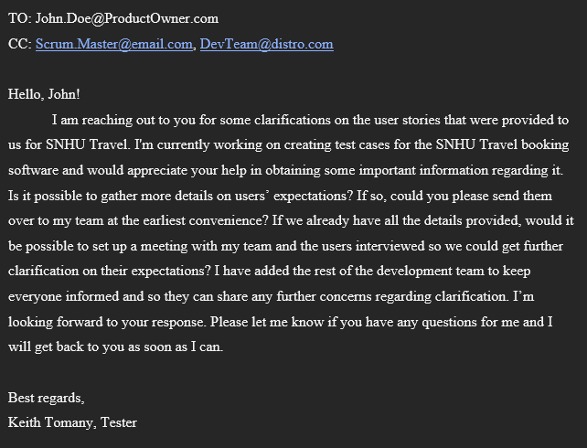
Figure 1 – Tester email from “4-3 Journal: Tester” assignment.

Organizational Tools
Our organization centered on the product backlog and user stories, which transformed the project’s requirements into a manageable, step-by-step roadmap. By prioritizing high-value tasks at the top of the backlog, we ensured that critical features were implemented first. This structured yet flexible approach proved essential when the client requested changes to the top five destinations. We adapted seamlessly without sacrificing our deadline.

Evaluating Agile Process
The Scrum-Agile framework provided significant advantages for the SNHU Travel project, most notably flexibility and transparency. When requirements shifted mid-development, our use of incremental delivery allowed the team to pivot by re-evaluating completed features and adjusting the roadmap without friction. Scrum events further bolstered success by ensuring constant communication and visibility across the board. However, the inherent flexibility of Scrum can lead to reduced predictability. Since the project evolves iteratively, forecasting an exact completion date may be difficult - a potential risk for projects with rigid deadlines. It also requires that the team adhere to their meeting schedule and maintain open communication to keep up with the constant flow of change. If radiator boards are not kept up-to-date, items could get lost in the shuffle and the sprint could quickly fall behind.
Ultimately, I believe the Scrum-Agile approach was the best choice for the SNHU Travel project. Given the high-risk factors, including a strict five-week deadline and potentially unclear requirements, the empirical process control of transparency, inspection, and adaptation was essential. Using the waterfall method, any changes in user expectations could set the entire project back weeks. The Agile approach offers the flexibility to adjust to changing parameters. A traditional waterfall approach would likely have resulted in a product that did not meet user expectations, whereas Agile’s frequent feedback loops ensured the final product remained aligned with customer needs and kept development smooth.

