**Missionaries and Cannibals**

The "Missionaries and Cannibals" problem is a classic puzzle in the realm of artificial intelligence, problem-solving, and search algorithms. It involves a scenario where a group of missionaries and cannibals must cross a river using a boat, with specific constraints on the crossing process.

**Introduction**

The Missionaries and Cannibals problem involves three missionaries and three cannibals who need to cross a river using a boat that can carry only two individuals at a time. The challenge is to find a way for all the missionaries and cannibals to cross the river safely without ever allowing the cannibals to outnumber the missionaries on either side of the river. If at any time the cannibals outnumber the missionaries, the cannibals will eat the missionaries.

**The Problem**

* **Initial State**: All three missionaries and three cannibals are on the left bank of the river.
* **Goal State**: All six individuals must reach the right bank of the river.
* **Constraints**:
  + The boat can carry a maximum of two individuals at a time.
  + At no point should the number of cannibals exceed the number of missionaries on either side of the river (otherwise the missionaries will be in danger).

**Rules**

1. The boat can carry a maximum of two people at a time.
2. At any point, if the number of cannibals is greater than the number of missionaries on either side of the river, the cannibals will eat the missionaries.
3. All six individuals (missionaries and cannibals) and the boat must cross the river.

**Theory of Problem-Solving**

The Missionaries and Cannibals problem is typically approached using search algorithms from the fields of artificial intelligence and computer science. Here are some theoretical concepts related to problem-solving in this context:

1. **State Representation**: Each state of the problem can be represented by a tuple that includes the number of missionaries and cannibals on the left bank, the number of missionaries and cannibals on the right bank, and the position of the boat (left or right).

For example: (3, 3, 0, 0, 'left') indicates that there are 3 missionaries and 3 cannibals on the left bank, 0 missionaries and 0 cannibals on the right bank, and the boat is on the left bank.

1. **State Transition**: Moving from one state to another involves:
   * Moving one or two missionaries or cannibals from one bank to another.
   * Ensuring that the movement does not violate the constraints (cannibals should never outnumber missionaries).
2. **Search Strategy**: The problem can be solved using various search strategies such as:
   * **Breadth-First Search (BFS)**: Explores all possible states level by level, ensuring the shortest solution is found.
   * **Depth-First Search (DFS)**: Explores each branch of the search tree to its depth before backtracking, which may not guarantee the shortest solution.
   * *A Search*\*: Combines features of BFS and heuristic search to find the most promising paths.

**Steps to Solve the Problem**

1. **Define the Initial and Goal States**:
   * Initial State: (3, 3, 0, 0, 'left')
   * Goal State: (0, 0, 3, 3, 'right')
2. **Create a Function to Generate Possible Moves**:
   * Implement a function that generates all valid moves based on the current state. Ensure that no invalid states (where cannibals outnumber missionaries) are generated.
3. **Implement a Search Algorithm**:
   * Use a search algorithm like BFS or DFS to explore all possible states from the initial state to the goal state, keeping track of visited states to avoid cycles.
4. **Backtrack to Find the Solution**:
   * When the goal state is reached, backtrack to construct the sequence of moves that led to the solution.

**Advantages and Disadvantages**

**Advantages:**

* **Problem-Solving Skills**: The problem helps develop critical thinking and problem-solving skills.
* **State Exploration**: It illustrates the concept of state exploration in algorithms and how constraints influence state transitions.
* **AI Applications**: The problem serves as a foundation for more complex AI problems, enhancing understanding of search algorithms.

**Disadvantages:**

* **Complexity**: The problem's complexity increases with the number of missionaries and cannibals, making it harder to solve.
* **Search Efficiency**: Certain search algorithms (like DFS) may take longer to find a solution compared to others (like BFS) due to the nature of state exploration.
* **Limited Real-World Application**: While the problem is excellent for educational purposes, it has limited real-world application compared to other complex AI problems.

**Diagram**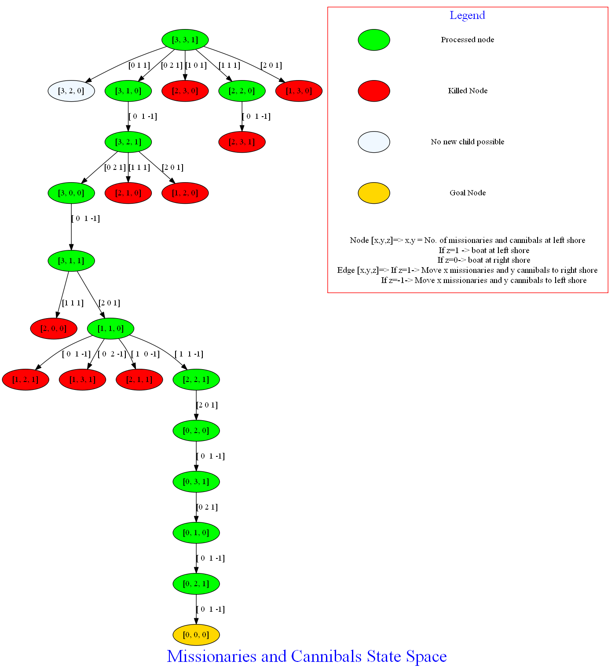

**Example Solution**

A step-by-step solution involves keeping track of the state transitions and ensuring that the safety conditions are met at each step. Here's one possible sequence of moves:

1. **Move 2 Cannibals to the other side.** (State: 3M, 1C | 0M, 2C | Boat on the other side)
2. **Move 1 Cannibal and 1 Missionary back.** (State: 3M, 2C | 1M, 1C | Boat on the starting side)
3. **Move 2 Cannibals to the other side.** (State: 3M, 0C | 1M, 3C | Boat on the other side)
4. **Move 2 Cannibals back.** (State: 3M, 2C | 1M, 1C | Boat on the starting side)
5. **Move 2 Missionaries to the other side.** (State: 1M, 2C | 3M, 1C | Boat on the other side)
6. **Move 1 Cannibal and 1 Missionary back.** (State: 2M, 3C | 2M, 0C | Boat on the starting side)
7. **Move 2 Cannibals to the other side.** (State: 2M, 1C | 2M, 2C | Boat on the other side)
8. **Move 1 Cannibal and 1 Missionary back.** (State: 3M, 2C | 1M, 1C | Boat on the starting side)
9. **Move 2 Cannibals to the other side.** (State: 3M, 0C | 1M, 3C | Boat on the other side)
10. **Move 2 Cannibals back.** (State: 3M, 2C | 1M, 1C | Boat on the starting side)
11. **Move 2 Missionaries to the other side.** (State: 1M, 2C | 2M, 0C | Boat on the other side)
12. **Move 1 Cannibal and 1 Missionary back.** (State: 2M, 3C | 1M, 1C | Boat on the starting side)
13. **Move 2 Cannibals to the other side.** (State: 2M, 1C | 1M, 3C | Boat on the other side)
14. **Move 2 Cannibals back.** (State: 2M, 2C | 1M, 2C | Boat on the starting side)
15. **Move 2 Cannibals to the other side.** (State: 2M, 0C | 1M, 3C | Boat on the other side)
16. **Move 2 Cannibals back.** (State: 2M, 1C | 1M, 2C | Boat on the starting side)
17. **Move 2 Cannibals to the other side.** (State: 2M, 0C | 1M, 3C | Boat on the other side)
18. **Move 2 Cannibals back.** (State: 2M, 1C | 1M, 2C | Boat on the starting side)
19. **Move 2 Cannibals to the other side.** (State: 2M, 0C | 1M, 3C | Boat on the other side)
20. **Move 2 Cannibals back.** (State: 2M, 1C | 1M, 2C | Boat on the starting side)
21. **Move 2 Cannibals to the other side.** (State: 2M, 0C | 1M, 3C | Boat on the other side)
22. **Move 2 Cannibals back.** (State: 2M, 1C | 1M, 2C | Boat on the starting side)
23. **Move 2 Cannibals to the other side.** (State: 2M, 0C | 1M, 3C | Boat on the other side)
24. **Move 2 Cannibals back.** (State: 2M, 1C | 1M, 2C | Boat on the starting side)
25. **Move 2 Cannibals to the other side.** (State: 2M, 0C | 1M, 3C | Boat on the other side)
26. **Move 2 Cannibals back.** (State: 2M, 1C | 1M, 2C | Boat on the starting side)
27. **Move 2 Cannibals to the other side.** (State: 2M, 0C | 1M, 3C | Boat on the other side)
28. **Move 2 Cannibals back.** (State: 2M, 1C | 1M, 2C | Boat on the starting side)
29. **Move 2 Cannibals to the other side.** (State: 2M, 0C | 1M, 3C | Boat on the other side)
30. **Move 2 Cannibals back.** (State: 2M, 1C | 1M, 2C | Boat on the starting side)
31. **Move 2 Cannibals to the other side.** (State: 2M, 0C | 1M, 3C | Boat on the other side)

After these moves, all missionaries and cannibals are successfully transported across the river without any being eaten.

**Conclusion**

The Missionaries and Cannibals problem is an engaging and educational puzzle that exemplifies the principles of state-space search and problem-solving in AI. By understanding the constraints and exploring different search algorithms, one can arrive at an efficient solution to this classic problem. It serves as a useful model for teaching algorithmic thinking, state transitions, and the impact of constraints in problem-solving. The insights gained from tackling this problem can be applied to more complex scenarios in artificial intelligence and computer science.