**Implement minmax algorithm for game playing**

**1. Introduction to Minimax Algorithm**

The Minimax algorithm is a popular decision-making algorithm used in two-player turn-based games such as Chess, Tic-Tac-Toe, and Checkers. It is a backtracking algorithm that helps a player make optimal decisions by simulating all possible moves and counter-moves. The goal of the algorithm is to minimize the possible loss in a worst-case scenario, assuming the opponent is also playing optimally.

The Minimax algorithm operates on a game tree that represents all possible moves of both players, aiming to either maximize the score (for the player) or minimize the opponent’s score.

**2. Key Concepts of Minimax**

* **Maximizing Player (Max)**: This player tries to get the highest possible score.
* **Minimizing Player (Min)**: This player attempts to minimize the maximizing player’s score.
* **Game Tree**: A tree-like structure that represents all possible moves of both players.
* **Depth of Tree**: The depth of the game tree determines how far into the game the algorithm will explore. It represents each move or turn.

At each turn, the algorithm assumes the **Max** player will try to maximize their score, while the **Min** player will try to minimize the opponent’s score.

**3. Components of Minimax Algorithm**

1. **Game Tree Representation**: Each node of the game tree represents a possible state of the game, and the branches represent possible moves.
2. **Terminal States**: These are the leaf nodes of the game tree that represent a final state (win, loss, or draw).
3. **Evaluation Function**: This function assigns a score to terminal states. Positive values represent favorable outcomes for Max, and negative values represent favorable outcomes for Min.
4. **Depth Limit**: The maximum depth the algorithm explores in the game tree.

**4. Steps to Implement Minimax Algorithm**

1. **Generate Game Tree**: Represent the game as a tree, where each node is a possible game state.
2. **Recursion**: Recursively simulate the game from the current state down to the terminal states.
3. **Maximizer’s Turn**: At each level where it is Max's turn, select the move that maximizes the value.
4. **Minimizer’s Turn**: At each level where it is Min's turn, select the move that minimizes the value.
5. **Backtrack**: Once terminal states are evaluated, backtrack through the tree to determine the optimal move for Max.

**5. Game Trees and Evaluation Function**

**Game Trees**: A game tree is a structure that represents all possible moves of a game. Each node represents a game state, and each edge represents a move.

**Evaluation Function**: The evaluation function assigns scores to the terminal states of the game tree. For example:

* **+10**: Max wins
* **-10**: Min wins
* **0**: Draw

**6. Example Application: Tic-Tac-Toe**

Let’s apply the Minimax algorithm to **Tic-Tac-Toe**, where the goal is to choose the optimal move for the player (Maximizer).

**Board Example:**

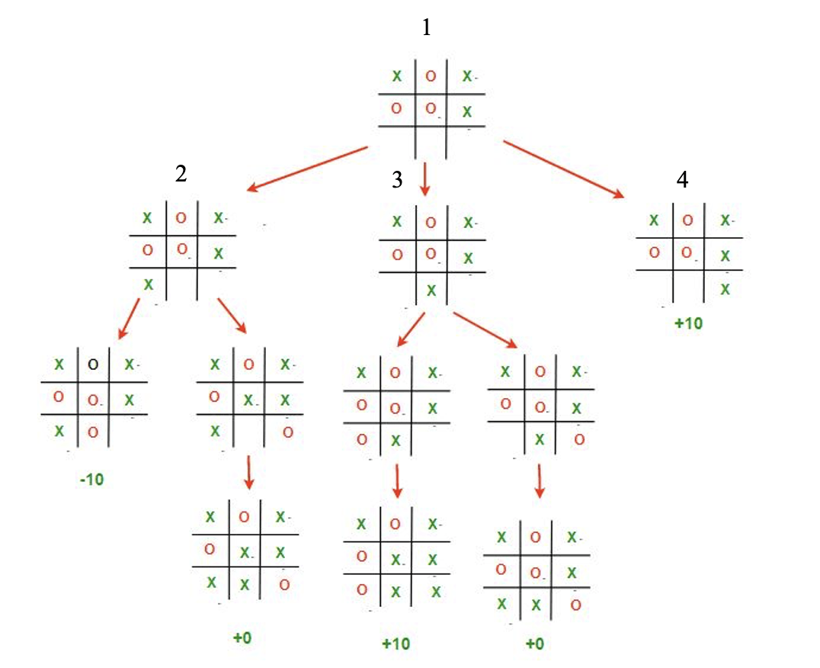

X | O | X

O | X |

| | O

In this game, the Minimax algorithm will:

* Explore all possible moves for the player.
* Simulate the opponent's moves in response to each of the player's moves.
* Evaluate the outcome of each game state.
* Choose the move that maximizes the player's chances of winning or minimizing losses.

**7. Pseudocode for Minimax Algorithm**

Here’s the pseudocode for the Minimax algorithm:

bash

function minimax(position, depth, isMaximizingPlayer)

if terminal state of position:

return evaluation function of the position

if isMaximizingPlayer:

maxEval = -infinity

for each child of position:

eval = minimax(child, depth + 1, false)

maxEval = max(maxEval, eval)

return maxEval

else:

minEval = +infinity

for each child of position:

eval = minimax(child, depth + 1, true)

minEval = min(minEval, eval)

return minEval

**Steps:**

1. **Maximizing Player’s Turn**: Choose the maximum value of the available moves.
2. **Minimizing Player’s Turn**: Choose the minimum value of the available moves.
3. **Base Case**: When a terminal state (win, loss, draw) is reached, return the evaluation of that state.

**8. Alpha-Beta Pruning**

**Alpha-Beta Pruning** is an optimization technique used to improve the efficiency of the Minimax algorithm by reducing the number of nodes that are evaluated in the game tree.

**Alpha-Beta Pruning Example:**

* **Alpha**: The best choice (maximum) found so far at any point along the path for the maximizer.
* **Beta**: The best choice (minimum) found so far at any point along the path for the minimizer.

The algorithm prunes branches of the game tree that cannot possibly influence the final decision, thus reducing the computation time.

**9. Advantages and Limitations of Minimax**

**Advantages:**

* **Optimality**: The Minimax algorithm ensures the best possible outcome for the player if both players play optimally.
* **Simplicity**: Minimax is conceptually simple and easy to understand, making it a suitable choice for many turn-based games.

**Limitations:**

* **Time Complexity**: Minimax has a high time complexity, especially for games with large game trees (e.g., Chess).
* **Space Complexity**: Since it evaluates every possible move and counter-move, Minimax requires a significant amount of memory to store the game tree.

**10. Applications of Minimax Algorithm**

The Minimax algorithm is used in a variety of two-player turn-based games and AI applications:

* **Tic-Tac-Toe**: Ensures optimal moves in this classic game.
* **Chess and Checkers**: Used to evaluate game trees to determine the best possible moves for the AI.
* **Connect Four**: Another example where Minimax is used to simulate different strategies and select the optimal move.

Beyond games, Minimax can also be applied to other decision-making problems where two adversarial parties are involved.

**11. Conclusion**

The **Minimax algorithm** is a powerful decision-making algorithm widely used in turn-based games. By exploring all possible moves and outcomes, the algorithm helps a player make optimal moves. While the algorithm ensures the best result when the opponent is also playing optimally, its efficiency can be significantly improved by integrating techniques like **Alpha-Beta Pruning**.