**Integrated Approach for Tomato Leaf Disease Detection, Fertilizer Application, and Precautionary Measures**

Komal Jadhav1 ,Komal Patankar2 ,Rutuja Sonawane3 , Anuradha Yenkikar4,Pranjal Pandit5

Department of Computer Science and Engineering (Artificial Intelligence),

Vishwakarma Institue of Information Technology, Kondhwa , Pune

1[komal.22320089@viit.ac.in](mailto:komal.22320089@viit.ac.in)

2[komal.22210480@viit.ac.in](mailto:komal.22210480@viit.ac.in)

3[rutuja.22210341@viit.ac.in](mailto:rutuja.22210341@viit.ac.in)

4[anuradha.yenkikar@viit.ac.in](mailto:anuradha.yenkikar@viit.ac.in)

5pranjal.pandit@viit.ac.in

**ABSTRACT**

Plant diseases represent a serious risk to agricultural productivity and cause large-scale financial losses on a worldwide scale. Effective illness management depends on the early detection and precise identification of these conditions. In this study, we undertake a comparative analysis of Convolutional Neural Networks (CNN), AlexNet, and InceptionV3 in detecting plant diseases using leaf images. We employ a dataset sourced from Kaggle and rigorously evaluate each model's accuracy as the primary metric. Beyond disease detection, our research introduces a comprehensive system that not only identifies plant diseases but also offers practical recommendations for fertilizer application and disease mitigation precautions. By integrating machine learning techniques with actionable insights, our study aims to empower agricultural practitioners with informed decision-making tools. Our research addresses a critical gap by providing a comparative analysis of various neural network architectures and presenting a holistic solution for disease management in agriculture. Through the provision of practical recommendations, we ensure that our study transcends theoretical analysis to directly impact agricultural practices, thereby contributing to improved crop health and enhanced productivity. We achieved promising results, with classification accuracy ranging from 97% to 100% across classes. The suggested model has a 99.21% accuracy on average for the nine diseases and one healthy class. These results highlight how well our method works to identify and categorise plant diseases. further enhancing its practical relevance for agricultural stakeholders.

Keywords: Disease Detection, Tomato Leaf, CNN, Inceptionv3, AlexNet, Machine Learning, Agriculture.

**INTRODUCTION**

Plant diseases present a significant challenge in agriculture, impacting both the quantity and quality of crops. It is crucial to identify diseases in tomato plants in order to maintain a healthy crop and achieve high yields. Machine learning offers a promising solution by enabling the automatic detection of tomato leaf diseases. By incorporating a diverse range of datasets featuring both healthy and diseased leaves, machine learning algorithms can learn to recognize characteristic patterns and symptoms of various diseases, including early blight, late blight, and leaf mold. This allows farmers to swiftly and accurately diagnose the presence of disease in tomato plants, facilitating timely intervention and management. This project aims to explore different machine learning algorithms and techniques to develop a robust system for detecting tomato leaf diseases. Detecting and identifying plant diseases in a timely and accurate manner is vital for farmers to effectively manage and protect their crops. Failure to do so can result in substantial economic losses and a significant threat to agricultural productivity. This research focuses on comparing the performance of various machine-learning models in detecting plant diseases. Specifically, proposed system analyze the effectiveness of different models in accurately identifying disease symptoms from images of plant leaves.

Tomato plants are susceptible to various diseases that can have a negative impact on crop yield.. Detecting these diseases early is crucial for farmers to implement necessary measures and prevent further spread. In recent years, machine learning has shown potential in automating the detection process by analyzing leaf images and identifying patterns. This project aims to create an efficient and accurate system that can detect tomato leaf diseases using machine learning algorithms. By training the model on a dataset containing healthy and diseased tomato leaves, we aim to create a reliable model that offers farmers timely and precise disease diagnosis, ultimately enhancing the health and yield of tomato crops. Our research focuses on comparing the performance and accuracy of CNN, AlexNet, and InceptionV3 models. Through experiments and evaluation using datasets from Kaggle, we aim to determine which models excel in disease detection. The findings of this study are anticipated to guide the selection of optimal machine learning models for plant disease detection, assisting farmers in implementing effective disease management strategies. Additionally, our research will not only focus on disease detection but also provide customized recommendations for fertilizer application and preventive measures to reduce disease recurrence. This comprehensive approach aims to equip farmers with practical insights to efficiently handle tomato plant diseases and promote healthier crops, ultimately contributing to enhanced agricultural sustainability and food security.

**LITERATURE SURVEY**

Tomato, a vital global crop, suffers from various leaf diseases that significantly impact yield. Early and accurate disease detection is crucial for effective control and minimizing losses. Farmers rely on visual inspection, which is time-consuming, subjective, and prone to errors[1].

Preprocessing techniques like noise reduction, color space transformation, and segmentation prepare the images [1]. Feature extraction techniques like color histograms, texture features, and local binary patterns (LBP) capture relevant information [2]. Traditional algorithms like SVMs and kNN have been used for disease classification based on extracted features, but their performance is often limited compared to deep learning.

Because CNNs can automatically learn characteristics from image data, they are the most often used method.. Pre-trained CNN models like VGGNet, ResNet, and DenseNet have been successfully fine-tuned for tomato leaf disease classification with high accuracy . Publicly available datasets like PlantVillage play a crucial role in training and testing deep learning models. These datasets contain labeled images of both healthy and diseased tomato leaves presenting various conditions. The model's ability to classify healthy and diseased leaves is typically measured using accuracy, precision, recall, and F1-score metrics. [2]. YOLOX, a recent object detection model, not only classifies diseases but also localizes them on the leaf, providing a more comprehensive analysis [3].

An incredible performance methodology for diagnosing plant diseases is deep transfer learning: Inception and ImageNet modules were used for pre-trained datasets Pepper, vegetable, potato, and tomato leaf pictures in the PlantVillage database were analyzed and improved using SVM and multi-layer neurons. The model achieves a superior accuracy of 94.35% after being trained..[10,9] With an accuracy of roughly 94.17%, tomato leaf disease detection is accomplished in the study with the use of a CNN enabling precise identification and categorization of eight distinct disease classes[11]. Using this dataset to train our CNN model, we were able to obtain a promising test accuracy of 98.39%. This high accuracy indicates that our method successfully predicts the presence of diseases in tomato leaves. [6].

An experimental study was conducted to identify tomato viral leaf diseases using machine learning classification techniques. The performance of traditional ML algorithms Random Forest, Support Vector Machine, Naive Bayes was compared to that of CNN in detecting tomato leaf diseases. CNN with Inceptionv3 model showed over 95% accuracy, outperforming traditional methods [5]. The following article describes a method for detecting diseases using deep learning. The technique involves using convolution neural networks for disease detection and classification. The model consists of three convolution layers, three max-pooling layers, and two fully connected layers. The experimental results indicate that this model outperforms pre-trained models such as VGG16, InceptionV3, and MobileNet. The suggested model has an average accuracy of 91.2% for the nine disease classes and one healthy class. However, the classification accuracy varies between 76% and 100% depending on the specific disease class. [1]

In a proposed CNN aimed at enhancing classification accuracy, The key advantage of this approach is its ability to automatically extract features from raw input images.. This results in a trained model achieving an best accuracy 99.18%. Notable merits of this approach include its high performance, although drawbacks include the computational intensity and the potential for reducing the size of deep neural networks (NN) [12]. Another machine learning model incorporating a CNN architecture, coupled with data augmentation techniques, addresses overfitting during training and achieves an overall accuracy of 89%. The benefits of this method include improved performance through data augmentation, but it necessitates transfer learning to classify all diseases [13].

In the literature, a CNN-based LeNet model has been presented, demonstrating an average accuracy range of 94-95%. Despite its efficient computational nature, there is potential for further performance enhancement by exploring various learning rate optimizers [14].A CNN and Faster R-CNN-based trained model yields a performance rate of 91.67%. While this method excels in recognizing high accuracy with transfer learning, it requires retraining the CNN for optimal performance [15]. A proposed methodology based on CNN achieves a classification accuracy of 98%. Noteworthy advantages include its high detection rate compared to existing methods, though it relies on the latest CNN techniques for previous results [16]. Another CNN-based methodology achieves a similar classification accuracy of 98%. Although it demonstrates high performance, its reliance on recent algorithms and classifiers may affect optimal results [17].

With a classification accuracy of 96.43%, a CNN-based Deep Learning model provides quick identification and detection. On the other hand, disadvantages include the need for a longer training period and difficulties figuring out the input image resolution [18]. The AlexNet model is a prominent example of a pretrained deep learning architecture for tomato leaves disease classification and detection, with a low execution time and a classification accuracy of 97.49%. Although this method reduces execution time while improving accuracy, accuracy may suffer from larger ini-batch sizes [19].

When comparing SqueezeNet and AlexNet, two Deep Learning Network-based architectures for tomato plant leaves disease detection, AlexNet shows a higher classification accuracy rate 95.65%. Due to its lightweight design, SqueezeNet uses less computational power. One of these is a longer training period, which can slow down the overall process. Additionally, the smaller batch size may also impact the efficiency of this method[20].

**METHODOLOGY**

1. **Data Collection and Preprocessing**

The Plant Village dataset consists of over 50,000 images of 14 different crops, such as tomatoes, blueberries, squash, potatoes, grapes, raspberries, soybeans, apples, corn, and strawberries. The dataset primarily focuses on tomato diseases, as it was our chosen crop for the study.

The following are images of different tomato classes (see figure 1.)

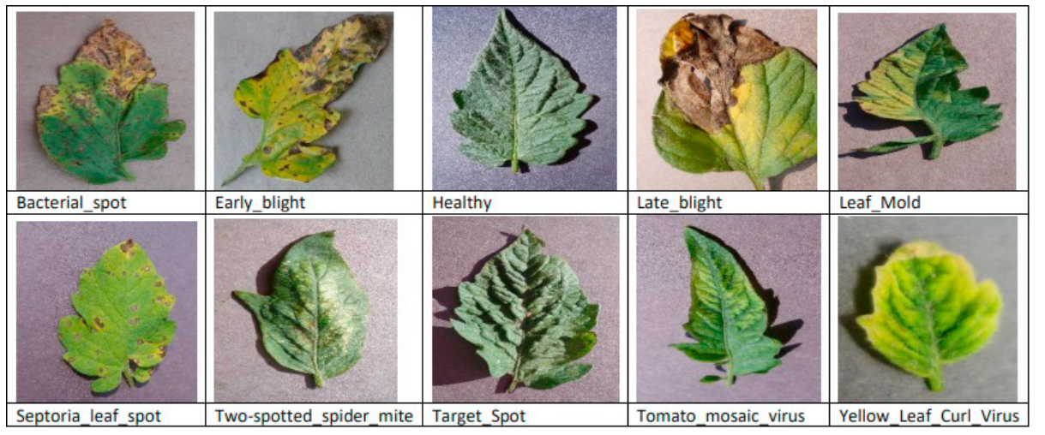

Fig. 1. A dataset sample image labelled by class.

|  |  |  |
| --- | --- | --- |
| Class | Disease Name | Image count |
| 1 | two-spotted spider mite | **465** |
| 2 | Early Blight | **316** |
| 3 | Septoria Leaf Spot | **484** |
| 4 | Target spot | **409** |
| 5 | yellow leaf curl virus | **1211** |
| 6 | healthy | **448** |
| 7 | Bacterial spot | **488** |
| 8 | Late blight | **520** |
| 9 | Leaf mold | **305** |
| 10 | Tomato mosaic virus | **147** |

Fig. 2. No. of images in dataset

Tomatoes can be affected by nine main disease categories. These include: 1) Target Spot, 2) Mosaic virus, 3) Bacterial spot, 4) Late blight, 5) Leaf Mold, 6) Yellow Leaf Curl Virus, 7) Spider mites (especially the Two-spotted spider mite), 8) Early blight, and 9) Septoria leaf spot. The diseases are listed in the order of their occurrence.The training dataset in the proposed study has 5000 photos, whereas the testing dataset contains 1300 images Out of the 5000 training images, 500 belong to each of the tomato disease categories mentioned above, while the remaining 500 are in the healthy category.. We took out of those files 125 randomly selected images from each class in the training set for testing.

Beyond disease detection, our research introduces a comprehensive system that not only identifies plant diseases but also offers practical recommendations for fertilizer application and disease mitigation precautions.

Below dataset contains fertilizer and precautions associated with the disease type as follows:

|  |  |  |
| --- | --- | --- |
| **Disease** | **Fertilizer** | **Precautions** |
| Tomato Bacterial spot | Organic fertilizers high in potassium | Apply copper-based fungicides. Remove and destroy infected plant parts. |
| Tomato Early blight | Balanced fertilizer with higher nitrogen content | Remove and destroy affected leaves. Practice crop rotation. |
| Tomato Late blight | Fertilizer rich in phosphorus | Apply fungicides and remove infected plant parts promptly. |
| Tomato Leaf Mold | Fertilizer with a balanced N-P-K ratio | Prune lower leaves and provide good airflow. Avoid overhead watering. |
| Tomato Septoria leaf spot | Nitrogen-rich fertilizer | Spray with insecticidal soap or neem oil. Remove heavily infested plants. |
| Tomato Spider mites Two-spotted spider mite | Fertilizer with low nitrogen content | Remove infected leaves and improve air circulation. |
| Tomato Target Spot | Slow-release fertilizer with micronutrients | Spray with insecticidal soap or neem oil. Remove heavily infested plants. |
| Tomato Yellow Leaf Curl Virus | High-phosphorus fertilizer | Control whiteflies and other insect vectors. Remove and destroy infected plants. |
| Tomato Tomato mosaic virus | Fertilizer with balanced nutrients | Control aphids and other insect vectors. Remove and destroy infected plants. |
| Tomato healthy | No specific recommendation needed | Maintain proper watering and nutrient  levels for healthy plants. |

Fig. 3. Fertilizer and precautions dataset

1. **Image Pre-Processing and Labeling**

Image pre-processing was executed to enhance the examine raw images before  model training. Developing a successful model involves evaluating the network design and the structure of the input data. The dataset was pre-processed to enable the proposed model to identify the relevant features from the images. The initial step involved standardizing the image size and resizing it to 224x224 pixels The use of data augmentation expanded the training set to include a wider range of images.. Data augmentation helps prevent overfitting by randomly modifying images in ways that do not impact interpretation, such as horizontal flipping, zooming, and rotation.

* Rescale: Adjusts the pixel values of the image.
* Shear_range: Specifies the counterclockwise shear angle in degrees.
* Zoom_range: Controls the zoom level.
* Horizontal_flip: Flips the image horizontally.

To effectively learn the features of the training data, this level of pre-processing requires a significant amount of training data. The next step was to categorizing images of tomato leaves according to type and labeling each image with the relevant disease acronym. For testing and training purposes, the dataset in this case contains  classes.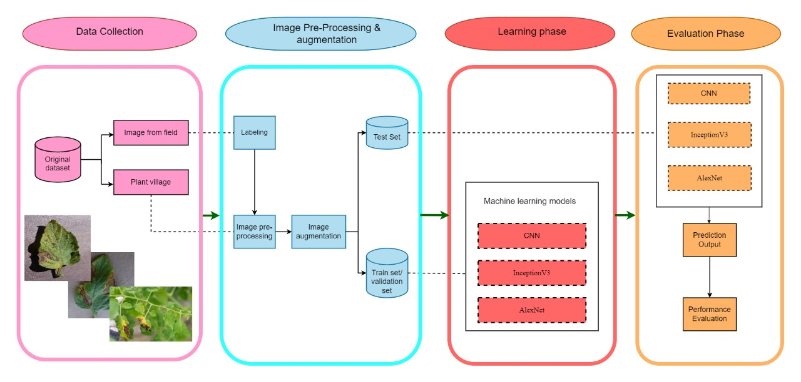

Fig. 4. Proposed system

1. **Model Selection and Training**
2. **CNN**

CNN is an abbreviation for Convolutional Neural Network. It is a type of deep learning model that is specifically designed for processing visual data, like images.They consist of layers that learn to extract features from input images through convolutional operations. These features are then downsampled using pooling layers to retain essential informationLastly, using the retrieved features as a basis, fully connected layers carry out classification or regression tasks. CNNs are trained through optimization algorithms to minimize a predefined loss function, enabling them to accurately classify images and perform various tasks in image processing. A CNN architecture was employed for detecting tomato leaf diseases. The model contains of multiple layers, each specifically designed to extract hierarchical features from input images and conduct multi-class classification.

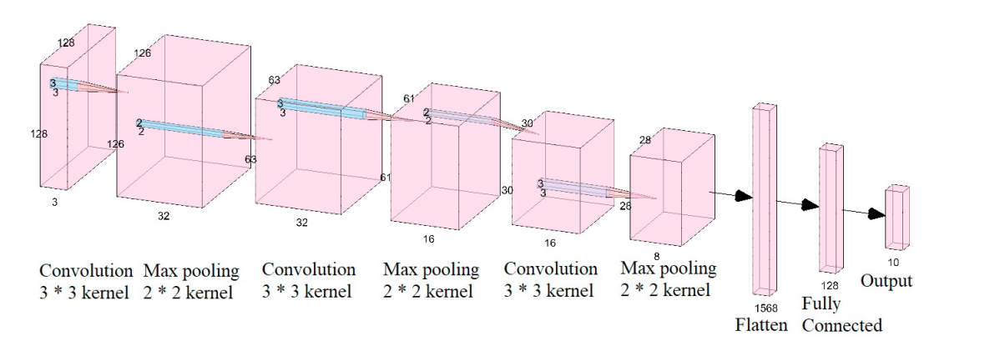

Fig. 5 . Convolution Neural Network

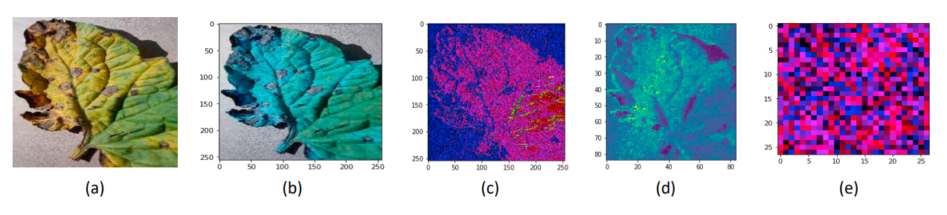

Figure 6. (a) The CNN model passed the image. Specifically, features were recovered at the first convolution layer ,(b) the second hidden layer ,(c) the third hidden layer ,(d) and the fourth hidden layer (e).

Below is a detailed overview of the model's architecture:

**1. Input Layer:**

The input layer establishes the input data's shape, defining the dimensions of the tomato leaf images. This enables the model to effectively process visual information.

**2. Convolutional Layers:**

The initial convolutional layer, named `conv2d_1`, is composed of 32 filters contains a kernel size of (5, 5). The model uses a type of activation function called Rectified Linear Unit (ReLU) which helps to introduce non-linearity in the neural network.Following this, a max-pooling layer, denoted as `max_pooling2d_1`, is applied with a pooling window size of (3, 3). This layer downsamples the feature maps, reducing computational complexity while preserving essential information. Another convolutional layer, referred to as `conv2d_2`, is then introduced. It consists of 32 filters with a size of (3, 3) and employs the ReLU activation function. To further downsample the feature maps, a subsequent max-pooling layer, labeled as `max_pooling2d_2`, is utilized with a pooling window size of (2, 2).

**3. Additional Convolutional Layer:**

In order to enhance the model's capability for feature extraction, a third convolutional layer, named `conv2d_3`, is added. This layer consists of 64 filters with a kernel size of (3, 3) and uses the ReLU activation function. After the third convolutional layer, a max-pooling layer is used, denoted as `max_pooling2d_3`, is applied. It employs a pooling window size of (2, 2) to further downsample the feature maps.

**4. Flattening Layer:**

"The flattening layer is an important tool in deep learning models that helps to convert the multi-dimensional feature maps into a single one-dimensional vector. This vector can be further used as input for fully connected layers in the neural network."after the convolutional and max-pooling layers referred to as `flatten_1`. This process facilitates seamless integration with densely connected layers.

**5. Densely Connected Layers:**

The flattened features are then passed through a dense layer, labeled as `dense_1`, which consists of 512 neurons. The ReLU activation function is working in this layer to promote non-linearity and enhance feature representation. To address overfitting, a dropout layer, denoted as `dropout_1`, is incorporated. It randomly deactivates a fraction of neurons during training, with a dropout rate of 0.25.

**6. Output Layer:**

The final dense layer, named `dense_3`, serves as the output layer. It contains neurons equal to the number of classes or disease categories. The softmax activation function is applied to this layer, generating probability distributions over the classes and enabling multi-class classification. The input layer defines the shape of the input data, specifying the dimensions of the tomato leaf images. This allows the model to process visual information effectively.

For the purpose of performance comparison, we also ran another machine learning model in the proposed work. The following is a brief discussion of several pre-trined models:

**2. InceptionV3:**

InceptionV3 is a deep CNN designed to extract hierarchical features from input images. Its input layer expects images sized (224, 224, 3), representing the three color channels (Red, Green, and Blue). Starting with convolutional layers, InceptionV3 performs feature extraction by convolving filters over the input, capturing low-level features like edges and textures. The distinguishing feature of InceptionV3 is its Inception modules, which include parallel convolutional pathways of various filter sizes (1x1, 3x3, and 5x5) and max-pooling operations. These pathways' outputs are concatenated to efficiently capture features at different spatial scales.Incorporating reduction layers, InceptionV3 utilizes convolutional and pooling layers to reduce spatial dimensions while increasing channel numbers, aiding in the extraction of higher-level features. The network ends with global average pooling, which converts spatial features into a one-dimensional vector.. This vector then enters one or more fully connected layers for classification based on extracted features.Lastly, the output layer is a dense layer with units equal to the task's class number, typically using softmax activation to output class probabilities. We utilized the pre-trained Inception V3 model for transfer learning in our tomato disease classification task with 10 classes. After training for 50 epochs, we observed an accuracy fluctuating between 85% to 90%. We noticed that the model tends to overfit for a small number of classes due to its deep architecture with 42 layers, especially when the distinguishing features are not pronounced or significant.

**3. Alexnet**

AlexNet, a convolutional neural network architecture devised by Alex Krizhevsky, Geoffrey Hinton and , Ilya Sutskever made waves in the 2012 ImageNet Large Scale Visual Recognition Challenge. The model's architecture, initialized as a Sequential model, comprises multiple convolutional and fully connected layers. It starts with convolutional layers featuring 96 filters in the first layer with an 11x11 kernel size and a 4x4 stride, followed by ReLU activation. Max pooling is then applied with a 2x2 pool size and stride. Subsequent layers follow a similar pattern, with variations in filter counts and kernel sizes. Batch normalization layers are integrated after each convolutional layer for stability during training. Flattening transitions the output from convolutional layers to Fully Connected layers. This layers consist of two sets of 4096-unit layers with ReLU activation and dropout regularization. The final layer, with softmax activation, outputs class probabilities, typically containing 1000 units for ImageNet classification. We attempted to apply pre-trained weights from AlexNet to classify 10 classes of tomato leaves. However, our experiments with transfer learning using AlexNet did not yield satisfactory results with our dataset sourced from the PlantVillage dataset folders. After training our model for 50 epochs, we observed a final accuracy ranging between 91% to 94%.

**RESULT AND DISCUSSION:**

Upon the conclusion of the training phase, a evaluation of each model was conducted, anlyzing by various metrics including accuracy, precision, F1-score and recall. After evaluating the models, we noticed that the CNN model performed better than the InceptionV3 and AlexNet models, demonstrating the highest accuracy in identifying tomato leaf illnesses 99.21% test accuracy and 95% validation accuracy were attained with the CNN model.

The figure below illustrates a comparison among three models: CNN, InceptionV3, and AlexNet[fig.7].

Fig. 7 Comaprison of model’s accuracy

The figure below depicts the relationship between accuracy and loss versus epochs during the training and testing phases of the model. The accuracy of the model on the training dataset typically becomes better as the number of epochs increases, while the loss generally goes down. This pattern suggests that as time goes on, the model learns and fits the training set with greater accuracy. However, it is essential to monitor the performance on the testing dataset to ensure that the model's generalization ability is not compromised. By analyzing the accuracy and loss curves, the proposed model assess the model's convergence and identify any signs of overfitting or underfitting[fig.8].

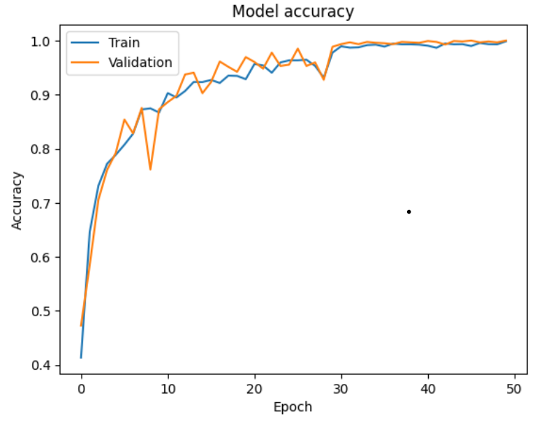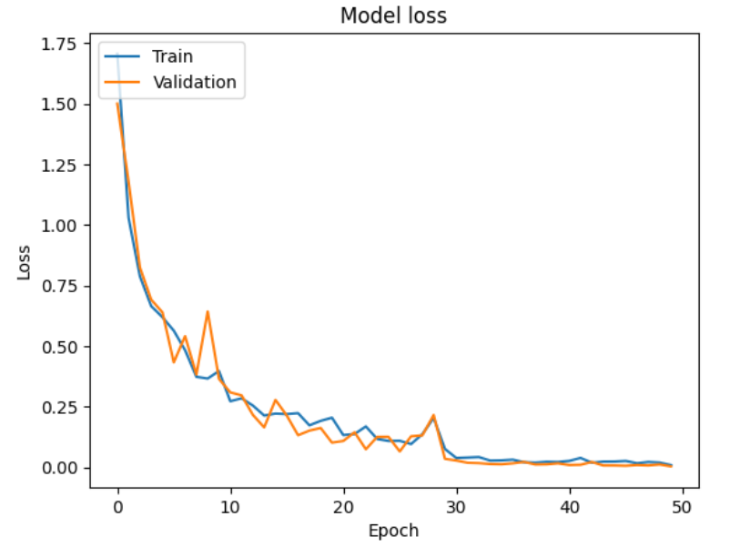

Fig. 8. (a) Model Accuracy (b) Validation loss of proposed model

After the disease detection, our research introduces a comprehensive system that not only identifies plant diseases but also offers practical recommendations for fertilizer application and disease mitigation precautions. By integrating machine learning techniques with actionable insights, our study aims to empower agricultural practitioners with informed decision-making tools. The figure below illustrates the workflow of this implementation, detailing how the system operates to suggest appropriate fertilizer types and recommend necessary precautions once a disease is predicted[fig. 9].

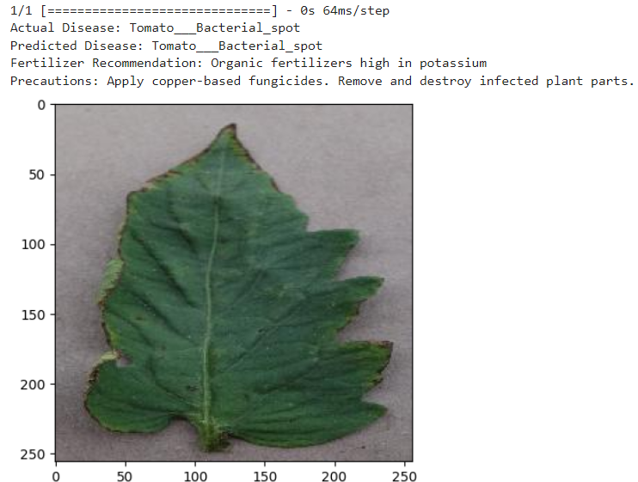

Fig. 9. Fertilizer and Precautions Recommedation

The proposed algorithm's performance evaluation encompasses multiple metrics(a) Accuracy (b)Precision (c) Recall (d) F1-Score .The figure below provides a comprehensive summary of the testing accuracy, precision, recall, and F1-score for each class of tomato leaf disease, emphasizing the significance of class 10[fig. 10].

1. (b)
2. (d)

Fig.10 . Various performance evaluation metrics for proposed algorithm

(a) Accuracy (b)Precision (c) Recall (d) F1-Score .

CNN are highly effective in detecting diseases in leaf images due to their ability to autonomously learn and extract pertinent features from raw image data. This capability enables CNNs to capture intricate details such as texture, shape, and color patterns, without necessitating manual feature engineering. As a result, CNNs can accurately identify signs of diseases in crops with remarkable precision, surpassing the performance of traditional machine learning methods.

Additionally, CNNs exhibit robustness to variations in leaf images caused by factors like lighting conditions and background clutter, ensuring reliable performance in diverse agricultural environments. By automating the disease detection process, CNNs streamline crop inspection, saving farmers time and effort. This automation facilitates early disease detection, empowering farmers to implement timely interventions and mitigate crop losses.

Furthermore, CNN-based disease detection systems enable precision agriculture methods by providing detailed insights into crop health status. By leveraging these insights, farmers can optimize resource usage, including the precise application of pesticides, fertilizers, and irrigation, ultimately leading to improved crop productivity and enhanced farm management. In summary, CNNs represent a powerful tool for disease detection in leaf images, offering farmers invaluable information to make informed decisions and protect their crops effectively.

**CONCLUSION** :

Our study undertook a comparative analysis of CNN, AlexNet, and InceptionV3 for detecting plant diseases using leaf images, focusing on tomato plants. We employed a dataset from Kaggle and rigorously evaluated each model's accuracy, with CNN emerging as the most effective model, achieving a validation accuracy of 95% and a test accuracy of 99.21%. This superior performance can be attributed to CNN's exceptional capacity to automatically extract relevant features from raw data and its unique architecture, which enables it to capture spatial relationships and hierarchical features within the input images. Moreover, CNNs' adaptability to diverse datasets and environmental conditions enhances their effectiveness in agricultural applications, making them a valuable tool for disease detection and crop management. Our research contributes to bridging the gap between machine learning techniques and practical agricultural solutions, empowering farmers with accurate disease detection tools and actionable insights for improving crop health and productivity.

The agricultural sector encompasses a diverse range of activities, where the profitability of farming heavily relies on both the quantity and quality of the yield generated. Among the various challenges faced by farmers, maximizing yield emerges as a paramount concern. In our study, we specifically delve into the cultivation of tomato plants, given their economic significance and vulnerability to various diseases. Tomato plants are susceptible to a range of diseases, which can severely impact crop health and productivity. Detecting and addressing these diseases promptly is crucial for ensuring optimal yields and minimizing losses for tomato farmers.To tackle this issue, our research aims on the development of robust machine learning algorithms for the prediction and detection of diseases in tomato plants. Through rigorous experimentation and analysis, we have successfully achieved an impressive accuracy rate of 99.21% in disease prediction.By effectively identifying and predicting diseases in tomato plants, our machine learning models offer significant potential to assist farmers in mitigating crop losses and optimizing their agricultural practices. This includes timely intervention strategies, targeted disease management, and overall improvement in tomato crop health and productivity.

**FUTURE SCOPE :**

The future potential for advancements and innovation in plant leaf disease detection is vast. Here are several important areas for future development and opportunities in this field:

* Multi-disease & nutrient deficiency detection
* Improved robustness to variations
* Explainable AI for reasoning and trust
* Disease progression prediction
* Yield estimation based on disease severity
* Real-time monitoring with drones/satellites
* Mobile applications for disease diagnosis
* Integration with smart agriculture systems
* Cloud platforms for agricultural consultants

**REFERNCES:**

1. Mohit Agarwal et al., "ToLeD: Tomato Leaf Disease Detection using Convolution Neural Network," Procedia Computer Science, vol. 167, pp. 293-301, 2020.
2. Amin Haque et al., "Monitoring Tomato Leaf Disease through Convolutional Neural Networks," Agronomy, vol. 12, no. 1, p. 22, Dec. 2021.
3. Tsung-Yi Lin et al., "Tomato Leaf Disease Identification Method Based on Improved YOLOX," Agriculture, vol. 13, no. 6, p. 1455, Jun. 2023.
4. (2022). Disease Detection in Tomato Plants Using CNN. doi: 10.1109/gcat55367.2022.9972186
5. Sanjeela, Sagar., Jaswinder, Singh. (2023). An experimental study of tomato viral leaf diseases detection using machine learning classification techniques. Bulletin of Electrical Engineering and Informatics, doi: 10.11591/eei.v12i1.4385
6. Tomato Leaf Disease Detection using convolutional neural networks.

<https://www.researchgate.net/publication/375224837_Tomato_Leaf_Disease_Detection_Using_Convolutional_Neural_Network>

1. Tomato leaf disease detection using deep learning <https://www.researchgate.net/publication/376886444_Tomato_Leaf_Disease_Detection_Using_Deep_Learning_Ensemble_Approach>
2. H. Kibriya, R. Rafique, W. Ahmad and S. M. Adnan, "Tomato Leaf Disease Detection Using Convolution Neural Network," 2021 , doi: 10.1109/IBCAST51254.2021.9393311.
3. Kurmi, Y., Gangwar, S., Agrawal, D., Kumar, S., & Srivastava, H. S. (2021). Leaf image analysis-based crop diseases classification. *Signal, Image and Video Processing*, *15*(3), 589-597.
4. Chen, Junde, et al. "Using deep transfer learning for image-based plant disease identification." *Computers and electronics in agriculture* 173 (2020): 105393.
5. Sun, Jun, et al. "Northern maize leaf blight detection under complex field environment based on deep learning." *IEEE access* 8 (2020): 33679-33688.
6. Brahimi, Mohammed, Kamel Boukhalfa, and Abdelouahab Moussaoui."Deep learning for tomato diseases: classification and symptomsvisualization." Applied Artificial Intelligence 31.4 (2017): 299-315
7. Adhikari, Santosh, et al. "Tomato plant diseases detection system usingimage processing." 1st KEC Conference on Engineering andTechnology, Lalitpur. Vol. 1. 2018
8. Tm, Prajwala, et al. "Tomato leaf disease detection using convolutionalneural networks." 2018 Eleventh International Conference onContemporary Computing (IC3). IEEE, 2018.
9. de Luna, R.G., Dadios, E.P. and Bandala, A.A., 2018, October.Automated image capturing system for deep learning-based tomato plantleaf disease detection and recognition. In TENCON 2018-2018 IEEERegion 10 Conference (pp. 1414-1419). IEEE
10. Karthik, R., et al. "Attention embedded residual CNN for diseasedetection in tomato leaves." Applied Soft Computing 86 (2020): 10593
11. Ashok, Surampalli, et al. "Tomato Leaf Disease Detection Using DeepLearning Techniques." 2020 5th International Conference onCommunication and Electronics Systems (ICCES). IEEE, 2020
12. Salih, Thair A. "Deep Learning Convolution Neural Network to Detectand Classify Tomato Plant Leaf Diseases." Open Access Library Journal7.05 (2020): 1.
13. Rangarajan, Aravind Krishnaswamy, Raja Purushothaman, and Aniirudh Ramesh. "Tomato crop disease classification using pre-trained deep learning algorithm." Procedia computer science 133 (2018): 1040-1047.
14. Durmu§, Halil, Ece Olcay Gune§, and Murvet Kirci. "Disease detection on the leaves of the tomato plants by using deep learning." 2017 6th International Conference on Agro-Geoinformatics. IEEE, 2017.
15. Tomato Leaf Disease Dataset : <https://www.kaggle.com/datasets/kaustubhb999/tomatoleaf>