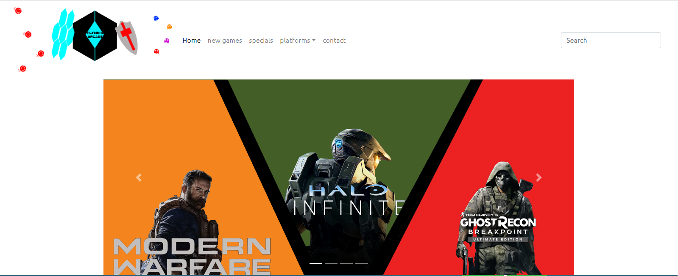

Flynn’s Website

MY WEBSITE

Kye Migdalski | IST | 30/08/19

Flynn's Arcade has been slowly losing money as the trend for accessing video games has moved away from social 'video game arcades' to at home 'video game consoles' such as the Atari & Commodore 64. Flynn wants to reposition his business as a venue for selling new games and trading used games. Flynn wants you to design and create ‘alpha phase’ website that communicates his new business model.

Areas of investigation

Wix is an easy drag and drop site used for making small business websites.

It also has preset templates for people to use it has many users but bigger companies dislike wix possibly because of how simple it is since it’s a drag and drop site, it is favored by companies just starting.

Wix was released in 2006 and had a low amount of users but recently it’s raised and now has 100 million users.

# Squarespace

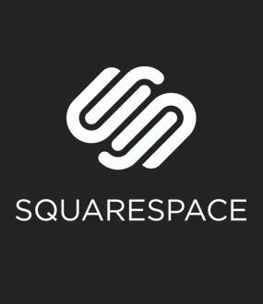Squarespace is a site similar to wix but also very different squarespace it has many templates but can be hard for some people to get used to due to usability issues.

But other than that it’s a well-rounded site and is good for blog websites portfolios and online stores.

# Related imageNotepad++

Notepad ++ is a coding site used for making websites it’s what we used to make our sites and its real good for making a starting site.

It was difficult to use at first but when you learn how to use it.

It becomes amazing because of all the stuff you can do with it.

# Weebly

Weebly is another website builder but is not as popular or as liked as wix or squarespace.

Weebly isn’t as advanced as wix or squarespace but it is easier to use for those who don’t often make websites or are new to computers etcetera.

Weebly also has many purchasable plans that come at a good price.



# Sitebuilder

Sitebuilder is a very beginner friendly website builder that is easy to learn to use but doesn’t quite hold up for making high-end websites but is still very good for small projects.

Webflow is a site builder that is made to be flexible and have the ability to make what you want for a site.

Webflow has hundreds of different types of templates for you to use which is one of its great features of being flexible.

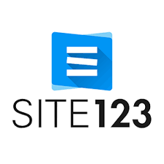

# Site123

Site123 is an easy to learn site which is sometimes faster to make compared to other sites, ­­­­­­­