# H1: Kayle's Kales

Catchphrase: Keep Calm and Kale On

CTA: Be Kale-curious

alt="Seasoning kale with chili flakes"

**The items highlighted in yellow are new content.

## H2: What is Kale?

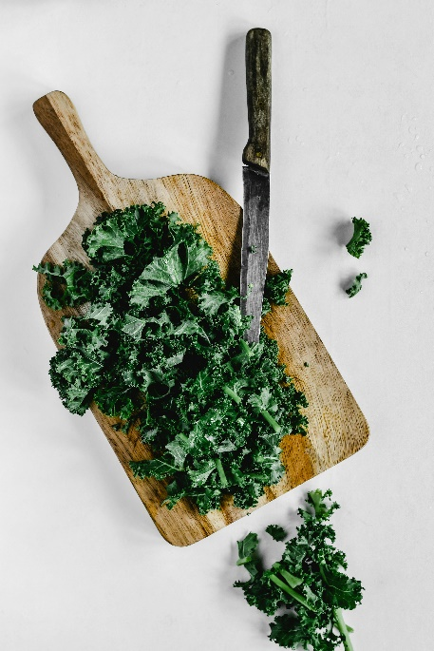

alt="Chopped kale on a cutting board"

Kale is a leafy green vegetable that belongs to the Brassica oleracea species, which is the same family as cabbage and broccoli. Its distinctive curly leaves that range from dark green to purple hues are just the beginning because it also includes fiber, antioxidants. and of course an assortment of vitamins like A, C, and K.

As someone who’s always on the go, I’ve discovered that kale isn’t just a fleeting food trend but it’s also a timeless superfood that transforms my lifestyle. It’s amazing how a simple green leaf can pack so many essential nutrients in every bite!

### H3: Incorporating Kale In Meals

Whether eaten raw, blended, sautéed, or baked, kale’s robust flavor and health benefits make it a wonderful addition to any meal. Experimenting with these ideas helped me seamlessly integrate this superfood into my routine and boost my overall well-being.

Over the years, I’ve learned that healthy eating is all about creativity and simplicity. I love finding new ways to integrate kale into my daily meals like tossing it into a quick stir-fry with garlic and olive oil, blending it into a refreshing smoothie, or even using it as the main part of a hearty soup. Its versatility lets me create dishes that are not only nutritious but also bursting with flavor. For me, kale is a lifestyle choice that fuels both my creativity and my well-being.

## H2: Kale Recipes

alt="Kale and egg sandwich with pesto and spices"

Here’s a little peek into my world of kale with some of my favorite ways to enjoy it in the kitchen. I’m often indulging in a fresh salad, blending up a nourishing smoothie, or creating a cozy bowl of soup, it's my little reminder that good food and good vibes go hand in hand.

I’ve experimented with countless recipes over the years. Here are some of my absolute favorites that make eating kale fun and delicious:

* Raw Kale Salad: Massage chopped kale with olive oil and lemon juice to soften the leaves, then toss in crisp apples, toasted walnuts, and a sprinkle of goat cheese.
* Kale Smoothie: Blend a handful of kale with banana, berries, and almond milk for a nutrient-packed start to your day.
* Sautéed Kale: Quickly sauté kale with garlic and olive oil until it turns bright green and tender, this is one of my favourite side dishes to complement any main course.
* Baked Kale Chips: Toss kale leaves with olive oil and your favorite seasonings, then bake until crispy for a guilt-free, crunchy snack.
* Kale Pesto: Blend kale with basil, garlic, and walnuts to create a vibrant twist on traditional pesto that elevates pasta dishes or sandwiches.

### H3: Crunchy Kale Caesar Salad

alt="Kale tossed salad"

One of my favorite kale recipes that perfectly showcases the art of incorporating fresh ingredients. Begin by gently massaging chopped kale leaves with a drizzle of extra virgin olive oil and a splash of lemon juice, which softens their texture and enhances the flavor. Add crisp slices of celery, juicy segments of orange, and a sprinkle of toasted almonds, creating a harmony of textures and tastes. This vibrant dish not only delivers on flavor but also celebrates the organic kale benefits that contribute to plant-based nutrition and overall wellness. It embodies creative kale salad ideas that are both satisfying and nutritious. Enjoy every bite of this refreshing, nutrient-packed meal. This delicious dish is perfect for a light lunch or a vibrant side that energizes your day.

### H3: Perfect Kale Chips

alt="Kale chips"

My signature kale chips recipe that transforms humble kale leaves into a crispy, savory snack bursting with flavor. Begin by gently tearing fresh kale into bite-sized pieces and then massaging them with a drizzle of olive oil and a light sprinkle of sea salt to awaken their taste. Arrange the leaves in a single layer on a baking sheet, ensuring each piece has space to crisp up. Bake in a preheated oven at 350°F for approximately 12 minutes until the edges turn golden and crunchy. This process not only preserves the organic kale benefits but also showcases how to cook kale in a fun and innovative way. Enjoy these irresistible, guilt-free treats as a perfect midday snack that nourishes your body.

### H3: Green Power Smoothie

alt="Kale smoothie"

A refreshing kale smoothie recipes creation that combines the goodness of kale with the natural sweetness of fresh fruits. Begin by blending a generous handful of kale leaves with a ripe banana and a cup of unsweetened almond milk for a smooth base. Add in a handful of frozen berries and a spoonful of chia seeds to boost texture and nutrition. This delightful blend not only provides kale superfood benefits but also serves as a revitalizing start to your day. The creamy, vibrant drink is perfect for a nourishing breakfast or an energizing snack, inviting you to embrace healthy eating tips with every sip. Every sip is a celebration of plant-based nutrition and the joy of indulging in quick healthy meals that leave you feeling refreshed and energized.

## H2: Kale Nutrition Facts

alt="Kale salad in front of a work station"

When I first discovered kale, I was blown away by its powerhouse nutrition. Can you believe that a serving of raw kale is mostly water (about 84%) and yet it’s packed with essential nutrients? It’s like nature’s little multivitamin and it makes me feel so balanced and ready to take on the day.

* How should I store kale? Keep it unwashed in a plastic bag in the refrigerator. Rinse and dry it right before use to maintain its freshness.
* What is the best way to prepare kale? For raw dishes, massage the leaves with a splash of olive oil and lemon juice to reduce bitterness. For cooking, lightly sauté or steam to preserve its nutrients.
* Is kale safe for everyone? Generally, kale is safe for most people. However, if you’re on any medications, consult your doctor about the appropriate intake.
* How long does kale last? Fresh kale can last up to a week in the refrigerator if stored properly. Blanching and freezing are excellent options for long-term storage.
* Can I eat kale raw? Absolutely! When properly massaged, raw kale becomes tender and is perfect for salads or smoothies.

### H3: Vibrant Vitamin Power of Kale

Diving into the kale nutrition facts reveals that this leafy green is a powerhouse of vitamins essential for vibrant health. According to the USDA, one cup of raw kale (approximately 67 grams) provides nearly 10,302 IU of Vitamin A, 80 mg of Vitamin C, and 547 mcg of Vitamin K. These nutrients support vision, immune function, and bone health while contributing to the overall kale vitamin content that fuels your well-being. I love how incorporating kale into my meals not only boosts flavor but also nourishes my body with vital antioxidants and minerals. Embracing these health benefits of kale inspires me to create innovative dishes that elevate my daily nutrient intake, making every bite a celebration of natural goodness and plant-powered vitality. This compelling data is backed by extensive nutritional research.

### H3: Antioxidant-Rich Powerhouse: Kale's Defenses

Delving into the kale nutrition facts regarding antioxidants reveals that kale is an exceptional defender against oxidative stress. A single cup of raw kale offers over 120 mg of antioxidants, including quercetin and kaempferol, which are scientifically proven to neutralize damaging free radicals. This impressive nutrient profile highlights the powerful health benefits of kale that contribute to reduced inflammation and enhanced cellular health. I am continually inspired by how incorporating kale into my meals not only provides a burst of refreshing flavor but also boosts my intake of antioxidant-rich foods essential for robust immunity. Every vibrant serving reinforces my commitment to creating delicious, nutrient-packed dishes that celebrate the remarkable qualities of this cruciferous vegetable. This evidence-based nutritional powerhouse motivates me every day to embrace a healthier lifestyle.

### H3: Empower Your Journey with Kale for Weight Loss

Exploring the kale nutrition facts for weight management reveals that this powerhouse leafy green is ideal for supporting a lighter lifestyle. A single cup of raw kale contains only about 33 calories and delivers 2.6 grams of fiber, which naturally promotes fullness and aids in digestion. Research indicates that high-fiber foods play a significant role in reducing overall calorie intake and enhancing metabolic health. I am always excited by how incorporating kale into my meals supports my commitment to kale for weight loss while offering a burst of refreshing flavor. This nutrient-dense vegetable seamlessly fits into my daily meal planning, inspiring me to create innovative dishes that support sustainable weight loss and overall wellness. These evidence-based benefits make kale a cornerstone in nutritional meal planning for a healthier body.

## H2: About Me



alt="A lady holding salad"

Hi, I’m Kayle! I’m passionate about all things kale. My mission is to show the world just how versatile and nutritious this leafy green can be. I aim to inspire healthier lifestyles one bite at a time, whether that’s sharing delicious recipes or providing tips on how to incorporate kale in your daily meals. So if you're also a kale enthusiast or just kale-curious, we can make this superfood fun and simple to enjoy.

I’ve been on this health journey for over a decade, continually exploring how the food we eat influences our creativity and energy. My love for kale grew through countless experiments in my own kitchen during long recording sessions and backstage moments. Backed by trusted research from the USDA and peer-reviewed nutritional studies, my experiences with kale are both personal and evidence-based. I’m committed to transparency and always welcome questions or feedback. Your health and creative inspiration mean the world to me. I’m proud to share my authentic experiences and detailed nutritional insights with you. This page is a living testament to the transformative power of kale and the joy it brings to my everyday life. I hope it inspires you to experiment, explore, and join me on this journey toward a healthier, more vibrant lifestyle.