北京邮电大学 本科毕业设计（论文）初期进度报告
Project Early-term Progress Report
学院  School | Queen Mary School Hainan | 专业  Programme | Information and Computational Sciences (ICS)
姓  Family name | Li | 名  First Name | Mingqi
BUPT学号  BUPT number | 2022213728 | QM学号  QM number | 221155590 | 班级  Class | 2022217702
论文题目  Project Title | Network Analysis of the Chinese High-Speed Railway System
Literature Review
This section reviews existing studies related to the network analysis of railway and high-speed railway (HSR) systems, focusing on three dimensions: spatial structure, topological characteristics, and network robustness. The purpose of this review is to clarify the position of this study in the existing literature, point out the limitations of relevant research methods, and elaborate on the innovative contributions of this study.
1. Problem Definition in Railway Network Research
Transportation systems are often modeled as network structures, where infrastructure elements are abstracted as nodes and edges to analyze system-level attribute characteristics. In the context of railway system research, stations are usually defined as network nodes, while track sections or operating lines constitute network edges. This abstract modeling method enables the application of complex network theory, through which the connectivity, accessibility, and operational efficiency of railway systems can be quantitatively analyzed. Specifically, there are multiple typical paradigms for railway network modeling: urban metro networks mostly adopt the L-space graph model，nodes correspond to stations and railway interchanges, and edges connect adjacent nodes that are directly linked by tracks.; some studies also construct supernetworks by integrating L-space and P-space (based on passenger service connections) models, in the P-space two nodes representing stations are connected by an edge if a passenger can reach one from the other without changing train. n contrast, HSR network modeling focuses more on integrating operational service characteristics, such as constructing weighted network models by incorporating elements like travel time and train frequency.
HSR networks are inherently different from traditional railway systems, characterized by large spatial scales, high operating speeds, and strong dependence on regional economic structures. This characteristic determines that the network topology of HSR is not only affected by geographical spatial distance but also by multiple factors such as policy decision-making orientation, passenger flow demand distribution, and spatial resource constraints. In comparison, the modeling of urban rail transit networks focuses more on matching local physical topology with passenger demand, while the analysis of HSR networks needs to incorporate broader socioeconomic elements, such as integrating urban population, GDP, or industrial economic data. Therefore, how to select an appropriate modeling paradigm according to research scenarios to accurately define and scientifically model HSR systems remains a core challenge in the current research field.
2. Importance and Research Motivation of HSR Network Analysis
The research motivation of HSR network analysis has both theoretical value and practical significance. From a theoretical perspective, large-scale railway systems are typical cases for studying spatially embedded networks, whose constraint conditions are significantly different from abstract networks or pure topological networks. From a practical perspective, an in-depth understanding of the structural attributes of HSR networks is crucial for improving system robustness, guiding infrastructure investment decisions, and supporting the formulation of regional development strategies. Specifically, the improvement of HSR networks not only reshapes the regional urban system structure—Jiao et al. (2017) found that the expansion of China's HSR significantly improved urban network connectivity，They used graph theory and complex network analysis methods to measure the connectivity of urban networks. The core indicators include two categories: one is the overall network connectivity indicator, which evaluates the connectivity level and structural characteristics of the macro network through Beta index (average number of edges between nodes), average path length (average number of shortest paths between nodes), and clustering coefficient (degree of node clustering); The second is the weighted centrality index, which combines train frequency (edge weight) and connection breadth (edge quantity) to reflect the connectivity importance of a single city in the network through weighted degree centrality (WDC, comprehensive direct connection number and train frequency), weighted proximity centrality (WCC, measuring the accessibility and convenience of nodes to other nodes), and weighted intermediate centrality (WBC, quantifying the intermediary control ability of nodes).but also profoundly affects the spatial layout and efficiency improvement of related industries such as tourism; the optimization of urban rail transit networks directly relates to residents' travel efficiency and balanced urban spatial development, which is confirmed by Wen et al.'s (2019) research on the Shenzhen Metro.
Numerous studies have shown that the failure of key nodes or lines in highly centralized transportation networks can severely impact the overall operational efficiency of the system. Robustness and resilience are core indicators ensuring the stable operation of both national-scale HSR networks and urban-scale metro networks. At the urban metro network level, Zhang et al. (2018) found that the network exhibits high robustness under random failures but is vulnerable to targeted attacks on high-degree nodes, and the removal of some high-degree nodes can lead to a rapid collapse of network connectivity. The resilience of metro networks with different topological structures varies, and polycentric structures are more susceptible to targeted disturbances than monocentric structures with high redundancy. With the continuous expansion of HSR networks, evaluating their vulnerability to various disturbances and their ability to maintain normal functions under pressure has become an urgent research direction.
3. Topological Characteristics of Railway and Metro Networks
A large number of existing studies use complex network indicators to analyze the structural attributes of railway and metro systems. Common analytical indicators include average degree, clustering coefficient, characteristic path length, and centrality measures such as betweenness centrality and closeness centrality. For railway networks of different scales, researchers also expand the indicator system according to research needs: in HSR network research, weighted centrality measures combined with operational data such as train frequency and travel time are often introduced, and Rindone & Russo (2025) further constructed constrained centrality indicators considering time thresholds; in metro network research, in addition to basic topological indicators, multiple indicators such as the size of the largest connected component and network efficiency are also used to comprehensively evaluate structural characteristics.
Studies on urban rail transit systems such as metro show that transportation networks often have small-world characteristics, and some also exhibit scale-free characteristics, where a small number of high-degree nodes (core transfer stations) dominate the network structure. Centrality-based measures can effectively identify key stations, whose failure will have a significant impact on the connectivity of the entire network. In the field of HSR network research, Jiao et al. (2017) found that HSR expansion significantly increased the network's beta index(Quantifies the overall connectivity by calculating the average number of edges (direct train connections) per node (city), expressed as β=v/e​ (where e = number of edges, v = number of nodes). A higher value indicates stronger network connectivity.), reduced the average path length, and enhanced the clustering coefficient, reflecting a comprehensive improvement in network connectivity; traditional unweighted centrality indicators are difficult to accurately reflect the actual connectivity of HSR networks, and weighted and constrained centrality indicators combined with travel time and train frequency can more accurately identify underserved but strategically important nodes.
Although the above studies provide an important methodological basis, there are obvious differences in the analysis of topological characteristics of networks of different scales. Most urban rail transit studies focus on matching local topological structures with operational efficiency and analyzing the spatial distribution characteristics of network accessibility; in contrast, HSR network research needs to consider the coupling of spatial scales and socioeconomic elements, emphasizing the interactive relationship between urban population, GDP and other elements and network structure. Therefore, the conclusions of urban-scale studies cannot be directly generalized to national-scale HSR systems.
4. Research on China's HSR Network
In recent years, China's HSR network has become a research hotspot due to its unprecedented scale and development speed. Many studies have modeled China's HSR system as a complex network to analyze its degree distribution, hierarchical structure, and spatial organization. Jiao et al.'s (2017) longitudinal study revealed the dynamic evolution law of China's HSR network, finding that the large-scale expansion of HSR from 2003 to 2014 led to differentiated changes in the spatial distribution of urban network centrality， Under the influence of factors such as the expansion of high-speed rail networks, the core position and influence of different cities in regional transportation networks exhibit non-uniform and differentiated trends in geographic space, This reflects the equalizing effect of HSR on regional development, while the network itself still presents a highly centralized structural characteristic and core hub cities play a leading role in long-distance transportation connectivity.
Other studies have incorporated socioeconomic factors into the analysis and found that the expansion of HSR networks is closely related to regional economic development and population distribution, and is a key factor driving the spatial restructuring and network integration of China's urban system, promoting the formation of economic agglomeration and a polycentric development pattern. At the industrial impact level, Wei et al.'s (2026) research focused on the role of HSR in tourism, finding that HSR enhanced inter-provincial tourism interaction, promoted the transformation of China's tourism spatial structure from a single-core to a more balanced multi-centered system, and significantly improved national tourism efficiency, but significant regional disparities still exist. These research conclusions highlight the importance of fully considering spatial heterogeneity when analyzing national-level transportation networks.
However, existing studies still have many shortcomings. First, although most HSR studies involve longitudinal analysis, the focus period is relatively limited, and insufficient attention is paid to the evolutionary characteristics of the network after continuous expansion in recent years. Second, existing studies mostly discuss the impact of HSR on the urban system or specific industries separately, lacking an integrated analysis of the interactive mechanism between network structure, urban development, and industrial efficiency. Third, compared with the refined topological analysis of urban rail transit networks (such as supernetwork models), the modeling of HSR networks still mostly stays at the traditional topological or simple weighted level, and the integration of service characteristics needs to be deepened. Fourth, although multi-city comparative studies on topology and resilience have been carried out in the field of urban rail transit, cross-regional comparative studies on HSR networks are still lacking.
5. Research on Robustness and Resilience of Transportation Networks
The common method for evaluating network robustness is to simulate node or edge failure scenarios and observe changes in network connectivity or operational efficiency. Random failure simulation is generally used to characterize accidental disturbance events, while targeted attack simulation is used to analyze intentional damage or high-impact failure events targeting key nodes. In transportation network research, researchers mostly use multiple indicators to comprehensively evaluate the impact of failures, including the size of the largest connected component, average path length, and network efficiency.
In transportation system research, many studies have found that highly centralized networks are vulnerable to targeted attacks. To overcome the limitations of static robustness measurement indicators, relevant studies have proposed the resilience triangle framework, which can dynamically evaluate the degradation process and recovery process of system performance. Zhang et al. (2018) applied this framework to the Shanghai Metro network, integrating topological analysis, robustness measurement, and recovery-oriented resilience index to construct a unified resilience evaluation framework, identifying the optimal recovery sequence and duration, which provides practical guidance for infrastructure protection and emergency management.
Although this framework has been widely used in infrastructure resilience research, its application to national-scale HSR network research is still relatively limited. Current HSR network robustness research mostly focuses on the topological structure level, with insufficient integration of operational characteristics and socioeconomic impacts; at the same time, existing studies mostly analyze robustness or resilience in isolation, lacking a complete analysis chain of "failure-evaluation-recovery" similar to that in metro network research; in addition, the mechanism of resilience differences between transportation networks of different regions and structural types is not clear, and cross-scale and cross-regional comparative studies are urgently needed to reveal it.
6. Limitations of Existing Research and Relevance to This Study
Despite significant progress in relevant research, there are still many limitations. First, most studies adopt a static network representation and fail to systematically analyze the temporal evolution characteristics of the network; existing longitudinal studies either have a limited time period or fail to fully integrate the dynamic interaction between network structure and socioeconomic elements. Second, when analyzing national-scale HSR networks, only limited topological indicators are often used, failing to fully integrate spatial constraints and multi-dimensional centrality measures; in contrast, urban rail transit networks have developed refined modeling methods such as supernetworks and multi-dimensional weighting, while HSR network research still mostly relies on traditional topological indicators with insufficient integration of service elements. Third, existing studies mostly analyze robustness and resilience in isolation, lacking a unified analytical framework; current HSR network research focuses more on static robustness evaluation, while metro networks have formed a complete resilience analysis chain of "failure simulation-performance evaluation-recovery optimization", and this mature framework has not been effectively migrated to HSR network research. Fourth, cross-scale and cross-regional comparative studies are insufficient, and the mechanism of resilience differences between transportation networks of different structural types is not fully revealed, making it difficult to form universal planning and guidance principles.
To address the above research gaps, this study constructs a consistent and scalable network model of China's HSR system. Based on mature complex network methodologies, this study draws on the refined modeling experience of urban rail transit networks, integrating temporal evolution analysis, refined topological evaluation (including weighted and constrained centrality indicators), and robustness evaluation under random failure and targeted attack scenarios. By introducing the resilience triangle framework, a complete analysis chain of "failure-evaluation-recovery" is constructed, enabling this study to more comprehensively reveal the structural stability and functional sustainability of China's HSR network. At the same time, this study will combine socioeconomic elements and industrial impacts to deepen the analysis of the interactive mechanism between network structure and regional development, providing more targeted theoretical support and practical guidance for HSR network planning optimization and regional coordinated development.

References
- Rindone C, Russo A. Centrality analysis for railway network planning: constrained measures for high-speed rail. Transp Eng. 2025;22:100393. doi:10.1016/j.treng.2025.100393.
- Cats O, Krishnakumari P. Metropolitan rail network robustness. Physica A. 2020;549:124317. doi:10.1016/j.physa.2020.124317.
- Zhang DM, Du F, Huang HW, Zhang F, Ayyub BM, Beer M. Resiliency assessment of urban rail transit networks: Shanghai metro as an example. Saf Sci. 2018;106:230–243. doi:10.1016/j.ssci.2018.03.023.
- Jiao J, Wang J, Jin F. Impacts of high-speed rail lines on the city network in China. J Transp Geogr. 2017;60:257–266. doi:10.1016/j.jtrangeo.2017.03.010.
- Wei W, Chai Y, Zhu R, Li T. Impact of high-speed rail on the spatial structure and efficiency of tourism in China. Res Transp Bus Manag. 2026;64:101558. doi:10.1016/j.rtbm.2025.101558.
- Yu W, Wang T, Zheng Y, Chen J. Parameter selection and evaluation of robustness of Nanjing metro network based on supernetwork. IEEE Access. 2019;7:70876–70890. doi:10.1109/ACCESS.2019.2917678.
- Frutos Bernal E, Martín del Rey A. Study of the structural and robustness characteristics of Madrid metro network. Sustainability. 2019;11(12):3486. doi:10.3390/su11123486.

-

As of now, this project has completed the study of 10 core academic papers in the field of transportation and network software, and written a literature review. Based on literature research, the project has completed the collection and preliminary preprocessing of the core dataset, successfully achieving the initial construction of the high-speed rail network.
The core dataset used in this project mainly includes two types: one is the national population statistics dataset, which covers city names, provinces, latitude and longitude, as well as the resident population in different years, providing basic data support for analyzing the correlation between population distribution and high-speed rail network layout; The second is the national high-speed rail network basic dataset, which includes core information such as high-speed rail line direction, station distribution, and operating mileage. The data covers the main high-speed rail trunk and branch networks in 31 provinces (autonomous regions, municipalities directly under the central government) across the country.

Based on the preprocessed dataset mentioned above, the project team has completed the visualization chart drawing of the high-speed rail network (see the figure below). This visualization chart is drawn using the Matplotlib tool, with dots indicating high-speed rail stations across the country, and corresponding city names labeled for all stations; High speed railway lines are presented in solid lines of different colors, with color codes directly corresponding to railway types, which can clearly distinguish different types of railway lines and visually display the spatial distribution patterns of various railway lines. This visualization chart clearly presents the core distribution trend of the high-speed rail network, providing intuitive visual support for subsequent network structure analysis and optimization research. 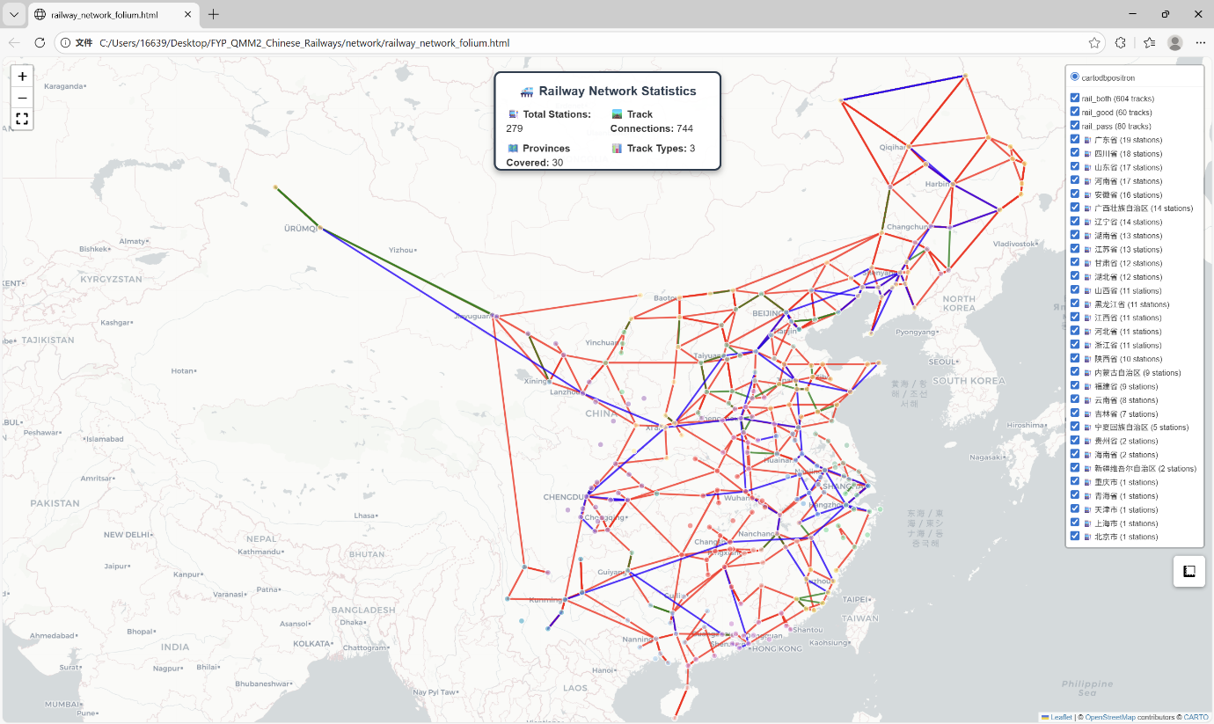

是否符合进度？On schedule as per GANTT chart?

YES

下一步Next steps:
Complete the integrity and bias evaluation of the dataset, refine and improve the report descriptions of the high-speed rail network-related dataset; advance the systematic review of existing transportation modeling methods, complete the method framework design and report writing to align with the research objectives of the project; prepare to simultaneously launch the code implementation of the methods, laying a technical foundation for subsequent experiments.

