SOFTWARE DESIGN

DOCUMENT

PROBLEM STATEMENT

**PREGNANCY ASSISTANCE APP**

Prepared by,

Madhav Vijayan

Prithviraj V Nair

Ron Siby

Sharon Sunny

Guided by

Ms. Dona Jose

Assistant Professor, Department of CSE

Contents

1. INTRODUCTION 4

1.1. SCOPE 4

1.2. PURPOSE 4

1.3. INTENDED AUDIENCE 4

2. DEFINITIONS 5

3. CONCEPTUAL MODEL FOR SOFTWARE DESIGN DESCRIPTION 6

3.1. SOFTWARE DESIGN IN CONTEXT 6

3.2. SOFTWARE DESIGN DESCRIPTIONS WITHIN THE LIFE CYCLE 6

3.2.1. INFLUENCES ON SDD PREPARATION 6

3.2.2. INFLUENCES ON SOFTWARE LIFE CYCLE PRODUCTS 6

3.2.3. DESIGN VERFICATION AND DESIGN ROLE IN VALIDATION 6

4. DESIGN DESCRIPTION INFORMATION CONTENT 7

4.1. INTRODUCTION 7

4.2. SDD IDENTIFICATION 7

4.3. DESIGN STAKEHOLDERS AND THEIR CONCERNS 7

4.4. DESIGN VIEWS 7

4.5. DESIGN VIEWPOINTS 7

4.6. DESIGN ELEMENTS 8

4.6.1. DESIGN ENTITIES 8

4.6.2. DESIGN ATTRIBUTES 8

4.6.3. DESIGN RELATIONSHIPS 9

4.6.4. DESIGN CONSTRAINTS 9

4.7. DESIGN RATIONALE 9

4.8. DESIGN LANGUAGES 10

5. DESIGN VIEWPOINTS 10

5.1. INTRODUCTION 10

5.2. CONTEXT VIEWPOINT 10

5.2.1. REGISTRATION/SIGN UP 11

5.2.2. LOGIN/SIGN IN 11

5.2.4. VIEW PREGNANCY INFORMATION 12

5.2.5. RECORD HEALTH DATA 13

5.2.6. APPOINTMENT SHEDULING 13

5.2.7. RECIEVE REMINDERS 14

5.2.8. CHAT/ASK QUESTIONS 14

5.2.9. EMERGENCY ASSISTANCE 15

5.2.10. EDUCATIONAL RESOURCES 15

5.2.11. POSTPARTUM CARE 15

5.3. INFORMATION VIEWPOINTS 17

5.4. INTERFACE VIEWPOINTS 18

5.4.1.1. USER COMPONENT 18

5.4.1.2. SERVER COMPONENT 19

5.4.2. USER INTERFACE 20

5.4.2.1. SIGN UP USER INTERFACE 20

5.4.2.2. SIGN IN USER INTERFACE 20

5.4.2.3. HOME PAGE 21

5.5. INTERACTION VIEWPOINTS 22

5.5.1. SIGN UP 22

5.5.4. VIEW PREGNANCY INFORMATION 24

5.5.5. RECORD HEALTH DATA 25

5.5.6. APPOINTMENT SCHEDULING 26

5.5.7. RECEIVE REMINDERS 27

5.5.8. CHAT/ASK QUESTIONS 27

5.5.9. EMERGENCY ASSISTANCE 28

5.5.10. EDUCATIONAL RESOURCES 29

5.5.11. POSTPARTUM CARE 29

# INTRODUCTION

Software Design Document (SDD) of Pregnancy Assistance Website provides necessary definitions to conceptualize and further formalize design of the software, whose requirements and functionalities were summarized in Software Requirements Specifications (SRS) Report. Aim is to provide guidance to a design which could be easily implemented by any programmer reading this report. The document complies with the IEEE standards (IEEE Std 1016 – 2009).

## SCOPE

This complete SDD will contain the general definition and features of the project, design constraints, the overall system architecture and data architecture, a brief explanation about our current progress and schedule of the project. With the help of UML diagrams, design of the system and subsystems/modules will be explained visually in order to help the programmer to understand all information stated in this document correctly and easily.

## PURPOSE

This SDD is intended to provide a software system design which will satisfy functional and nonfunctional requirements stated in SRS Document of Pregnancy Assistance Website. Purpose of this document is serving as a guideline throughout development phase of the project for developers.

## INTENDED AUDIENCE

Audience is the staff who will develop the application described in this document and advisors of this staff.

# DEFINITIONS

DEFINITIONS TABLE

|  |  |
| --- | --- |
| TERMS | DEFINITIONS |
| **Acquirer** | Project Consultant – Ms Dona Jose |
| **Customer** | Pregnant women |
| **GUI** | Graphical User Interface |
| **DBMS** | Database Management System |
| **IEEE** | Institute of Electrical and Electronics Engineers |
| **SDD** | Software Design Description |
| **SRS** | System Requirements Specification |
| **API** | Application Programming Interface |
| **Pregnant Woman** | User who will use the app as an assistant during pregnancy period |
| **Doctor** | User who will provide medical assistance to the users |
| **Hospitals** | Institution that provides medical services |
| **SMS** | Short Message Service |
| **CAPTCHA** | Completely Automated Public Turing test to tell Computers and Humans Apart |
| **ER** | Entity Relation |
| **HTML** | Hyper Text Markup Language |
| **UML** | Unified Modeling Language |

# CONCEPTUAL MODEL FOR SOFTWARE DESIGN DESCRIPTION

Basic terms, concepts and context of SDD will be given in this part.

## SOFTWARE DESIGN IN CONTEXT

This project aims to develop a Pregnancy Assistance Website, providing a user-friendly platform for expectant mothers. The app is designed to offer essential services such as personalized health tracking, educational resources, appointment scheduling, and a supportive community. The goal is to empower pregnant women, enhancing their overall experience by delivering necessary tools, information, and a sense of community throughout their pregnancy journey.

窗体底端

The project will use HTML and JSP for scripting, CSS for styling, and integrate the Google Maps API for location information retrieval, creating a dynamic and visually appealing web application.

## SOFTWARE DESIGN DESCRIPTIONS WITHIN THE LIFE CYCLE

## INFLUENCES ON SDD PREPARATION

The key software life cycle product that drives a software design is typically the software requirements specification. The requirements in the SRS (product perspective, functional and non-functional requirements and interface requirements) and also the demands of the stakeholders specify the design of the project.

## INFLUENCES ON SOFTWARE LIFE CYCLE PRODUCTS

During the preparation phase of SDD and/or during the implementation stage of the project some requirements may change. Besides, SDD influences test plans and test documentation of the Pregnancy Assistance Website.

## DESIGN VERFICATION AND DESIGN ROLE IN VALIDATION

Verification and validation will be tested after preparation of the test cases. All system parts will be tested against these cases. It will be checked for whether the requirements fulfilled or not.

# DESIGN DESCRIPTION INFORMATION CONTENT

## INTRODUCTION

Software Design Description of Pregnancy Assistance Website identifies how this web application will be designed and implemented. Throughout the document identification, diagrams, user views and user viewpoints are provided.

## SDD IDENTIFICATION

After testing for the verification and validation Pregnancy Assistance Website will be deployed to the real world environment. Users can use this application as the pregnant woman. Every user has their own profiles and they can have access with given password to the system. The pregnant women can use the app for guidance and support during thein pregnancy period.

## DESIGN STAKEHOLDERS AND THEIR CONCERNS

Stakeholders include developers, testers and end users of “Pregnancy Assistance Website”. Since it will be a web application, usage should be easy and interfaces should be practical and appealing. In addition, it must be a trustworthy environment for stakeholders that their profile information should be kept in private.

## DESIGN VIEWS

This project will be implemented as modular structure. MVC architecture will be used as architecture pattern. Object-oriented design is chosen for this project. This give us an advantage to integrate new features to our project and remove and replace the components which we want to.

For instance, we are about to integrate an activity module to our system, MVC architecture and object-oriented design provide us an environment to adapt our web application to this new feature easily. Context view gives us structured analysis context diagram and UML use case diagram of systems services and users. Interface views clearly specify which inputs give which outputs.

## DESIGN VIEWPOINTS

Context viewpoint shows what is expected from the user actor in the system. The roles of the users and stakeholders are clearly specified. System boundary should be designated. Design entities will be user, and the information will flow between this user and system. Input-output relations will be explained in context viewpoint-design elements. Analysis technique and evaluation technique can be applied to this viewpoint.

In addition, information view provides us persistent information with help of UML class diagram and entity relation diagram. With composition view we made team organization. This view also shows estimated cost, staffing and scheduling. Relationships of the classes are easily perceived. Interaction views gives service definition and service access. Interface viewpoint is needed for the test cases. It includes the details of the external and internal interfaces. State dynamic view shows the state transitions with diagrams.

## DESIGN ELEMENTS

## DESIGN ENTITIES

* User
* Contact Info
* Doctor
* Hospital
* Message
* Alerts and Reminders
* Appointment Schedules
* Nutritious Food Information
* Virtual Consultation
* Health Assistance and Tips
* Community Support
* Postpartum Support
* Hospital Ratings

## DESIGN ATTRIBUTES

Attributes and attributes types of the entities can be seen at entity-relationship diagram in section 5.4. Information Viewpoint.

DEFINITIONS TABLE

|  |  |
| --- | --- |
| TABLE NAME | DESCRIPTION |
| **User** | Holds the information of the user |
| **Pregnancy Record** | Holds information related to pregnancy |
| **Appointment** | Holds information related to appointments and schedules |
| **Medical Report** | Holds health and medical information |
| **Healthcare Provider** | Holds information related to doctors and hospitals |
| **Food Suggestions** | Holds information about nutritious food suggestions |

## DESIGN RELATIONSHIPS

The relationship of all tables is illustrated in section 5.4. Information Viewpoint

## DESIGN CONSTRAINTS

The Pregnancy Assistance Website faces certain constraints that need consideration. For instance, ensuring the security and privacy of user data is paramount. While legal frameworks may protect sensitive health information, specific regulations for app-related user interactions might be lacking. Additionally, the app's functionality heavily relies on a remote server, meaning any server disruptions could temporarily hinder its operations. This dependency introduces a reliability constraint, emphasizing the importance of a robust server infrastructure. Furthermore, storing user information in a database raises concerns about potential privacy breaches if the database is compromised. Despite these challenges in regulatory compliance, reliability, and data security, the constraints are manageable with proper measures in place.

## DESIGN RATIONALE

We chose MVC as architecture design pattern and object oriented design pattern because MVC architectural pattern separates an application into three main components: the model, the view, and the controller. We control our data which are in model, and views via controller. That makes easy to change information in tables.

Moreover, with object-oriented design we can easily maintain our project as we mentioned before we can easily add some extra features and identify the source of error and fixed it immediately. Finally, each function in the software will be commented so that it can be understandable for the other developers and also they can change the code by help of these comments.

We choose four viewpoints which are Context Viewpoint, Logical Viewpoint, Information Viewpoint, Interface Viewpoint, Interaction Viewpoint, State Dynamic Viewpoint.

Context Viewpoint is chosen because our project is an event-based application so it is very useful showing user events on the system in detail.

Information Viewpoint is chosen because database management is crucial for our system and it should be handled in more detail in terms of ER Diagrams.

Interface Viewpoint is chosen because our system is a web-based application and user behavior is very significant on our system. Therefore, we should provide some user interfaces and component diagram to handle over this issue.

System reactions to user events, such as sign up and sign in events, should be clear for both developers and stakeholders. For that reason, Interaction Viewpoint is chosen.

In our system and almost all web-based applications, every single web page can be considered as a state and transitions between states are very crucial. Therefore, we chose to use State Dynamic Viewpoint.

## DESIGN LANGUAGES

Unified Modeling Language (UML) is selected as a part of design viewpoint specification.

# DESIGN VIEWPOINTS

## INTRODUCTION

In this document, four viewpoint are designed for the system as listed below;

* Context Viewpoint
* Information Viewpoint
* Interface Viewpoint
* Interaction Viewpoint

## CONTEXT VIEWPOINT

There is only one kind of user in our system. The system supplies twelve services to them, namely sign up, sign in, sign out, add transportation route, delete transportation route, request transportation route, search transportation route, send message, reply to message, block user, rate user and change language.

A more detailed information about use cases can be found in system requirement specification document.

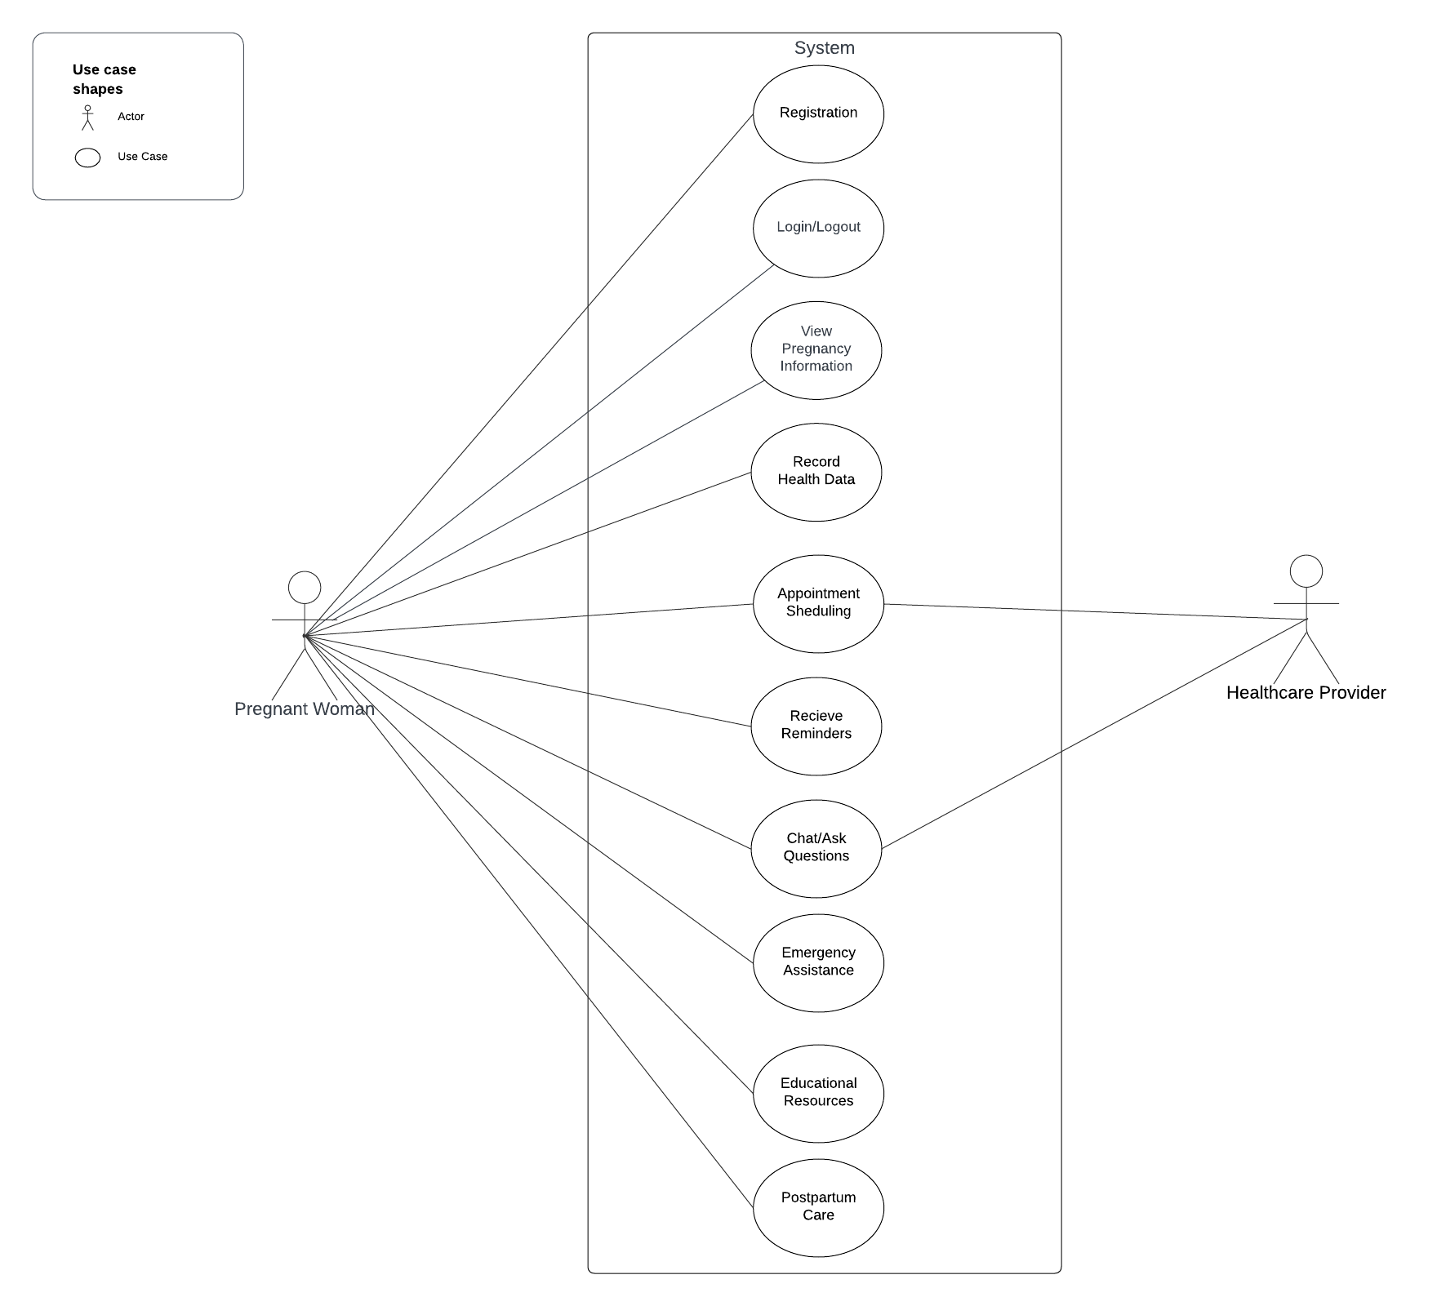

*Figure 1. Visualization of Use Case Diagram*

## REGISTRATION/SIGN UP

Users(Pregnant Woman) need to be signed up in order to benefit from the website. They need to specify their unique username and password. They are required to enter their name, surname, e- mail, age, job, phone, and last period date.

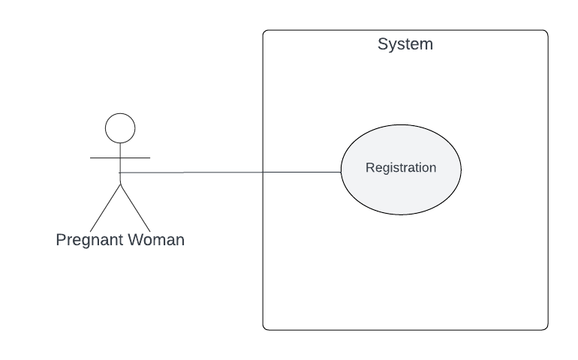

*Figure 2. Visualization of Sign Up Use Case Diagram*

## LOGIN/SIGN IN

Users may sign in to the system by entering their unique username and password in main page. She needs to be signed up first.

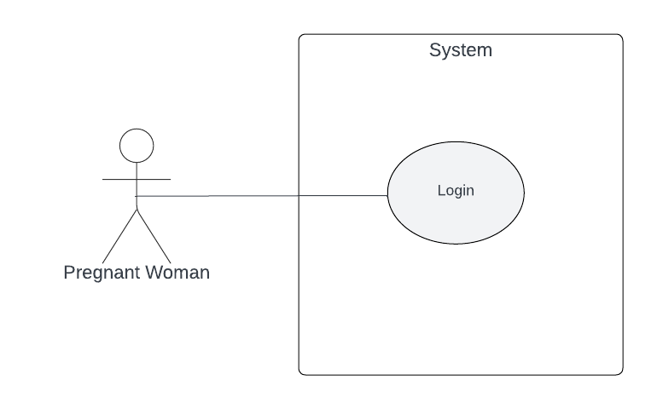

*Figure 3. Visualization of Sign In Use Case Diagram*

* + 1. LOGOUT/SIGN OUT

Users who have been signed may sign out by clicking sign out button that exists in every page.

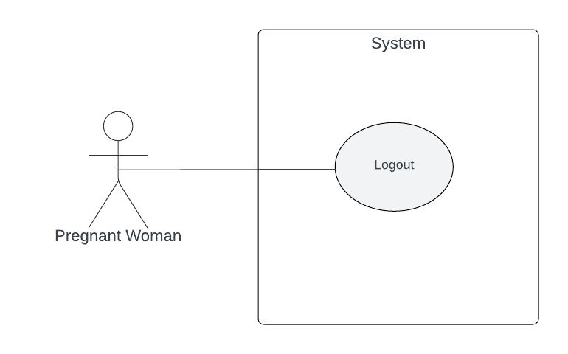

*Figure 4. Visualization of Sign Out Use Case Diagram*

## VIEW PREGNANCY INFORMATION

Users can effortlessly access pregnancy information through the app. By specifying key details such as the desired time period or specific topics of interest, users can seamlessly retrieve relevant and personalized content. This feature provides a user-friendly experience, allowing individuals to navigate and explore pregnancy-related information tailored to their needs.

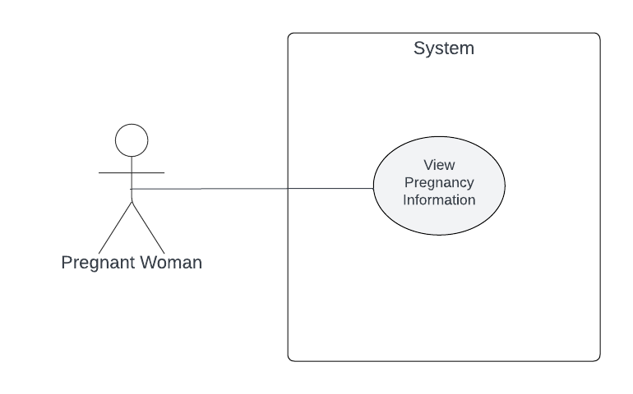

*Figure 5. Visualization of View Pregnancy Information Use Case Diagram*

## RECORD HEALTH DATA

Users can record essential health information such as weight, blood pressure, and other relevant data points. The app offers a user-friendly interface for seamless data entry, ensuring a comprehensive and organized health record throughout the pregnancy journey.

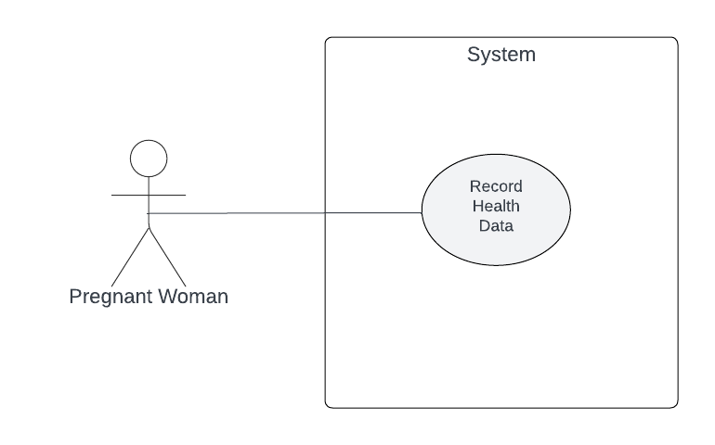

*Figure 6. Visualization of Record Health Data Use Case Diagram*

## APPOINTMENT SHEDULING

By specifying preferred dates and times, users can easily secure appointments with healthcare professionals. This user-friendly functionality aims to enhance the overall pregnancy experience by ensuring efficient and organized access to essential medical appointments.

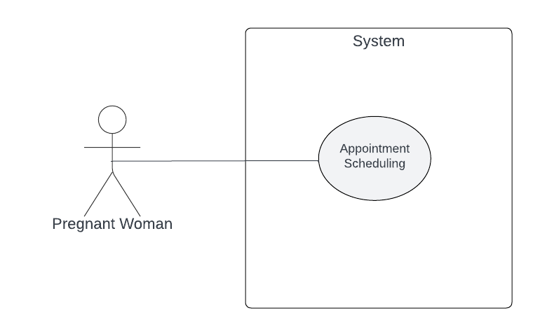

*Figure 7. Visualization of Appointment Scheduling Use Case Diagram*

## RECIEVE REMINDERS

Enables users to stay organized and informed by receiving timely reminders for important events, appointments, and key milestones throughout their pregnancy journey.

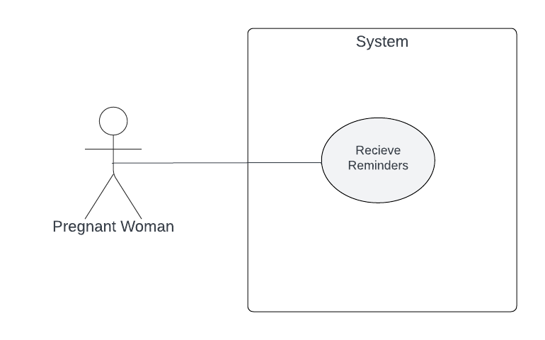

*Figure 8. Visualization of Receive Reminders Use Case Diagram*

## CHAT/ASK QUESTIONS

Provides users with a platform to engage in real-time conversations, ask questions, and connect with the broader community.

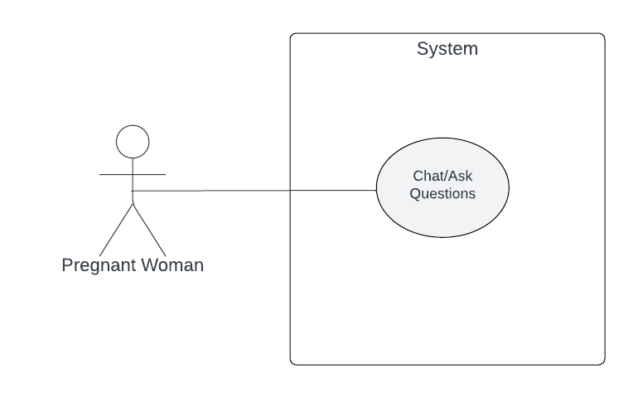

*Figure 9. Visualization of Chat/Ask Questions Use Case Diagram*

## EMERGENCY ASSISTANCE

## Allowing users to swiftly access emergency contacts and services. This functionality ensures that users can easily and quickly reach out for help or assistance in critical situations, enhancing the safety and well-being of expectant mothers using the website.

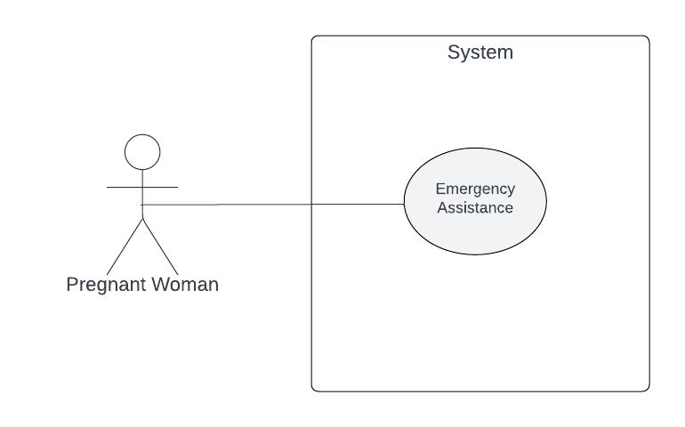

*Figure 10. Visualization of Emergency Assistance Use Case Diagram*

## EDUCATIONAL RESOURCES

Users can explore a diverse range of informative content on prenatal care, nutrition, exercise, and other relevant topics.

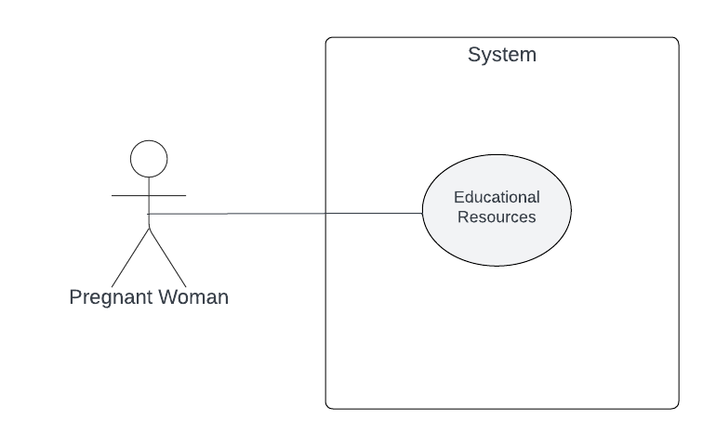

*Figure 11. Visualization of Educational Resources Use Case Diagram*

## POSTPARTUM CARE

Users can access comprehensive information, tips, and guidance on postpartum care, aiding them in managing their physical and emotional well-being during this important phase of the pregnancy journey.

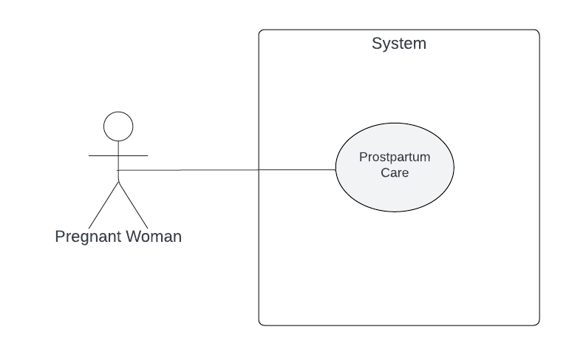

*Figure 12. Visualization of Postpartum care Use Case Diagram*

## INFORMATION VIEWPOINTS

ER Diagram of the system is illustrated as below and elements and attributes of the diagram is explained in section 4.6.1. Design Entities and 4.6.2. Design Attributes.

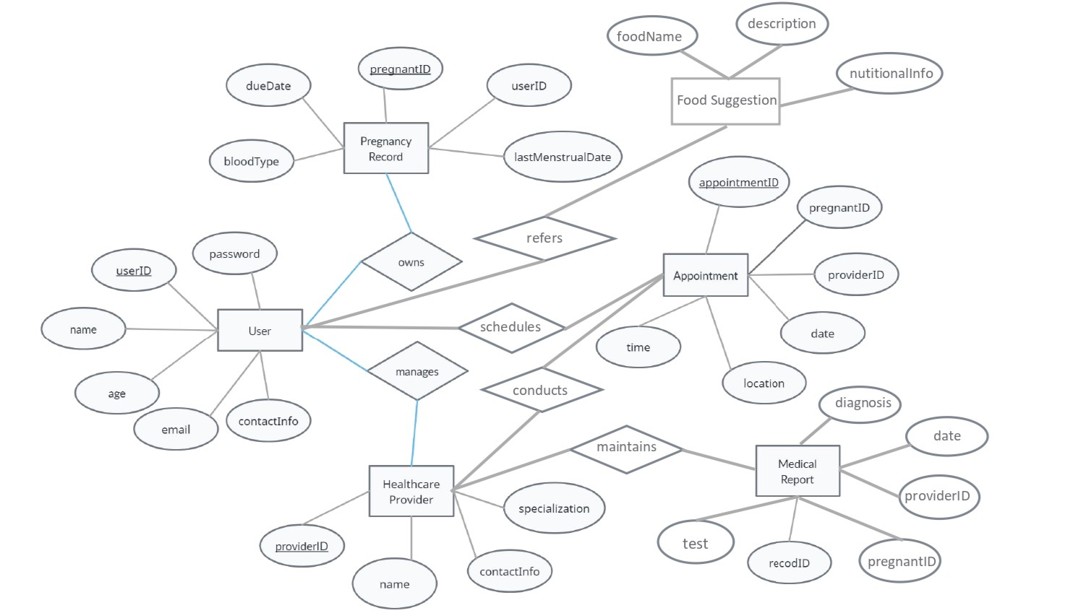

*Figure 13. Visualization of ER Diagram*

## INTERFACE VIEWPOINTS

* + 1. SYSTEM INTERFACE

This viewpoint gives information about the correct usage of services provided by a design object. The design contains three main components in terms of User, Server and Google Map Server. Server and Google Map Server are connected with User Management Component of User Component. As a result of this connection, the project arises as a structure of the system.

The component diagram for interfaces can be seen as below;

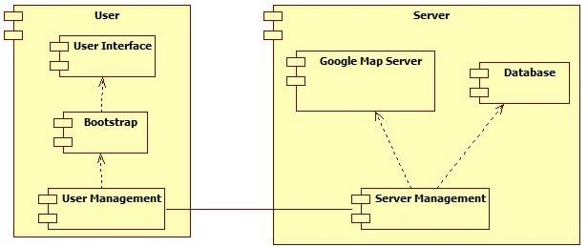

*Figure 14. Visualization of System Component Diagram*

## USER COMPONENT

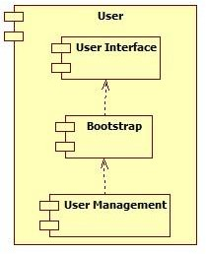

*Figure 15. Visualization of User Component Diagram*

User Component aims to visualizes events from the system and react the user event to the system via Web browsers. User Component has three inside components in terms of User Management, Bootstrap and User Interface Component.

User Management Component is connected with Server and Google Map Component to handle events in the system.

Bootstrap Component helps User Interface Component to show elegant design to the users.

User Interface Component aims to show interface of the system to users via

HTML.

## SERVER COMPONENT

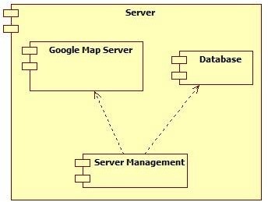

*Figure 16. Visualization of Server Component Diagram*

Server Component aims to handle control of data flow over the system as managing the server side. Server Component has two components in terms of Server Management and Database Component.

Server Management Component aims to handle event listening responding with User Management Component.

Database Component is responsible from holding the user, transportation and event information in database.

Google Map Database Component is responsible from provide geographical service from Google Map API.

## USER INTERFACE

All of the user interface layouts are mentioned in section 5.1. in SRS document . Some of these are shown below with Bootstrap facilities.

## SIGN UP USER INTERFACE

Sign up interface of the system has ten attributes in terms of username, name, surname, e-mail address, password, phone number, address, birthday and last period date.

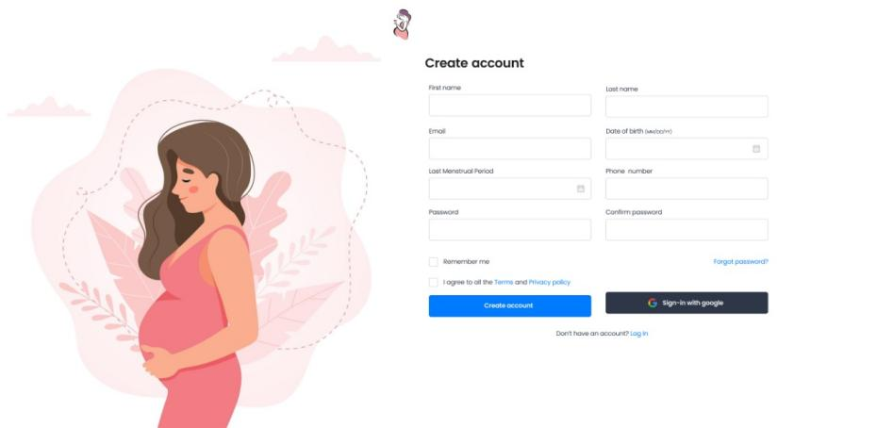

*Figure 17. Visualization of Sign Up User Interface*

## SIGN IN USER INTERFACE

Sign in interface of the system has three attributes in terms of e-mail address, password and forgot password field

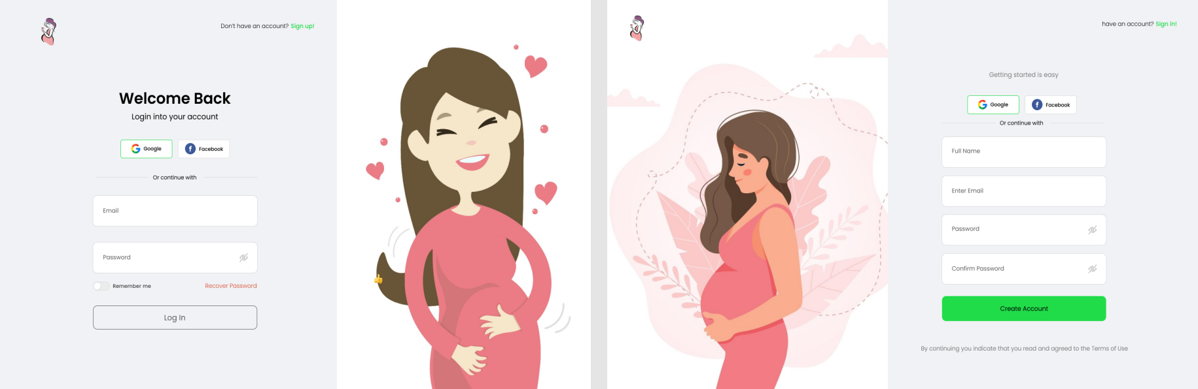

*Figure 18. Visualization of Sign In User Interface*

## HOME PAGE

The homepage of the pregnancy assistance app welcomes users with a visually comforting design, featuring intuitive navigation for easy access to essential sections like "My Pregnancy", "Community", and "Resources" through the “Services” Section. Users can track their pregnancy progress at a glance.

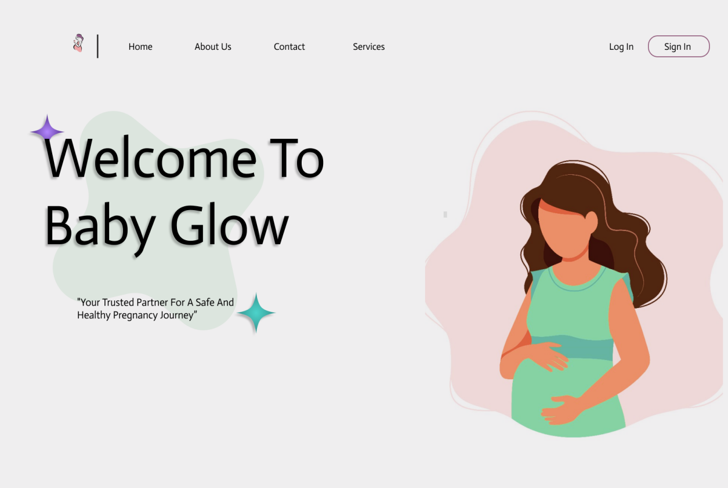

*Figure 19. Visualization of Home Page User Interface*

* 1. INTERACTION VIEWPOINTS

## SIGN UP

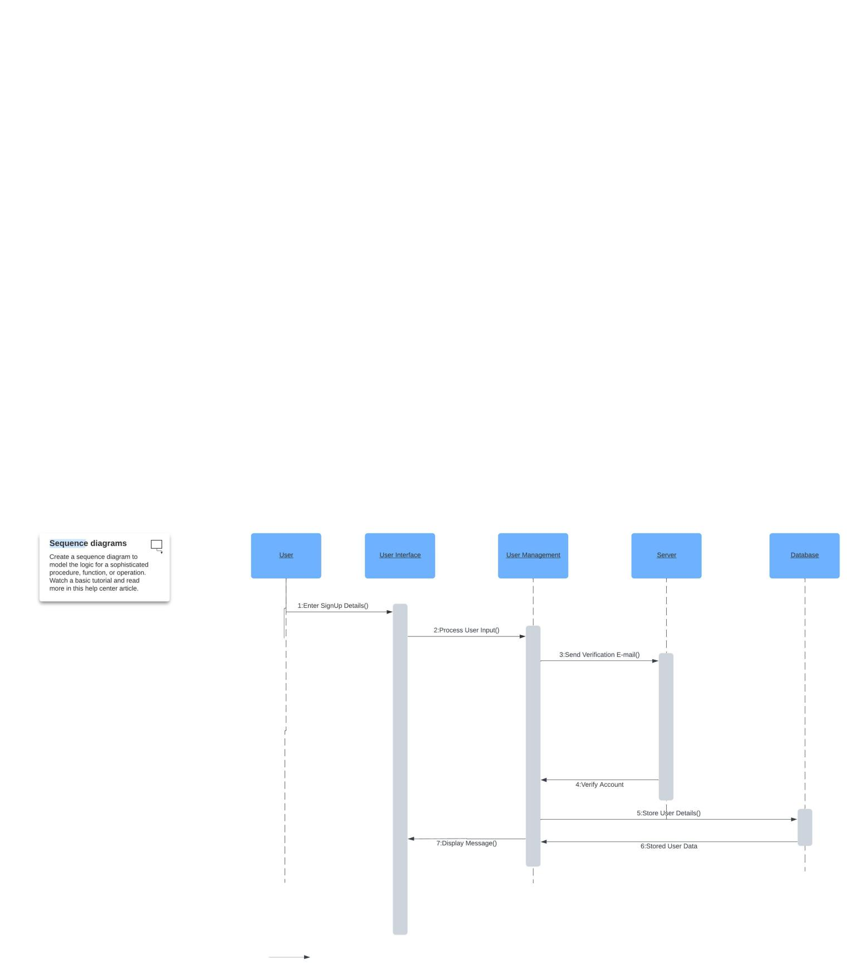

*Figure 20. Visualization of Sign Up Sequence Diagram*

User performs register operation by this functionality. User enters his or her name, surname, password and e-mail information and receives verification e-mail send by the system. By confirming register information, user successfully finish the register operation.

* + 1. SIGN IN

After sign up process, user can sign in to the system by entering his or her account information. Then, user can benefit from system functionalities.

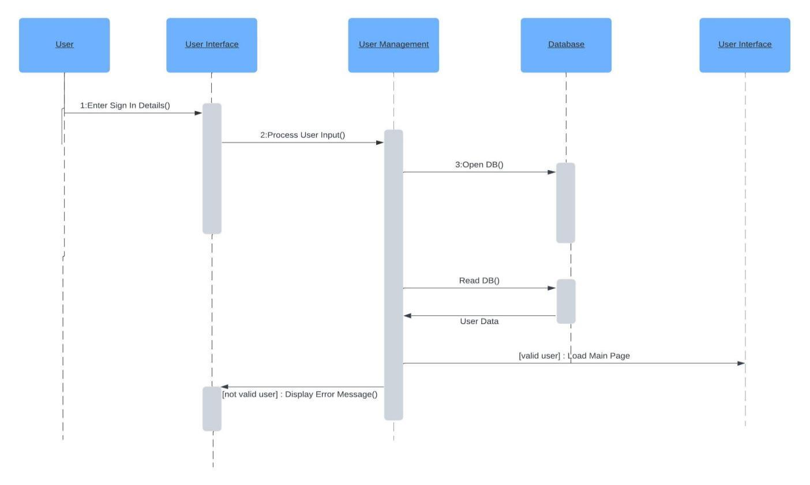

*Figure 21. Visualization of Sign In Sequence Diagram*

* + 1. SIGN OUT

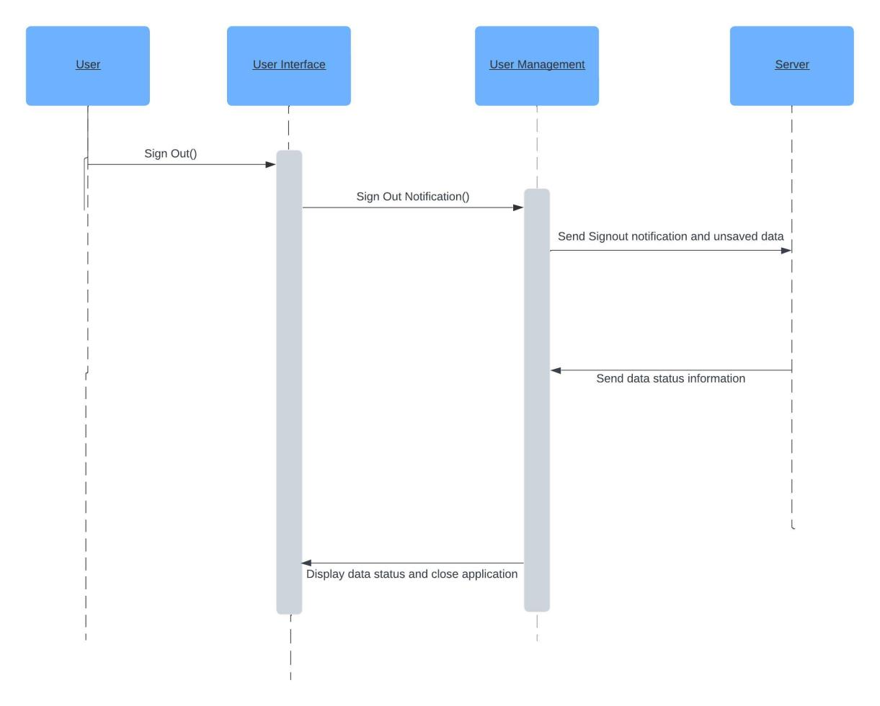

*Figure 22. Visualization of Sign Out Sequence Diagram*

When the user click sign out button through the system interface, he or she can perform secure exit from the system. All cookies and sessions will be cleared by the system.

## VIEW PREGNANCY INFORMATION

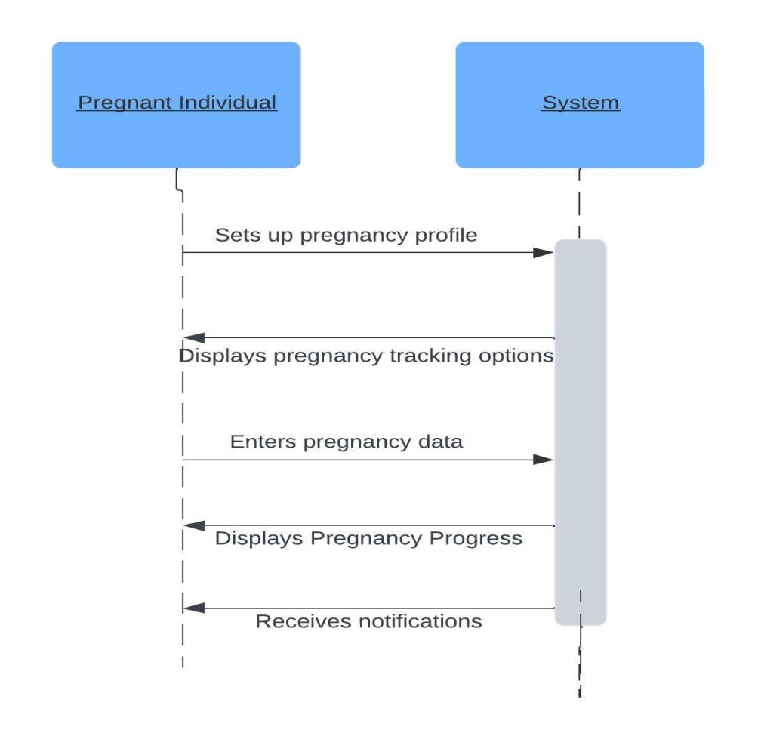

*Figure 23. Visualization of View Pregnancy Information Sequence Diagram*

The Pregnant Individual interacts with the system to set up their pregnancy profile. The system displays various options for tracking pregnancy progress. The Pregnant Individual can enter data such as weight, symptoms, and other relevant information into the system. The system processes the data and displays the pregnancy progress to the Pregnant Individual. The Pregnant Individual may receive notifications or reminders from the system regarding appointments, medication, or other relevant information.

## RECORD HEALTH DATA

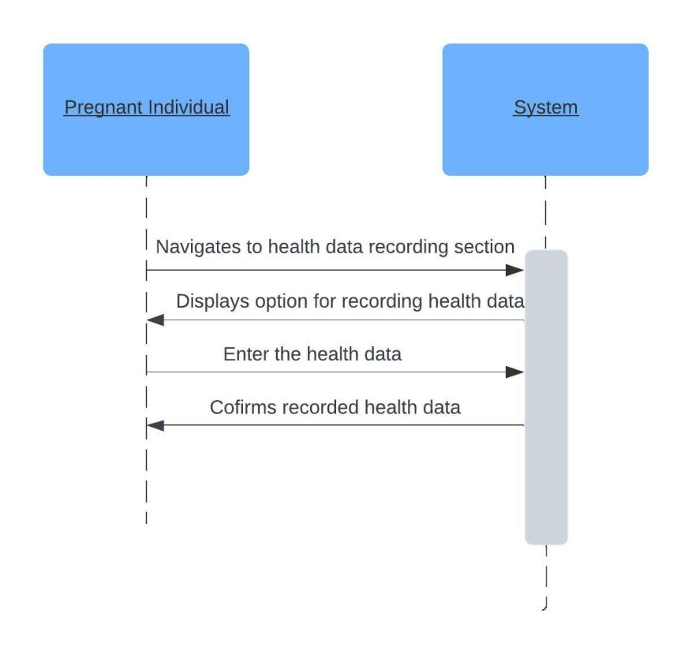

*Figure 24. Visualization of Record Health Data Sequence Diagram*

The Pregnant Individual interacts with the system to access the health data recording section. The system displays options for recording various health data. The Pregnant Individual can enter data such as blood pressure, glucose levels, symptoms, and other relevant health information into the system. The system confirms the recorded health data to the Pregnant Individual.

## APPOINTMENT SCHEDULING

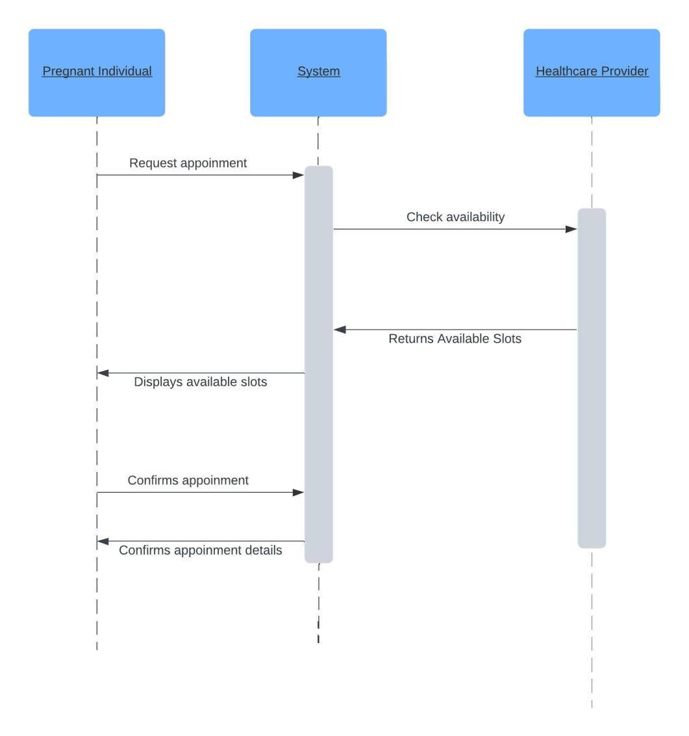

*Figure 25. Visualization of Appointment Scheduling Sequence Diagram*

The Pregnant Individual interacts with the system to request an appointment. The system communicates with the Healthcare Provider to check the availability of appointment slots. Once the available slots are returned, the system presents them to the Pregnant Individual. The Pregnant Individual selects a preferred slot, which is then confirmed with the Healthcare Provider. Finally, the system confirms the appointment details with the Pregnant Individual.

## RECEIVE REMINDERS

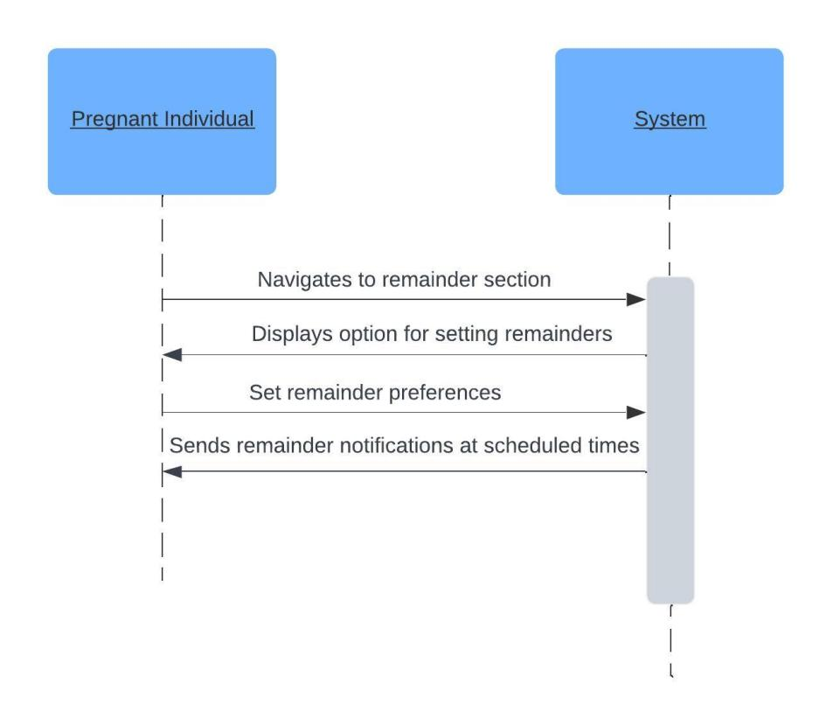

*Figure 26. Visualization of Receive Reminders Sequence Diagram*

The Pregnant Individual interacts with the system to access the reminders section. The system displays options for setting various reminders. The Pregnant Individual sets preferences for receiving reminders, such as appointment reminders, medication reminders, or other relevant reminders. The system sends reminder notifications to the Pregnant Individual at scheduled times.

## CHAT/ASK QUESTIONS

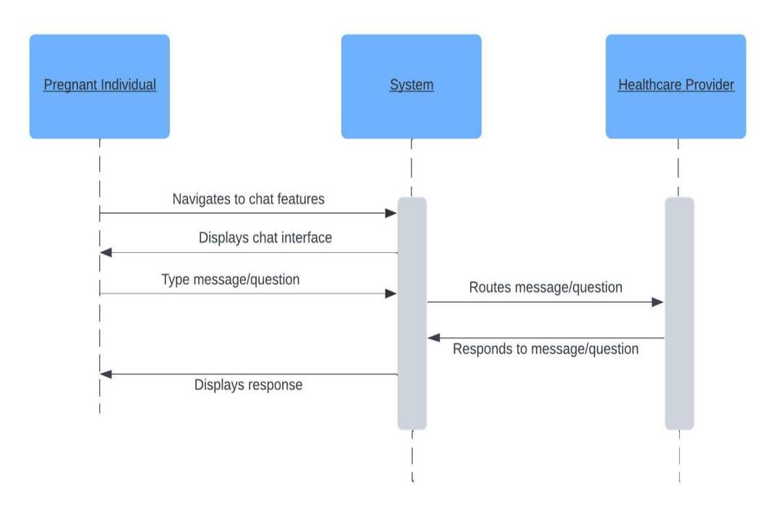

*Figure 27. Visualization of Chat/Ask Questions Sequence Diagram*

The Pregnant Individual interacts with the system to access the chat feature. The system displays the chat interface where the Pregnant Individual can type messages or ask questions. The Pregnant Individual sends a message or question to the system. The system routes the message or question to the Healthcare Provider. The Healthcare Provider responds to the message or question. The system displays the response to the Pregnant Individual.

## EMERGENCY ASSISTANCE

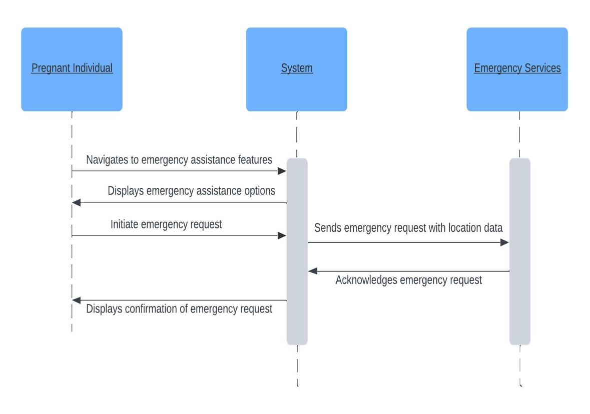

*Figure 28. Visualization of Emergency Assistance Sequence Diagram*

The Pregnant Individual interacts with the system to access the emergency assistance feature. The system displays options for initiating emergency assistance. The Pregnant Individual initiates an emergency assistance request. The system sends the emergency request to Emergency Services along with location data. Emergency Services acknowledges the emergency request. The system confirms to the Pregnant Individual that the emergency request has been received.

## EDUCATIONAL RESOURCES

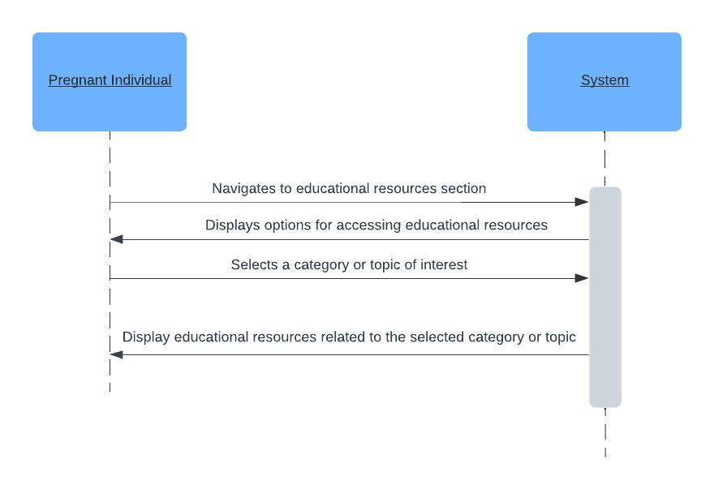

*Figure 29. Visualization of Educational Resources Sequence Diagram*

The Pregnant Individual interacts with the system to access the educational resources section. The system displays options for accessing educational resources, which may include articles, videos, podcasts, etc. The Pregnant Individual selects a category or topic of interest, such as prenatal care, nutrition, childbirth, etc. The system retrieves and displays educational resources related to the selected category or topic.

## POSTPARTUM CARE

The Postpartum Individual interacts with the system to access the postpartum care section. The system displays options for accessing postpartum care resources, which may include articles, videos, tips, etc. The Postpartum Individual selects a category or topic of interest, such as recovery, breastfeeding, emotional well-being, etc. The system retrieves and displays postpartum care resources related to the selected category or topic.

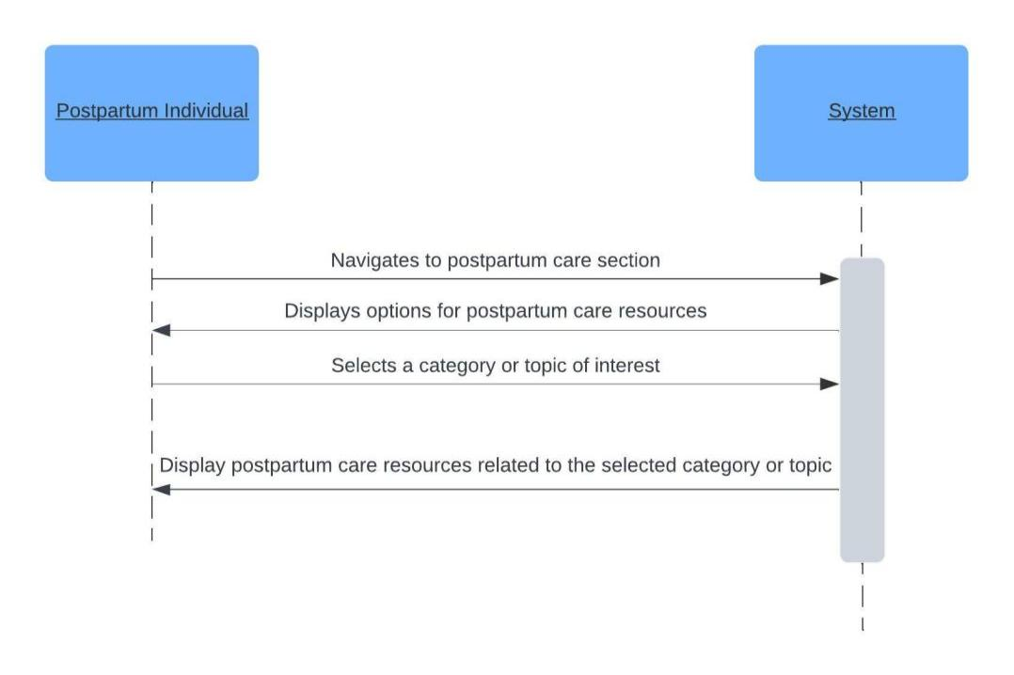

*Figure 30. Visualization of Postpartum Care Sequence Diagram*

窗体底端