description

foodName

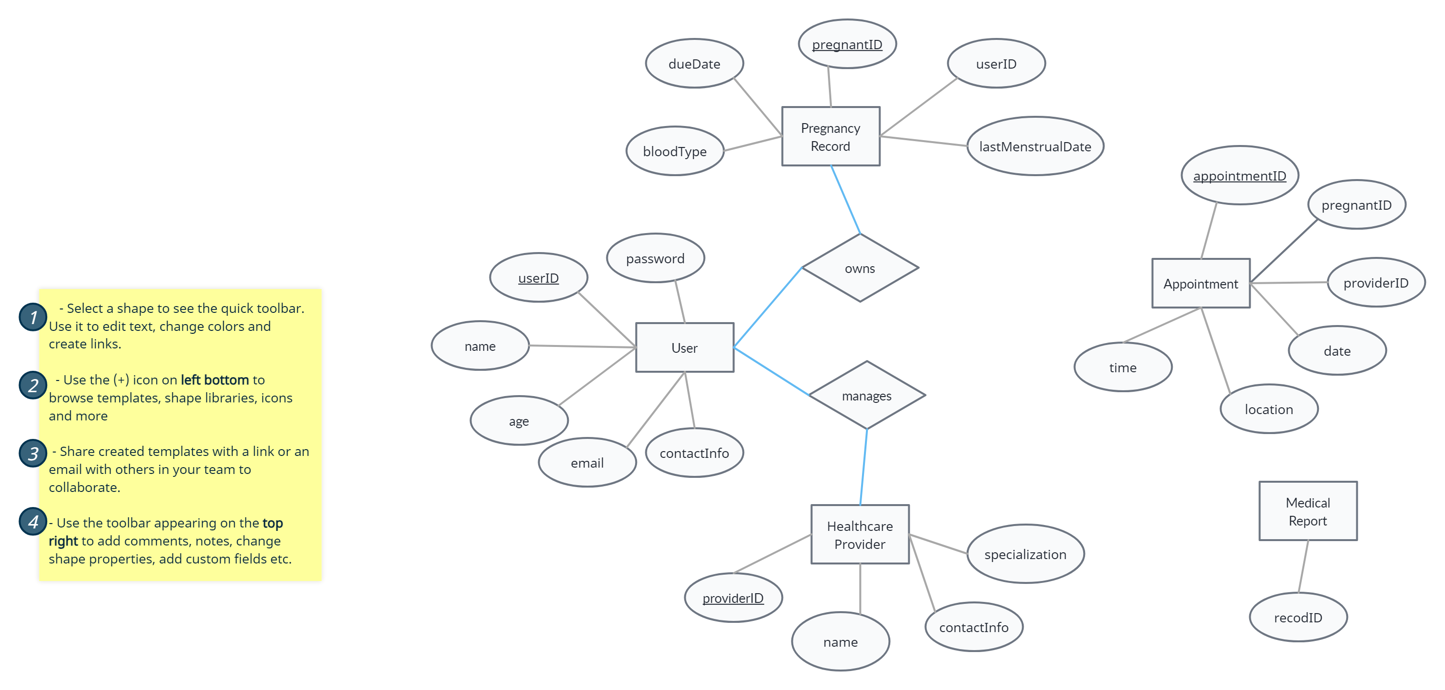

nutitionalInfo

refers

Food Suggestion

Food S

schedules

conducts

maintains

test

diagnosis

date

providerID

dasd

pregnantID