*

**Install the development environment**

**Install**

**1. JDK 11  
2. IDE - IntelliJ IDEA  
3. Maven  
4. Git**

**Set up your Git credentials**

git config --global user.name "Petr Novak"   
git config --global user.email "xnovak@fi.muni.cz"

**Generate ssh key pair (optional)**

This is an optional step, to avoid writing your password every time when you want to push your changes to remote.

However, if you don't have ssh-key, you need to download your repository using **https** protocol (f.e. git clone <https://gitlab.fi.muni.cz/pb162/2017-pb162-seminar-project>)

You should have program "Git Bash" installed. Open it (command line will show up) and type:

ssh-keygen.exe -b 2048 -C "xnovak@fi.muni.cz" # Windows  
ssh-keygen -b 2048 -C "xnovak@fi.muni.cz" # Linux

where xnovak is your login.

You can leave defaults and just hit enter on following questions. Output may look like this:  
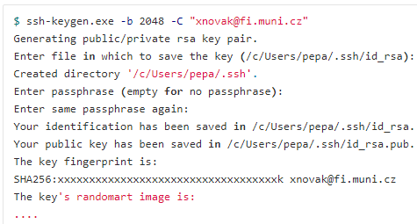

That created **id_rsa.pub** file, which you will use later to setup your Gitlab account.

**Set up the IDE and useful shortcuts - IntelliJ IDEA**

**Change default code template**  
Go to File → Settings → Editor → File and Code Templates → Includes → File header, then edit to:  
  
where Marek Sabo represents your name without diacritics. Then click OK.

**Disable star import**  
Go to File → Settings → Editor → Code Style → Java → Imports → Class count to use import with ’’* → type big number like 1000

**Shorcuts**

* sout<tab> – prints System.out.println();
* fori<tab> – creates for-each cycle
* Shift + F10 – runs the lastly run project
* Shift + Shift (double shift) – opens the search where you can write f.e. class name
* Ctrl + Space – when there is a dot before the cursor, it shows all the methods
* Alt + Insert – generates getters, setters, etc.
* Ctrl + mouse click – go to that class/method implementation
* Ctrl + Q – it shows Javadoc when cursor is on method or class
* Shift + F6 – renames variable
* Ctrl + Shift + up/down-arrow – moves the line above/below
* Ctrl + Alt + L – proper formates the class (careful, ubuntu maps it to lock your PC)
* Ctrl + Tab – similiar as in browser, changing tabs according to last recent ordering
* Ctrl + E – as previous one, but without holding buttons
* Ctrl + middle mouse button – creates multiple cursors, can copy&paste easily
* Ctrl + F4 – close the current tab
* Alt + left/right arrow – move to left/right tab
* Shift + Esc – hide the window (terminal, project, maven window)
* Ctrl + W – extend selection

**More Shortcuts**: <https://resources.jetbrains.com/storage/products/intellij-idea/docs/IntelliJIDEA_ReferenceCard.pdf>

<https://gitlab.fi.muni.cz/users/sign_in>  
To access the gitlab.fi.muni.cz, use the same credentials you use to login to the school computers   
(i.e, **xnovak** and **faculty password**). If you are not from FI, use xUCO and secondary password.  
xsafar1  
s0…Mu ddyX123fv

*  
*

*  
*