Issue 1: The Heading is not displayed properly

Used device/browser:

Chrome (Version 104.0.5112.102 (64bit)) on Windows 10

Steps to reproduce issue:

1. Visit <http://www.libertyvan.com/>
2. Check out the Title

Description:

The Headings are overlapping and the links are also overlapping and it is unclear which text to click to be taken to link ( <http://www.libertyvan.com/home/> )

Screenshot:



Issue 2: The information on posting something is in different colour for no apparent reason.

Used device/browser:

Chrome (Version 104.0.5112.102 (64bit)) on Windows 10

Steps to reproduce:

1. Visit <http://www.libertyvan.com/>
2. Check out the “Posted” section

Screenshot:

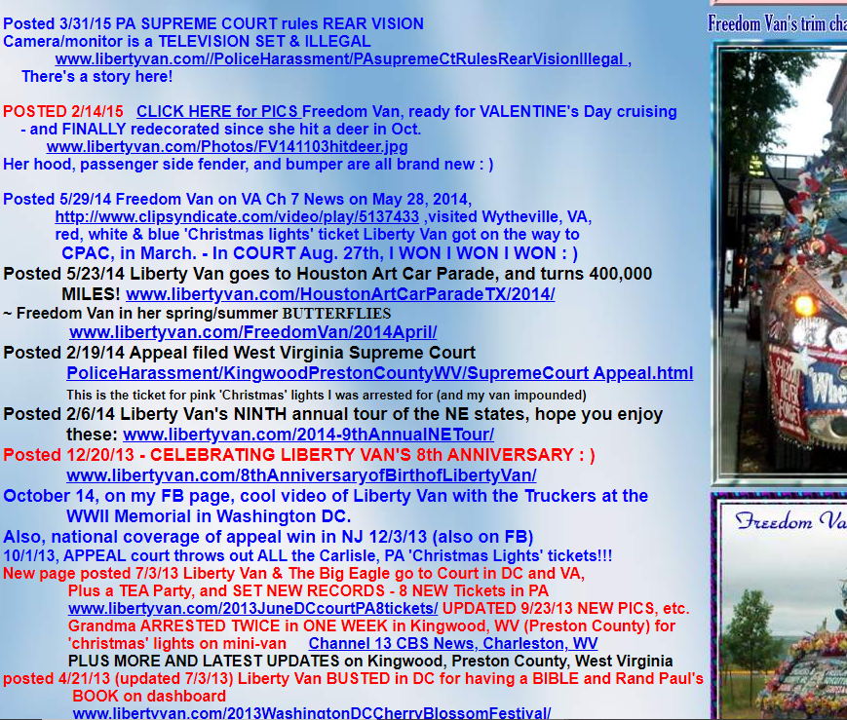

Issue 3: The text overlaps with different text sections and with pictures

Used device/browser:

Chrome (Version 104.0.5112.102 (64bit)) on Windows 10

Steps to reproduce issue:

1. Visit <http://www.libertyvan.com/>
2. Scroll down to this section.

Screenshot:

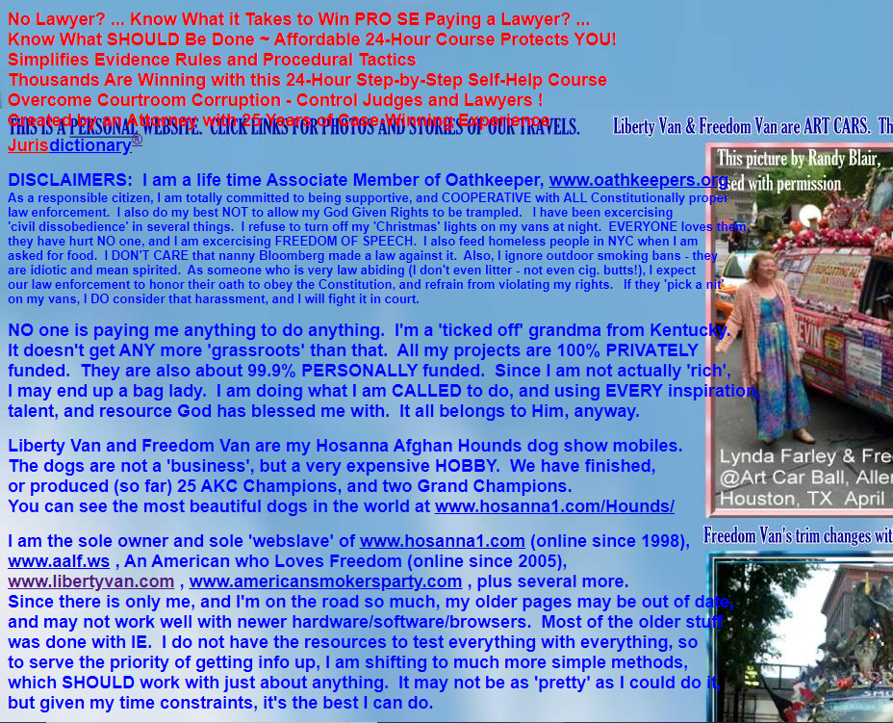

Issue 4: Some links have different font sizes in them ([www.americansmokersparty.com/Kentucky](http://www.americansmokersparty.com/Kentucky)) – shown in a screenshot, and some links do not work properly ([www.hosanna1.com/Hounds](http://www.hosanna1.com/Hounds)) – shown in a screenshot.

Used device/browser:

Chrome (Version 104.0.5112.102 (64bit)) on Windows 10

Steps to reproduce issue:

1. Visit <http://www.libertyvan.com/>
2. Check out the links.

Screenshot:



Issue 5: The [www.oathkeepers.com](http://www.oathkeepers.com) link is not working properly.

Used device/browser:

Chrome (Version 104.0.5112.102 (64bit)) on Windows 10

Steps to reproduce issue:

1. Visit <http://www.libertyvan.com/>
2. Check out the link in question.

Description:

The link stated ([www.oathkeepers.com](http://www.oathkeepers.com)) takes the user to a website [www.oathkeepers.org](http://www.oathkeepers.org)

Screenshots:



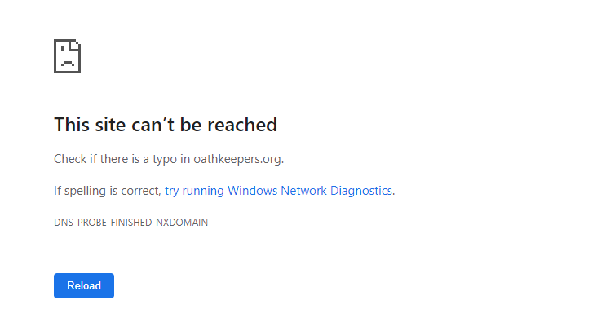

Issue 1: There is a picture on the bottom of the page named “Counter” which doesn’t load properly.

Used device/browser:

Chrome (Version 104.0.5112.102 (64bit)) on Windows 10

Steps to reproduce issue:

1. Visit <http://www.gatesnfences.com/index.html>
2. Scroll to bottom of the page.

Screenshots:

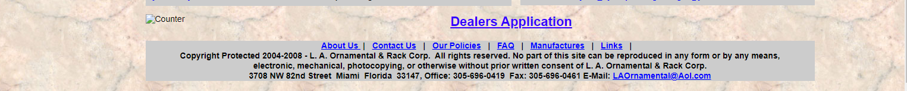

Issue 2: Search field doesn’t work.

Used device/browser:

Chrome (Version 104.0.5112.102 (64bit)) on Windows 10

Steps to reproduce issue:

1. Visit <http://www.gatesnfences.com/index.html>
2. Click on search field
3. Enter “gate”
4. Click on the Search button

Description:

The user should be able to search the term of his interest. When a term, such as “gate” which is expected to show some results is searched, the page redirects to <http://www.gatesnfences.com/.search?results_page=&p=gate&name=Search>, but it doesn’t load, it shows “Unauthorized” message.

Screenshot:

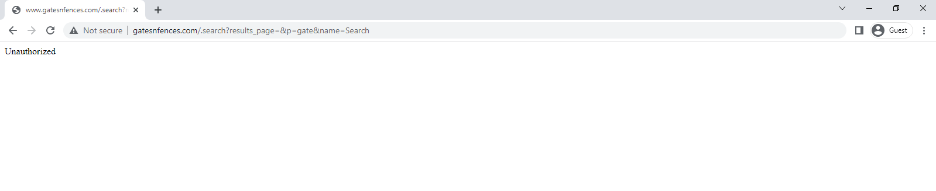

Issue 3: Driveway gates page doesn’t load properly.

Used device/browser:

Chrome (Version 104.0.5112.102 (64bit)) on Windows 10

Steps to reproduce issue:

1. Visit <http://www.gatesnfences.com/index.html>
2. Click on “Driveway gates” field.

Description:

The heading is overlapping with info section.

Screenshot:

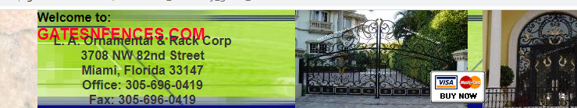

Issue 4: The section Hysecurity has a message behind the sitebuilder frame which contains the heading.

Used device/browser:

Chrome (Version 104.0.5112.102 (64bit)) on Windows 10

Steps to reproduce issue:

1. Visit <http://www.gatesnfences.com/index.html>
2. Click on “Hysecurity” field

Description:

When taken to link <http://www.gatesnfences.com/HySecurity-GateOperators.html> a user will see parts of some message behind the frame on top of page (on left and right).

Screenshot:

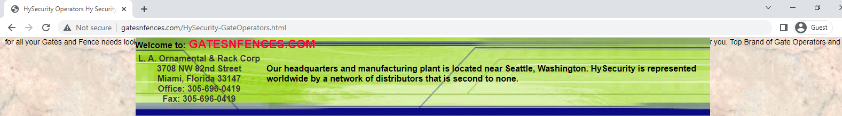

Issue 5: The names of tabs aren’t proper

Used device/browser:

Chrome (Version 104.0.5112.102 (64bit)) on Windows 10

Steps to reproduce issue:

1. Visit <http://www.gatesnfences.com/index.html>
2. Check the tab name.
3. Click on “Driveway Gates” field
4. Check the tab name.
5. Click on “Garden Gates” field.
6. Check the tab name.

Description:

The names of tabs should be concise and clear.

Screenshots:

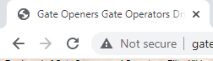

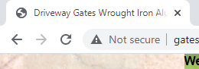

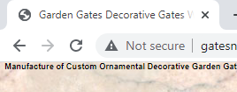

Issue 6: Privacy gates page doesn’t load properly.

Used device/browser:

Chrome (Version 104.0.5112.102 (64bit)) on Windows 10

Steps to reproduce issue:

1. Visit <http://www.gatesnfences.com/index.html>
2. Click on “Driveway Gates” field
3. Click on “Privacy gates” link.

Description:

The Privacy gates page loads only on the left side of the browser window.

Screenshot:

