Table of Contents

Downloading the Repository 2

Setting up Bellyful on a Windows Computer 2

Installing 2

Dependencies 2

Frontend 2

Backend 4

MySQL server setup 5

Running the application 8

Setting up Bellyful on a Mac 9

Installing 9

Dependencies 11

Frontend 11

Backend 13

MySQL server setup 14

Running the application on a Mac 17

# Downloading the Repository

Clone the Git repository.

Navigate to the GitHub Repository and download the project. Click “Code”, “Download ZIP” and then extract the files.



# Setting up Bellyful on a Windows Computer

## Installing

Before we can begin setting up the servers, we need to install some things first.

Install Node.js from here:

<https://nodejs.org/en/download/>

Install XAMPP from here:

<https://www.apachefriends.org/download.html>

## Dependencies

After installing Node.js and XAMPP, we can install the dependencies for the project.

We will have to do this twice because the backend and frontend have separate dependencies

### Frontend

1. Navigate to the frontend folder:

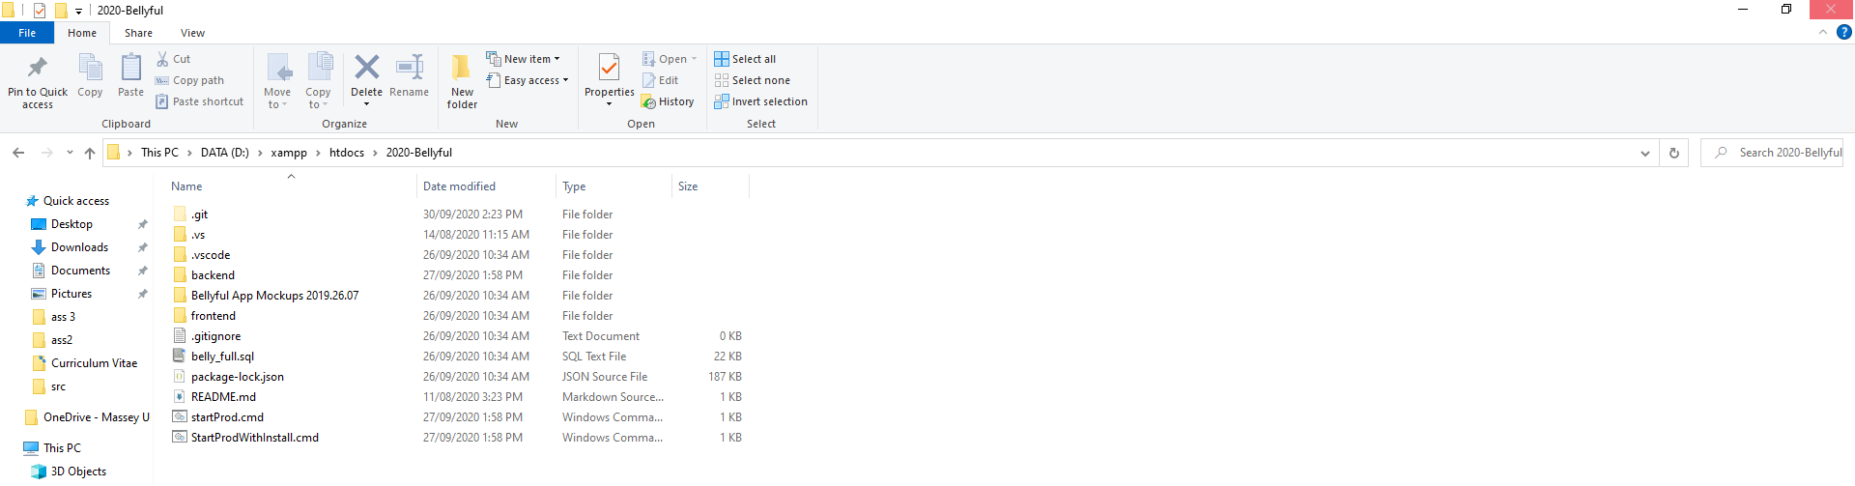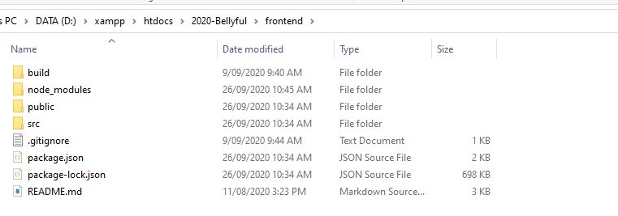

1. Highlight the navigation bar and open a terminal by typing “cmd” and pressing enter

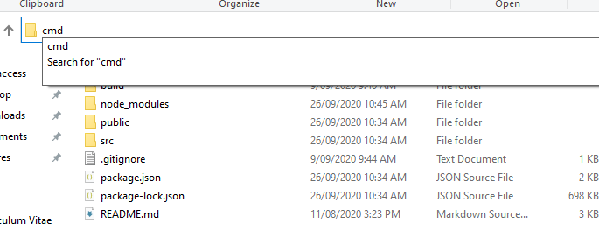

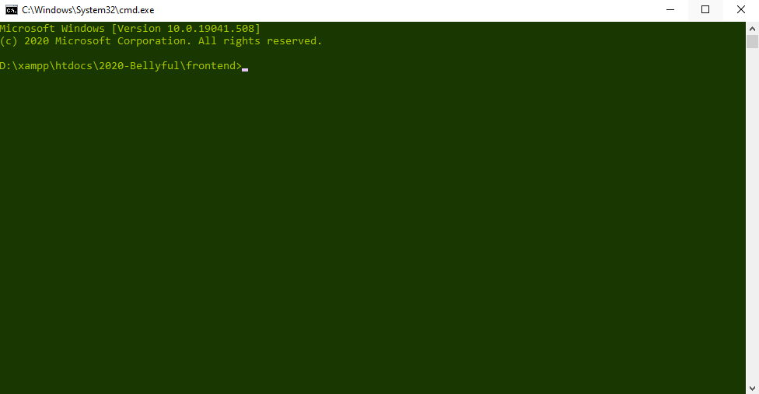

1. Type “npm install”, installing the dependencies required for the project (can take some time)

### Backend

1. Navigate to the backend folder

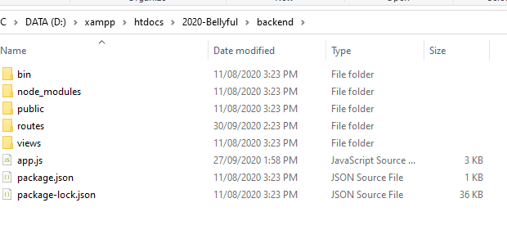

1. Open the console by typing “CMD” in the navigation bar

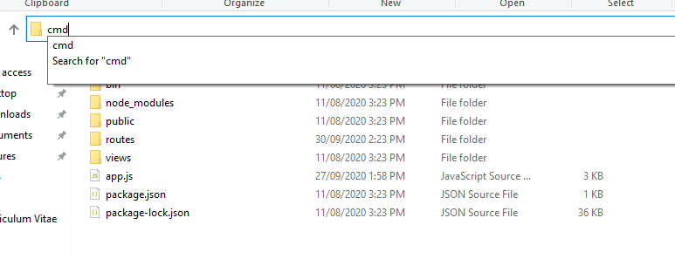

1. Run “NPM INSTALL” on the console



### MySQL server setup

After installing XAMPP, open the XAMPP console and start the MySQL and Apache processes.

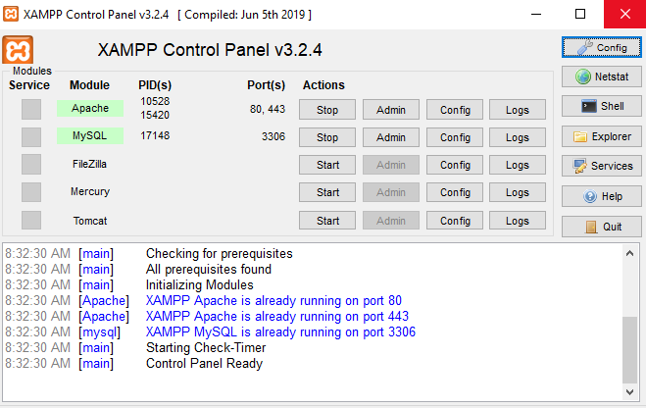

Once this is done, locate the belly_full.sql file in the main folder.

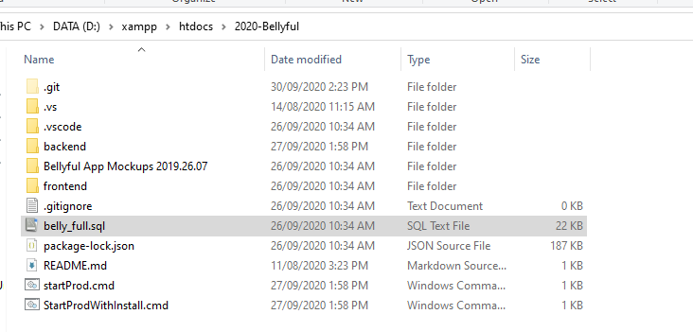

On a web browser, type in <http://localhost/phpmyadmin>

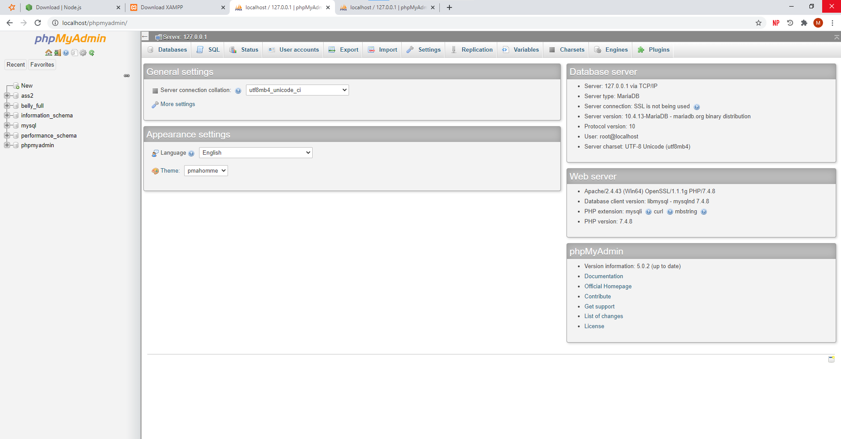

Find the import button on the top bar and click it



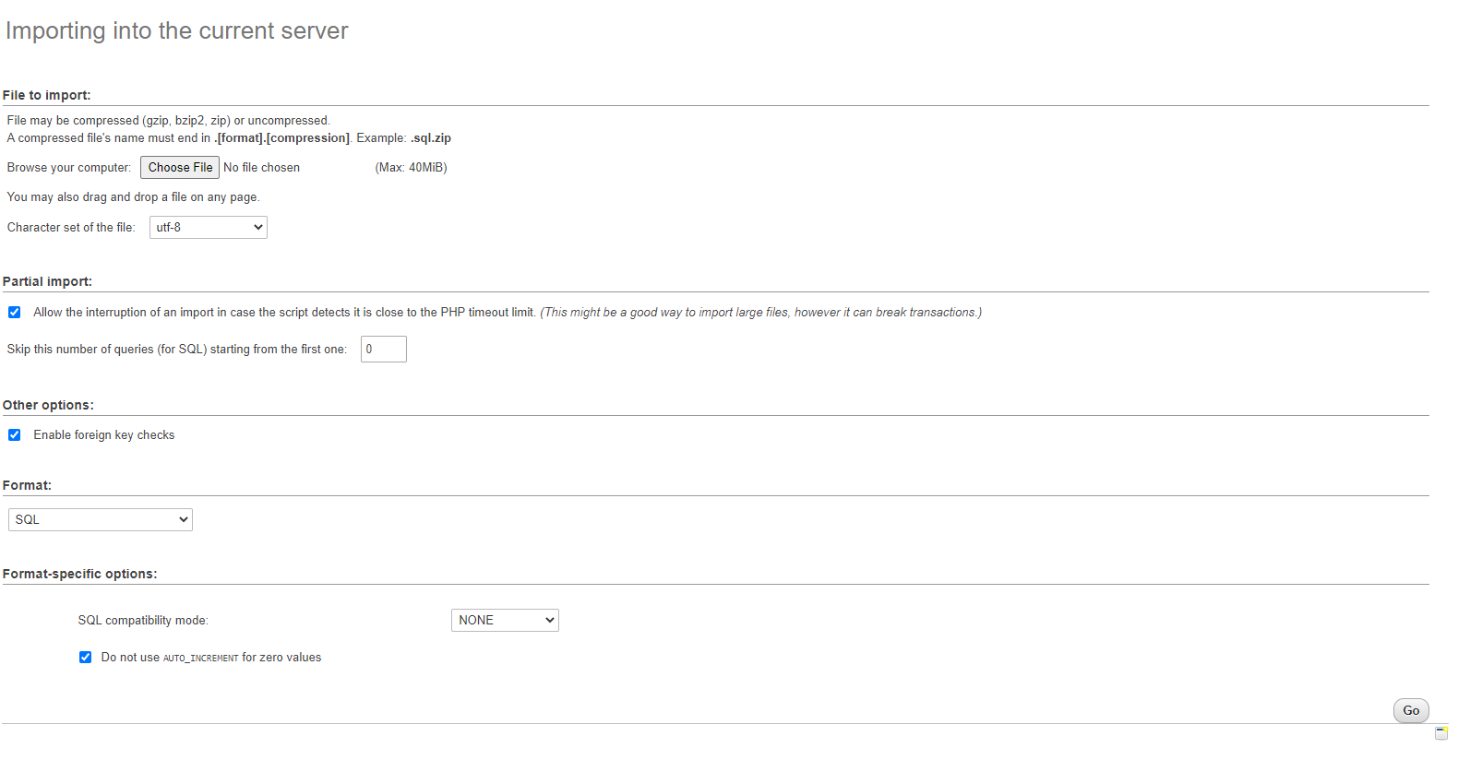

Click choose file and upload the belly_full.sql file here.

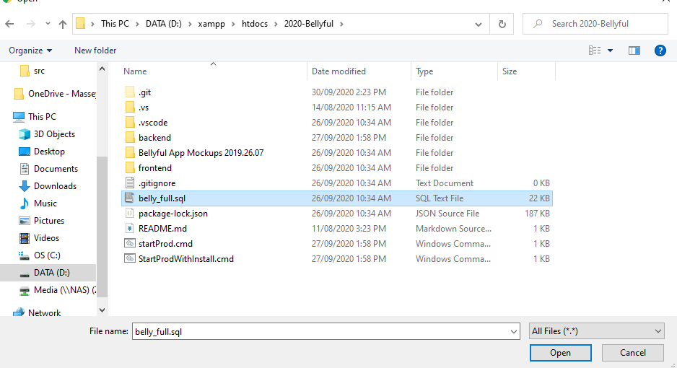

Finally hit “go”.

After this the setup is complete!

## Running the application

Find the batch file called “startProd.cmd”.

Run the batch file, it runs two commands on the terminal:

1. start cmd.exe @cmd /k "cd backend & npm start"
2. start cmd.exe @cmd /k "cd frontend & npm start"

This starts two terminals, navigates them to the frontend and backend and then starts the server.

The frontend will prompt you to ask if it should run on port 3001, accept it by typing “Y”.

# Setting up Bellyful on a Mac

## Installing

Before we can begin setting up the servers, we need to install some things first.

Install Node.js from here, select the macOS Installer:

<https://nodejs.org/en/download/>

Install XAMPP from here (link current as of 6 October 2020):

<https://sourceforge.net/projects/xampp/files/XAMPP%20Mac%20OS%20X/7.4.10/>

Or follow these steps:

1. Download XAMPP
   1. <https://www.apachefriends.org/download.html>
   2. Graphical user interface, application

      Description automatically generated



Select "More Downloads"

1. A picture containing website

   Description automatically generated



Select "XAMPP Mac OS X"

1. A picture containing table

   Description automatically generated



Select the latest version

1. A screenshot of a cell phone

   Description automatically generated



Select the installer.dmg file ([xampp-osx-7.4.10-0-installer.dmg](https://sourceforge.net/projects/xampp/files/XAMPP%20Mac%20OS%20X/7.4.10/xampp-osx-7.4.10-0-installer.dmg/download)) NOT vm.dmg

Follow the instructions to run the installer.

## Dependencies

After installing Node.js and XAMPP, we can install the dependencies for the project.

We will have to do this twice because the backend and frontend have separate dependencies

### Frontend

1. Navigate to the frontend folder:Graphical user interface, text, application

   Description automatically generated
2. Right click on the navigation bar and click “Copy “frontend” as Pathname”Graphical user interface, application, Word

   Description automatically generated

Open up a new terminal window

Type “cd ” and then CMD + V to paste the pathname you just copied. Then press enter.

Type “npm install”, installing the dependencies required for the project (can take some time)

### Backend

Follow the same steps you did for the frontend except do them with the backend folder.

1. Navigate to the backend folder. Right click on the navigation bar “Copy “backend” as Pathname”. Graphical user interface, text, application

   Description automatically generated
2. Open a new terminal window.
3. Type “cd “ followed by CMD +V to paste the path to the backend folder.
4. Type “npm install” to install the dependencies.

### MySQL server setup

After installing XAMPP, open the XAMPP console and start the MySQL and apache processes.

* 1. You may need to enter your administrator password when opening the application.
  2. Go to “Manage Servers” Graphical user interface, application

     Description automatically generated



* 1. Click “Start” on the MySQL Database and “Apache Web Server”.
     1. Alternatively you can click the “Start All” button at the bottomGraphical user interface

        Description automatically generated



* + 1. Once you have done this you should see the servers are running.Graphical user interface, application

       Description automatically generated

Once this is done, locate the belly_full.sql file in the main project folder.

On a web browser, type in <http://localhost/phpmyadmin>

Find the import button on the top bar and click it

Click choose file and upload the belly_full.sql file here.

Finally, click “Go”

## Running the application on a Mac

Make sure you have followed the steps to start the MySQL server. After this is running, do the following:

Navigate to the project directory in Terminal.

* 1. Copy the path of the 2020-Bellyful folderGraphical user interface, application, Word

     Description automatically generated
  2. In a new terminal window, type "cd “ followed by CMD + V to paste the path of 2020-bellyful folder. Press enter.
  3. Type "cd backend". Press enter
  4. "npm start". Press enter.
     1. Leave that terminal window open while you are running the project.
  5. Next, follow the same steps as above except navigate to the frontend folder.
  6. In a new terminal window, type "cd “ followed by CMD + V to paste the path of 2020-bellyful folder. Press enter.
  7. Type "cd frontend". Press enter
  8. "npm start". Press enter.
  9. "y". Press enter
  10. You should see a browser window open. It will take a while to load but then the Bellyful login page should appear
  11. Graphical user interface, application

      Description automatically generated