Eng_Jap_RAG_Assisstant

Github Repo: https://github.com/1morshed1/eng_japanese_RAG

Usage of AI:

For initial planning and validation I used claude pro, deepseek, qwen, kimi, glm 4.6 and cursor agent, Then for finalizing the plan and designing the initial system claude pro, deepseek and cursor was used. Cursor along with its mcp servers(context7, sequential thinking, exa search) was used all the time for checking on the correctness of my code. Cursor’s memory bank was used to always have the full context of the project, and I also setup cursorrules so that the code format remains consistent overall. For debugging I used cursor agent, claude pro and deepseek.
The cursor mcp servers integration helped with my knowledge gap and implementing boilerplate codes. Each script was run through over and over in claude pro, deepseek and cursor , in order to maintain quality. Finally glm 4.6 used via CLine extension was used for file indexing , so that all the AI’s which do not have knowledge bank like cursor can have full context to work with each time i open them. Also Claude Desktop along with mcp tools was used for final verification.The mcp tools were integrated from the site: https://smithery.ai/
The mermaid diagrams(flowcharts) were made with the help of file indexing capabilities of glm 4.6 agent mode, cursor agent mode and deepseek. Then visualized via the site: https://mermaid.live/edit

Running the app:
- Clone the repo
- Install the dependencies from requirements.txt
- Setup .env file
- Run the command uvicorn app.main:app --host 0.0.0.0 --port 8000 --reload
- Setup api authentication
- Start calling the api endpoints

Postman Screenshots:

You can find the json for the postman collection in the github repo.

English Doc Ingest Endpoint:
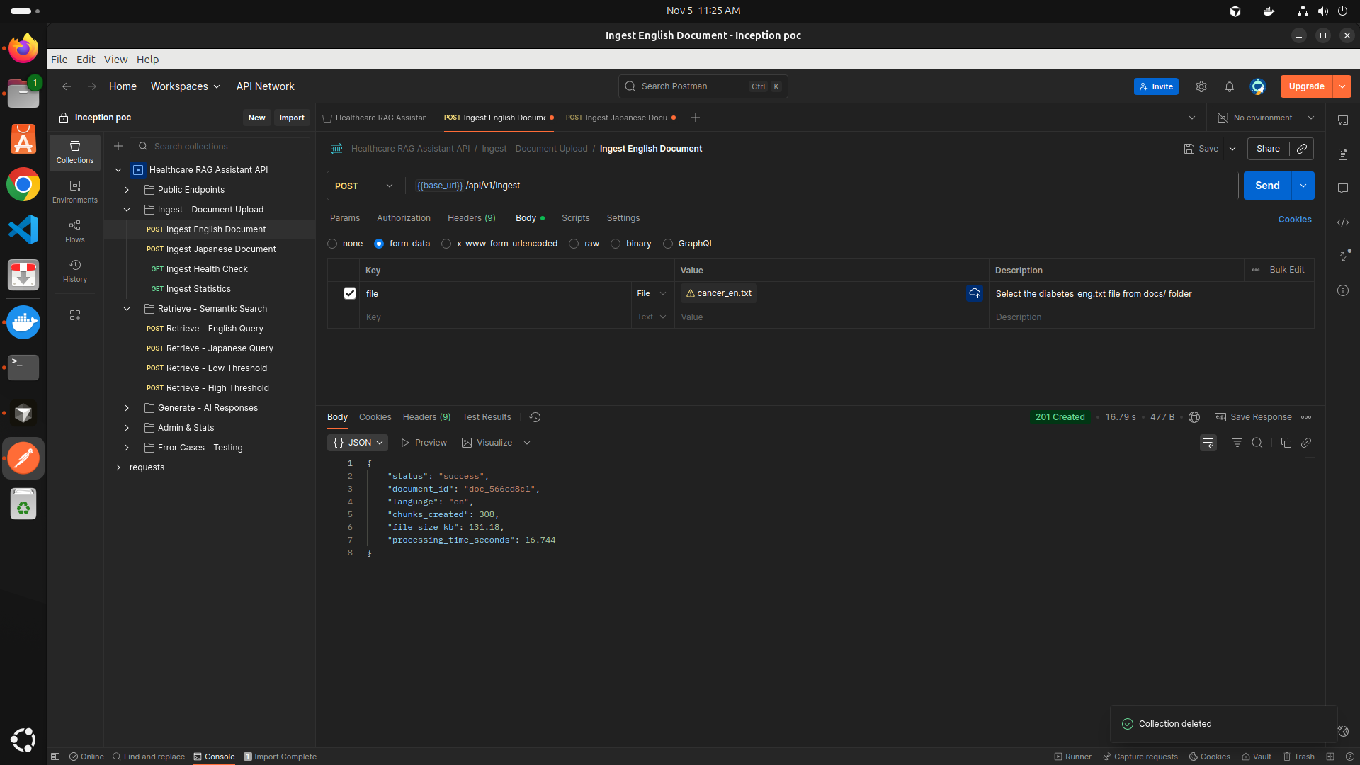

Japanese Doc Ingest Endpoint:

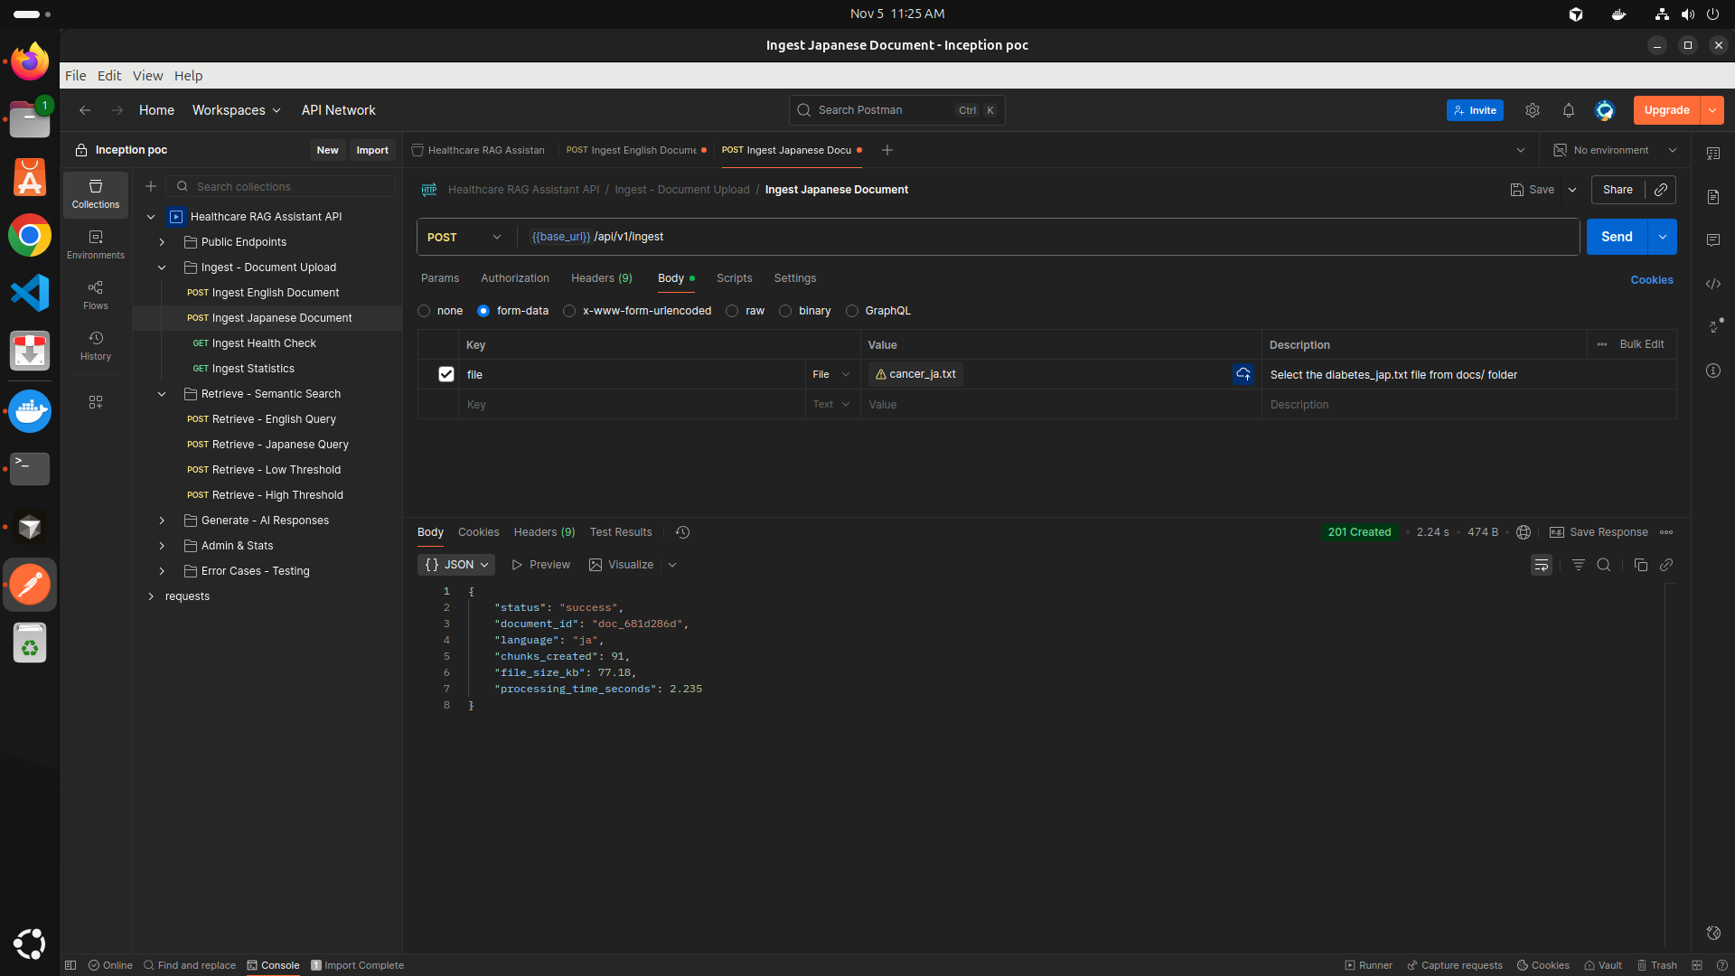

English Query Retrieve Endpoint:
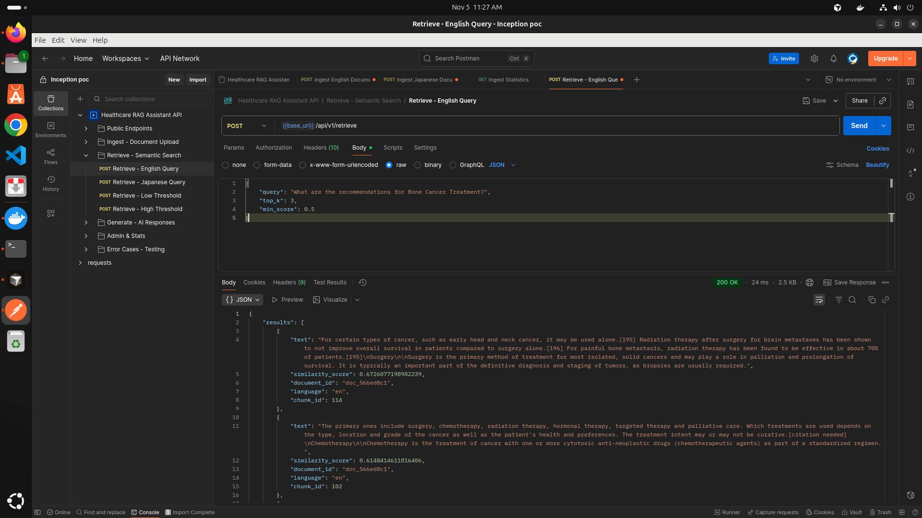

Japanese Query Retrieve Endpoint:

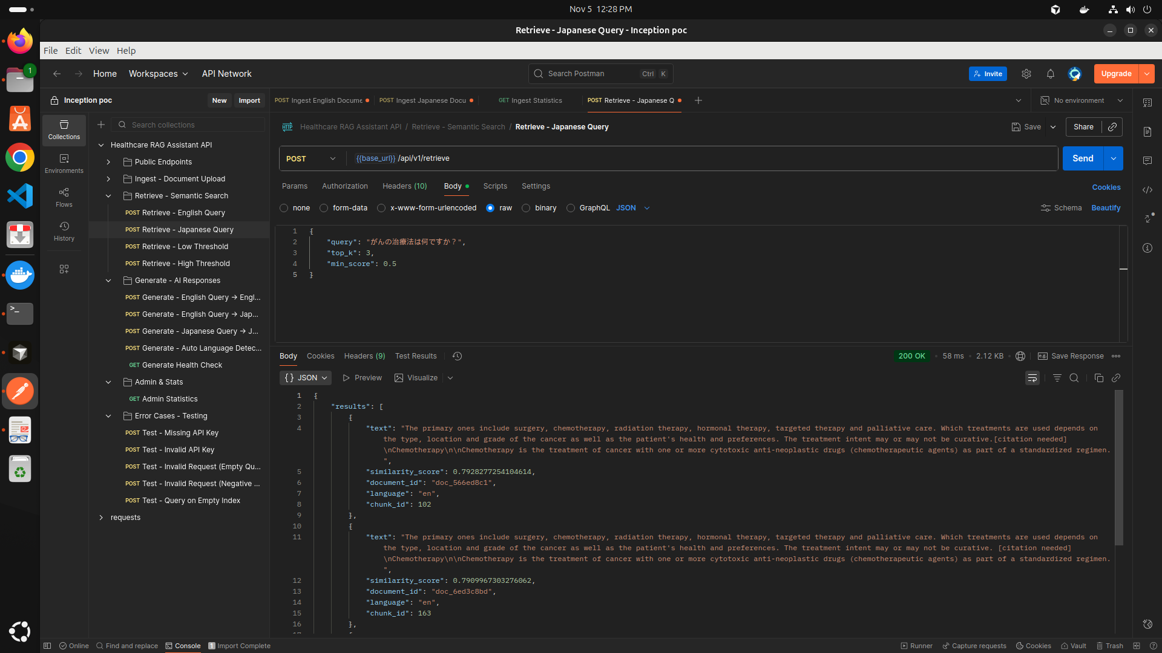

English query to English Response generate endpoint:
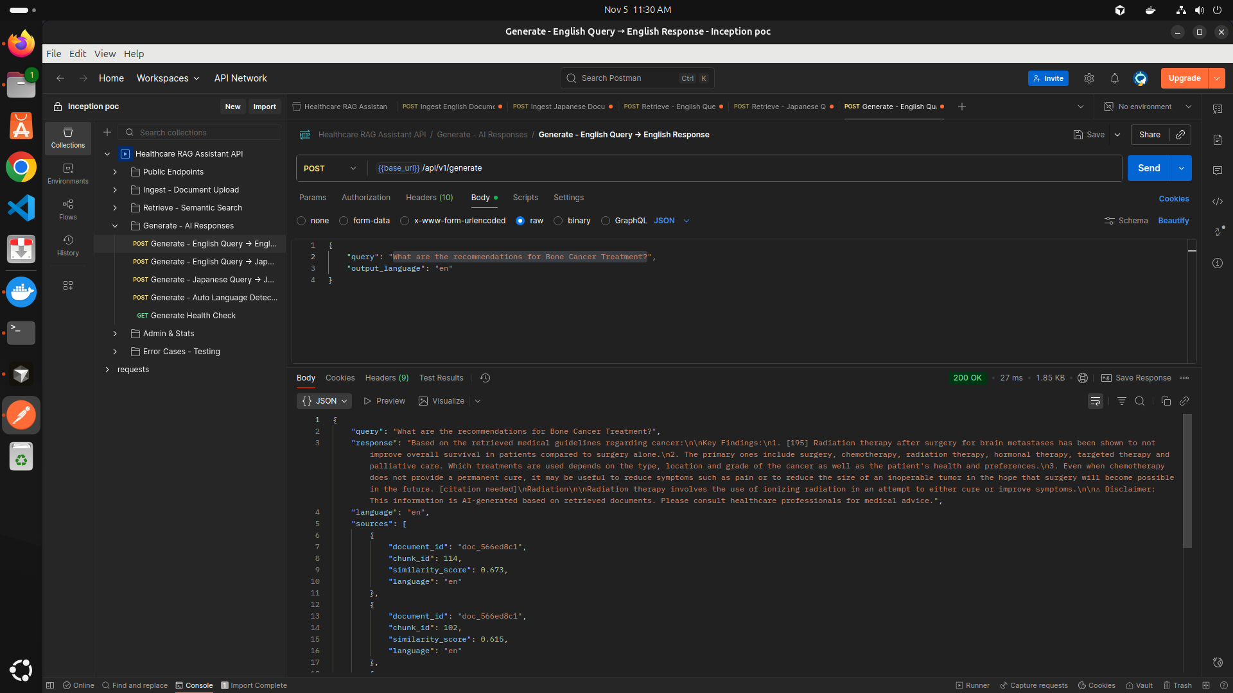

English query japanese response generate endpoint:

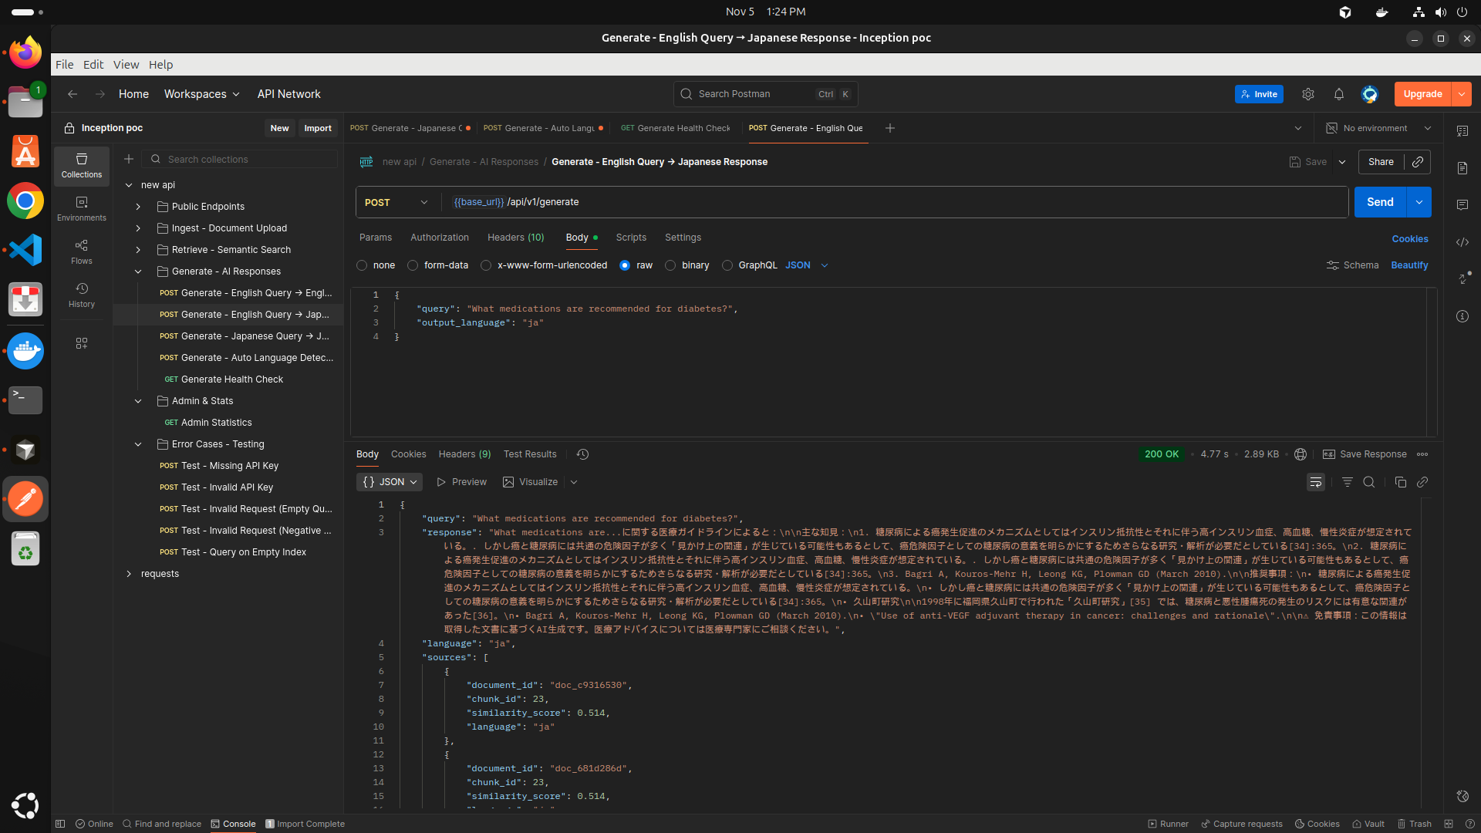

Japanese query japanese response generate endpoint:
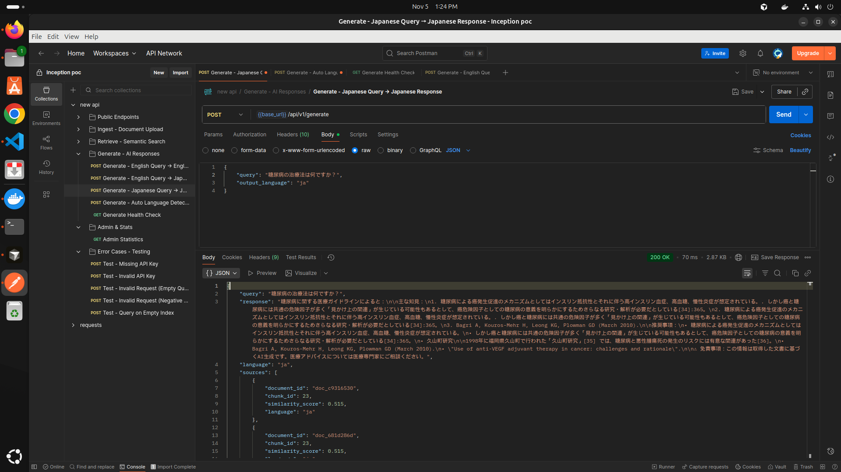

Auto detect language generate endpoint:

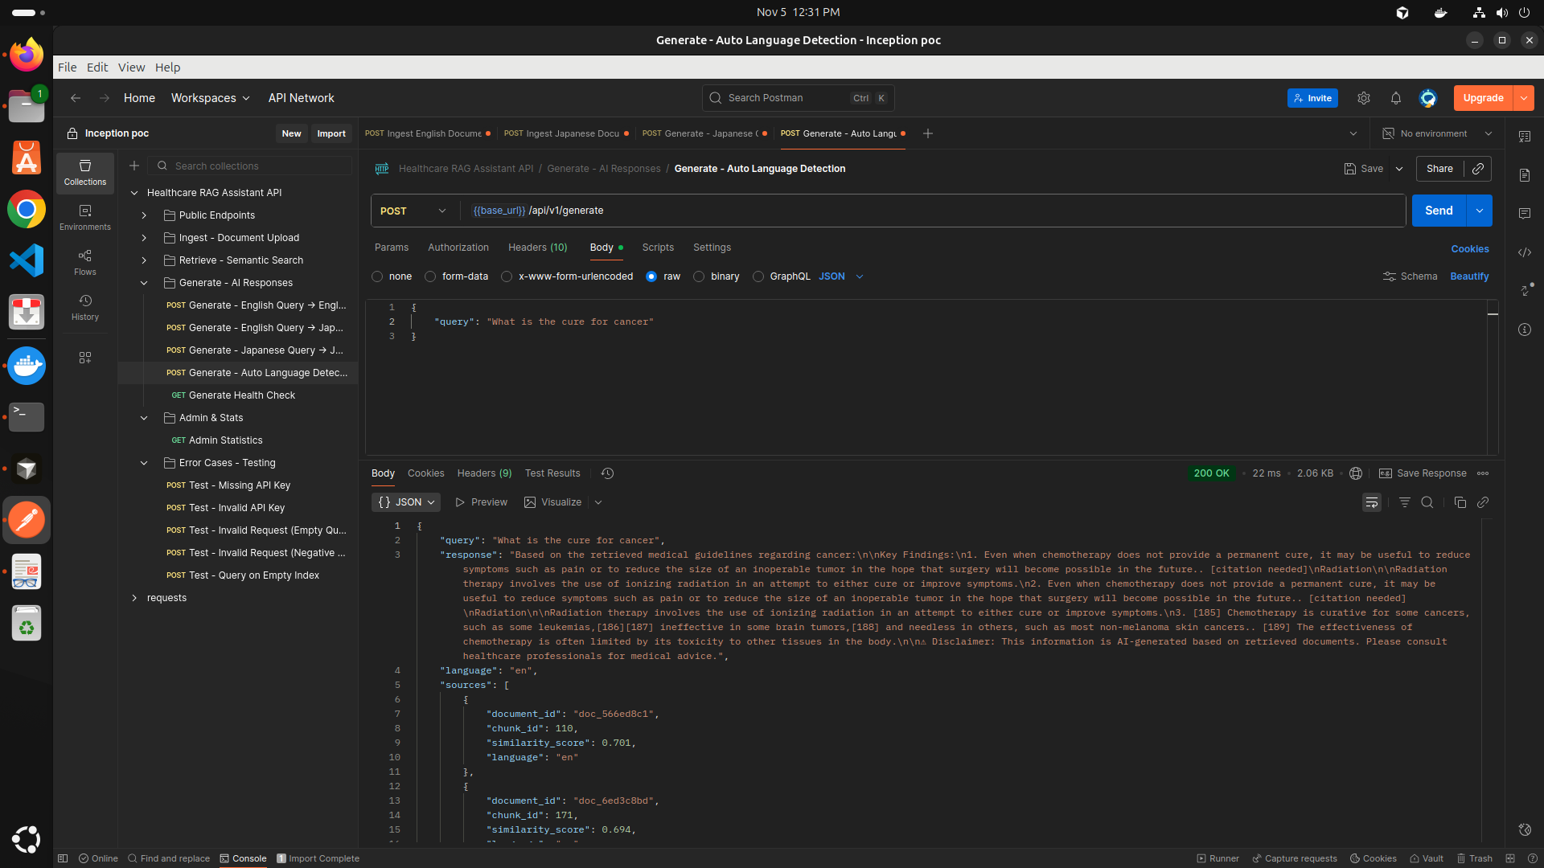

Project Structure

eng_japanese_RAG/
├── .dockerignore # Docker ignore file
├── .env # Environment variables (not tracked in git)
├── .env.example # Example environment variables template
├── .gitignore # Git ignore file
├── docker-compose.yml # Docker Compose configuration
├── Dockerfile # Docker image configuration
├── Healthcare_RAG_Assistant.postman_collection.json # Postman API collection
├── README.md # Project documentation
├── requirements.txt # Python dependencies
├── app/ # Main application directory
│ ├── __init__.py # Package initialization
│ ├── config.py # Application configuration
│ ├── main.py # FastAPI application entry point
│ │
│ ├── middleware/ # Middleware components
│ │ ├── __init__.py # Package initialization
│ │ └── auth.py # Authentication middleware
│ │
│ ├── models/ # Data models and schemas
│ │ ├── __init__.py # Package initialization
│ │ └── schemas.py # Pydantic schemas for API
│ │
│ ├── routes/ # API route handlers
│ │ ├── __init__.py # Package initialization
│ │ ├── generate.py # Text generation routes
│ │ ├── ingest.py # Data ingestion routes
│ │ └── retrieve.py # Information retrieval routes
│ │
│ ├── services/ # Business logic services
│ │ ├── __init__.py # Package initialization
│ │ ├── embedding_service.py # Text embedding service
│ │ ├── faiss_service.py # FAISS vector database service
│ │ ├── llm_service.py # Large Language Model service
│ │ └── translation_service.py # Translation service
│ │
│ └── utils/ # Utility functions
│ ├── __init__.py # Package initialization
│ ├── language_detector.py # Language detection utilities
│ └── logger.py # Logging configuration
│
├── data/ # Data storage directory
│ └── (vector database files, documents, etc.)
│
├── logs/ # Application logs directory
│ └── (application log files)
│
└── screenshots/ # Project screenshots (22 files)

Project Configurations

Embedding Model: paraphrase-multilingual-MiniLM-L12-v2

Embedding Dim: 384

Translation Models:
Eng to Jap: Helsinki-NLP/opus-mt-en-jap
Jap to Eng: Helsinki-NLP/opus-mt-jap-en

Tokenization:
For English: NLTK punkt tokenizer
For Japanese: Used Regex pattern
FAISS Indexing: IndexFlatIP
API Lifecycle:

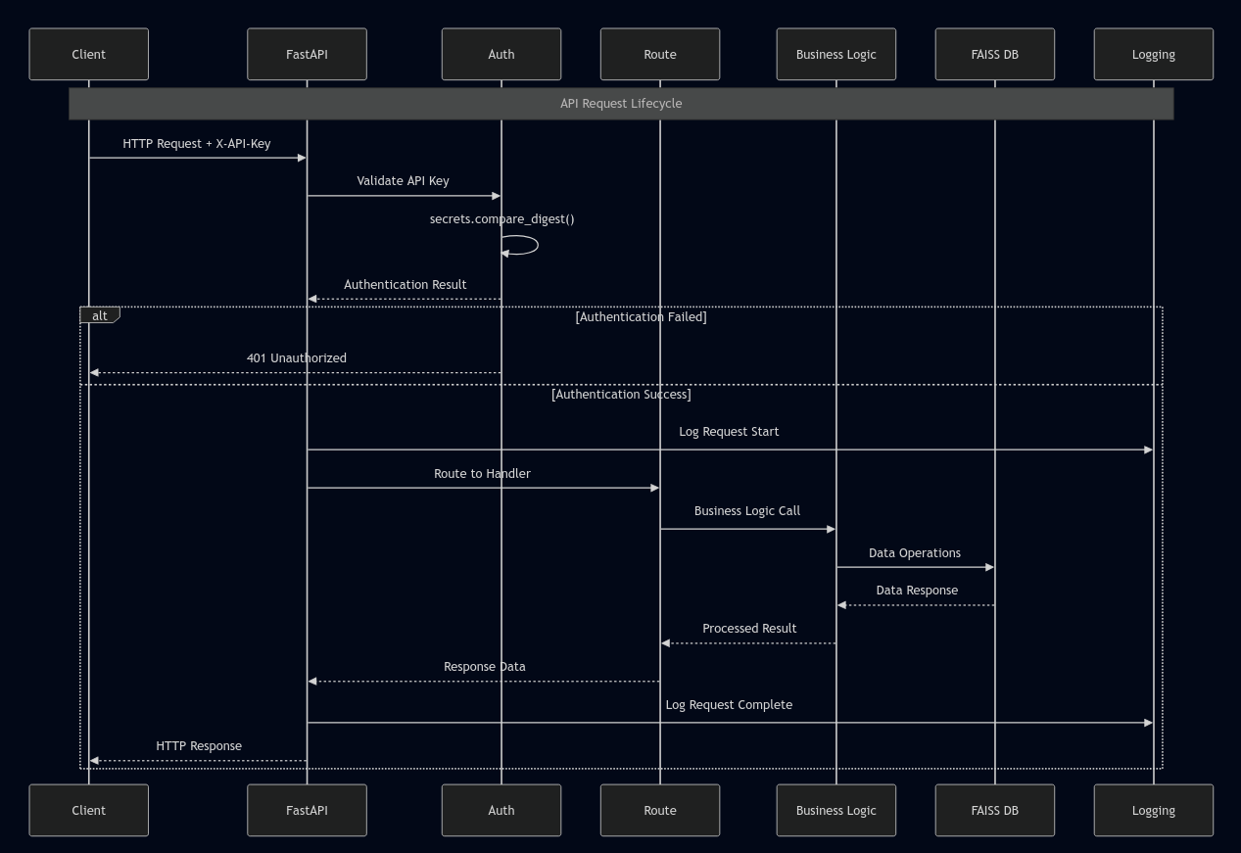
Initiation: The process starts with an HTTP Request coming from the Client, which includes an X-API-Key header for authentication.

Authentication:

The request enters the Auth component.

The system Validates the API Key using secrets.compare_digest(), a secure method for comparing keys.

The result is a decision point:

Authentication Failed: The flow immediately jumps to sending a 401 Unauthorized HTTP Response back to the client.

Authentication Success: The flow continues to the next stage.

Request Logging & Routing:

Upon successful auth, the Logging component records the Request Start.

The FastAPI framework then Routes the request to the appropriate handler function.

Business Logic Execution:

The Route handler calls the Business Logic.

The Business Logic, in turn, performs Data Operations with the FAISS DB (a vector database often used for similarity search).

Response Formation:

The FAISS DB returns a Data Response.

The Business Logic processes this into a Processed Result.

This result is formatted as Response Data.

Completion:

The Logging component records that the Request is Complete.

Finally, an HTTP Response containing the data is sent back to the Client.

Service Interactions:

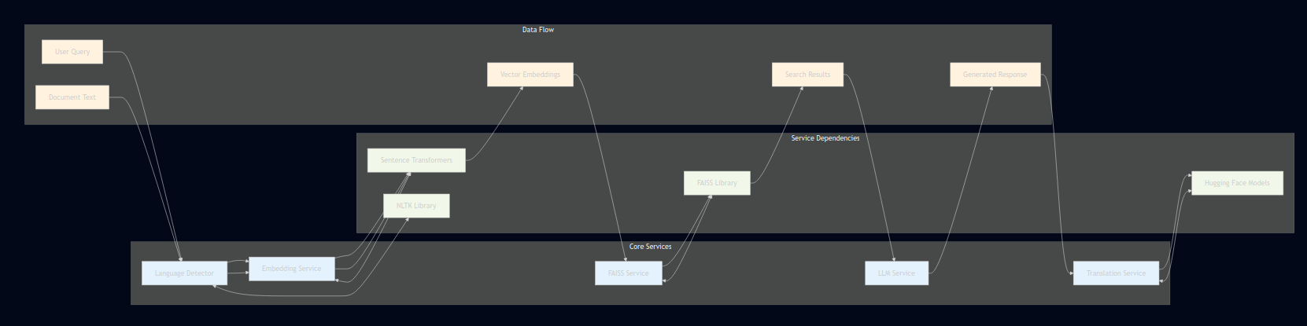

The system has five main services:

Embedding Service - turns text into numbers

FAISS Service - searches through those numbers

LLM Service - generates answers

Translation Service - translates between languages

Language Detector - identifies what language text is in

Here's how it works:

A user question comes in and gets checked for language

The text is converted to numbers (embeddings)

The system searches for similar information using FAISS

The LLM service creates an answer based on the search results

If needed, the answer gets translated

The final response goes back to the user

The system uses popular AI libraries like Sentence Transformers, Hugging Face, FAISS, and NLTK to power these services.

Data Flow Diagram:
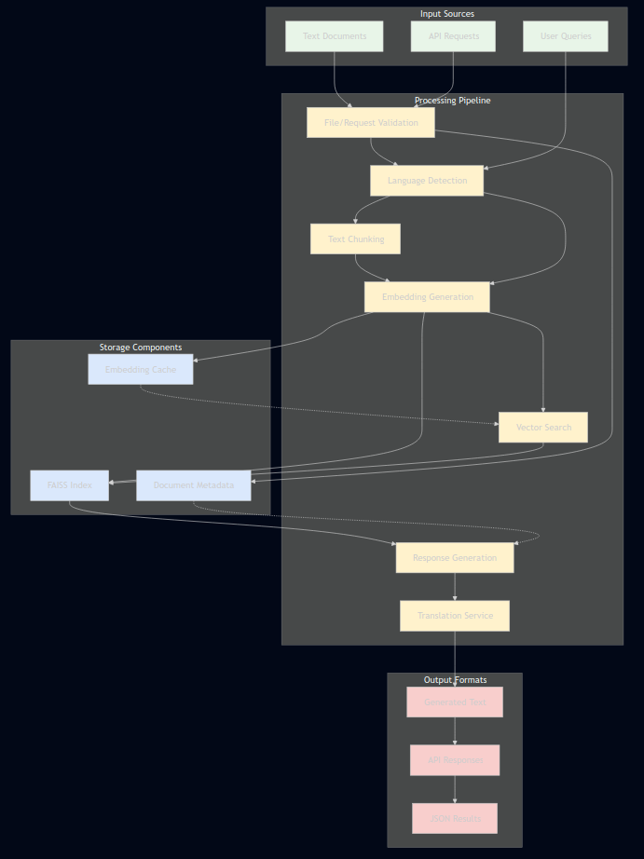
The system has four main parts:

Input Sources - Where information comes from

Text Documents (files to search through)

User Queries (questions people ask)

API Requests (programmatic requests)

Processing Pipeline - The steps that handle the work

Validation - checks if files and requests are valid

Language Detection - figures out what language text is in

Text Chunking - breaks large documents into smaller pieces

Embedding Generation - converts text into number vectors

Vector Search - finds similar content using math

Response Generation - creates answers using AI

Translation - converts between languages

Storage Components - Where data is saved

FAISS Index - stores vectors for fast searching

Document Metadata - keeps information about documents

Embedding Cache - stores pre-computed vectors to save time

Output Formats - What the system produces

API Responses - data for other programs

JSON Results - structured data format

Generated Text - AI-created answers

How it works:

For adding documents:
Text files get validated, have their language detected, are split into chunks, converted to vectors, and stored in the database.

For answering questions:
User questions get processed through language detection and vector conversion, then the system searches for similar content and generates answers, with optional translation.
Document Ingestion Flow:
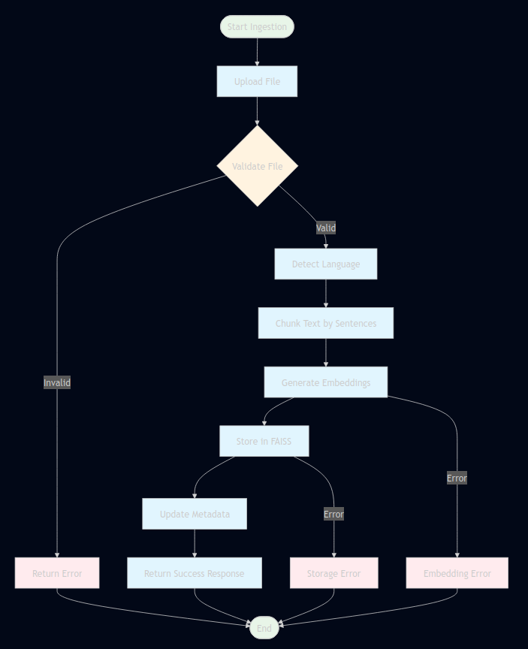
The process starts when a file needs to be added to the system.

Step 1: Upload and Validate

First, a file is uploaded

The system checks if the file is valid

If invalid, it returns an error and stops

If valid, it continues to the next step

Step 2: Process the Content

Detect what language the text is in

Split the text into smaller chunks by sentences

Convert these text chunks into number vectors (embeddings)

Step 3: Store and Finish

Save the vectors in the FAISS search database

Update the document metadata (information about the document)

Return a success message to confirm everything worked

Error Handling:
If anything goes wrong during embedding generation or storage, the system catches the error and stops the process.

The process ends after either:

Successfully storing the document

Encountering any error along the way
Document Retrieval Flow:
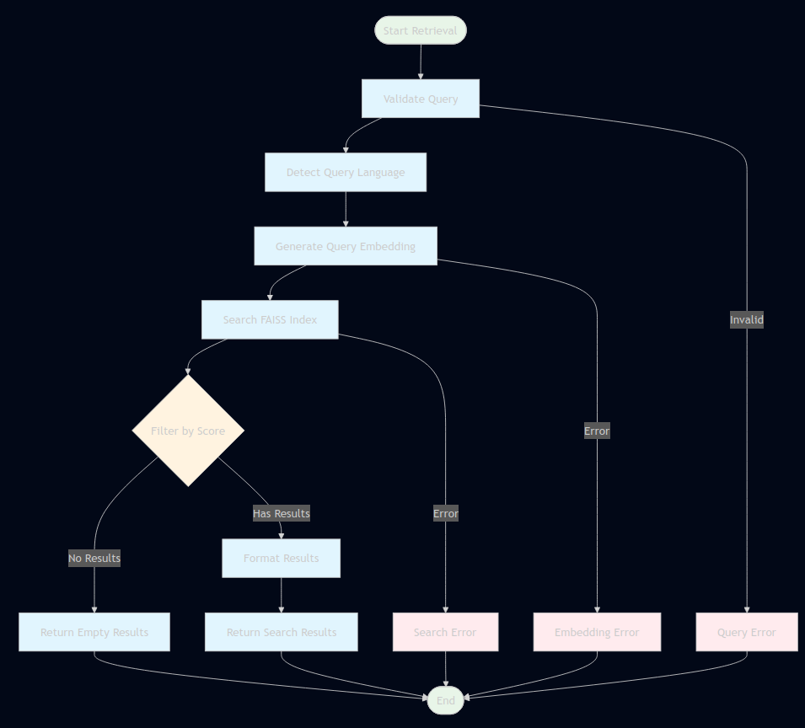
The process goes like this:

Start - Begin the document ingestion process

Upload File - The document file is uploaded

Validate File - System checks if the file is valid

If invalid: Return error and end

If valid: Continue to next step

Process the document:

Detect what language the text is in

Split the text into smaller sentence chunks

Convert text chunks into number vectors (embeddings)

Store these vectors in the FAISS search database

Update document information in the metadata

Final step - Return success message

Error handling: If anything fails during embedding generation or storage, the system catches the error and stops the process.

The process ends when either:

The document is successfully added

Any error occurs along the way
Response Generation Flow:

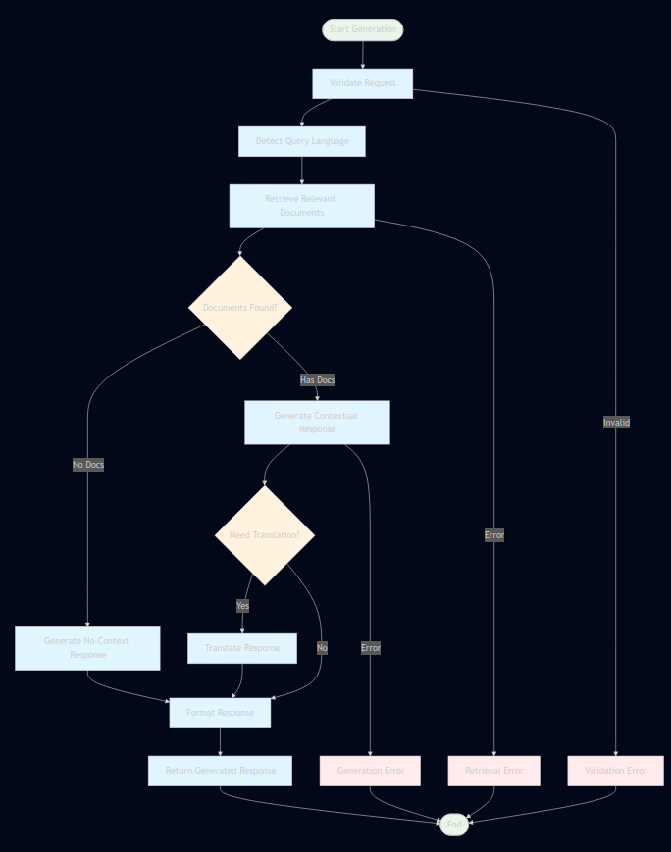
The process goes like this:

Start - Begin processing a user's question

Validate Request - Check if the request is valid

If invalid: Return error and stop

Detect Language - Figure out what language the question is in

Search - Look for relevant documents in the database

Check Results - See if any documents were found

If no documents found: Generate a general answer without context

If documents found: Create an answer using the found information

Translation Check - Decide if the answer needs translation

If translation needed: Translate the response

If no translation needed: Keep the original response

Final Steps - Format the response properly and return it to the user

Error handling: If anything fails during search or answer generation, the system catches the error and stops.
Deployment Architecture:
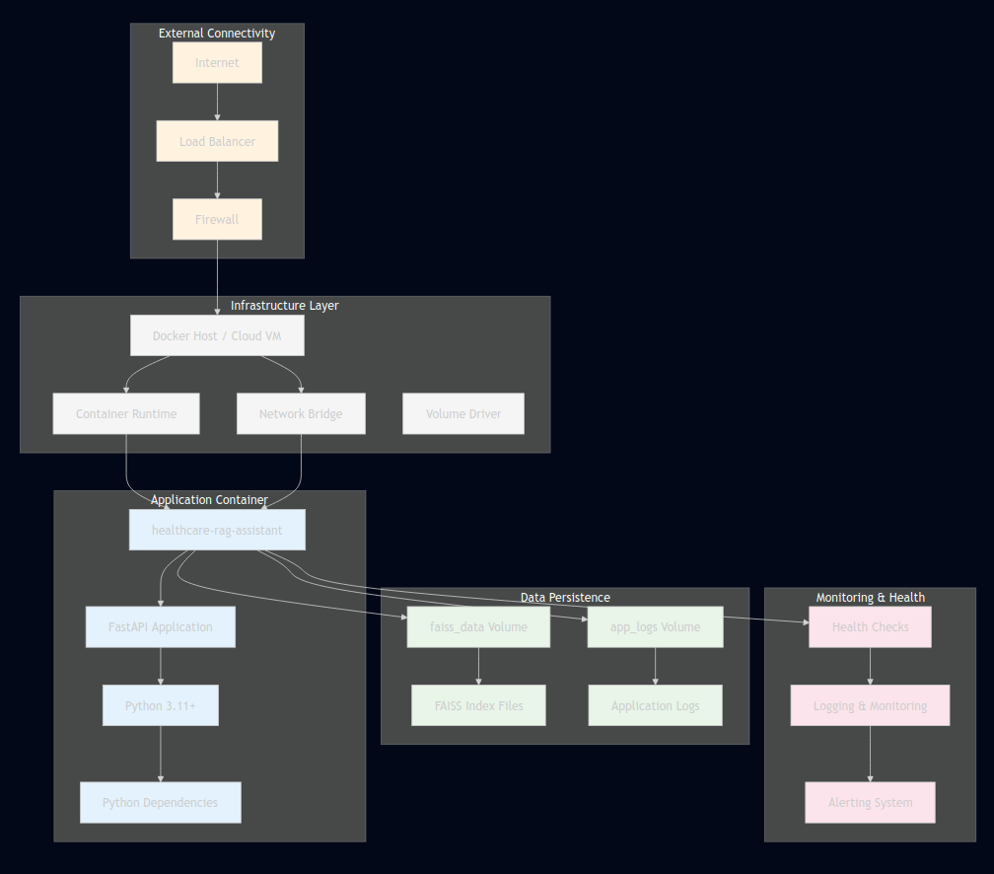
The System Infrastructure:

Runs on a Docker host or cloud virtual machine

Uses container technology to package the application

Has network and storage systems set up

The Application:

A container called "healthcare-rag-assistant" running a FastAPI application

Uses Python 3.11 with all necessary libraries and dependencies

Data Storage:

FAISS Volume: Stores the search index files for fast document retrieval

Logs Volume: Stores application logs and activity records

Network Connections:

Internet traffic comes through a load balancer

Passes through a firewall for security

Reaches the Docker host and finally the application container

Monitoring & Health:

Health checks continuously verify the application is working

Monitoring systems track performance and logs

Alerting system notifies if problems occur

How it all connects:
Users on the internet send requests that flow through the load balancer, firewall, and network to reach the application container. The application uses the FAISS data to answer questions and saves logs to the storage volumes. Health monitoring runs constantly to ensure everything works properly.
Security Architecture:

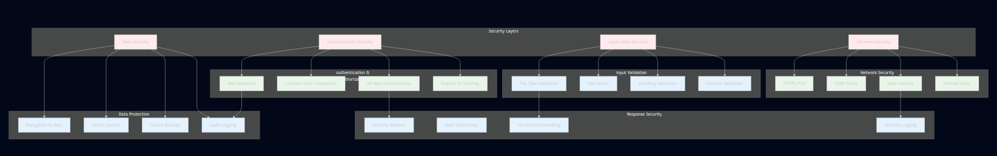
Security Layers:
The system has four main security areas:

Network Security

Application Security

Data Security

Authentication Security

Network Security:

Uses HTTPS encryption for all connections

Implements CORS policies to control access

Has rate limiting to prevent abuse

Uses firewall rules to block unauthorized access

Authentication & Authorization:

Requires API keys for access

Uses secure constant-time comparison for key checking

Validates all API keys

Tracks requests with unique IDs

Input Validation:

Checks file types to prevent malicious uploads

Enforces size limits

Validates text encoding

Checks content for safety

Response Security:

Adds security headers to all responses

Sanitizes data before sending

Uses secure error handling that doesn't leak information

Logs security events

Data Protection:

Encrypts stored data

Controls who can access what data

Securely backs up data

Keeps audit logs of all access

How it works together:
The system checks security at every step - from network connections to user authentication, input validation, and data protection. All security measures work together to protect the healthcare data and ensure only authorized users can access the system.
Technology Stack:

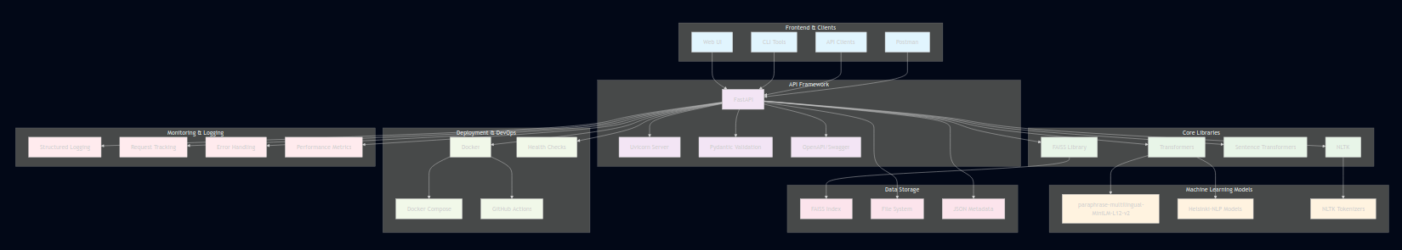

Frontend & Clients:

Web UI for browser access

Command line tools for developers

API clients for programmatic access

Postman for testing

API Framework:

FastAPI as the main web framework

Uvicorn as the web server

Pydantic for data validation

OpenAPI/Swagger for documentation

Core Libraries:

Transformers for AI models

FAISS Library for vector search

Sentence Transformers for text embeddings

NLTK for text processing

Machine Learning Models:

A multilingual embedding model for converting text to vectors

Helsinki-NLP models for translation

NLTK tokenizers for breaking down text

Data Storage:

FAISS Index for vector storage

File system for general storage

JSON files for metadata

Deployment & DevOps:

Docker for containerization

Docker Compose for multi-container setup

GitHub Actions for automation

Health checks for monitoring

Monitoring & Logging:

Structured logging for organized records

Request tracking for debugging

Error handling for reliability

Performance metrics for optimization

How everything connects:
All clients connect to the FastAPI application, which uses the AI libraries and models to process requests. The system stores data in FAISS and files, runs in Docker containers, and is monitored with comprehensive logging. The entire setup is automated with GitHub Actions.
Now codes for individuals files will be shared below:
app/main.py:

# app/main.py
import time
import uuid
import logging
import nltk
from fastapi import FastAPI, Request, Depends
from fastapi.middleware.cors import CORSMiddleware

from app.config import settings
from app.middleware.auth import api_key_auth
from app.routes import ingest, retrieve, generate
from app.utils.logger import setup_logging
from app.services.faiss_service import faiss_service
from app.services.embedding_service import embedding_service

# Setup logging
setup_logging()
logger = logging.getLogger(__name__)

# Track startup time
start_time = time.time()

# Create FastAPI app
app = FastAPI(
title="Healthcare RAG Assistant",
description="Bilingual medical knowledge assistant for clinicians",
version="1.0.0"
)

# Security headers middleware
@app.middleware("http")
async def add_security_headers(request: Request, call_next):
response = await call_next(request)
response.headers["X-Content-Type-Options"] = "nosniff"
response.headers["X-Frame-Options"] = "DENY"
response.headers["X-XSS-Protection"] = "1; mode=block"
response.headers["Strict-Transport-Security"] = "max-age=31536000; includeSubDomains"
return response

# Request logging middleware
@app.middleware("http")
async def log_requests(request: Request, call_next):
request_id = str(uuid.uuid4())
request.state.request_id = request_id

start = time.time()

logger.info(
"Request started",
extra={
"request_id": request_id,
"method": request.method,
"path": request.url.path,
"client_ip": request.client.host if request.client else "unknown"
}
)

response = await call_next(request)

duration = time.time() - start

logger.info(
"Request completed",
extra={
"request_id": request_id,
"status_code": response.status_code,
"duration": duration
}
)

response.headers["X-Request-ID"] = request_id
return response

# CORS middleware
app.add_middleware(
CORSMiddleware,
allow_origins=settings.CORS_ORIGINS.split(",") if hasattr(settings, 'CORS_ORIGINS')
else ["http://localhost:3000", "http://localhost:8000"],
allow_credentials=True,
allow_methods=["GET", "POST"],
allow_headers=["X-API-Key", "Content-Type"],
)

# Startup event
@app.on_event("startup")
async def startup_event():
"""Initialize services on startup"""
logger.info("Starting Healthcare RAG Assistant...")

# Download NLTK data if not present
try:
nltk.data.find('tokenizers/punkt_tab')
logger.info("NLTK punkt_tab already available")
except LookupError:
try:
logger.info("Downloading NLTK punkt_tab tokenizer...")
nltk.download('punkt_tab', quiet=True)
logger.info("NLTK punkt_tab downloaded successfully")
except Exception as e:
logger.warning(f"Failed to download NLTK punkt_tab (will use fallback): {e}")

logger.info("FAISS index loaded automatically")
logger.info("Services ready")

# Shutdown event
@app.on_event("shutdown")
async def shutdown_event():
"""Cleanup on shutdown"""
logger.info("Shutting down...")
faiss_service._save_index()
logger.info("Shutdown complete")

# Include routes
app.include_router(ingest.router, prefix="/api/v1", tags=["ingest"])
app.include_router(retrieve.router, prefix="/api/v1", tags=["retrieve"])
app.include_router(generate.router, prefix="/api/v1", tags=["generate"])

@app.get("/")
async def root():
"""Root endpoint"""
return {
"message": "Healthcare RAG Assistant API",
"version": "1.0.0",
"docs": "/docs"
}

@app.get("/health")
async def health_check():
"""Enhanced health check endpoint"""
try:
return {
"status": "healthy",
"faiss_index_size": faiss_service.index.ntotal if faiss_service.index else 0,
"total_documents": faiss_service.doc_counter,
"model_loaded": embedding_service.model is not None,
"uptime_seconds": int(time.time() - start_time)
}
except Exception as e:
logger.error(f"Health check failed: {e}")
return {
"status": "unhealthy",
"error": str(e)
}

@app.get("/admin/stats", dependencies=[Depends(api_key_auth)])
async def get_admin_stats():
"""System statistics (requires authentication)"""
import os

index_size_mb = 0
if faiss_service.index_path.exists():
index_size_mb = os.path.getsize(faiss_service.index_path) / (1024 * 1024)

return {
"faiss": {
"total_vectors": faiss_service.index.ntotal if faiss_service.index else 0,
"total_documents": faiss_service.doc_counter,
"embedding_dimension": faiss_service.embedding_dim,
"index_size_mb": round(index_size_mb, 2)
},
"uptime_seconds": int(time.time() - start_time)
}

This is the main application file for Healthcare Search Assistant API built with FastAPI.

What the application does:

Provides a bilingual medical knowledge assistant for doctors and clinicians

Allows uploading, searching, and generating answers from medical documents

Key features:

Security & Setup:

Uses API key authentication

Adds security headers to prevent attacks

Sets up CORS to control which websites can access the API

Downloads necessary language processing data on startup

Logging & Monitoring:

Assigns a unique ID to every request for tracking

Logs all requests with timing information

Provides health checks to monitor system status

Routes & Endpoints:

/ - Basic API information

/health - System health check (shows index size, uptime, model status)

/admin/stats - Detailed statistics (requires API key)

Three main API routes: /ingest, /retrieve, /generate

How it works:

When the server starts, it loads the search index and language tools

Every request gets logged and assigned a tracking ID

Security headers are added to all responses

The health check monitors if the search system is working properly

On shutdown, it automatically saves the search index

Main components:

FastAPI web framework

FAISS for document search

Embedding service for text processing

NLTK for language analysis

This is the core server that handles all document processing, searching, and question-answering functionality for the healthcare application.

app/config.py:

# app/config.py
"""
Application configuration management using Pydantic Settings.

Environment variables are loaded from .env file or system environment.
All configuration is validated at startup.
"""

from pydantic_settings import BaseSettings, SettingsConfigDict
from pydantic import Field, field_validator
from typing import Optional
import os

class Settings(BaseSettings):
"""
Application settings with validation.

Environment Variables:
API_KEYS: Comma-separated API keys (required)
LOG_LEVEL: Logging level (default: INFO)
MAX_FILE_SIZE_MB: Maximum file upload size (default: 10)
EMBEDDING_MODEL: Sentence transformer model name
ENV: Environment (development/production/testing)
"""

model_config = SettingsConfigDict(
env_file=".env",
env_file_encoding="utf-8",
case_sensitive=True,
extra="ignore"
)

# API Configuration

API_KEYS: str = Field(
default="",
description="Comma-separated list of valid API keys"
)
HOST: str = Field(default="0.0.0.0", description="API host")
PORT: int = Field(default=8000, ge=1024, le=65535, description="API port")
ENV: str = Field(default="development", description="Environment")
CORS_ORIGINS: str = Field(
default="http://localhost:3000,http://localhost:8000",
description="Comma-separated CORS origins"
)

# Logging Configuration

LOG_LEVEL: str = Field(
default="INFO",
description="Logging level (DEBUG, INFO, WARNING, ERROR, CRITICAL)"
)

# Model Configuration

EMBEDDING_MODEL: str = Field(
default="paraphrase-multilingual-MiniLM-L12-v2",
description="Sentence transformer model for embeddings"
)
TRANSLATION_MODEL_EN_JA: str = Field(
default="Helsinki-NLP/opus-mt-en-ja",
description="English to Japanese translation model"
)
TRANSLATION_MODEL_JA_EN: str = Field(
default="Helsinki-NLP/opus-mt-ja-en",
description="Japanese to English translation model"
)

# FAISS Configuration

FAISS_INDEX_DIR: str = Field(
default="data/faiss_index",
description="Directory for FAISS index storage"
)
EMBEDDING_DIM: int = Field(
default=384,
description="Embedding dimension (must match model)"
)

# File Upload Limits

MAX_FILE_SIZE_MB: int = Field(
default=10,
ge=1,
le=100,
description="Maximum file upload size in MB"
)
MAX_CHUNK_SIZE: int = Field(
default=500,
ge=100,
le=2000,
description="Target chunk size in characters"
)
MAX_CHUNK_OVERLAP: int = Field(
default=1,
ge=0,
le=5,
description="Number of sentences to overlap between chunks"
)
ALLOWED_EXTENSIONS: str = Field(
default=".txt",
description="Comma-separated allowed file extensions"
)

# Validators

@field_validator('API_KEYS', mode='before')
@classmethod
def validate_api_keys(cls, v):
"""Ensure API keys are provided"""
if not v or v.strip() == "":
raise ValueError(
"API_KEYS must be set in environment variables. "
"Example: API_KEYS=key1,key2,key3"
)
return v

@field_validator('LOG_LEVEL')
@classmethod
def validate_log_level(cls, v):
"""Validate log level"""
valid_levels = ["DEBUG", "INFO", "WARNING", "ERROR", "CRITICAL"]
if v.upper() not in valid_levels:
raise ValueError(f"LOG_LEVEL must be one of {valid_levels}")
return v.upper()

@field_validator('ENV')
@classmethod
def validate_env(cls, v):
"""Validate environment"""
valid_envs = ["development", "production", "testing"]
if v.lower() not in valid_envs:
raise ValueError(f"ENV must be one of {valid_envs}")
return v.lower()

@field_validator('EMBEDDING_DIM')
@classmethod
def validate_embedding_dim(cls, v):
"""Validate embedding dimension"""
valid_dims = [128, 256, 384, 512, 768, 1024]
if v not in valid_dims:
raise ValueError(
f"EMBEDDING_DIM must be one of {valid_dims}. "
f"Must match your embedding model's output dimension."
)
return v

@field_validator('FAISS_INDEX_DIR', mode='after')
@classmethod
def create_index_dir(cls, v):
"""Ensure FAISS index directory exists"""
os.makedirs(v, exist_ok=True)
return v

# Helper Methods

def get_api_keys_list(self) -> list[str]:
"""
Parse API_KEYS string into list.

Returns:
List of API key strings
"""
return [key.strip() for key in self.API_KEYS.split(",") if key.strip()]

def get_cors_origins_list(self) -> list[str]:
"""
Parse CORS_ORIGINS string into list.

Returns:
List of allowed CORS origin URLs
"""
return [origin.strip() for origin in self.CORS_ORIGINS.split(",") if origin.strip()]

def get_allowed_extensions_set(self) -> set[str]:
"""
Parse ALLOWED_EXTENSIONS string into set.

Returns:
Set of allowed file extensions
"""
return {ext.strip() for ext in self.ALLOWED_EXTENSIONS.split(",") if ext.strip()}

@property
def max_file_size_bytes(self) -> int:
"""
Convert MAX_FILE_SIZE_MB to bytes.

Returns:
Maximum file size in bytes
"""
return self.MAX_FILE_SIZE_MB * 1024 * 1024

@property
def is_production(self) -> bool:
"""Check if running in production"""
return self.ENV == "production"

@property
def is_development(self) -> bool:
"""Check if running in development"""
return self.ENV == "development"

# Create global settings instance
settings = Settings()

# Print configuration summary (only in development)
if settings.is_development:
print("\n" + "="*50)
print("Healthcare RAG Assistant - Configuration Loaded")
print("="*50)
print(f"Environment: {settings.ENV}")
print(f"Host: {settings.HOST}:{settings.PORT}")
print(f"Log Level: {settings.LOG_LEVEL}")
print(f"API Keys Configured: {len(settings.get_api_keys_list())}")
print(f"Max File Size: {settings.MAX_FILE_SIZE_MB}MB")
print(f"FAISS Index Dir: {settings.FAISS_INDEX_DIR}")
print(f"Embedding Model: {settings.EMBEDDING_MODEL}")
print(f"Embedding Dimension: {settings.EMBEDDING_DIM}")
print("="*50 + "\n")

This is the configuration file for the Healthcare Search Assistant. It manages all the settings and options for the application.

What it does:

Loads settings from environment variables or a .env file

Validates all configuration values

Provides default values for missing settings

Main configuration sections:

API Settings:

API keys (required - must be set)

Host and port where the server runs

Environment (development/production/testing)

CORS origins (which websites can access the API)

Logging & Files:

Log level (how detailed the logs should be)

Maximum file upload size (default 10MB)

Allowed file extensions (only .txt files by default)

AI Model Settings:

Embedding model for converting text to vectors

Translation models for English-Japanese translation

Embedding dimension (384 - must match the model)

Search Index Settings:

Where to store the FAISS search index

How to chunk documents (500 characters with 1 sentence overlap)

Safety Features:

Validates that API keys are provided

Checks that log levels are valid

Ensures the FAISS directory exists

Validates embedding dimensions match the model

Helper Methods:

Converts API keys string to a list

Converts file size from MB to bytes

Checks if running in production or development

Parses allowed file extensions

Startup Output:
In development mode, it prints a summary showing all the loaded configuration.

This file ensures the application has all the necessary settings to run properly and securely.

app/middleware/auth.py:

# app/middleware/auth.py
"""
API Key authentication middleware for FastAPI.

Provides secure API key validation using constant-time comparison
and comprehensive logging for security monitoring.
"""

import logging
import secrets
from typing import Optional

from fastapi import Header, HTTPException, Request
from app.config import settings

logger = logging.getLogger(__name__)

async def api_key_auth(
request: Request,
x_api_key: Optional[str] = Header(None, alias="X-API-Key")
) -> str:
"""
API Key authentication dependency.

Validates the X-API-Key header against configured API keys using
constant-time comparison to prevent timing attacks.

Args:
request: FastAPI request object for logging and tracking
x_api_key: API key from X-API-Key header

Returns:
str: The validated API key

Raises:
HTTPException: 401 if API key is missing or invalid

Example:
>>> @app.get("/protected", dependencies=[Depends(api_key_auth)])
>>> async def protected_endpoint():
>>> return {"message": "Success"}

Security:
- Uses secrets.compare_digest() for constant-time comparison
- Logs authentication attempts without exposing keys
- Includes request tracking via request_id
"""
# Get request ID for tracking
request_id = getattr(request.state, 'request_id', 'unknown')

# Get client IP for logging
client_ip = request.client.host if request.client else "unknown"

# Log authentication attempt
logger.info(
"Authentication attempt",
extra={
"request_id": request_id,
"path": request.url.path,
"method": request.method,
"client_ip": client_ip,
"has_api_key": x_api_key is not None
}
)

# Check if API key is provided
if not x_api_key:
logger.warning(
"Missing API key",
extra={
"request_id": request_id,
"client_ip": client_ip,
"path": request.url.path
}
)
raise HTTPException(
status_code=401,
detail="Missing API key. Include 'X-API-Key' header in your request.",
headers={"WWW-Authenticate": "ApiKey"}
)

# Get valid API keys from settings
valid_keys = settings.get_api_keys_list()

# Validate API key using constant-time comparison
# This prevents timing attacks that could leak valid key information
is_valid = any(
secrets.compare_digest(x_api_key, valid_key)
for valid_key in valid_keys
)

if not is_valid:
# Log failed authentication (but don't log the actual key)
logger.warning(
"Invalid API key",
extra={
"request_id": request_id,
"client_ip": client_ip,
"path": request.url.path,
"api_key_prefix": x_api_key[:8] + "..." if len(x_api_key) > 8 else "***"
}
)
raise HTTPException(
status_code=401,
detail="Invalid API key. Please check your credentials.",
headers={"WWW-Authenticate": "ApiKey"}
)

# Log successful authentication
logger.info(
"Authentication successful",
extra={
"request_id": request_id,
"client_ip": client_ip,
"path": request.url.path
}
)

return x_api_key

class APIKeyAuth:
"""
Alternative class-based authentication dependency.

Useful if you need to maintain state or customize behavior per instance.

Example:
>>> auth = APIKeyAuth()
>>> @app.get("/protected", dependencies=[Depends(auth)])
>>> async def protected_endpoint():
>>> return {"message": "Success"}
"""

def __init__(self):
"""Initialize the API key authenticator."""
self.valid_keys = set(settings.get_api_keys_list())
logger.info(f"APIKeyAuth initialized with {len(self.valid_keys)} valid keys")

async def __call__(
self,
request: Request,
x_api_key: Optional[str] = Header(None, alias="X-API-Key")
) -> str:
"""
Validate API key.

This is a wrapper around the api_key_auth function for class-based usage.
"""
# Use the same logic as the function
return await api_key_auth(request, x_api_key)

# Create a global instance for easy importing
api_key_auth_instance = APIKeyAuth()

This is the authentication system for the Healthcare Search Assistant API. It handles API key security.

What it does:

Protects API endpoints by requiring valid API keys

Validates keys securely to prevent attacks

Logs all authentication attempts for security monitoring

How it works:

Key Validation:

Looks for an X-API-Key header in incoming requests

Compares the provided key against a list of valid keys from the configuration

Uses secrets.compare_digest() for secure comparison (prevents timing attacks)

Security Features:

Constant-time comparison: Always takes the same time to check keys, preventing attackers from guessing valid keys by timing responses

Secure logging: Logs authentication attempts but never exposes the full API key in logs (only shows first 8 characters for tracking)

Request tracking: Links all authentication events to request IDs for debugging

Error Handling:

If no API key is provided: Returns 401 error "Missing API key"

If invalid API key is provided: Returns 401 error "Invalid API key"

Includes security headers in error responses

Logging:

Logs every authentication attempt with request details

Records successful and failed attempts

Tracks client IP addresses and request paths

Uses request IDs to trace authentication through the system

Two Ways to Use:

Function version: api_key_auth - directly protect endpoints

Class version: APIKeyAuth - for more complex scenarios

This authentication system ensures that only authorized users with valid API keys can access the healthcare application's sensitive endpoints.

app/models/schemas.py:

# app/models/schemas.py
"""
Pydantic models for request/response validation.

All models are automatically validated by FastAPI and generate
OpenAPI documentation with examples.
"""

from pydantic import BaseModel, Field, field_validator, ConfigDict
from typing import Optional, List, Literal
from datetime import datetime

# Shared Validators

def validate_query_field(v: str) -> str:
"""
Shared validator for query fields.

Ensures query is not empty or just whitespace.
"""
if not v or not v.strip():
raise ValueError('Query cannot be empty or whitespace')
return v.strip()

# Ingest Models

class IngestResponse(BaseModel):
"""
Response model for document ingestion.

Returned after successfully processing and storing a document.
"""
model_config = ConfigDict(
json_schema_extra={
"example": {
"status": "success",
"document_id": "doc_a1b2c3d4",
"language": "en",
"chunks_created": 15,
"file_size_kb": 42.3,
"processing_time_seconds": 2.4
}
}
)

status: str = Field(
...,
description="Status of the ingestion operation",
examples=["success"]
)
document_id: str = Field(
...,
description="Unique identifier for the ingested document",
examples=["doc_a1b2c3d4"]
)
language: str = Field(
...,
description="Detected language of the document (en or ja)",
examples=["en", "ja"]
)
chunks_created: int = Field(
...,
description="Number of text chunks created",
ge=0,
examples=[15]
)
file_size_kb: float = Field(
...,
description="Size of the uploaded file in kilobytes",
ge=0,
examples=[42.3]
)
processing_time_seconds: float = Field(
...,
description="Time taken to process the document",
ge=0,
examples=[2.4]
)

# Retrieve Models

class RetrieveRequest(BaseModel):
"""
Request model for document retrieval.

Searches the vector database for documents semantically similar
to the provided query.
"""
model_config = ConfigDict(
str_strip_whitespace=True,
json_schema_extra={
"example": {
"query": "What are the latest recommendations for Type 2 diabetes management?",
"top_k": 3,
"min_score": 0.5
}
}
)

query: str = Field(
...,
min_length=1,
max_length=500,
description="Search query in English or Japanese",
examples=["What are the diabetes management guidelines?"]
)
top_k: int = Field(
default=3,
ge=1,
le=10,
description="Number of results to return",
examples=[3]
)
min_score: float = Field(
default=0.5,
ge=0.0,
le=1.0,
description="Minimum similarity score threshold (0.0-1.0)",
examples=[0.5]
)

@field_validator('query')
@classmethod
def query_not_empty(cls, v: str) -> str:
"""Validate query is not empty"""
return validate_query_field(v)

class SearchResult(BaseModel):
"""
Individual search result from vector database.

Represents a single document chunk with similarity score.
"""
model_config = ConfigDict(
json_schema_extra={
"example": {
"text": "Type 2 diabetes management requires...",
"similarity_score": 0.87,
"document_id": "doc_a1b2c3d4",
"language": "en",
"chunk_id": 5
}
}
)

text: str = Field(
...,
description="Content of the document chunk"
)
similarity_score: float = Field(
...,
ge=0.0,
le=1.0,
description="Cosine similarity score (0.0-1.0)"
)
document_id: str = Field(
...,
description="ID of the source document"
)
language: str = Field(
...,
description="Language of the document (en or ja)"
)
chunk_id: int = Field(
...,
ge=0,
description="Chunk index within the document"
)

class RetrieveResponse(BaseModel):
"""
Response model for document retrieval.

Contains search results and metadata about the query.
"""
model_config = ConfigDict(
json_schema_extra={
"example": {
"results": [
{
"text": "Type 2 diabetes management requires...",
"similarity_score": 0.87,
"document_id": "doc_a1b2c3d4",
"language": "en",
"chunk_id": 5
}
],
"query_language": "en",
"results_found": 3
}
}
)

results: List[SearchResult] = Field(
...,
description="List of search results ordered by similarity"
)
query_language: str = Field(
...,
description="Detected language of the query (en or ja)"
)
results_found: int = Field(
...,
ge=0,
description="Total number of results found"
)

# Generate Models

class GenerateRequest(BaseModel):
"""
Request model for response generation.

Generates a contextual response based on retrieved documents.
"""
model_config = ConfigDict(
str_strip_whitespace=True,
json_schema_extra={
"example": {
"query": "What are the dietary recommendations for diabetes?",
"output_language": "ja"
}
}
)

query: str = Field(
...,
min_length=1,
max_length=500,
description="Question to answer based on retrieved documents",
examples=["What are the dietary recommendations?"]
)
output_language: Optional[Literal["en", "ja"]] = Field(
default=None,
description="Desired output language (en or ja). If not specified, uses query language."
)

@field_validator('query')
@classmethod
def query_not_empty(cls, v: str) -> str:
"""Validate query is not empty"""
return validate_query_field(v)

class Source(BaseModel):
"""
Source document reference in generated response.
"""
model_config = ConfigDict(
json_schema_extra={
"example": {
"document_id": "doc_a1b2c3d4",
"chunk_id": 5,
"similarity_score": 0.87,
"language": "en"
}
}
)

document_id: str = Field(..., description="Source document ID")
chunk_id: int = Field(..., ge=0, description="Chunk index")
similarity_score: float = Field(..., ge=0.0, le=1.0, description="Relevance score")
language: str = Field(..., description="Language of source (en or ja)")

class GenerateResponse(BaseModel):
"""
Response model for generated answers.

Contains the AI-generated response with source citations.
"""
model_config = ConfigDict(
json_schema_extra={
"example": {
"query": "What are the dietary recommendations?",
"response": "Based on the retrieved medical guidelines regarding diabetes management...",
"language": "en",
"sources": [
{
"document_id": "doc_a1b2c3d4",
"chunk_id": 5,
"similarity_score": 0.87
}
],
"generation_time_seconds": 1.2
}
}
)

query: str = Field(
...,
description="Original query that was answered"
)
response: str = Field(
...,
description="Generated response based on retrieved documents"
)
language: str = Field(
...,
description="Language of the response (en or ja)"
)
sources: List[Source] = Field(
...,
description="Source documents used to generate the response"
)
generation_time_seconds: float = Field(
...,
ge=0,
description="Time taken to generate the response"
)

# Common Response Models

class HealthResponse(BaseModel):
"""Health check response model."""
model_config = ConfigDict(
json_schema_extra={
"example": {
"status": "healthy",
"faiss_index_size": 1523,
"total_documents": 12,
"model_loaded": True,
"uptime_seconds": 3600
}
}
)

status: str = Field(..., description="Health status")
faiss_index_size: int = Field(..., ge=0, description="Number of vectors in FAISS")
total_documents: int = Field(..., ge=0, description="Number of documents ingested")
model_loaded: bool = Field(..., description="Whether embedding model is loaded")
uptime_seconds: int = Field(..., ge=0, description="Server uptime in seconds")

class ErrorResponse(BaseModel):
"""Standard error response model."""
model_config = ConfigDict(
json_schema_extra={
"example": {
"error": "Invalid file format",
"detail": "Only .txt files are supported",
"status_code": 400
}
}
)

error: str = Field(..., description="Error type")
detail: str = Field(..., description="Detailed error message")
status_code: int = Field(..., description="HTTP status code")

class StatsResponse(BaseModel):
"""Admin statistics response model."""
model_config = ConfigDict(
json_schema_extra={
"example": {
"faiss": {
"total_vectors": 1523,
"total_documents": 12,
"embedding_dimension": 384,
"index_size_mb": 8.4
},
"uptime_seconds": 3600
}
}
)

class FAISSStats(BaseModel):
"""FAISS index statistics."""
total_vectors: int
total_documents: int
embedding_dimension: int
index_size_mb: float

faiss: FAISSStats
uptime_seconds: int

This file defines all the data structures (models) that the Healthcare Search Assistant API uses for requests and responses.

What it does:

Defines the exact format for all API inputs and outputs

Automatically validates data

Provides examples for API documentation

Ensures consistent data structure throughout the application

Main Models:

1. Document Upload (Ingest)

Request: File upload (handled separately)

Response: Shows upload success with details like:

Document ID

Detected language (English/Japanese)

Number of text chunks created

File size and processing time

2. Document Search (Retrieve)

Request: Search query with options:

Query text (required)

Number of results to return (1-10)

Minimum similarity score (0.0-1.0)

Response: Search results with:

List of matching document chunks

Similarity scores

Source document information

Query language detected

3. Answer Generation (Generate)

Request: Question to answer with optional:

Output language (English/Japanese)

Response: AI-generated answer with:

The generated response

Source citations showing where information came from

Generation time

Response language

4. Support Models

Health Check: System status, index size, uptime

Error Response: Standard error format

Admin Statistics: Detailed system metrics

Key Features:

Validation: Ensures queries aren't empty, numbers are within ranges

Documentation: Includes examples for API docs

Security: Validates all inputs before processing

Consistency: Standard formats across all endpoints

Examples:

If you search for "diabetes treatment", the API expects a specific request format and returns results in a predictable structure

If you upload a document, you get back a consistent response showing what was processed

All errors follow the same format

These models act as contracts between the frontend and backend, ensuring everyone knows exactly what data to send and what to expect back.

app/routes/generate.py:

# app/routes/generate.py
"""
Generate endpoint for creating contextual responses using RAG.

Provides natural language responses based on retrieved medical documents
with support for bilingual queries and responses.
"""

import logging
import time
import uuid
from typing import List, Dict, Any
from fastapi import APIRouter, Depends, HTTPException, status
from asyncio import timeout as async_timeout

from app.middleware.auth import api_key_auth
from app.models.schemas import GenerateRequest, GenerateResponse
from app.services.embedding_service import embedding_service
from app.services.faiss_service import faiss_service
from app.services.llm_service import llm_service
from app.services.translation_service import translation_service
from app.utils.language_detector import detect_language
from app.config import settings

logger = logging.getLogger(__name__)

router = APIRouter()

# Configuration
GENERATION_TOP_K = getattr(settings, 'GENERATION_TOP_K', 5)
GENERATION_MIN_SCORE = getattr(settings, 'GENERATION_MIN_SCORE', 0.3)
GENERATION_TIMEOUT = getattr(settings, 'GENERATION_TIMEOUT', 30)

@router.post(
"/generate",
response_model=GenerateResponse,
status_code=status.HTTP_200_OK,
summary="Generate Response",
description=(
"Generate contextual medical responses using retrieved documents. "
"Supports both English and Japanese queries with optional output "
"language specification. Uses RAG (Retrieval-Augmented Generation) "
"to provide accurate, source-backed responses."
),
responses={
200: {
"description": "Response generated successfully",
"model": GenerateResponse
},
400: {
"description": "Invalid request"
},
401: {
"description": "Invalid API key"
},
429: {
"description": "Too many requests"
},
500: {
"description": "Internal server error"
},
503: {
"description": "Service temporarily unavailable"
}
}
)
async def generate_response(
request: GenerateRequest,
api_key: str = Depends(api_key_auth)
) -> GenerateResponse:
"""
Generate a contextual response using retrieved documents.

This endpoint:
1. Detects the query language
2. Translates query to English if needed (for better retrieval)
3. Generates embeddings and retrieves relevant documents
4. Generates a structured response using retrieved context
5. Translates response to requested output language if needed

Args:
request: GenerateRequest containing query and optional output language
api_key: API key for authentication (injected by dependency)

Returns:
GenerateResponse with generated response and source information

Raises:
HTTPException: Various status codes for different error conditions

Example:
```python
POST /generate
{
"query": "What are the diabetes management guidelines?",
"output_language": "ja"
}
```
"""
# Generate request ID for tracking
request_id = str(uuid.uuid4())[:8]
start_time = time.time()

logger.info(
"Response generation request received",
extra={
"request_id": request_id,
"query_preview": request.query[:100],
"output_language": request.output_language,
"api_key": api_key[:8] + "..."
}
)

try:
# Apply timeout to entire operation
async with async_timeout(GENERATION_TIMEOUT):
return await _process_generation_request(
request, request_id, start_time
)

except TimeoutError:
logger.error(
"Response generation timed out",
extra={
"request_id": request_id,
"timeout": GENERATION_TIMEOUT
}
)
raise HTTPException(
status_code=status.HTTP_504_GATEWAY_TIMEOUT,
detail=f"Request timed out after {GENERATION_TIMEOUT} seconds"
)

except HTTPException:
# Re-raise HTTP exceptions
raise

except Exception as e:
logger.error(
"Unexpected error in response generation",
extra={
"request_id": request_id,
"error": str(e),
"error_type": type(e).__name__
},
exc_info=True
)
raise HTTPException(
status_code=status.HTTP_500_INTERNAL_SERVER_ERROR,
detail="An unexpected error occurred. Please try again."
)

async def _process_generation_request(
request: GenerateRequest,
request_id: str,
start_time: float
) -> GenerateResponse:
"""
Process the generation request with detailed error handling.

Args:
request: The generate request
request_id: Unique request identifier
start_time: Request start timestamp

Returns:
GenerateResponse with generated content
"""
# Step 1: Detect query language
try:
query_language = detect_language(request.query)
logger.debug(
"Query language detected",
extra={
"request_id": request_id,
"detected_language": query_language
}
)
except Exception as e:
logger.warning(
f"Language detection failed, defaulting to English: {e}",
extra={"request_id": request_id}
)
query_language = "en"

# Step 2: Determine output language
output_language = request.output_language or query_language

# Validate output language
if output_language not in ["en", "ja"]:
raise HTTPException(
status_code=status.HTTP_400_BAD_REQUEST,
detail=f"Unsupported output language: {output_language}"
)

# Step 3: Use original query for retrieval
query_for_retrieval = request.query

logger.debug(
"Using original query for retrieval",
extra={
"request_id": request_id,
"query_language": query_language,
"query_preview": request.query[:50]
}
)

# Step 4: Generate query embedding
try:
query_embedding = embedding_service.encode_single(query_for_retrieval)
logger.debug(
"Query embedding generated",
extra={
"request_id": request_id,
"embedding_shape": query_embedding.shape
}
)
except Exception as e:
logger.error(
"Embedding generation failed",
extra={
"request_id": request_id,
"error": str(e)
},
exc_info=True
)
raise HTTPException(
status_code=status.HTTP_500_INTERNAL_SERVER_ERROR,
detail="Failed to process query. Please try again."
)

# Step 5: Retrieve relevant documents
try:
retrieved_docs = faiss_service.search(
query_embedding=query_embedding,
top_k=GENERATION_TOP_K,
min_score=GENERATION_MIN_SCORE
)

logger.debug(
"Documents retrieved",
extra={
"request_id": request_id,
"documents_found": len(retrieved_docs),
"top_score": retrieved_docs[0].get('similarity_score', 0) if retrieved_docs else 0
}
)

except Exception as e:
logger.error(
"Document retrieval failed",
extra={
"request_id": request_id,
"error": str(e)
},
exc_info=True
)
raise HTTPException(
status_code=status.HTTP_503_SERVICE_UNAVAILABLE,
detail="Document retrieval service temporarily unavailable."
)

# Step 6: Validate retrieved documents
if not retrieved_docs:
logger.warning(
"No documents retrieved for query",
extra={"request_id": request_id}
)
# LLM service will handle no results with appropriate message
else:
# Check quality of results
high_quality_count = sum(
1 for doc in retrieved_docs
if doc.get('similarity_score', 0) >= 0.5
)

if high_quality_count == 0:
logger.warning(
"No high-quality documents found",
extra={
"request_id": request_id,
"best_score": retrieved_docs[0].get('similarity_score', 0)
}
)

# Step 7: Generate response using LLM service
try:
llm_response = llm_service.generate_response(
query=request.query, # Use original query for context
retrieved_docs=retrieved_docs,
language=output_language
)

logger.debug(
"LLM response generated",
extra={
"request_id": request_id,
"response_length": len(llm_response["response"]),
"sources_count": len(llm_response["sources"])
}
)

except Exception as e:
logger.error(
"LLM response generation failed",
extra={
"request_id": request_id,
"error": str(e)
},
exc_info=True
)
raise HTTPException(
status_code=status.HTTP_500_INTERNAL_SERVER_ERROR,
detail="Failed to generate response. Please try again."
)

# Step 8: Prepare final response
generation_time = time.time() - start_time

response = GenerateResponse(
query=request.query,
response=llm_response["response"],
language=output_language,
sources=llm_response["sources"],
generation_time_seconds=round(generation_time, 3)
)

logger.info(
"Response generation completed successfully",
extra={
"request_id": request_id,
"query_language": query_language,
"output_language": output_language,
"documents_used": len(retrieved_docs),
"generation_time": round(generation_time, 3),
"response_length": len(response.response)
}
)

return response

@router.get(
"/generate/health",
summary="Health Check",
description="Check if the generate endpoint and its dependencies are healthy"
)
async def health_check() -> Dict[str, Any]:
"""
Health check for generate endpoint.

Verifies that all required services (embedding, FAISS, LLM) are operational.

Returns:
Dictionary with health status of all services
"""
health_status = {
"endpoint": "generate",
"status": "healthy",
"services": {}
}

# Check embedding service
try:
embedding_health = embedding_service.health_check()
health_status["services"]["embedding"] = embedding_health
except Exception as e:
health_status["services"]["embedding"] = {
"status": "unhealthy",
"error": str(e)
}
health_status["status"] = "degraded"

# Check FAISS service
try:
faiss_health = faiss_service.health_check()
health_status["services"]["faiss"] = faiss_health
except Exception as e:
health_status["services"]["faiss"] = {
"status": "unhealthy",
"error": str(e)
}
health_status["status"] = "degraded"

# Check LLM service
try:
llm_health = llm_service.health_check()
health_status["services"]["llm"] = llm_health
except Exception as e:
health_status["services"]["llm"] = {
"status": "unhealthy",
"error": str(e)
}
health_status["status"] = "degraded"

# Check translation service
try:
translation_health = translation_service.health_check()
health_status["services"]["translation"] = translation_health
except Exception as e:
health_status["services"]["translation"] = {
"status": "unhealthy",
"error": str(e)
}
health_status["status"] = "degraded"

return health_status

This is the answer generation endpoint for the Healthcare Search Assistant. It creates AI-powered responses to medical questions using retrieved documents.

What it does:

Takes a user's medical question and generates an intelligent answer

Searches through medical documents to find relevant information

Creates a well-structured response with source citations

Supports both English and Japanese questions and answers

How it works step by step:

Receive Question

User sends a question like "What are diabetes treatment guidelines?"

Optionally specifies output language (English/Japanese)

Process the Request

Detect the language of the question

Determine what language to answer in

Convert the question to numerical vectors (embeddings)

Search for Information

Search the document database for relevant medical information

Find the most similar document chunks

Filter by quality scores

Generate Answer

Use AI to create a response based on the found documents

Include citations showing which documents were used

Format the response properly

Return Result

Send back the generated answer with sources

Include processing time and metadata

Key Features:

Error Handling:

30-second timeout to prevent hanging requests

Handles missing documents gracefully

Validates all inputs

Comprehensive error logging

Bilingual Support:

Automatically detects question language

Can answer in either English or Japanese

Uses original language for best search results

Monitoring:

Tracks every request with unique IDs

Logs processing times and success rates

Health check endpoint to verify all services are working

Security:

Requires API key authentication

Validates all inputs

Timeout protection
This endpoint combines document search with AI generation to provide accurate, source-backed medical information to healthcare professionals.
app/routes/ingest.py:

# app/routes/ingest.py
"""
Document ingestion endpoint for uploading and processing text documents.

Handles file validation, text chunking, embedding generation, and storage
in the vector database with support for English and Japanese documents.
"""

import time
import uuid
import re
import hashlib
import logging
from pathlib import Path
from typing import List, Dict, Any
from asyncio import timeout as async_timeout

from fastapi import APIRouter, Depends, UploadFile, File, HTTPException, status
import nltk
from nltk.tokenize import sent_tokenize

from app.middleware.auth import api_key_auth
from app.models.schemas import IngestResponse
from app.services.embedding_service import embedding_service
from app.services.faiss_service import faiss_service
from app.utils.language_detector import detect_language
from app.config import settings

logger = logging.getLogger(__name__)
router = APIRouter()

# Ensure NLTK data is available
try:
nltk.data.find('tokenizers/punkt')
except LookupError:
try:
nltk.download('punkt', quiet=True)
logger.info("Downloaded NLTK punkt tokenizer")
except Exception as e:
logger.warning(f"Failed to download NLTK data: {e}")

# Configuration
MAX_FILE_SIZE_BYTES = settings.MAX_FILE_SIZE_MB * 1024 * 1024
MAX_CHUNK_SIZE = getattr(settings, 'MAX_CHUNK_SIZE', 500)
ALLOWED_EXTENSIONS = {'.txt'}
INGEST_TIMEOUT = 60 # seconds

def sanitize_filename(filename: str) -> str:
"""
Sanitize filename to prevent security issues.

Args:
filename: Original filename

Returns:
Sanitized filename
"""
# Get just the filename, no path components
filename = Path(filename).name

# Remove any dangerous characters
filename = re.sub(r'[^\w\s.-]', '', filename)

# Limit length
if len(filename) > 100:
name, ext = filename.rsplit('.', 1) if '.' in filename else (filename, '')
filename = name[:95] + '.' + ext if ext else name[:100]

return filename or "unnamed.txt"

def calculate_content_hash(content: str) -> str:
"""
Calculate SHA-256 hash of content for duplicate detection.

Args:
content: Text content

Returns:
Hex digest of content hash
"""
return hashlib.sha256(content.encode('utf-8')).hexdigest()

def chunk_text_by_sentences(
text: str,
language: str = "en",
max_chunk_size: int = 500,
overlap_sentences: int = 1
) -> List[str]:
"""
Split text into chunks by sentences, maintaining semantic boundaries.

Uses language-aware sentence splitting for English and Japanese.

Args:
text: Input text to chunk
language: Language of text ('en' or 'ja')
max_chunk_size: Target maximum characters per chunk
overlap_sentences: Number of sentences to overlap between chunks

Returns:
List of text chunks

Example:
>>> chunks = chunk_text_by_sentences("Text here.", "en", 500)
>>> len(chunks)
1
"""
# Split into sentences based on language
if language == "ja":
# Japanese sentence endings: 。！？
sentences = re.split(r'(?<=[。！？])\s*', text)
sentences = [s.strip() for s in sentences if s.strip()]
else:
# English - use NLTK
try:
sentences = sent_tokenize(text)
except Exception as e:
logger.warning(f"NLTK tokenization failed, using fallback: {e}")
# Fallback to simple splitting
sentences = re.split(r'(?<=[.!?])\s+', text)

if not sentences:
return []

chunks = []
current_chunk = []
current_size = 0

for sentence in sentences:
sentence_size = len(sentence)

# If adding this sentence exceeds limit and we have content
if current_size + sentence_size > max_chunk_size and current_chunk:
# Save current chunk
chunks.append(' '.join(current_chunk))

# Start new chunk with overlap
if overlap_sentences > 0 and len(current_chunk) > overlap_sentences:
overlap = current_chunk[-overlap_sentences:]
else:
overlap = []

current_chunk = overlap + [sentence]
current_size = sum(len(s) for s in current_chunk)
else:
current_chunk.append(sentence)
current_size += sentence_size

# Add final chunk if not empty
if current_chunk:
chunks.append(' '.join(current_chunk))

return chunks

async def validate_upload_file(file: UploadFile) -> tuple[str, str]:
"""
Validate uploaded file and return its content and sanitized filename.

Args:
file: Uploaded file

Returns:
Tuple of (file content as string, sanitized filename)

Raises:
HTTPException: If validation fails
"""
# Sanitize filename
sanitized_name = sanitize_filename(file.filename or "unnamed.txt")

# Check file extension
file_ext = Path(sanitized_name).suffix.lower()
if file_ext not in ALLOWED_EXTENSIONS:
raise HTTPException(
status_code=status.HTTP_400_BAD_REQUEST,
detail=f"Invalid file type. Only {', '.join(ALLOWED_EXTENSIONS)} files are allowed."
)

# Read file content
try:
content = await file.read()
except Exception as e:
logger.error(f"Failed to read uploaded file: {e}")
raise HTTPException(
status_code=status.HTTP_400_BAD_REQUEST,
detail="Failed to read uploaded file."
)

# Check file size
if len(content) == 0:
raise HTTPException(
status_code=status.HTTP_400_BAD_REQUEST,
detail="File is empty."
)

if len(content) > MAX_FILE_SIZE_BYTES:
max_size_mb = MAX_FILE_SIZE_BYTES / (1024 * 1024)
raise HTTPException(
status_code=status.HTTP_413_REQUEST_ENTITY_TOO_LARGE,
detail=f"File too large. Maximum size is {max_size_mb:.1f}MB."
)

# Decode and validate encoding
try:
text = content.decode('utf-8')
except UnicodeDecodeError:
try:
# Try other common encodings
text = content.decode('latin-1')
logger.warning(f"File decoded as latin-1: {sanitized_name}")
except Exception:
raise HTTPException(
status_code=status.HTTP_400_BAD_REQUEST,
detail="File must be UTF-8 or Latin-1 encoded text."
)

# Validate content
if not text.strip():
raise HTTPException(
status_code=status.HTTP_400_BAD_REQUEST,
detail="File contains only whitespace."
)

# Reset file pointer for potential reuse
await file.seek(0)

return text, sanitized_name

@router.post(
"/ingest",
response_model=IngestResponse,
status_code=status.HTTP_201_CREATED,
summary="Ingest Document",
description=(
"Upload and process a text document for storage in the vector database. "
"Supports English and Japanese documents. The document is automatically "
"chunked, embedded, and indexed for retrieval."
),
responses={
201: {
"description": "Document ingested successfully",
"model": IngestResponse
},
400: {
"description": "Invalid file or request"
},
401: {
"description": "Invalid API key"
},
413: {
"description": "File too large"
},
429: {
"description": "Too many requests"
},
500: {
"description": "Internal server error"
}
}
)
async def ingest_document(
file: UploadFile = File(..., description="Text file to ingest (.txt only)"),
api_key: str = Depends(api_key_auth)
) -> IngestResponse:
"""
Ingest a document by processing, chunking, and storing it in the vector database.

Args:
file: Text file to ingest (.txt format)
api_key: API key for authentication (injected by dependency)

Returns:
IngestResponse with processing results including document ID

Raises:
HTTPException: Various status codes for different error conditions

Example:
```bash
curl -X POST "http://localhost:8000/ingest" \
-H "X-API-Key: your-api-key" \
-F "file=@document.txt"
```
"""
# Generate request ID for tracking
request_id = str(uuid.uuid4())[:8]
start_time = time.time()

logger.info(
"Document ingestion request received",
extra={
"request_id": request_id,
"file_name": file.filename,
"content_type": file.content_type,
"api_key": api_key[:8] + "..." if api_key else None
}
)

try:
# Apply timeout to entire operation
async with async_timeout(INGEST_TIMEOUT):
return await _process_ingestion(file, request_id, start_time)

except TimeoutError:
logger.error(
"Document ingestion timed out",
extra={
"request_id": request_id,
"timeout": INGEST_TIMEOUT
}
)
raise HTTPException(
status_code=status.HTTP_504_GATEWAY_TIMEOUT,
detail=f"Document processing timed out after {INGEST_TIMEOUT} seconds"
)

except HTTPException:
# Re-raise HTTP exceptions
raise

except Exception as e:
logger.error(
"Unexpected error in document ingestion",
extra={
"request_id": request_id,
"file_name": file.filename,
"error": str(e),
"error_type": type(e).__name__
},
exc_info=True
)
raise HTTPException(
status_code=status.HTTP_500_INTERNAL_SERVER_ERROR,
detail="An unexpected error occurred while processing the document."
)

async def _process_ingestion(
file: UploadFile,
request_id: str,
start_time: float
) -> IngestResponse:
"""
Process document ingestion with detailed error handling.

Args:
file: Uploaded file
request_id: Unique request identifier
start_time: Request start timestamp

Returns:
IngestResponse with processing results
"""
# Step 1: Validate and read file
try:
text_content, sanitized_filename = await validate_upload_file(file)
file_size_kb = len(text_content.encode('utf-8')) / 1024

logger.debug(
"File validated successfully",
extra={
"request_id": request_id,
"file_name": sanitized_filename,
"size_kb": round(file_size_kb, 2)
}
)
except HTTPException:
raise
except Exception as e:
logger.error(
"File validation failed",
extra={"request_id": request_id, "error": str(e)},
exc_info=True
)
raise HTTPException(
status_code=status.HTTP_400_BAD_REQUEST,
detail="File validation failed. Please check file format and try again."
)

# Step 2: Detect language
try:
language = detect_language(text_content)
logger.debug(
"Language detected",
extra={
"request_id": request_id,
"language": language
}
)
except Exception as e:
logger.warning(
f"Language detection failed, defaulting to English: {e}",
extra={"request_id": request_id}
)
language = "en"

# Step 3: Calculate content hash (for duplicate detection)
content_hash = calculate_content_hash(text_content)

# Step 4: Chunk text
try:
chunks = chunk_text_by_sentences(
text_content,
language=language,
max_chunk_size=MAX_CHUNK_SIZE
)

if not chunks:
raise HTTPException(
status_code=status.HTTP_400_BAD_REQUEST,
detail="No meaningful chunks could be extracted from the document."
)

# Validate chunks
valid_chunks = [chunk for chunk in chunks if 10 <= len(chunk) <= 2000]

if not valid_chunks:
raise HTTPException(
status_code=status.HTTP_400_BAD_REQUEST,
detail="Document contains no valid text chunks."
)

if len(valid_chunks) < len(chunks):
logger.warning(
f"Filtered out {len(chunks) - len(valid_chunks)} invalid chunks",
extra={"request_id": request_id}
)

chunks = valid_chunks

logger.debug(
"Text chunked successfully",
extra={
"request_id": request_id,
"chunk_count": len(chunks),
"avg_chunk_size": sum(len(c) for c in chunks) / len(chunks)
}
)

except HTTPException:
raise
except Exception as e:
logger.error(
"Text chunking failed",
extra={"request_id": request_id, "error": str(e)},
exc_info=True
)
raise HTTPException(
status_code=status.HTTP_500_INTERNAL_SERVER_ERROR,
detail="Failed to process document text."
)

# Step 5: Generate embeddings
try:
embeddings = embedding_service.encode(
chunks,
batch_size=32,
show_progress_bar=False
)

logger.debug(
"Embeddings generated",
extra={
"request_id": request_id,
"embedding_count": len(embeddings),
"embedding_shape": embeddings.shape
}
)

except Exception as e:
logger.error(
"Embedding generation failed",
extra={"request_id": request_id, "error": str(e)},
exc_info=True
)
raise HTTPException(
status_code=status.HTTP_500_INTERNAL_SERVER_ERROR,
detail="Failed to generate document embeddings."
)

# Step 6: Generate document ID
document_id = faiss_service.generate_document_id()

# Step 7: Add to FAISS index
try:
chunks_created = faiss_service.add_document(
document_id=document_id,
chunks=chunks,
embeddings=embeddings,
language=language,
metadata={
"file_name": sanitized_filename,
"original_size_kb": round(file_size_kb, 2),
"chunk_count": len(chunks),
"content_hash": content_hash,
"ingested_at": time.time()
}
)

logger.debug(
"Document added to FAISS index",
extra={
"request_id": request_id,
"document_id": document_id,
"chunks_created": chunks_created
}
)

except Exception as e:
logger.error(
"Failed to add document to FAISS index",
extra={
"request_id": request_id,
"document_id": document_id,
"error": str(e)
},
exc_info=True
)
raise HTTPException(
status_code=status.HTTP_500_INTERNAL_SERVER_ERROR,
detail="Failed to store document in database."
)

# Step 8: Prepare response
processing_time = time.time() - start_time

response = IngestResponse(
status="success",
document_id=document_id,
language=language,
chunks_created=chunks_created,
file_size_kb=round(file_size_kb, 2),
processing_time_seconds=round(processing_time, 3)
)

logger.info(
"Document ingestion completed successfully",
extra={
"request_id": request_id,
"document_id": document_id,
"language": language,
"chunks_created": chunks_created,
"processing_time": round(processing_time, 3),
"file_name": sanitized_filename
}
)

return response

@router.get(
"/ingest/health",
summary="Health Check",
description="Check if the ingest endpoint and its dependencies are healthy"
)
async def health_check() -> Dict[str, Any]:
"""
Health check for ingest endpoint.

Verifies that all required services are operational.

Returns:
Dictionary with health status of all services
"""
health_status = {
"endpoint": "ingest",
"status": "healthy",
"services": {}
}

# Check embedding service
try:
embedding_health = embedding_service.health_check()
health_status["services"]["embedding"] = embedding_health
except Exception as e:
health_status["services"]["embedding"] = {
"status": "unhealthy",
"error": str(e)
}
health_status["status"] = "degraded"

# Check FAISS service
try:
faiss_health = faiss_service.health_check()
health_status["services"]["faiss"] = faiss_health
except Exception as e:
health_status["services"]["faiss"] = {
"status": "unhealthy",
"error": str(e)
}
health_status["status"] = "degraded"

return health_status

@router.get(
"/ingest/stats",
summary="Ingestion Statistics",
description="Get statistics about ingested documents"
)
async def get_stats(
api_key: str = Depends(api_key_auth)
) -> Dict[str, Any]:
"""
Get statistics about ingested documents.

Returns:
Dictionary with ingestion statistics
"""
try:
stats = faiss_service.get_statistics()
return {
"status": "success",
"statistics": stats
}
except Exception as e:
logger.error(f"Failed to get statistics: {e}")
raise HTTPException(
status_code=status.HTTP_500_INTERNAL_SERVER_ERROR,
detail="Failed to retrieve statistics"
)

This is the document upload and processing endpoint for the Healthcare Search Assistant. It handles adding new medical documents to the search system.

What it does:

Accepts text file uploads

Processes and prepares documents for searching

Stores documents in the vector database

Step-by-step process:

File Validation

Checks file type (only .txt files allowed)

Verifies file size (max 10MB by default)

Validates text encoding (UTF-8 or Latin-1)

Ensures file isn't empty

Sanitizes filename for security

Content Processing

Detects document language (English or Japanese)

Calculates content hash to detect duplicates

Splits text into meaningful chunks by sentences

Uses language-specific splitting rules:

English: Uses NLTK sentence tokenizer

Japanese: Splits at 。！？ characters

AI Processing

Converts text chunks into numerical vectors (embeddings)

Uses the embedding model to create semantic representations

Database Storage

Generates unique document ID

Stores vectors in FAISS search index

Saves metadata (filename, size, language, chunk count)

Response

Returns success with document ID and processing details

Includes number of chunks created and processing time

Key Features:

Security & Validation:

API key authentication required

File size limits to prevent abuse

Filename sanitization

Encoding validation

Duplicate detection via content hashing

Error Handling:

60-second timeout for processing

Comprehensive error messages

Graceful handling of corrupt files

Detailed logging with request IDs

Bilingual Support:

Automatic language detection

Language-specific text processing

Supports both English and Japanese documents

Monitoring:

Health check endpoint

Statistics endpoint (requires auth)

Detailed processing logs

Performance tracking
This endpoint transforms raw text documents into searchable content that the system can use to answer medical questions. It's the foundation that populates the knowledge base.

app/routes/retrieve.py:

# app/routes/retrieve.py

"""
Document retrieval endpoint for semantic search.

Searches the vector database for documents semantically similar to queries
with support for English and Japanese.
"""

import time
import uuid
import logging
from typing import Dict, Any
from asyncio import timeout as async_timeout

from fastapi import APIRouter, Depends, HTTPException, status

from app.middleware.auth import api_key_auth
from app.models.schemas import RetrieveRequest, RetrieveResponse, SearchResult
from app.services.embedding_service import embedding_service
from app.services.faiss_service import faiss_service
from app.utils.language_detector import detect_language
from app.config import settings

logger = logging.getLogger(__name__)
router = APIRouter()

# Configuration
RETRIEVE_TIMEOUT = getattr(settings, 'RETRIEVE_TIMEOUT', 10)
DEFAULT_TOP_K = getattr(settings, 'DEFAULT_TOP_K', 3)
MAX_TOP_K = getattr(settings, 'MAX_TOP_K', 100)

@router.post(
"/retrieve",
response_model=RetrieveResponse,
status_code=status.HTTP_200_OK,
summary="Retrieve Documents",
description=(
"Search for relevant documents based on semantic similarity. "
"Supports bilingual queries (English and Japanese) with "
"configurable result count and similarity threshold."
),
responses={
200: {
"description": "Documents retrieved successfully",
"model": RetrieveResponse
},
400: {
"description": "Invalid request parameters"
},
401: {
"description": "Invalid API key"
},
429: {
"description": "Too many requests"
},
500: {
"description": "Internal server error"
}
}
)
async def retrieve_documents(
request: RetrieveRequest,
api_key: str = Depends(api_key_auth)
) -> RetrieveResponse:
"""
Retrieve relevant document chunks based on semantic similarity.

Process:
1. Validates query parameters
2. Detects query language
3. Generates query embedding
4. Searches FAISS index for similar documents
5. Filters results by similarity threshold
6. Returns ranked results with metadata

Args:
request: RetrieveRequest containing query and search parameters
api_key: API key for authentication (injected)

Returns:
RetrieveResponse with ranked search results

Example:
```bash
curl -X POST "http://localhost:8000/retrieve" \
-H "X-API-Key: your-api-key" \
-H "Content-Type: application/json" \
-d '{"query": "diabetes management", "top_k": 3}'
```
"""
# Generate request ID for tracking
request_id = str(uuid.uuid4())[:8]
start_time = time.time()

logger.info(
"Document retrieval request received",
extra={
"request_id": request_id,
"query_preview": request.query[:100],
"top_k": request.top_k,
"min_score": request.min_score,
"api_key": api_key[:8] + "..."
}
)

try:
# Apply timeout to entire operation
async with async_timeout(RETRIEVE_TIMEOUT):
return await _process_retrieval(request, request_id, start_time)

except TimeoutError:
logger.error(
"Document retrieval timed out",
extra={
"request_id": request_id,
"timeout": RETRIEVE_TIMEOUT
}
)
raise HTTPException(
status_code=status.HTTP_504_GATEWAY_TIMEOUT,
detail=f"Request timed out after {RETRIEVE_TIMEOUT} seconds"
)

except HTTPException:
# Re-raise HTTP exceptions
raise

except Exception as e:
logger.error(
"Unexpected error in document retrieval",
extra={
"request_id": request_id,
"error": str(e),
"error_type": type(e).__name__
},
exc_info=True
)
raise HTTPException(
status_code=status.HTTP_500_INTERNAL_SERVER_ERROR,
detail="An unexpected error occurred. Please try again."
)

async def _process_retrieval(
request: RetrieveRequest,
request_id: str,
start_time: float
) -> RetrieveResponse:
"""
Process retrieval request with detailed error handling.

Args:
request: The retrieve request
request_id: Unique request identifier
start_time: Request start timestamp

Returns:
RetrieveResponse with search results
"""
# Step 1: Validate query
if not request.query.strip():
raise HTTPException(
status_code=status.HTTP_400_BAD_REQUEST,
detail="Query cannot be empty or whitespace"
)

# Validate top_k
if request.top_k < 1 or request.top_k > MAX_TOP_K:
raise HTTPException(
status_code=status.HTTP_400_BAD_REQUEST,
detail=f"top_k must be between 1 and {MAX_TOP_K}"
)

# Step 2: Detect query language
try:
query_language = detect_language(request.query)
logger.debug(
"Query language detected",
extra={
"request_id": request_id,
"language": query_language
}
)
except Exception as e:
logger.warning(
f"Language detection failed, defaulting to English: {e}",
extra={"request_id": request_id}
)
query_language = "en"

# Step 3: Generate query embedding
try:
# FIX: Extract first element from array
query_embedding = embedding_service.encode([request.query])[0]

logger.debug(
"Query embedding generated",
extra={
"request_id": request_id,
"embedding_shape": query_embedding.shape
}
)

except Exception as e:
logger.error(
"Embedding generation failed",
extra={
"request_id": request_id,
"error": str(e)
},
exc_info=True
)
raise HTTPException(
status_code=status.HTTP_500_INTERNAL_SERVER_ERROR,
detail="Failed to process query. Please try again."
)

# Step 4: Search FAISS index
try:
search_results = faiss_service.search(
query_embedding=query_embedding,
top_k=request.top_k,
min_score=request.min_score
)

logger.debug(
"Search completed",
extra={
"request_id": request_id,
"results_found": len(search_results),
"top_score": search_results[0].get('similarity_score', 0) if search_results else 0
}
)

except Exception as e:
logger.error(
"FAISS search failed",
extra={
"request_id": request_id,
"error": str(e)
},
exc_info=True
)
raise HTTPException(
status_code=status.HTTP_503_SERVICE_UNAVAILABLE,
detail="Search service temporarily unavailable."
)

# Step 5: Check for empty results
if not search_results:
logger.info(
"No documents found matching query",
extra={
"request_id": request_id,
"query": request.query,
"min_score": request.min_score
}
)
# Return empty results (not an error)
return RetrieveResponse(
results=[],
query_language=query_language,
results_found=0
)

# Step 6: Convert to response format
results = []
for result in search_results:
try:
search_result = SearchResult(
text=result.get('text', ''),
similarity_score=result.get('similarity_score', 0.0),
document_id=result.get('doc_id', 'unknown'),
language=result.get('language', 'en'),
chunk_id=result.get('chunk_id', 0)
)
results.append(search_result)
except Exception as e:
logger.warning(
f"Failed to parse search result: {e}",
extra={"request_id": request_id}
)
continue

# Step 7: Prepare response
retrieval_time = time.time() - start_time

response = RetrieveResponse(
results=results,
query_language=query_language,
results_found=len(results)
)

logger.info(
"Document retrieval completed successfully",
extra={
"request_id": request_id,
"query_language": query_language,
"results_found": len(results),
"retrieval_time": round(retrieval_time, 3)
}
)

return response

@router.get(
"/retrieve/health",
summary="Health Check",
description="Check if the retrieve endpoint and its dependencies are healthy"
)
async def health_check() -> Dict[str, Any]:
"""
Health check for retrieve endpoint.

Returns:
Dictionary with health status
"""
health_status = {
"endpoint": "retrieve",
"status": "healthy",
"services": {}
}

# Check embedding service
try:
embedding_health = embedding_service.health_check()
health_status["services"]["embedding"] = embedding_health
except Exception as e:
health_status["services"]["embedding"] = {
"status": "unhealthy",
"error": str(e)
}
health_status["status"] = "degraded"

# Check FAISS service
try:
faiss_health = faiss_service.health_check()
health_status["services"]["faiss"] = faiss_health
except Exception as e:
health_status["services"]["faiss"] = {
"status": "unhealthy",
"error": str(e)
}
health_status["status"] = "degraded"

return health_status

This is the document search endpoint for the Healthcare Search Assistant. It finds relevant medical documents based on semantic similarity to a user's query.

What it does:

Takes a search query and finds the most relevant document chunks

Supports both English and Japanese queries

Returns ranked results by relevance

Step-by-step process:

Receive Query

User sends a search query like "diabetes treatment guidelines"

Can specify number of results (top_k) and minimum similarity score

Process Query

Validates the query isn't empty

Detects query language (English or Japanese)

Converts the query to numerical vectors (embeddings)

Search Database

Searches the FAISS vector database for similar documents

Uses cosine similarity to find closest matches

Filters results by minimum score threshold

Return Results

Returns ranked list of matching document chunks

Includes similarity scores and source information

Shows detected query language and result count

Key Features:

Search Options:

top_k: Number of results to return (1-100, default 3)

min_score: Minimum similarity score (0.0-1.0, default 0.5)

Results are automatically ranked by relevance

Bilingual Support:

Automatically detects query language

Works with both English and Japanese queries

No translation needed for searching

Error Handling:

10-second timeout to prevent hanging requests

Validates all inputs

Handles empty results gracefully (not an error)

Comprehensive error logging with request IDs

Performance & Monitoring:

Tracks search performance and timing

Health check endpoint to verify services

Detailed logging of search patterns

Request ID tracking for debugging

Response Format:

List of results with text content, similarity scores, document IDs, and chunk information

Query language detected

Total number of results found

This endpoint provides the core search functionality that powers the question-answering system by finding relevant medical information from the document database.

app/utils/language_detector.py:

"""
Language detection utilities for Healthcare RAG Assistant.

Provides robust language detection with fallback mechanisms for
English and Japanese text processing.
"""

import logging
from typing import Optional
from langdetect import detect, detect_langs, DetectorFactory
from langdetect.lang_detect_exception import LangDetectException

# Initialize logger
logger = logging.getLogger(__name__)

# Set seed for consistent results
DetectorFactory.seed = 0

# Supported languages
SUPPORTED_LANGUAGES = {'en', 'ja'}
DEFAULT_LANGUAGE = 'en'

# Minimum confidence threshold for language detection
MIN_CONFIDENCE = 0.7

def detect_language(
text: str,
fallback: str = DEFAULT_LANGUAGE,
min_confidence: float = MIN_CONFIDENCE
) -> str:
"""
Detect the language of input text with robust fallback mechanisms.

Attempts to detect language using langdetect library with confidence
scoring. Falls back to character-based detection (checking for Japanese
characters) if primary detection fails or confidence is too low.

Args:
text: Text to detect language from
fallback: Language to return if detection fails (default: 'en')
min_confidence: Minimum confidence threshold for langdetect (0.0-1.0)

Returns:
str: Language code ('en' or 'ja')

Raises:
ValueError: If text is None or empty

Examples:
>>> detect_language("Hello, how are you?")
'en'

>>> detect_language("こんにちは、元気ですか？")
'ja'

>>> detect_language("2型糖尿病の管理")
'ja'

>>> detect_language("Type 2 diabetes management")
'en'

Notes:
- Prioritizes Japanese detection for medical terms
- Uses character-based fallback for short texts
- Logs warnings when fallback mechanisms are used
"""
# Validate input
if text is None:
raise ValueError("Text cannot be None")

if not text or not text.strip():
logger.warning("Empty text provided for language detection")
return fallback

# Clean text for detection
text_cleaned = text.strip()

# For very short text, use character-based detection
if len(text_cleaned) < 10:
logger.debug(
"Text too short for reliable detection, using character-based fallback",
extra={"text_length": len(text_cleaned)}
)
return _detect_by_characters(text_cleaned, fallback)

try:
# Try detection with confidence scoring
detected_langs = detect_langs(text_cleaned)

if not detected_langs:
logger.warning("No languages detected")
return _detect_by_characters(text_cleaned, fallback)

# Get most probable language
top_lang = detected_langs[0]
detected_lang = top_lang.lang
confidence = top_lang.prob

logger.debug(
"Language detected",
extra={
"language": detected_lang,
"confidence": round(confidence, 3),
"text_preview": text_cleaned[:50]
}
)

# Check if detected language is supported
if detected_lang not in SUPPORTED_LANGUAGES:
logger.warning(
"Unsupported language detected, using fallback",
extra={
"detected_language": detected_lang,
"confidence": round(confidence, 3)
}
)
return _detect_by_characters(text_cleaned, fallback)

# Check confidence threshold
if confidence < min_confidence:
logger.warning(
"Low confidence detection, using character-based fallback",
extra={
"language": detected_lang,
"confidence": round(confidence, 3),
"threshold": min_confidence
}
)
return _detect_by_characters(text_cleaned, fallback)

return detected_lang

except LangDetectException as e:
logger.warning(
"Language detection exception, using fallback",
extra={
"error": str(e),
"text_preview": text_cleaned[:50]
}
)
return _detect_by_characters(text_cleaned, fallback)

except Exception as e:
logger.error(
"Unexpected error in language detection",
extra={
"error": str(e),
"error_type": type(e).__name__
},
exc_info=True
)
return fallback

def _detect_by_characters(text: str, fallback: str = DEFAULT_LANGUAGE) -> str:
"""
Detect language based on character ranges (fallback method).

Checks for presence of Japanese characters (hiragana, katakana, kanji).
If found, returns 'ja', otherwise returns fallback language.

Args:
text: Text to analyze
fallback: Language to return if no Japanese characters found

Returns:
str: 'ja' if Japanese characters detected, otherwise fallback

Notes:
This is a simple heuristic and may not work for mixed-language text.
"""
if _contains_japanese_chars(text):
logger.debug(
"Japanese characters detected",
extra={"text_preview": text[:50]}
)
return 'ja'

logger.debug(
"No Japanese characters found, using fallback",
extra={"fallback_language": fallback}
)
return fallback

def _contains_japanese_chars(text: str) -> bool:
"""
Check if text contains Japanese characters.

Checks for:
- Hiragana (U+3040 - U+309F)
- Katakana (U+30A0 - U+30FF)
- Kanji/CJK Unified Ideographs (U+4E00 - U+9FFF)
- Katakana Phonetic Extensions (U+31F0 - U+31FF)

Args:
text: Text to check

Returns:
bool: True if Japanese characters found, False otherwise

Examples:
>>> _contains_japanese_chars("hello")
False

>>> _contains_japanese_chars("こんにちは")
True

>>> _contains_japanese_chars("糖尿病")
True
"""
for char in text:
code = ord(char)

# Hiragana
if 0x3040 <= code <= 0x309F:
return True

# Katakana
if 0x30A0 <= code <= 0x30FF:
return True

# Katakana Phonetic Extensions
if 0x31F0 <= code <= 0x31FF:
return True

# Kanji (CJK Unified Ideographs)
if 0x4E00 <= code <= 0x9FFF:
return True

# CJK Compatibility Ideographs
if 0xF900 <= code <= 0xFAFF:
return True

# Half-width Katakana
if 0xFF65 <= code <= 0xFF9F:
return True

return False

def is_japanese(text: str) -> bool:
"""
Check if text is primarily Japanese.

Convenience function that returns True if detected language is Japanese.

Args:
text: Text to check

Returns:
bool: True if Japanese, False otherwise

Example:
>>> is_japanese("こんにちは")
True

>>> is_japanese("Hello")
False
"""
return detect_language(text) == 'ja'

def is_english(text: str) -> bool:
"""
Check if text is primarily English.

Convenience function that returns True if detected language is English.

Args:
text: Text to check

Returns:
bool: True if English, False otherwise

Example:
>>> is_english("Hello")
True

>>> is_english("こんにちは")
False
"""
return detect_language(text) == 'en'

def get_language_name(lang_code: str) -> str:
"""
Get full language name from code.

Args:
lang_code: Two-letter language code ('en' or 'ja')

Returns:
str: Full language name

Example:
>>> get_language_name('en')
'English'

>>> get_language_name('ja')
'Japanese'
"""
language_names = {
'en': 'English',
'ja': 'Japanese'
}
return language_names.get(lang_code, lang_code.upper())

This is the language detection utility for the Healthcare Search Assistant. It automatically identifies whether text is in English or Japanese.

What it does:

Detects if text is English or Japanese

Uses multiple methods for reliable detection

Provides fallback options when detection is uncertain

How it works:

Primary Detection Method:

Uses the langdetect library for AI-powered language detection

Analyzes text patterns and word frequencies

Provides confidence scores (0.0-1.0)

Requires at least 70% confidence to trust the result

Fallback Method (for short or uncertain text):

Checks for Japanese characters in the text

Looks for specific character ranges:

Hiragana (e.g., こんにちは)

Katakana (e.g., アメリカ)

Kanji (e.g., 糖尿病)

If Japanese characters are found, returns 'ja'

Otherwise, defaults to English

Key Features:

Reliability:

Handles very short text (under 10 characters) with character-based detection

Uses confidence thresholds to avoid uncertain results

Multiple fallback mechanisms for edge cases

Supported Languages:

English ('en')

Japanese ('ja')

All other languages default to English

Error Handling:

Handles empty or None text inputs

Logs warnings when fallbacks are used

Provides detailed debugging information

Helper Functions:

is_japanese(text) - Returns True if text is Japanese

is_english(text) - Returns True if text is English

get_language_name('ja') - Returns "Japanese" (full language name)

Use Cases in the System:

Determines language of uploaded documents

Detects language of user queries

Helps route text to appropriate processing pipelines

Ensures correct language handling throughout the application

This utility ensures that the system properly handles both English and Japanese medical content without requiring users to specify the language manually.
app/utils/logger.py:
# app/utils/logger.py
"""
Structured logging setup for the Healthcare RAG Assistant.

Provides JSON-formatted logging for production and human-readable
logs for development. Supports custom fields via the 'extra' parameter.

Usage:
from app.utils.logger import setup_logging
import logging

setup_logging()
logger = logging.getLogger(__name__)

logger.info(
"Document processed",
extra={
"doc_id": "doc_123",
"chunks": 15,
"duration": 2.4
}
)
"""

import logging
import sys
import json
import os
from datetime import datetime
from pathlib import Path
from logging.handlers import RotatingFileHandler
from typing import Optional

class JSONFormatter(logging.Formatter):
"""
Custom JSON formatter for structured logging.

Formats log records as JSON with timestamp, level, message,
module, function, line number, and any additional fields
passed via the 'extra' parameter in log calls.

Example:
logger.info(
"Request completed",
extra={
"request_id": "abc123",
"duration": 1.5,
"status_code": 200
}
)

Output:
{
"timestamp": "2025-11-04T12:34:56.789Z",
"level": "INFO",
"message": "Request completed",
"module": "main",
"function": "handle_request",
"line": 45,
"request_id": "abc123",
"duration": 1.5,
"status_code": 200
}
"""

# Standard logging attributes that should not be included as extra fields
RESERVED_ATTRS = {
'name', 'msg', 'args', 'created', 'filename', 'funcName',
'levelname', 'levelno', 'lineno', 'module', 'msecs', 'message',
'pathname', 'process', 'processName', 'relativeCreated',
'thread', 'threadName', 'exc_info', 'exc_text', 'stack_info',
'taskName'
}

def format(self, record: logging.LogRecord) -> str:
"""
Format the log record as JSON.

Args:
record: LogRecord instance

Returns:
JSON string representation of the log record
"""
# Base log data
log_data = {
"timestamp": datetime.utcnow().isoformat() + "Z",
"level": record.levelname,
"message": record.getMessage(),
"module": record.module,
"function": record.funcName,
"line": record.lineno
}

# Add logger name if not root
if record.name != "root":
log_data["logger"] = record.name

# Add process/thread info for debugging
if os.getenv("LOG_PROCESS_INFO", "false").lower() == "true":
log_data["process_id"] = record.process
log_data["thread_id"] = record.thread

# Add all custom extra fields
for key, value in record.__dict__.items():
if key not in self.RESERVED_ATTRS and not key.startswith('_'):
try:
# Ensure value is JSON serializable
json.dumps(value)
log_data[key] = value
except (TypeError, ValueError):
# If not serializable, convert to string
log_data[key] = str(value)

# Include exception info if present
if record.exc_info:
log_data["exception"] = self.formatException(record.exc_info)

# Include stack info if present
if record.stack_info:
log_data["stack_info"] = self.formatStack(record.stack_info)

return json.dumps(log_data, default=str)

def setup_logging(log_level: Optional[str] = None) -> logging.Logger:
"""
Configure application logging with structured output.

Sets up both console and file handlers with appropriate formatting
based on environment (JSON for production, simple for development).

Args:
log_level: Logging level (DEBUG, INFO, WARNING, ERROR, CRITICAL).
If None, uses value from settings.LOG_LEVEL

Returns:
Configured root logger instance

Raises:
ValueError: If log_level is invalid

Example:
>>> from app.utils.logger import setup_logging
>>> setup_logging("INFO")
>>> logger = logging.getLogger(__name__)
>>> logger.info("Application started")
"""
# Get logger
logger = logging.getLogger()

# Prevent duplicate handlers if called multiple times
if logger.hasHandlers():
logger.handlers.clear()

# Get log level from settings if not provided
if log_level is None:
try:
from app.config import settings
log_level = settings.LOG_LEVEL
except ImportError:
log_level = "INFO"

# Validate log level
log_level = log_level.upper()
if log_level not in ["DEBUG", "INFO", "WARNING", "ERROR", "CRITICAL"]:
raise ValueError(
f"Invalid log level: {log_level}. "
"Must be one of: DEBUG, INFO, WARNING, ERROR, CRITICAL"
)

# Set log level
logger.setLevel(getattr(logging, log_level))

# Create logs directory
logs_dir = Path("logs")
try:
logs_dir.mkdir(exist_ok=True)
except OSError as e:
print(f"Warning: Could not create logs directory: {e}", file=sys.stderr)

# Console Handler

console_handler = logging.StreamHandler(sys.stdout)
console_handler.setLevel(logging.DEBUG)

# Determine environment
try:
from app.config import settings
env = settings.ENV
except (ImportError, AttributeError):
env = os.getenv("ENV", "development")

# Use JSON format in production, simple format in development
if env == "production":
console_handler.setFormatter(JSONFormatter())
else:
# Human-readable format for development
console_handler.setFormatter(
logging.Formatter(
fmt='%(asctime)s - %(name)s - %(levelname)s - %(message)s',
datefmt='%Y-%m-%d %H:%M:%S'
)
)

logger.addHandler(console_handler)

# File Handler (with rotation)

try:
file_handler = RotatingFileHandler(
'logs/app.log',
maxBytes=10 * 1024 * 1024,
backupCount=5,
encoding='utf-8'
)
file_handler.setLevel(logging.DEBUG)

# Always use JSON format for file logs (easy to parse)
file_handler.setFormatter(JSONFormatter())

logger.addHandler(file_handler)
except OSError as e:
logger.warning(f"Could not set up file logging: {e}")

# ========================================
# Configure third-party loggers
# ========================================
# Reduce noise from third-party libraries
logging.getLogger("urllib3").setLevel(logging.WARNING)
logging.getLogger("filelock").setLevel(logging.WARNING)
logging.getLogger("transformers").setLevel(logging.WARNING)
logging.getLogger("sentence_transformers").setLevel(logging.WARNING)
logging.getLogger("httpx").setLevel(logging.WARNING)
logging.getLogger("httpcore").setLevel(logging.WARNING)

# Log startup message
logger.info(
"Logging configured",
extra={
"log_level": log_level,
"environment": env,
"console_format": "json" if env == "production" else "simple",
"file_logging": True
}
)

return logger

def get_logger(name: str) -> logging.Logger:
"""
Get a logger instance with the given name.

Convenience function for getting module-specific loggers.

Args:
name: Logger name (typically __name__)

Returns:
Logger instance

Example:
>>> from app.utils.logger import get_logger
>>> logger = get_logger(__name__)
>>> logger.info("Module initialized")
"""
return logging.getLogger(name)

# Context Managers for Request Logging

from contextlib import contextmanager
import time

@contextmanager
def log_execution_time(logger: logging.Logger, operation: str, **extra_fields):
"""
Context manager to log execution time of an operation.

Args:
logger: Logger instance to use
operation: Description of the operation
**extra_fields: Additional fields to include in log

Example:
>>> logger = get_logger(__name__)
>>> with log_execution_time(logger, "document_processing", doc_id="doc_123"):
>>> process_document()
"""
start_time = time.time()

logger.info(
f"{operation} started",
extra=extra_fields
)

try:
yield
except Exception as e:
duration = time.time() - start_time
logger.error(
f"{operation} failed",
extra={
**extra_fields,
"duration_seconds": round(duration, 3),
"error": str(e)
},
exc_info=True
)
raise
else:
duration = time.time() - start_time
logger.info(
f"{operation} completed",
extra={
**extra_fields,
"duration_seconds": round(duration, 3)
}
)
This is the logging system for the Healthcare Search Assistant. It provides structured, organized logging for monitoring and debugging the application.

What it does:

Creates consistent log formats across the entire application

Supports both development (human-readable) and production (JSON) formats

Handles log rotation to prevent disk space issues

Adds useful context to log messages

Key Features:

Two Log Formats:

Development: Easy-to-read text format with timestamps

Production: JSON format for machine parsing and log analysis tools

Multiple Outputs:

Console: Shows logs in terminal during development

File: Saves logs to logs/app.log with rotation

Max 10MB per file

Keeps 5 backup files

Prevents disk space issues

Automatic Setup:

Detects environment (development/production)

Sets appropriate log level from configuration

Configures third-party libraries to reduce noise

Creates logs directory if needed

Helper Functions:

setup_logging() - Initializes the logging system

get_logger(__name__) - Gets a logger for any module

log_execution_time() - Times how long operations take
Use Cases:

Track API request flow with request IDs

Monitor processing times for performance

Debug errors with full context

Audit document processing steps

Health monitoring and alerting

This logging system provides the visibility needed to monitor the healthcare application's operations, troubleshoot issues, and understand system performance.
app/service/embedding_service.py:

# app/services/embedding_service.py

import numpy as np
from typing import List, Union
from sentence_transformers import SentenceTransformer
import logging
from app.config import settings

logger = logging.getLogger(__name__)

class EmbeddingService:
"""
Service for generating multilingual embeddings using sentence-transformers.
Handles embedding generation for both English and Japanese text.
"""

def __init__(self, model_name: str = None):
"""
Initialize the embedding service.

Args:
model_name: Name of the sentence-transformers model to use.
Defaults to settings.EMBEDDING_MODEL
"""
self.model_name = model_name or settings.EMBEDDING_MODEL
self.model = None
self.embedding_dim = settings.EMBEDDING_DIM
self._model_loaded = False

logger.info(f"EmbeddingService initialized with model: {self.model_name}")

def _load_model(self):
"""
Lazy load the embedding model to avoid slow startup.
"""
if self._model_loaded:
return

try:
logger.info(f"Loading embedding model: {self.model_name}")
self.model = SentenceTransformer(self.model_name)
self._model_loaded = True
logger.info("Embedding model loaded successfully")

# Verify embedding dimension
test_embedding = self.model.encode(["test"])
actual_dim = test_embedding.shape[1]
if actual_dim != self.embedding_dim:
logger.warning(
f"Model embedding dimension ({actual_dim}) doesn't match "
f"configured dimension ({self.embedding_dim}). Updating config."
)
self.embedding_dim = actual_dim

except Exception as e:
logger.error(f"Failed to load embedding model: {str(e)}")
raise RuntimeError(f"Could not load embedding model: {str(e)}")

def encode(
self,
texts: Union[str, List[str]],
batch_size: int = 32,
normalize_embeddings: bool = True,
show_progress_bar: bool = False
) -> np.ndarray:
"""
Generate embeddings for input text(s).

Args:
texts: Single text string or list of text strings
batch_size: Number of texts to process in parallel
normalize_embeddings: Whether to L2 normalize embeddings
show_progress_bar: Whether to show progress bar for large batches

Returns:
numpy array of shape (len(texts), embedding_dim) containing embeddings

Raises:
RuntimeError: If model fails to load or encode
ValueError: If input texts are invalid
"""
if not texts:
raise ValueError("Texts cannot be empty")

# Convert single text to list
if isinstance(texts, str):
texts = [texts]

if not all(isinstance(text, str) for text in texts):
raise ValueError("All texts must be strings")

# Filter out empty strings
valid_texts = [text for text in texts if text.strip()]
if not valid_texts:
raise ValueError("No valid non-empty texts provided")

if len(valid_texts) != len(texts):
logger.warning(f"Filtered out {len(texts) - len(valid_texts)} empty texts")

try:
self._load_model()

logger.debug(
f"Generating embeddings for {len(valid_texts)} texts, "
f"batch_size={batch_size}"
)

embeddings = self.model.encode(
valid_texts,
batch_size=batch_size,
show_progress_bar=show_progress_bar,
normalize_embeddings=normalize_embeddings,
convert_to_numpy=True
)

logger.debug(
f"Generated embeddings shape: {embeddings.shape}, "
f"dtype: {embeddings.dtype}"
)

return embeddings

except Exception as e:
logger.error(
f"Embedding generation failed for {len(valid_texts)} texts: {str(e)}",
extra={"error": str(e), "text_count": len(valid_texts)}
)
raise RuntimeError(f"Embedding generation failed: {str(e)}")

def encode_single(self, text: str) -> np.ndarray:
"""
Generate embedding for a single text.

Args:
text: Input text string

Returns:
numpy array of shape (embedding_dim,) containing the embedding
"""
embeddings = self.encode([text])
return embeddings[0]

def get_embedding_dimension(self) -> int:
"""
Get the embedding dimension of the model.

Returns:
Integer representing embedding dimension
"""
self._load_model()
return self.embedding_dim

def get_model_info(self) -> dict:
"""
Get information about the loaded model.

Returns:
Dictionary containing model information
"""
self._load_model()

return {
"model_name": self.model_name,
"embedding_dimension": self.embedding_dim,
"model_loaded": self._model_loaded,
"max_seq_length": self.model.max_seq_length if self.model else None
}

def health_check(self) -> dict:
"""
Perform health check on the embedding service.

Returns:
Dictionary with health status and metrics
"""
try:
self._load_model()

# Test with a simple embedding
test_text = "Health check"
embedding = self.encode_single(test_text)

return {
"status": "healthy",
"model_loaded": self._model_loaded,
"embedding_dimension": self.embedding_dim,
"test_embedding_shape": embedding.shape,
"test_embedding_norm": float(np.linalg.norm(embedding))
}

except Exception as e:
return {
"status": "unhealthy",
"model_loaded": self._model_loaded,
"error": str(e)
}

# Global instance for easy dependency injection
embedding_service = EmbeddingService()

# For testing purposes
if __name__ == "__main__":
# Quick test
service = EmbeddingService()

# Test single text
embedding = service.encode_single("Hello, world!")
print(f"Single embedding shape: {embedding.shape}")

# Test multiple texts
texts = ["Hello world", "こんにちは世界", "Medical diagnosis and treatment"]
embeddings = service.encode(texts)
print(f"Batch embeddings shape: {embeddings.shape}")

# Test model info
info = service.get_model_info()
print(f"Model info: {info}")

# Test health check
health = service.health_check()
print(f"Health check: {health}")
This is the embedding service that converts text into numerical vectors for the Healthcare Search Assistant.

What it does:

Transforms medical text (English or Japanese) into mathematical vectors

Enables semantic search by converting text to numbers that computers can compare

Uses AI models to understand the meaning behind words

Key Features:

Model Management:

Uses the paraphrase-multilingual-MiniLM-L12-v2 model by default

Supports both English and Japanese text

Lazy loading - only loads the model when needed (saves startup time)

Automatically verifies embedding dimensions match configuration

Core Functions:

encode(texts) - Convert text to vectors

Handles single texts or lists of texts

Processes in batches for efficiency

Filters out empty text automatically

Returns numpy arrays of shape [number_of_texts, 384] (384-dimensional vectors)

encode_single(text) - Convenience for single text

Returns a single vector of shape [384]

Technical Details:

Embedding Dimension: 384 numbers per text (configurable)

Normalization: Automatically scales vectors to unit length for better similarity comparison

Batch Processing: Default 32 texts at once for optimal performance

Error Handling: Comprehensive validation and error reporting

Quality Control:

Validates all input texts are non-empty strings

Warns about empty texts being filtered out

Logs embedding generation details for monitoring

Health check verifies the service is working properly
Health Monitoring:

health_check() returns service status and test results

get_model_info() shows model details and capabilities

Automatic dimension verification on startup

app/service/faiss.service.py:

"""
FAISS service for vector similarity search with persistent storage.

Provides robust vector index management with automatic persistence,
metadata tracking, and support for document chunking.
"""

import faiss
import json
import numpy as np
import time
import uuid
import hashlib
import threading
from pathlib import Path
from typing import List, Dict, Optional, Tuple
import logging
from app.config import settings

logger = logging.getLogger(__name__)

class FAISSService:
"""
Service for managing FAISS vector index with persistent storage.
"""

def __init__(self, index_dir: str = None):
"""
Initialize FAISS service with persistent storage.

Args:
index_dir: Directory for storing FAISS index and metadata
"""
self.index_dir = Path(index_dir or settings.FAISS_INDEX_DIR)
self.index_dir.mkdir(parents=True, exist_ok=True)

# File paths
self.index_path = self.index_dir / "index.faiss"
self.metadata_path = self.index_dir / "metadata.json"
self.config_path = self.index_dir / "config.json"

# FAISS index and metadata
self.index = None
self.metadata = {}
self.doc_counter = 0
self.embedding_dim = settings.EMBEDDING_DIM

# Statistics
self.total_vectors = 0
self.total_documents = 0

# Thread safety
self._lock = threading.Lock()

# Load or initialize index
self._load_or_initialize()

logger.info(
"FAISSService initialized",
extra={
"total_vectors": self.total_vectors,
"total_documents": self.total_documents,
"index_dir": str(self.index_dir)
}
)

def _load_or_initialize(self):
"""Load existing FAISS index or create new one."""
try:
if self.index_path.exists() and self.metadata_path.exists():
logger.info("Loading existing FAISS index from disk")

# Load FAISS index
self.index = faiss.read_index(str(self.index_path))

# Verify index type and dimension
if self.index.d != self.embedding_dim:
logger.error(
f"Index dimension mismatch: expected {self.embedding_dim}, "
f"got {self.index.d}"
)
raise ValueError("Index dimension mismatch")

# Load metadata
with open(self.metadata_path, 'r', encoding='utf-8') as f:
self.metadata = json.load(f)

# Load configuration
if self.config_path.exists():
with open(self.config_path, 'r') as f:
config = json.load(f)
self.doc_counter = config.get('doc_counter', 0)
self.total_vectors = config.get('total_vectors', self.index.ntotal)
self.total_documents = config.get('total_documents', 0)
else:
# Backward compatibility
self.total_vectors = self.index.ntotal
self._recalculate_document_count()

logger.info(
"FAISS index loaded successfully",
extra={
"vectors": self.total_vectors,
"documents": self.total_documents
}
)

else:
logger.info("No existing index found, creating new FAISS index")
self._create_new_index()

except Exception as e:
logger.error(
"Failed to load FAISS index",
extra={"error": str(e)},
exc_info=True
)
logger.info("Creating new index due to loading failure")
self._create_new_index()

def _create_new_index(self):
"""
Create a new FAISS index.

Uses IndexFlatIP (inner product) which computes dot product.
After L2 normalization, dot product equals cosine similarity.
"""
try:
# Use IndexFlatIP for cosine similarity (after normalization)
self.index = faiss.IndexFlatIP(self.embedding_dim)
self.metadata = {}
self.doc_counter = 0
self.total_vectors = 0
self.total_documents = 0

# Save initial state
self._save_index()
logger.info("Created new FAISS index (IndexFlatIP)")

except Exception as e:
logger.error(
"Failed to create new FAISS index",
extra={"error": str(e)},
exc_info=True
)
raise RuntimeError(f"Could not create FAISS index: {str(e)}")

def generate_document_id(self) -> str:
"""
Generate a unique document ID.

Returns:
String document ID in format "doc_XXXXXXXX"
"""
data = f"{self.doc_counter}_{time.time()}_{uuid.uuid4()}"
hash_part = hashlib.md5(data.encode()).hexdigest()[:8]
return f"doc_{hash_part}"

def add_document(
self,
document_id: str,
chunks: List[str],
embeddings: np.ndarray,
language: str,
metadata: Optional[Dict] = None
) -> int:
"""
Add a document to the FAISS index with immediate persistence.

Args:
document_id: Unique identifier for the document
chunks: List of text chunks from the document
embeddings: numpy array of embeddings for each chunk
language: Language of the document ('en' or 'ja')
metadata: Additional metadata for the document

Returns:
Number of chunks added

Raises:
ValueError: If input validation fails
RuntimeError: If FAISS operation fails
"""
# Input validation
if not document_id or not chunks or len(embeddings) == 0:
raise ValueError("Document ID, chunks, and embeddings cannot be empty")

# Ensure embeddings is 2D
if len(embeddings.shape) == 1:
embeddings = embeddings.reshape(1, -1)

if len(embeddings.shape) != 2:
raise ValueError(
f"Embeddings must be 1D or 2D array, got shape {embeddings.shape}"
)

if len(chunks) != embeddings.shape[0]:
raise ValueError(
f"Number of chunks ({len(chunks)}) must match number of embeddings "
f"({embeddings.shape[0]})"
)

if embeddings.shape[1] != self.embedding_dim:
raise ValueError(
f"Embedding dimension {embeddings.shape[1]} does not match "
f"index dimension {self.embedding_dim}"
)

with self._lock:
try:
start_time = time.time()

# Check if document already exists
existing_chunks = self.get_document_chunks(document_id)
is_new_document = len(existing_chunks) == 0

if not is_new_document:
logger.warning(
f"Document {document_id} already exists, adding more chunks",
extra={"document_id": document_id}
)

start_idx = self.index.ntotal

# Normalize embeddings for cosine similarity
embeddings = embeddings.astype('float32')
faiss.normalize_L2(embeddings)

# Add to FAISS index
self.index.add(embeddings)

# Store metadata for each chunk
for i, (chunk, embedding) in enumerate(zip(chunks, embeddings)):
vector_idx = start_idx + i
self.metadata[str(vector_idx)] = {
"doc_id": document_id,
"chunk_id": i,
"text": chunk,
"language": language,
"vector_index": vector_idx,
"timestamp": time.time(),
"embedding_norm": float(np.linalg.norm(embedding)),
"deleted": False,
**({} if metadata is None else metadata)
}

chunks_added = len(chunks)
self.total_vectors += chunks_added

if is_new_document:
self.total_documents += 1
self.doc_counter += 1

# Persist immediately to prevent data loss
self._save_index()

processing_time = time.time() - start_time
logger.info(
"Document added to FAISS index",
extra={
"document_id": document_id,
"chunks_added": chunks_added,
"language": language,
"processing_time": round(processing_time, 3),
"total_vectors": self.total_vectors,
"total_documents": self.total_documents,
"is_new": is_new_document
}
)

return chunks_added

except Exception as e:
logger.error(
"Failed to add document to FAISS index",
extra={
"document_id": document_id,
"error": str(e)
},
exc_info=True
)
raise RuntimeError(f"Failed to add document to index: {str(e)}")

def search(
self,
query_embedding: np.ndarray,
top_k: int = 3,
min_score: float = 0.5,
language_filter: Optional[str] = None
) -> List[Dict]:
"""
Search for similar documents in the FAISS index.

Args:
query_embedding: Query embedding vector (1D or 2D)
top_k: Number of top results to return
min_score: Minimum similarity score (0-1)
language_filter: Filter results by language ('en' or 'ja')

Returns:
List of search results with metadata and similarity scores

Example:
>>> results = service.search(embedding, top_k=3, min_score=0.7)
>>> for result in results:
>>> print(f"{result['text']}: {result['similarity_score']:.3f}")
"""
if self.index.ntotal == 0:
logger.debug("Index is empty, returning no results")
return []

if top_k <= 0:
raise ValueError("top_k must be positive")

# Ensure query_embedding is 2D
if len(query_embedding.shape) == 1:
query_embedding = query_embedding.reshape(1, -1)

if query_embedding.shape[0] != 1:
raise ValueError(
f"Only single query supported, got {query_embedding.shape[0]} queries. "
"Use search_batch() for multiple queries."
)

if query_embedding.shape[1] != self.embedding_dim:
raise ValueError(
f"Query embedding dimension {query_embedding.shape[1]} does not match "
f"index dimension {self.embedding_dim}"
)

with self._lock:
try:
# Normalize query embedding
query_embedding = query_embedding.astype('float32')
faiss.normalize_L2(query_embedding)

# Search FAISS index (search more than needed for filtering)
search_k = min(top_k * 3, self.index.ntotal)
scores, indices = self.index.search(query_embedding, search_k)

results = []
for score, idx in zip(scores[0], indices[0]):
if idx == -1: # No result
continue

metadata = self.metadata.get(str(idx))
if not metadata:
continue

# Skip deleted chunks
if metadata.get('deleted', False):
continue

# Apply language filter if specified
if language_filter and metadata.get('language') != language_filter:
continue

# Score is already cosine similarity (using IndexFlatIP)
similarity_score = float(score)

# Clamp to [0, 1] due to numerical precision
similarity_score = max(0.0, min(1.0, similarity_score))

if similarity_score >= min_score:
results.append({
**metadata,
"similarity_score": similarity_score
})

# Sort by similarity score and return top_k
results.sort(key=lambda x: x['similarity_score'], reverse=True)
final_results = results[:top_k]

logger.debug(
"FAISS search completed",
extra={
"results_found": len(final_results),
"min_score": min_score,
"top_k": top_k,
"language_filter": language_filter
}
)

return final_results

except Exception as e:
logger.error(
"FAISS search failed",
extra={"error": str(e)},
exc_info=True
)
raise RuntimeError(f"Search failed: {str(e)}")

def get_document_chunks(self, document_id: str) -> List[Dict]:
"""
Retrieve all chunks for a specific document.

Args:
document_id: Document ID to retrieve

Returns:
List of chunks with metadata, sorted by chunk_id
"""
chunks = []
for vector_idx, metadata in self.metadata.items():
if (metadata.get('doc_id') == document_id and
not metadata.get('deleted', False)):
chunks.append(metadata)

# Sort by chunk_id
chunks.sort(key=lambda x: x.get('chunk_id', 0))
return chunks

def delete_document(self, document_id: str) -> bool:
"""
Delete all chunks of a document from the index.

Args:
document_id: Document ID to delete

Returns:
True if document was found and deleted, False otherwise
"""
with self._lock:
chunks_to_delete = []

# Find all chunks for this document
for vector_idx, metadata in list(self.metadata.items()):
if (metadata.get('doc_id') == document_id and
not metadata.get('deleted', False)):
chunks_to_delete.append(vector_idx)

if not chunks_to_delete:
logger.warning(
f"Document {document_id} not found for deletion",
extra={"document_id": document_id}
)
return False

# Mark chunks as deleted in metadata
for vector_idx in chunks_to_delete:
if vector_idx in self.metadata:
self.metadata[vector_idx]['deleted'] = True
self.metadata[vector_idx]['deleted_at'] = time.time()

# Update document count
self._recalculate_document_count()

self._save_index()

logger.info(
"Document marked as deleted",
extra={
"document_id": document_id,
"chunks_deleted": len(chunks_to_delete),
"total_documents": self.total_documents
}
)

return True

def compact_index(self):
"""
Rebuild index without deleted documents.

This removes deleted vectors from memory and rebuilds the index.
This is an expensive operation and should be done periodically.

Returns:
Dictionary with compaction statistics
"""
with self._lock:
logger.info("Starting index compaction...")
start_time = time.time()

# Collect non-deleted entries
valid_vectors = []
valid_metadata = {}

for idx in range(self.index.ntotal):
metadata = self.metadata.get(str(idx))
if metadata and not metadata.get('deleted', False):
# Get vector from index
vector = self.index.reconstruct(int(idx))
valid_vectors.append(vector)

# Store with new index
new_idx = len(valid_vectors) - 1
valid_metadata[str(new_idx)] = {
**metadata,
"vector_index": new_idx
}

# Create new index
new_index = faiss.IndexFlatIP(self.embedding_dim)
if valid_vectors:
vectors_array = np.array(valid_vectors).astype('float32')
new_index.add(vectors_array)

# Store old stats
old_vector_count = self.index.ntotal
old_doc_count = self.total_documents

# Replace old index
self.index = new_index
self.metadata = valid_metadata
self.total_vectors = len(valid_vectors)
self._recalculate_document_count()

self._save_index()

duration = time.time() - start_time

stats = {
"vectors_before": old_vector_count,
"vectors_after": self.total_vectors,
"vectors_removed": old_vector_count - self.total_vectors,
"documents_before": old_doc_count,
"documents_after": self.total_documents,
"duration_seconds": round(duration, 2)
}

logger.info(
"Index compaction completed",
extra=stats
)

return stats

def _recalculate_document_count(self):
"""Recalculate total_documents from metadata."""
doc_ids = set()
for metadata in self.metadata.values():
if not metadata.get('deleted', False):
doc_ids.add(metadata['doc_id'])
self.total_documents = len(doc_ids)

def _save_index(self):
"""Persist FAISS index, metadata, and configuration to disk."""
try:
# Save FAISS index
faiss.write_index(self.index, str(self.index_path))

# Save metadata
with open(self.metadata_path, 'w', encoding='utf-8') as f:
json.dump(self.metadata, f, ensure_ascii=False, indent=2)

# Save configuration
config = {
"doc_counter": self.doc_counter,
"total_vectors": self.total_vectors,
"total_documents": self.total_documents,
"embedding_dim": self.embedding_dim,
"last_updated": time.time(),
"index_type": "IndexFlatIP"
}

with open(self.config_path, 'w') as f:
json.dump(config, f, indent=2)

logger.debug("FAISS index persisted to disk")

except Exception as e:
logger.error(
"Failed to persist FAISS index",
extra={"error": str(e)},
exc_info=True
)
raise RuntimeError(f"Index persistence failed: {str(e)}")

def get_statistics(self) -> Dict:
"""Get statistics about the FAISS index."""
with self._lock:
deleted_count = sum(
1 for m in self.metadata.values()
if m.get('deleted', False)
)

return {
"total_vectors": self.total_vectors,
"total_documents": self.total_documents,
"deleted_vectors": deleted_count,
"active_vectors": self.total_vectors - deleted_count,
"embedding_dimension": self.embedding_dim,
"index_size": self.index.ntotal,
"doc_counter": self.doc_counter,
"index_type": "IndexFlatIP"
}

def health_check(self) -> Dict:
"""Perform health check on the FAISS service."""
try:
# Test search with random vector
test_vector = np.random.rand(1, self.embedding_dim).astype('float32')
results = self.search(test_vector, top_k=1, min_score=0)

return {
"status": "healthy",
"index_loaded": True,
"total_vectors": self.total_vectors,
"total_documents": self.total_documents,
"embedding_dimension": self.embedding_dim,
"test_search_works": True
}

except Exception as e:
return {
"status": "unhealthy",
"index_loaded": False,
"error": str(e)
}

def clear_index(self):
"""Clear the entire FAISS index (for testing purposes)."""
with self._lock:
logger.warning("Clearing entire FAISS index")
self._create_new_index()

# Global instance for dependency injection
faiss_service = FAISSService()

This is the vector database service for the Healthcare Search Assistant. It's the core search engine that stores and retrieves medical documents using AI-powered similarity search.

What it does:

Stores document vectors for fast similarity search

Finds the most relevant medical information for any query

Manages document metadata and chunking

Provides persistent storage so data survives restarts

Key Components:

Storage System:

FAISS Index: Stores vectors for fast similarity search

Metadata: Stores document text, IDs, languages, and other info

Configuration: Tracks document counts and settings

Automatic Persistence: Saves everything to disk automatically

Core Functions:

add_document() - Add documents to search index

Takes document text chunks and their vector embeddings

Stores vectors in FAISS and metadata in JSON

Generates unique document IDs

Handles both English and Japanese content

search() - Find similar documents

Takes a query vector and finds most similar documents

Uses cosine similarity (0.0-1.0) to rank results

Supports language filtering and score thresholds

Returns results with text, scores, and source info

Document Management

get_document_chunks() - Retrieve all parts of a document

delete_document() - Remove documents (soft delete)

compact_index() - Clean up deleted content

Technical Details:

Search Algorithm:

Uses FAISS IndexFlatIP (Inner Product) for cosine similarity

All vectors are L2-normalized so dot product = cosine similarity

Returns scores from 0.0 (no similarity) to 1.0 (perfect match)

Data Organization:

Each document is split into chunks (sentences/paragraphs)

Each chunk gets its own vector and metadata

Documents can have multiple chunks but one ID

Performance Features:

Thread-safe: Multiple requests won't corrupt data

Lazy Loading: Only loads from disk when needed

Automatic Recovery: Creates new index if loading fails

Efficient Storage: Compaction removes deleted items
Monitoring & Maintenance:

get_statistics() - Shows vector counts, document counts, storage info

health_check() - Verifies service is working

Automatic persistence on every change

Periodic compaction to optimize performance
app/service/llm__service.py:

# app/services/llm_service.py
"""
Mock LLM service for generating structured medical responses.

Provides template-based response generation with medical domain knowledge
for both English and Japanese languages.
"""

import logging
import re
import time
from typing import List, Dict, Optional, Set
import nltk
from app.config import settings
from app.utils.language_detector import detect_language
from app.services.translation_service import translation_service

logger = logging.getLogger(__name__)

# Download NLTK data if not present
try:
nltk.data.find('tokenizers/punkt')
except LookupError:
nltk.download('punkt', quiet=True)

class LLMService:
"""
Service for generating structured medical responses using retrieved documents.

Provides mock LLM functionality with template-based response generation,
medical keyword extraction, and bilingual support.

Features:
- Template-based response generation
- Medical domain knowledge
- Bilingual support (English/Japanese)
- Source tracking
- Medical disclaimers

Example:
>>> service = LLMService()
>>> response = service.generate_response(query, documents, "en")
>>> print(response["response"])
"""

def __init__(self):
"""Initialize LLM service with response templates and medical patterns."""

self.response_templates = {
"en": {
"introduction": "Based on the retrieved medical guidelines regarding {topic}:",
"findings_header": "Key Findings:",
"recommendations_header": "Recommendations:",
"disclaimer": "\n⚠️ Disclaimer: This information is AI-generated based on retrieved documents. Please consult healthcare professionals for medical advice.",
"no_results": "I couldn't find specific information about '{topic}' in the available medical guidelines. Please consult a healthcare provider for personalized medical advice.",
"summary_template": "The guidelines indicate that {summary}",
"error": "I apologize, but an error occurred while generating the response. Please try again later."
},
"ja": {
"introduction": "{topic}に関する医療ガイドラインによると：",
"findings_header": "主な知見：",
"recommendations_header": "推奨事項：",
"disclaimer": "\n⚠️ 免責事項：この情報は取得した文書に基づくAI生成です。医療アドバイスについては医療専門家にご相談ください。",
"no_results": "利用可能な医療ガイドラインに'{topic}'に関する具体的な情報が見つかりませんでした。個別の医療アドバイスについては医療提供者にご相談ください。",
"summary_template": "ガイドラインによれば、{summary}",
"error": "申し訳ございません。応答の生成中にエラーが発生しました。しばらくしてからもう一度お試しください。"
}
}

# Medical term patterns for extraction
self.medical_patterns = {
"recommendation_keywords": {
"en": ["recommend", "suggest", "should", "advise", "indicated", "preferable", "appropriate"],
"ja": ["推奨", "勧告", "すべき", "提案", "適応", "望ましい"]
},
"treatment_keywords": {
"en": ["treatment", "therapy", "medication", "dose", "management", "intervention"],
"ja": ["治療", "療法", "薬物", "投与量", "管理", "介入"]
},
"diagnosis_keywords": {
"en": ["diagnosis", "symptoms", "signs", "test", "evaluation", "assessment"],
"ja": ["診断", "症状", "徴候", "検査", "評価", "判定"]
}
}

# Medical topics with synonyms
self.medical_topics = {
"en": {
"diabetes": ["diabetes", "diabetic", "blood sugar", "glucose", "insulin", "glycemic"],
"hypertension": ["hypertension", "high blood pressure", "blood pressure", "bp"],
"heart disease": ["heart disease", "cardiac", "cardiovascular", "coronary", "cvd"],
"cancer": ["cancer", "tumor", "oncology", "malignant", "carcinoma"],
"asthma": ["asthma", "bronchial", "respiratory"],
},
"ja": {
"糖尿病": ["糖尿病", "血糖", "インスリン", "血糖値"],
"高血圧": ["高血圧", "血圧"],
"心臓病": ["心臓病", "心疾患", "心血管", "冠動脈"],
"がん": ["がん", "癌", "腫瘍", "悪性"],
"喘息": ["喘息", "気管支"],
}
}

self.response_count = 0
logger.info("LLMService initialized with template-based response generation")

def generate_response(
self,
query: str,
retrieved_docs: List[Dict],
language: str = "en"
) -> Dict:
"""
Generate structured medical response from retrieved documents.

Args:
query: User's query string
retrieved_docs: List of retrieved document chunks with metadata
language: Output language ('en' or 'ja')

Returns:
Dictionary containing:
- response: Generated response text
- sources: List of source documents used
- language: Output language
- generation_time_seconds: Time taken to generate
- documents_used: Number of documents used

Raises:
ValueError: If query is empty

Example:
>>> response = service.generate_response(
... "What are diabetes guidelines?",
... documents,
... "en"
... )
"""
start_time = time.time()

try:
# Validate inputs
if not query or not query.strip():
raise ValueError("Query cannot be empty")

if retrieved_docs is None:
retrieved_docs = []

# Validate and normalize language
if language not in ["en", "ja"]:
logger.warning(
f"Unsupported language '{language}', defaulting to 'en'",
extra={"requested_language": language}
)
language = "en"

if not retrieved_docs:
return self._generate_no_results_response(query, language)

# Extract main topic from query
topic = self._extract_topic(query, language)

# Build structured response
response_parts = []

# 1. Introduction
introduction = self._generate_introduction(topic, language)
response_parts.append(introduction)

# 2. Key findings from documents
findings = self._extract_key_findings(retrieved_docs, language)
if findings:
findings_header = self.response_templates[language]["findings_header"]
response_parts.append(f"\n{findings_header}\n{findings}")

# 3. Recommendations
recommendations = self._extract_recommendations(retrieved_docs, language)
if recommendations:
rec_header = self.response_templates[language]["recommendations_header"]
response_parts.append(f"\n{rec_header}\n{recommendations}")

# 4. Summary if no specific findings/recommendations
if not findings and not recommendations:
summary = self._generate_summary(retrieved_docs, language)
if summary:
response_parts.append(f"\n{summary}")

# 5. Medical disclaimer
disclaimer = self.response_templates[language]["disclaimer"]
response_parts.append(disclaimer)

# Combine all parts
response_text = "\n".join(response_parts)

# Prepare sources information
sources = self._prepare_sources(retrieved_docs)

self.response_count += 1
generation_time = time.time() - start_time

logger.info(
"Response generated successfully",
extra={
"query_preview": query[:50],
"language": language,
"documents_used": len(retrieved_docs),
"generation_time": round(generation_time, 3),
"response_length": len(response_text)
}
)

return {
"response": response_text,
"sources": sources,
"language": language,
"generation_time_seconds": round(generation_time, 3),
"documents_used": len(retrieved_docs)
}

except ValueError as e:
logger.warning(f"Validation error: {str(e)}")
raise
except Exception as e:
logger.error(
"Response generation failed",
extra={
"query_preview": query[:50] if query else None,
"error": str(e)
},
exc_info=True
)
return self._generate_error_response(query, language)

def _extract_topic(self, query: str, language: str) -> str:
"""
Extract main medical topic from query.

Args:
query: User query
language: Query language

Returns:
Extracted topic string
"""
query_lower = query.lower()
topics_dict = self.medical_topics.get(language, self.medical_topics["en"])

# Check for topic matches with synonyms
for topic, synonyms in topics_dict.items():
if any(syn.lower() in query_lower for syn in synonyms):
return topic

# Fallback: return first few words or entire short query
words = query.split()
if len(words) <= 5:
return query
else:
return " ".join(words[:3]) + "..."

def _generate_introduction(self, topic: str, language: str) -> str:
"""Generate introduction section of response."""
template = self.response_templates[language]["introduction"]
return template.format(topic=topic)

def _extract_key_findings(self, documents: List[Dict], language: str) -> str:
"""
Extract key findings from retrieved documents.

Args:
documents: List of document chunks
language: Output language

Returns:
Formatted findings text
"""
findings = []

for i, doc in enumerate(documents[:3], 1):
text = doc.get('text', '')
doc_lang = doc.get('language', 'en')

if not text:
continue

# Translate document text if language mismatch
if doc_lang != language:
try:
logger.info(f"Translating document text from {doc_lang} to {language}")
# Translate first 400 chars
text_to_translate = text[:400]
translated_text = translation_service.translate(text_to_translate, doc_lang, language, max_length=300)

# Use translation even if quality is uncertain
if translated_text and len(translated_text) > 5:
text = translated_text
logger.info(f"Translation completed: {len(text)} chars")
else:
logger.warning(f"Translation returned empty/short result, using original")

except Exception as e:
logger.warning(f"Translation failed: {e}, using original text")
# Use original if translation completely fails

# Extract first 1-2 meaningful sentences

sentences = self._split_into_sentences(text, language)
meaningful_sentences = []

for sentence in sentences[:2]:
if len(sentence.strip()) > 10:
meaningful_sentences.append(sentence.strip())

if meaningful_sentences:
summary = ('。' if language == 'ja' else '. ').join(meaningful_sentences)
if not summary.endswith('.') and not summary.endswith('。'):
summary += '。' if language == 'ja' else '.'
findings.append(f"{i}. {summary}")

return "\n".join(findings) if findings else ""

def _extract_recommendations(self, documents: List[Dict], language: str) -> str:
"""
Extract recommendation sentences from documents.

Args:
documents: List of document chunks
language: Output language

Returns:
Formatted recommendations text
"""
recommendations = []
seen_sentences: Set[str] = set()
keywords = self.medical_patterns["recommendation_keywords"][language]

for doc in documents[:5]:
text = doc.get('text', '')
doc_lang = doc.get('language', 'en')

if not text:
continue

# Translate document text if language mismatch
if doc_lang != language:
try:
logger.info(f"Translating recommendation from {doc_lang} to {language}")
# Translate first 400 chars
text_to_translate = text[:400]
translated_text = translation_service.translate(text_to_translate, doc_lang, language, max_length=300)

# Use translation
if translated_text and len(translated_text) > 5:
text = translated_text
logger.info(f"Translation completed: {len(text)} chars")
else:
logger.warning(f"Translation returned empty/short, using original")

except Exception as e:
logger.warning(f"Translation failed: {e}, using original")

# Use target language for sentence splitting
sentences = self._split_into_sentences(text, language)

for sentence in sentences[:3]:
sentence_normalized = ' '.join(sentence.split())

# Skip if already seen (avoid duplicates)
if sentence_normalized.lower() in seen_sentences:
continue

# Include sentence if it has keywords OR is substantial (>20 chars)
has_keyword = any(keyword.lower() in sentence.lower() for keyword in keywords)
is_substantial = len(sentence.strip()) > 20

if has_keyword or is_substantial:
clean_sentence = sentence.strip()
recommendations.append(f"• {clean_sentence}")
seen_sentences.add(sentence_normalized.lower())
if len(recommendations) >= 5: # Limit to 5 recommendations
break

if len(recommendations) >= 5:
break

return "\n".join(recommendations[:5])

def _generate_summary(self, documents: List[Dict], language: str) -> str:
"""
Generate summary when no specific findings/recommendations are found.

Args:
documents: List of document chunks
language: Output language

Returns:
Summary text
"""
# Extract and translate summary from documents
translated_texts = []

for doc in documents[:3]:
text = doc.get('text', '')
doc_lang = doc.get('language', 'en')

if not text:
continue

# Translate if language mismatch
if doc_lang != language:
try:
logger.info(f"Translating summary text from {doc_lang} to {language}")
text_to_translate = text[:300]
translated = translation_service.translate(text_to_translate, doc_lang, language, max_length=200)

if translated and len(translated) > 5:
text = translated
logger.info(f"Summary translation successful")
else:
logger.warning(f"Translation short, using original")

except Exception as e:
logger.warning(f"Summary translation failed: {e}, using original")

translated_texts.append(text)

if not translated_texts:
# Fallback if no text
if language == "ja":
fallback_text = "個別の症例については医療専門家にご相談ください"
else:
fallback_text = "consultation with healthcare professionals is recommended for specific cases"
template = self.response_templates[language]["summary_template"]
return template.format(summary=fallback_text)

# Combine texts and split into sentences
all_text = " ".join(translated_texts)
sentences = self._split_into_sentences(all_text, language)

# Use first meaningful sentence as summary
for sentence in sentences:
if self._is_meaningful_sentence(sentence, language):
template = self.response_templates[language]["summary_template"]
return template.format(summary=sentence.strip())

# Fallback
if language == "ja":
fallback_text = "個別の症例については医療専門家にご相談ください"
else:
fallback_text = "consultation with healthcare professionals is recommended for specific cases"

template = self.response_templates[language]["summary_template"]
return template.format(summary=fallback_text)

def _prepare_sources(self, documents: List[Dict]) -> List[Dict]:
"""Prepare source information for response."""
sources = []
for doc in documents:
sources.append({
"document_id": doc.get('doc_id', 'unknown'),
"chunk_id": doc.get('chunk_id', 0),
"similarity_score": round(doc.get('similarity_score', 0.0), 3),
"language": doc.get('language', 'en')
})
return sources

def _split_into_sentences(self, text: str, language: str) -> List[str]:
"""
Split text into sentences using NLTK for English, regex for Japanese.

Args:
text: Input text
language: Text language

Returns:
List of sentences
"""
try:
if language == "ja":
# For Japanese, use regex (NLTK doesn't handle Japanese well)
sentences = re.split(r'(?<=[。！？])\s*', text)
else:
# Use NLTK for English (better handling of abbreviations)
from nltk.tokenize import sent_tokenize
sentences = sent_tokenize(text)

# Clean and filter sentences
clean_sentences = []
for sentence in sentences:
sentence = sentence.strip()
if sentence and len(sentence) > 10:
clean_sentences.append(sentence)

return clean_sentences

except Exception as e:
logger.debug(f"Sentence tokenization failed, using fallback: {e}")
# Fallback to simple regex
if language == "ja":
sentences = re.split(r'[。！？]', text)
else:
sentences = re.split(r'[.!?]', text)
return [s.strip() for s in sentences if s.strip() and len(s.strip()) > 10]

def _is_meaningful_sentence(self, sentence: str, language: str) -> bool:
"""
Check if sentence contains meaningful medical content.

Args:
sentence: Sentence to check
language: Sentence language

Returns:
True if sentence is meaningful
"""
if len(sentence) < 20:
return False

# Check for medical keywords
all_keywords = []
for pattern in self.medical_patterns.values():
all_keywords.extend(pattern.get(language, []))

sentence_lower = sentence.lower()
has_keyword = any(keyword in sentence_lower for keyword in all_keywords)

# Also accept sentences with numbers
has_number = bool(re.search(r'\d', sentence))

return has_keyword or has_number

def _generate_no_results_response(self, query: str, language: str) -> Dict:
"""Generate response when no documents are retrieved."""
topic = self._extract_topic(query, language)
template = self.response_templates[language]["no_results"]
response_text = template.format(topic=topic)

logger.info(
"Generated no-results response",
extra={"query_preview": query[:50], "language": language}
)

return {
"response": response_text,
"sources": [],
"language": language,
"generation_time_seconds": 0.0,
"documents_used": 0
}

def _generate_error_response(self, query: str, language: str) -> Dict:
"""Generate error response when generation fails."""
response_text = self.response_templates[language]["error"]

return {
"response": response_text,
"sources": [],
"language": language,
"generation_time_seconds": 0.0,
"documents_used": 0
}

def get_service_info(self) -> Dict:
"""Get information about the LLM service."""
return {
"service_type": "template_based",
"response_count": self.response_count,
"supported_languages": ["en", "ja"],
"templates_available": list(self.response_templates.keys()),
"medical_topics_count": sum(len(topics) for topics in self.medical_topics.values())
}

def health_check(self) -> Dict:
"""Perform health check on LLM service."""
try:
# Test response generation
test_query = "diabetes management"
test_docs = [{
"text": "Diabetes management involves regular monitoring of blood glucose levels and adherence to prescribed medications.",
"doc_id": "test_doc",
"chunk_id": 0,
"similarity_score": 0.9,
"language": "en"
}]

response = self.generate_response(test_query, test_docs, "en")

return {
"status": "healthy",
"response_generation_works": True,
"response_count": self.response_count,
"service_type": "template_based",
"test_response_length": len(response["response"])
}

except Exception as e:
logger.error(f"Health check failed: {e}", exc_info=True)
return {
"status": "unhealthy",
"error": str(e),
"response_count": self.response_count
}

# Global instance for dependency injection
llm_service = LLMService()

# For testing purposes
if __name__ == "__main__":
print("Testing LLM Service...\n")

service = LLMService()

# Test data
test_documents = [
{
"text": "Type 2 diabetes management requires comprehensive lifestyle modifications including dietary changes and physical activity. Regular monitoring of HbA1c levels is essential for glycemic control.",
"doc_id": "doc_1",
"chunk_id": 0,
"similarity_score": 0.95,
"language": "en"
},
{
"text": "First-line pharmacological therapy for type 2 diabetes typically includes metformin. Patients should be advised on proper medication adherence and potential side effects.",
"doc_id": "doc_1",
"chunk_id": 1,
"similarity_score": 0.88,
"language": "en"
}
]

# Test English response
print("=" * 60)
print("TEST 1: English Response")
print("=" * 60)
response_en = service.generate_response(
"What are the guidelines for diabetes management?",
test_documents,
"en"
)
print(response_en["response"])
print(f"\nSources: {response_en['sources']}")
print(f"Generation time: {response_en['generation_time_seconds']:.3f}s\n")

# Test Japanese response
print("=" * 60)
print("TEST 2: Japanese Response")
print("=" * 60)
response_ja = service.generate_response(
"糖尿病管理のガイドラインは何ですか？",
test_documents,
"ja"
)
print(response_ja["response"])
print(f"\nSources: {response_ja['sources']}")
print(f"Generation time: {response_ja['generation_time_seconds']:.3f}s\n")

# Test no results
print("=" * 60)
print("TEST 3: No Results Response")
print("=" * 60)
response_no_results = service.generate_response(
"What about quantum physics?",
[],
"en"
)
print(response_no_results["response"])
print()

# Test service info
print("=" * 60)
print("TEST 4: Service Info")
print("=" * 60)
info = service.get_service_info()
print(f"Service info: {info}\n")

# Test health check
print("=" * 60)
print("TEST 5: Health Check")
print("=" * 60)
health = service.health_check()
print(f"Health check: {health}\n")

print("All tests completed!")

This is the AI response generator for the Healthcare Search Assistant. It creates structured medical answers based on retrieved documents.

What it does:

Takes medical questions and found documents

Generates well-organized, professional medical responses

Supports both English and Japanese output

Creates responses with proper medical formatting

How it works:

Response Structure:

Introduction - "Based on the retrieved medical guidelines regarding [topic]:"

Key Findings - Main medical facts from documents

Recommendations - Treatment suggestions and advice

Disclaimer - Medical disclaimer for safety

Key Features:

Template-Based System:

Uses predefined templates for consistent formatting

Different templates for English and Japanese

Handles medical terminology appropriately

Medical Intelligence:

Extracts key medical topics (diabetes, hypertension, cancer, etc.)

Identifies recommendations and findings

Uses medical keywords to find important content

Filters out irrelevant or duplicate information

Bilingual Support:

Full support for English and Japanese

Automatic translation of document content when needed

Language-specific sentence splitting

Culturally appropriate medical phrasing

Content Processing:

Sentence Extraction: Gets 1-2 most relevant sentences per document

Duplicate Removal: Avoids repeating the same information

Quality Filtering: Only uses meaningful medical content

Source Tracking: Cites which documents were used
Error Handling:

No Documents: "I couldn't find specific information about [topic]..."

Generation Errors: "I apologize, but an error occurred..."

Translation Failures: Falls back to original text

Quality Controls:

Minimum sentence length requirements

Medical keyword detection

Duplicate sentence filtering

Meaningful content validation

Monitoring:

Tracks response counts and performance

Health checks verify service is working

Detailed logging of generation process

app/services/translation_service.py:

# app/services/translation_service.py
"""
Translation service for English-Japanese bidirectional translation.

Provides reliable translation using Helsinki-NLP MarianMT models with
lazy loading, batch processing, and GPU support.
"""

import logging
import time
from typing import List, Optional, Dict, Any
from transformers import MarianMTModel, MarianTokenizer
import torch
from app.config import settings
from app.utils.language_detector import detect_language

logger = logging.getLogger(__name__)

class TranslationService:
"""
Service for handling translation between English and Japanese.

Features:
- Lazy loading of translation models
- Bidirectional EN↔JA translation
- Batch processing for efficiency
- GPU support with automatic detection
- Error handling and fallbacks

Example:
>>> service = TranslationService()
>>> result = service.translate("Hello", "en", "ja")
>>> print(result) # こんにちは
"""

def __init__(self, device: Optional[str] = None):
"""
Initialize translation service with lazy loading.

Args:
device: Device to use ('cuda', 'cpu', or None for auto-detect)
"""
# Model names for Helsinki-NLP MarianMT models
self.en_ja_model_name = "Helsinki-NLP/opus-mt-en-jap"
self.ja_en_model_name = "Helsinki-NLP/opus-mt-jap-en"

# Device configuration
if device is None:
self.device = "cuda" if torch.cuda.is_available() else "cpu"
else:
self.device = device

# Lazy loading - models loaded on first use
self.en_ja_model: Optional[MarianMTModel] = None
self.en_ja_tokenizer: Optional[MarianTokenizer] = None
self.ja_en_model: Optional[MarianMTModel] = None
self.ja_en_tokenizer: Optional[MarianTokenizer] = None

# Model loading flags
self.en_ja_loaded = False
self.ja_en_loaded = False

# Translation statistics
self.translation_count = 0
self.error_count = 0

logger.info(
"TranslationService initialized",
extra={
"device": self.device,
"en_ja_model": self.en_ja_model_name,
"ja_en_model": self.ja_en_model_name
}
)

def _load_en_ja_model(self):
"""Load English to Japanese translation model and tokenizer."""
if self.en_ja_loaded:
return

try:
logger.info(f"Loading English→Japanese model: {self.en_ja_model_name}")

self.en_ja_tokenizer = MarianTokenizer.from_pretrained(
self.en_ja_model_name
)
self.en_ja_model = MarianMTModel.from_pretrained(
self.en_ja_model_name
)

# Set model to evaluation mode and move to device
self.en_ja_model.eval()
self.en_ja_model = self.en_ja_model.to(self.device)

self.en_ja_loaded = True
logger.info(f"English→Japanese model loaded on {self.device}")

except Exception as e:
logger.error(
"Failed to load English→Japanese model",
extra={"error": str(e)},
exc_info=True
)
raise RuntimeError(f"Could not load translation model: {str(e)}")

def _load_ja_en_model(self):
"""Load Japanese to English translation model and tokenizer."""
if self.ja_en_loaded:
return

try:
logger.info(f"Loading Japanese→English model: {self.ja_en_model_name}")

self.ja_en_tokenizer = MarianTokenizer.from_pretrained(
self.ja_en_model_name
)
self.ja_en_model = MarianMTModel.from_pretrained(
self.ja_en_model_name
)

# Set model to evaluation mode and move to device
self.ja_en_model.eval()
self.ja_en_model = self.ja_en_model.to(self.device)

self.ja_en_loaded = True
logger.info(f"Japanese→English model loaded on {self.device}")

except Exception as e:
logger.error(
"Failed to load Japanese→English model",
extra={"error": str(e)},
exc_info=True
)
raise RuntimeError(f"Could not load translation model: {str(e)}")

def translate(
self,
text: str,
source_lang: str,
target_lang: str,
max_length: int = 512
) -> str:
"""
Translate text between English and Japanese.

Args:
text: Text to translate
source_lang: Source language ('en' or 'ja')
target_lang: Target language ('en' or 'ja')
max_length: Maximum length for translation

Returns:
Translated text

Raises:
ValueError: For unsupported language pairs or invalid input
RuntimeError: If translation fails

Example:
>>> result = service.translate("Hello", "en", "ja")
>>> print(result) # こんにちは
"""
# Validate inputs
if not text or not text.strip():
return text if text is not None else ""

if source_lang == target_lang:
return text.strip()

# Validate language codes
if source_lang not in ['en', 'ja'] or target_lang not in ['en', 'ja']:
raise ValueError(
f"Unsupported language pair: {source_lang} → {target_lang}. "
"Only 'en' and 'ja' are supported."
)

# Check text length (rough estimate: 1 token ≈ 4 chars)
max_chars = max_length * 4
if len(text) > max_chars:
logger.warning(
"Text too long, truncating",
extra={
"text_length": len(text),
"max_chars": max_chars,
"truncated": True
}
)
text = text[:max_chars]

start_time = time.time()

try:
if source_lang == 'en' and target_lang == 'ja':
self._load_en_ja_model()
result = self._translate_with_model(
text, self.en_ja_model, self.en_ja_tokenizer, max_length
)

elif source_lang == 'ja' and target_lang == 'en':
self._load_ja_en_model()
result = self._translate_with_model(
text, self.ja_en_model, self.ja_en_tokenizer, max_length
)

else:
raise ValueError(f"Unsupported translation direction: {source_lang} → {target_lang}")

self.translation_count += 1
translation_time = time.time() - start_time

logger.debug(
"Translation completed",
extra={
"source_lang": source_lang,
"target_lang": target_lang,
"text_length": len(text),
"translation_time": round(translation_time, 3),
"device": self.device
}
)

return result

except Exception as e:
self.error_count += 1
logger.error(
"Translation failed",
extra={
"source_lang": source_lang,
"target_lang": target_lang,
"text_length": len(text),
"error": str(e)
},
exc_info=True
)
raise RuntimeError(f"Translation failed: {str(e)}")

def _translate_with_model(
self,
text: str,
model: MarianMTModel,
tokenizer: MarianTokenizer,
max_length: int
) -> str:
"""
Perform translation using a loaded model and tokenizer.

Args:
text: Text to translate
model: Loaded MarianMT model
tokenizer: Loaded tokenizer
max_length: Maximum sequence length

Returns:
Translated text
"""
try:
# Tokenize input text
inputs = tokenizer(
text,
return_tensors="pt",
padding=True,
truncation=True,
max_length=max_length
)

# Move to device
inputs = {k: v.to(self.device) for k, v in inputs.items()}

# Generate translation
with torch.no_grad():
translated_tokens = model.generate(
**inputs,
max_length=max_length,
num_beams=4,
early_stopping=True
)

# Decode translation
result = tokenizer.decode(
translated_tokens[0],
skip_special_tokens=True
)

return result.strip()

except Exception as e:
logger.error(f"Model translation failed: {str(e)}", exc_info=True)
raise

def batch_translate(
self,
texts: List[str],
source_lang: str,
target_lang: str,
max_length: int = 512,
batch_size: int = 8
) -> List[str]:
"""
Translate multiple texts in batches for efficiency.

Args:
texts: List of texts to translate
source_lang: Source language ('en' or 'ja')
target_lang: Target language ('en' or 'ja')
max_length: Maximum sequence length per text
batch_size: Number of texts to process in batch

Returns:
List of translated texts in same order as input

Example:
>>> texts = ["Hello", "How are you?", "Good morning"]
>>> results = service.batch_translate(texts, "en", "ja")
"""
if not texts:
return []

# Handle same language
if source_lang == target_lang:
return [text.strip() if text else "" for text in texts]

# Validate language pair
if source_lang not in ['en', 'ja'] or target_lang not in ['en', 'ja']:
raise ValueError(f"Unsupported language pair: {source_lang} → {target_lang}")

# Filter and track empty texts
texts_to_translate = []
empty_indices = set()
for i, text in enumerate(texts):
if text and text.strip():
texts_to_translate.append(text.strip())
else:
empty_indices.add(i)

if not texts_to_translate:
return [""] * len(texts)

# Load appropriate model
if source_lang == 'en' and target_lang == 'ja':
self._load_en_ja_model()
model = self.en_ja_model
tokenizer = self.en_ja_tokenizer
elif source_lang == 'ja' and target_lang == 'en':
self._load_ja_en_model()
model = self.ja_en_model
tokenizer = self.ja_en_tokenizer
else:
raise ValueError(f"Unsupported language pair: {source_lang} → {target_lang}")

results = []

try:
# Process in batches
for i in range(0, len(texts_to_translate), batch_size):
batch = texts_to_translate[i:i + batch_size]

# Tokenize entire batch at once
inputs = tokenizer(
batch,
return_tensors="pt",
padding=True,
truncation=True,
max_length=max_length
)

# Move to device
inputs = {k: v.to(self.device) for k, v in inputs.items()}

# Generate translations
with torch.no_grad():
translated_tokens = model.generate(
**inputs,
max_length=max_length,
num_beams=4,
early_stopping=True
)

# Decode each translation
batch_results = [
tokenizer.decode(tokens, skip_special_tokens=True).strip()
for tokens in translated_tokens
]

results.extend(batch_results)
self.translation_count += len(batch_results)

logger.debug(
"Batch translation completed",
extra={
"source_lang": source_lang,
"target_lang": target_lang,
"text_count": len(texts_to_translate),
"batch_size": batch_size
}
)

# Reconstruct full results with empty strings in original positions
final_results = []
result_idx = 0
for i in range(len(texts)):
if i in empty_indices:
final_results.append("")
else:
final_results.append(results[result_idx])
result_idx += 1

return final_results

except Exception as e:
self.error_count += len(texts_to_translate)
logger.error(
"Batch translation failed, falling back to individual",
extra={"error": str(e)},
exc_info=True
)
# Fallback: translate individually
fallback_results = []
for text in texts:
try:
if text and text.strip():
fallback_results.append(
self.translate(text, source_lang, target_lang, max_length)
)
else:
fallback_results.append("")
except Exception:
fallback_results.append(text if text else "")
return fallback_results

def detect_and_translate(self, text: str, target_lang: str) -> str:
"""
Detect language and translate to target language if needed.

Args:
text: Text to potentially translate
target_lang: Target language ('en' or 'ja')

Returns:
Translated text if language differs, otherwise original text

Example:
>>> result = service.detect_and_translate("Hello", "ja")
>>> print(result) # こんにちは
"""
if not text or not text.strip():
return text if text is not None else ""

source_lang = detect_language(text)

if source_lang == target_lang:
return text

try:
return self.translate(text, source_lang, target_lang)
except Exception as e:
logger.warning(
f"Auto-translation failed, returning original text: {e}",
extra={"detected_lang": source_lang, "target_lang": target_lang}
)
return text

def warmup(self):
"""
Warm up translation models with dummy translations.

Ensures models are fully loaded and compiled for better
first-call performance.
"""
logger.info("Warming up translation models...")

try:
# Warm up EN→JA
self._load_en_ja_model()
_ = self._translate_with_model(
"test",
self.en_ja_model,
self.en_ja_tokenizer,
50
)

# Warm up JA→EN
self._load_ja_en_model()
_ = self._translate_with_model(
"テスト",
self.ja_en_model,
self.ja_en_tokenizer,
50
)

logger.info("Translation models warmed up successfully")

except Exception as e:
logger.warning(f"Translation warmup failed: {e}")

def unload_models(self):
"""
Unload models from memory to free resources.

Useful for testing or when switching configurations.
"""
if self.en_ja_model is not None:
del self.en_ja_model
del self.en_ja_tokenizer
self.en_ja_model = None
self.en_ja_tokenizer = None
self.en_ja_loaded = False

if self.ja_en_model is not None:
del self.ja_en_model
del self.ja_en_tokenizer
self.ja_en_model = None
self.ja_en_tokenizer = None
self.ja_en_loaded = False

# Clear CUDA cache
if torch.cuda.is_available():
torch.cuda.empty_cache()

logger.info("Translation models unloaded from memory")

def get_model_info(self) -> Dict[str, Any]:
"""Get information about loaded translation models."""
return {
"en_ja_loaded": self.en_ja_loaded,
"ja_en_loaded": self.ja_en_loaded,
"en_ja_model": self.en_ja_model_name,
"ja_en_model": self.ja_en_model_name,
"translation_count": self.translation_count,
"error_count": self.error_count,
"device": self.device,
"cuda_available": torch.cuda.is_available()
}

def health_check(self) -> Dict[str, Any]:
"""Perform health check on translation service."""
try:
# Test translation in both directions
test_text_en = "Hello, how are you?"
test_text_ja = "こんにちは、元気ですか？"

# Test EN→JA
self._load_en_ja_model()
result_ja = self._translate_with_model(
test_text_en, self.en_ja_model, self.en_ja_tokenizer, 100
)

# Test JA→EN
self._load_ja_en_model()
result_en = self._translate_with_model(
test_text_ja, self.ja_en_model, self.ja_en_tokenizer, 100
)

return {
"status": "healthy",
"en_ja_loaded": self.en_ja_loaded,
"ja_en_loaded": self.ja_en_loaded,
"test_translation_works": True,
"device": self.device,
"translation_count": self.translation_count,
"error_count": self.error_count
}

except Exception as e:
return {
"status": "unhealthy",
"en_ja_loaded": self.en_ja_loaded,
"ja_en_loaded": self.ja_en_loaded,
"error": str(e)
}

def preload_models(self):
"""
Preload both translation models (useful for warm startup).

Alias for warmup() for backward compatibility.
"""
logger.info("Preloading translation models...")
self._load_en_ja_model()
self._load_ja_en_model()
logger.info("Translation models preloaded successfully")

# Also do warmup
self.warmup()

# Global instance for dependency injection
translation_service = TranslationService()

# For testing purposes
if __name__ == "__main__":
print("Testing Translation Service...\n")

service = TranslationService()

print("=" * 60)
print("TEST 1: English to Japanese")
print("=" * 60)
result_ja = service.translate("Hello, how are you today?", "en", "ja")
print(f"EN→JA: {result_ja}\n")

print("=" * 60)
print("TEST 2: Japanese to English")
print("=" * 60)
result_en = service.translate("こんにちは、今日は元気ですか？", "ja", "en")
print(f"JA→EN: {result_en}\n")

print("=" * 60)
print("TEST 3: Batch Translation")
print("=" * 60)
texts_en = ["Hello", "How are you?", "Good morning"]
results_ja = service.batch_translate(texts_en, "en", "ja")
print(f"Batch EN→JA:")
for orig, trans in zip(texts_en, results_ja):
print(f" {orig} → {trans}")
print()

print("=" * 60)
print("TEST 4: Auto-detect and Translate")
print("=" * 60)
result_auto = service.detect_and_translate("Hello", "ja")
print(f"Auto (Hello → JA): {result_auto}\n")

print("=" * 60)
print("TEST 5: Model Info")
print("=" * 60)
info = service.get_model_info()
print(f"Model info: {info}\n")

print("=" * 60)
print("TEST 6: Health Check")
print("=" * 60)
health = service.health_check()
print(f"Health check: {health}\n")

print("All tests completed!")

This is the translation service for the Healthcare Search Assistant. It handles converting medical text between English and Japanese.

What it does:

Translates medical text between English and Japanese

Uses AI translation models for accurate medical terminology

Supports both single texts and batch processing

Automatically detects when translation is needed

Key Features:

Translation Models:

English → Japanese: Uses Helsinki-NLP/opus-mt-en-jap model

Japanese → English: Uses Helsinki-NLP/opus-mt-jap-en model

GPU Support: Automatically uses GPU if available for faster processing

Lazy Loading: Only loads models when needed to save memory

Core Functions:

translate(text, source_lang, target_lang) - Single translation

Translates one piece of text

Handles text length limits automatically

Returns cleaned, trimmed translation

batch_translate(texts, source_lang, target_lang) - Multiple translations

Processes multiple texts efficiently in batches

Preserves original order of texts

Handles empty texts gracefully

detect_and_translate(text, target_lang) - Smart translation

Automatically detects text language

Only translates if needed

Falls back to original text if translation fails

Technical Details:

Performance Optimizations:

Batch Processing: Translates multiple texts together for efficiency

Beam Search: Uses 4 beams for better translation quality

Length Management: Automatically truncates very long texts

Memory Management: Can unload models to free memory

Error Handling:

Same Language: Returns original text if no translation needed

Empty Text: Handles empty inputs gracefully

Translation Failures: Falls back to original text with warnings

Model Loading: Comprehensive error reporting for model issues
Monitoring & Maintenance:

Health Checks: Verifies both translation directions work

Model Info: Shows loaded models and usage statistics

Performance Tracking: Counts translations and errors

Warmup: Pre-loads models for faster first response

Use Cases in the System:

Translating document content for consistent language responses

Converting user queries for better search results

Ensuring generated responses are in the requested language

Handling mixed-language document collections
This concludes all the files and their explanation in the project.
Things to be added in the future for further improvements:
- Unit and Integration Tests
- PDF/DOCX support
- Real LLM Integration (OpenAI, Anthropic)
- Prometheus Metrics
- User management and RBAC
- Automatic Backups
- Multi Language Support (beyond En/ Jap)
- Chat History and context
- Fine Tuned Models
- Caching( via Redis, celery)
- Admin dashboard
- Database Integration (MongoDB or Postgresql)
- Rate Limiting Tiers
- Document Versioning

