Human Resource Management Review 21 (2011) 107–122

Contents lists available at ScienceDirect

108 M.A. Rosen et al. / Human Resource Management Review 21 (2011) 107–122
Milner, & Wiechmann, 2004; Entin & Serfaty, 1999; Kozlowski et al., 1999; Lepine, 2003, 2005). Throughout the scientiﬁc literature, researchers describe team adaptation as a complex phenomenon, one comprising multiple inputs, interaction processes,

M.A. Rosen et al. / Human Resource Management Review 21 (2011) 107–122 109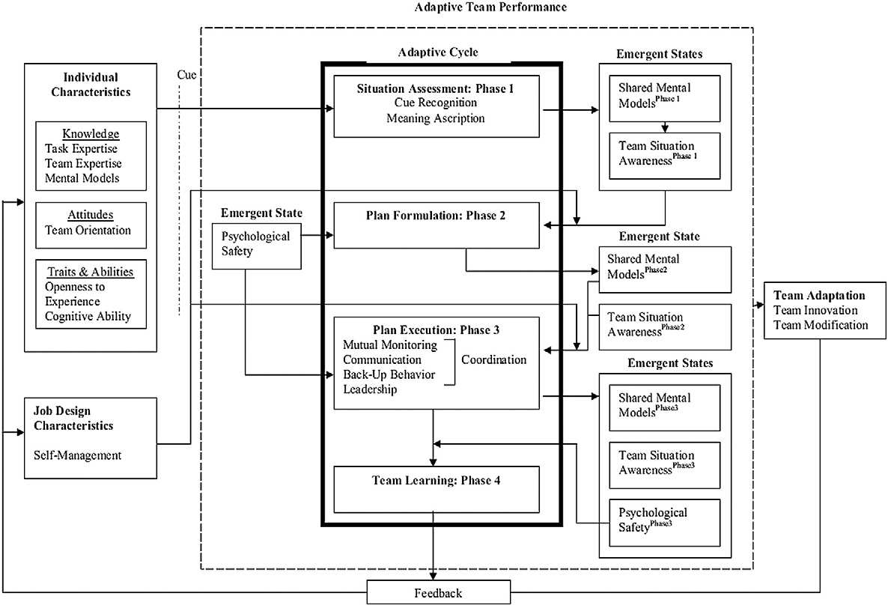

110 M.A. Rosen et al. / Human Resource Management Review 21 (2011) 107–122
and diagnose strengths and weaknesses. In the integration component, the team summarizes the lessons learned and develops a plan for integrating these lessons into the team's processes in future performance episodes.

M.A. Rosen et al. / Human Resource Management Review 21 (2011) 107–122 111

level representations are subsequently communicated to the team and can potentially be altered based on input from other team members (Cooke, Salas, Kiekel, & Bell, 2004).

112 M.A. Rosen et al. / Human Resource Management Review 21 (2011) 107–122
Sometimes a plan runs into unanticipated changes in the environment, and revisions must be made mid-execution to the existing strategy. This is known as reactive strategy planning (Marks et al., 2001), and it is the adjustment of strategies based on

M.A. Rosen et al. / Human Resource Management Review 21 (2011) 107–122 113

performance (Smith-Jentsch, Zeisig, Acton, & McPherson, 1998). Individually, team members analyze prior adaptability cycles for relevant information. As a group, members should discuss noted errors or near misses, which serve as diagnostic signs of larger

114 M.A. Rosen et al. / Human Resource Management Review 21 (2011) 107–122
and contribute during plan formulation. Psychological safety, while important in all phases, has particular weight in several processes within this model. For example, during plan development, if members feel like contributions will be valued, the

M.A. Rosen et al. / Human Resource Management Review 21 (2011) 107–122 115

Table 1
Behavioral markers of team adaptability.

116 M.A. Rosen et al. / Human Resource Management Review 21 (2011) 107–122
Table 1 (continued)
Team adaptability processes Markers Selected references

M.A. Rosen et al. / Human Resource Management Review 21 (2011) 107–122
Coordination: the orchestration of the sequence and timing of interdependent actions (Marks et al., 2001)
117

118 M.A. Rosen et al. / Human Resource Management Review 21 (2011) 107–122
assessment and plan execution phases. Situation assessment is an individual-level process of gathering information whereby at least one team member scans the environment for cues that have the potential to affect the success of the mission (Endsley, 1995;

M.A. Rosen et al. / Human Resource Management Review 21 (2011) 107–122 119

suited to capture member activities that are more covert in nature. Self-report scales of team learning behaviors have been developed as well (e.g., Edmondson, 1999). A communication content analysis would be appropriate for certain research

120 M.A. Rosen et al. / Human Resource Management Review 21 (2011) 107–122
5. Concluding remarks

M.A. Rosen et al. / Human Resource Management Review 21 (2011) 107–122 121

De Dreu, C. K. W., & Weingart, L. R. (2003). Task versus relationship conﬂict, team performance, and team member satisfaction: A meta-analysis. The Journal of Applied Psychology, 88, 741−749.
DeShon, R., Kozlowski, S., Schmidt, A., Milner, K., & Wiechmann, D. (2004). A multiple-goal, multilevel model of feedback effects on the regulation of individual and

122 M.A. Rosen et al. / Human Resource Management Review 21 (2011) 107–122
Stagl, K. C., Burke, C. S., Salas, E., & Pierce, L. (2006). Team adaptation: Realizing team synergy. In C. S. Burke, L. G. Pierce & E. Salas (Eds.), Understanding adaptability:
A prerequisite for effective performance within complex environments (pp. 117–141). Amsterdam: Elsevier.
Sundstrom, E., De Meuse, K. P., & Futrell, D. (1990). Work teams: Applications and effectiveness. The American Psychologist, 45(2), 120−133.

