**null – The Open Security Community**

null Community Chapter Model

**Prepared by: Pankaj Mouriya, null Community Manager**

<https://null.community>, @null0x00

## 

**Why do we need this? 3**

**Who can create a chapter? 3**

**Workflow Diagram of the new chapter model: 3**

**Detailed Information: 4**

Seed Chapters: 4

Incubated Chapters: 5

Graduated Chapters: 5

General Guidelines: 5

Mentors: 6

Celebrations/Recognition: 6

## 

## 

**Quick Note:** null is a community purely driven by volunteers and their availability. It is possible that some of these documents have not been updated, and processes may have changed over time. For example, the chapter creation process has evolved, with multiple steps being added or removed. Please reach out to **chapters@null.community** or **info@null.community** for clarification. If no response is received, kindly CC your query to **pankaj@null.community**.

## Why do we need this?

* The chapter model will be implemented in the null community to foster a more open and accessible community that encourages participation and collaboration among members.
* By providing a clear path for chapters to progress from a **Seed** chapter to an **Incubated** chapter, and ultimately to a **Graduated** chapter, we hope to empower members to take ownership of their local communities and to grow and develop their skills and knowledge.
* The chapter model will also help to showcase the diversity and strength of the null community to the broader public, and to attract new members who are interested in contributing to an open and inclusive community of like-minded individuals.

## Who can create a chapter?

* The null community welcomes anyone who is interested in starting a chapter and does not require any approvals or permissions to do so.
* Anyone can create a new chapter by following the guidelines and requirements outlined on the null community chapter creation page - https://null.community/pages/3-how-to-start-a-chapter
* The null community believes in the power of grassroots movements and wants to encourage members to take the initiative to start and grow their own local communities.
* By removing any barriers or dependencies on human approvals, the null community hopes to empower members to take action and contribute to the community in their own unique way.
* The null community recognizes that each chapter will have its own distinct culture and approach, and celebrates the diversity of perspectives and experiences that come with each new chapter.

## Workflow Diagram of the new chapter model:

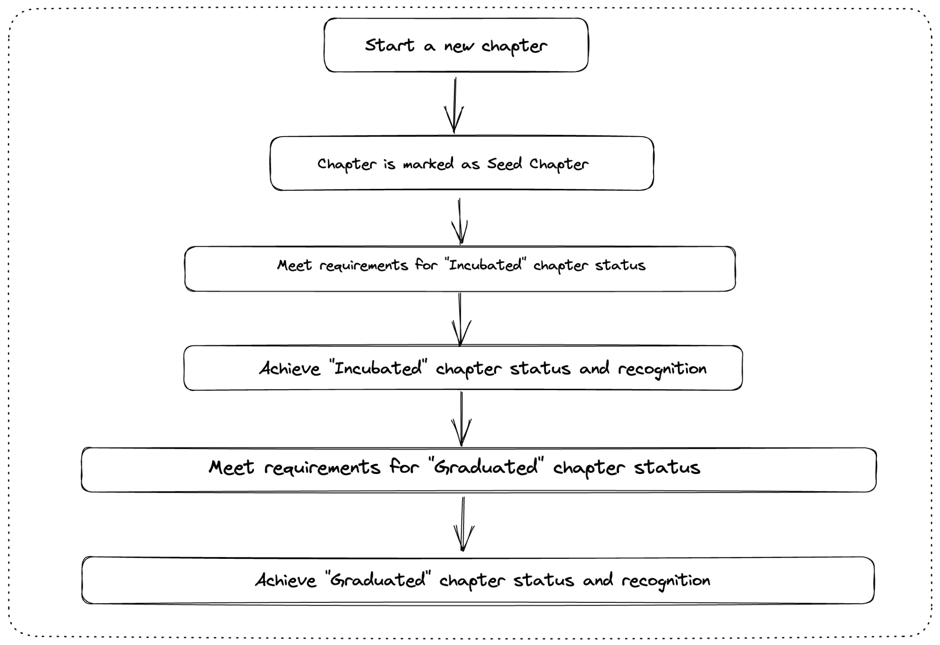

## Detailed Information:

### Seed Chapters:

1. Every new chapter will be a **Seed** chapter
2. At Least one chapter lead is required for chapter moderation
3. The chapter should adhere to null community’s code of conduct
4. There should not be another chapter in the same area.
5. The chapter should be open to all members of the null community and anyone who wants to be part of the chapter.

### Incubated Chapters:

1. To become an **Incubated chapter,** a Seed chapter should have conducted at least 3 events in the last 6 months.
2. The chapter should adhere to null community’s code of conduct
3. The chapter should be open to all members of the null community and anyone who wants to be part of the chapter

### Graduated Chapters:

1. To become a **Graduated** chapter, an Incubated chapter should be active for at least 9 months with minimum of 6 events
2. The chapter should have a minimum of 2 active Leadership who regularly conduct events and manage the chapter.
3. The leadership should not be from the same organization.
4. For at least 3 events, there should be an external contributor/speaker other than the leadership
5. The chapter should be open to all members of the null community and anyone who wants to be part of the chapter

### General Guidelines:

1. All chapters should have a clearly defined purpose and goal that aligns with the values of the null community.
2. Chapters should hold regular meetings and events.
3. Chapters should have a code of conduct that is aligned with the values of the null community.
4. Chapters should be open and welcoming to new members and contributors.
5. Chapters should share their knowledge and resources with the wider null community via the null blog posts.
6. All members of the null community are encouraged to participate in any chapter of their choice.
7. A chapter will be removed from the list of active chapters after consecutive 6 months of inactivity
8. Chapters are free to conduct creative experiments for different events, however any experiment conducted by the chapter should be shared with the wider moderators community
9. Any chapter/leadership found violating the community’s code of conduct will be deactivated

### Mentors:

1. Seed chapters can request a mentor who is an experienced member of the null community/has been a chapter leader. Although this can not be guaranteed but is an option
2. The mentor will provide guidance and support to the **Seed** chapters to help them meet the criteria for becoming an **Incubated** chapter.
3. The mentor will provide feedback and advice to the **Incubated** chapter to help them meet the criteria for becoming a **graduated** chapter.

### Celebrations/Recognition:

1. Chapters that meet the criteria for becoming an Incubated or Graduated chapter will be celebrated by the null community by making a public announcement and sharing the same over the internet through null social media handles
2. Celebrations may include recognition on the null community website
3. Graduated chapters will have access to all of the resources and benefits provided by the null community if any introduced in future
4. All members of the null community are encouraged to celebrate the achievements of each chapter
5. Chapter leaders of Incubated/graduation are eligible for obtaining a certificate of contribution to null community

What is not accepted?

1. No live hacking session or any activity can be performed beyond the law of the land.
2. For events that require an internet connection, we recommend using a personal hotspot. Campus internet should only be used after obtaining written permission from the authorities/E-Governance department in the campus, and this written permission should be shared over email.
3. Physical, verbal, sexual harassment, or offensive behavior of any kind during chapter events/meetups will not be tolerated, and chapter leaders are expected to take immediate action in such cases.
4. Chapter leadership should maintain professional and personal boundaries. Any form of personal relationship—whether public or private—between leaders or within the leadership team is discouraged, as it can lead to conflicts of interest or affect the chapter's functioning. Leaders should ensure the focus remains on fostering a collaborative and inclusive community atmosphere.