schedulers
A scheduler is an application designed to manage and automate the execution of background programs or jobs at designated times, eliminating the need for manual intervention. Schedulers are utilized to handle tasks that must be performed regularly or at specific times, ensuring efficient resource management. They play a vital role in controlling background program execution, often referred to as batch processing. By automating these tasks, schedulers enhance efficiency, optimize workload management, and contribute to overall system stability.

Key Features of Schedulers

Job Scheduling
A job consists of a sequence of instructions or commands that the scheduler carries out. Each job may have a priority, meaning higher-priority jobs are executed before others, and some jobs can be dependent on the completion of others. For instance, you might schedule a daily job to back up a database at 3 AM when server activity is lower.

Job Prioritization
Jobs can be assigned varying levels of priority, which ensures that more critical tasks are addressed first. For example, an emergency patch deployment would be a high-priority job, whereas cleaning up log files might be categorized as lower priority.

Job Dependencies
Certain jobs may need to wait for others to finish before they can begin execution. For example, a report generation job should only run after the data aggregation job has successfully completed.

Recurrence Scheduling
A significant feature of many schedulers is their ability to handle repetitive tasks. Recurrence schedules specify how often a job should run, whether it’s every minute, hourly, daily, or weekly. For example, you could configure a scheduler to execute a maintenance script every Sunday at midnight.

Example of a Scheduler: Cron
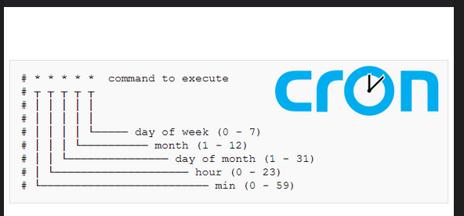

Cron Scheduler on Unix
Cron is a built-in time-based job scheduler in Unix-like operating systems. It automates the execution of scripts or commands at specified intervals, allowing users to run tasks in the background without manual intervention.

How Cron Works
Cron uses a configuration file called a crontab (short for "cron table") to define the schedule for jobs. Each user can have their own crontab file, and there is also a system-wide crontab.

Crontab Syntax
Each line in a crontab file follows a specific syntax:
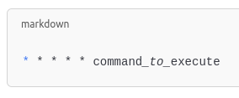

The five asterisks represent:
- Minute: (0 - 59)
- Hour: (0 - 23)
- Day of the Month: (1 - 31)
- Month: (1 - 12)
- Day of the Week: (0 - 7) (where both 0 and 7 represent Sunday)

Example Job
Let's say you want to create a job that backs up a directory to a remote server every day at 3:15 AM. Here’s how you would set that up:
- Open the crontab file for editing. You can do this by typing the following command in your terminal:

crontab -e

- Add the following line to the crontab file:
15 3 * * * /path/to/backup_script.sh
This line means:
- 15: At the 15th minute
- 3: During the 3rd hour (3 AM)
- *: Every day of the month
- *: Every month
- *: Every day of the week

- Save and exit the editor. The cron service will automatically recognize the new job.

Breakdown of the Example
- The command /path/to/backup_script.sh is the script that will be executed at the specified time. This script could contain commands to copy files from your directory to a backup location.
- Cron will run this script every day at 3:15 AM, ensuring that your backup happens automatically without needing to remember or initiate it manually.
Checking Cron Jobs

To see all scheduled cron jobs for your user, you can run:
crontab -l

Conclusion
Cron is a powerful tool for automating repetitive tasks in Unix-like systems. By using crontab, users can easily schedule jobs to run at specific times, improving efficiency and ensuring that important tasks are completed regularly.

Embedded Schedulers
Aside from operating system schedulers like Cron, applications can include their own embedded schedulers. This is useful in enterprise-level systems or microservices, where scheduling tasks within the application itself allows for tighter integration with business logic.
Example: Spring Task Scheduler
In Java, frameworks like Spring provide tools for embedding a scheduler directly into the application.
@Scheduled(cron = "0 0 12 * * ?")
public void generateReport() {
// Code to generate a report
}
- Use Cases: This is common in applications that require background tasks, like a web application that sends newsletters or processes data in the background.
- Benefits: Embedded schedulers allow developers to have more control over task execution and can be optimized for the specific application’s needs.
- Java Example: Quartz Scheduler
- Quartz is a popular Java-based scheduler that can be embedded in any Java application. It allows for creating complex job schedules and managing dependencies within the application.
- Example:

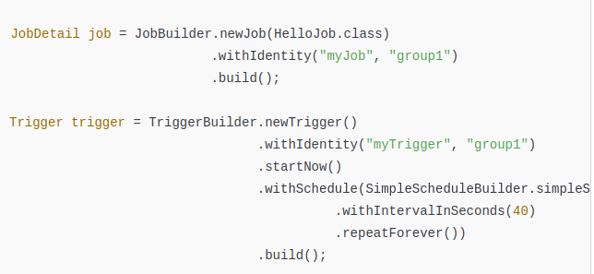
This code schedules a job that runs every 40 seconds indefinitely.

Importance of Schedulers
- Efficiency: Schedulers optimize resource usage by ensuring that jobs run when the system is least busy or when resources are available, reducing idle time.
- Automation: They eliminate the need for manual intervention, allowing tasks to run automatically, which saves time and reduces human error.
- Reliability: By managing job execution and dependencies, schedulers ensure that critical tasks are completed on time, contributing to the overall reliability of systems.
- Flexibility: Users can easily modify job schedules and parameters, enabling dynamic responses to changing needs and priorities.

