Student: Amir Yakubov.

Group: IA-2002.

Assignment 5.

**Practice task 1.**

Create "Shipping service" and «Package» tables, including all of their columns, data types, and constraints. Make sure to create the foreign key constraint. Note that columns with bold are NOT NULL constraints. The following tasks 1-3 will be based on given data. Fill data in each table, at the least 5 records.

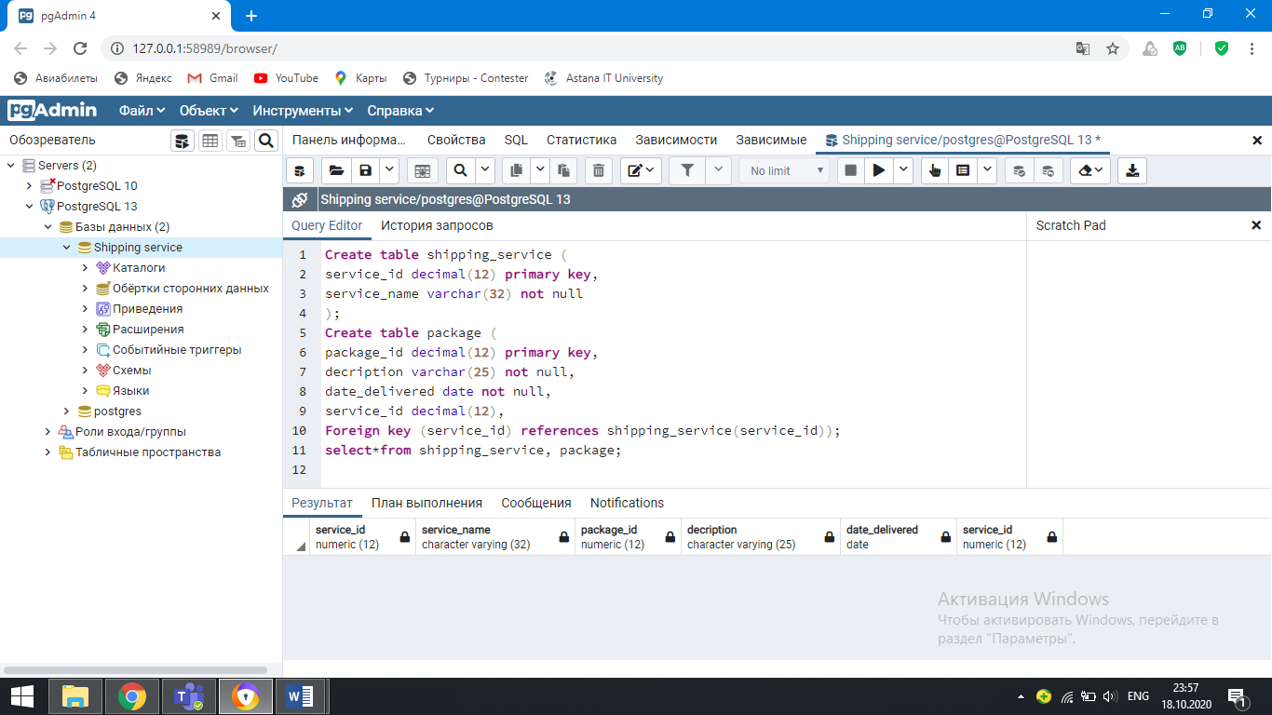

**Practice task 2.**

1. Write a SQL statements to rename the tables “package” to “package new” and “shipping_service” to ”shipping services”.

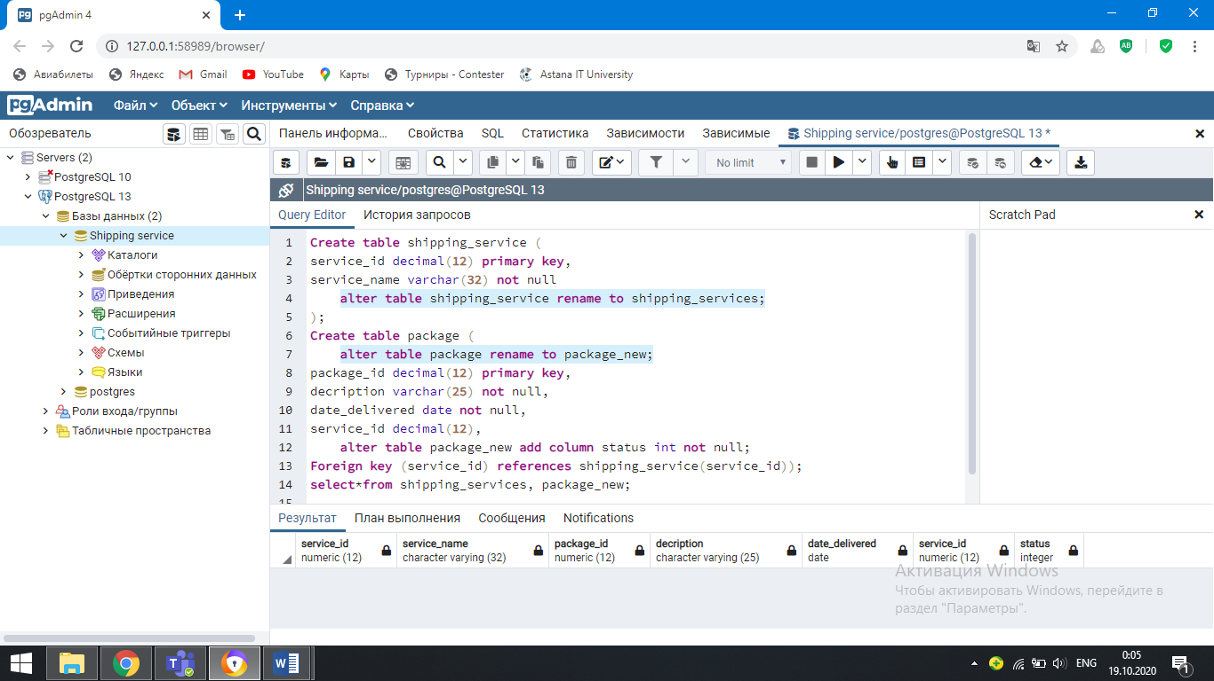

b. Write a SQL statement to add a column “status (INT)” to the table package.

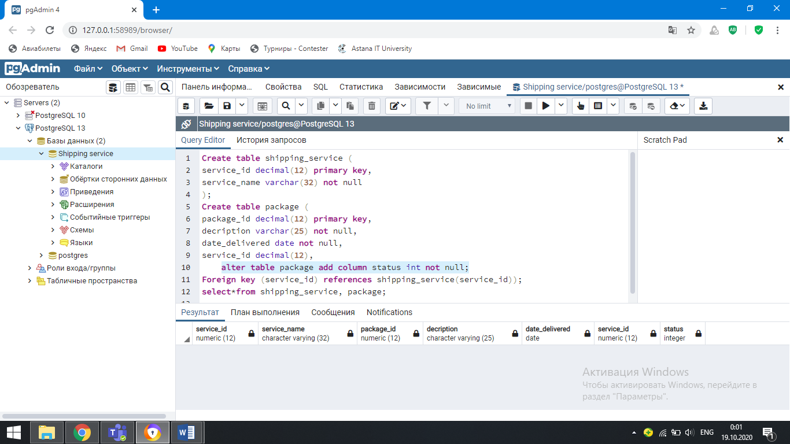

**Practice task 3.**

1. Write a SQL statement to change the data type of the column “status” to VARCHAR.

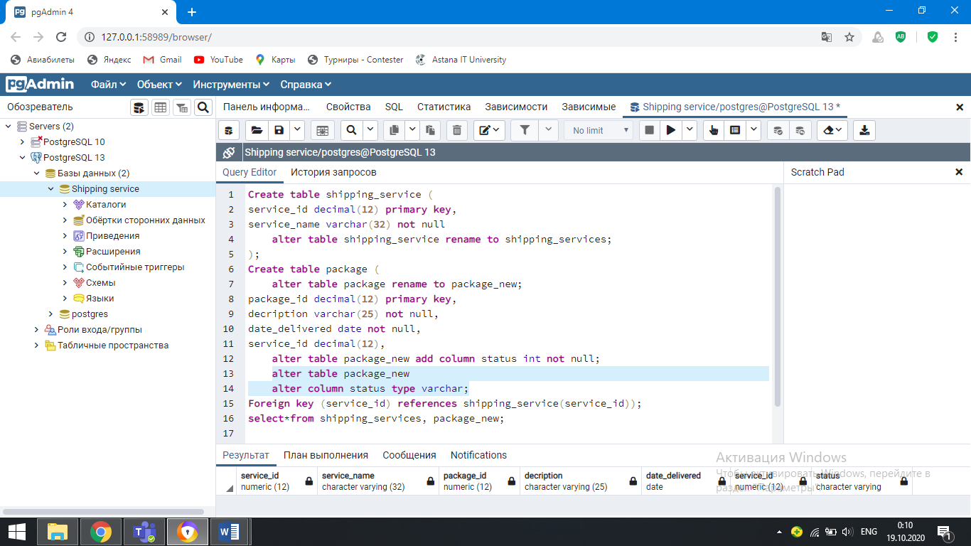

1. Write a SQL statement to drop the table “package”. Take the screenshot of the execution. Why the step b is failed? Please, explain.

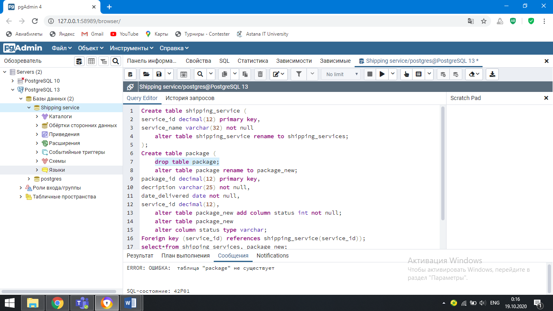

I cannot delete because the "package" table does not exist.

**Practice task 4.**

a. Create a table Employee including all columns and data types as well as fill it.

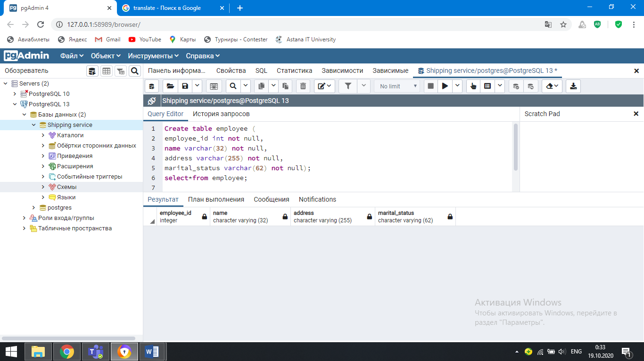

b. Write a SQL statement to add a PK for the column employee_id.

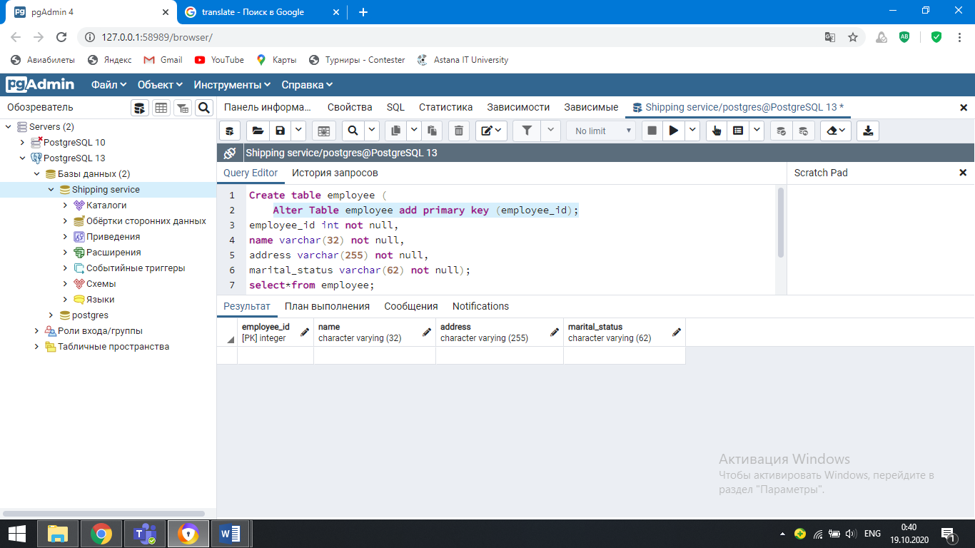

c. Write a SQL statement to add a column “gender” to the table employee.

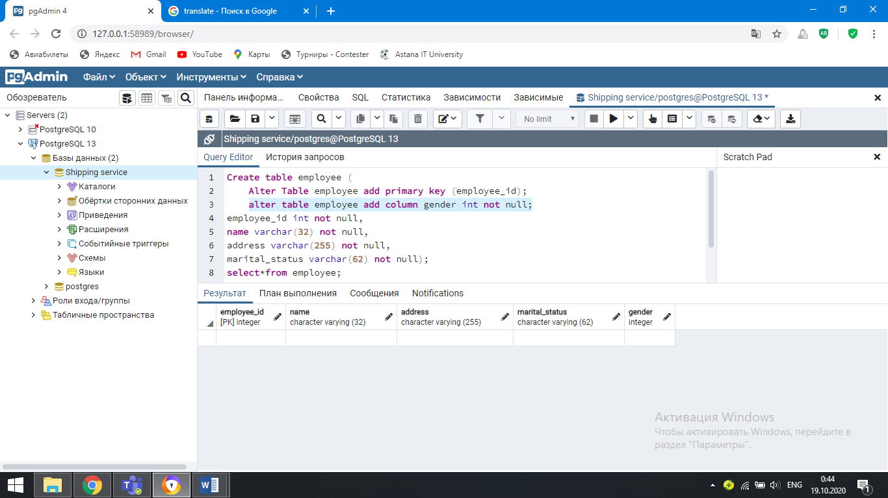

d. Write a SQL statement to drop the column “address” from the table.

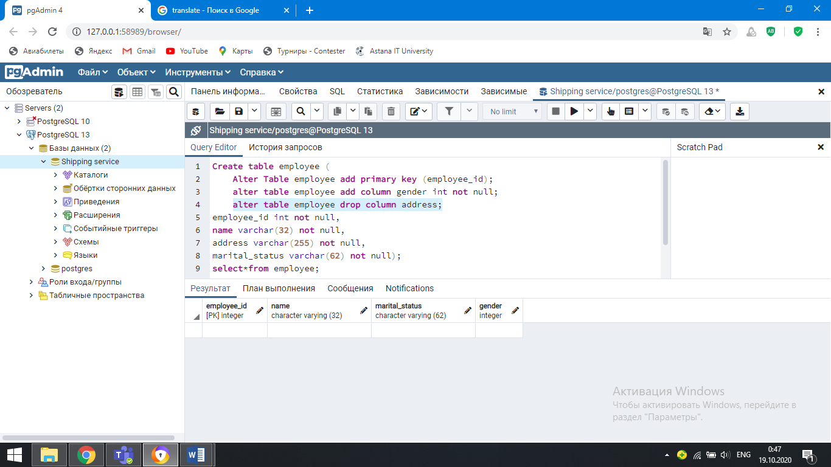

e. Write a SQL statement to remove the whole table.

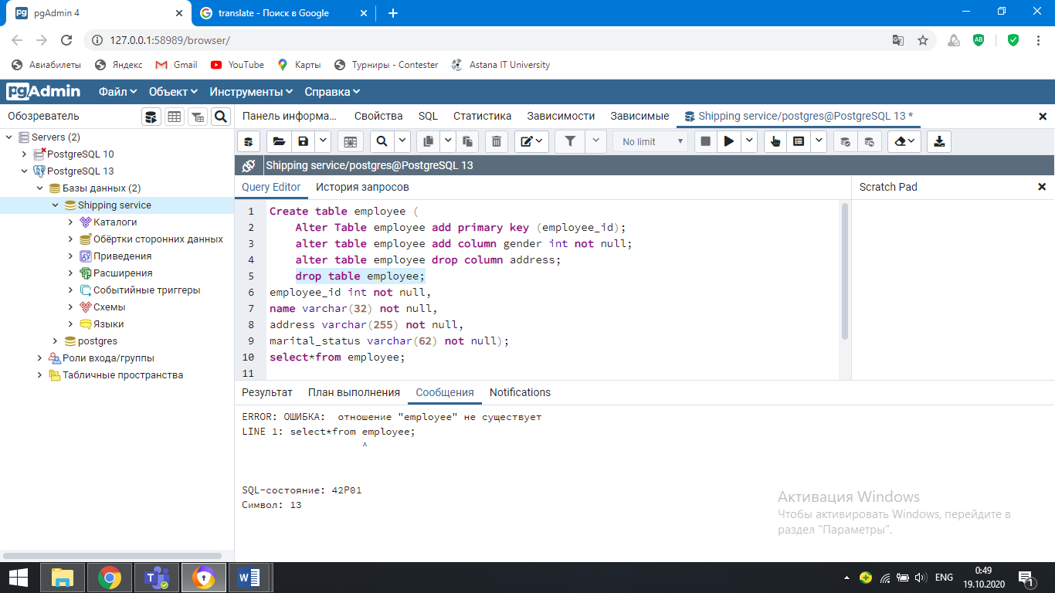

**Practice task 5.**

Create two tables that will store data about salary’s range regarding to all positions in Company X, and another table that will store data about all employees assigned for those positions within working period (start and end date) for that company. For the given scenario above, please

a. Create table(s) to logically organize the given data including all columns and data types. Fill the tables with 5 records.

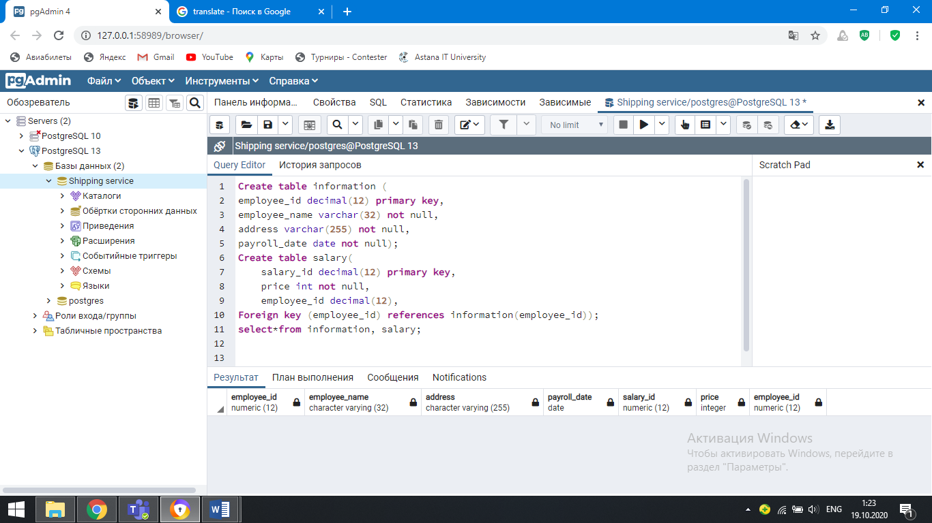

b. Write a SQL statement to assign PK where its applicable.

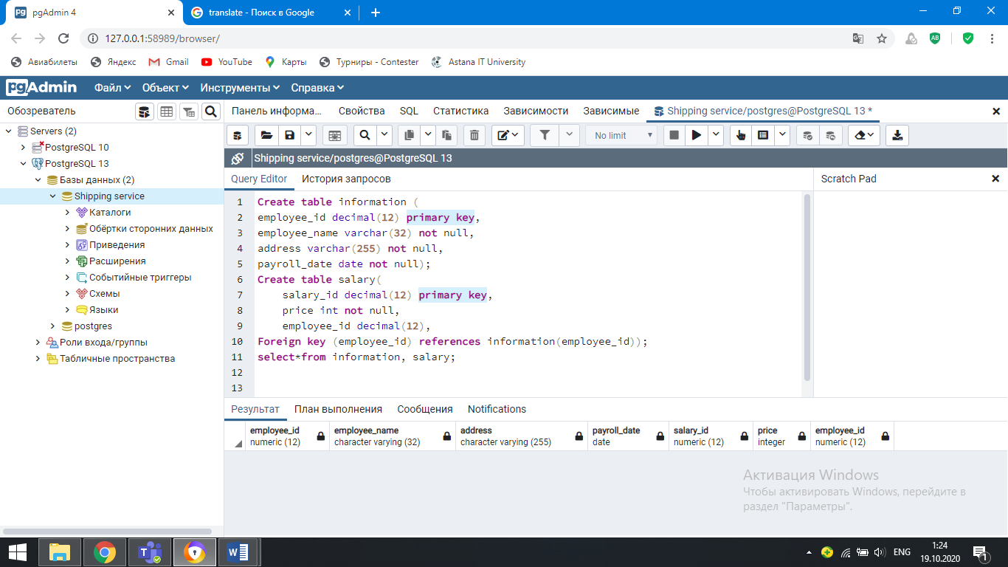

c. Write a SQL statement to assign FK, so that those tables are logically could be related.

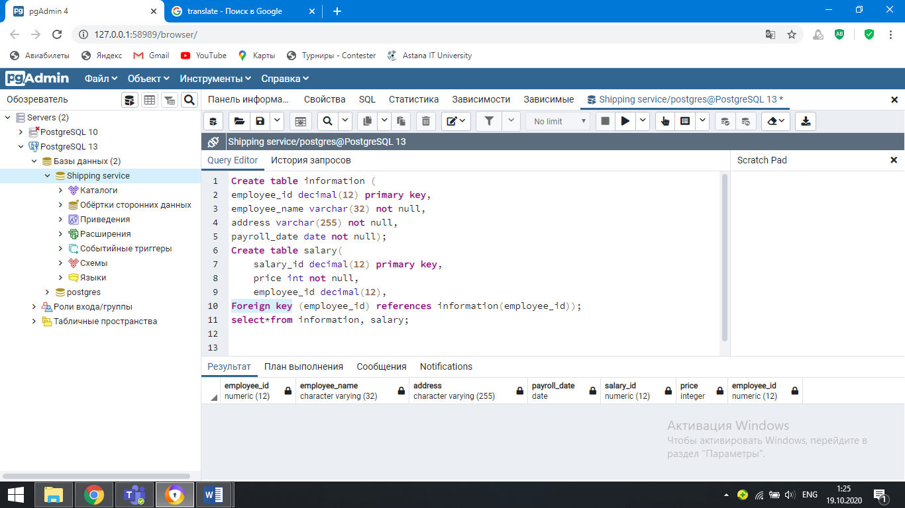

d. Write a SQL statement to rename one of the tables.

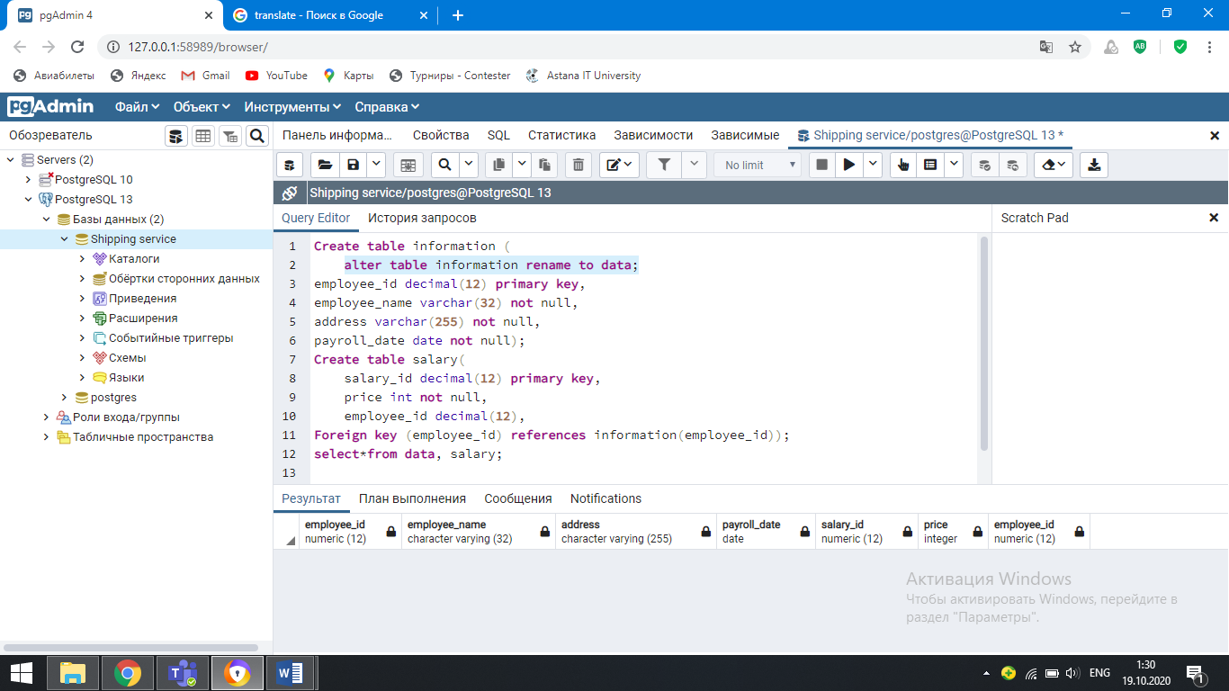

e. Write a SQL statement to add NOT NULL constraint to all possible columns.

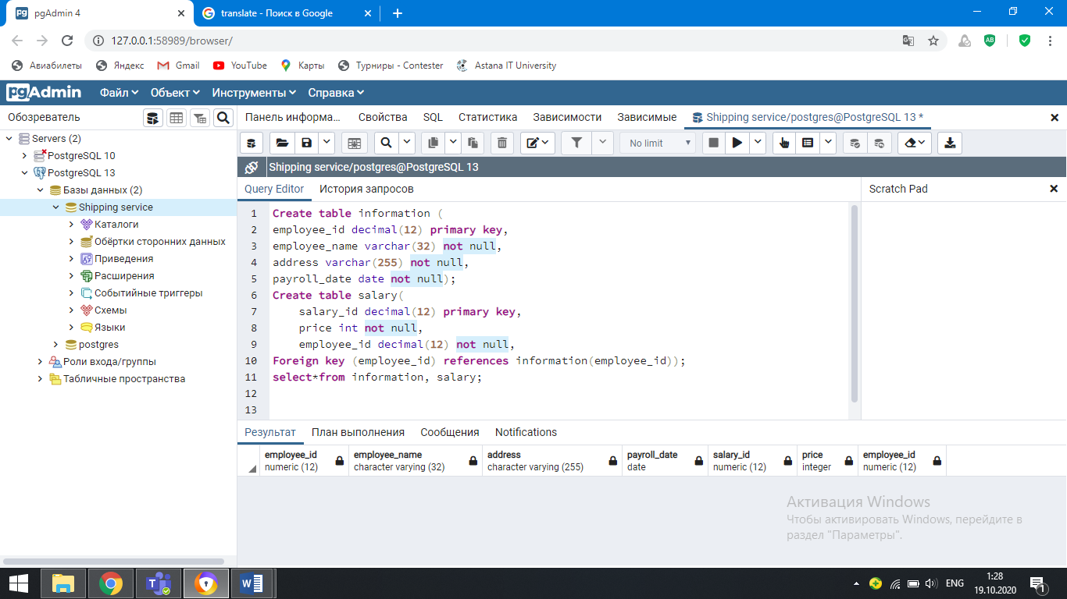

**Practice task 6.**

a. Write a SQL statement to drop table 1.

1. Sреcifу thе nаmе оf thе tаblе tо bе rеmоvеd.
2. Sреcifн thе nаmе оf thе dаtаbаsе in whiсh thе tаblе wаs crеаtеd аnd thе nаmе оf thе schеmа tо whiсh thе tаblе bеlоngs. Thе dаtаbаsе nаmе is оptiоnаl. If yоu skiр it, thе DROP TABLE stаtеmеnt will drор thе tаblе in thе currеntlу cоnnеctеd dаtаbаsе.
3. Usе IF EXIST clausе tо rеmovе thе tablе only if it еxists. If yоu rеmоvе а tаblе thаt dоes nоt еxist, yоu will gеt аn еrrоr. Thе IF EXIST clause conditionаllу rеmоves thе tаble if it аlreadу еxists.

b. Write a SQL statement to drop table 2.

The same as in а. We need to write alter table (name of the table to be deleted).