Quiz.

A PL/SQL block must consist of the following three sections:

• A Declarative section, which begins with the keyword DECLARE and ends when the executable section starts.

• An Executable section, which begins with the keyword BEGIN and ends with END.

• An Exception handling section, which begins with the keyword EXCEPTION and is nested within the executable section.

Answer: False.

Practice 2.

4)

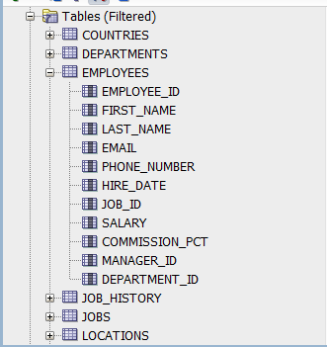

6)

Practice 3.

1. No correct answer. (If there is, I think is D)

SET SERVEROUTPUT ON

BEGIN

dbms_output.put_line(‘Hello World.');

END;

/