Answer: True.

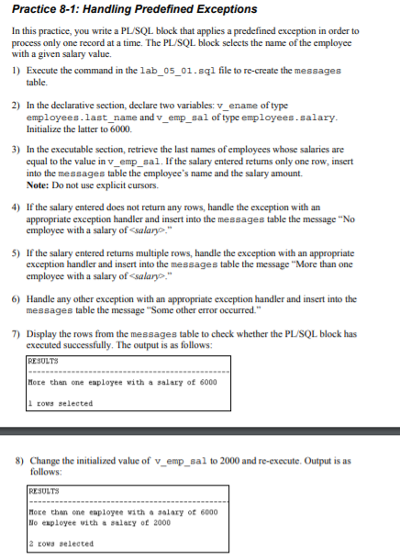

1,2)

DECLARE

v_ename employees.last_name%TYPE;

v_emp_sal employees.salary%TYPE := 6000;

3)

BEGIN

select last_name into v_ename from employees

where salary = v_emp_sal;

insert into messages(my_results)

values (v_ename || ' - ' || v_emp_sal);

4)

when no_data_found

then insert into messages(my_results)

values ('No employee with a salary of ' || to_char(v_emp_sal));

5)

when too_many_rows

then insert into messages(my_results)

values ('More than one employee with a salary of ' || to_char(v_emp_sal));

6)

when others

then insert into messages(my_results)

values ('Some other error occurred.'); END;

7)

select * from messages;

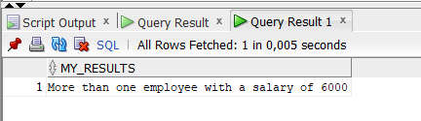

8)

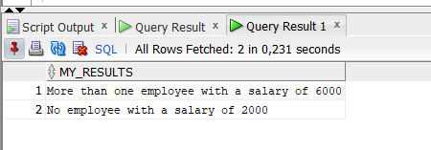

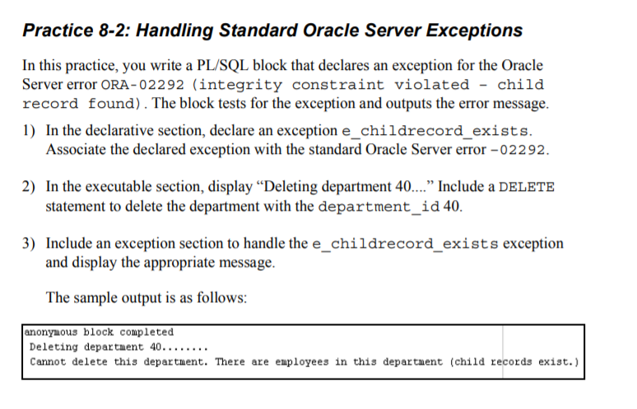

1)

DECLARE

e_childrecord_exists EXCEPTION;

PRAGMA EXCEPTION_INIT(e_childrecord_exists, -02292);

2)

BEGIN

DBMS_OUTPUT.PUT_LINE('Deleting department 40.....');

delete from departments where department_id = 40;

3)

EXCEPTION

when e_childrecord_exists

then DBMS_OUTPUT.PUT_LINE(' Cannot delete this department. There are employees in this departments (child recoord exists.)');

END;

