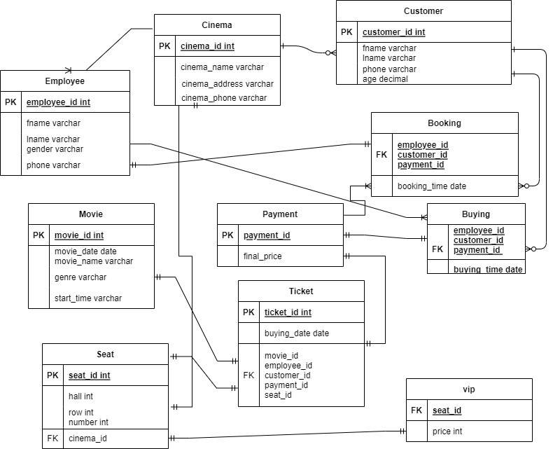

The ERD diagram of Cinema Database.

**Steps of creation.**

**Step 1.** First of all I created ‘Cinema’ table which have its own id, name, address, phone. Then 2 table emanate: customer and employee. Customer have his own id, first name, last name, phone number and age. And employee have own id, first name, last name, gender and phone.

**Step 2.** The client can make a reservation. The customer order table links to the ‘Booking’ table. The “booking” table has data such as booking time and all information about movie, and employee who accepted the order through foreign keys and finally getting total price.

**Step 3.** If customer came to cinema and wants buy ticket immediately, he also have information about movie and employee, and after payment – getting ticket through payment_id keys.

**Step 4.** About movie table, here we have information about his name, date, genre, start and end times.

**Step 5.** Now the “ticket” table. It has its own id, buying date, employee information, customer_id, payment_id, seat_id.

**Step 6.** ‘Seat table’ have hall, row and number of seat, also in which cinema.

**Step 7.** ‘Vip’ table talking about vip seats, and his price.

**Step 8.** And last remaining table is ‘payment’. In this table we store information about final total prices.

1. **Using the join to query the customers who bought the most expensive tickets:**

select fname, lname, final_price

from customer

inner join booking

on customer.customer_id=booking.customer_id

inner join payment

on payment.payment_id=booking.payment_id

where payment.final_price>5000;

1. **Movie which titles starts with letter A:**

select*from movie

where movie_name like 'A%';

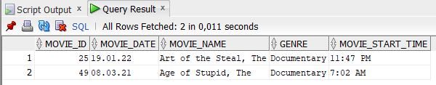

1. **Movies released in 2020:**

select buying_date, movie_name

from ticket

inner join movie

on movie.movie_id=ticket.movie_id

where buying_date between '01-01-2020' and '01-01-2021';

1. **Child rate (customers under 18 years of age):**

select fname, lname, age

from customer

where age < 18;

1. **Male workers:**

select fname, lname

from employee

where gender = 'Male'

1. **All data where client id = 7:**

select * from ticket

inner join movie

on movie.movie_id=ticket.movie_id

where customer_id = 7;



1. **3 minimum prices of the vip seat:**

select seat_id, price

from vip

order by price asc

fetch first 3 rows only;

1. **Most popular genres in descending order:**

select count(*) as quantity, genre

from movie

group by genre

order by quantity desc;

1. **Customer, employee first names, final price where booking date is 7th April of 2021:**

select customer.fname c_fname, employee.fname e_fname, final_price, booking_time

from customer

inner join booking

on customer.customer_id=booking.customer_id

inner join employee

on employee.employee_id=booking.employee_id

inner join payment

on payment.payment_id=booking.payment_id

where booking_time = '07-04-2021';

1. **Counting customers by hall:**

select count(*) as quantity, hall

from seat

group by hall

order by quantity desc;

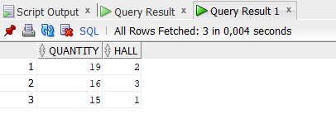

Descriptions:

* INSERT is an SQL statement that allows you to add rows to a table by filling them with values. Values ​​can be inserted by enumeration using the word values ​​and enumerating them in parentheses, separated by commas, or by using the select statement.
* WHERE is an SQL statement that specifies that a data management language statement should only act on records that meet certain criteria.
* The SQL ORDER BY statement sorts the output values. The SQL ORDER BY statement can be applied to both numeric and string columns.
* The SQL GROUP BY clause is used to combine the results of a selection on one or more columns. This query uses the SQL AS statement to specify a new column name.
* The LIKE operator is used in a WHERE clause to search for a specified pattern in a column. There are two wildcards often used in conjunction with the LIKE operator: The percent sign (%) represents zero, one, or multiple characters
* JOIN is an operator of the SQL language, which is an implementation of the operation of joining tables by their foreign key.
* The COUNT() function returns the number of rows that matches a specified criterion

Procedures:

1. **Procedure that showing movies released in 2020.**

create procedure movies2020()

language plpgsql

as $$

declare m2020 record;

begin

for m2020 in

select buying_date, movie_name

from ticket

inner join movie

on movie.movie_id=ticket.movie_id

where buying_date between '01-01-2020' and '01-01-2021'

loop

raise notice 'Movies released in 2020. Date: %, movie title: %', m2020.buying_date, m2020.movie_name;

end loop;

end;$$;

1. **A procedure that shows all data about customer with an input id.**

create procedure cust_info(

input_id int

)

language plpgsql

as $$

declare cust_info record;

begin

for cust_info in

select * from ticket

inner join movie

on movie.movie_id=ticket.movie_id

where customer_id = input_id

loop

raise notice 'All information: %', cust_info;

end loop;

end;$$;

Example with id = 7:

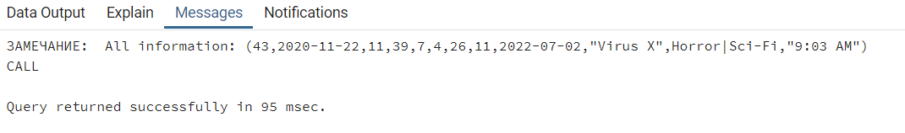

1. **A procedure that shows all data by input date.**

create or replace procedure by_date()

language plpgsql

as $$

declare info_by_date record;

begin

for info_by_date in

select customer.fname, employee.fname, final_price, booking_time

from customer

inner join booking

on customer.customer_id=booking.customer_id

inner join employee

on employee.employee_id=booking.employee_id

inner join payment

on payment.payment_id=booking.payment_id

where booking_time = '07-04-2021'

loop

raise notice '%', info_by_date;

end loop;

end;$$;

1. **A procedure that shows male workers.**

create procedure male()

language plpgsql

as $$

declare male record;

begin

for male in

select fname, lname

from employee

where gender = 'Male'

loop

raise notice 'Male workers. First name: %, last name: %', male.fname, male.lname;

end loop;

end;$$;

1. **A procedure that shows popularity of genres in descending order.**

create procedure popular_genres()

language plpgsql

as $$

declare pg record;

begin

for pg in

select count(*) as quantity, genre

from movie

group by genre

order by quantity desc

loop

raise notice '%', pg;

end loop;

end;$$;

Cursor that shows the data the name of the client, employee, final price by date, in the example I used the date 7-04-2021

Cursors:

**Cursor that shows the data: the first name of the customer, employee, final price by date, in the example I used the date 07-04-2021.**

SET SERVEROUTPUT ON

DECLARE

CURSOR by_date IS

select customer.fname, employee.fname, final_price, booking_time

from customer

inner join booking

on customer.customer_id=booking.customer_id

inner join employee

on employee.employee_id=booking.employee_id

inner join payment

on payment.payment_id=booking.payment_id

where booking_time = '07-04-2021';

cfn customer.fname%TYPE;

efn employee.fname%TYPE;

fp payment.final_price%TYPE;

bt booking.booking_time%TYPE;

BEGIN

OPEN by_date; LOOP

FETCH by_date INTO cfn, efn, fp, bt;

EXIT WHEN by_date%NOTFOUND;

DBMS_OUTPUT.PUT_LINE('Customers first name: '|| cfn || ',

Employees first name:' || efn || ',

Final price:' || fp || ',

Booking time:' || bt);

end loop; close by_date; end;

**Cursor that shows the data the buying date and movie title in 2020.**

SET SERVEROUTPUT ON

DECLARE

CURSOR movies2020 IS

select buying_date, movie_name

from ticket

inner join movie

on movie.movie_id=ticket.movie_id

where buying_date between '01-01-2020' and '01-01-2021';

bd ticket.buying_date%TYPE;

mn movie.movie_name%TYPE;

BEGIN

OPEN movies2020; LOOP

FETCH movies2020 INTO bd, mn;

EXIT WHEN movies2020%NOTFOUND;

DBMS_OUTPUT.PUT_LINE('Buying date: ' || bd || ', movie title: ' || mn);

end loop; close movies2020; end;

Triggers:

**The trigger shown in this example saves information about the current user in that row whenever a row is added or changed. In addition, it requires that the employee's name be provided:**

CREATE FUNCTION check_customer() RETURNS trigger AS $check_customer$

BEGIN

IF NEW.fname IS NULL THEN

RAISE EXCEPTION 'fname cannot be null';

END IF;

RETURN NEW;

END;

$check_customer$ LANGUAGE plpgsql;

CREATE TRIGGER check_customer BEFORE INSERT OR UPDATE ON customer

FOR EACH ROW EXECUTE PROCEDURE check_customer();

**The trigger shown in this example ensures that any addition, change, or deletion of a row in the customer table is committed to the changes table:**

CREATE OR REPLACE FUNCTION changes() RETURNS TRIGGER AS $changes$

BEGIN

IF (TG_OP = 'DELETE') THEN

INSERT INTO customer SELECT 'D', now(), user, OLD.*;

RETURN OLD;

ELSIF (TG_OP = 'UPDATE') THEN

INSERT INTO customer SELECT 'U', now(), user, NEW.*;

RETURN NEW;

ELSIF (TG_OP = 'INSERT') THEN

INSERT INTO customer SELECT 'I', now(), user, NEW.*;

RETURN NEW;

END IF;

RETURN NULL;

END;

$changes$ LANGUAGE plpgsql;

CREATE TRIGGER changes

AFTER INSERT OR UPDATE OR DELETE ON customer

FOR EACH ROW EXECUTE PROCEDURE changes();

