Student: Amir Yakubov

Group: BD-2008

Assignment 4.

1. Write a SQL query to count the number of patients who booked an appointment after 2nd of October, 2018. (5 points).

do $$  
 declare  
 pat_id appointment.patient_id%type;  
 begin  
 select count(patient_id)  
 into pat_id  
 from appointment  
 where appointment_date > '2018-10-02';  
 raise notice 'Number of patients who booked an appointment after "2018-10-02": %', pat_id;  
end;$$;

1. Write an SQL statement to find the doctors that work in less than two hospitals.(5 points).

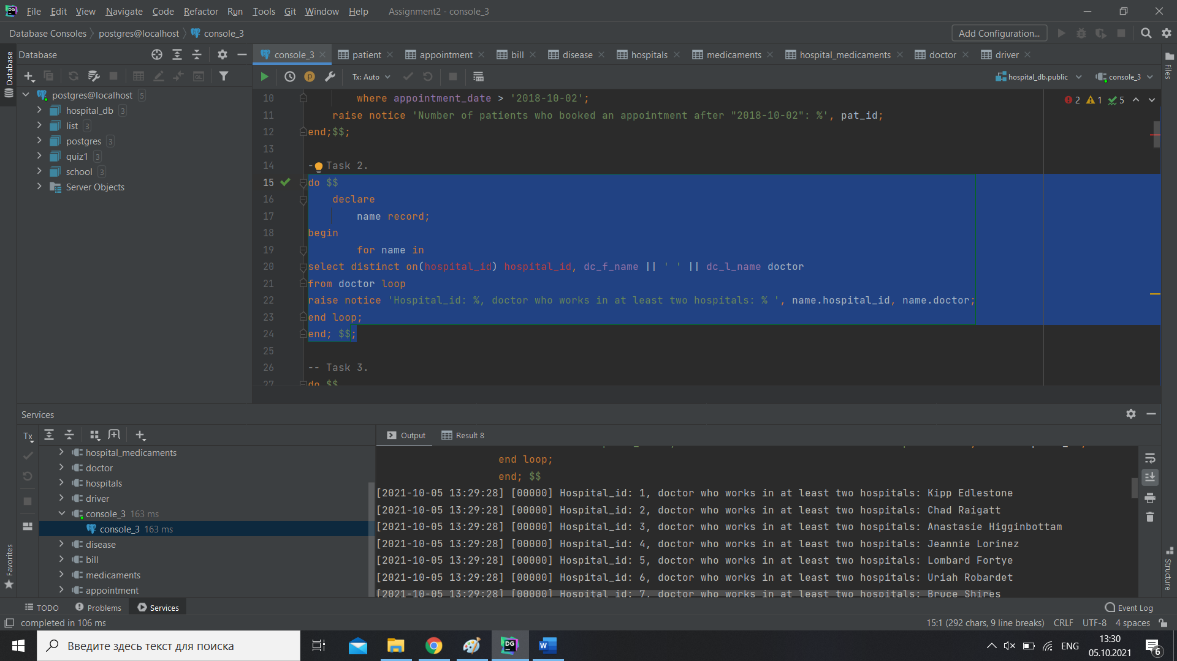

do $$  
 declare  
 name record;  
begin  
 for name in  
select distinct on(hospital_id) hospital_id, dc_f_name || ' ' || dc_l_name doctor  
from doctor loop  
raise notice 'Hospital_id: %, doctor who works in at least two hospitals: % ', name.hospital_id, name.doctor;  
end loop;  
end; $$;

1. Write a SQL query to find the patients with their doctors by whom they got their treatment.(10 points).

do $$  
 declare  
 al record;  
begin  
for al in  
select ptn_f_name, ptn_l_name, dc_f_name, dc_l_name  
from patient  
inner join appointment  
on patient.patient_id = appointment.patient_id  
inner join doctor  
on appointment.doctor_id = doctor.doctor_id  
where appointment_id > 0 loop  
raise notice 'Patient % % got their treatment with doctor: % %', al.ptn_f_name, al.ptn_l_name, al.dc_f_name, al.dc_l_name;  
end loop;  
end; $$;

1. Write a SQL query to count number of unique patients who got an appointment.(5 points).

do $$  
 declare  
 unique_patients appointment.patient_id%type;  
 begin  
 select count(DISTINCT appointment.patient_id)  
 into unique_patients  
 from appointment;  
 raise notice 'Number of unique patients who got an appointment: %', unique_patients;  
end;$$;

1. Write a SQL query to find those patients who taken the appointment on the “2008-04-09”. (5 points).

do $$  
 declare  
 pat record;  
begin  
 for pat in  
select ptn_f_name, ptn_l_name  
from patient  
inner join appointment  
on patient.patient_id = appointment.patient_id  
where appointment_date = '2008-04-09' loop  
raise notice 'Patient who taken the appointment on the “2008-04-09”: % %', pat.ptn_f_name, pat.ptn_l_name;  
end loop;  
end; $$;

1. Write a SQL query to find the appointment that have the largest bill paid by patient. (5 points).

do $$  
 declare  
 largest record;  
begin  
 for largest in  
select bill_price  
from bill  
inner join appointment  
 on bill.bill_id = appointment.bill_id  
 where bill_price = (select max(bill_price) from bill) loop  
raise notice 'The largest bill paid by patient: %', largest.bill_price;  
end loop;  
end; $$;

1. Write a SQL query to find the doctor f_name and doctor l_name working in each hospital. (5 points).

do $$  
 declare  
 each record;  
begin  
for each in  
select dc_f_name, dc_l_name, hospital_name  
from doctor  
inner join hospitals  
on hospitals.hospital_id = doctor.hospital_id  
where doctor.doctor_id > 0 loop  
raise notice 'Doctor % % working in % hospital', each.dc_f_name, each.dc_l_name, each.hospital_name;  
end loop;  
end; $$;

1. Write a SQL query to find all doctors who treat “COVID-19”. (10 points).

do $$  
 declare  
 drs record;  
begin  
for drs in  
select dc_f_name, dc_l_name  
from doctor  
inner join appointment  
on doctor.doctor_id = appointment.doctor_id  
inner join disease  
on appointment.disease_id = disease.disease_id  
where disease_name = 'COVID-19' loop  
raise notice '% % treats "COVID-19"', drs.dc_f_name, drs.dc_l_name;  
end loop;  
end; $$;

1. Write a SQL query to find all doctors who doesn’t have an appointment on date “2018-06-25”. (5 points).

do $$  
 declare  
 doc record;  
begin  
 for doc in  
select dc_f_name, dc_l_name  
from doctor  
inner join appointment  
on doctor.doctor_id = appointment.doctor_id  
where appointment_date != '2018-06-25' loop  
raise notice 'Doctors who doesn’t have an appointment on date "2018-06-25" % %', doc.dc_f_name, doc.dc_f_name;  
end loop;  
end; $$;

1. Write a SQL query to find the driver f_name driver l_name working in each ambulance. (5 points).

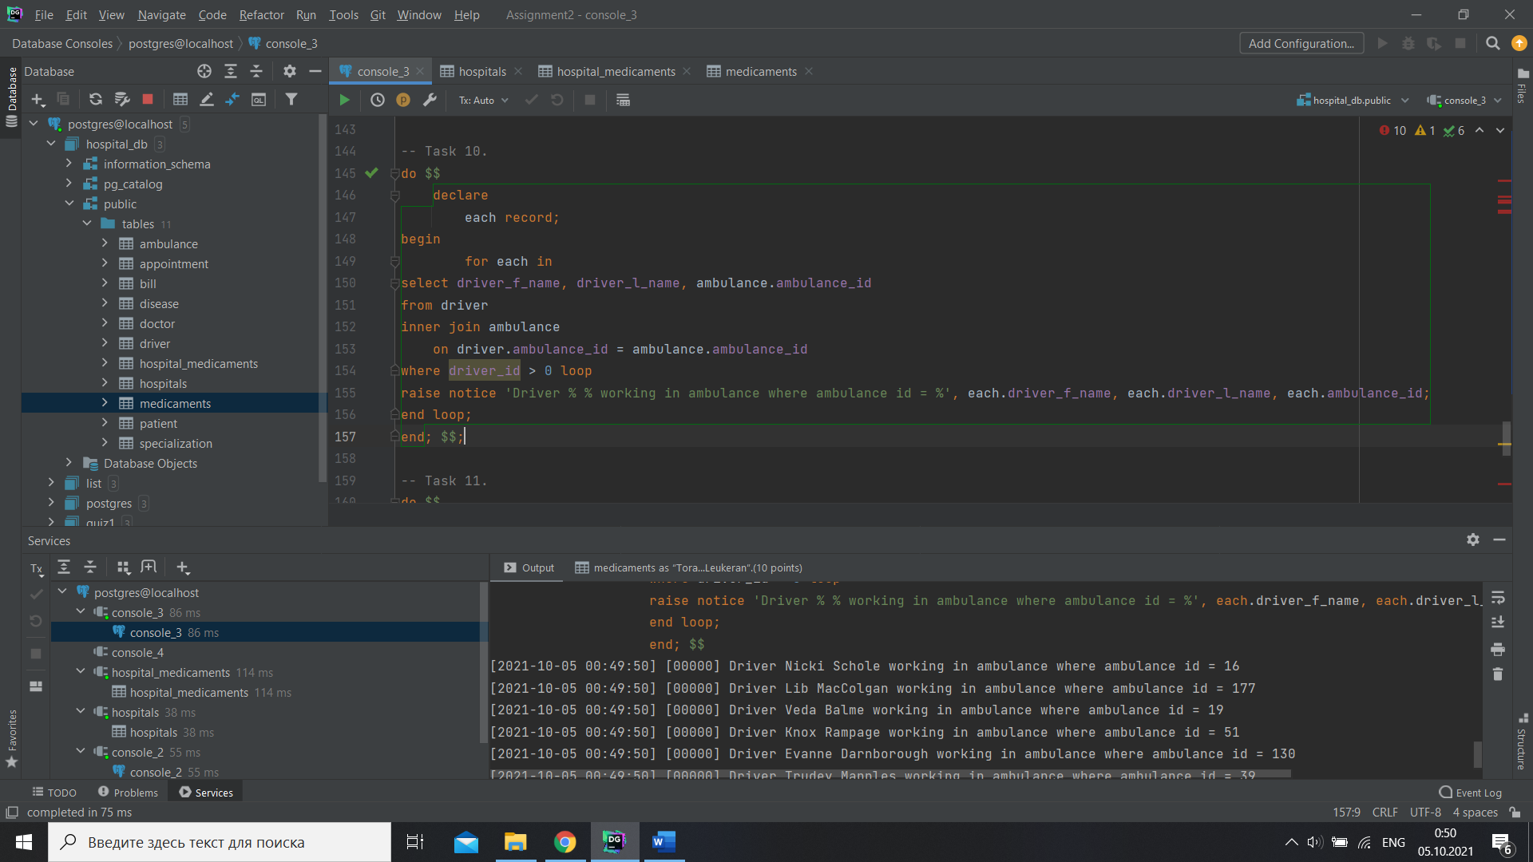

do $$  
 declare  
 each record;  
begin  
 for each in  
select driver_f_name, driver_l_name, ambulance.ambulance_id  
from driver  
inner join ambulance  
 on driver.ambulance_id = ambulance.ambulance_id  
where driver_id > 0 loop  
raise notice 'Driver % % working in ambulance where ambulance id = %', each.driver_f_name, each.driver_l_name, each.ambulance_id;  
end loop;  
end; $$;

1. Write a SQL query to find the addresses of the hospitals which have in stock medicaments as “Toradol” and “Leukeran”.(10 points).

do $$  
 declare  
 med record;  
begin  
 for med in  
select hospital_address  
from hospitals  
inner join hospital_medicaments  
on hospitals.hospital_id = hospital_medicaments.hospital_id  
inner join medicaments  
on medicaments.medicament_id = hospital_medicaments.medicament_id  
where medicament_name = 'Toradol' or medicament_name = 'Leukeran' loop  
raise notice 'Addresses of the hospitals which have "Toradol" or "Leukeran:" %', med.hospital_address;  
end loop;  
end; $$;

1. Write a SQL query using Self Join. Change the database if needed. (10 points).

do $$  
 declare  
 name record;  
begin  
 for name in  
select p.ptn_f_name || ' ' || p.ptn_l_name patient,  
 d.dc_f_name || ' ' || d.dc_l_name doctor  
from patient p  
inner join appointment a  
on p.patient_id = a.patient_id  
inner join doctor d  
on a.doctor_id = d.doctor_id loop  
raise notice 'Patient: %, Doctor: %', name.patient, name.doctor;  
end loop;  
end; $$;

1. Write a SQL query using Сross Join. Change the database if needed.(10 points).

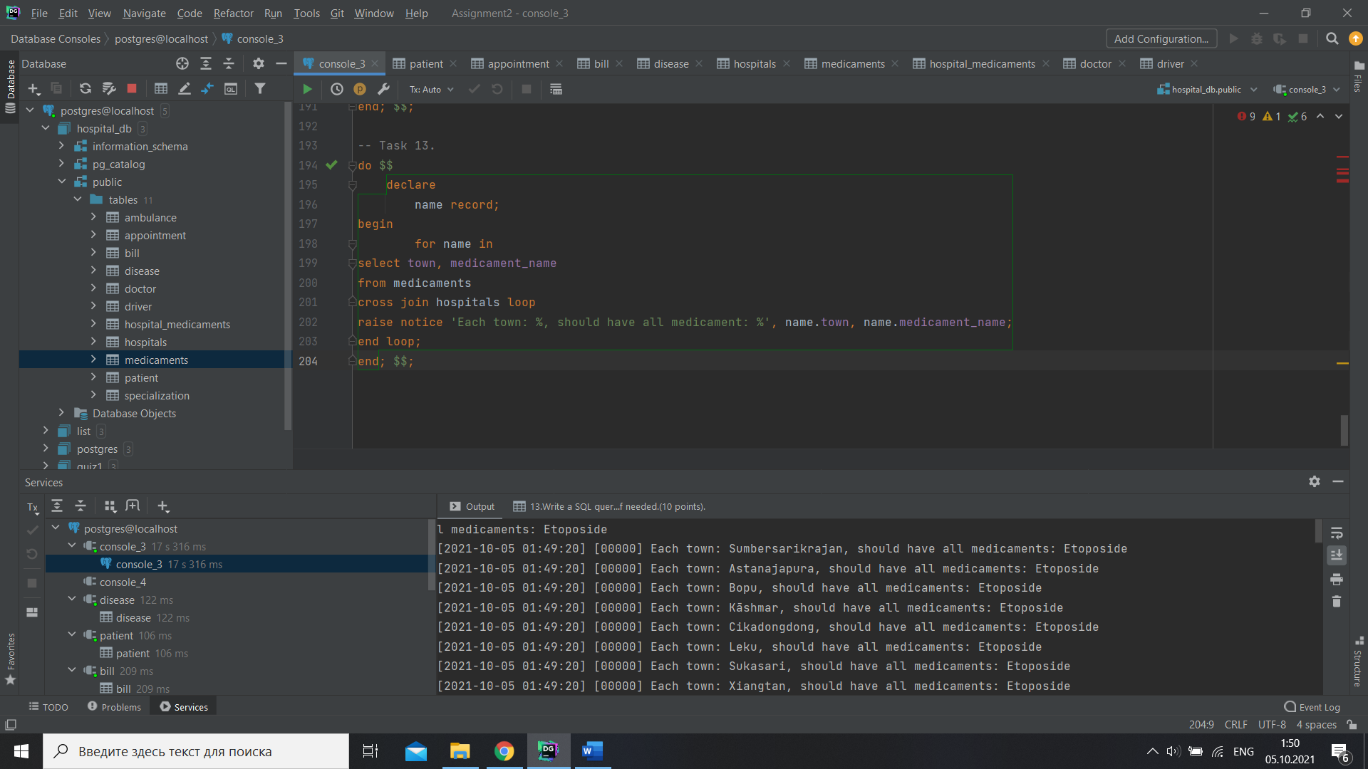

do $$  
 declare  
 name record;  
begin  
 for name in  
select town, medicament_name  
from medicaments  
cross join hospitals loop  
raise notice 'Each town: %, should have all medicament: %', name.town, name.medicament_name;  
end loop;  
end; $$;

1. Write a SQL query using Natural Join. Change the database if needed.(10 points).

do $$  
 declare  
 new record;  
begin  
 for new in  
select medicament_id, medicament_name  
from medicaments  
natural join hospital_medicaments loop  
raise notice 'Medicament id: %, medicament name: %', new.medicament_id, new.medicament_name;  
end loop;  
end; $$;