Swimmerpen

User Guide

Table of Contents

Introduction 1

Camera Screen 2

Settings 2

Recording 4

Annotation Screen 5

Annotation 5

Annotation Tools/Features 7

Introduction

t

his app was created in order to make it easy to both record and annotate swimmers. This app focuses on annotating the timestamp of the swimmer at the various distance checkpoints as well as the number of strokes performed between different distance segments. From the distance-time annotation and strokes annotation, other metrics can be derived and presented in graphs.

# Camera Screen

## Settings

1. 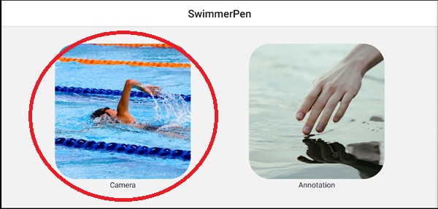Start by pressing the camera button.

Figure 1: Button to navigate to camera screen

1. At the camera screen, you can adjust these settings:
2. 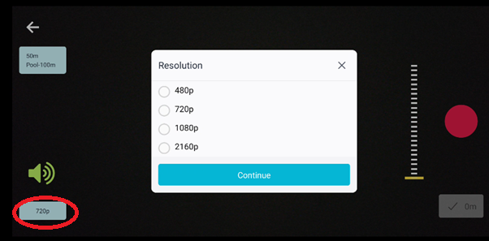**Resolution**
   1. 480p
   2. 720p
   3. 1080p
   4. 2160p

Figure 2: Resolution button at bottom right of the screen opens a modal to choose resolution for recording video

1. 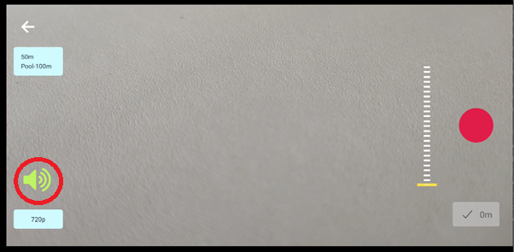Mute/Unmute

Figure 3: Unmute/mute button is above the resolution button

1. Select Race Configuration
2. 25m pool: 50m, 100m, 200m, 400m races
3. 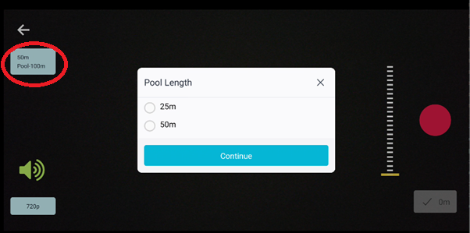50m pool: 50m, 100m, 200m, 400m races

Figure 4: Pool configuration setting can be adjusted at the top left button on camera screen

1. Control Zoom

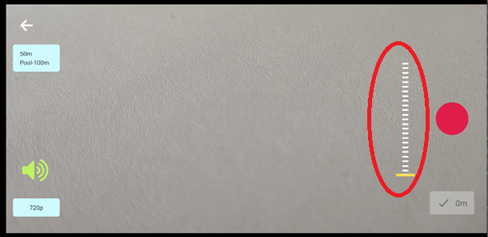

Figure 5: Zoom of camera can be adjusted by sliding

## Recording

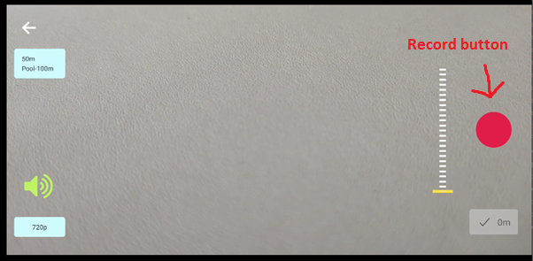1. Start recording by pressing the record button

Figure 6: Record button

2. Annotate while recording by pressing on the distance checkpoint buttons

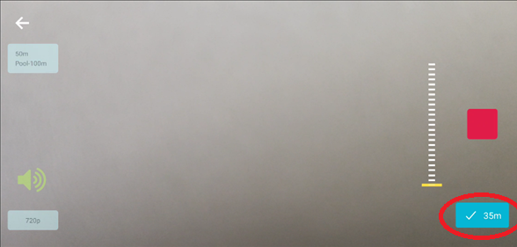

Figure 7: While recording, checkpoint button can be pressed to mark timestamp of swimmer crossing specific distances

1. After finishing with annotation, stop recording of video

# Annotation Screen

## Annotation

1. 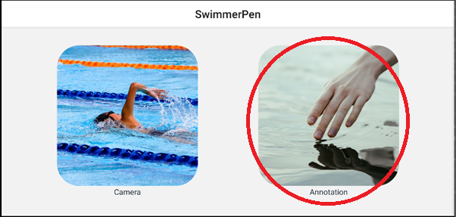Start by pressing the annotation button.

Figure 8: Button to navigate to the annotation screen

1. Press load video

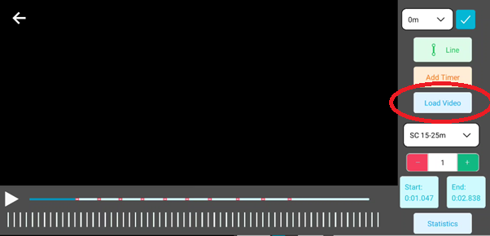

Figure 9: Loads a video that is stored in the app

1. Wait for the app to lookup video files, this might take a few seconds. After it is loaded, screen can be slide horizontally to find the select the right video.

Figure 10: File picker screen

1. 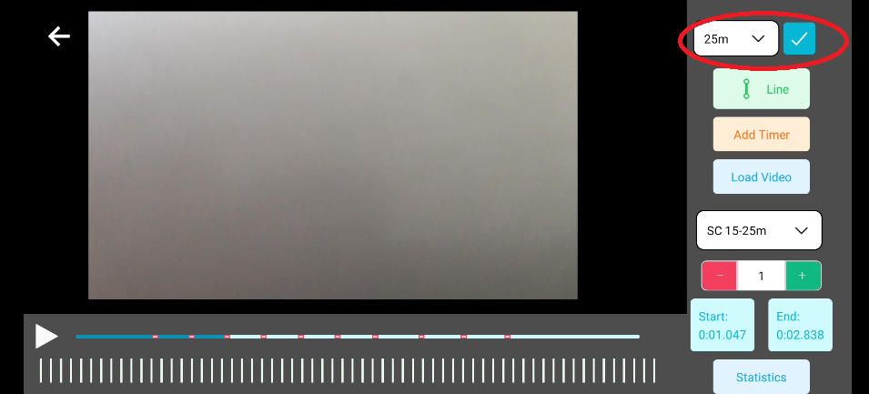Confirm the timing of the swimmer crossing the various distance

Figure 11: Correct inaccuracies made during the video recording by pressing the checkmark button

1. Add stroke information
   1. 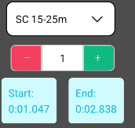At the start of the stroke, press the left time button

Figure 12: Stroke count for distance segments can be adjusted here

* 1. Press play video and start counting strokes
  2. Stop the video once done with counting strokes
  3. Input the amount of strokes counted
  4. Mark the end of the strokes by pressing the right time button
  5. Repeat for other distance segments

1. Press statistics to view charts computed from the annotations

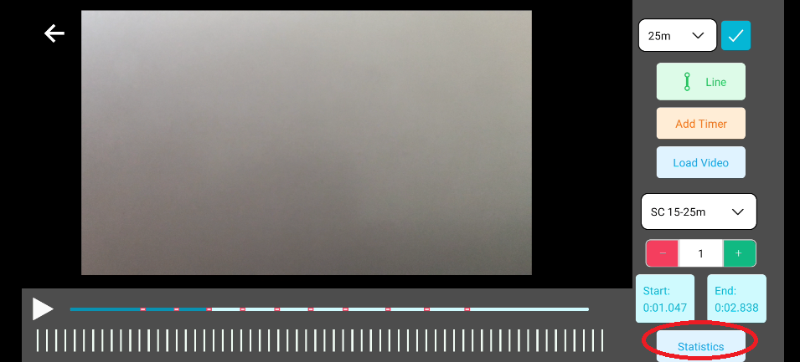

Figure 13: After annotation, statistics can be computed by clicking on this button

1. Press screenshot to share/save an image of the graphs

Figure 14: Statistics Screen

## Annotation Tools/Features

1. Line

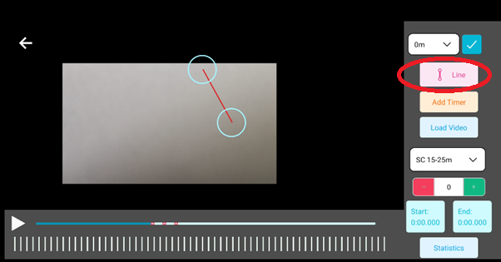

Figure 15: Line tool can be useful in verifying if a swimmer has passed a certain distance

1. Timer
   1. Multiple timers can be placed
   2. To remove a timer, long press on it

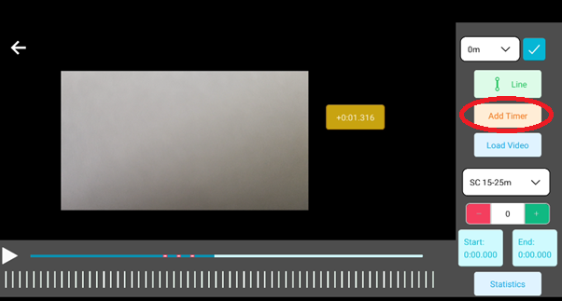

Figure 16: Timer

1. Pinch to zoom

Figure 17: Screen can be pinched to zoom in or zoom out on the video

4. Tapping on the screen to hide/show controls

Figure 18: Controls disappearing after a single tap on the screen