AdaptixC2隐匿部署

架构流程
客户端--->HTTPS ---> Cloudflare CDN ---> HTTPS ---> VPS Nginx 443 ---> 路径匹配/v3/auth ---> AdaptixC2 127.0.0.1:58443 ---> 不匹配路径 302 跳转到 https://www.baidu.com
1、Cloudflare CDN : 隐藏 VPS 真实 IP
2、Nginx 路径过滤 : 只响应 /v3/auth，其他跳转 baidu
3、AdaptixC2 本地监听: 只监听 127.0.0.1，不暴露端口到公网

前置条件
- VPS：hpanel.hostinger.com Kali 2026.2
- 域名：www.namesilo.com
- Cloudflare：dash.cloudflare.com （获取NS代理、源站证书、请求缓存规则）
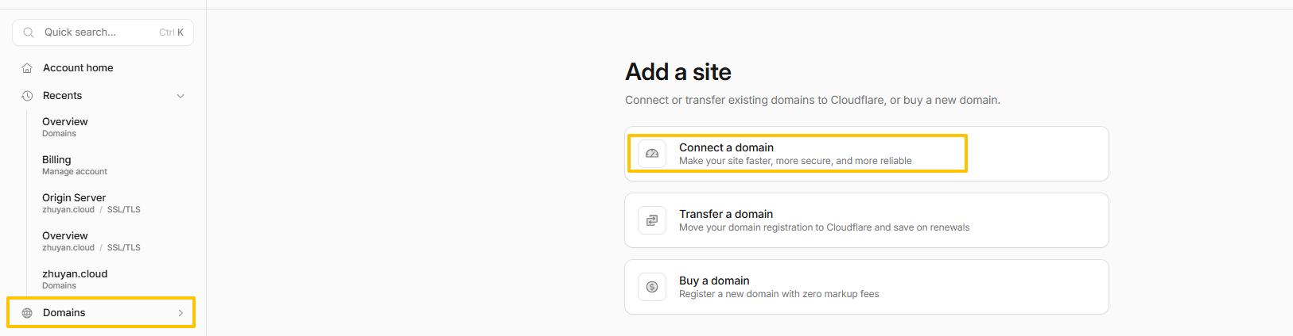
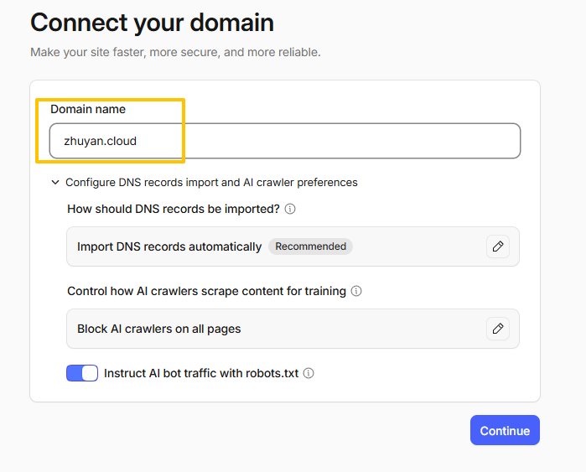
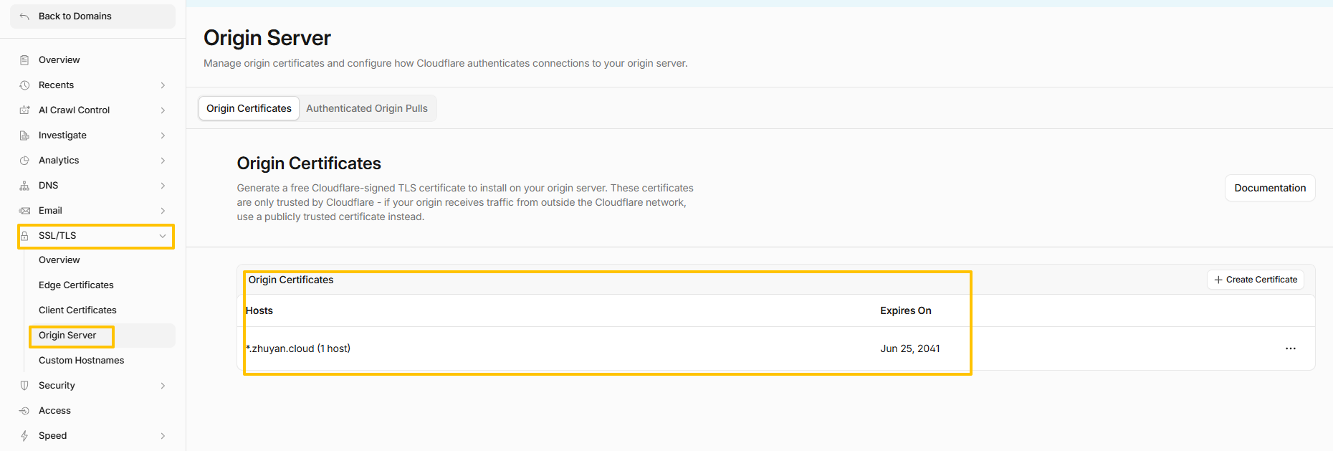
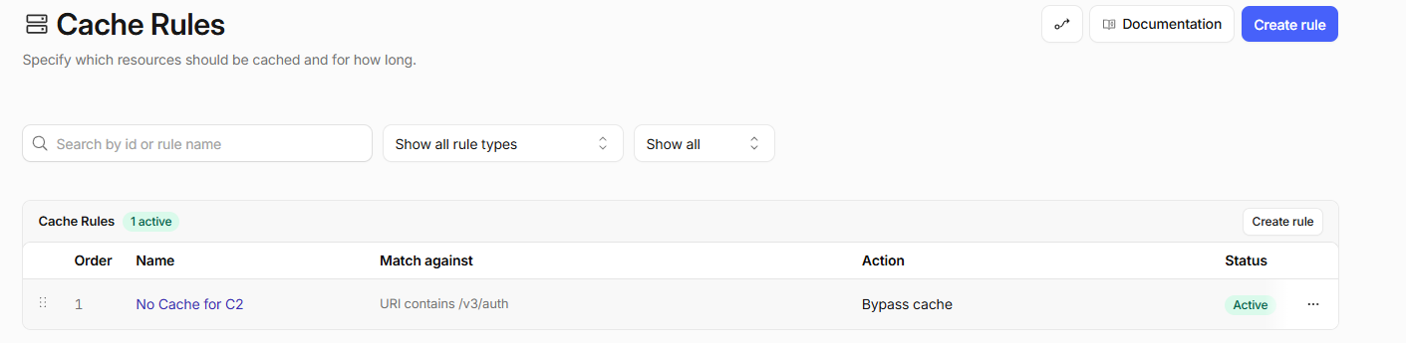

配置AdaptixC2服务
3.1、安装AdaptixC2 服务端
cd /opt
git clone https://github.com/Adaptix-Framework/AdaptixC2.git AdaptixC2-v1.2
cd AdaptixC2-v1.2
git checkout tags/v1.2
chmod +x pre_install_linux_all.sh
./pre_install_linux_all.sh all
make server-ext

cp /opt/AdaptixC2-v1.2/dist/adaptixserver /usr/bin/adaptixserver
cp /opt/AdaptixC2-v1.2/dist/profile.yaml /opt/adaptixc2/profile.yaml
mkdir -p /opt/adaptixc2/{certs,logs,static,data,extenders}
cp -r /opt/AdaptixC2-v1.2/dist/extenders/* /opt/adaptixc2/extenders/
rm -rf AdaptixC2-v1.2
3.2、生成自签名证书
openssl req -x509 -newkey rsa:4096 -keyout /opt/adaptixc2/certs/server.key -out /opt/adaptixc2/certs/server.crt -days 365 -nodes -subj
"/C=US/ST=California/L=LosAngeles/O=Security/CN=127.0.0.1"

chmod 600 /opt/adaptixc2/certs/server.key

3.3、创建自定义 404 页面
cat > /opt/adaptixc2/static/404.html << 'EOF'
<html>
<head><title>404 Not Found</title></head>
<body>
<center><h1>404 Not Found</h1></center>
<hr><center>nginx</center>
</body>
</html>
EOF

3.4、修改配置文件
more /opt/adaptixc2/profile.yaml
Teamserver:
interface: "127.0.0.1"
port: 58443
endpoint: "/v3/auth"
password: "123456@2026"
operators:
admin: "123456@2026"
only_password: true
cert: "/opt/adaptixc2/certs/server.rsa.crt"
key: "/opt/adaptixc2/certs/server.rsa.key"
extenders:
- "/opt/adaptixc2/extenders/beacon_listener_http/config.yaml"
- "/opt/adaptixc2/extenders/beacon_listener_smb/config.yaml"
- "/opt/adaptixc2/extenders/beacon_listener_tcp/config.yaml"
- "/opt/adaptixc2/extenders/beacon_listener_dns/config.yaml"
- "/opt/adaptixc2/extenders/beacon_agent/config.yaml"
- "/opt/adaptixc2/extenders/gopher_listener_tcp/config.yaml"
- "/opt/adaptixc2/extenders/gopher_agent/config.yaml"
axscripts: []
access_token_live_hours: 12
refresh_token_live_hours: 168

HttpServer:
error:
status: 404
headers:
Content-Type: "text/html; charset=UTF-8"
Server: "nginx"
page: "/opt/adaptixc2/static/404.html"
http:
max_header_bytes: 8192
read_header_timeout_sec: 20
read_timeout_sec: 30
write_timeout_sec: 30
idle_timeout_sec: 60
request_timeout_sec: 60
request_timeout_message: "504 Gateway Timeout"
disable_keep_alives: false
enable_http2: true
tls:
min_version: "TLS1.2"
max_version: "TLS1.3"
prefer_server_cipher_suites: false
cipher_suites:
- "TLS_ECDHE_RSA_WITH_AES_128_GCM_SHA256"
- "TLS_ECDHE_RSA_WITH_AES_256_GCM_SHA384"
- "TLS_ECDHE_ECDSA_WITH_AES_128_GCM_SHA256"
- "TLS_ECDHE_ECDSA_WITH_AES_256_GCM_SHA384"
- "TLS_RSA_WITH_AES_128_GCM_SHA256"
- "TLS_RSA_WITH_AES_256_GCM_SHA384"
3.5、创建 systemd 服务
more /etc/systemd/system/adaptixc2.service
[Unit]
Description=AdaptixC2 Server
After=network.target

[Service]
Type=simple
User=root
WorkingDirectory=/opt/adaptixc2
ExecStart=/usr/bin/adaptixserver -profile /opt/adaptixc2/profile.yaml
Restart=on-failure
RestartSec=10
StandardOutput=append:/opt/adaptixc2/logs/access.log
StandardError=append:/opt/adaptixc2/logs/error.log

[Install]
WantedBy=multi-user.target

systemctl daemon-reload
systemctl enable adaptixc2
systemctl start adaptixc2
systemctl status adaptixc2

3.6、日志配置
more /etc/logrotate.d/adaptixc2
/opt/adaptixc2/logs/*.log {
daily
rotate 7
dateext
dateformat -%Y%m%d
compress
delaycompress
missingok
notifempty
create 644 root root
sharedscripts
postrotate
systemctl restart adaptixc2 > /dev/null 2>&1 || true
endscript
}
logrotate -d /etc/logrotate.d/adaptixc2
3.7、测试验证
netstat -tlnp | grep 58443
ps aux | grep adaptixserver | grep -v grep

配置Nginx服务
4.1、安装Nginx服务端
apt install -y nginx curl wget git
4.2、部署 Cloudflare 源站证书
mkdir -p /etc/nginx/ssl
vim /etc/nginx/ssl/cloudflare.crt # 粘贴 Origin Certificate
vim /etc/nginx/ssl/cloudflare.key # 粘贴 Private Key
chmod 600 /etc/nginx/ssl/cloudflare.key
4.3、创建 Nginx 配置文件
rm -rf /etc/nginx/sites-enabled/default

more /etc/nginx/sites-available/adaptix
log_format adaptix '$http_x_forwarded_for - $remote_user [$time_local] "$request" '
'$status $body_bytes_sent "$http_referer" "$http_user_agent"';

server {
listen 80;
server_name _;
return 301 https://www.baidu.com;
}

server {
listen 443 ssl;
listen [::]:443 ssl;
http2 on;

server_name app.test.cloud;

ssl_certificate /etc/nginx/ssl/cloudflare.crt;
ssl_certificate_key /etc/nginx/ssl/cloudflare.key;
ssl_protocols TLSv1.2 TLSv1.3;
ssl_ciphers HIGH:!aNULL:!MD5;
ssl_prefer_server_ciphers on;

add_header X-Content-Type-Options "nosniff" always;
add_header X-Frame-Options "SAMEORIGIN" always;
add_header Referrer-Policy "no-referrer" always;
add_header Server "nginx" always;

access_log /var/log/nginx/adaptix/access.log adaptix;
error_log /var/log/nginx/adaptix/error.log;

location ~* ^/v3/auth {
proxy_pass https://127.0.0.1:58443;

proxy_http_version 1.1;
proxy_set_header Upgrade $http_upgrade;
proxy_set_header Connection "upgrade";

proxy_set_header Host $host;
proxy_set_header X-Real-IP $remote_addr;
proxy_set_header X-Forwarded-For $proxy_add_x_forwarded_for;
proxy_set_header X-Forwarded-Proto $scheme;
proxy_ssl_verify off;
proxy_buffering off;

add_header Cache-Control "no-cache, no-store, must-revalidate, private" always;
add_header Pragma "no-cache" always;
add_header Expires "0" always;
add_header X-Accel-Expires "0" always;

proxy_connect_timeout 60s;
proxy_send_timeout 60s;
proxy_read_timeout 60s;
}

location / {
return 302 https://www.baidu.com;
}

server_tokens off;
}
mkdir -p /var/log/nginx/adaptix
chown -R www-data:www-data /var/log/nginx/adaptix
ln -sf /etc/nginx/sites-available/adaptix /etc/nginx/sites-enabled/
nginx -t
systemctl start nginx
systemctl enable nginx
systemctl reload nginx
systemctl status nginx
4.4、 日志配置
more /etc/logrotate.d/nginx-adaptix
/var/log/nginx/adaptix/*.log {
daily
missingok
rotate 7
dateext
dateformat -%Y%m%d
compress
delaycompress
notifempty
create 640 www-data adm
sharedscripts
postrotate
if [ -f /var/run/nginx.pid ]; then
kill -USR1 `cat /var/run/nginx.pid`
fi
endscript
}

logrotate -d /etc/logrotate.d/nginx-adaptix

4.5、验证

netstat -antlp | grep nginx
ps aux | grep nginx | grep -v grep

编译AdaptixC2客户端
5.1、安装 MSYS2运行环境

https://www.msys2.org/

C:\msys64
5.2、 安装Qt运行环境
https://www.qt.io/download-qt-installer-oss
自定义安装C:\Qt

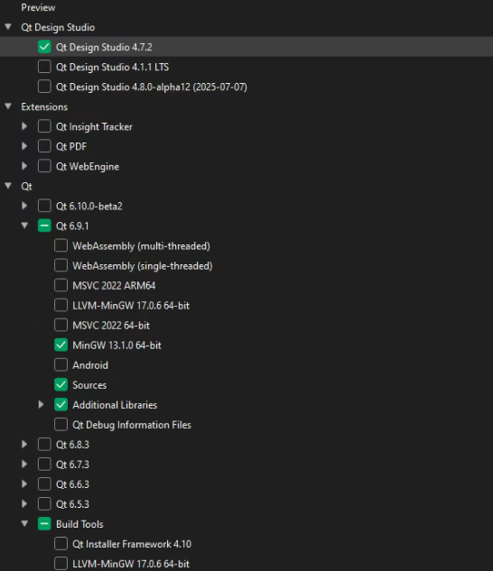
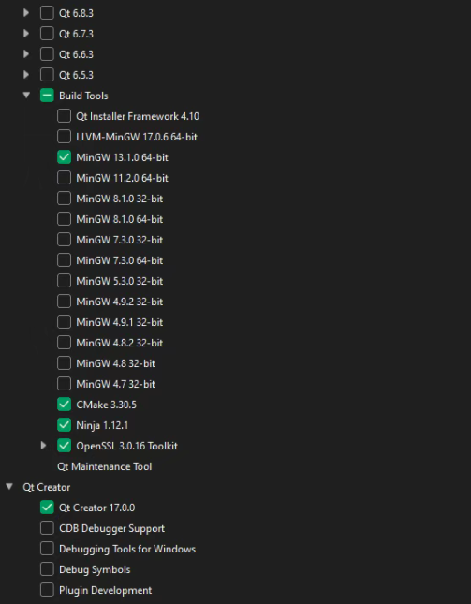

5.2、安装MSYS2依赖环境
pacman -S mingw-w64-ucrt-x86_64-openssl
5.3、下载源码
cd D:\
git clone --branch v1.2 https://github.com/Adaptix-Framework/AdaptixC2.git AdaptixC2-v1.2
5.4、编译源码
set PATH=C:\Qt\Tools\mingw1310_64\bin;C:\Qt\Tools\CMake_64\bin;%PATH%

cd AdaptixC2-v1.2\AdaptixClient

mkdir build_release

cd build_release

cmake -G "MinGW Makefiles"
-DCMAKE_C_COMPILER=C:/Qt/Tools/mingw1310_64/bin/gcc.exe -DCMAKE_CXX_COMPILER=C:/Qt/Tools/mingw1310_64/bin/g++.exe -DCMAKE_BUILD_TYPE=Release
-DCMAKE_PREFIX_PATH=C:/Qt/6.11.1/mingw_64
-DOPENSSL_ROOT_DIR=C:/msys64/ucrt64
-DOPENSSL_INCLUDE_DIR=C:/msys64/ucrt64/include -DOPENSSL_CRYPTO_LIBRARY=C:/msys64/ucrt64/lib/libcrypto.dll.a ..

cmake --build . --config Release

cd build_release

C:\Qt\6.11.1\mingw_64\bin\windeployqt.exe AdaptixClient.exe
