

Oracle Morning Checks (AMChecks)

# What is AMChecks? (aka ‘the Story So far’)

AMChecks is a (very) loose collection of scripts – a bunch of korn shell scripts (ksh) and SQL scripts (including anonymous PL/SQL blocks but no actual procedures) that are intended to run from a ‘central’ linux server, primarily via a series of crons on that server. For anything very useful you’ll also need a database repository on this server as well – Standard Edition will do, although there are still some scripts that can run without a repository.

The basic idea behind AMChecks is to have something that can keep an eye on your Oracle infrastructure and give enough information to help you look after your Oracle estate while you’re off doing more exciting things (say, perhaps creating more scripts for AMChecks or, more rewardingly, picking the fluff out of your belly button). It’s as lightweight as I could make it – all you need to do for each target database is create a new login that has read access to the data dictionary*. If you want to monitor mountpoint space (linux only at present) then there’s a little more effort required but you can add this in later once you’re happy with how AMChecks is running ‘out of the box’.

# What isn’t it?

It’s not a banana called Graham. It’s also not intended to replace anything you’ve paid actual money for. It will not give you a shiny interface and it won’t allow you to drill down into performance metrics. It is not intended to replace Oracle Cloud Control or serious monitoring software like BMC Patrol or Quest’s Foglight. You might find it useful if you have nothing else checking up on your databases. Feel free to give it a go and feel equally free to delete it when you find something more appropriate for your organisation.

# Is it free?

Yes. Of course it’s free. Do you think I could actually charge for this? ..although all donations, monetary or otherwise, will be gratefully received!

Please be aware that whereas I’ve tried to develop this for the lowest common denominator (so no diagnostic pack, no tuning pack, no enterprise edition even) there is no actual guarantee that running the scripts will not invalidate your Oracle license in any way. I mean they *look* OK but use them at your own risk. You have been warned! If you spot a red flag please let me know ASAP.

There is NO support offered for AMChecks either – you’re pretty much on your own although there might be some other poor unfortunates who also use the scripts that may be able to help you. If you can help them and either add new scripts or improve existing scripts (I suspect there’s A LOT of scope here..) please let me know – that would be 👍*awesome*👍.

# Pre-Installation

Check that you are clear to proceed as there may be company change control procedures, management sign-off or other non-technical ‘opportunities’ to overcome before any actual installation. Consider a plan for how you will roll-out these checks (e.g. test each script against a ‘sandbox’ database first, then deploy to your UAT environment). Be cautious – some databases will behave differently to each script so a ‘big bang’ deployment might just end up being all too appropriately named.

Identify the (linux) server that you intend to run the scripts from and make sure that you can ping all of your intended Oracle database hosts from this machine.

At the very least install an Oracle client on this box but realistically you’re going to want to install the database software too (check your Oracle licensing first of course before installing anything).

Make sure that you can run **sqlplus** to these boxes too.

You don’t need a new OS user/login but you might want to consider it. I developed these using user ‘oracle’ but feel free to give another user a whirl.

Check that this user has access to **cron** (unless you plan to use an alternative scheduler for your checks) and that the cron daemon is running on your ‘master’ server. E.g. run: **ps -elf | grep crond**

Find your Linux administrator (anywhere that has a significant amount of caffeine is a good place to start your search) if it’s not you (if it is you I’m not going to help you ‘find yourself’ – this isn’t self-help therapy) and discuss this section with them.

Make sure that you have the korn shell installed on your nominated server (unless you want to have fun converting the ksh scripts into some other kind of script (please share the pain/joy if you do!). Once installed, note the path of your ksh on the server. If it’s NOT **/bin/ksh** then either change the first line of **every** .ksh script to where your ksh is or create a symbolic link from where it is to /bin/ksh using the relevant user (probably ‘root’). Go with whatever your Linux administrator advises. e.g.

ln –s /blah/ksh /bin/ksh

Find or create a tnsnames.ora file. This should only contain the databases you want to check, at least to begin with. Edit the file to have all connect information for a database on a single line e.g.

FRED = (DESCRIPTION = (ADDRESS = (PROTOCOL = TCP)(HOST = bedrock.com)(PORT = 1521)) (CONNECT_DATA = (SERVER = DEDICATED) (SERVICE_NAME = FRED)))

WILMA = (DESCRIPTION = (ADDRESS = (PROTOCOL = TCP)(HOST = bedrock.com)(PORT = 1522)) (CONNECT_DATA = (SERVER = DEDICATED) (SERVICE_NAME = WILMA)))

This may not be your usual tnsnames.ora file – you’ll want to keep it simple, so you might need to add new simple entries for your high availability databases and remove other entries. You also don’t want to have any entries for your standby databases, with the possible exception of active standbys. Only instances that you are licensed to run queries against should be in your tnsnames.ora.

Test this most-likely-slimmed-down tnsnames.ora (using **tnsping** with **TNS_ADMIN** is probably the easiest way to test). Keep this file safe as you will need to copy this into your ‘AMChecks’ top level directory once you’ve downloaded the scripts.

# Installation

* Grab a caffeine-infused beverage. Tea is a good example although green tea is to be avoided, not just for this step but for the entirety of your life if possible: it tastes foul.
* Unpack the files that you’ve downloaded onto the box you intend to run your scripts from. The suggested directory is: **~oracle/amchecks**
* Copy your **tnsnames.ora** that you were working on in the pre-installation steps into this directory but call it **tnsnames.ora.full**. Create a slimmed down version of this file, called **tnsnames.ora** which contains just one line – the connect details for your ‘master’ database.
* Create the following OS directories if they don’t exist (it seems unlikely unless you were foolish enough to try AMChecks before):

**mkdir –p ~oracle/amchecks/external_tables**

**mkdir –p /tmp/amchecks**

* If you don’t have a database to host your checks, create it and come back here when you are done. Unless you have a massive Oracle estate the schema itself should be well under 1 Gig.
* Create 2 new users – one to own the metadata and one to run the checks. Do this by editing (to change the passwords) and then running **users.sql** when connected to your host/master database (NOT the databases you will be monitoring) as a god-like user (e.g. ‘system’). Note that if you want to tighten up access you can almost certainly replace the ‘**SELECT_CATALOG_ROLE’** role with a bunch of more specific, focused system or object permissions. Be my guest but I’ve not explored this option yet. Also resist using **’SELECT ANY DICTIONARY’** especially if you are on Oracle 9 databases (don’t be embarrassed - you’re in good company!) – you don’t really want to be able to run : **select name, password from sys.user$** . Currently **’SELECT ANY DICTIONARY’** is only needed for 1 script: **password_expiry_check11.sql** The amu user shouldn’t really be able to see any business sensitive data or change anything. Don’t change this by adding any additional permissions.
* Know how to change all of your ‘amu’ passwords – this can be pretty easy as you can run something like: **ALTER USER amu IDENTIFIED BY t0pSecritPasswd;** on every database in a few seconds (but remember to change the **CONNECT_PWD** in the file mentioned in the next section). Currently there is no provision to have different passwords on your monitored databases (although it wouldn’t be that hard to add in this functionality).
* Edit **~oracle/amchecks/.amcheck** using your favourite editor and change the database, connection details and anything else that looks likely. If you’re not comfortable with this then, no offence, you probably don’t want to continue with the installation.

**export ORACLE_SID=ORCL**

**export CONNECT_USERNAME=amu**

**export CONNECT_PWD=** **fabum0use**

**export CONNECT="${CONNECT_USERNAME}/${CONNECT_PWD}"**

**export OWNER_CONNECT=amo/** **ferretH8er**

**export READER_CONNECT=amr/** **orch1dfr0g**

**export AMCHECK_TNS="${CONNECT}@${ORACLE_SID}"**

**export MAIL_RECIPIENT='fred.flintstone@bedrock.com,wilma.rubble@bedrock.com’**

**export ORACLE_BASE=/u01/app/oracle**

**export ORACLE_HOME=/u01/app/oracle/product/11204/**

**export PATH=$PATH:${ORACLE_HOME}/bin**

**alias SQLPLUS='sqlplus $CONNECT@$ORACLE_SID'**

**export TERM=xterm**

**export FROM_ADDRESS="DBAs@bedrock.com"**

I’m not sure why I have the CONNECT_USERNAME and CONNECT_PWD separate. Also I’m not convinced that I’m using all of these variables you know; I’ll need to check at some point…

ORACLE_SID is the local database name of your master database; amu is the user that runs the checks; amo is the owner of the metadata objects. Amr is intended to be a purely read only user but I’m not currently using it as it’s too similar to amu at this stage.

Check file permissions of this file. Be sure to keep it as private as possible as it contains the passwords for the AMChecks (do something like **chmod 500** **~oracle/amchecks/.amcheck** once you are finished).

* At this point you can run one of the scripts – **is_oracle_ok.ksh**. You will need to tell it not to connect to the database to determine the list of targets but to get the list from parsing the tnsnames.ora file. Do this by running: **~oracle/amchecks/is_oracle_ok.ksh -t -p**

As an aside, once you ‘go live’ you’ll probably stop using the ‘-t’ option but it can be useful to run it periodically to check that your tnsnames.ora is not bloated with dead entries.

If this all works OK (it probably won’t as you might need to change environment variables or some other bits and bobs) then you can add other databases into your tnsnames.ora file until it is indistinguishable from **tnsnames.ora.full**

* Now setup **sendmail** on your ‘master’ server if it’s not already enabled. Do this as follows (again you’ll need to track down your linux administrator or whoever is responsible for linux mail) Note that some commands may vary depending on linux distro, version etc.:
  + **ps –elf | grep sendmail:** (look for a running process or two ..other than your **grep**!)
  + **systemctl list-unit-files | grep**  (look for an enabled service)

or better still, as root type **chkconfig |grep sendmail** (this will show the run levels too).

* + If its installed but not started, kick it off as root with **chkconfig sendmail** or **service sendmail start on**  which will add it as an automatically started service.
  + If it’s not installed, then install it (as root) e.g. **yum install sendmail**
  + Find and check your config file – e.g. **/etc/mail/sendmail.cf** checking that your relay host (if present) is added plus anything else your organisation normally sets. This will vary so you will have your own specific changes to make here.
  + If sendmail refuses to start (as root running **service sendmail start**) you may have something else using your port (25). Check this via:  **lsof –i :25**  (as root) to see what is using it (assuming **lsof** is installed..).

Generally this section tends to be the most frustrating (it’d the least Oracley and least databasey) but stick with it – it’s worth it!

* Next you can add a cron to periodically check your database connectivity by something like the following:

**02,07,12,17,22,27,32,37,42,47,52,57 * * * 1-5 ksh -c '/home/oracle/amchecks/is_oracle_ok.ksh -t –m’**

This will run Monday through Friday every 5 minutes. You can schedule however you want. Of course, if you have any other scheduler then feel free to use that in preference to cron.

If your sendmail is working and your environment variables are all OK then you should get an e-mail that looks something like this:

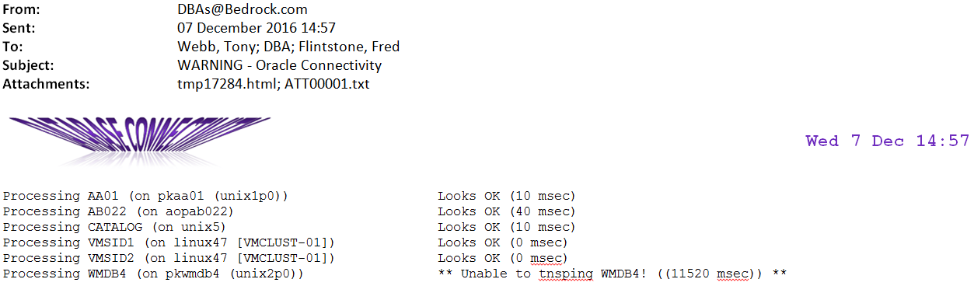

Different command line parameters will alter if/when you get an e-mail. When testing keep the parameters simple.

This is a good point to stop and celebrate your success before carrying on!

* Next you want to create and populate your master database. This will take a while but again it’s something that you should start small with. Add 1 or 2 non-critical, and non-production target databases first. Running some of the other check scripts on a database has the potential, like most new queries, to impact performance of your database so it’s a good idea pick a suitable looking victim database to test with first.

So, as user **amo**, on your ‘master’ database, run ‘**am_schema.sql**’

You are encouraged to keep an additional file named ‘**add_to_schema.sql**’ that contains any changes you have made to the **amo** schema, post-install. You might have your own tables (rare), your own columns (very common) so you should keep a note of these should you ever reinstall. If your download includes an ‘**add_to_schema.sql**’ already then take a look. You may or may not want to run it.

The schema will be mostly empty at this stage. Add in a couple of databases and their servers (add the server into **amo.am_server** before adding the databases into **amo.am_database**). You can start using other tables and bulking out these two tables later.

From the command line run the main am_checks.ksh script. Specify it to run on one database and to run just one script. You might as well e-mail the output too:

**./amchecks.ksh –d ORCL –s instance_summary.sql -m**

Again, once this seems to be working (you might get a few issues again) you should stop. Maybe try a few more databases and a few more scripts.

Eventually let rip with all of the scripts on the one database, i.e. use the ‘**–d** ’ flag but NOT the ‘**-s** ’ flag and then one script on all databases (‘-s’ but not ‘–d’).

At this point you may start exploring the SIDSKIP and SCRIPTSKIP tables…

Next, read the relevant READ_ME and any other likely looking text files in the installation directory. These SHOULD be more up-to-date than this document.

There will be some bugs and some things won’t work for you whereas they do for me, probably because I’ve made some unintended assumption that works for my databases but not for yours. Sorry about that. If you do manage to fix any of these or you improve the code (which, quite frankly wouldn’t be that difficult in some places..) please let me know as you may be helping others who use this script; more importantly you might be helping me ☺.

# Important Tables and Columns

If you decide to keep using the scripts on anything other than an ad hoc basis you’ll gain more familiarity with the AMChecks database. You are encouraged to add your own columns and tables over time. If you can share these with other DBAs then even better but please avoid using any features that you wouldn’t find in a ‘vanilla’ Standard Edition (SE, SE1, SE2) database running on Linux.

Personally I find maintenance and enhancements of AMChecks a good way to keep my hand in should I have to work on other, non-Oracle, databases or, worse still, do non-DBA work!

If you don’t have the luxury of this then here are the key tables and columns you should know about.

# **AM_SERVER**

COLUMN: SERVER

The short name for the server (e.g. hostname –s). It must be unique.

COLUMN: DISABLED

This column appears on a lot of tables. As the name suggests, it’s an easy way to disable that particular row, so setting this to ‘Y’ in this table will cause the server in question to be ignored (unless you are referencing it via a non-disabled row in another able e.g. am_database). One thing to watch out for – disabling a row in a ‘skip’ table disables the skip itself, not the thing you are skipping. I’ve not explained that very well but hopefully you know what I mean!

COLUMN: CLUSTER_NAME

This is optional. If you have some kind of container for your server, e.g. a VM Cluster then specify this here.

COLUMN: PHYSICAL SERVER

This is the full name including the domain name (e.g. hostname).

COLUMN: PING_DISABLED

Some servers may not be pingable for one reason or another. To skip just the ping tests (in is_oracle_ok.ksh) set this column to ‘Y’.

VIRTUAL COLUMN: PHYSICAL_SERVER_ABBREV

This is derived from PHYSICAL SERVER and for many, or quite possibly all, of your entries it will be the same as column ‘SERVER’.

# **AM_DATABASE**

COLUMN: SERVER

The short name of the server where the database lives (join column to AM_SERVER).

COLUMN: XXX_IND

You can have as many ‘IND’ columns as you like. e.g. PRODUCTION_IND. All IND columns should only have ‘Y’ and ‘N’ specified. Each column can be used to restrict/categorise which databases you run your scripts against. You can see a few examples of this in the sample cron. Again, you are encouraged to add your own IND columns as necessary.

COLUMN: OS_CHECKS_IND

This is different from the other IND columns (although it could be used in a similar fashion). It determines whether or not this database has an external table for that server’s space reporting. Only one database on each server should have this set. See a later section for more details on this.

COLUMN: RUN_ORDER

This will determine when the database is processed when a list of databases is being processed.

# **AM_SCRIPTS**

COLUMN: SCRIPT_ID

A unique identifier for each script

COLUMN: SCRIPT_TYPE

This is used by amchecks.ksh when running a series of related scripts. Scripts are normally categorised into either ‘CHECK’ which is a health check; ‘SUMMARY’ which is informative or ‘SPECIAL’ which describes scripts that don’t fall into either of the previous two categories.

COLUMNS: DB_VERSION_FROM and DB_VERSION_TO

Some scripts don’t work on older versions of the database. If you want to exclude scripts in this fashion set one or both of these columns. Number format should be three digits – e.g. 101 for version 10.1, 110 for version 11.0.

COLUMNS: PARAM1 and PARAM2

Columns to describe what parameters a script should take. Use the string ‘DBNAME’ to get the actual database name passed as a parameter, else use a literal value.

COLUMN: RUN_ON_MASTER

Indicates that when processing through a list of scripts for a target this particular script needs to get it’s information from the ‘master’ database. Normally the script will have a param (see PARAM1 above) of ‘DBNAME’

# **AM_SIDSKIP**

When NOT to run scripts against a particular database. Useful for planned outages.

COLUMN: SIDSKIP_TYPE

DAILY – means skip the database for every day between the specified ‘from’ and ‘to’ dates/times.; SATURDAY, SUNDAY etc. – specifying an actual day will only exclude the scripts for that database on a particular day of the week

COLUMN: SIDSKIP_NOTES

The message to display when skipping a particular database.

COLUMN: DISABLED

If you have a database that periodically needs to be skipped but at irregular times it is worth having an open-ended entry here and just toggling the DISABLED column to ‘Y’ when you want it skipped rather than explicitly setting an outage window. However, be careful that youdon’t forget to re-enable this when you want checks to start again (..I’m speaking from experience here!)

# **AM_SCRIPTSKIP**

Which scripts should be excluded for specific databases (don’t forget that you can also exclude scripts for specific versions of the database via the AM_SCRIPTS table itself).

# **AM_OS_SPACE**

A brief history of filesystem space usage on database hosts. Used for alerting, nor capacity planning.

# **AM_TABLESPACE_SPACE**

Tablespace growth information. Could be used for capacity planning.

Adding OS space checks to AMChecks

For each (target) server:

as oracle: mkdir -p ~oracle/amchecks/external_tables

mkdir -p /tmp/amchecks

. oraenv (pick your ONE database where the external table will 'live')

Copy the latest version of script 'os_space_check.ksh' from the master

AMChecks database server ~oracle/amchecks directory to this server’s

~oracle/amchecks directory and make it executable.

as sys: GRANT CREATE TABLE TO amu; (should already be set)

CREATE DIRECTORY amcheck_dir AS '/u01/app/oracle/amchecks/external_tables';

(or wherever your amchecks external tables will live)

GRANT ALL ON DIRECTORY amcheck_dir TO amu;

as amu: CREATE TABLE AMU.AM_OS_SPACE_LOAD

(

SERVER VARCHAR2(30 CHAR),

FILESYSTEM VARCHAR2(200 CHAR),

SIZEK NUMBER(10),

USEDK NUMBER(10),

AVAILK NUMBER(10),

PCTUSED NUMBER(3),

MOUNTPOINT VARCHAR2(200 CHAR),

DF_DOW VARCHAR2(10 CHAR),

DF_TIMESTAMP VARCHAR2(40 CHAR)

)

ORGANIZATION EXTERNAL

(

TYPE ORACLE_LOADER

DEFAULT DIRECTORY AMCHECK_DIR

ACCESS PARAMETERS

( RECORDS DELIMITED BY NEWLINE NOBADFILE NODISCARDFILE NOLOGFILE

SKIP 0 FIELDS TERMINATED BY ', ' MISSING FIELD VALUES ARE NULL

)

LOCATION (AMCHECK_DIR: 'am_os_space_load.dbf')

)

REJECT LIMIT UNLIMITED;

as oracle: crontab -e

# Amchecks crons:

##################

18 * * * * ksh -c '/u01/app/oracle/amchecks/os_space_check.ksh 1> /tmp/amchecks/os_space_check_last_output 2>&1'

(check/change full path to os_space_check.ksh)

Actually, change the cron so it runs while you wait (don't just run it from the

command line) then change it to the time you really want it run..

as amu: select * from AM_OS_SPACE_LOAD;

If all looks good, correct the cron and put your feet up.

as amo on master database: UPDATE AM_DATABASE SET OS_CHECKS_IND = 'Y' WHERE…

update the record for the database chosen in the first step)

Sample Cron:

#

# Amchecks below here

#

##########################################################################################################################################################

## Database Connectivity checks should list everything once a day and check for errors only every 15 minutes

## Database check scripts - e.g. space, backups. Run these once in the morning, lunchtime and the evening with only error checks except the morning check

##########################################################################################################################################################

18 * * * * ksh -c '/home/oracle/amchecks/os_space_check.ksh 1> /tmp/amchecks/os_space_check_last_output 2>&1'

##########################################################################################################################################################

########################

# Non-Prd Section

########################

04,34 06-18 * * 1-5 ksh -c '/home/oracle/amchecks/is_oracle_ok.ksh -v -e -c -s -m -l non-prdisook -h "Non-Prod Connectivity Test" -S90 PRODUCTION_IND+N 1> /tmp/amchecks/nonprod_is_oracle_ok_last_output 2>/tmp/amchecks/nonprod_is_oracle_ok_last_error'

24 08 * * 3 ksh -c '/home/oracle/amchecks/amchecks.ksh -c -m -x -t "CHECK" -h "Non-Prod Error Check" PRODUCTION_IND+N 1> /tmp/amchecks/nonprod_amchecks_nonprod_output 2>/tmp/amchecks/nonprod_amchecks_nonprod_error'

50 08 * * 3 ksh -c '/home/oracle/amchecks/amchecks.ksh -c -m -x -t "CHECK" -a "fred.flintstone.@bedrock.com" -h "Non-Prod Error Check" PRODUCTION_IND+N 1> /tmp/amchecks/nonprod_amchecks_nonprod_output 2>/tmp/amchecks/nonprod_amchecks_nonprod_error'

########################

# All Databases Section

########################

22 05 * * * ksh -c '/home/oracle/amchecks/reconcile.ksh -m 1> /tmp/amchecks/reconcile_output 2>/tmp/amchecks/reconcile_last_error'

37 06 * * 1 ksh -c '/home/oracle/amchecks/amchecks.ksh -d ORCL -c -s cluster_summary.sql -H -h "VMWare Cluster Summary" -m 1> /tmp/amchecks/cluster_summary_last_output 2>/tmp/amchecks/cluster_summary_last_run'

31 06 * * * ksh -c '/home/oracle/amchecks/amchecks.ksh -d ORCL1 -c -s rman_catalog_summary.sql -H -h "RMAN Backup Summary" -m 1> /tmp/amchecks/rman_backup_last_output 2>/tmp/amchecks/rman_backup_last_run'

35 06 * * 1 ksh -c '/home/oracle/amchecks/amchecks.ksh -d ORCL -c -s rman_speed.sql -H -h "RMAN Backup Speeds" -m 1> /tmp/amchecks/rman_speed_last_output 2>/tmp/amchecks/rman_speed_last_run'

29 08,12,16 * * * ksh -c '/home/oracle/amchecks/is_oracle_ok.ksh -v -e -c -m 1> /tmp/amchecks/is_oracle_ok_last_output 2>/tmp/amchecks/is_oracle_ok_last_run'

32 07 * * * ksh -c '/home/oracle/amchecks/is_sss_ok.ksh -M 1> /tmp/amchecks/is_sss_ok_last_output 2>/tmp/amchecks/is_sss_ok_last_run'

03,08,13,18,23,28,33,38,43,48,53,58 * * * * ksh -c '/home/oracle/amchecks/is_sss_ok.ksh -S 1> /tmp/amchecks/is_sss_ok_last_output 2>/tmp/amchecks/is_sss_ok_last_error'

11 17 * * * ksh -c '/home/oracle/amchecks/total_space_check.ksh -m 1> /tmp/amchecks/total_space_check_output 2>/tmp/amchecks/total_space_check_error'

31 17 * * * ksh -c '/home/oracle/amchecks/tablespace_space_check.ksh -m 1> /tmp/amchecks/tablespace_space_check_output 2>/tmp/amchecks/tablespace_space_check_error'

00 05 * * * ksh -c '/home/oracle/amchecks/amchecks.ksh -c -m 1> /tmp/amchecks/amchecks_last_output 2>/tmp/amchecks/amchecks_last_error'

53 06,09,12,15 * * 1-5 ksh -c '/home/oracle/amchecks/all_os_space_check.ksh -R -S -m 1> /tmp/amchecks/all_os_space_check_output 2>/tmp/amchecks/all_os_space_check_last_run'

58 09,12,15 * * 1-5 ksh -c '/home/oracle/amchecks/all_os_space_check.ksh -v -p -r -S -m -t "Prod OS Space Alerts" PRODUCTION_IND+Y 1> /tmp/amchecks/all_os_space_check_output 2>/tmp/amchecks/all_os_space_check_last_run'

58 06 * * 1-5 ksh -c '/home/oracle/amchecks/all_os_space_check.ksh -v -p -S -m 1> /tmp/amchecks/all_os_space_check_output 2>/tmp/amchecks/all_os_space_check_last_run'

53 06 * * 0,6 ksh -c '/home/oracle/amchecks/all_os_space_check.ksh -v -p -S -m 1> /tmp/amchecks/all_os_space_check_output 2>/tmp/amchecks/all_os_space_check_last_run'

#####################

# Production Section

#####################

02,32 * * * 0,6 ksh -c '/home/oracle/amchecks/is_oracle_ok.ksh -v -e -c -s -m -l prdisook -h "Production Connectivity Test" -S90 PRODUCTION_IND+Y 1> /tmp/amchecks/prod_is_oracle_ok_last_output 2>/tmp/amchecks/prod_is_oracle_ok_last_error'

02,07,12,17,22,27,32,37,42,47,52,57 * * * 1-5 ksh -c '/home/oracle/amchecks/is_oracle_ok.ksh -v -e -c -s -m -l prdisook -h "Production Connectivity Test" -S15 PRODUCTION_IND+Y 1> /tmp/amchecks/prod_is_oracle_ok_last_output 2>/tmp/amchecks/prod_is_oracle_ok_last_error'

04 6,16 * * * ksh -c '/home/oracle/amchecks/amchecks.ksh -c -m -x -t "CHECK" -h "URGENT Production Error Check" PRODUCTION_IND+Y 1> /tmp/amchecks/amchecks_last_output 2>/tmp/amchecks/amchecks_last_error'

00 07 * * 1 ksh -c '/home/oracle/amchecks/amchecks.ksh -c -m -h "Production Error Check" PRODUCTION_IND+Y 1> /tmp/amchecks/amchecks_last_output 2>/tmp/amchecks/amchecks_last_error'

# **Some Scripts Explained**

is_oracle_ok.ksh

This is where it all began. A script originally designed to read through your tnsnames.ora file and tnsping all instances that it finds. Functionality was added to e-mail the results, then to connect using sqlplus, then to skip specific databases and then to have the database list held in a database.

Be careful about how you schedule multiple occurrences of this as they could trip over each other when reporting results.



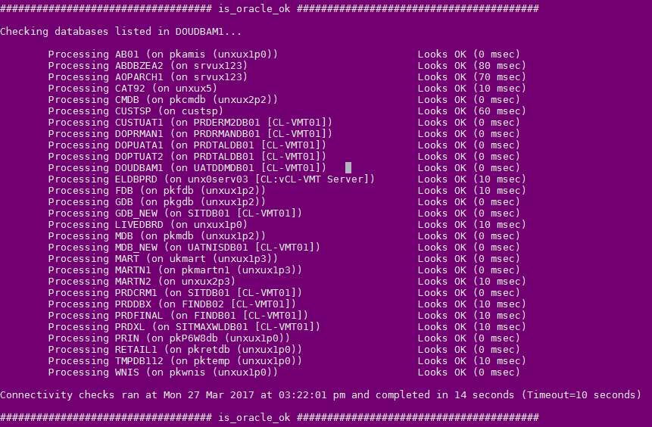

amchecks.ksh

This is the main script. It’s basically a harness to process a bunch of scripts listed in a database against a bunch of databases. It’s pretty flexible but has mutated over the years to a point now where it would seriously benefit from a complete rewrite!

Be careful about file permissions. This script will run any sql script you tell it to (I thought about restricting this but this flexibility also makes the script really useful for ad hoc reports so no checks are currently in place). For this reason keep the file permissions on all sql and on the amchecks directory tight.

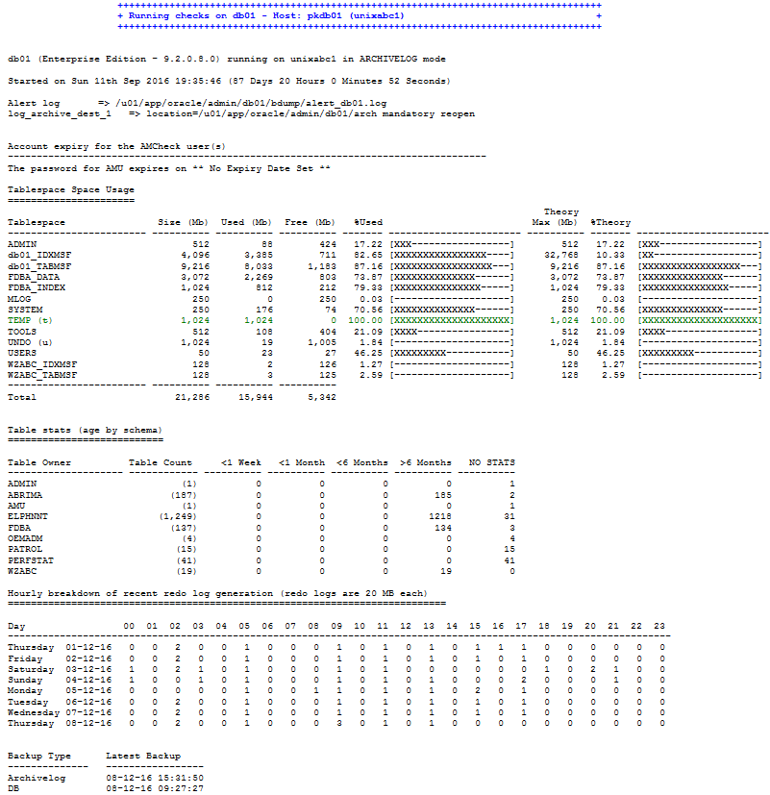

all_os_space_check.ksh

This is an attempt to move out of the database and to do some host checks. I’m not too keen on this as it means you have to spend a little effort creating external tables on your monitored databases. Still, it’s there if you don’t have anything else looking after disk space; you might need it (as I did). It can be useful but can also be prone to spamming.

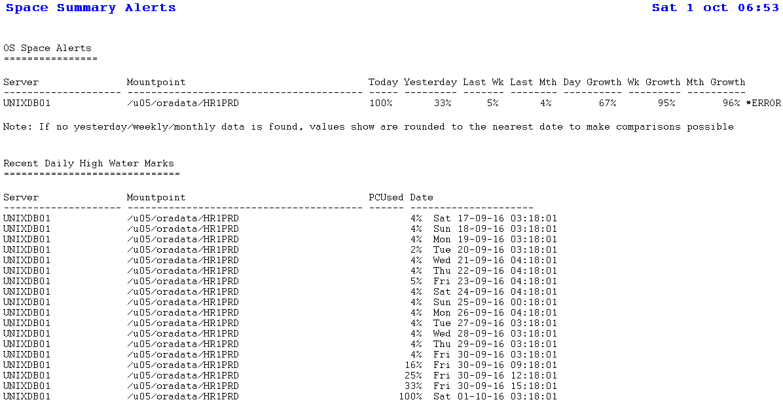

tablespace_space_check.ksh and total_space_check.ksh

These are space reports showing how your databases are growing. They’ll be a bit useless until you’ve been capturing details for a few months.

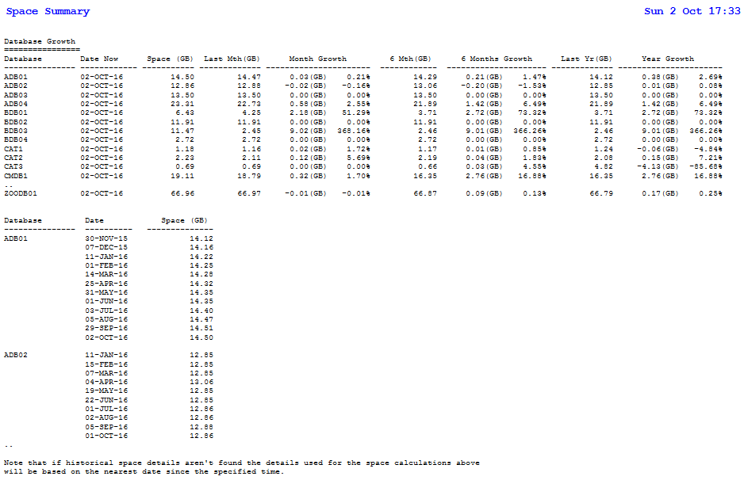

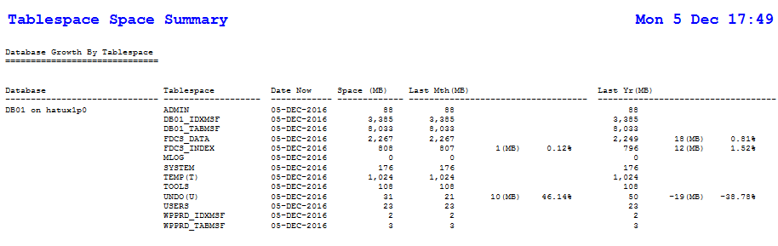

SQL Scripts

102_instance_summary.sql

amazon_disclaimer.sql

am_expire.sql

am_schema.sql

archivelog_check.sql

blocking.sql

broken_jobs.sql

cluster.sql

cluster_summary.sql

database_space.sql

dba_feature_usage.sql

dblink_summary.sql

dfspace_check.sql

growth_report.sql

instance_summary.sql

license_pack_usage_details.sql

login.sql

metric_check.sql

metric_report.sql

metrics.sql

options_packs_usage_statistics.sql

os_space_check.sql

os_space_summary.sql

pa_patches.sql

parameter_summary.sql

password_expiry_check11.sql

password_expiry_check.sql

preaudit.sql

prompt.sql

r12_checks.sql

R12PROD_disclaimer.sql

R12_stats_disclaimer.sql

recent_creations.sql

redo_activity.sql

redo_check.sql

rman_catalog_summary.sql

rman_check_10.sql

rman_check_r12.sql

rman_disclaimer.sql

rman_speed_db.sql

rman_speed.sql

rman_summary_10.sql

rman_summary_r12.sql

segment_growth.sql

space_check.sql

space_summary.sql

sptrends.sql

standard_checks_header.sql

standby_check.sql

stats_check_10.sql

stats_check_9.sql

stats_check.sql

tableinfo.sql

tablespace_growth_check.sql

tablespace_growth_report.sql

total_space.sql

totrace.sql

true_space_check.sql

true_space_gig.sql

true_space_meg.sql

users.sql

version.sql

when_analyzed.sql

Writing Your Own Scripts

These scripts, particularly the wrapper shell script amchecks.ksh can be a handy tool for running ad hoc queries against all of your databases (or logical groupings of databases using the ’IND’ columns in table amo.am_database). However, this is clearly open to abuse as you can run any crappy code against your nice highly tuned production instance’s data dictionaries!

It’s common sense really but run any new code against non-production databases first, preferably starting with just one database and then running on larger numbers of databases.

If you want 1 line output for every database rather than a page full of output for each database target you may want to turn off the database title/name and suppress timings by using the -D and -f flags on amchecks.ksh although you’ll probably want to select the database name some other way in order to make the output useful.

For example, if you want to produce a list of how long all of your databases have been up for, you could create something like:

adhoc99.sql:

SET LINES 140

SET PAGES 0

COL instance_started FORMAT A80 HEADING "Instance Started"

COL uptime FORMAT A55 HEADING "Uptime"

SELECT v.instance_name || ' running on ' ||

NVL(SUBSTR(v.host_name,1, INSTR(v.host_name, '.')-1),v.host_name) || ' started on ' ||

TO_CHAR(v.startup_time, 'Dy ddth Mon YYYY "at" hh24:mi:ss') AS instance_started,

'(up ' || TO_CHAR(FLOOR((SYSDATE-v.startup_time)) || ' Days ' ||

MOD(FLOOR((SYSDATE-v.startup_time)*24),24) || ' Hours ' ||

MOD(FLOOR((SYSDATE-v.startup_time)*24*60),60) || ' Minutes '||

MOD(FLOOR((SYSDATE-v.startup_time)*24*60*60),60) || ' Seconds' ||')') AS uptime

FROM sys.v_$instance v;

exit;

Run this script via: amchecks.ksh -Df -s adhoc99.sql -m

html output will look something like:

####################################################### amchecks ###########################################################

APPLE running on fruitsv1 started on Sun 11th Sep 2016 at 19:35:46 (up 114 Days 19 Hours 7 Minutes 26 Seconds)

APRICOT running on fruitsv2 started on Sun 01st Jan 2017 at 16:34:14 (up 2 Days 22 Hours 8 Minutes 58 Seconds)

BANANA running on fruitsrv3 started on Sun 11th Sep 2016 at 19:35:46 (up 114 Days 19 Hours 7 Minutes 26 Seconds)

CHERRY running on fruitsrv1 started on Sun 01st Jan 2017 at 16:34:14 (up 2 Days 22 Hours 8 Minutes 58 Seconds)

…

####################################################### amchecks ###########################################################