Accenture Upgrade Toolkit for Oracle Database (AUTODB)

Setup Guide

Document Revision History

Version | Date | Author | Status | Notes
08/20/2015 | V1.0 | Huzaifa Zainuddin | Initial Draft | 08/20/2015

Table of Contents
1 Introduction 4
1.1 Objectives 4
1.2 Overview of Upgrade 4
1.3 Prerequisites 4
Step 1. Extraction and Execution 5
Step 2. Setting the Configuration File 5
Step 3. Pre-Upgrade Stage 7
Step 4. Upgrade Stage 8
Step 5. Post-Upgrade Stage 10
2 Appendix 12
2.1 Directory Structure 12
2.1.1 AUTODB Directory 12
2.1.2 Bin Directory 12
2.1.3 Logs Directory 13
2.1.4 SQL Directory 13
2.2 Log Files 13
2.2.1 Pre-Upgrade logs 13
2.2.2 Upgrade logs 13
2.2.3 Post-Upgrade logs 14
2.3 Scripts 14

Introduction
This guide will aid the database upgrade team to successfully use the AUTODB utility to upgrade Oracle Database 11g to 12c. The document provides a step by step procedure on how to extract the utility, run the script and check for validations upon completion.

Objectives
The primary objective is to have functional Oracle 12c Database upgraded autonomously without manual intervention

Overview of Upgrade

AUTODB utility consists of the following stages:

- Configuration – configuration file will store all database and environment variables

- Pre-Upgrade – before the user begins the database upgrade, pre-upgrade scripts must be run in order to check for validations and other dependencies

- Upgrade – at this stage, the main upgrade takes place of the database

- Post-Upgrade – after the upgrade stage has completed the post-upgrade stage completes validation and verifies other dependencies

Prerequisites

- Oracle 11g database is installed as well as Oracle 12c binaries installed on server
- Software owner will execute utility
- Active working directory with permissions to read and execute
- Recommended: database should be in archivelog mode and set to flashback on for creation of restore points

Step 1. Extraction and Execution

- Extract AUTODB.tar into a working directory which has read and execute permissions.
  - $ tar –xvf AUTODB.tar
- The necessary files and folders will be placed in to the current working directory as <Working Directory>/AUTODB
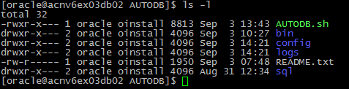
- From the AUTODB directory run AUTODB.sh calling one parameter: ORACLE_SID
  - $ ./AUTODB.sh <ORACLE_SID>

Step 2. Setting the Configuration File

Once the script is executed, the user will be presented with four options.

Figure 1.1
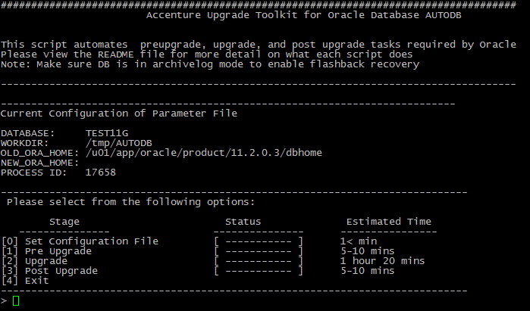

Prior to any database upgrade stages taking place, it is crucial to set a configuration file which stores all database and environment variables. To set configuration file:

- Type 0 to select the option
- The user will be presented with two fields to input:
  - Full absolute path of Oracle Home on target database
  - Email address to send progress notifications.
Figure 1.2 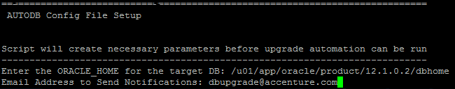

- Once information has been successfully inputted user will be presented with the details of the newly created configuration file
- The configuration file is saved in to the AUTODB/config/param_$ORACLE_SID
- At the end of this stage the user will be brought back to the options menu to continue to the next step
Figure 1.4
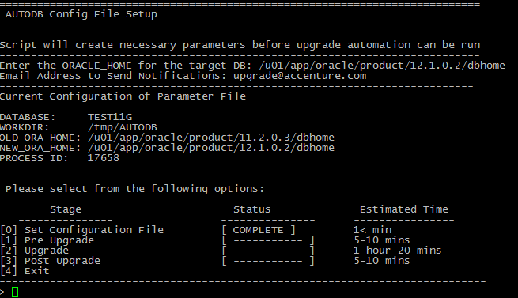

Step 3. Pre-Upgrade Stage

Once the configuration file has been set and saved, the user may proceed to begin the database upgrade process.
- Select Option 1 from menu by typing 1 in the command line
- The user will be presented with a validation prompt
  - Confirm all fields are correct and continue
Figure 2.1 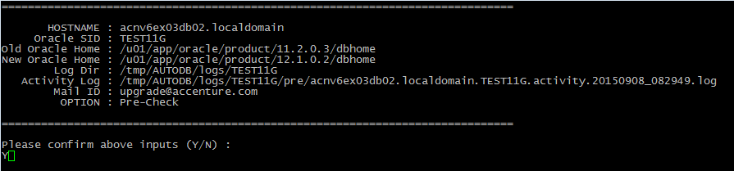

- Upon successful completion of script user is presented with pre-upgrade results and actions required prior to upgrade of database
- Open a new terminal window to view the Oracle prupgrade.log file for any errors and warnings
  - cat ../app/oracle/cfgtoollogs/$ORACLE_SID/preupgrade/preupgrade.log
- Press any key to continue
Figure 2.2
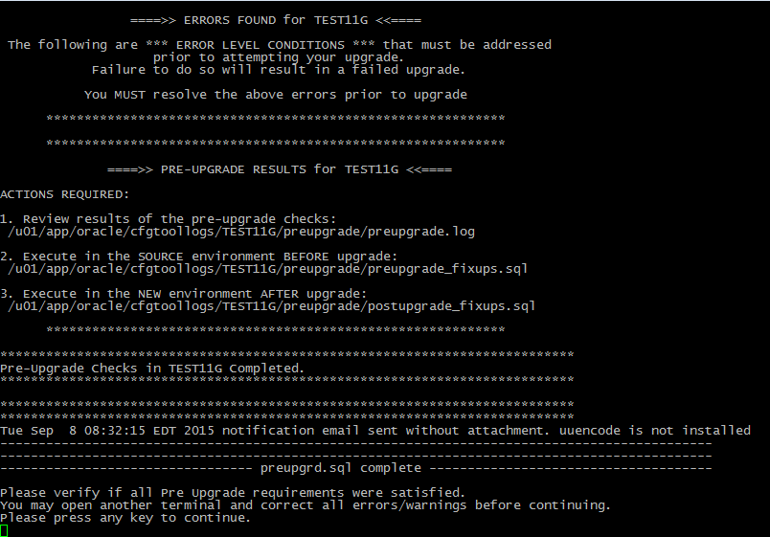

Step 4. Upgrade Stage

Upon successful completion of the pre-upgrade stage, the database is ready to be upgraded. It is critical that all pre-upgrade warnings and errors have been addressed at this point. This stage cannot be repeated or re-run.

- Select option 2 from menu by typing 2 in the command line
- If archivelog is not enabled, user will be given an option to enable
- If flashback is not enabled, user will be given an option to enable
- User will be presented with a confirmation screen prior to executing upgrade script
- Ensure all pre-upgrade steps have been completed and type y to continue
- The upgrade process will begin
Note: A restore point will not be created if flashback is off.

Figure 3.1
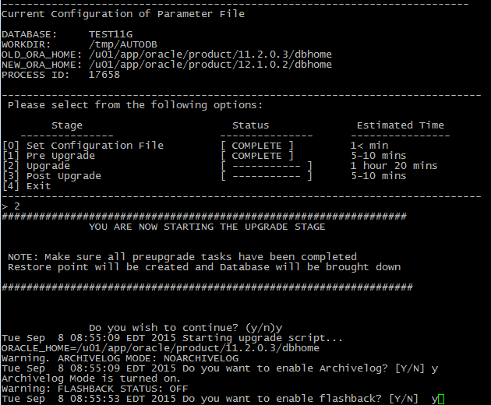

Figure 3.2
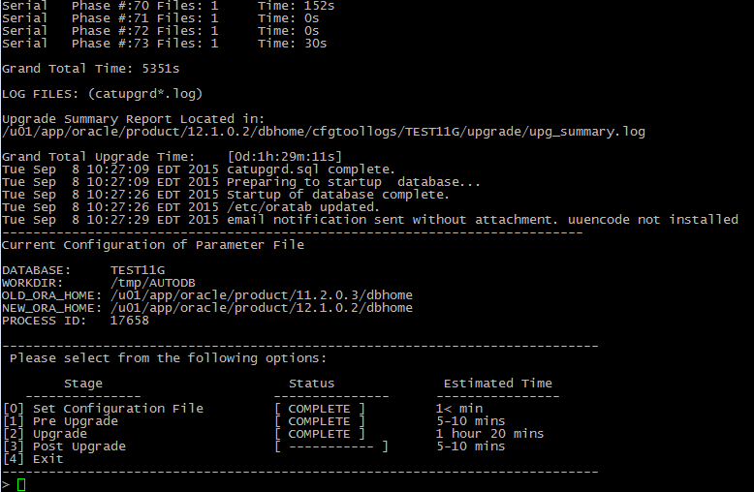
Note: Upgrade takes approximately 1 hour and 20 minutes to complete.
Successful completion of upgrade will yield log: $ORACLE_HOME/cfgtoollogs/$ORACLE_SID/upg_summary.log

Figure 3.3
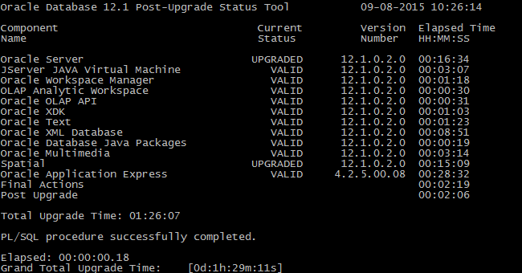

Step 5. Post-Upgrade Stage

After upgrade stage has been completed on the database, the user will be brought back to the options menu in order to continue to the final stage of the database upgrade process.

- Select Option 3 from menu by typing ‘3’ in command line
- The user will be presented with a validation screen
- Confirm credentials by typing ‘y’ and execute script

Figure 4.1
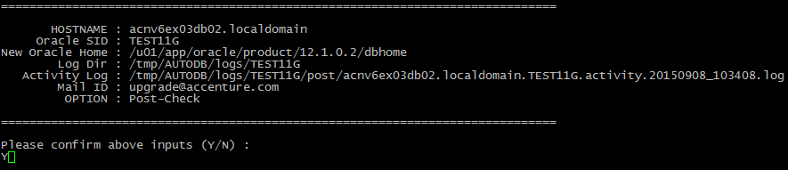

Figure4.2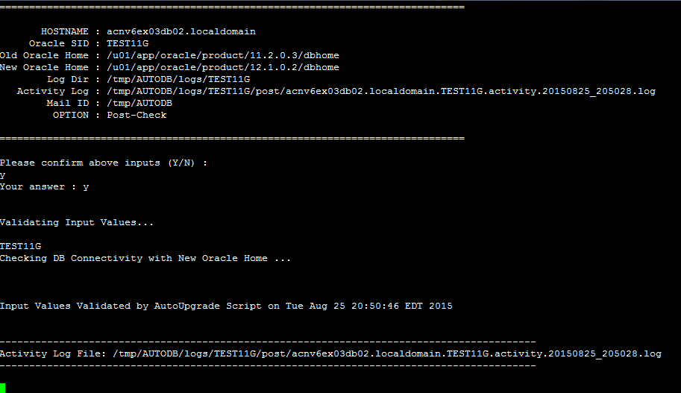

Figure 4.3
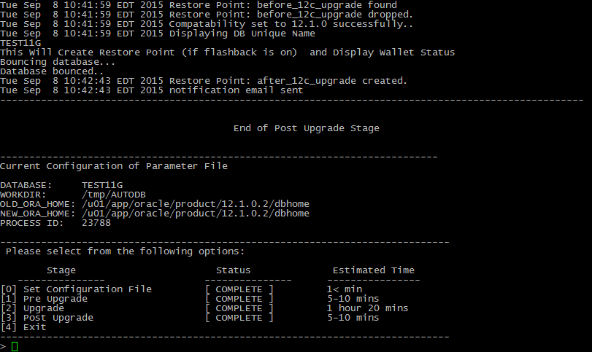
Note: The script takes roughly 5-10 minutes to execute.

- Once stage is completed user will be brought back to main menu screen
- Confirm all stages are marked as ‘COMPLETE’
- Database upgrade is now complete
- Exit utility by typing 4

Figure 4.3
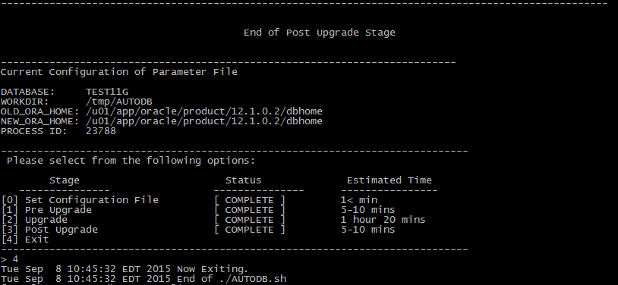

Appendix

Directory Structure

This section outlines the main folders and files of the AUTODB utility

AUTODB Directory

Directory/File | Description
/AUTODB.sh | Main installer file to run utility
/README.txt | Readme file designed to detail each script AUTODB utility calls
/bin | Holds all various shell scripts that are called during the upgrade stages
/logs | Generated logs and outputs are stored in this directory
/config | Configuration files are stored here
/sql | SQL scripts that are called within the upgrade stages are stored here

Bin Directory

File | Description
/bin/setupEnv.sh | Creates the configuration file
/bin/preUpgrade.sh | Called during the pre-upgrade stage Option 1
/bin/Run_preupgrade.sh | Calls Oracle preuprd.sql to be run
/bin/enablearchiveflash.sh | Checks for archive log and flashback allows option to enable
/bin/before_upg_restorepnt.sh | Creates restore point before upgrade during pre-upgrade stage
/bin/shtdwnSrc.sh | Bring source database down
/bin/upgrade.sh | Main upgrade script; calls Oracle catctl.pl and catupgrd.sql to be run
/bin/strtup_Trgt.sh | Starts database on target
/bin/update_oratab.sh | Updates oratab with new 12c Oracle Home value
/bin/post.sh | Calls Oracle defined post-upgrade scripts and /sql/postupg.sql to be run
/bin/post2.sh | Sets 12c compatibility and drops before upgrade restore points
/bin/post3.sh | Bounces the database and creates a restore point after the upgrade
/bin/11g_Env.sh | Sets environment for 11g database
/bin/12c_Env.sh | Sets environment for 12c database

Logs Directory
Directory/File | Description
/logs/$ORACLE_SID | Each database that is being upgraded has separate log
/logs/$ORACLE_SID/pre | All logs created during the pre-upgrade stage are held directory
/logs/$ORACLE_SID/upgrade | All logs created during the upgrade stage are held in this directory
/logs/$ORACLE_SID/post | All logs created during the post-upgrade stage are held in this directory
/logs/$ORACLE_SID/backup | Backups of Oracle files are placed here

SQL Directory
Directory/File | Description
/sql/preUpg.sql | Pre upgrade verification sql script called during pre-upgrade stage
/sql/postUpg.sql | Post upgrade verification sql script called during post upgrade stage

Log Files

All logs are stored under logs/$ORACLE_SID

Pre-Upgrade logs
All pre-upgrade stage logs are stored in logs/$ORACLE_SID/pre

Directory/File | Description
$HOSTNAME.$ORACLE_SID.activity.$TIMESTAMP.log | Activity log file generated from preUpgrade.sh, this log is sent during email notification
$HOSTNAME.$ORACLE_SID.tmp.$TIMESTAMP.log | Activity log tmp file back-up file

Upgrade logs
All upgrade stage logs are stored in logs/$ORACLE_SID/upgrade

Directory/File | Description
flasharchive.log | Log spool generated from enablearchiveflash.sh, checks if flashback is enabled
flashenable.log | Log spool generated from enablearchiveflash.sh, checks if archivelog is enabled
before _12c_restorepoint.log | Log spool generated from before_upg_restorepnt.sh
shtdwnSrc.log | Log spool generated from shtdwnSrc.sh
Upgradesh.log | Log spool generated from upgrade.sh
upgrade.log | Log spool generated from enablearchiveflash.sh
strtuptrg.log | Log spool generated from strtup_Trgt.sh

Post-Upgrade logs
All post upgrade logs are stored in logs/$ORACLE_SID/post

Directory/File | Description
$HOSTNAME.$ORACLE_SID.activity.$TIMESTAMP.log | Activity log file generated from post.sh, this log is sent during email notification
$HOSTNAME.$ORACLE_SID.tmp.$TIMESTAMP.log | Activity log tmp file back-up file
post2$ORACLE_SID_$DT.log | Log spool generated from post2.sh
post2$ORACLE_SID_$DT_check.log | Log spool generated from post2.sh to check if archivelog in order for restore point dropping and creation
post2$ORACLE_SIDcompatible_$DT.log | Log spool from post2.sh for 12.1.0 compatibility setting
post3$ORACLE_SID_$DT.log | Log spool generated from post3.sh
post3_$ORACLE_SID_$DT_checkcl.log | Log spool generated from post3.sh, checks if database is in cluster
Post3$ORACLE_SID_bouncedb_$DT.log | Log spook generated from post3.sh, process when database is bounced after setting compatibility

Note: $DT is date

Scripts

These scripts are located in the bin directory

File | Description
AUTODB.sh | Installer script that runs the AUTODB utility for upgrade
setupEnv.sh | Sets the configuration file and saves output to the config directory
preUpgrade.sh | Checks Oracle Database Vault Status  Checks the Recycle Bin  Checks Time Stamp with Time zone Data  Verifies NLS_NCHAR_CHARACTERSET  List all Control files, Datafiles Tempfiles, Redo Logs files,  Checks Materialized View from Last Refresh  Gathers Data Dictionary Stats  Checks for DB Links  Ensures no files need media recovery or in backup mode  Provides Invalid Object Status Count  Checks for distributed transaction  Checks for Logical Corruption - Analyze object(s)  Checks for Standby Database Configuration  Checks just AUD$ count to estimate the delay  Checks SYS, SYSTEM users default tablespace
Run_preupgrade.sh | Runs Oracle preupgrd.sql from $ORACLE_HOME/rdbms/admin  For details on this script visit Oracle Documentation
enablearchiveflash.sh | Checks for archivelog and flashback and prompts to have user enable them
before_upg_restorpnt.sh | Creates a restore point before 12c upgrade (if flashback is enabled)
shtdwnSrc.sh | Brings down source database prior to running upgrade.sh
upgrade.sh | Calls catctl.pl and catupgrd.sql scripts to upgrade the Oracle database
strtup_Trgt.sh | Starts database on the target environment
update_oratab.sh | Updates oratab file with new entry of the updated Oracle_Home,  Old Oracle_Home is commented out
post.sh | The script calls the following SQL scripts:  $ORACLE_HOME/rdms/admin/catuppst.sql  $ORACLE_HOME/rdbms/admin/utlrp.sql  $ORACLE_BASE/cfgtoollogs/$ORACLE_SID/preupgrade/postupgrade_fixups.sql  $ORACLE_HOME/rdbms/admin/utluiobj.sql  ../AUTODB/sql/postUpg.sql
post2.sh | Drops restore point before 12c upgrade (if flashback is enabled)  Sets compatibility to 12.1.0
post3.sh | Starts database clusters (if on RAC environment)  Creates a restore point after 12c upgrade (if flashback is on)
11g_Env.sh | Profile used to set 11g environment
12c_Env.sh | Profile used to set 12c environment

