**MySQL安装文档**

1. 查看mysql用户：

Id mysql



1. 如不存在则创建：

useradd mysql -s /sbin/nologin –M

3、下载安装包：

Wget https://downloads.mysql.com/archives/get/file/mysql-5.5.31.tar.gz --no-check-certificate

4、安装依赖环境包：

yum install zlib libxml libjpeg freetype libpng gd curl libiconv zlib-devel libxml2-devel libjpeg-devel freetype-devel libpng-devel gd-devel curl-devel curl libxml2 libxml2-devel libmcrypt libmcrypt-devel libxslt* ncurses-devel openssl openssl-devel pcre pcre-devel gcc gcc-c++ dtrace systemtap-sdt-devel make cmake –y

5、解压：

tar -zxf mysql-5.5.31.tar.gz

6、进入解压后的目录并且执行安装预编译：

cd mysql-5.5.31

cmake \

-DCMAKE_INSTALL_PREFIX=/usr/local/mysql-5.5.31 \

-DMYSQL_DATADIR=/usr/local/mysql-5.5.31/data \

-DWITH_INNOBASE_STORAGE_ENGINE=1 \

-DWITH_ARCHIVE_STORAGE_ENGINE=1 \

-DWITH_BLACKHOLE_STORAGE_ENGINE=1 \

-DWITH_PARTITION_STORAGE_ENGINE=1 \

-DWITH_PERFSCHEMA_STORAGE_ENGINE=1 \

-DWITH_FEDERATED_STORAGE_ENGINE=1 \

-DWITH_MEMORY_STORAGE_ENGINE=1 \

-DWITH_READLINE=1 \

-DMYSQL_UNIX_ADDR=/tmp/mysql.sock \

-DMYSQL_TCP_PORT=3306 \

-DENABLED_LOCAL_INFILE=1 \

-DEXTRA_CHARSETS=all \

-DDEFAULT_CHARSET=utf8 \

-DDEFAULT_COLLATION=utf8_general_ci

7、执行make && make install 安装：

make && make install

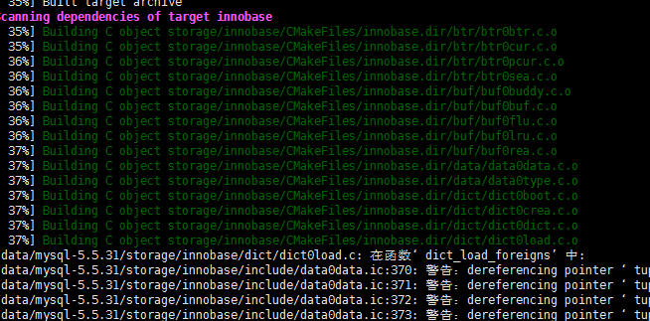

8、进入安装目录初始化数据库：

cd /usr/local/mysql-5.5.31/

chown mysql.mysql data/ -R #更改目录权限

./scripts/mysql_install_db --user=mysql --basedir=/usr/local/mysql-5.5.31 --datadir=/usr/local/mysql-5.5.31/data

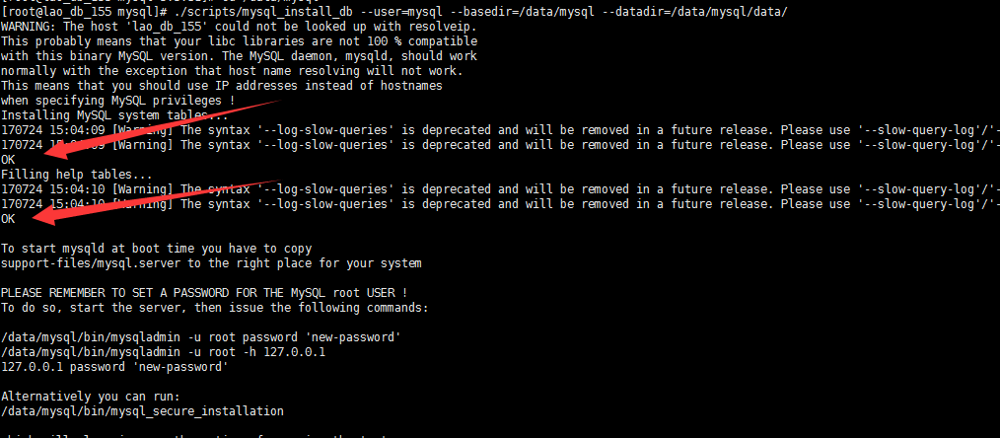

出现2个OK 表示初始化成功~~~~~

可以执行安装脚本mysql_install.sh