USER MANUAL

This section shows the user manual of the DILG Laguna PDMU’s web application. It includes a step-by-step on how to use the system.
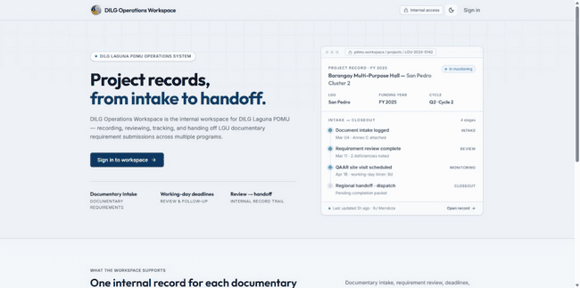
For Provincial Administrator (Admin)
The Provincial Administrator (designated as Admin in the application) possesses province-wide operational authority over project documentary approvals, compliance returns, official notice releases, and inter-agency regional handoffs. This operational role is distinct from PDMU Staff (who verify documents and prepare drafts), Field Officers (who handle assigned-LGU evidence collection), and the System Administrator (who manages technical settings, AI providers, and system diagnostics without operational project access).
Figure 67. The figure above shows the website’s landing page. It is the first thing users will see when they type in the URL of the website.
Step 1. Go to https://dilgpdmu.tech/
Step 2. Press ‘Enter’ to open the site.
Step 3. Click the ‘Sign in to workspace’ button at the left center part of the screen to redirect to the Login page. You can also click the Sign
in at the upper right to Login.
Step 4. Click the ‘moon’ icon on the upper right of the screen to turn
on Dark Mode. Once on Dark Mode, click the ‘sun’ icon to turn back to
Light Mode.
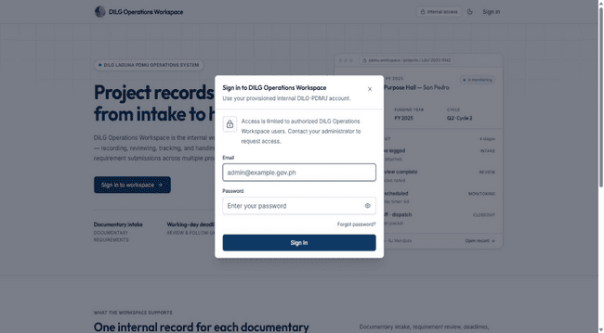
Figure 68. The figure above shows the Login form.
Step 1. Enter your email and password.
Step 2. Once done, click ‘Sign In’ and you will be redirected to the
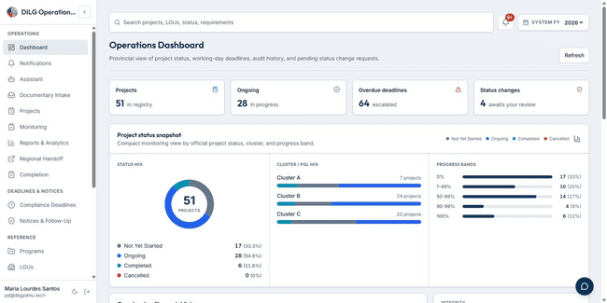
Dashboard of your account.
Figure 69. The Figure above shows the Dashboard of the Admin.
Step 1. Click the arrow beside the FY 2026 to select a Fiscal Year.
Step 2. Click the ‘Search bar’ to search for projects and
requirements within the system.
Step 3. Click ‘Refresh’ to refresh the information shown in the
Dashboard.
Step 4. Click the blue ‘message’ icon in the bottom right to instantly
access the Chatbot Assistant.
Step 5. Click the ‘Assistant’ in the navigation sidebar to view the
Chatbot Assistant.
Step 6. Click the ‘DMS Intake and Review’ to view and upload
the list of documents received through the DMS or Field upload.
Step 7. Click the ‘Project’ to view the list of all projects registered
from all LGUs.
Step 8. Click the ‘Monitoring’ to view major monitoring tools.
Step 9. Click the ‘Reports & Analytics’ to view reports and statuses
across monitored programs and projects.
Step 10. Click the ‘Regional Handoff’ to view and manage the
Regional Drive and push approved requirements.
Step 11. Click the ‘Completion’ to view and track all completion
requirements.
Step 12. Click the ‘Compliance Deadline’ to view all deadlines and
overdue requirements.
Step 13. Click the ‘Notices & Follow-Up’ to prepare reminds and
notices to overdue requirements.
Step 14. Click the ‘Programs’ to see the list of programs monitored.
Step 15. Click the ‘LGUs’ to see the list of LGUs.
Step 16. Click the ‘Archives & Communications’ to view
documentary history.
Step 17. Click the ‘Reference Library’ to view memorandum orders,
circulars, annexes, and reusable templates in one place.
Step 18. Click the ‘Account’ to view your personal account.
Step 19. Click the ‘Clusters’ to view the list of all Clusters, and edit
each Cluster’s information.
Step 20. Click the ‘Users’ to view all the system’s users, as well as
to assign them a role and LGU.
Step 21. Click the ‘Audit Log’ to view system activities.
Step 22. Click the ‘Settings’ to modify system configurations.
Step 23. Click the ‘Log out’ icon on the bottom left, beside ‘moon’
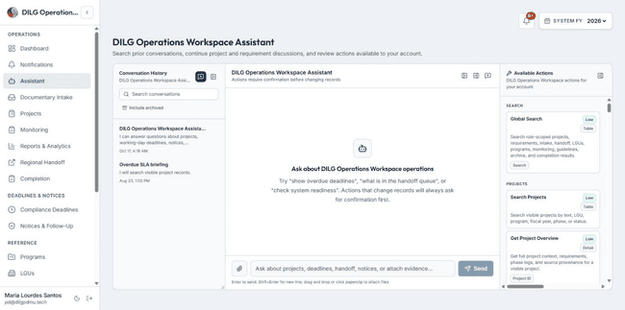
icon to logout from the system.
Figure 70. The figure above shows the Chatbot Assistant.
Step 1. Type in your query on the ‘Text box’.
Step 2. Press ‘Send’ to send the query to the chatbot and wait for
the answer.
Step 3. Press the “message” icon with a + sign to create a new
conversation.
Step 4. Scroll on the left sidebar to view all available actions for the
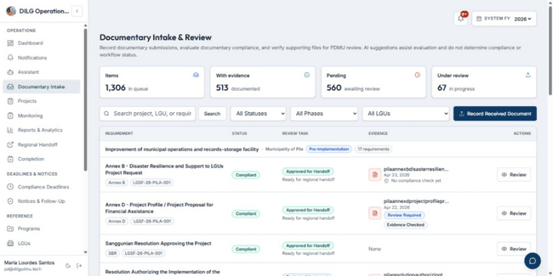
chatbot.
Figure 71. The figure above shows the DMS Intake & Documentary Review.
Step 1. Click the ‘All Statuses’ to filter out the results based on the
document status.
Step 2. Click the ‘All Phases’ to filter out the results based on the
project phase.
Step 3. Click the ‘All LGUs’ to filter out the results based on the
LGU.
Step 4. Click the ‘Record Received Document’ to open the Smart
Document Intake.
Step 5. Click the ‘Upload’ to manually upload a documentary
requirement to a specific requirement.
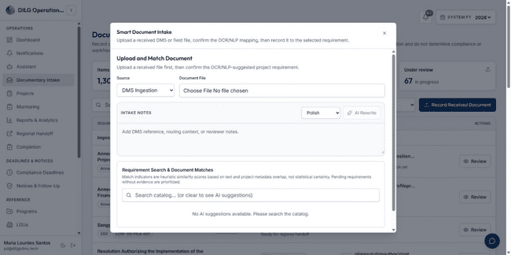
Figure 72. The figure above shows the Smart Document Intake where the Admin can upload documents.
Step 1. Click the ‘Source’ dropdown to pick the source of the
uploaded document.
Step 2. Click the ‘Choose File’ under the Document File to open the
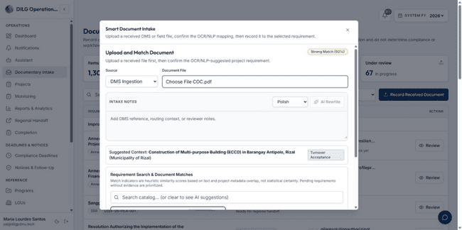
device’s file manager and browse documents to be uploaded.
Figure 73. The figure above shows the Requirement Search & AI Suggestions.
Step 1. After a document is uploaded, the system will scan the
document to search for matching requirements.
Step 2. The system will show a list of matching requirements. The
user has the ability to pick which matching document the uploaded
file belongs to.
Step 3. Scroll down and press the ‘Record to Selected Requirement’
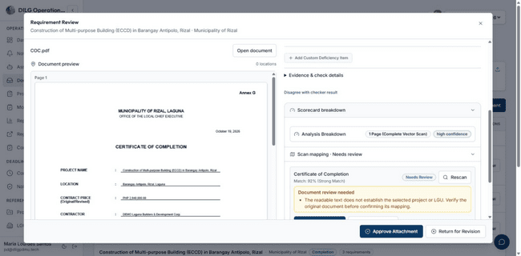
to upload the document.
Figure 74. The figure above shows the Requirement Review Modal.
Step 1. Press the ‘Review’ button for all documentary requirements
under the ‘Under Review’ status.
Step 2. The Requirement Review modal will appear.
Step 3. Click the ‘Run Checker’ to make the system scan the
document and check if it matches the requirement.
Step 4. Click the ‘Approve Attachment’ to approve the submitted
document.
Step 5. Click the ‘Return for Revision’ to return the requirement to
the field officer for revision.
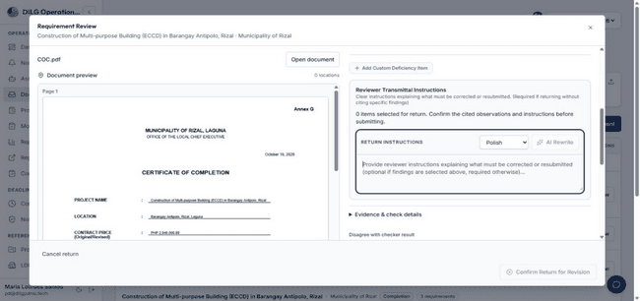
Figure 75. The figure above shows the Return Notes when the user clicks the ‘Return for Revision’ button.
Step 1. Type in the Text box to attach notes in regards to what is
needed to be revised in the submitted file.
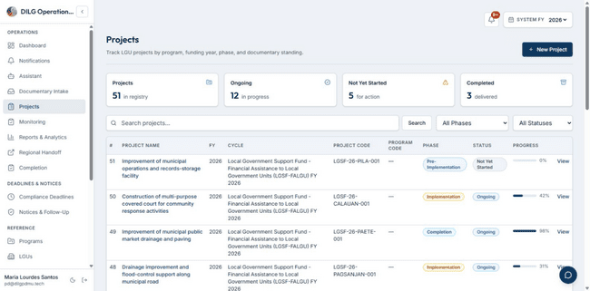
Step 2. Click the ‘Confirm Return’ to finalized the document return.
Figure 76. The figure above is the Projects. It displays the list of projects under all the LGUs.
Step 1. Click the ‘All Statuses’ to filter out the results based on the
document status.
Step 2. Click the ‘All Phases’ to filter out the results based on the
project phase.
Step 3. Click the ‘All LGUs’ to filter out the results based on the
LGU.
Step 4. Click the ‘New Project’ button on the top to enroll a new
project.
Step 5. Fill up all the needed information for the project and click
the ‘Enroll Project’.
Step 6. Back to the main Projects page. Click the ‘View’ button on
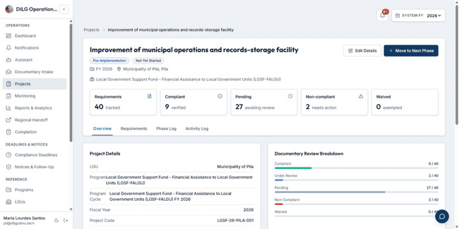
the right side of the project names to view the details of the project.
Figure 77. The figure above shows the Project Details and other information regarding the project.
Step 1. Click the ‘Edit Details’ to update the current information
regarding the project.
Step 2. Click the ‘Move to Next Phase’ to move the project to the
next project phase.
Step 3. Click the ‘Requirements’ tab to view all documentary
requirements under the project.
Step 4. Click the ‘Phase Log’ when a project transitioned to a phase. Step 5. Click the ‘Activity Log’ to view all activities done to the
project.
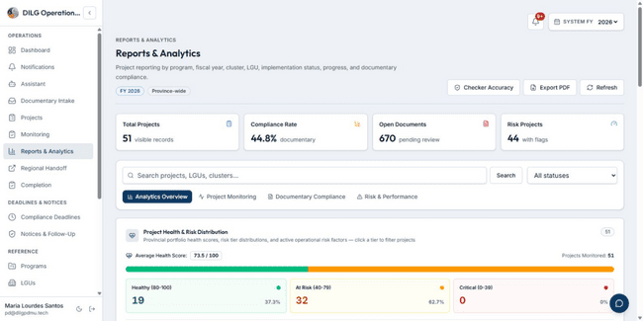
Figure 78. The figure above shows the Reports & Analytics page.
Step 1. Click the ‘Project Monitoring’ tab to all analytics per
project.
Step 2. Click the ‘Documentary Compliance’ tab so see the status
breakdown across all projects.
Step 3. Click the ‘Risk & Performance’ tab to view the risk health
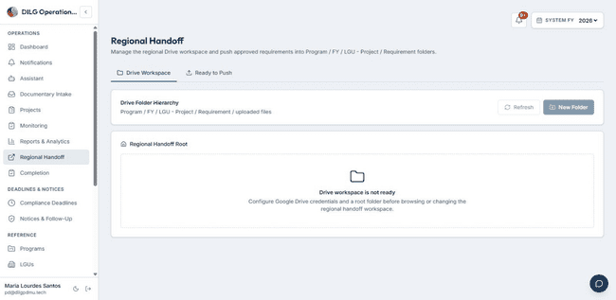
of each project.
Figure 79. The figure above shows the Regional Handoff for approved documentary requirements that can now be submitted to the Google Drive shared with the regional office.
Step 1. Click the ‘New Folder’ to add a new folder.
Step 2. Click the ‘Ready to Push’ tab to view the list of documentaries
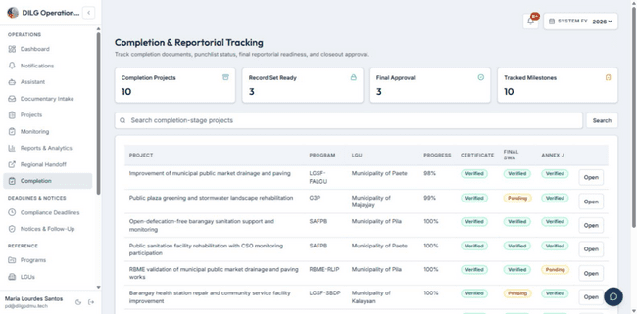
requirements ready to be pushed to the Google Drive.
Figure 80. The figure above shows the Completion which tracks all completion documents.
Step 1. Click ‘Open’ on the side of the projects to see the list of
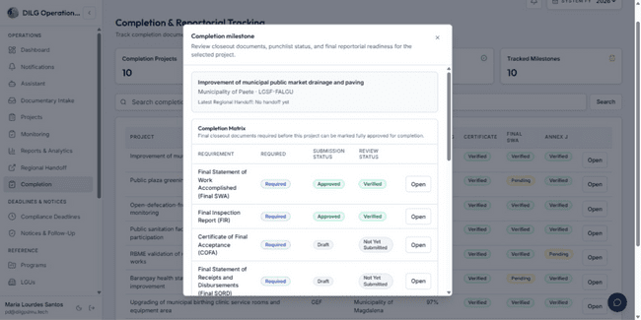
completion documents.
Figure 81. The figure above shows the Completion Milestone for the selected project.
Step 1. Click the ‘Open’ to view the uploaded documentary
evidence.
Step 2. Scroll down to view other information in regards to the
completion requirements.
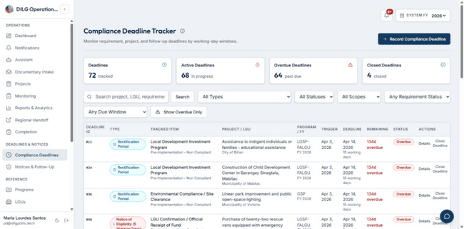
Step 3. Click the ‘Save Completion Record’ to save the changes.
Figure 82. The figure above shows the Compliance Deadlines that shows all requirement deadlines.
Step 1. Click the ‘New Compliance Deadline’ to set a deadline to a
specific project requirement. Fill up all the needed information and
click ‘Create Deadline’ so save the new deadline.
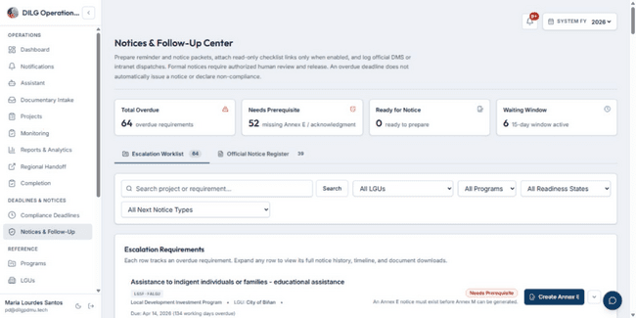
Step 2. Click the ‘Resolve’ button beside the requirement to resolve.

Figure 83. The figure above shows the Notices & Follow-up page.
Step 1. Click the ‘Open Latest’ to see the latest given notice to a
document.
Step 2. Click the ‘Prepare Annex M’ to prepare the annex.
Step 3. Click the ‘Create Annex E’ to create the annex.
Step 4. Scroll down to see all the Notices for Projects.
Step 5. Click ‘Edit’ to edit the content of the notices. Click the ‘Save
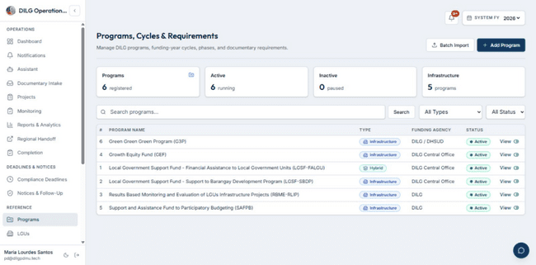
Notice’ to save the changes.
Figure 84. The figure above shows the Programs, which lists all the programs being monitored.
Step 1. Click the ‘Batch Import’ to import a CSV or XLSX file and
import multiple program details.
Step 2. Click the ‘Add Programs’ to add a new program. Fill in the
required information and click ‘Create Program’
Step 3. Click the ‘View’ to view the program information.
Step 4. Within the program information. Click the ‘Add Cycle’ to
add a new cycle to the program.
Step 5. Within the program information. Click the ‘Import’ to
import a CSV or XLSX file for that specific program.
Step 6. Within the program information. Click the ‘Workbook’ to
view the uploaded CSV or XLSX file.
Step 7. Within the program information. Click the ‘Add Phase’ to
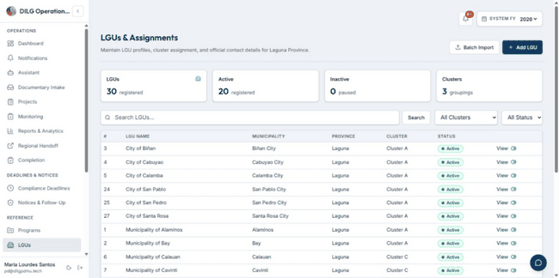
add a new phase to the program.
Figure 85. The figure above shows the LGUs, which displays the list of all LGUs.
Step 1. Click the ‘Add LGU’ to add an LGU and fill in all the needed
information before clicking ‘Save LGU Profile’ to save.
Step 2. Click ‘View’ to view the LGU’s details.
Step 3. Within the LGU details. Click the ‘Edit Profile’ to edit the
information of the LGU. Click ‘Deactivate’ to deactivate the LGU.

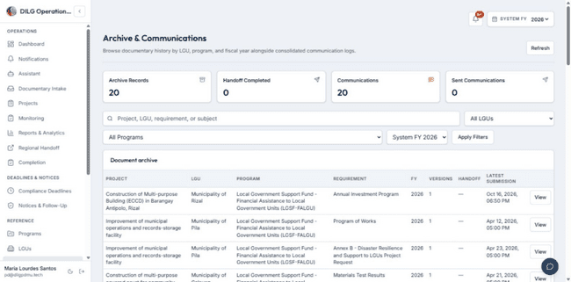
Figure 86. The figure above shows the Archive & Communications that displays all document history.
Step 1. Click the ‘View’ button on the right to view the Document
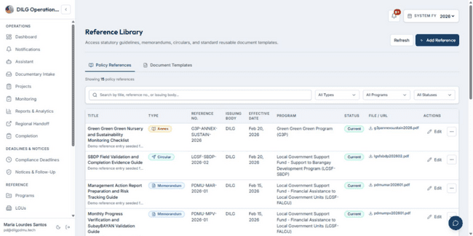
Version Record.
Figure 87. The figure above shows the Reference Library. It shows the references for memorandums, circular orders, and annexes.
Step 1. Click the ‘Add’ to add a new reference or template in the
system.
Step 2. Click the ‘Checker’ to check the reference profile.
Step 3. Click the ‘Edit’ to edit the reference.
Step 4. Click the ‘Delete’ to delete the reference.
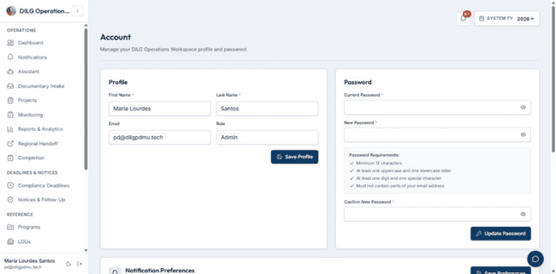
Figure 88. The figure above shows the Account page.
Step 1. To change Profile info, edit First Name and Last Name.
Note that Email and Role are read-only. Press 'Save Profile' to save changes.
Step 2. To the change the password. Fill in your current password, and
then fill in your new password in the two text boxes. Click ‘Update
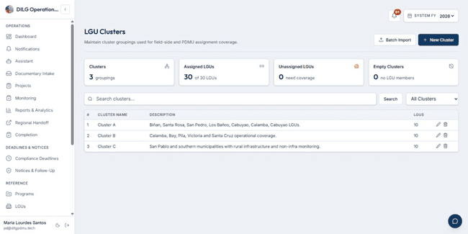
Password’ to save the new one.
Figure 89. The figure above shows the Clusters list.
Step 1. Click the ‘New Cluster’ to add a new cluster.
Step 2. Click the ‘Pen’ icon to edit a cluster.
Step 3. Click the ‘Trash’ icon to delete a cluster.
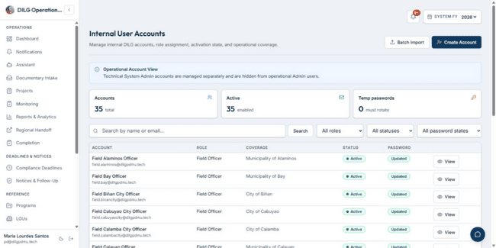
Figure 90. The figure above shows the Users list.
Step 1. Click the ‘Create Account’ to create a new user account.
Step 2. Click the ‘Batch Import’ to import a CSV or XLSX file that
contains multiple account information.
Step 3. Click the ‘View’ to view an account’s information. You can
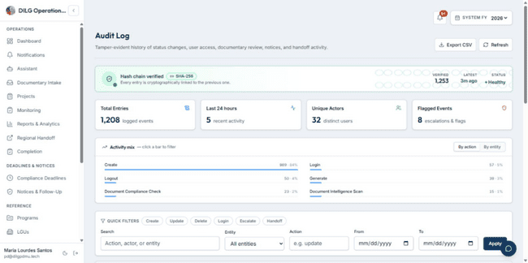
change the role and LGU assignment in it.
Figure 91. The figure above shows the Audit Log for the system. It shows all actions
within the system.
Step 1. Click the ‘Export CSV’ to export the audit logs into an Excel
file.
Step 2. Click the ‘Details’ on the right of an audit log to view the
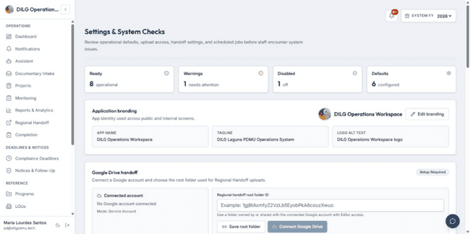
details.
Figure 92. The figure above shows the Settings of the system.
Step 1. Click the ‘Edit Branding’ to edit the app name, logo, browser
icon, and app tagline.
Step 2. Click the ‘Connect Google Drive’ to connect a Google Drive
for the Regional Handoff.

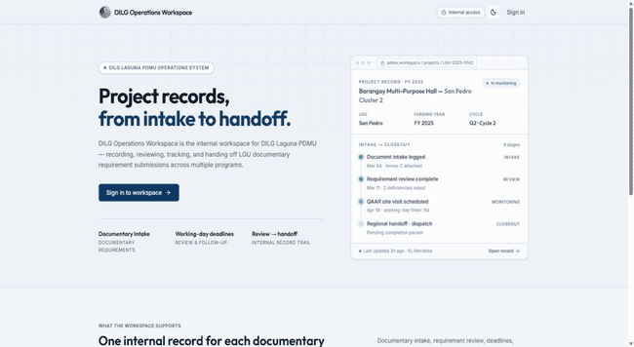
For Staff
Figure 93. The figure above shows the Landing Page.
Step 1. Open your web browser and enter the DILG Laguna PDMU
web application URL.
Step 2. The Landing Page displays a 'Sign In' button.
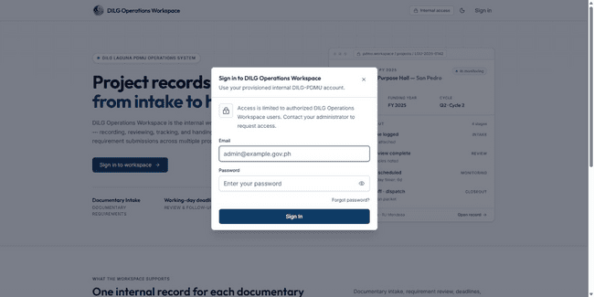
Step 3. Click 'Sign In' to proceed to the Login page.

Figure 94. The figure above shows the Login form.
Step 1. Enter your email and password.
Step 2. Once done, click ‘Sign In’ and you will be redirected to the
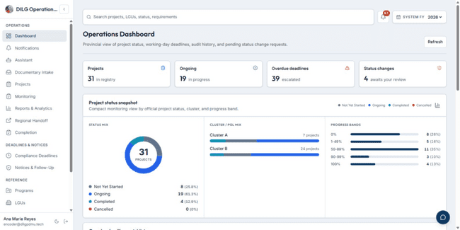
Dashboard of your account.
Figure 95. The figure above shows the Dashboard for Staff.
Step 1. View the fiscal year selector at the top of the Dashboard.
Step 2. Click the fiscal year dropdown to select a different fiscal year.
Step 3. View the 'Status Summary' section showing project statuses
within your assigned cluster.
Step 4. View the 'Cluster Status Summary' showing your assigned
cluster statistics.
Step 5. View the 'Progress Bands' section displaying project completion
percentages.
Step 6. View the 'Action Summary' section showing monitoring action
items.
Step 7. View the 'SLA Summary' section displaying compliance
deadline information.
Step 8. View the 'Monitoring Summary' section showing monitoring
workbench data.
Step 9. Click 'Refresh' to update the Dashboard information.
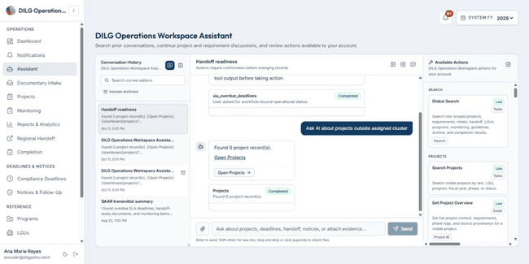
Figure 96. The figure above shows the Chatbot Assistant Page.
Step 1. Click 'Assistant' in the sidebar to open the AI Assistant page. Step 2. Type your question or request in the message input field.
Step 3. Click the send button to submit your message.
Step 4. View the assistant's response in the conversation area.
Step 5. The assistant can search for projects, retrieve requirement details, and provide information about documents within your assigned cluster scope.
Step 6. Review any tool confirmation requests before approving actions.

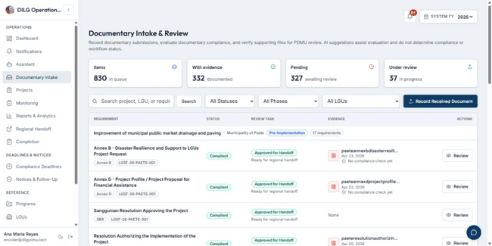
Figure 97. The figure above shows the Documentary Intake Queue.
Step 1. Click 'Documentary Intake' in the sidebar.
Step 2. View the list of submitted requirements awaiting review from
projects in your assigned cluster.
Step 3. Use the 'Search' field to filter requirements by project name or
requirement name.
Step 4. Filter by status using the 'Status' dropdown.
Step 5. Click on a requirement row to view requirement details and
uploaded documents.
Step 6. Review the uploaded document files.
Step 7. Run the Document Checker to verify compliance if applicable.
Step 8. Verify the requirement by clicking 'Verify' if it meets standards.
Step 9. Approve the requirement by clicking 'Staff Approve' to advance
it to Provincial Admin review.
Step 10. Return the requirement for revision by clicking 'Return' if deficiencies are found.

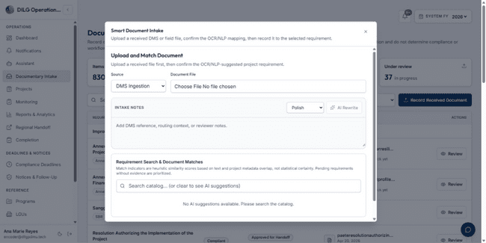
Figure 98. The figure above shows the Smart Document Intake modal for recording received documents with AI-assisted requirement matching.
Step 1. Navigate to the Documentary Intake page.
Step 2. Click 'Record Received Document' button to open the Smart
Document Intake modal.
Step 3. Click 'Choose File' and select the document file.
Step 4. Click 'Preview' to run OCR and NLP analysis on the document.
Step 5. Review the AI-suggested requirement matches displayed in the
modal.
Step 6. Use the requirement search field to find alternative requirements
if needed.
Step 7. Select the appropriate requirement from the suggestions or search results.
Step 8. Click 'Submit' to create the submission with the matched
requirement.
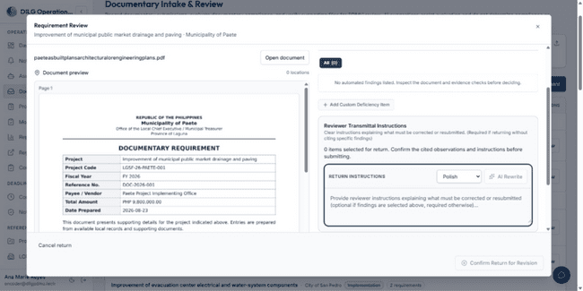
Figure 99. The figure above shows the Return for Revision action within the Requirement Review Modal.
Step 1. Open a requirement from the Documentary Intake queue.
Step 2. Review the uploaded document and requirement details.
Step 3. Click the 'Return' button to initiate the return action.
Step 4. Enter revision notes explaining what needs to be corrected.
Step 5. Confirm the return action.
Step 6. The requirement status changes to 'returned' and the LGU or
Field Officer is notified.
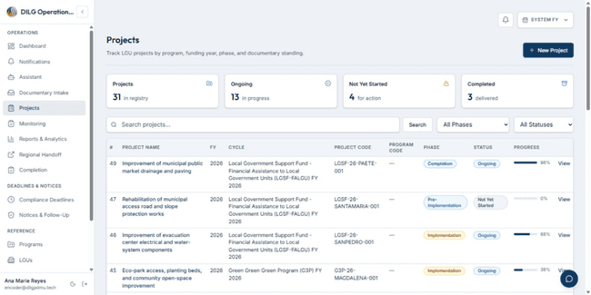
Figure 100. The figure above shows the Projects List Page for Staff.
Step 1. Click 'Projects' in the sidebar.
Step 2. View the list of projects from your assigned cluster.
Step 3. Use the 'Search' field to filter projects by name or code.
Step 4. Filter by fiscal year using the fiscal year dropdown.
Step 5. Filter by status using the 'Status' dropdown.
Step 6. Filter by phase using the 'Phase' dropdown.
Step 7. Filter by program using the 'Program' dropdown.
Step 8. Click on a project row to open the Project Details page.

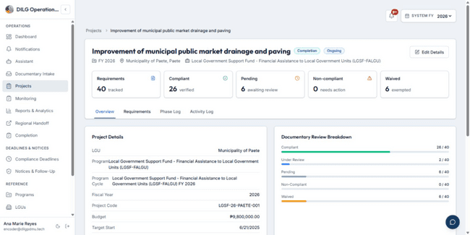
Figure 101. The figure above shows the Project Details Page.
Step 1. Open a project from the Projects list.
Step 2. View the project name, code, and overall status at the top of the
page.
Step 3. View the project LGU, program, fiscal year, and phase
information.
Step 4. View the project timeline including start date and target
completion date.
Step 5. View the physical completion percentage.
Step 6. Scroll to the 'Documentary Requirements' section.
Step 7. View the list of requirements assigned to the project.
Step 8. Click on a requirement to view requirement details.
Step 9. View the requirement status, last updated date, and assigned
phase.
Step 10. Upload a document for a requirement by clicking 'Upload' if
permitted.
Step 11. Review submitted documents by clicking 'View Submissions'.
Step 12. View the project activity log at the bottom of the page showing
recent actions.
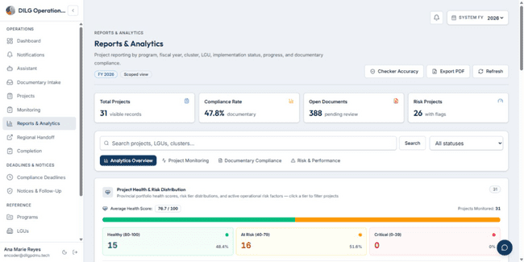
Figure 102. The figure above shows the Reports and Analytics Page.
Step 1. Click 'Reports & Analytics' in the sidebar.
Step 2. Select a fiscal year from the fiscal year dropdown.
Step 3. View the 'Executive Summary' section showing key metrics for your assigned cluster.
Step 4. View the 'Project Status Distribution' chart.
Step 5. View the 'Documentary Compliance' section showing requirement statuses.
Step 6. View the 'SLA Performance' section displaying deadline adherence.
Step 7. View the 'Cluster Performance' table showing statistics by cluster.
Step 8. Click 'Export to PDF' to generate a PDF report.
Step 9. Click 'Export to Excel' to download an Excel file with detailed data.
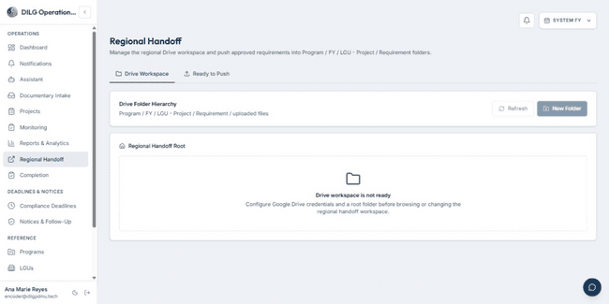
Figure 103. The figure above shows the Regional Handoff Page.
Step 1. Click 'Regional Handoff' in the sidebar.
Step 2. View the list of projects eligible for regional handoff from your assigned cluster.
Step 3. Filter by fiscal year using the fiscal year dropdown.
Step 4. Filter by program using the 'Program' dropdown.
Step 5. Select projects to include in the handoff package using the checkboxes.
Step 6. Click 'Prepare Handoff Package' to generate the handoff documentation.
Step 7. Review the generated handoff package.
Step 8. Click 'Submit to Regional Office' to complete the handoff process
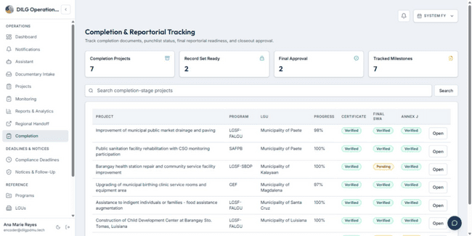
Figure 104. The figure above shows the Completion Page.
Step 1. Click 'Completion' in the sidebar.
Step 2. View the list of projects in the completion phase from your assigned cluster.
Step 3. Use the 'Search' field to filter projects.
Step 4. Filter by fiscal year using the fiscal year dropdown.
Step 5. Click on a project row to open the project completion details.
Step 6. View the completion milestone information within the Project Details page.
Step 7. View closeout requirements and their statuses.
Step 8. Upload closeout documents if required.
Step 9. Review the completion status and any pending actions.
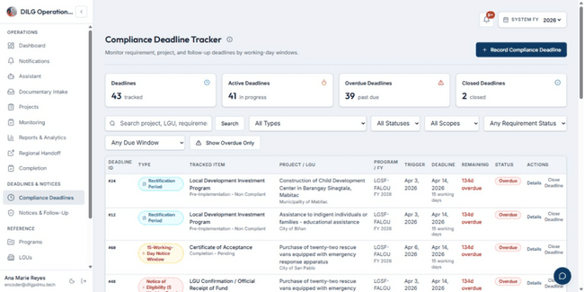
Figure 105. The figure above shows the Compliance Deadlines Page.
Step 1. Click 'Compliance Deadlines' in the sidebar.
Step 2. View the SLA Dashboard showing deadline statistics for your assigned cluster.
Step 3. View the 'Overdue' count showing deadlines that have passed.
Step 4. View the 'Due Soon' count showing deadlines approaching within the next 7 working days.
Step 5. View the 'All Deadlines' section listing all compliance deadlines.
Step 6. Filter deadlines by project using the 'Project' dropdown.
Step 7. Filter by deadline type using the 'Type' dropdown.
Step 8. Filter by status using the 'Status' dropdown.
Step 9. Click on a deadline row to view deadline details.
Step 10. Click 'Resolve' on an overdue deadline to mark it as resolved.
Step 11. Enter resolution notes and click 'Submit' to complete the resolution.
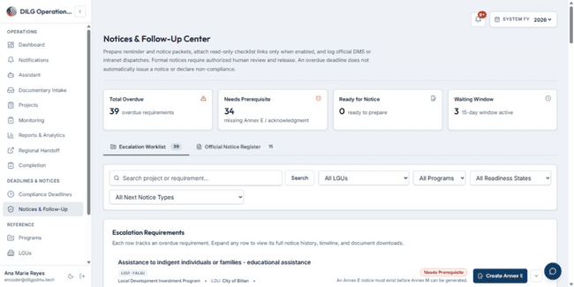
Figure 106. The figure above shows the Notices and Follow-Up Page.
Step 1. Click 'Notices & Follow-Up' in the sidebar.
Step 2. View the escalation dashboard showing compliance breach statistics for your assigned cluster.
Step 3. View the list of escalation notices.
Step 4. Filter notices by status using the 'Status' dropdown.
Step 5. Filter by notice type using the 'Type' dropdown.
Step 6. Click on a notice row to view notice details.
Step 7. Click 'Create Notice' to generate a new escalation notice.
Step 8. Select the project and deadline to escalate.
Step 9. Use AI-assisted drafting to generate notice content.
Step 10. Review and edit the notice content.
Step 11. Click 'Generate Document' to create the notice document.
Step 12. Note: Staff can create and prepare notices but require Admin approval to release them.
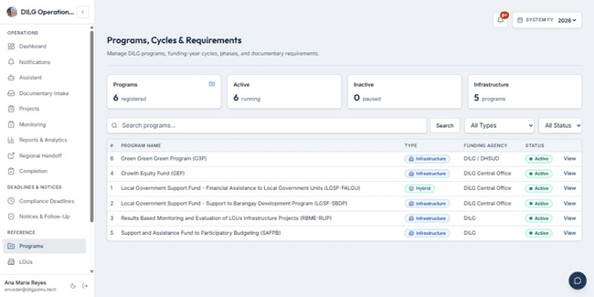
Figure 107. The figure above shows the Programs Page.
Step 1. Click 'Programs' in the sidebar.
Step 2. View the list of active programs.
Step 3. Use the 'Search' field to filter programs by name.
Step 4. Filter by fiscal year using the fiscal year dropdown.
Step 5. Click on a program row to open the Program Details page.
Step 6. View program information including name, type, and active status.
Step 7. View program cycles and their associated projects.
Step 8. View program guidelines and reference materials.
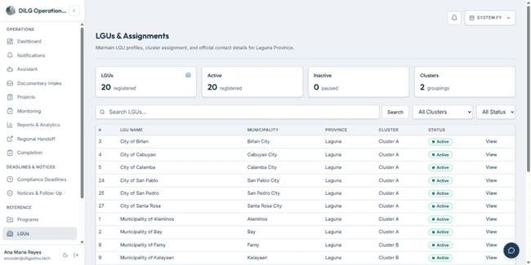
Figure 108. The figure above shows the LGUs Page for Staff.
Step 1. Click 'LGUs' in the sidebar.
Step 2. View the list of LGUs in your assigned cluster.
Step 3. Use the 'Search' field to filter LGUs by name or municipality.
Step 4. Filter by cluster using the 'Cluster' dropdown.
Step 5. Click on an LGU row to open the LGU Details page.
Step 6. View LGU information including name, municipality, province, and contact details.
Step 7. View the list of projects assigned to the LGU.
Step 8. View project counts and requirement statistics for the LGU.
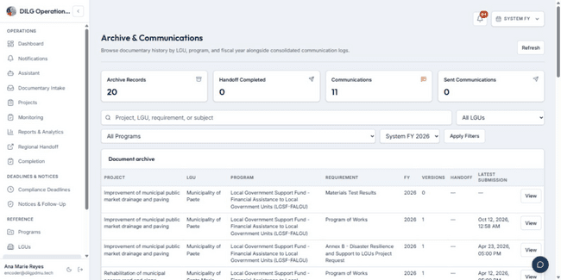
Figure 109. The figure above shows the Archive and Communications Page.
Step 1. Click 'Archive & Communications' in the sidebar.
Step 2. View the list of communication logs for your assigned cluster.
Step 3. Filter by LGU using the 'LGU' dropdown.
Step 4. Filter by communication type using the 'Type' dropdown.
Step 5. Filter by date range using the date filters.
Step 6. Click on a communication log to view details.
Step 7. View the communication content, date, recipient, and status.
Step 8. Download attached documents if available.
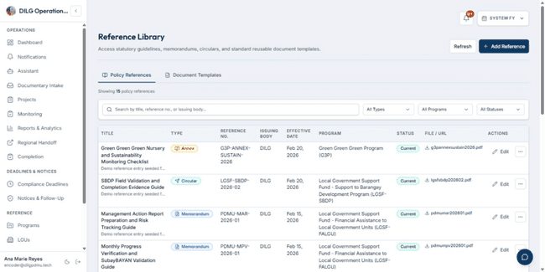
Figure 110. The figure above shows the Reference Library Page.
Step 1. Click 'Reference Library' in the sidebar.
Step 2. View the library catalog showing available templates and guides.
Step 3. Use the 'Search' field to find documents by title or keyword.
Step 4. Filter by category using the 'Category' dropdown.
Step 5. Click on a document to view document details.
Step 6. Click 'Download' to download the document file.
Step 7. View document metadata including version, upload date, and description.
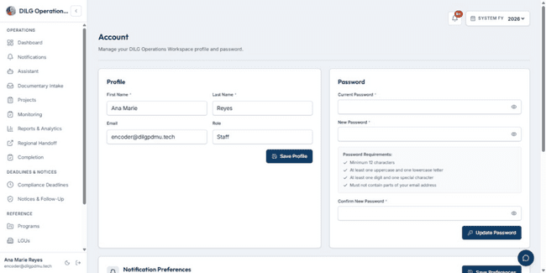
Figure 111. The figure above shows the Account Page.
Step 1. Click 'Account' in the sidebar.
Step 2. View account info (Name, and read-only Email and Role).
Step 3. View your assigned cluster information.
Step 4. Click 'Change Password' to update your password.
Step 5. Enter your current password in the 'Current Password' field.
Step 6. Enter your new password in the 'New Password' field.
Step 7. Re-enter your new password in the 'Confirm Password' field.
Step 8. Click 'Update Password' to save the new password.
Step 9. View your notification preferences and update them if needed.

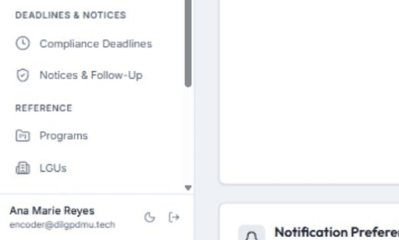
Figure 112. The figure above shows the Logout icon in the sidebar.
Step 1. Click the logout icon in the sidebar at the bottom of the screen.
Step 2. You will be logged out and redirected to the Landing Page.

For Field Officer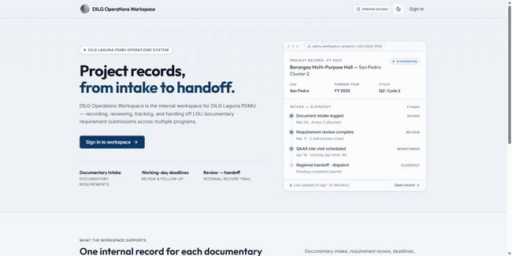
Figure 113. The figure above shows the Landing Page.
Step 1. Open your web browser and enter the DILG Laguna PDMU web application URL.
Step 2. The Landing Page displays a 'Sign In' button.
Step 3. Click 'Sign In' to proceed to the Login page.
Figure 114. The figure above shows the Login form.
Step 1. Enter your email and password.
Step 2. Once done, click ‘Sign In’ and you will be redirected to the Dashboard of your account.
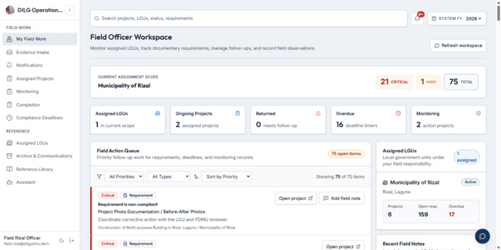
Figure 115. The figure above shows the Field Officer Workspace Dashboard.
Step 1. View your current assignment scope displaying your assigned LGUs at the top of the page.
Step 2. View the action priority counters showing critical, high, and total action items.
Step 3. View the 'Assigned LGUs' KPI showing the number of LGUs assigned to you.
Step 4. View the 'Ongoing Projects' KPI showing active projects in your assigned LGUs.
Step 5. View the 'Returned' KPI showing requirements that need follow-up.
Step 6. View the 'Overdue' KPI showing deadline timers that have passed.
Step 7. View the 'Monitoring' KPI showing monitoring action projects.
Step 8. Scroll to the 'Field Action Queue' section to view your priority work items.
Step 9. Click 'Refresh workspace' to update the dashboard information.
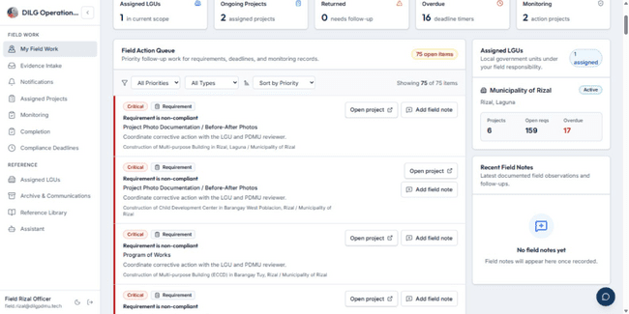
Figure 116. The figure above shows the Field Action Queue.
Step 1. View the Field Action Queue displaying priority follow-up work for requirements, deadlines, and monitoring records.
Step 2. Use the 'All Priorities' dropdown to filter action items by priority.
Step 3. Use the 'All Types' dropdown to filter by action type.
Step 4. Use the 'Sort by' dropdown to change the sort order.
Step 5. Click 'Clear filters' to reset all filters.
Step 6. View each action item showing priority badge, type icon, due date, title, and description.
Step 7. Click 'Open project' to view the full project details for an action item.
Step 8. Click 'Add field note' to record a field observation or follow-up note for a requirement.
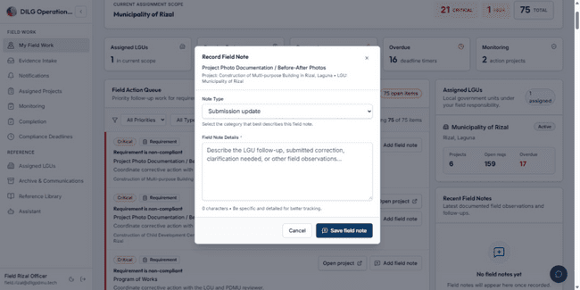
Figure 117. The figure above shows the Add Field Note Modal.
Step 1. Click 'Add field note' on an action item in the Field Action Queue.
Step 2. The modal opens showing the requirement name and project information.
Step 3. Select the note type from the 'Note Type' dropdown.
Step 4. Enter your field observation in the 'Field Note' text area.
Step 5. Click 'Save field note' to record the note.
Step 6. The note is saved and appears in the Recent Field Notes section.
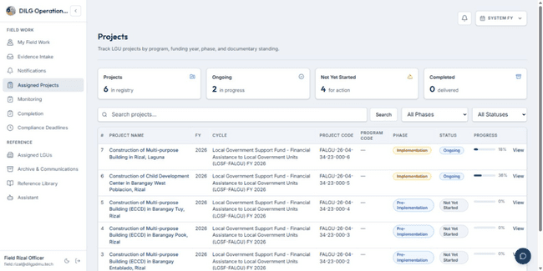
Figure 118. The figure above shows the Assigned Projects Page.
Step 1. Click 'Assigned Projects' in the sidebar.
Step 2. View the list of projects from your assigned LGUs.
Step 3. Use the 'Search' field to filter projects by name or code.
Step 4. Filter by fiscal year using the fiscal year dropdown.
Step 5. Click on a project row to open the Project Details page.
Step 6. View project status, phase, and completion percentage.

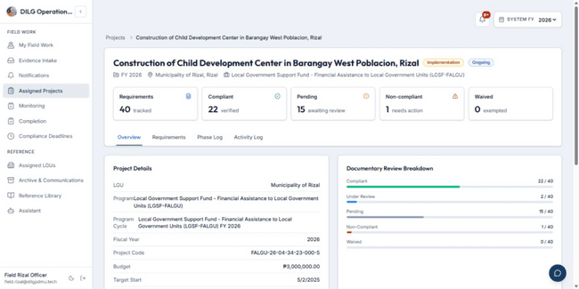
Figure 119. The figure above shows the Project Details Page for Field Officer.
Step 1. Open a project from the Assigned Projects list.
Step 2. View the project name, code, and overall status.
Step 3. View the project LGU, program, and phase information.
Step 4. Scroll to the 'Documentary Requirements' section.
Step 5. View the list of requirements assigned to the project.
Step 6. Click on a requirement to view requirement details.
Step 7. View the requirement status and last updated date.
Step 8. Click 'Upload Document' to upload evidence for a requirement.
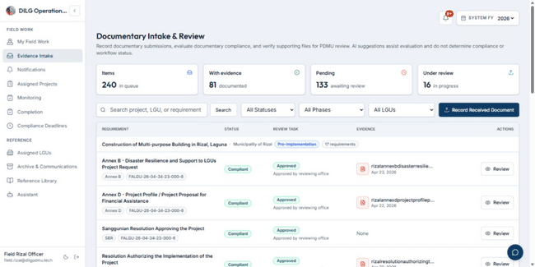
Figure 120. The figure above shows the Evidence Intake Page.
Step 1. Click 'Evidence Intake' in the sidebar.
Step 2. Select a project from the 'Project' dropdown (shows assigned LGU projects only).
Step 3. Select a requirement from the 'Requirement' dropdown.
Step 4. Click 'Choose File' to select the document file from your computer.
Step 5. Select the file type from the 'File Type' dropdown if applicable.
Step 6. Enter a description in the 'Description' field if applicable.
Step 7. Click 'Upload Document' to submit the document.
Step 8. The document is uploaded and associated with the selected requirement.
Step 9. The requirement status changes to 'submitted' and is forwarded to the Provincial Office for review.
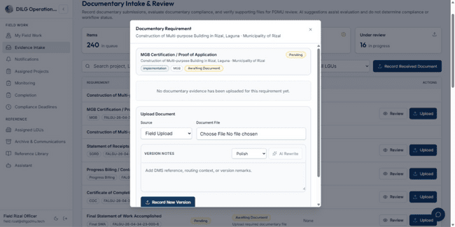
Figure 121. The figure above shows the Upload Document Modal.
Step 1. Open a project and navigate to a requirement that needs a document.
Step 2. Click the 'Upload' button for the requirement.
Step 3. The upload modal opens.
Step 4. Click 'Choose File' to browse your computer for the document.
Step 5. Select the document file and click 'Open'.
Step 6. The file name appears in the upload field.
Step 7. Enter any additional notes in the 'Notes' field if applicable.
Step 8. Click 'Submit' to upload the document.
Step 9. The document is uploaded and the requirement status is updated.
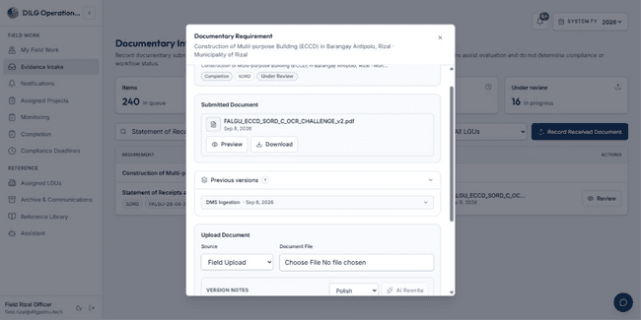
Figure 122. The figure above shows the View Submissions Page.
Step 1. Open a requirement that has uploaded documents.
Step 2. Click 'Previous Versions' to view the submission history.
Step 3. View the list of Previous versions.
Step 4. View the submission date, uploader name, and status for each version.
Step 5. Click 'Download' to download a submission file.
Step 6. View any review notes or deficiencies attached to the submission.

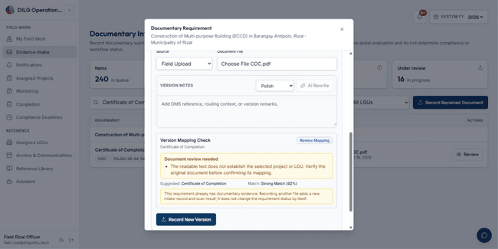
Figure 123. The figure above shows the Replace Document Modal.
Step 1. Open a returned requirement that needs a corrected document.
Step 2. Click 'Choose File' to select the corrected document from your computer.
Step 3. Enter any notes explaining the corrections in the 'Notes' field.
Step 4. Click 'Submit' to upload the corrected document.
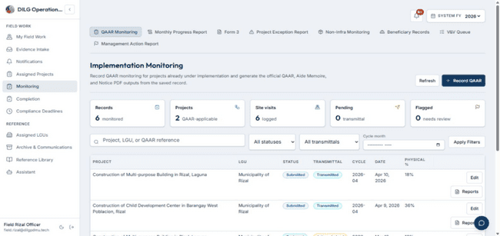
Figure 124. The figure above shows the Monitoring Page for Field Officer.
Step 1. Click 'Monitoring' in the sidebar.
Step 2. View monitoring records for projects in your assigned LGUs.
Step 3. View QAAR inspections if assigned to you.
Step 4. View management actions and their statuses.
Step 5. View monitoring workflow queue items.
Step 6. Click on a monitoring record to view details.
Step 7. View inspection findings and recommendations.
Step 8. View monitoring report attachments and download them if needed.
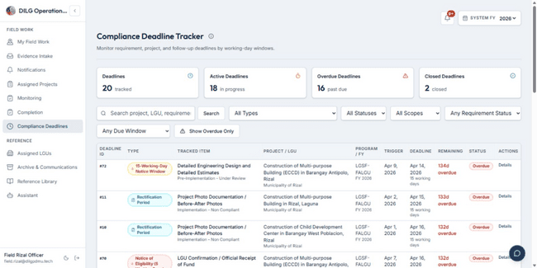
Figure 125. The figure above shows the Compliance Deadlines Page for Field Officer.
Step 1. Click 'Compliance Deadlines' in the sidebar.
Step 2. View the SLA Dashboard showing deadline statistics for your assigned LGUs.
Step 3. View the 'Overdue' count showing deadlines that have passed.
Step 4. View the 'Due Soon' count showing deadlines approaching.
Step 5. View the 'All Deadlines' section listing compliance deadlines for your assigned projects.
Step 6. Filter deadlines by project using the 'Project' dropdown.
Step 7. Click on a deadline row to view deadline details.
Step 8. View the trigger date, deadline date, and remaining working days.
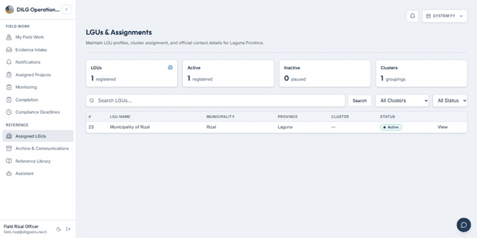
Figure 126. The figure above shows the Assigned LGUs List.
Step 1. View the 'Assigned LGUs' panel on the Field Officer Workspace.
Step 2. Use the search bar to filter LGUs by name, municipality, or province if more than three LGUs are assigned.
Step 3. View each LGU card showing the LGU name, municipality, and province.
Step 4. View the 'Projects' count showing the number of projects in the LGU.
Step 5. View the 'Open reqs' count showing open requirements.
Step 6. View the 'Overdue' count showing overdue deadlines.
Step 7. Click on an LGU name to open the LGU Details page.
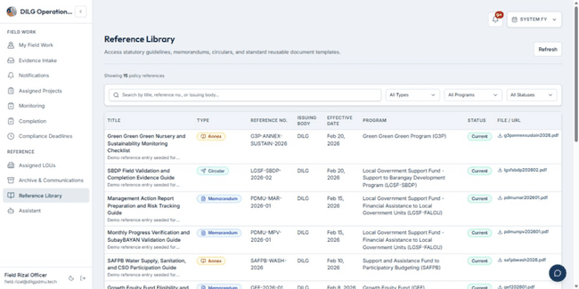
Figure 127. The figure above shows the Reference Library Page for Field Officer.
Step 1. Click 'Reference Library' in the sidebar.
Step 2. View the library catalog showing available templates and guides.
Step 3. Use the 'Search' field to find documents by title or keyword.
Step 4. Click on a document to view document details.
Step 5. Click 'Download' to download the document file.
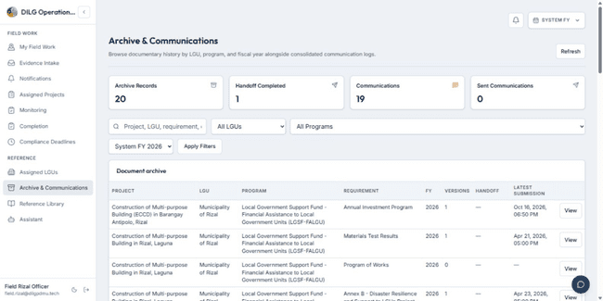
Figure 128. The figure above shows the Archive & Communications that displays all document history.
Step 1. Click 'Archive & Communications' in the sidebar.
Step 2. View historical documentary submissions for your
assigned LGUs.
Step 3. Use the search bar to locate records by project,
requirement, or keyword.
Step 4. Use the LGU and Program dropdowns, and enter
a Fiscal Year in the text field to filter.
Step 5. Click 'Apply Filters' to refresh the document archive list.
Step 6. Click 'View' on any record to open the Document
Version Record drawer.
Step 7. Inspect previous submission versions and click the
download icon to retrieve files.

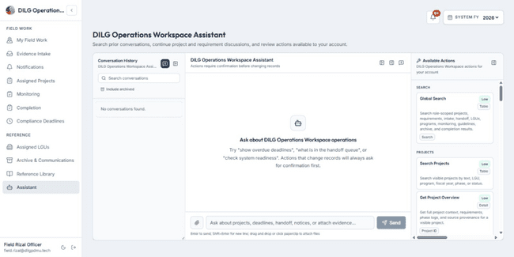
Figure 129. The figure above shows the Chatbot Assistant Page.
Step 1. Click 'Assistant' in the sidebar to open the AI Assistant page. Step 2. Type your question or request in the message input field.
Step 3. Click the send button to submit your message.
Step 4. View the assistant's response in the conversation area.
Step 5. The assistant can search for projects, retrieve requirement details, and provide information about documents within your assigned cluster scope.
Step 6. Review any tool confirmation requests before approving actions.

For System Administrator
Figure 130: The figure above shows the Landing Page.
Step 1. Open your web browser and enter the DILG Laguna PDMU web application URL.
Step 2. The Landing Page displays a 'Sign In' button.
Step 3. Click 'Sign In' to proceed to the Login page.
Figure 131. The figure above shows the Login form.
Step 1. Enter your email and password.
Step 2. Once done, click ‘Sign In’ and you will be redirected to the Dashboard of your account.
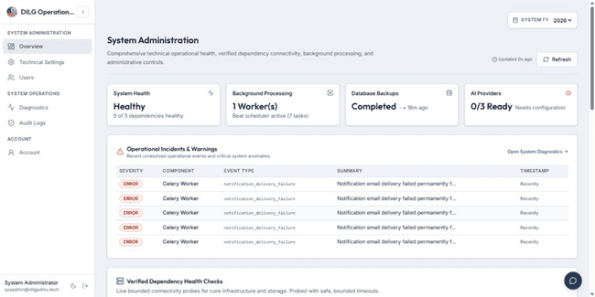
Figure 132. The figure above shows the System Administration Overview Page.
Step 1. View the 'System Health' KPI showing the overall readiness status.
Step 2. View the number of ready checks and total checks.
Step 3. View the 'AI Providers' KPI showing the number of configured AI providers.
Step 4. View the 'Runtime Status' KPI showing the environment and application name.
Step 5. Scroll to the 'Quick Actions' section.
Step 6. Click 'Technical Settings' to view the Technical Settings page.
Step 7. Click 'Manage Users' to view the Users page.
Step 8. Click 'Audit Log' to view the Audit Log page.
Step 9. Scroll to the 'Provider And Runtime Status' section.
Step 10. View the provider configuration table showing AI providers, document intelligence providers, and object storage status.
Step 11. Scroll to the 'Readiness Checks' section.
Step 12. View the readiness checks table showing technical readiness check results.
Step 13. Click 'Refresh' to update the overview information.
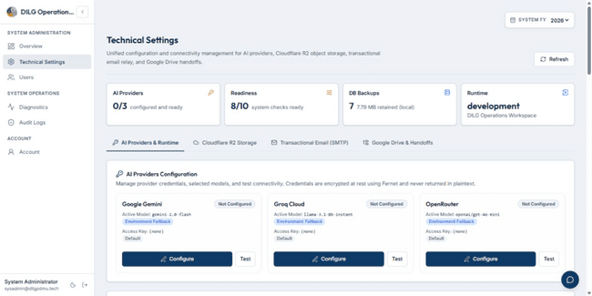
Figure 133. The figure above shows the Technical Settings Page.
Step 1. Click 'Technical Settings' in the sidebar.
Step 2. View the 'AI Providers' section showing configured AI providers and their models.
Step 3. View the provider order showing the fallback sequence.
Step 4. View the request timeout, temperature, and token limits.
Step 5. View the 'Document Intelligence' section showing OCR and NLP provider configuration.
Step 6. View AWS Textract and Rekognition status if configured.
Step 7. View LanguageTool integration status for grammar checking.
Step 8. View the 'Object Storage' section showing the storage provider and environment.
Step 9. View the 'Runtime' section showing environment, application name, and feature flags.
Step 10. This page is view-only for monitoring configuration status.
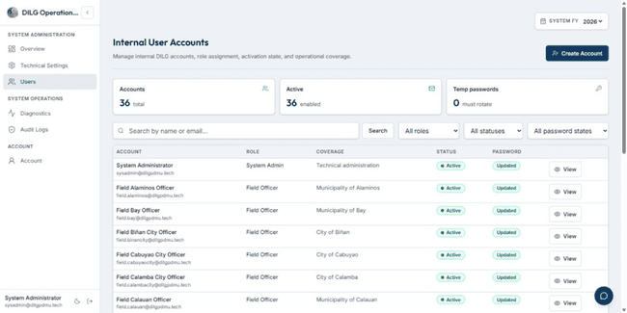
Figure 134. The figure above shows the Users Page.
Step 1. Click 'Users' in the sidebar.
Step 2. View the list of all user accounts in the system.
Step 3. Use the 'Search' field to filter users by name or email.
Step 4. Filter by role using the 'Role' dropdown.
Step 5. Filter by status using the 'Status' dropdown.
Step 6. View user information including name, email, role, and status.
Step 7. Click on a user row to view user details.
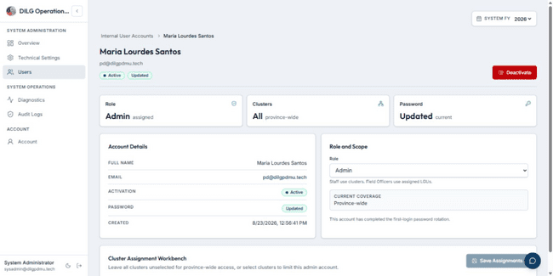
Figure 135. The figure above shows the User Details Page.
Step 1. Open a user from the Users list.
Step 2. View the user's full name, email, and role.
Step 3. View the user's active status.
Step 4. View the user's assigned clusters or LGUs.
Step 5. View the user's account creation date and last updated date.
Step 6. View the user's token version for session management.
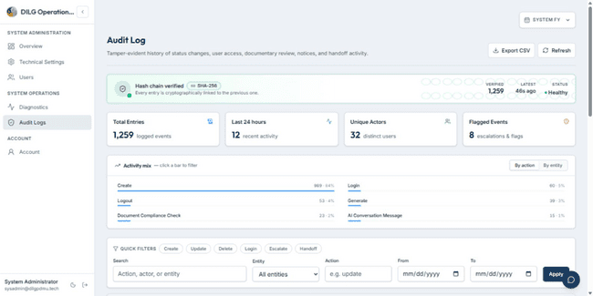
Figure 136. The figure above shows the Audit Log Page.
Step 1. Click 'Audit Log' in the sidebar.
Step 2. View the list of audit log entries showing system activities.
Step 3. Filter by user using the 'User' dropdown.
Step 4. Filter by action type using the 'Action' dropdown.
Step 5. Filter by entity type using the 'Entity Type' dropdown.
Step 6. Filter by date range using the date pickers.
Step 7. View each log entry showing timestamp, user, action, entity type, entity ID, and details.
Step 8. Click on a log entry to view full details.
Step 9. View the log details including IP address, user agent, and action parameters.
Step 10. Click 'Export' to download the audit log as a CSV file.

