Polymarket US — data inventory and actual examples
Updated 9 September 2026; saved API observations are from 8 September. API and capture timestamps are UTC. Website screenshots preserve the site's displayed labels. We retrieved structured public data directly from Polymarket US without a login, cookies, API key or VPN. The examples establish that an internal market-context panel is technically possible. They do not establish company usage rights, complete market coverage or production reliability. This report and its evidence remain local; they have not been published to GitHub. A local interactive MVP is implemented and tested; its 9 September browser captures and validation are recorded separately below.
The companion Polymarket-Data-Inventory.xlsx contains the detailed inventory and example values. Original responses and the request manifest are in polymarket-evidence/2026-09-08/. Each manifest entry records its URL, HTTP status, request/receipt times and SHA-256 hash. Main API samples were received at 19:02:54–19:02:56; the resolved-market settlement sample at 19:03:47. These are observations at those times, not current trading recommendations.
Workbook AllObservedFields catalogues every terminal field observed in all 13 saved responses, with array positions grouped as [], observed types, occurrence counts and up to three actual example values. FieldExamples adds explanations for selected fields. This is a complete catalogue of those observed responses; documented optional fields and the wider exchange catalogue can exceed the sample. The newer chart has separate MVPHistory provenance.

1. What is available without an account
The public base is https://gateway.polymarket.us. We checked 13 requests: 12 returned HTTP 200; the open market's settlement request returned HTTP 404. The official documentation describes this API as sufficient for applications displaying market information. .
Data | Actual response inspected | Application use
Search and event | One Fed event, containing five contracts | Find relevant topics and group related outcomes
Market definition | IDs, question, rules, dates, status, side identities and quotes | Explain exactly what a displayed number refers to
Event and market images | Image URLs, including a Fed-event portrait and a sports-team logo | Event artwork; separate from article images or an image-reuse licence
Best bid/offer (BBO) | Bid, ask, last price, depth counts and statistics | Compact quote card and spread
Order book | 13 bid levels and six offer levels | Depth and liquidity context
Price history | 249 daily-window and 57 weekly-window samples | Historical display-price charts
Settlement | Open-market 404; resolved-market value 1 | Distinguish unresolved contracts from final results
Reference data | Two series, two leagues and five tags | Navigation and classification
The reference counts are the requested sample sizes, not catalogue totals. No ongoing collector was started for that evidence capture. The local MVP's interactive refresh behaviour is described in section 9.
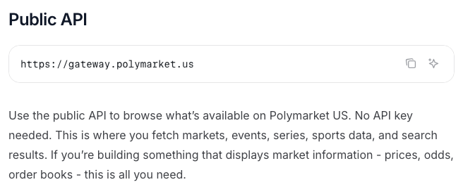
Actual browser screenshot of the official documentation, captured at 2026-09-08 19:11:16.306 UTC. This is documentation evidence, not an API response.

2. A real macro example: September Fed decision
Search GET /v1/search?query=Fed&limit=1 returned event 65124, slug usfed-fomc-2026-09-16. The event-detail response contained five contracts, all active and open. The event category was macro; its tags included Econ, macro and Fed. The following quotes come from one saved event response, received at 19:02:54.365 UTC.
Contract title | Market ID | Best bid, USD | Best ask, USD
50+ bps Increase | 313136 | 0.0100 | 0.0200
25 bps Increase | 313137 | 0.5100 | 0.5200
No Change | 313138 | 0.4700 | 0.4800
25 bps Decrease | 313139 | Not supplied | 0.0100
50+ bps Decrease | 313140 | Not supplied | 0.0100
Values are at event.markets[].bestBidQuote.value and event.markets[].bestAskQuote.value. A missing bid is not zero. These prices must not be normalized into an invented probability distribution. Establish outcome definitions and settlement rules before combining contracts.
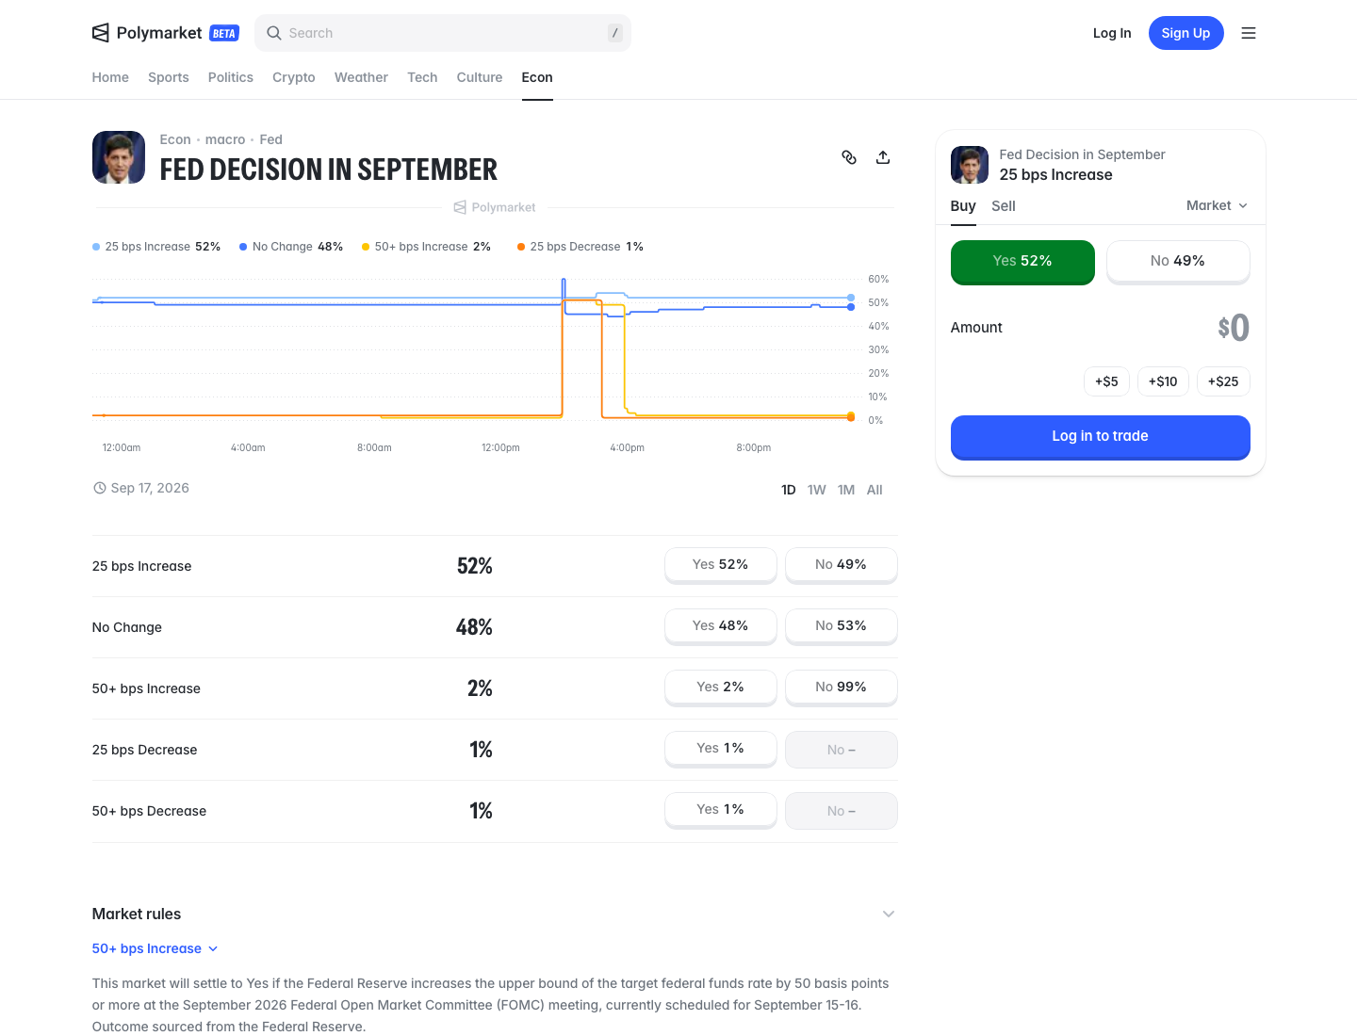
Actual Polymarket US website screenshot, captured at 2026-09-08 19:04:10.892 UTC. It is a separate observation from the earlier API samples: website prices may differ. Source: .

3. Market definitions and field mapping
We inspected GET /v1/market/slug/rdc-usfed-fomc-2026-09-16-nochng. The singular /market/slug/ path differs from the plural quote/book routes. Its market object identified No Change, ID 313138. The description defines settlement using the upper bound of the federal funds target rate at the September FOMC meeting and names the Federal Reserve as the source. Preserve the complete rules in an approved implementation; this report paraphrases them.
Field path | Observed value or meaning
market.slug | rdc-usfed-fomc-2026-09-16-nochng
market.status | MARKET_STATUS_OPEN; closed was false
market.marketSides[].id | Yes: 625838; No: 625839
market.marketSides[].long | Yes: true; No: false
market.marketSides[].quote.value | Yes: 0.4800; No: 0.53
market.orderPriceMinTickSize | 0.01
market.minimumTradeQty | 0.01
Two actual inconsistencies matter. Event endDate was September 16 at 23:59, whereas the contract's endDate was September 30 at 23:00. Store both, with their field meaning; do not infer the meeting date from either alone. Also, legacy outcomes/outcomePrices arrays were incomplete or misleading across the five contracts. The 50+ bps decrease contract had two outcome labels but only one price. Validate explicit side identities and quote fields rather than zipping legacy arrays. .

4. Quotes, depth and trading statistics
For the same No Change contract, the BBO response contained:
JSON path under marketData | Value
bestBid.value / bestAsk.value | 0.4700 / 0.4800 USD
lastTradePx.value / currentPx.value | 0.4800 / 0.4700 USD
longQuote.value / shortQuote.value | 0.4800 / 0.53 USD
bidDepth / askDepth | 13 / 6
sharesTraded / openInterest | 37233.5500 / 456927.4600
The book confirmed marketData.bids[0] at 0.4700, quantity 566.1400, and marketData.offers[0] at 0.4800, quantity 5129.0200. The spread is 0.0100 USD. These are available quoted quantities at the sampled instant, not guaranteed fills or proof of enduring liquidity.
Book stats also supplied open/high/low/close, last-trade quantity, notional and individual update timestamps. For example, lastTradeQty was 0.3800 and lastTradeSetTime was 19:00:56.848 UTC, about two minutes before collection. notionalTraded.value was 1828974.7500, with currency USD; preserve the reported field and verify its units and measurement period before calculating turnover. Field availability alone does not validate our interpretation.
Do not collapse all price fields into “probability.” Current price, last trade, executable quotes and sampled display prices differ even within these responses. ,

5. History: useful data, with visible gaps
Both requests used /v1/price-history, with the contract slug as symbol. Each history[] item contains Unix-seconds timestamp, longPrice and shortPrice. These are book-derived display prices, not executed trades.
Requested parameters | Actual returned coverage
fixedInterval=INTERVAL_1D&fidelity=5 | 249 points; September 7 19:00 to September 8 19:00
fixedInterval=INTERVAL_1W&fidelity=180 | 57 points; September 1 18:00 to September 8 18:00
The weekly samples were three hours apart. Daily samples were usually five minutes apart, with gaps from September 8 06:25–06:50 and 06:50–09:55. The response does not establish why points were absent. Do not invent data between observations or promise a complete historical archive.
The latest daily point was 0.48 long / 0.53 short. Their sum exceeds one: these display prices reflect the two sides and spread, rather than a pair of complementary verified probabilities. The live lastPriceSample.shortPx field was 0.52 instead; retain field identity and timestamp when comparing sources.
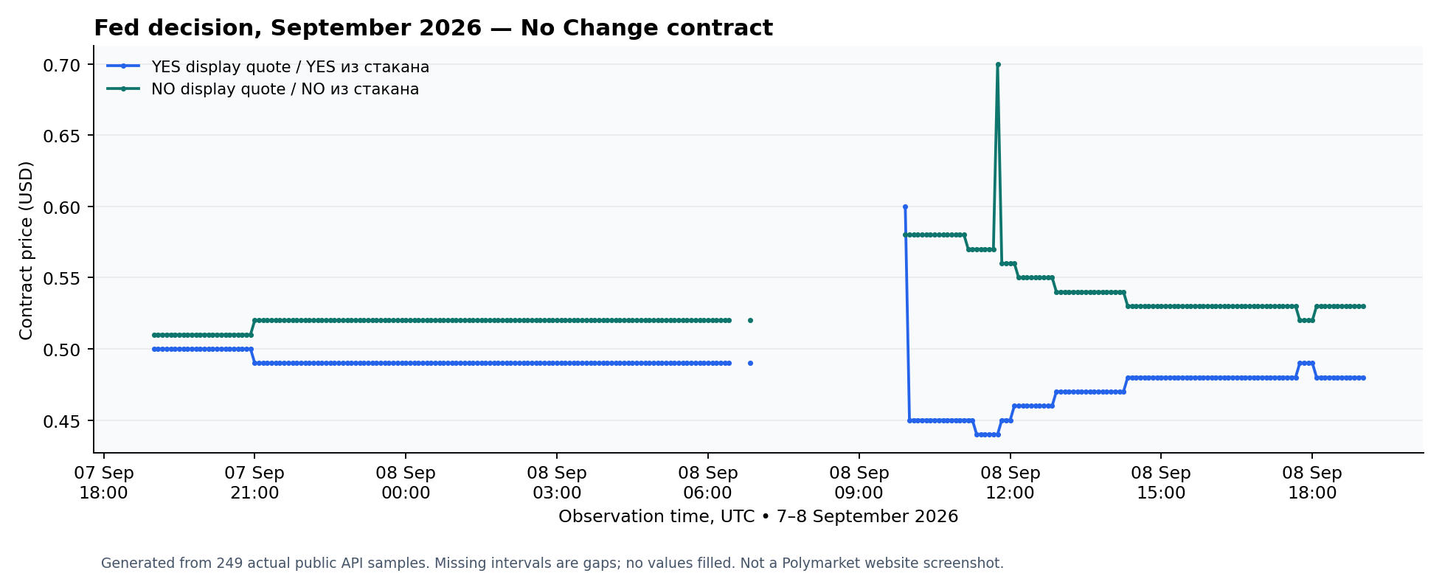
Chart generated from the actual saved history samples. It is our visualization, not a screenshot of Polymarket's interface; missing samples remain missing.

6. Settlement and reference data
The open Fed contract's dedicated settlement endpoint returned 404, with “Settlement not found.” Nevertheless, its BBO/book contained settlementPx.value=0.5000. That field is therefore not proof of final event resolution. A separate resolved sports contract, aec-nfl-lac-ten-2025-11-02, returned 200 and settlement: 1; its market status was MARKET_STATUS_RESOLVED. Resolve state and side identity together.
Reference calls returned series NFL and NFL 2025, leagues UEFA and MLB, and five tags including Supreme Court. They expose IDs, labels, slugs and sometimes parent/league relationships. A tag's existence does not prove an active market or usable liquidity. Teams and schedules are documented capabilities but were not separately requested in this inventory.

7. Images and news: different content sources
The public market schema includes image, subject images and team logos/icons. Actual responses contained event artwork: the Fed event's image was a portrait URL, while the sports-market sample referenced a team logo. Contract description fields explain the question and settlement rules; they are not article bodies. Image URLs establish technical availability, not unrestricted rights to copy, redistribute or use third-party photographs and logos. Market reference.
Polymarket does publish journalism. Its separate publication, The Oracle, contains news analysis and interviews. The current US API documentation index has no documented news/article endpoint. International Journalism Tools also offer a market timeline with related stories, but that website feature does not establish a supported news-ingestion API or a republication licence for us. , ,
The MVP therefore uses Polymarket US for market data and event artwork and our existing news sources for a separately labelled Related news section. Keep the original publisher, date and article link. A topic match is contextual; it does not establish that the article caused a price change. A link to The Oracle is distinct from importing or reproducing its articles. News-provider content and image rights remain governed by their own terms.

8. Connection options beyond the saved samples
Route | Documented capability | Verification status
Retail market WebSocket | Real-time books, price updates and trades; API key required | Optional credentialed connection implemented for the MVP; upstream authentication and delivery not tested
Direct Exchange data API | Read-only reference data, BBO, depth and statistics through REST/gRPC | Documentation reviewed; no credentials obtained
Private/account API | Own balances, positions, orders and private updates | Not accessed; unnecessary for the proposed panel
Public REST is documented at 20 requests/second/IP. It requires polling and does not capture every intervening change. Retail keys require account and identity verification; institutional data access has separate onboarding. No measured streaming latency or service guarantee follows from these tests. The local preview refreshes selected market data through REST every 10 seconds; this is polling, not an authenticated WebSocket session or a lossless trade feed. , ,

9. Local MVP implementation and capture record
The local preview at /polymarket combines search and topic selection, event graphics, YES/NO price tabs, a time-based history chart with shaded gaps, order-book context, statistics, contract rules and related article cards. Its path is Next.js page → server-side adapter → public Polymarket US REST. It is separate from the future persistent Postgres collector and employee production deployment. Optional WebSocket support uses a server-side connection and forwards status, quote and book updates to the page through SSE. It requires server-side credentials; none are configured locally and no authenticated upstream stream has been verified.
The preview deliberately limits scope: search returns up to eight events, with up to 40 contracts per event; the page shows the top five bid and ask levels from an adapter capped at 50 per side. It displays six news cards from at most 12 results and offers one-day and one-week history views. These bounds describe the local interface, not an exhaustive exchange archive.
Preview refresh | Implemented behaviour
Selected quotes and book | REST refresh every 10 seconds; pause control and hidden-tab pause
History | Reuse identical requests for 30 seconds; retain time spacing and gaps
Event detail | Refresh every 60 seconds
Related news | Refresh every five minutes through the separate news endpoint
The product AI panel is hidden on this page and Polymarket prices are not sent to its AI pipeline. Related news comes through the existing provider path.
Charts use returned historical display-price samples. They must retain gaps and identify empty history rather than generate illustrative prices. Poll timestamps, upstream price timestamps and last-trade timestamps describe different things. Related news retains its own provider attribution; it is not presented as a Polymarket news API response.
Validation completed at 2026-09-09 02:27:04.221871 UTC. Eleven recorded browser checks covered public quotes/book/history, a loaded event image, automatic refresh, pause/resume, day/week switching, keyboard chart inspection, search and contract identity, simulated upstream failure with labelled old data, 390-pixel mobile layout, desktop/dark rendering and no browser runtime errors. Ten real quote responses had receipt times from 02:26:20.925 to 02:27:00.930 UTC. The code also passed 19 unit tests, targeted ESLint, TypeScript checking and a production build. Authenticated upstream WebSocket remains untested.
The separately saved local response for Fed No Change recorded bid 0.47, ask 0.48, YES 0.48, NO 0.53, and last trade 0.48; the quote receipt was 02:26:45.750 UTC. Its chart data contained 243 points and four gaps, received at 02:26:21.673 UTC. Workbook MVPHistory records these normalized points and their file hash. They are distinct from the older 249-point sample in section 5; each screenshot has its own capture time.
The related-news request returned nine results with eight image URLs; the page displayed six cards. The newest returned article was dated 30 August 2026. A successful provider request therefore does not establish real-time news: the UI preserves article dates and source attribution. An additional browser check confirmed that selecting a Bitcoin event changes related news to the Crypto category; the news request uses that category without sending Polymarket contract text to the news provider.
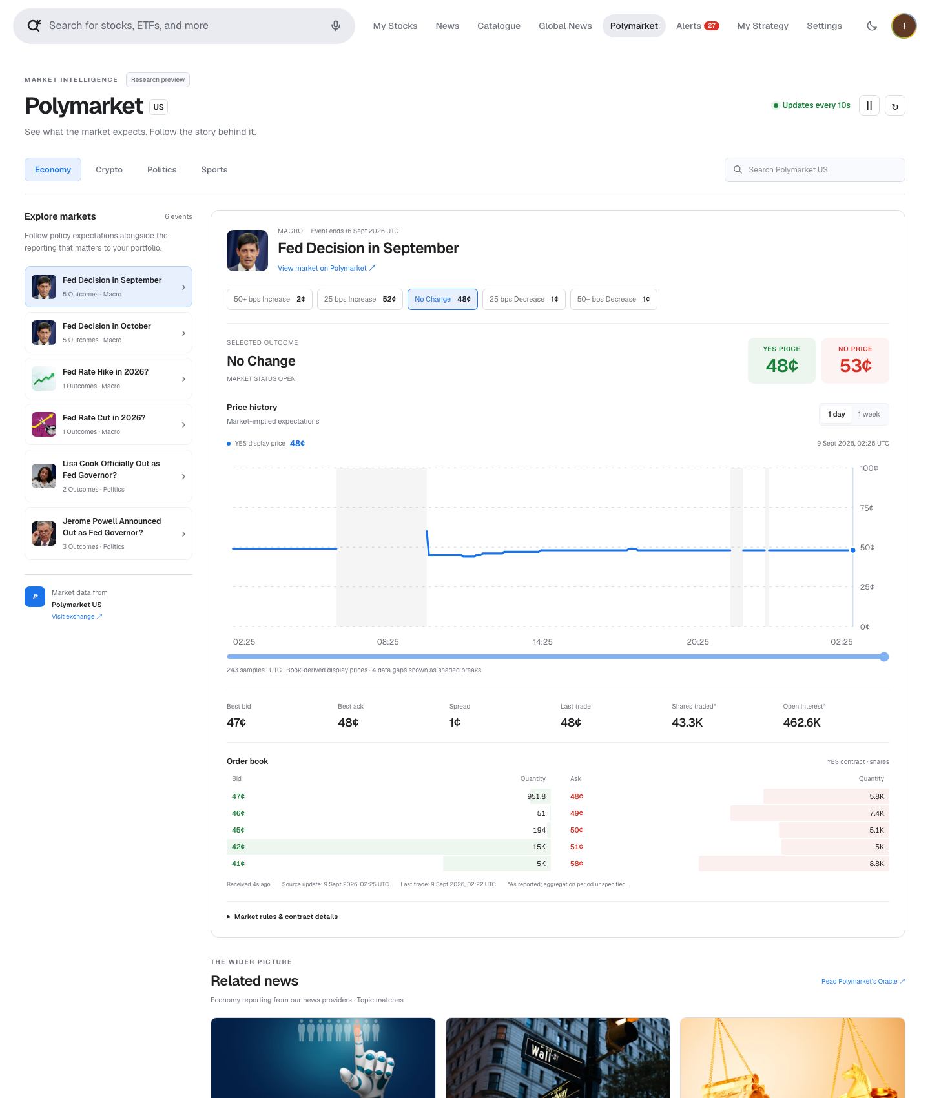
Actual local MVP at http://127.0.0.1:3000/polymarket, captured on 9 September 2026 at 02:26:51.323448 UTC, using public REST data and an actual event image. This is our interface, not the Polymarket website; the chart uses the separately recorded local-response history, not the older static report sample.
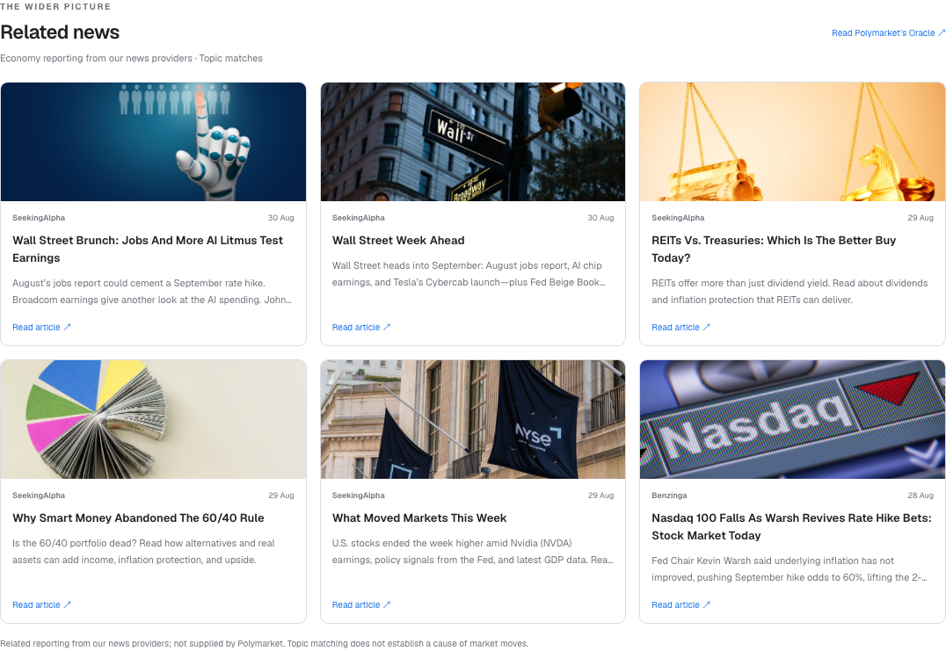
Actual local MVP related-news section, captured on 9 September 2026 at 02:26:51.853924 UTC. Article cards are attributed to configured providers; they were not obtained through a Polymarket article API. Capture hashes and the mobile/dark screenshots are in the validation record.

10. Permission, cost and the practical next step
No key was needed for these public reads; company usage permission is still unresolved. We made the requests without contacting Polymarket or requesting individual technical approval. US documentation welcomes data displays, while linked app terms limit the standard data licence to personal, noncommercial trading-related use. Our interpretation is that neither public accessibility nor a personal login establishes rights for recurring corporate analytics. Confirm our specific use in writing, or obtain the appropriate agreement, before production collection.
Question | Conclusion for our project
Can it connect without contacting Polymarket? | Public REST can; no key or separate technical approval step is required
Must we pay? | Not established; no public price for our intended corporate use was found
Does a working local page establish permission? | No; it demonstrates technical behaviour, not a corporate data licence or a provider-approved trial
What is needed before recurring production use? | Written confirmation of our public-API usage scope or an applicable agreement
Calling a page local, internal or a pilot does not create a licensing exemption. The saved samples and interactive development checks should be described by their actual scope, not as an approved free commercial dataset.
The documented Market Data Agreement route is data@polymarket.us. We have not established its price, that payment is inevitable, or that every public API request requires institutional onboarding. The market response's feeCoefficient is not a data-licence quote. Confirm employee display, storage, retention, backups, event images, derived metrics and external AI processing explicitly. No licensing request, purchase or trading action was made.
Polymarket's July 2026 Institutional Research announcement separately offers commercial data sales for both its US and international exchanges through institutional@polymarket.com. It does not publish our price or say that every public read requires payment. The US fee schedule describes trading charges; those charges are not a quote for a read-only data licence. ,
This inventory concerns Polymarket US. International polymarket.com uses separate APIs and licensing; ICE's international role does not establish a US requirement.

Sources
Official sources were reviewed on 8–9 September 2026. Local evidence retains its exact request or capture time; the terms cited are effective 25 September 2025.
- Local validation evidence. Original request manifest.
- Polymarket US. Public API introduction.
- Polymarket US. public event page.
- Polymarket US. Market reference.
- Polymarket US. BBO.
- Polymarket US. order book.
- Polymarket US. History reference.
- Polymarket US. Settlement API.
- Polymarket / The Oracle. The Oracle.
- Polymarket US. US API index.
- Polymarket / The Oracle. Journalism Tools announcement. 2 April 2026.
- Polymarket US. Limits.
- Polymarket US. WebSocket.
- Polymarket US. institutional guide.
- Local validation evidence. Recorded browser checks.
- Local validation evidence. Local normalized response.
- Local validation evidence. Screenshot metadata and hashes.
- Polymarket US. US terms, effective 25 September 2025, §§5, 7 and 19. 25 September 2025.
- Polymarket US. Data onboarding.
- Polymarket / The Oracle. Institutional Research announcement. 8 July 2026.
- Polymarket US. Trading fees.

Original request manifest.
Public API introduction.
public event page.
Market reference.
BBO.
order book.
History reference.
Settlement API.
The Oracle.
US API index.
Journalism Tools announcement.
Limits.
WebSocket.
institutional guide.
Recorded browser checks.
Local normalized response.
Screenshot metadata and hashes.
US terms, effective 25 September 2025, §§5, 7 and 19.
Data onboarding.
Institutional Research announcement.
Trading fees.

