show collections
department
student

db.student.insertMany([{studentno:2,name:"soni",city:"bangalore"},{studentno:3,name:"Prathap",city:"bangalore"}])
{
"acknowledged" : true,
"insertedIds" : [
ObjectId("62550654d3c77e70f37398ef"),
ObjectId("62550654d3c77e70f37398f0")
]
}
> db.student.find().pretty()
{
"_id" : ObjectId("624bb89536acd308ea6aa0ba"),
"studentno" : 1,
"name" : " sonal",
"city" : "kolar"
}
{
"_id" : ObjectId("62550654d3c77e70f37398ef"),
"studentno" : 2,
"name" : "soni",
"city" : "bangalore"
}
{
"_id" : ObjectId("62550654d3c77e70f37398f0"),
"studentno" : 3,
"name" : "Prathap",
"city" : "bangalore"
}

db.department.insertMany([{deptno:1,deptname:"ISE",location:"second"},{deptno:3,deptname:"EEE",location:"third"}])
{
"acknowledged" : true,
"insertedIds" : [
ObjectId("62550703d3c77e70f37398f1"),
ObjectId("62550703d3c77e70f37398f2")
]
}
> db.department.find().pretty()
{
"_id" : ObjectId("624bbb3036acd308ea6aa0bc"),
"deptno" : 2,
"deptname" : "CSE",
"location" : "first"
}
{
"_id" : ObjectId("62550703d3c77e70f37398f1"),
"deptno" : 1,
"deptname" : "ISE",
"location" : "second"
}
{
"_id" : ObjectId("62550703d3c77e70f37398f2"),
"deptno" : 3,
"deptname" : "EEE",
"location" : "third"
}

OR OPERATION

> db.department.find({$or:[{ deptno:1},{deptname:"CSE"}]})
{ "_id" : ObjectId("624bbb3036acd308ea6aa0bb"), "deptno" : 1, "location" : "first" }
{ "_id" : ObjectId("624bbb3036acd308ea6aa0bc"), "deptno" : 2, "deptname" : "CSE", "location" : "first" }

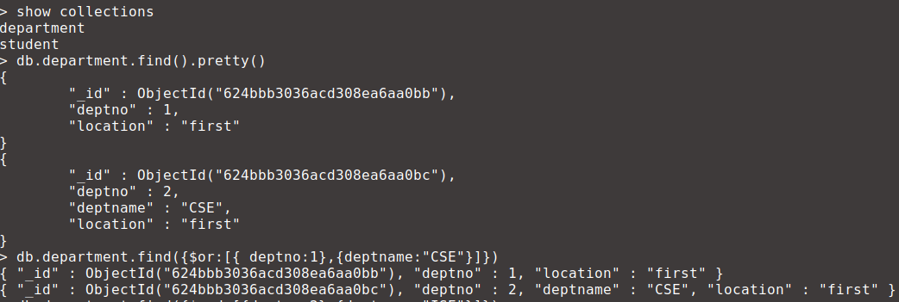
AND OPERATION

> db.department.find({$and:[{deptno:2},{deptname:"ISE"}]})
> db.department.find({$and:[{deptno:2},{deptname:"CSE"}]})
{ "_id" : ObjectId("624bbb3036acd308ea6aa0bc"), "deptno" : 2, "deptname" : "CSE", "location" : "first" }

SORT OPERATIONS
Ascending order
db.department.find().sort({deptno:1})
{ "_id" : ObjectId("62550703d3c77e70f37398f1"), "deptno" : 1, "deptname" : "ISE", "location" : "second" }
{ "_id" : ObjectId("624bbb3036acd308ea6aa0bc"), "deptno" : 2, "deptname" : "CSE", "location" : "first" }
{ "_id" : ObjectId("62550703d3c77e70f37398f2"), "deptno" : 3, "deptname" : "EEE", "location" : "third" }

Descending order
db.department.find().sort({deptno:-1})
{ "_id" : ObjectId("62550703d3c77e70f37398f2"), "deptno" : 3, "deptname" : "EEE", "location" : "third" }
{ "_id" : ObjectId("624bbb3036acd308ea6aa0bc"), "deptno" : 2, "deptname" : "CSE", "location" : "first" }
{ "_id" : ObjectId("62550703d3c77e70f37398f1"), "deptno" : 1, "deptname" : "ISE", "location" : "second" }

