show collections

department

student

db.student.insertMany([{studentno:2,name:"soni",city:"bangalore"},{studentno:3,name:"Prathap",city:"bangalore"}])

{

"acknowledged" : true,

"insertedIds" : [

ObjectId("62550654d3c77e70f37398ef"),

ObjectId("62550654d3c77e70f37398f0")

]

}

> db.student.find().pretty()

{

"_id" : ObjectId("624bb89536acd308ea6aa0ba"),

"studentno" : 1,

"name" : " sonal",

"city" : "kolar"

}

{

"_id" : ObjectId("62550654d3c77e70f37398ef"),

"studentno" : 2,

"name" : "soni",

"city" : "bangalore"

}

{

"_id" : ObjectId("62550654d3c77e70f37398f0"),

"studentno" : 3,

"name" : "Prathap",

"city" : "bangalore"

}

db.department.insertMany([{deptno:1,deptname:"ISE",location:"second"},{deptno:3,deptname:"EEE",location:"third"}])

{

"acknowledged" : true,

"insertedIds" : [

ObjectId("62550703d3c77e70f37398f1"),

ObjectId("62550703d3c77e70f37398f2")

]

}

> db.department.find().pretty()

{

"_id" : ObjectId("624bbb3036acd308ea6aa0bc"),

"deptno" : 2,

"deptname" : "CSE",

"location" : "first"

}

{

"_id" : ObjectId("62550703d3c77e70f37398f1"),

"deptno" : 1,

"deptname" : "ISE",

"location" : "second"

}

{

"_id" : ObjectId("62550703d3c77e70f37398f2"),

"deptno" : 3,

"deptname" : "EEE",

"location" : "third"

}

**OR OPERATION**

> db.department.find({$or:[{ deptno:1},{deptname:"CSE"}]})

{ "_id" : ObjectId("624bbb3036acd308ea6aa0bb"), "deptno" : 1, "location" : "first" }

{ "_id" : ObjectId("624bbb3036acd308ea6aa0bc"), "deptno" : 2, "deptname" : "CSE", "location" : "first" }

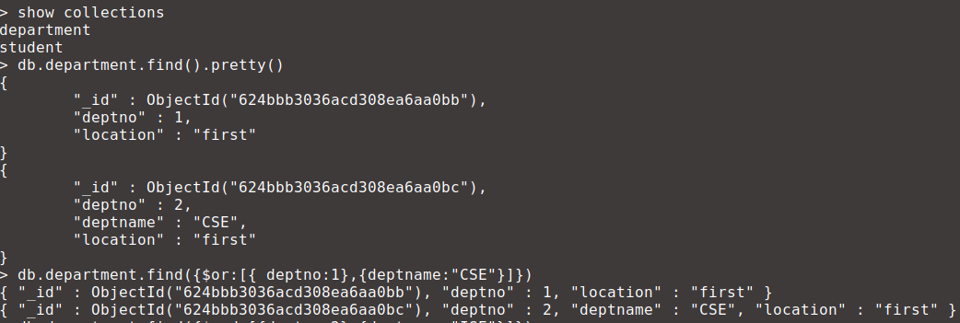

**AND OPERATION**

> db.department.find({$and:[{deptno:2},{deptname:"ISE"}]})

> db.department.find({$and:[{deptno:2},{deptname:"CSE"}]})

{ "_id" : ObjectId("624bbb3036acd308ea6aa0bc"), "deptno" : 2, "deptname" : "CSE", "location" : "first" }



**SORT OPERATIONS**

**Ascending order**

db.department.find().sort({deptno:1})

{ "_id" : ObjectId("62550703d3c77e70f37398f1"), "deptno" : 1, "deptname" : "ISE", "location" : "second" }

{ "_id" : ObjectId("624bbb3036acd308ea6aa0bc"), "deptno" : 2, "deptname" : "CSE", "location" : "first" }

{ "_id" : ObjectId("62550703d3c77e70f37398f2"), "deptno" : 3, "deptname" : "EEE", "location" : "third" }



**Descending order**

db.department.find().sort({deptno:-1})

{ "_id" : ObjectId("62550703d3c77e70f37398f2"), "deptno" : 3, "deptname" : "EEE", "location" : "third" }

{ "_id" : ObjectId("624bbb3036acd308ea6aa0bc"), "deptno" : 2, "deptname" : "CSE", "location" : "first" }

{ "_id" : ObjectId("62550703d3c77e70f37398f1"), "deptno" : 1, "deptname" : "ISE", "location" : "second" }

