**1NT19IS156**

Starting the Hadoop

start-all.sh  
WARNING: Attempting to start all Apache Hadoop daemons as hdoop in 10 seconds.  
WARNING: This is not a recommended production deployment configuration.  
WARNING: Use CTRL-C to abort.  
Starting namenodes on [localhost]  
Starting datanodes  
Starting secondary namenodes [admin1-HP-280-G4-MT-Business-PC]  
Starting resourcemanager

Starting nodemanagers

Using jps command

jps  
4498 DataNode  
5074 NodeManager  
4739 SecondaryNameNode  
4358 NameNode  
5417 Jps  
4926 ResourceManager

Creating directory in hadoop

hadoop fs -mkdir sonal  
hdoop@admin1-HP-280-G4-MT-Business-PC:~$ hadoop fs -ls  
Found 2 items  
drwxr-xr-x   - hdoop supergroup          0 2022-03-30 11:00 saurabh  
drwxr-xr-x   - hdoop supergroup          0 2022-05-24 09:19 sonal

Creating empty file in Hadoop

hadoop fs -touchz p.txt  
hdoop@admin1-HP-280-G4-MT-Business-PC:~$ hadoop fs -ls  
Found 3 items  
-rw-r--r--   1 hdoop supergroup          0 2022-05-24 09:27 p.txt  
drwxr-xr-x   - hdoop supergroup          0 2022-03-30 11:00 saurabh  
drwxr-xr-x   - hdoop supergroup          0 2022-05-24 09:19 sonal

Copying from local to hadoop

hadoop fs -copyFromLocal 1.txt gg.txt  
2022-05-24 09:42:59,353 INFO sasl.SaslDataTransferClient: SASL encryption trust check: localHostTrusted = false, remoteHostTrusted = false

hadoop fs -ls  
Found 5 items  
-rw-r--r--   1 hdoop supergroup          6 2022-05-24 09:42 gg.txt  
-rw-r--r--   1 hdoop supergroup          0 2022-05-24 09:27 p.txt  
drwxr-xr-x   - hdoop supergroup          0 2022-03-30 11:00 saurabh  
drwxr-xr-x   - hdoop supergroup          0 2022-05-24 09:39 sonal  
-rw-r--r--   1 hdoop supergroup         16 2022-05-24 09:36 tt.txt

Displaying the contents of the copied file

hadoop fs -cat gg.txt  
2022-05-24 09:43:25,199 INFO sasl.SaslDataTransferClient: SASL encryption trust check: localHostTrusted = false, remoteHostTrusted = false  
sonal



Copying the contents of the file from Hadoop to local

hadoop fs -copyToLocal tt.txt k.txt  
2022-05-24 10:12:43,549 INFO sasl.SaslDataTransferClient: SASL encryption trust check: localHostTrusted = false, remoteHostTrusted = false



Displaying the size of the files and directories

hadoop fs -du  
6   6   gg.txt  
0   0   p.txt  
0   0   saurabh  
16  16  sonal  
16  16  tt.txt

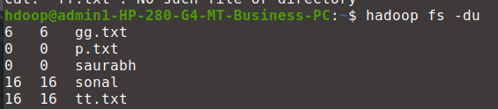

Creating one more directory with our USN

hadoop fs -mkdir 1nt19is156  
hdoop@admin1-HP-280-G4-MT-Business-PC:~$ hadoop fs -ls  
Found 6 items  
drwxr-xr-x   - hdoop supergroup          0 2022-05-24 10:18 1nt19is156  
-rw-r--r--   1 hdoop supergroup          6 2022-05-24 09:42 gg.txt  
-rw-r--r--   1 hdoop supergroup          0 2022-05-24 09:27 p.txt  
drwxr-xr-x   - hdoop supergroup          0 2022-03-30 11:00 saurabh  
drwxr-xr-x   - hdoop supergroup          0 2022-05-24 09:39 sonal  
-rw-r--r--   1 hdoop supergroup         16 2022-05-24 09:36 tt.txt

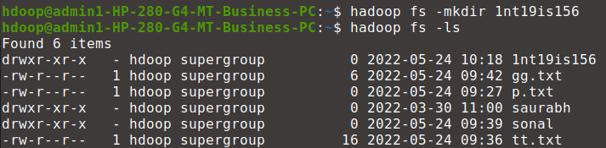

Moving the directory with our usn into the directory with our name

hadoop fs -mv 1nt19is156 sonal  
hdoop@admin1-HP-280-G4-MT-Business-PC:~$ hadoop fs -ls  
Found 5 items  
-rw-r--r--   1 hdoop supergroup          6 2022-05-24 09:42 gg.txt  
-rw-r--r--   1 hdoop supergroup          0 2022-05-24 09:27 p.txt  
drwxr-xr-x   - hdoop supergroup          0 2022-03-30 11:00 saurabh  
drwxr-xr-x   - hdoop supergroup          0 2022-05-24 10:19 sonal  
-rw-r--r--   1 hdoop supergroup         16 2022-05-24 09:36 tt.txt

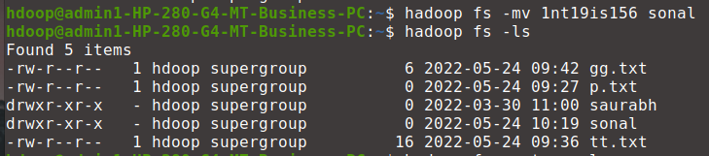

Moving the text files into the directory

 hadoop fs -mv gg.txt sonal  
hdoop@admin1-HP-280-G4-MT-Business-PC:~$ hadoop fs -ls  
Found 4 items  
-rw-r--r--   1 hdoop supergroup          0 2022-05-24 09:27 p.txt  
drwxr-xr-x   - hdoop supergroup          0 2022-03-30 11:00 saurabh  
drwxr-xr-x   - hdoop supergroup          0 2022-05-24 10:20 sonal  
-rw-r--r--   1 hdoop supergroup         16 2022-05-24 09:36 tt.txt

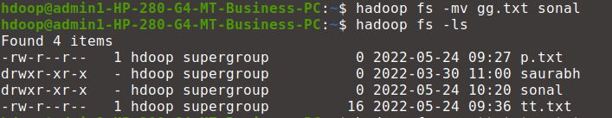

Using copy command , to copy the contents

hadoop fs -cp tt.txt q.txt  
2022-05-24 10:26:16,688 INFO sasl.SaslDataTransferClient: SASL encryption trust check: localHostTrusted = false, remoteHostTrusted = false  
2022-05-24 10:26:16,779 INFO sasl.SaslDataTransferClient: SASL encryption trust check: localHostTrusted = false, remoteHostTrusted = false  
hdoop@admin1-HP-280-G4-MT-Business-PC:~$ hadoop fs -ls  
Found 5 items  
-rw-r--r--   1 hdoop supergroup          0 2022-05-24 09:27 p.txt  
-rw-r--r--   1 hdoop supergroup         16 2022-05-24 10:26 q.txt  
drwxr-xr-x   - hdoop supergroup          0 2022-03-30 11:00 saurabh  
drwxr-xr-x   - hdoop supergroup          0 2022-05-24 10:20 sonal  
-rw-r--r--   1 hdoop supergroup         16 2022-05-24 09:36 tt.txt

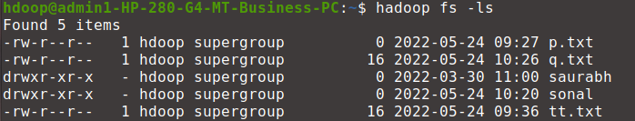

Deleting the files using delete command  
hdoop@admin1-HP-280-G4-MT-Business-PC:~$ hadoop fs -rmr q.txt  
rmr: DEPRECATED: Please use '-rm -r' instead.  
Deleted q.txt

Displaying the size of the files created using dus command  
hdoop@admin1-HP-280-G4-MT-Business-PC:~$ hadoop fs -dus  
dus: DEPRECATED: Please use 'du -s' instead.  
38  38  .

Using stat command

hadoop fs -stat sonal  
2022-05-24 04:50:55



Displaying the contents of the directory

hadoop fs -ls sonal  
Found 3 items  
-rw-r--r--   1 hdoop supergroup         16 2022-05-24 09:39 sonal/1.txt  
drwxr-xr-x   - hdoop supergroup          0 2022-05-24 10:18 sonal/1nt19is156  
-rw-r--r--   1 hdoop supergroup          6 2022-05-24 09:42 sonal/gg.txt

