**1NT19IS156**

Using the Hadoop command for setting up the environment

Using ./start-all.sh command to start all the Hadoop demons and all the nodes

Then we use the JPS command to check out all the Hadoop demons.

Cd conf command to check the configuration

Using the ls command to check for metastore_db

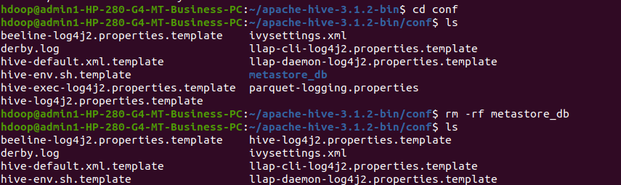

If the metastore_db is present then we are removing it using rm -rf command

Then we are using the schematool -initSchema -dbType derby command

We use hive command to get into the hive

**Creating the database**

Create database using “create database if not exists command”

We are creating bookdb and using that database

**Creating the tables**

Inside bookdb we are creating book table having bookid,bookname,genre,author ,price as attributes

Desc book

Insert values into the table using insert command

Select * from book

**Dropping the table and Altering the table book**

Renaming the table book to 1nt19is156_book

**Show tables**

**Built in operators**

Arithmetic operators in Hive

Select bookname,(price*10)/2 from 1nt19is156_book;

Select bookname,price+800 from 1nt19is156_book;

Relational operators in hive

Select * from 1nt19is156_book where price>2000;

**Built in functions**

Mathematical functions in Hive

Select bookname, sqrt(price) from 1nt19is156_book;

Select bookname, floor(price) from 1nt19is156_book;

Select bookname,cos(price) from 1nt19is156_book;

**Aggregate functions in hive**

Select max(price) from 1nt19is156_book where bookname=’The War’

**Other built in function**

Select author,reverse(bookname) from 1nt19is156_book;

Select author,upper(bookname) from 1nt19is156_book;

Select author,concat(bookname,price) from 1nt19is156_book;

Select author , trim(bookname) from 1nt19is156_book;

**Views**

Create view booksss as select * from 1nt19is56_book where genre=”horror”;

Select * from booksss;

Create view bookss as select * from 1nt19is156_book where genre =”sci-fi”;

Select * from books;

**HIVEQL**

**Group by**

Select author , bookid from 1nt19is156_book group by author,bookid;

**Where**

Select * from 1nt19is156_book where author=”all”;

**Order by**

Select * from 1nt19is156_book order by price;

