LAB-02

>OR OPERATION

db.employee.find({$or:[{Age:{$lt:28}},{sex:"M"}]})

OUTPUT:

{ "_id" : ObjectId("624bbe0ba0d049924c5006ca"), "Id" : 101, "Name" : "Sonal.M", "Age" : 27, "sex" : "F", "PhoneNo" : 7637791737, "Place" : "Bangalore" }
{ "_id" : ObjectId("624bbe0ba0d049924c5006cb"), "Id" : 102, "Name" : "Prathap.K", "sex" : "M", "Phone" : 9874255456, "Place" : "Bangalore" }
{ "_id" : ObjectId("624bbe0ba0d049924c5006cc"), "Id" : 103, "Name" : "Sampreeth", "Age" : 27, "sex" : "M", "PhoneNo" : 6783327876, "Place" : "Bangalore" }

>AND OPERATION

> db.employee.find({$and:[{Name:"Sampreeth"},{Id:103}]})

OUTPUT:

{ "_id" : ObjectId("624bbe0ba0d049924c5006cc"), "Id" : 103, "Name" : "Sampreeth", "Age" : 27, "sex" : "M", "PhoneNo" : 6783327876, "Place" : "Bangalore" }

>COUNT

> db.employee.estimatedDocumentCount()
> db.employee.count()

OUTPUT :
4


>SORT:

1) Ascending order

> db.employee.find().sort({Id:1})

OUTPUT:

{ "_id" : ObjectId("624bbc3ca0d049924c5006c9"), "Id" : 101, "Name" : "soni.a", "Age" : 28, "sex" : "F", "PhoneNo" : 9837791737, "Place" : "Bangalore" }
{ "_id" : ObjectId("624bbe0ba0d049924c5006ca"), "Id" : 101, "Name" : "Sonal.M", "Age" : 27, "sex" : "F", "PhoneNo" : 7637791737, "Place" : "Bangalore" }
{ "_id" : ObjectId("624bbe0ba0d049924c5006cb"), "Id" : 102, "Name" : "Prathap.K", "sex" : "M", "Phone" : 9874255456, "Place" : "Bangalore" }
{ "_id" : ObjectId("624bbe0ba0d049924c5006cc"), "Id" : 103, "Name" : "Sampreeth", "Age" : 27, "sex" : "M", "PhoneNo" : 6783327876, "Place" : "Bangalore" }

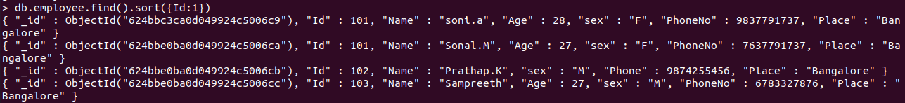
2)Descending Order:

> db.employee.find().sort({Id:-1})

OUTPUT:

{ "_id" : ObjectId("624bbe0ba0d049924c5006cc"), "Id" : 103, "Name" : "Sampreeth", "Age" : 27, "sex" : "M", "PhoneNo" : 6783327876, "Place" : "Bangalore" }
{ "_id" : ObjectId("624bbe0ba0d049924c5006cb"), "Id" : 102, "Name" : "Prathap.K", "sex" : "M", "Phone" : 9874255456, "Place" : "Bangalore" }
{ "_id" : ObjectId("624bbc3ca0d049924c5006c9"), "Id" : 101, "Name" : "soni.a", "Age" : 28, "sex" : "F", "PhoneNo" : 9837791737, "Place" : "Bangalore" }
{ "_id" : ObjectId("624bbe0ba0d049924c5006ca"), "Id" : 101, "Name" : "Sonal.M", "Age" : 27, "sex" : "F", "PhoneNo" : 7637791737, "Place" : "Bangalore" }

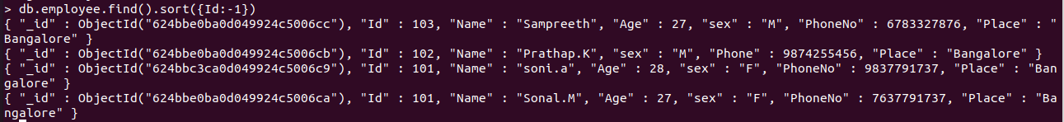

>AGGREGATE FUNCTION:

> db.employee.aggregate([{$match:{Age:{$gt:27}}}])

OUTPUT:

{ "_id" : ObjectId("624bbc3ca0d049924c5006c9"), "Id" : 101, "Name" : "soni.a", "Age" : 28, "sex" : "F", "PhoneNo" : 9837791737, "Place" : "Bangalore" }

