

DATA VISUALIZATION
LA-1

Submitted to:
Dr.Manoj Kumar M V

Submitted by:
Team 29: The Boys

Chethan K S - 1NT24IS066
Abhishek R Raykar - 1NT24IS008

R-PUB LINK:

Quarto Document:
http://rpubs.com/Chethu/1422392

http://rpubs.com/Chethu/1422405

Data_Visualization

Quarto
Quarto enables you to weave together content and executable code into a finished document. To learn more about Quarto see https://quarto.org.

Running Code
When you click the Render button a document will be generated that includes both content and the output of embedded code. You can embed code like this:

STUDENT TEST SCORES BY PREPARATION COURSE

STEP 1. Load required libraries
library(ggplot2)
library(dplyr)
Attaching package: 'dplyr'
The following objects are masked from 'package:stats':
filter, lag
The following objects are masked from 'package:base':
intersect, setdiff, setequal, union
library(tidyr)

STEP 2. Read your CSV data file
data <- read.csv(file.choose()) # Click your CSV file when dialog opens

STEP 3. Quick data check (optional - remove if not needed)
print("Data preview:")
[1] "Data preview:"
head(data)
gender race.ethnicity parental.level.of.education lunch
1 female group B bachelor's degree standard
2 female group C some college standard
3 female group B master's degree standard
4 male group A associate's degree free/reduced
5 male group C some college standard
6 female group B associate's degree standard
test.preparation.course math.score reading.score writing.score
1 none 72 72 74
2 completed 69 90 88
3 none 90 95 93
4 none 47 57 44
5 none 76 78 75
6 none 71 83 78
print("Column names:")
[1] "Column names:"
colnames(data)
[1] "gender" "race.ethnicity"
[3] "parental.level.of.education" "lunch"
[5] "test.preparation.course" "math.score"
[7] "reading.score" "writing.score"

STEP 4. Calculate average scores by test preparation
prep_data <- data %>%
group_by(test.preparation.course) %>%
summarise(
Math = mean(`math.score`, na.rm = TRUE),
Reading = mean(`reading.score`, na.rm = TRUE),
Writing = mean(`writing.score`, na.rm = TRUE),
n_students = n(), # Count students per group
.groups = 'drop'
)

STEP 5. Convert to long format for plotting
prep_long <- prep_data %>%
pivot_longer(
cols = c(Math, Reading, Writing),
names_to = "Subject",
values_to = "Score"
)

STEP 6. Create bar chart
p <- ggplot(prep_long,
aes(x = Subject,
y = Score,
fill = test.preparation.course)) +
geom_bar(stat = "identity",
position = position_dodge(0.8),
width = 0.7,
alpha = 0.85) +
geom_text(aes(label = round(Score, 1)),
position = position_dodge(0.8),
vjust = -0.25,
size = 4,
fontface = "bold",
color = "white") +
scale_fill_brewer(type = "qual", palette = "Set2", name = "Test Prep") +
labs(title = "Average Scores by Test Preparation Course",
subtitle = "Math • Reading • Writing | Impact of Preparation",
x = "Subject",
y = "Average Score",
caption = "Data: Student Performance Dataset") +
theme_minimal(base_size = 14) +
theme(
legend.position = "bottom",
plot.title = element_text(hjust = 0.5, face = "bold", size = 16),
plot.subtitle = element_text(hjust = 0.5, size = 12, color = "gray50"),
plot.caption = element_text(hjust = 1, size = 10, color = "gray40"),
axis.title = element_text(face = "bold"),
panel.grid.minor = element_blank()
) +
coord_cartesian(ylim = c(0, max(prep_long$Score) * 1.1))

STEP 7. Display plot
print(p)
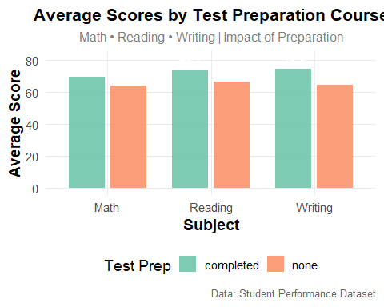

STEP 8. Save high-quality plot (optional)
ggsave("test_prep_scores.png", p, width = 10, height = 7, dpi = 300)
print("Plot saved as 'test_prep_scores.png'")
[1] "Plot saved as 'test_prep_scores.png'"

STEP 9. Show summary table
print("Summary Table:")
[1] "Summary Table:"
print(prep_data)
# A tibble: 2 × 5
test.preparation.course Math Reading Writing n_students
<chr> <dbl> <dbl> <dbl> <int>
1 completed 69.7 73.9 74.4 358
2 none 64.1 66.5 64.5 642

