Step 1: <https://bitnami.com/tag/postgresql>

Step 2: For windows

Step 3: Install

Step 4: When prompt to create password, put anything u like, but please remember it. Else put: group18@CS2102

Step 5: Once installed, start all servers. By right should auto start already. Else

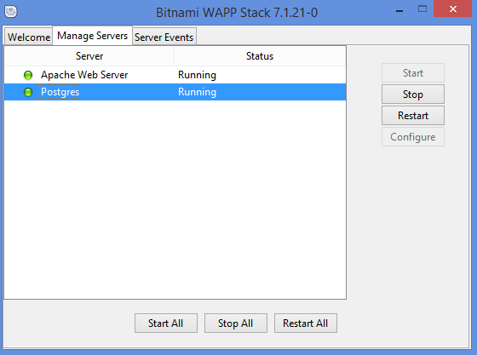

Step 6: Go to application a.k.a localhost

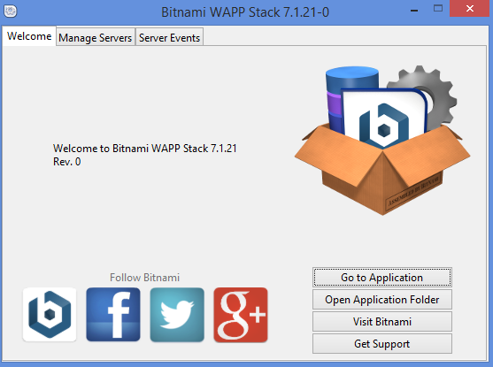

Step 7: Read the docs if u feel like it, else go to phpPgAdmin

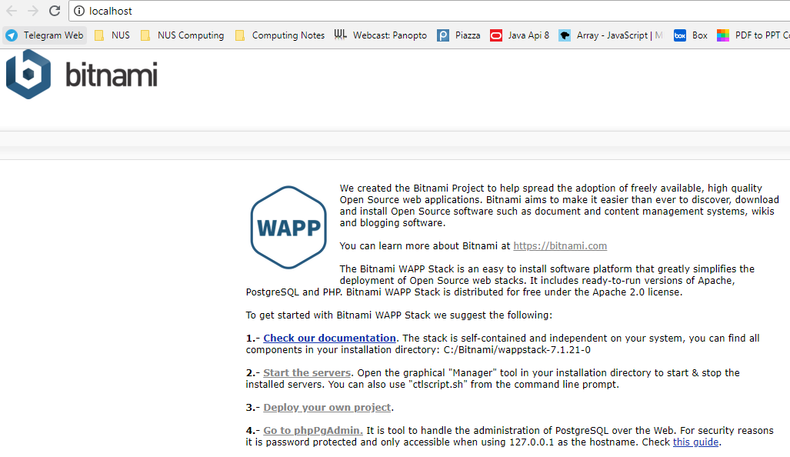

Step 8: Login into your database

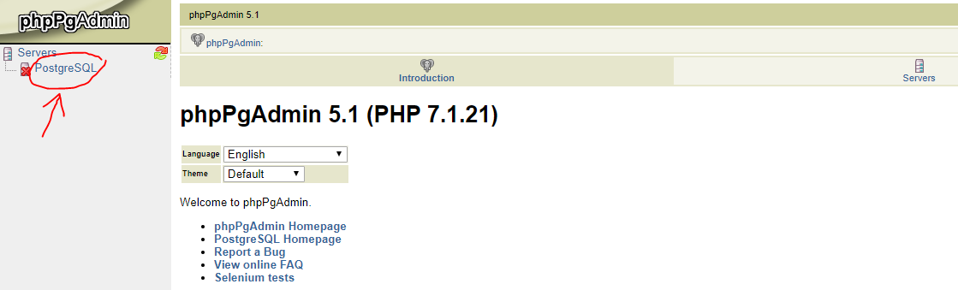

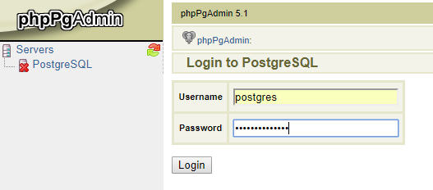

Password is the one you used above, else use group18@CS2102

Step 9: Create database called: Project1

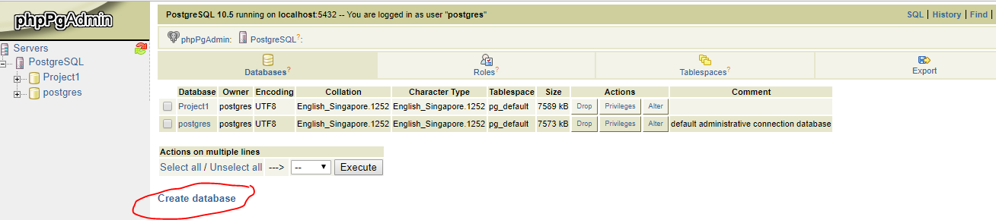

Step 10a: Then create the table called book using sql

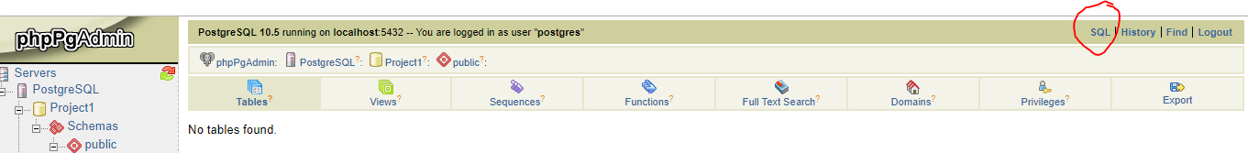

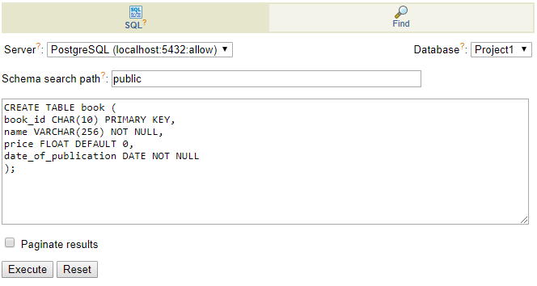

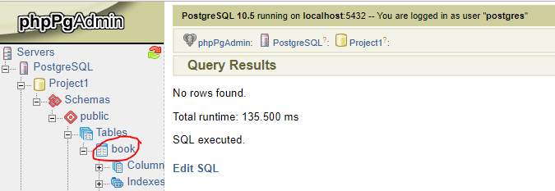

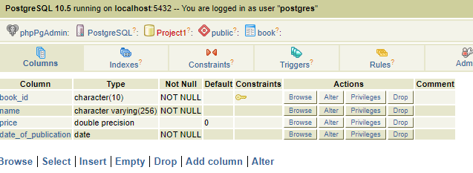

Step 10b: Initialise table with records.

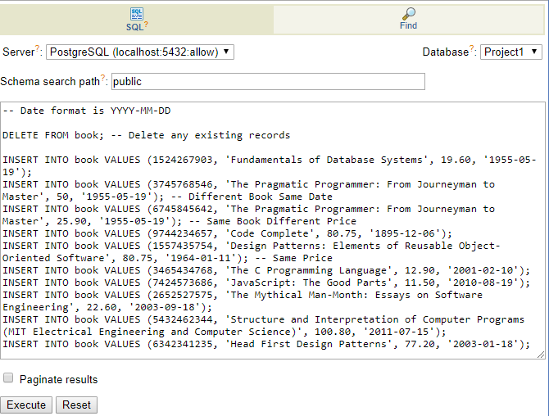

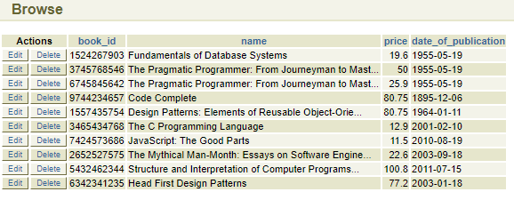

Step 11: Go to C:\Bitnami\wappstack-7.1.21-0\apache2\htdocs then add in the php file from ivle > demo.zip.

After that, change the password in the file

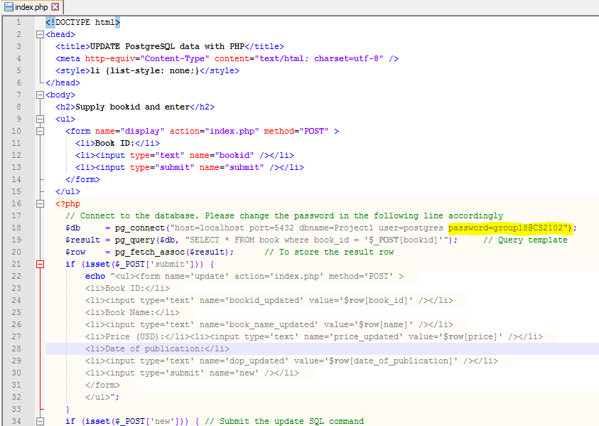

Step 13: Run the php on localhost

Just open a new tab <http://127.0.0.1/index.php>

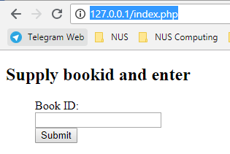

Step 14: Try find an id that already exist in table

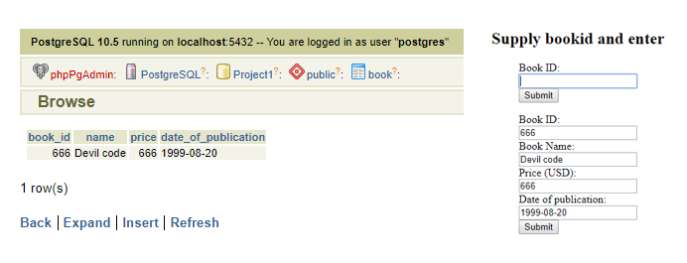

Step 15: Try add something that does not exist

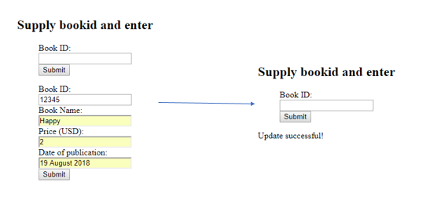

By right should appear in the database, but mine didnt, somehow it overwrote the existing (either php file or the table in database gt issue)