Test Table

|  |  |  |  |  |  |  |  |  |  |
| --- | --- | --- | --- | --- | --- | --- | --- | --- | --- |
| Mark | Plain-Text | Plugboard | Rotor 1 | Rotor 2 | Rotor 3 | Reflector | Encryption | Decryption | Cipher-Text |
|  |  |  |  |  |  |  |  |  |
| **Working** | **Working** | **Working** | **Working** | **Working** | **Working** | **Working** | **Working** | **Working** |

* Plain-Text

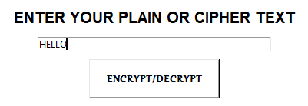



* Plugboard
* Default-Plugboard

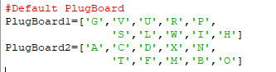

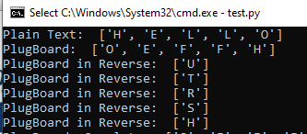

* Custom-Plugboard

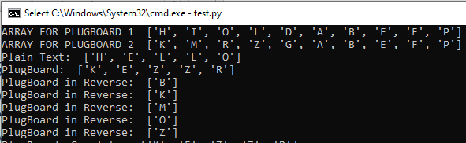

* Rotor 1

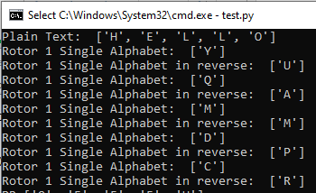

* Rotor 2

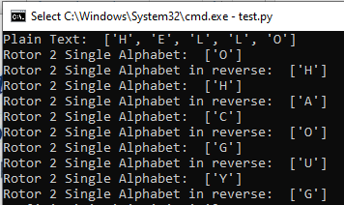

* Rotor 3

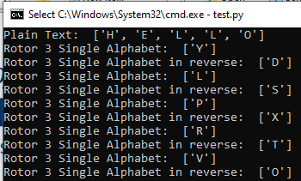

* Reflector

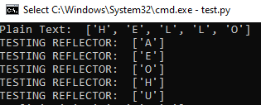

* Encryption

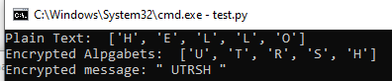

* Decryption

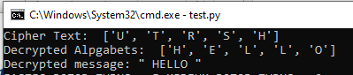

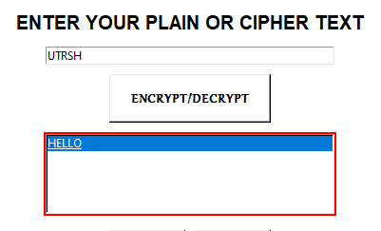

USABILITY Test Table

|  |  |  |  |  |  |
| --- | --- | --- | --- | --- | --- |
| Mark | Rotors | Plugboard | Text-Box | Output-Box | Export |
|  |  |  |  |  |
| **Working** | **Working** | **Working** | **Working** | **Working** |

* Rotors

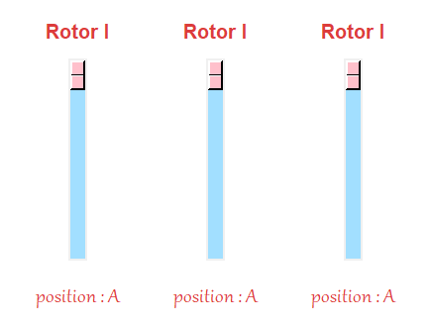 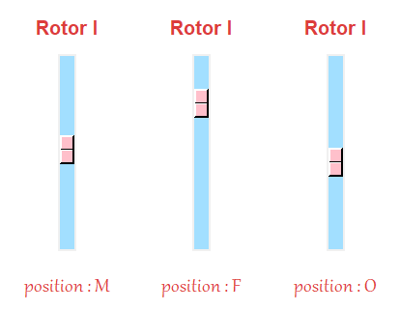

* Plugboard

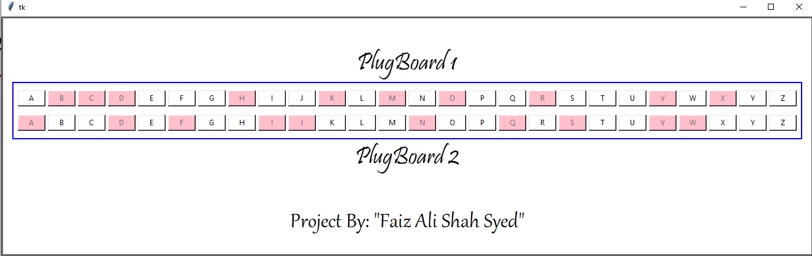

* Text-box & Output-box

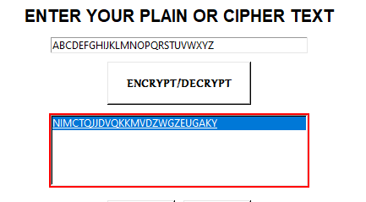

* Export

