**Task-1**

**Hash Functions on Windows and Linux**

Using Command Prompt to view image hashes

For single image use command “**certutil -hashfile img.jfif sha384**”

For all images use command “**FORFILES /M *.jfif /C "cmd /C certutil -hashfile @FILE"**”

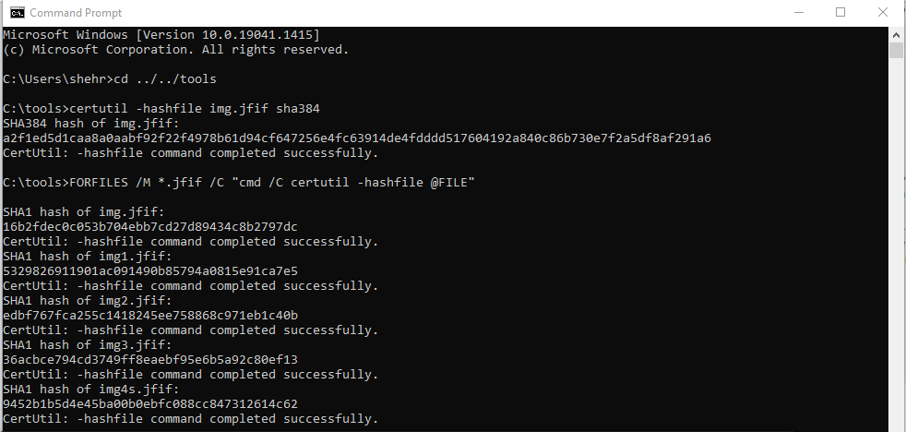

Using Windows-Powershell to view image hashes

For all images use command “**Get-FileHash -A SHA1 *.jfif**”

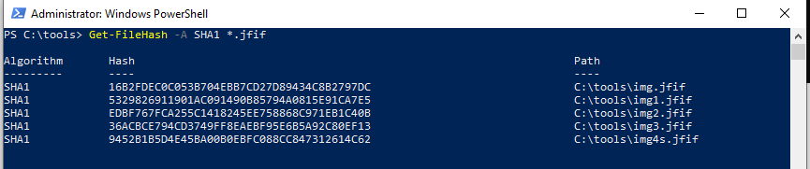

Using Kali-Linux to view hashes of a file

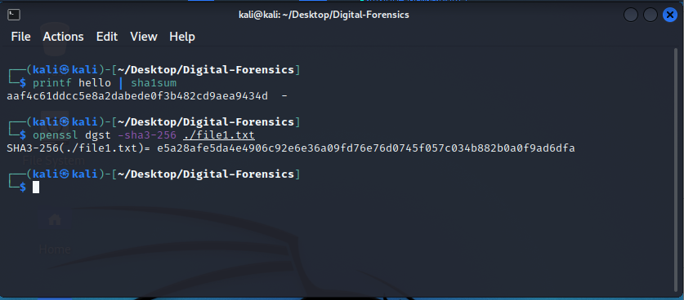

**Task-2**

**Creating a Virtual Hard Drive and Attaching it to a VM using Oracle VirtualBox**

Here we are creating 1GB virtual hard disk

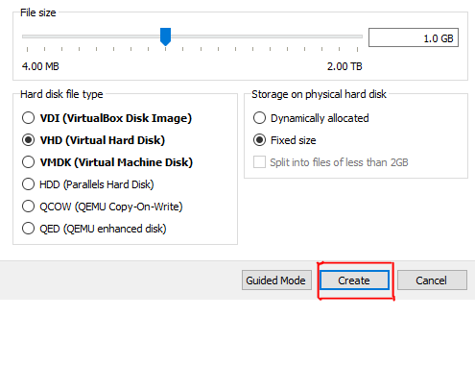

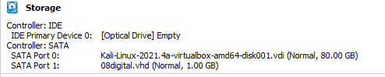

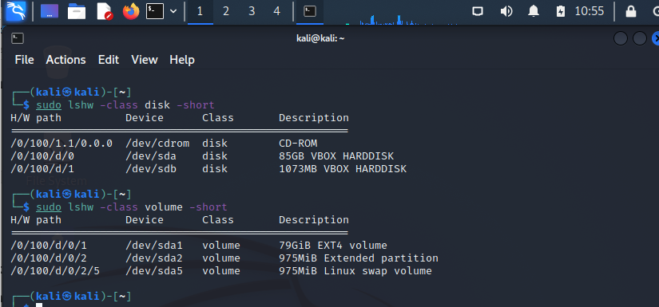

After creating the hard disk, we have to create new partition in our Linux machine using gparted software

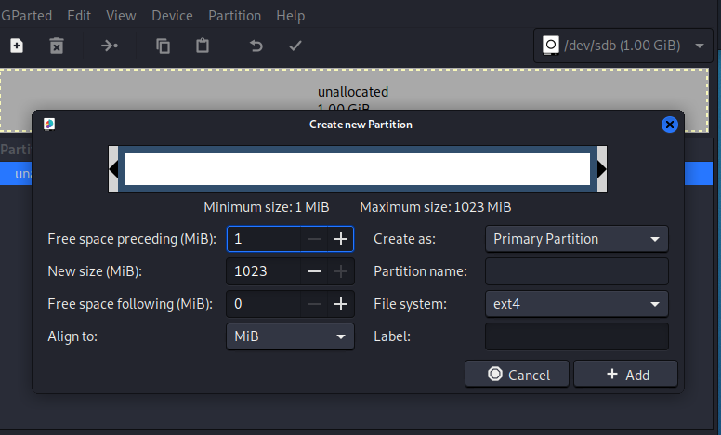

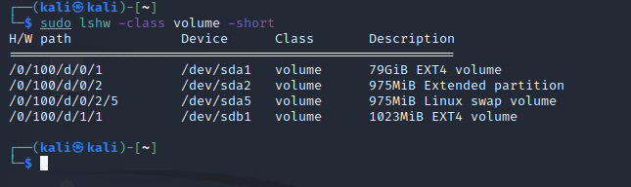

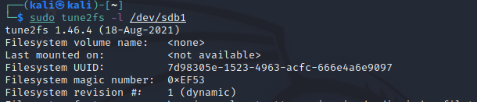

After mounting it we see that it has been given a random name so we will change it to “bitcoin” using tune2fs tool

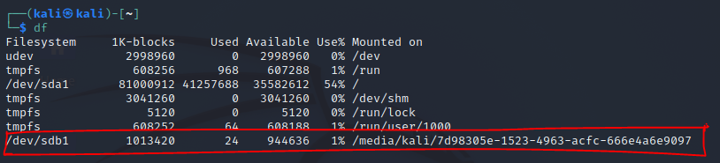

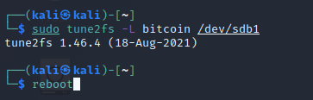

After rebooting the name has been changed our next step is to take ownership of the hard disk

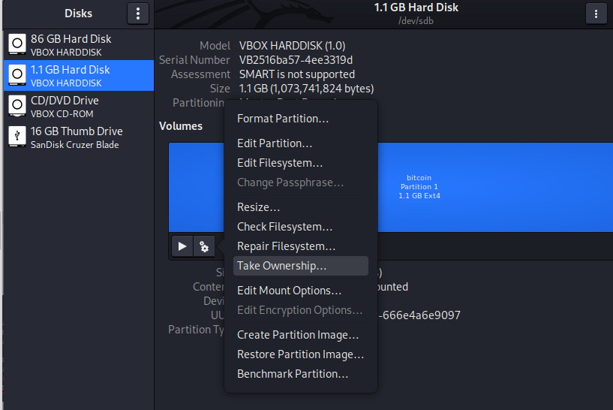

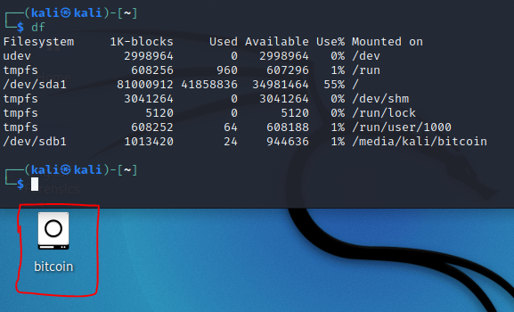

**Task-4**

**Linux Image Carving using recoverjpeg Tool**

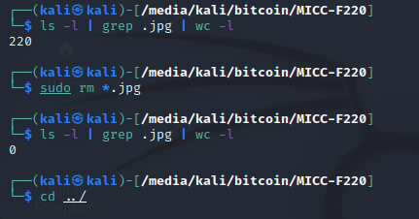

After downloading the folders and unzipping them, we deleted .jpg extension images. After that we use **recoverjpeg** **tool** to recover the images back in to **jpegrecovery** folder.

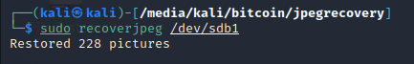

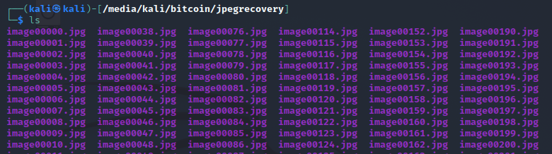

**Task-5**

**Data Recovery using foremost Tool**

Using Foremost tool to recover the images

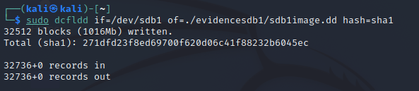

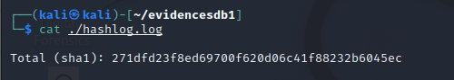

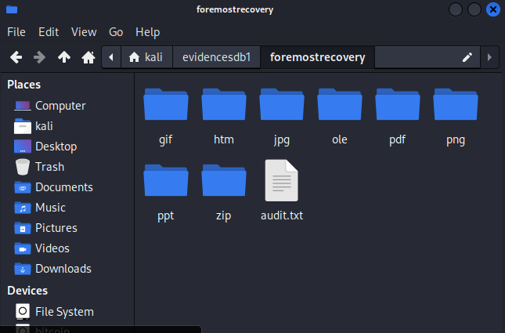

**Task-6**

**Data Recovery using scalpel Tool**

Using scalpel tool to recover deleted images

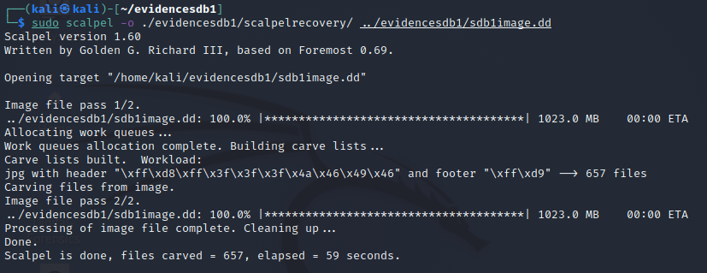

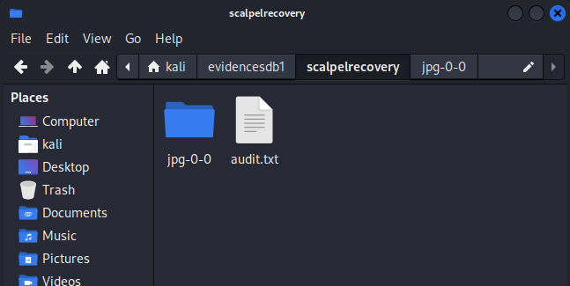

**Task-7**

**Data Recovery and Information Retrieval using bulk_extractor**

Using tool called bulk_extractor to recover deleted files

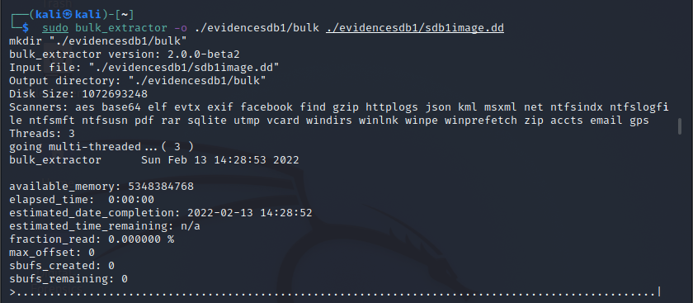

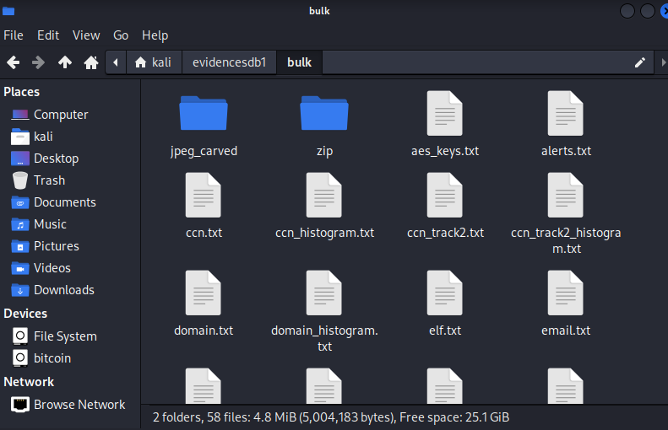

**Summary**

This whole lab was to learn about creating or dealing with virtual hard-disk and deleting or recovering images using different tools. First of all, we created a virtual hard disk and gave it 1GB storage file-type ext4. After that we went to the kali linux setting and added it as virtual box storage device. Then we used **gparted** tool to allocate it as a hard-disk and then we renamed it using tool called **tune2fs.** After that we went to the image’s recovery section, at first, we download two files that were given to us and then we unzipped them in our custom created hard disk. We then deleted all the images from both folders. Now we used a tool called **recoverjpeg** to recover all of the deleted images and stored it in a file called jpegrecovery. Then we use a tool called foremost to recover the deleted content from the hard disk. Scalpel is tool similar to foremost but scalpel might carve more files than foremost. We have also used it to recover the deleted content from the hard disk. Bulk_extractor is another recovery tool but digs more information such as email addresses, encryption keys, domain names, credit card numbers, among others that can also be stored on suspect media.

**🡨END🡪**