并行程序设计实践大作业

专业和班级：计算机2018-5
姓名：刘羽翯
学号：201801120916
时间：2020年10月30日

目录
并行程序的发展和当前应用概述 3
GPU编程实践作业 3
MPICH编程实践作业 7

并行程序的发展和当前应用概述
40 年代开始的现代计算机发展历程可以分为两个明显的发展时代：串行计算时代、并行计算时代。每一个计算时代都从体系结构发展开始，接着是系统软件、应用软件，最后随着问题求解环境的发展而达到顶峰。创建和使用并行计算机的主要原因是因为并行计算机是解决单处理器速度瓶颈的最好方法之一。多核计算平台的普及化使得并行程序设计成为一种编程技术主流。其实并行计算的软件技术早已存在了几十年，然而其原来主要服务于高性能计算一类的应用，所以并行化编程一直也都为阳春白雪的光环笼罩。任何新事物，都是在旧事物的基础上发展演变出来的，新的并行编程模型的产生也是一样，不会完全摆脱现在流行的并行编程模型的影响。目前流行的并行编程模型主要有以下几种：
（1）SMP编程模型
（2）消息传送编程模型
（3）数据并行编程模型
（4）面向对象等其他编程模型
预测模型的构造和模拟、工程设计和自动化、能源勘探、医学、军事、机械制造、计算数学、石油资源模拟问题，常常涉及到现代的复杂数学问题和计算方法，具有很强的实用性。这些领域的许多现象的描述都是各种数学物理方程，从数学物理方程的求解方法导出大型稀疏线性方程组，而并行计算在求解大型稀疏线性方程组方面具有巨大的优势。到目前为止，并行程序已经在勘探地球物理、机械制造、计算数学、人工智能、图像处理等领域得到了广泛的应用。

GPU编程实践作业
编写一个矩阵乘法的GPU并行程序，并且与对应规模的串行程序进行运行时间的比对（n=10，100，200，500，1000，1500，2000……）
矩阵A（n，n）
矩阵B（n，n）
C = A x B

程序源代码
1  2  3  4  5  6  7  8  9  10  11  12  13  14  15  16  17  18  19  20  21  22  23  24  25  26  27  28  29  30  31  32  33  34  35  36  37  38  39  40  41  42  43  44  45  46  47  48  49  50  51  52  53  54  55  56  57  58  59  60  61  62  63  64  65  66  67  68  69  70  71  72  73  74  75  76  77  78  79  80  81  82  83  84  85  86  87  88  89  90  91  92  93  94  95  96  97  98  99  100  101  102 | #include <fstream>  #include <iostream>  #include <cstdlib>  #include <cuda_runtime.h>  #include <ctime>  using namespace std;  const int N = 2000;  const int x = 20;  const int y = 20;  // 10 10X10  // 100 10X10  // 200 10X10  // 500 20X20  // 1000 25X25 20X20 10X10  // 1500 25X25 30X30  // 2000 25X25 20X20 10X10  // 核函数  __global__ void mul(double A[N][N], double B[N][N], double C[N][N]) {  int i = blockDim.x * blockIdx.x + threadIdx.x;  int j = blockDim.y * blockIdx.y + threadIdx.y;  for (int k = 0; k < N; k++) {  C[i][j] += A[i][k] * B[k][j];  }  }  int main() {  string inName = "in" + to_string(N);  string outName = "out_gpu" + to_string(N);  ifstream fin(inName);  ofstream fout(outName);  // 分配存储空间  double (*a)[N] = new double[N][N];  double (*b)[N] = new double[N][N];  double (*c)[N] = new double[N][N];  // 给数组中的元素赋值  for (int i = 0; i < N; i++) {  for (int j = 0; j < N; j++) {  fin >> a[i][j];  }  }  for (int i = 0; i < N; i++) {  for (int j = 0; j < N; j++) {  fin >> b[i][j];  }  }  for (int i = 0; i < N; i++) {  for (int j = 0; j < N; j++) {  c[i][j] = 0;  }  }  // ==========  double (*A)[N] = new double[N][N];  double (*B)[N] = new double[N][N];  double (*C)[N] = new double[N][N];  cudaMalloc((void**)&A, sizeof(double)*N*N);  cudaMalloc((void**)&B, sizeof(double)*N*N);  cudaMalloc((void**)&C, sizeof(double)*N*N);  cudaMemcpy(A, a, sizeof(double)*N*N, cudaMemcpyHostToDevice);  cudaMemcpy(B, b, sizeof(double)*N*N, cudaMemcpyHostToDevice);  cudaEvent_t start, finish;  float elapsedTime;  cudaEventCreate(&start);  cudaEventCreate(&finish);  cudaEventRecord(start, 0);  // ====  dim3 threadPerBlock(x, y);  dim3 blocksPerGrid(N / threadPerBlock.x, N / threadPerBlock.y);  mul <<< blocksPerGrid, threadPerBlock >>> (A, B, C);  // ====  cudaEventRecord(finish, 0);  cudaEventSynchronize(start);  cudaEventSynchronize(finish);  cudaEventElapsedTime(&elapsedTime, start, finish);  cudaMemcpy(c, C, sizeof(double)*N*N, cudaMemcpyDeviceToHost);  // ==========  // 输出计算结果  for (int i = 0; i < N; i++) {  for (int j = 0; j < N; j++) {  if (j == 0) {  fout << c[i][j];  } else {  fout << " " << c[i][j];  }  }  fout << endl;  }  // 输出运行时间  cout << elapsedTime << " ms" << endl;  // 释放分配的空间  cudaFree(A);  cudaFree(B);  cudaFree(C);  delete [] a;  delete [] b;  delete [] c;  return 0;  }

实验结果
n | 10 | 100 | 200 | 500 | 1000 | 1500 | 2000
CPU（ms） | 0 | 10 | 70 | 960 | 7640 | 30170 | 111480
GPU（ms） | 0.236928 | 0.479584 | 1.79219 | 40.3474 | 365.949 | 875.436 | 2136.89
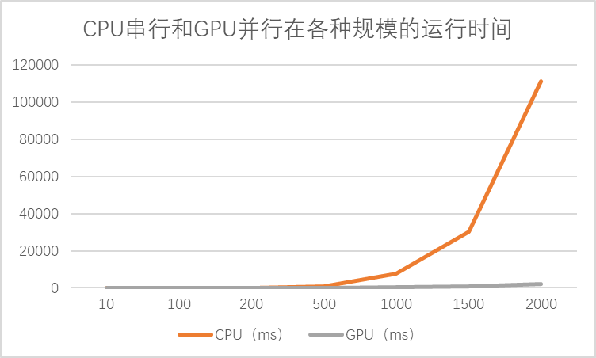

 | 25X25 | 20X20 | 15X15
1000 | 367.593 | 308.576 | 223.603
2000 | 2164.45 | 1799.2 | 1429.85
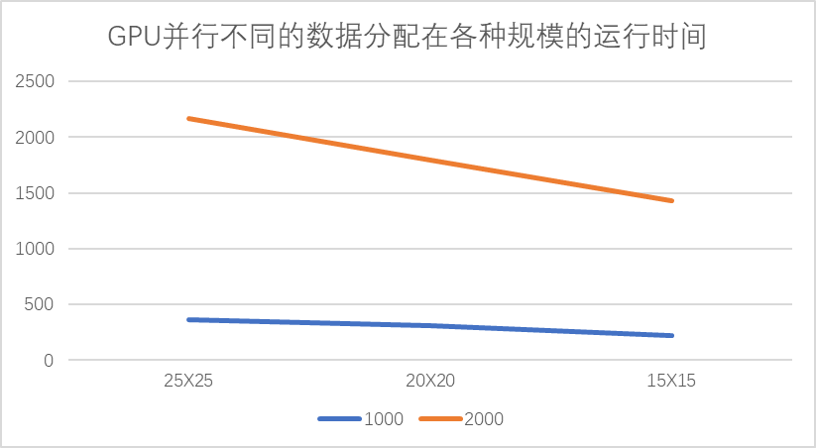

MPICH编程实践作业
作业一：
MPI源代码
1  2  3  4  5  6  7  8  9  10  11  12  13  14  15  16  17  18  19  20  21  22  23  24  25  26  27  28  29  30  31  32  33  34  35  36  37  38  39  40  41  42 | #include <stdio.h>  #include "mpi.h"  int main(int argc, char **argv) {  double dx = 1e-8;  int n = 1 / dx;  int rank, size, i;  MPI_Init(&argc, &argv);  MPI_Comm comm = MPI_COMM_WORLD;  MPI_Status status;  MPI_Comm_rank(comm, &rank);  MPI_Comm_size(comm, &size);  // 每个块的大小  int blockSize = n / size;  double sum = 0, start, finish;  if (rank == 0) {  // 开始计时  start = MPI_Wtime();  }  for (i = rank * blockSize; i < rank * blockSize + blockSize; i++) {  sum += dx / (1 + (i * dx) * (i * dx));  }  // 将其他进程的计算结果发送到0号进程  if (rank != 0) {  MPI_Send(&sum, 1, MPI_DOUBLE, 0, 99, comm);  } else {  // 0号进程接收其他进程的计算结果，并进行累加  double total = 0, tmp;  for (i = 1; i < size; i++) {  MPI_Recv(&tmp, 1, MPI_DOUBLE, i, 99, comm, &status);  total += tmp;  }  total += sum;  finish = MPI_Wtime();  // 输出计算结果和时间  printf("PI = %lf\n", total * 4);  printf("Time = %lf\n", finish - start);  }  MPI_Finalize();  return 0;  }

OpenMP源代码
1  2  3  4  5  6  7  8  9  10  11  12  13  14  15  16  17  18  19  20  21  22  23  24 | #include <cstdio>  #include <ctime>  #include <omp.h>  int main() {  // 微小变量dx  double dx = 1e-8;  // 迭代次数  int n = 1 / dx;  // 开始计时  double start = omp_get_wtime();  double sum = 0;  // OpenMP优化for循环  #pragma omp parallel for reduction(+:sum)  for (int i = 0; i < n; i++) {  sum += dx / (1 + (i * dx) * (i * dx));  }  // 结束计时  double finish = omp_get_wtime();  // 输出结果和时间  printf("PI = %lf\n", sum * 4);  printf("Time = %lf\n", finish - start);  return 0;  }

MPI+OpenMP源代码
1  2  3  4  5  6  7  8  9  10  11  12  13  14  15  16  17  18  19  20  21  22  23  24  25  26  27  28  29  30  31  32  33  34  35  36  37  38  39  40  41  42  43  44  45  46 | #include <stdio.h>  #include "mpi.h"  #include "omp.h"  int main(int argc, char **argv) {  double dx = 1e-8;  int n = 1 / dx;  int rank, size, i;  MPI_Init(&argc, &argv);  MPI_Comm comm = MPI_COMM_WORLD;  MPI_Status status;  MPI_Comm_rank(comm, &rank);  MPI_Comm_size(comm, &size);  // 每个块的大小  int blockSize = n / size;  double sum = 0, start, finish;  if (rank == 0) {  // 开始计时  start = MPI_Wtime();  }  // OpenMP优化for循环  #pragma omp parallel for reduction(+:sum)  for (i = rank * blockSize; i < rank * blockSize + blockSize; i++) {  sum += dx / (1 + (i * dx) * (i * dx));  }  // 将其他进程的计算结果发送到0号进程  if (rank != 0) {  MPI_Send(&sum, 1, MPI_DOUBLE, 0, 99, comm);  } else {  // 0号进程接收其他进程的计算结果，并进行累加  double total = 0, tmp;  for (i = 1; i < size; i++) {  MPI_Recv(&tmp, 1, MPI_DOUBLE, i, 99, comm, &status);  total += tmp;  }  total += sum;  // 结束计时  finish = MPI_Wtime();  // 输出计算结果和时间  printf("PI = %lf\n", total * 4);  printf("Time = %lf\n", finish - start);  }  MPI_Finalize();  return 0;  }

实验结果
 | CPU串行 | MPI | OpenMP | MPI+OpenMP
1.00E-09 | 3.524 | 2.87211 | 1.041123 | 1.659399
1.00E-08 | 0.35 | 0.292236 | 0.11072 | 0.308473
1.00E-07 | 0.036 | 0.029169 | 0.011789 | 0.148021
1.00E-06 | 0.003 | 0.003516 | 0.008378 | 0.112544

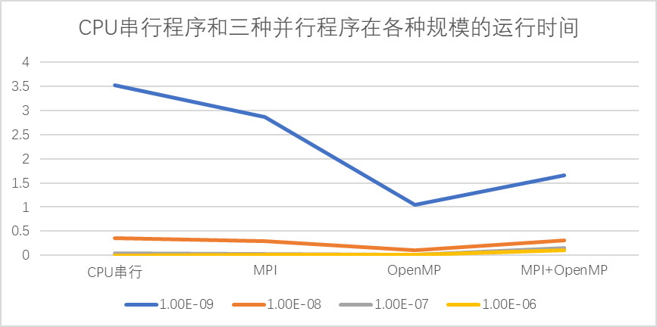
作业二：
MPI源代码
1  2  3  4  5  6  7  8  9  10  11  12  13  14  15  16  17  18  19  20  21  22  23  24  25  26  27  28  29  30  31  32  33  34  35  36  37  38  39  40  41  42  43  44  45  46  47  48  49  50  51  52  53  54 | #include <stdio.h>  #include <stdlib.h>  #include <time.h>  #include "mpi.h"  #define N 1e8  // 判断该点是否在圆内  int func(double x, double y, double center_x, double center_y, double r) {  return ((x - center_x) * (x - center_x) + (y - center_y) * (y - center_y)) <= r * r;  }  int main(int argc, char **argv) {  // 初始化随机种子  srand((unsigned int)time(NULL));  MPI_Init(&argc, &argv);  MPI_Comm comm = MPI_COMM_WORLD;  MPI_Status status;  int rank, size, i, n = N;  MPI_Comm_size(comm, &size);  MPI_Comm_rank(comm, &rank);  // 圆心坐标和半径  double r = 0.5, center_x = 0.5, center_y = 0.5, start, finish;  // 每个块的大小  int blockSize = n / size;  if (rank == 0) {  // 开始计时  start = MPI_Wtime();  }  int cnt = 0;  for (i = rank * blockSize; i < rank * blockSize + blockSize; i++) {  double x = (double) rand() / RAND_MAX;  double y = (double) rand() / RAND_MAX;  if (func(x, y, center_x, center_y, r)) {  ++cnt;  }  }  if (rank != 0) {  MPI_Send(&cnt, 1, MPI_INT, 0, 99, comm);  } else {  int total = 0, tmp;  for (i = 1; i < size; i++) {  MPI_Recv(&tmp, 1, MPI_INT, i, 99, comm, &status);  total += tmp;  }  total += cnt;  // 结束计时  finish = MPI_Wtime();  // 输出计算结果和时间  printf("PI = %lf\n", total * 4.0 / n);  printf("Time = %lf\n", finish - start);  }  MPI_Finalize();  return 0;  }

OpenMP源代码
1  2  3  4  5  6  7  8  9  10  11  12  13  14  15  16  17  18  19  20  21  22  23  24  25  26  27  28  29  30  31  32  33  34  35 | #include <cstdio>  #include <cstdlib>  #include <ctime>  #include <omp.h>  #define N 1e8  // 判断该点是否在圆内  int func(double x, double y, double center_x, double center_y, double r) {  return ((x - center_x) * (x - center_x) + (y - center_y) * (y - center_y)) <= r * r;  }  int main() {  srand((unsigned int) time(NULL));  double r = 0.5, center_x = 0.5, center_y = 0.5;  int cnt = 0;  int n = N;  // 开始计时  double start = omp_get_wtime();  // OpenMP优化for循环  #pragma omp parallel for reduction(+:cnt)  for (int i = 0; i < n; i++) {  double x = (double) rand() / RAND_MAX;  double y = (double) rand() / RAND_MAX;  if (func(x, y, center_x, center_y, r)) {  ++cnt;  }  }  // 结束计时  double finish = omp_get_wtime();  // 输出计算结果和时间  printf("PI = %lf\n", cnt * 4.0 / N);  printf("Time = %lf\n", (finish - start));  return 0;  }

MPI+OpenMP源代码
1  2  3  4  5  6  7  8  9  10  11  12  13  14  15  16  17  18  19  20  21  22  23  24  25  26  27  28  29  30  31  32  33  34  35  36  37  38  39  40  41  42  43  44  45  46  47  48  49  50  51  52  53  54  55  56  57 | #include <stdio.h>  #include <stdlib.h>  #include <time.h>  #include "mpi.h"  #include "omp.h"  #define N 1e8  // 判断该点是否在圆内  int func(double x, double y, double center_x, double center_y, double r) {  return ((x - center_x) * (x - center_x) + (y - center_y) * (y - center_y)) <= r * r;  }  int main(int argc, char **argv) {  // 初始化随机种子  srand((unsigned int)time(NULL));  MPI_Init(&argc, &argv);  MPI_Comm comm = MPI_COMM_WORLD;  MPI_Status status;  int rank, size, i, n = N;  MPI_Comm_size(comm, &size);  MPI_Comm_rank(comm, &rank);  // 圆心坐标和半径  double r = 0.5, center_x = 0.5, center_y = 0.5, start, finish;  // 每个块的大小  int blockSize = n / size;  if (rank == 0) {  // 开始计时  start = MPI_Wtime();  }  int cnt = 0;  // OpenMP优化for循环  #pragma omp parallel for reduction(+:cnt)  for (i = rank * blockSize; i < rank * blockSize + blockSize; i++) {  double x = (double) rand() / RAND_MAX;  double y = (double) rand() / RAND_MAX;  if (func(x, y, center_x, center_y, r)) {  ++cnt;  }  }  if (rank != 0) {  MPI_Send(&cnt, 1, MPI_INT, 0, 99, comm);  } else {  int total = 0, tmp;  for (i = 1; i < size; i++) {  MPI_Recv(&tmp, 1, MPI_INT, i, 99, comm, &status);  total += tmp;  }  total += cnt;  // 结束计时  finish = MPI_Wtime();  // 输出计算结果和时间  printf("PI = %lf\n", total * 4.0 / n);  printf("Time = %lf\n", finish - start);  }  MPI_Finalize();  return 0;  }

实验结果

 | CPU串行 | MPI | OpenMP | MPI+OpenMP
1.00E+09 | 52.516 | 23.26808 | 15.66943 | 45.024098
1.00E+08 | 4.969 | 2.408503 | 1.622264 | 3.662788
1.00E+07 | 0.458 | 0.216475 | 0.142642 | 0.390876
1.00E+06 | 0.043 | 0.021946 | 0.01878 | 0.155687
