## Logical Volume Management Cheat Sheet

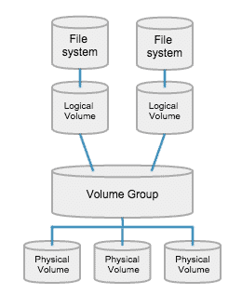

Run all commands as root with **sudo**. Example: **sudo lvs**

pvs : Show short details of physical volumes  
vgs : Show short details of volume groups  
lvs : Show short details of logical volumes

For the purpose of this cheat sheet I will use “*vgname*” in place of what your volume group name is, so ensure you replace *vgname* anywhere in this document with YOUR volume group name. To see what Volume Groups your system has, run **vgs** in the terminal. I will also use */dev/sdxx* as a device name. Replace this with the partition you are planning to use on your new drive. You can confirm this with **sudo fdisk -l**

To find where your physical volume path is, run **lvdisplay** and look for the LV Path in the list. We will use this path with the lvextend command later.

### To extend partitions to a new drive

Create empty LVM partition on new drive with fdisk or gparted.

Create Physical Volume on new disk with **pvcreate /dev/sdxx**

You can verify the new partition name with **sudo pvs** which should have a blank entry under VG.

Extend your Volume Group to the new disk with **vgextend vgname /dev/sdxx**

Extend your logical volume and resize the partition inside with **lvextend -l +100%FREE -r /dev/vgname/root**

On the previous command, you can change the **+100%FREE** to any value depending on how much space you want the new logical volume to take on the new drive. You could say **+50%FREE**, or, if you want to extend if by a specific size, use **lvextend -L +10G -r /dev/vgname/root** where the +10G extends it by 10 Gigabytes. You can also use **+500M** for 500 Megabytes and so on. Note that if you specify sizes, the command changes from lower-case -l to upper-case -L after lvextend.



If all was successful, you have now extended your space to the new drive. Congrats!

***-DorianDotSlash***