**Paper Topic Classification with Active Learning**

Daehyun Cho 2020010429, Dept. of Artificial Intelligence

Bayesian Machine Learning (XAI623), 2021 Fall, Project Proposal Report (Due Oct 28, 6PM)

1. Project Proposal
   1. Project Goal

I apply active learning to A.I. subfield classification task with the following pipeline.

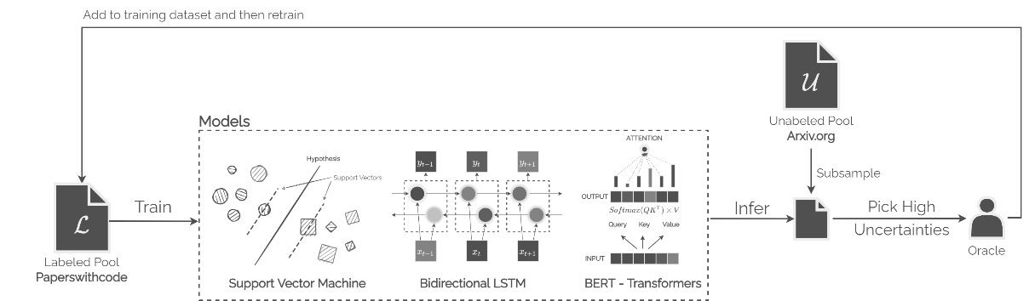

Through this, I would like to learn below

* Proper study and application of active learning in current pipeline.
* Use less data to achieve high performance
  1. Data Description

Here I use two databases – **paperswithcode** and **arxiv** – which contain paper title, abstract and the subfield in A.I. Title and abstract will be used as an input feature for the model to predict the subfield. The subfields are as follows – adversarial, audio, computer-code, computer-vision, graphs, knowledge-base, medical, methodology, miscellaneous, music, natural-language, playing-games, reasoning, robots, speech and time-series. Since the arxiv dataset does not contain this detailed subfield but only tells rough subfield in the computer science or statistics, this will be used as an unlabeled pool.

The paperswithcode dataset contains around 50k data and arxiv from computer science only contains 300k papers. Number of data intersecting between two databases are 19k and paperswithcode alone has 29k. Therefore, I plan to use 29k non-intersecting data as a labeled pool and 19k as unlabeled pool.

* 1. Proposed Methods
* **Models:** SVM, Forests, Recurrent networks, Attention-based networks
* **Sampling Method:** Random sampling, BALD, BatchBALD
* **Uncertainty approximation:** One sample (without approximation), MC Dropout, Full Ensemble

1. Related Works & Reference

Detailed explanations about the related works were delivered through the video.

[1] Shen, Yanyao, et al. "Deep active learning for named entity recognition." arXiv preprint arXiv:1707.05928 (2017).

[2] Houlsby, Neil, et al. "Bayesian active learning for classification and preference learning." arXiv preprint arXiv:1112.5745 (2011).

[3] Settles, Burr. "Active learning literature survey." (2009).

[4] Margatina, Katerina, Loic Barrault, and Nikolaos Aletras. "Bayesian Active Learning with Pretrained Language Models." arXiv preprint arXiv:2104.08320 (2021).

[5] Houlsby, Neil, et al. "Bayesian active learning for classification and preference learning." arXiv preprint arXiv:1112.5745 (2011).

[6] Gal, Yarin, and Zoubin Ghahramani. "Dropout as a bayesian approximation: Representing model uncertainty in deep learning." international conference on machine learning. PMLR, 2016.

[7] Kirsch, Andreas, Joost Van Amersfoort, and Yarin Gal. "Batchbald: Efficient and diverse batch acquisition for deep bayesian active learning." Advances in neural information processing systems 32 (2019): 7026-7037.

[8] Beluch, William H., et al. "The power of ensembles for active learning in image classification." Proceedings of the IEEE Conference on Computer Vision and Pattern Recognition. 2018.