**UVVM Essential Mechanisms** –Quick Reference  
  
This document explains some of the essential mechanisms necessary for running UVVM, in addition to helpful and important VVC status and configuration records which are accessible directly from the testbench. A more comprehensive review can be found in the VVC Framework Manual.

1 Libraries 2

2 UVVM Initialization 2

3 UVVM and VVC Shared Variables 3

4 VVC Status, Configuration and Transaction information 4

5 Multiple Central Sequencers 4

6 Compile scripts 5



# Libraries

In order to use a VVC the following libraries need to be included:

library uvvm_util;

context uvvm_util.uvvm_util_context;

library uvvm_vvc_framework;

use uvvm_vvc_framework.ti_vvc_framework_support_pkg.all;

library bitvis_vip_<name>;

context bitvis_vip_<name>.vvc_context;

# UVVM Initialization

The following mechanisms are required for running UVVM

|  |  |
| --- | --- |
| **Mechanism** | **Description** |
| **ti_uvvm_engine** | **ti_uvvm_engine**  This entity contains a process that will initialize the UVVM environment, and has to be instantiated in the testbench harness, or alternatively in the top-level testbench.  Example:  i_ti_uvvm_engine : entity uvvm_vvc_framework.ti_uvvm_engine; |
| **await_uvvm_initialization()** | **await_uvvm_initialization(VOID)**  This procedure is a blocking procedure that has to be called from the testbench sequencer, prior to any VVC calls, to ensure that the UVVM engine has been initialized and is ready. This procedure will check the shared_uvvm_state on each delta cycle until the UVVM engine has been initialized.  Note that this method is depending on the ti_uvvm_engine mechanism.  Note that this method uses the t_void parameter, defined in the UVVM Utility Library types package.  Example:  await_uvvm_initialization(VOID); |

# UVVM and VVC Shared Variables

UVVM and VVC shared variables are defined in the UVVM methods package and VVC methods package, respectively.

Shared variables

|  |  |
| --- | --- |
| **Shared variable** | **Description** |
| shared_uvvm_status | Shared variable providing access to VVC related information via the info_on_finishing_await_any_completion record element, i.e.  shared_uvvm_status.info_on_finishing_await_any_completion  This record element gives access to the name, command index and the time of completion of the VVC that first fulfilled the await_any_completion(). The available record fields are:  vvc_name : string -- default “no await_any_completion() yet”  vvc_cmd_idx : natural -- default 0  vvc_time_of_completion : time -- default 0 ns  For more information regarding other fields available in the shared_uvvm_status see the UVVM Util QuickRef, section 1.4 |
| shared_<vvc_name>_vvc_config | Shared variable providing access to configuration parameters for each VVC instance and channel if applicable. E.g.  shared_sbi_vvc_config(1).inter_bfm_delay.delay_type := TIME_START2START;  shared_uart_vvc_config(RX,1).bfm_config.bit_time := C_BIT_TIME; |
| shared_<vvc_name>_vvc_status | Shared variable providing access to status parameters for each VVC instance and channel if applicable. E.g.  v_num_pending_cmds := shared_sbi_vvc_status(1).pending_cmd_cnt;  v_current_cmd_idx := shared_uart_vvc_status(TX,2).current_cmd_idx;  v_previous_cmd_idx := shared_uart_vvc_status(TX,2).previous_cmd_idx; |
| shared_<vvc_name>_transaction_info | Shared variable providing access to VVC instances transaction information to include in the wave view during simulation.  Available information is dependent on VVC type and typical information is:  operation : t_operation; -- default NO_OPERATION  data : std_logic_vector(C_VVC_CMD_DATA_MAX_LENGTH-1 downto 0); -- default 0x0  msg : string(1 to C_VVC_CMD_STRING_MAX_LENGTH); -- default empty |

# VVC Status, Configuration and Transaction information

The VVC status, configuration and transaction information records are defined in each individual VVC methods package.

Each VVC instance and channel can be configured and useful information can be accessed from the testbench via dedicated shared variables.

From the VVC configuration shared variable, one is given the ability to tailor each VVC to one’s needs, in addition to access the BFM configuration record via the bfm_config identifier. In addition to BFM configuration possibility, the configuration settings consist of command and result queue settings, BFM access separation delay and a VVC dedicated message ID panel.  
Note that some BFMs require user configuration, e.g. the bit_time setting in serial interface BFMs.

The VVC status shared variable provide access to the command status parameters for each of the VVCs, such as the current and previous command index, and the number of pending commands in the VVCs command queue. This provide a helpful tool, e.g. when synchronizing VVCs in the test sequencer using the await_completion() or await_any_completion() methods.

When using a wave viewer during simulation, the transaction shared variable provides helpful information regarding current VVC operation and transaction information such as address and data. Note that the accessible fields depend on the VVC and its implementation. An example of two SBI VVCs performing FIFO write operations, followed by check operations, is shown in Figure 4‑1.

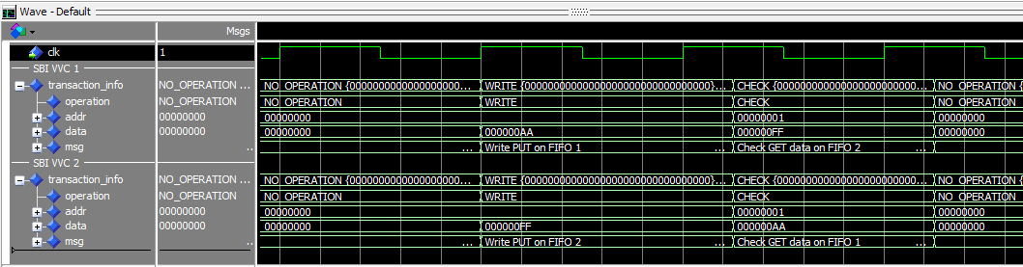

Figure 4‑1 VVC Transaction info example

# Multiple Central Sequencers

A structured test environment is important and we recommend the use of a test harness to instantiate VVCs, DUT, clock generator and so forth. The testbench may consist of one or more test sequencers which are used to control the complete testbench architecture with any number of VVCs, although for a better testbench overview we recommend to have a single central test sequencer only.

# Compile scripts

There are compile scripts for all UVVM components located in the script folder of each UVVM component.

In UVVM VVC Framework the script compile_all.do compiles all UVVM components. This script may be called with one input argument which is the directory of the module when called from another directory. The libraries are compiled to the working directory.

The compile scripts located in the script folder of all UVVM VIPs, compile_uvvm.do, compile_src.do and compile_bfm.do, may also be called with the same input argument mentioned previously.

Disclaimer: This IP and any part thereof are provided "as is", without warranty of any kind, express or implied, including but not limited to the warranties of merchantability, fitness for a particular purpose and noninfringement.  
In no event shall the authors or copyright holders be liable for any claim, damages or other liability, whether in an action of contract, tort or otherwise, arising from, out of or in connection with this IP.

**INTELLECTUAL**

**PROPERTY**